

Name: Mariam Begum
Student ID: 2324210
Module Code: BMHP5019,
Module BMHP5015
Assignment title: Assignment 1
Lecturer: Caroline Salami
Date of submission 20.04.2026

DSA Student
I confirm that I have used AL generated in my work as a DSA student at the university.
https://www.grammarly.com/ 27th March 2026

Introduction
This assignment critically reflects on the key learning experiences gained from Units 1, 2, 3, and 4 of the modules "Changemakers: Building Your Personal Brand for Sustainable Employment." The purpose of this reflection is to evaluate how the knowledge and skills developed throughout the module have contributed to my personal and professional growth within the health and social care sector. Reflection is an essential process that supports continuous learning and improvement in professional practice (Graham Gibbs, 1988).

Unit 1 focused on developing my understanding of personal branding through concepts such as ambition, emotional intelligence, and professional autonomy. Unit 2 expanded my awareness of working in diverse and global environments by exploring comfort zones, networking, and reflective practice. Unit 3 helped me recognise opportunities through concepts such as perception, serendipity, and transferable skills. Finally, Unit 4 strengthened my resilience by addressing limiting beliefs, grit, and social learning.

Throughout this assignment, I will draw on my own experiences, including my 20 years of work in care and my responsibilities as a parent, to demonstrate how these concepts have influenced my development. This reflection highlights how self-awareness, adaptability, and continuous learning can support sustainable employment in health and social care.

Reflection on Unit 1: Brand You
Unit 1, I focused on developing self-awareness and understanding key aspects of personal and professional identity within the health and social care sector. The main Topics explored included ambition, emotional intelligence and professional autonomy. These concepts encouraged me to reflect on my strengths and development areas and my future career goals.

Ambition

Ambition plays a vital role in motivating individuals to achieve their career goals and continuously improve their knowledge and skills. Through this unit, I have realised that having a clear ambition is essential in developing a strong personal brand. I have worked in the care sector for 20 years, which shows my commitment and dedication; however, I had not clearly defined my long-term career goals.

I now I recognise my ambitions to become a care manager for example in my current role on support individuals with diverse needs but I want to take a greater leadership and decision making responsibilities as a parent of a seven years old I sometimes find it challenging to balance work studies and family responsibilities however this has motivated me to improve my time management and stay focused on my goals and now I take greater responsibility for my learning by engaging more activity literally in studies on competing coursework on time

Emotional Intelligence

Emotional Intelligence refers to the ability to recognise, understand, and manage our own and other people's emotions. According to Daniel Goleman (1998), emotional intelligence is essential in professional environments, particularly in roles that involve working closely with people.

In health and social care, emotional intelligence is closely linked to legislation such as the Care Act (2014) and the Health and Social Care Act 2008 (2008), which emphasise person-centred care, dignity and respect. These frameworks require professionals to understand and respond to individuals' emotional and social needs.

From my experience I I use emotional intelligence daily when supporting service users. For example, I have worked with individuals who feel anxious or distressed, and I respond by listening carefully, remaining calm and showing empathy. This helps build trust and improve the quality of care. I recognise that I need to improve my stress management during complex or challenging situations. To develop this, I will continue reflecting on my practice, seek feedback from colleagues, and take part in training opportunities (Goleman, 1998).

Professional Autonomy

Professional autonomy refers to the ability to make decisions and exercise professional judgment in practice. Michael Lipsky (2010) explains that professionals rely on their judgment when dealing with complex and unpredictable situations.

In my role, I frequently utilise autonomy when supporting individuals with diverse needs. For instance, I may need to determine the most effective way to communicate with a service user or respond appropriately to a situation while still adhering to organisational policies and procedures. This requires a balance between independence and accountability.

This concept has helped me recognise that autonomy comes with responsibility and professional accountability. It has motivated me to continue developing my knowledge and skills to ensure that I provide safe, effective, and person-centred care (Lipsky, 2010).

- Ambition Activity
- Emotional Intelligence Reflection
- Autonomy Activity

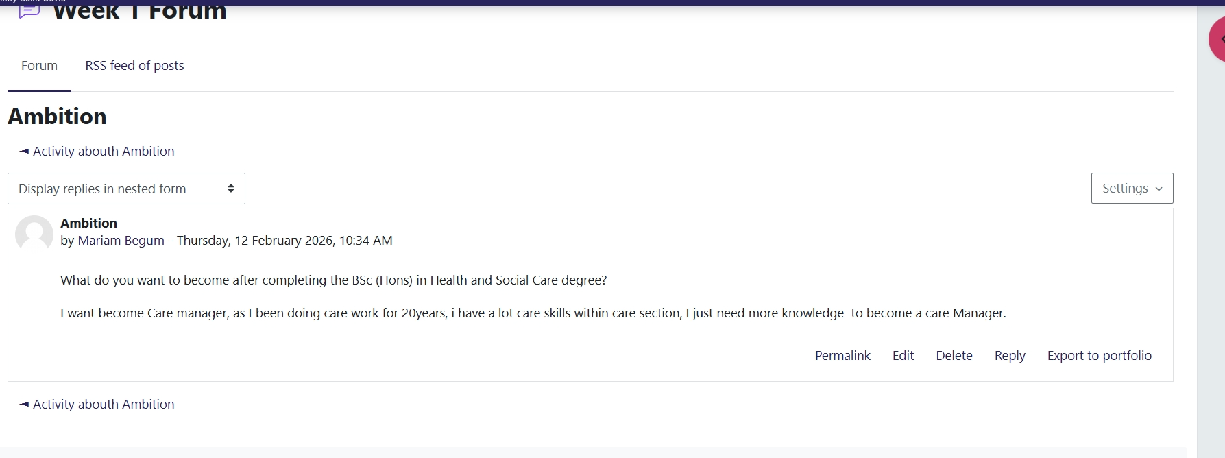

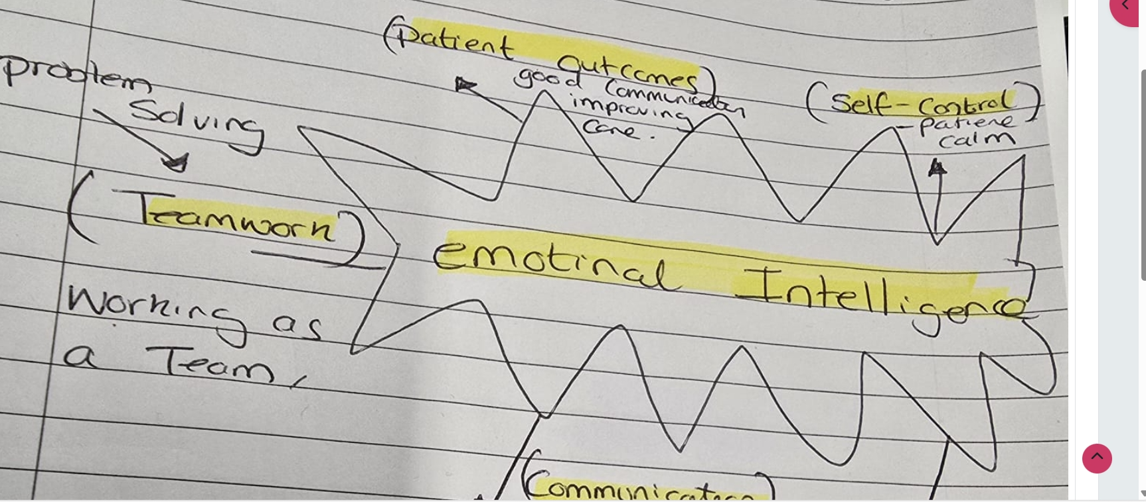

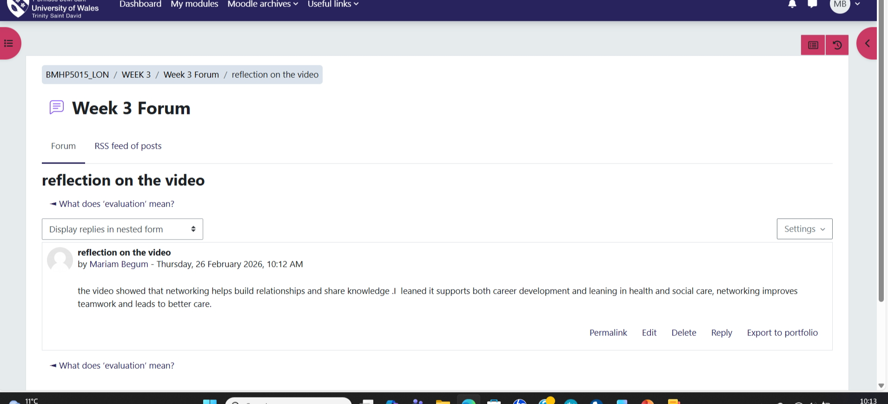

Task 2 – Reflection on Unit 2:
Unit 2 covered important topics including comfort zones, networking, and reflective practice. These concepts enhanced my understanding of global connections in health and social care. They taught me the necessity of adapting my approach, communicating effectively, and continuously improving my practice while working with individuals from diverse cultural and social backgrounds.

Comfort Zone
Judith M. Bardwick (1991) describes the comfort zone as a state where individuals feel safe and tend to avoid unfamiliar situations. I have come to realize that staying within my comfort zone can limit my effectiveness in providing care in multicultural environments. Although I have 20 years of experience in the care field, I still feel less confident when interacting with individuals from unfamiliar cultural backgrounds. As a parent to a 7-year-old, I also face challenges with time management, which can make it difficult to embrace new experiences.

However, I have started to step out of my comfort zone by engaging more with diverse individuals and learning about their cultures. This effort has helped improve my confidence and awareness of global diversity in care.
Networking
is a vital aspect of professional development. As Herminia Ibarra and Mark Hunter (2007) note, networking allows individuals to build professional relationships and share knowledge. I recognise that networking is particularly important in health and social care, where collaboration across organisations and communities is essential.

Reflecting on my own experiences, I have engaged with many professionals but haven’t always been proactive in establishing strong connections. My responsibilities as a parent sometimes limit my available time, and this has posed a challenge. However, I am now making a concerted effort to communicate with colleagues, exchange ideas, and learn from others. This proactive approach has enhanced my understanding of how care practices vary globally and how professionals can work collaboratively to improve outcomes.

Reflective Practice, using Graham Gibbs (1998) Gibbs reflective cycle, helped me evaluate my experience and identity areas for improvement, particularly when working outside my comfort zone

Gibbs Reflective cycle
Stage | Description | Example from my practice
Description | What Happened | I worked with individuals from diverse cultural backgrounds and felt unsure when communicating with them
feelings | What were you thinking and feeling? | I felt nervous but also willing to learn and improve
Evaluation | What was good and bad? | I engaged with individuals, but my confidence affected my communication.
Analysis | Why did it happen? | I stayed within my comfort zone and had limited exposure to different cultures, along with time pressures from parenting.
Conclusion | What else could you have done? | I should have been more open and asked more questions.
Action plan | What will you do next time? | I am committed to enhancing my communication skills, embracing challenges outside my comfort zone, and regularly reflecting on my experiences to elevate my practice.
This reflective process has enhanced my understanding of the significance of continuous improvement and the value of considering diverse perspectives in global health and social care.
: Comfort Zone Activity
: Reflective Practice (Gibbs)
: Networking Discussion

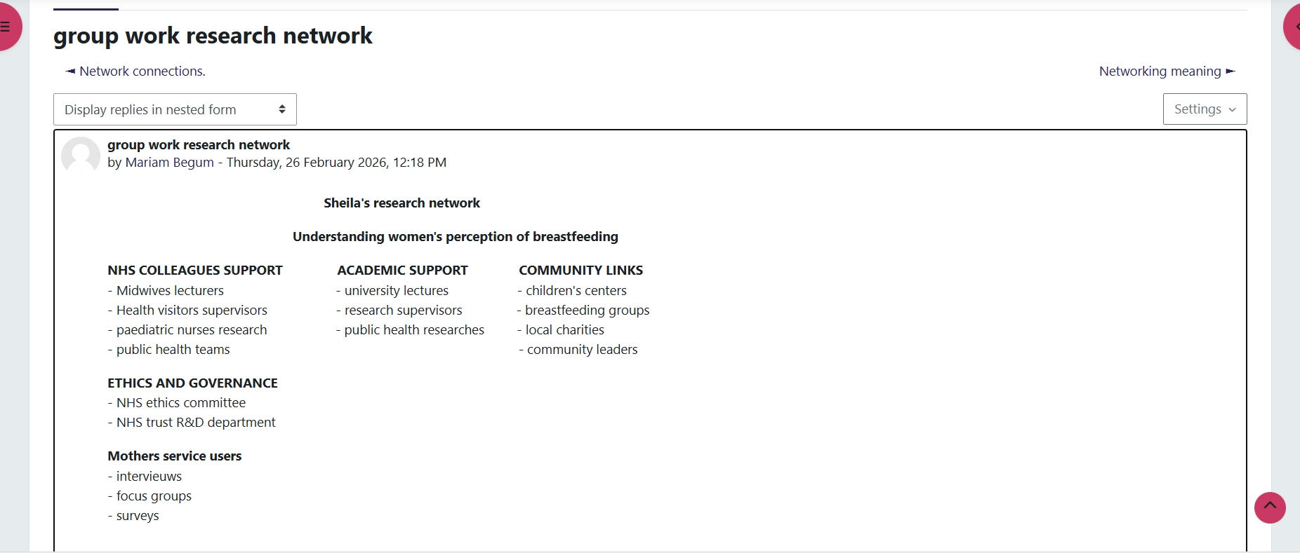

Reflection on Unit 3:Opportunity knocks

Unit 3 focused on recognising opportunities and understanding how factors such as perception, success, and skills influence personal and professional development. I explored three main topics: Perception, Success and Luck (Serendipity), and The Five Cs (Communication, Collaboration, Connection, Completing, and Combining). These concepts helped me adopt a more proactive approach to my learning and career in health and social care.

Perception
Perception refers to how individuals interpret situations and respond to challenges. According to Albert Bandura (1997), beliefs and attitudes significantly influence how individuals approach various situations. From my 20 years of experience in care, I have encountered many complex scenarios. In the past, I sometimes viewed challenges as barriers, particularly when balancing my work responsibilities with parenting my 7-year-old child. However, this unit has helped me shift my perception and recognise challenges as opportunities for learning and growth. This change in mindset will enhance my confidence and adaptability in my practice (Bandura, 1997).

Success and Luck (Serendipity)

Success and luck, particularly the idea of serendipity, refer to unexpected opportunities that arise by chance. Robert K. Merton (2004) emphasises that valuable discoveries often occur when individuals are open to new experiences. I have come to realise that success is not always planned, and I need to be more receptive to opportunities. For instance, in my current role, I may be presented with additional responsibilities or training opportunities. In the past, I often hesitated to take on these challenges due to time constraints or a lack of confidence. Now, I understand that embracing these opportunities can facilitate my professional growth and career advancement (Merton, 2004).

The Five Cs
The Five Cs—communication, collaboration, connection, completion, and combination—are essential skills for recognising and utilising opportunities in health and social care. These skills support teamwork, problem-solving, and effective care delivery.

The Five Cs in Practice
Skill | What it Means | Real-Life Example from My Practice
Communication | Sharing information  Clearly and effectively | I effectively communicate with service users by actively listening and clearly explaining care plans in a respectful and straightforward manner.
Collaboration | Working with others to achieve a common goal | I collaborate with colleagues and other professionals to guarantee that individuals receive safe and effective care..
Connection | Building positive relationships | I establish strong trust with service users by demonstrating empathy and thoroughly understanding their needs.
Completing | Finishing tasks responsibly and efficiently | I consistently complete all care tasks promptly, even amidst busy shifts and family responsibilities.
Combining | Using different skills and knowledge together | I utilise my experience, communication skills, and teamwork to effectively manage complex care situations with professionalism and respect.
Through this, I realized that these skills are essential in my daily practice. However, I also recognize that enhancing my communication and collaboration skills will help me seize more opportunities, such as leadership roles.
- Figure 1: Perception activity
- Figure 2: Serendipity/opportunity task
- Figure 3: Five Cs activity

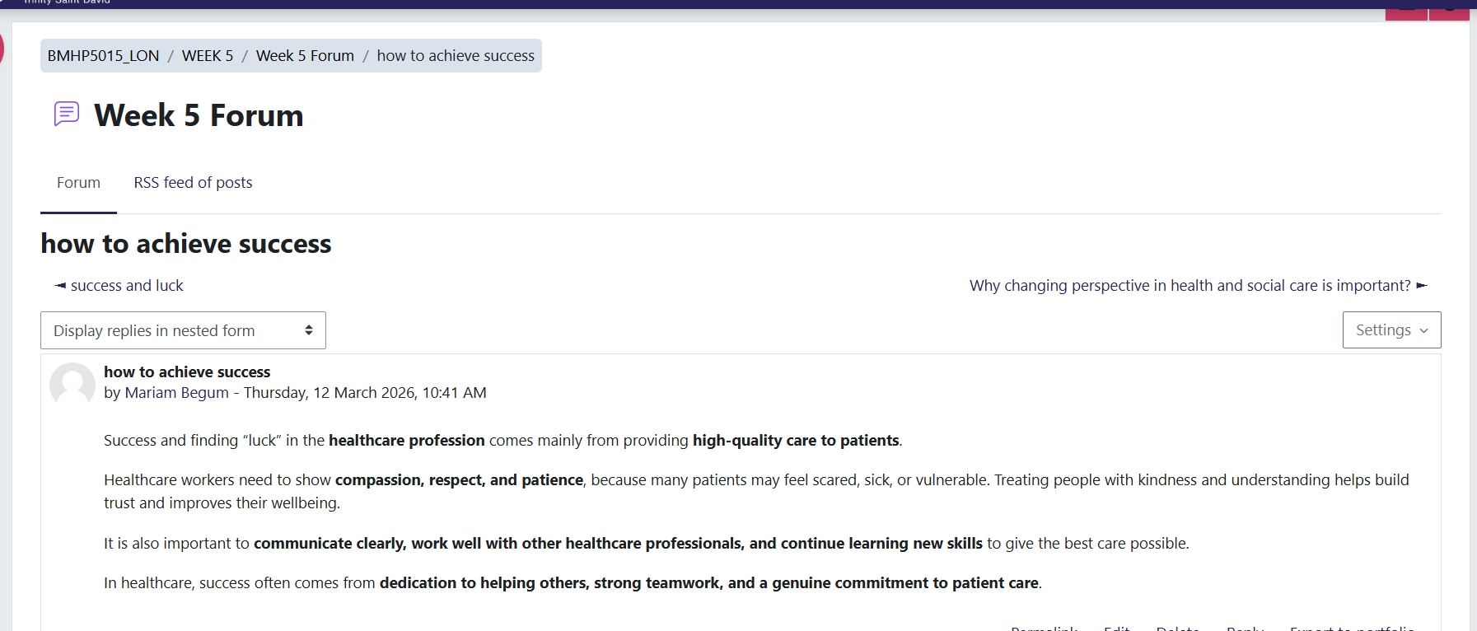

Reflection on Unit 4: The Pursuit of Happiness
Unit 4 -centred around resilience and personal development. I explored three main topics: Limiting Beliefs, Grit, and Social Learning and Mentoring. These concepts have helped me understand how to manage challenges and continue my development in the health and social care sector.
Limiting Beliefs

Limiting beliefs are negative thoughts that can hinder individuals from achieving their goals. Through this unit, I realised that my beliefs could affect my confidence and prevent me from embracing new opportunities. For instance, despite having 20 years of experience in the care field, I sometimes doubt my ability to move into a leadership role. As a parent of a 7-year-old, balancing work, studies, and family responsibilities can also be challenging.

However, this unit has helped me challenge these limiting beliefs and develop a more positive mindset. I now understand that changing my thought patterns can enhance my confidence and support my career progression. This aligns with the idea that individuals can develop their abilities through effort and a positive mindset (Dweck, 2006).

Grit

Grit refers to the perseverance and determination required to achieve long-term goals. Angela Duckworth (2016) explains that success results from consistent effort and resilience. I have come to realise that grit is essential in the health and social care sectors, where challenges are common.

In my many years of working in care, I have learned that patience and commitment are crucial. There were times when I felt stressed, particularly while managing responsibilities at home. However, this unit has helped me understand that staying focused on my goals, even during difficult times, is vital for success. This understanding has strengthened my determination to achieve my goal of becoming a Care Manager (Duckworth, 2016).

Social learning and mentoring
Albert Bandura (1977) explains that individuals learn through observing others. This helped me understand the importance of mentoring and learning from experienced colleagues.

Social learning and mentoring in practice.
Area | What it means | Real-life example from my practice
Observation | Learning by watching others | I actively observe senior staff handling challenging situations and apply their strategies to enhance my own approach.
Mentoring | Receiving guidance from experienced staff | I actively seek guidance from experienced colleagues who empower me to enhance my skills and build my confidence.
Applying learning | Using knowledge in practice | I actively apply my learnings to enhance my communication and decision-making skills with service users.  .
Confidence Building | Developing self-belief through support | Mentoring boosts my confidence and empowers me to embrace new responsibilities with assurance.
Through this experience, I realized that learning from others is essential for my professional development. It helps me improve my skills and prepares me for future roles. Social learning also supports continuous development in professional practice (Bandura, 1977).

- Limiting beliefs activity
- Grit reflection task
- Mentoring/social learning activity

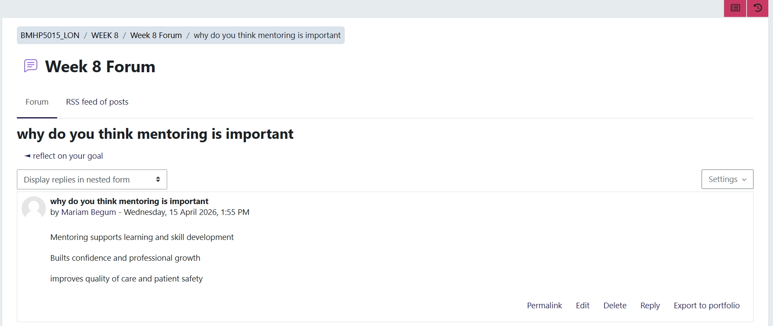

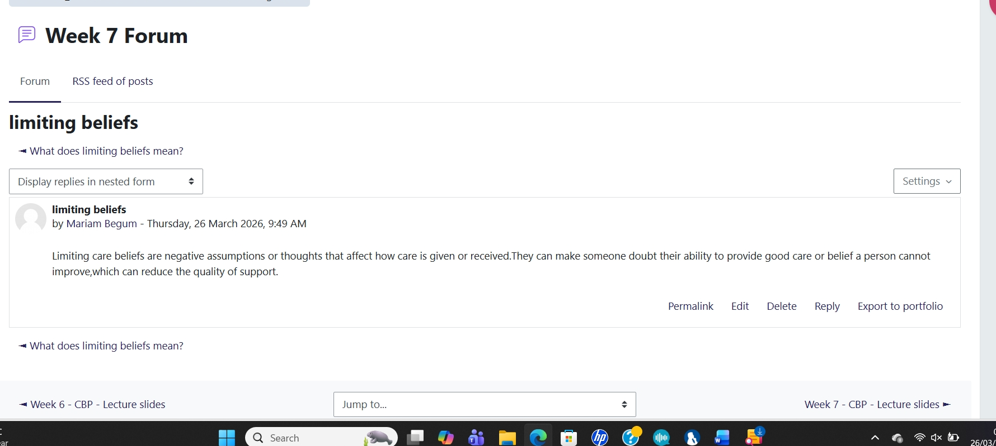

Conclusion
In conclusion, this assignment allowed me to reflect on the knowledge and skills gained from Units 1 to 4, which have significantly influenced my personal and professional growth.

Unit 1 clarified my career ambition of becoming a Care Manager. Unit 2 expanded my understanding of diversity in global environments, while Unit 3 enhanced my communication and collaboration skills. Unit 4 improved my resilience and ability to manage challenges.

A key skill developed was creating a professional CV. Previously lacking confidence in presenting my experience, I can now effectively highlight my 20 years in care and my career goals, boosting my confidence for future opportunities.

Overall, this module has enhanced my ability to reflect and adapt, preparing me for my future role in health and social care.

References (Harvard Style)
Bandura, A. (1977) Social Learning Theory. Available at: https://www.simplypsychology.org/bandura.html (Accessed: 20 March 2026).
Bandura, A. (1997) Self-efficacy: The exercise of control. Available at: https://www.uky.edu/~eushe2/Bandura/BanEncy.html (Accessed: 17 March 2026).
Bardwick, J.M. (1991) Danger in the Comfort Zone. Available at: https://www.goodreads.com/book/show/1628126.Danger_in_the_Comfort_Zone (Accessed: 22th March2026).
Duckworth, A. (2016) Grit: The Power of Passion and Perseverance. Available at: https://angeladuckworth.com/grit-book/ (Accessed: 17 March 2026).
Gibbs, G. (1988) Learning by Doing: A Guide to Teaching and Learning Methods. Available at: https://www.ed.ac.uk/reflection/reflectors-toolkit/reflecting-on-experience/gibbs-reflective-cycle (Accessed: 19 March 2026).
Goleman, D. (1998) Working with Emotional Intelligence. Available at: https://www.goodreads.com/book/show/26329.Working_with_Emotional_Intelligence (Accessed: 20 March 2026).
Ibarra, H. and Hunter, M. (2007) ‘How leaders create and use networks’, Harvard Business Review. Available at: https://hbr.org/2007/01/how-leaders-create-and-use-networks (Accessed: 28 March 2026).
Lipsky, M. (2010) Street-Level Bureaucracy. Available at: https://www.russellsage.org/publications/street-level-bureaucracy (Accessed: 20 March 2026).
Merton, R.K. (2004) The Travels and Adventures of Serendipity. Available at: https://press.princeton.edu/books/paperback/9780691117544/the-travels-and-adventures-of-serendipity (Accessed: 17 March 2026).
Dweck, C. (2006) Mindset: The New Psychology of Success. Available at: https://www.mindsetworks.com/science/ (Accessed: 17 March 2026).

