Domnica Iacoban
1813025

MANAGING PROJECTS IN THE ORGANISATION

Executive Summary
Project management is the complex process of organising, planning, implementing, reporting and competing certain project tasks. This is the main responsibility of a project manager, although is not bound by the title itself since managers, employees, etc. often act as project manager in a multitude of projects in their professional works.
Designing a project requires much more deliberations which is done through scope management and the project implementation plan requires other relevant considerations like monitoring, communication methods, risk management, etc. to make the project a success. Reflecting on project management process also can help project associates to develop own professional development scheme.
This report intends to discuss the act of managing projects for organisations by specifically focusing on a telemedicine consultation project for the Pharmacy2U organisation in the UK. Since, the timely need requires for online meetings these days more than physical ones and Phrmacy2U thriving in providing online pharmacy services, this project is expected to boost the company productivity and profitability along with proving for the needs of stakeholders in this unprecedented time. So, this report will include all the relevant steps of a project management processes described above to create a greater understanding of project management in organisations.

Table of Contents
Executive Summary 2
Introduction 4
Quality of a Project Manager 4
Project Scope Management 4
Company Overview of Pharmacy2U: 4
Project Title: 5
Background of the Project: 5
Scope of the Project: 5
Requirements: 5
Affected Parties/business processes: 5
Specific Exclusions: 6
Timeline/Schedule: 6
Project Implementation Plan 7
Project Communication Method 8
Stakeholder Mapping 9
Communication Method for Different Stakeholders 10
Project Risk Management 10
Change Management of Projects 12
Kotter’s change management model 12
ADKAR change management model 12
Change Management in this Pharmacy2U’s Project 13
Reflection of the Project 13
SWOT Analysis of My Project Management Skills 13
Reflection on My Project Manager skills 13
My Personal Development Plan (PDP) 14
Conclusion 15
References 16

Introduction
Projects are regular activities within workplaces whether or not named as such. It is the process of developing or improving products or services by organizations focusing on the needs and relevance to stakeholders of the organization (Berkun, 2008). Hence, project management refer to the act of planning, organizing, directing, communicating and, henceforth, finishing the project works.
The benefits of project management lies in the fact that each project- big or small has their own significance and influence on the organizational performance outcome and an effective project management will lead to favourable outcome. Project usually have multiple concentration to consider which is enabled to be proper and in sync with a project management plan and implementation. Different project also allows for company expansion into new market or domain in the market increasing the profitability and productivity if the organizations. The cost and timescale of a project also depends on effective project management as both can be minimised and optimized for the best performance respectively (Cleland, 2002). Finally, a project management plan surely helps with defining, streamlining and managing project activities for delivering valid and relevant outcome that signifies the effectiveness of the project in the first place.
This is a report discussing the project management process within the Pharmacy2U Organization in the UK. in this report, discussions and deliberations will be made for outlining a project scope, its implementation plan, communication method for connecting with the relevant stakeholders, devise a risk management and change management strategy as well as provide a reflection over the project to analyse and plan for future professional development for myself as a successful project manager.

Quality of a Project Manager
A project manager is the person responsible for directing the planned tasks within a project (Wysocki, 2009). The effectiveness of such personnel is necessary for a successful project outcome. The qualities of a project manager are as below-
- Project managers rigorously plans out the details of project
- A good project manager has the ability to decide with the help of facts and figures instead of optimism
- They need to be decisive
- A project manager should be accountable for the overall project (Baldenius, 2019)
- A good project manager is a motivator for his people working in the project
- Being a good project manager requires them to be good communicators
- A good project manager must have the quality of delegating tasks to others (Berkun, 2008)

Project Scope Management

Company Overview of Pharmacy2U:
Pharmacy2U is an online pharmacy company based in the UK. It was established in 1999 by pharmacist Daniel Lee and launched its operations with public during the year 2000 (Pharmacy2U, 2020). Apart from delivering prescription products in the UK, the company also sells to global market with its retail products. It has been working with NHS in dispensing their repeat perspirations with the service of reminders for patients in the UK. The company currently employees about 200 employees and has been working alongside different pharmacists and enthusiasts over the automated pharmacy services and other relevant options for is customers.

Project Title:
The title for the project to be discussed herein is- “The telemedicine consultation by Pharmacists on Over-the-Counter medication.”

Background of the Project:
The emergence of online based shopping and delivery services are at its peak in recent years. But, there are a lot less concentrations when comes to the attempt to sale and deliver medicines and other medical products. Oftentimes, the shopping of medicines through physical presence is far less convenient (Venhuis, 2014). However, the chances of miscommunication and error in this sector can be devastating. All these apart, the current pandemic-ridden world is explicitly imposing restrictions on physical gatherings which brings into questions the necessity of selling pharmaceutical products through online. Pharmacy2U is a leading online pharmacy (Pharmacy2U, 2020). However, the need for increased social distancing requires us to have the pharmacists’ consultations which are the basis for selling OTP medicines. Hence, this project of providing telemedicine consultations on OTP Drugs by the company came about which involves the customers, the company and the pharmacists who will be participating in the project. The main purpose of this project is to bring ease in buying required medicines and medications with proper safety and security guidance as present in physical pharmacies.

Scope of the Project:
This specific project by the Pharmacy2U on providing telemedicine consultation service by pharmacists on OTP drug distribution to customers has the scope for effectuating the online selling of drugs and medicines with proper prescriptions to individuals. It will, henceforth, cover the interest of specific relevant stakeholder groups more than the others with some exclusions in play as the whole operational process of the organisations do not need to be changed. The discussion is provided below-

Requirements:
The project will utilise the online platform provided within the website which will allow for online interactions without needing to install an app for this. This is to create convenience for the customers’ whether or not they are regulars.
This project will also need to have congruent information storage on medication purchase to follow through on possible over-medication issues as well as identifying the repeat prescription ny the NHS being collected.
The project will also include routing and notification options for purchased products to the customers through email service so that the customer can be continually updated on their product delivery and track the progress of the order.

Affected Parties/business processes:
This project as involves the interest of various stakeholder groups of the Pharmacy2U company in the UK, will impacts customers, the business owners, IT, finance and marketing departments, Pharmacists, etc. to various extents. While the pharmacist will be employed through the project into the company for consultations purposes, customers will be served through the service developed through the project. On the other hand, departments like the IT employees will need to work on the website extension to enable interactive telemedicine service, finance department needs to oversee and optimise the budget, while marketing department needs to deliver market analysis to develop the project on, helps with dissemination of information to stakeholders, create marketing mix strategy, etc.

Specific Exclusions:
As the project involves a wide variety of stakeholders and a few steps in the project process, there needs to be set an exclusion criteria (Laufer, 2015). For example, the customers will be notified on the new system only after completion of the project, whereas they might be initially conducted for survey purposes as a means of assessing customer needs, rather than making promises. Only after collecting and analysing market analysis, will the project planning progress with definite aims and objectives to achieve through the process. This project will also exclude inclusion of considerations on customer service and supply chain system of the company due to them being quite less affected by change.

Timeline/Schedule:
Timeline of a project helps avail the entire project time limit for actionable division for subtasks of the project. It can help design, develop and deploy the time of the project completion for effective completion of each tasks. A Gantt chart is a project management tool that visually distributes the time schedule for each tasks in the project process (Hodgson, 2006). On the other hand, PERT chart is a flow chart describing the timeline of tasks in project with uncertainty of their completion within time and affecting other takas in the project process (Hodgson, 2006). The following include these charts that help project management to be timely and help project manager to monitor and control the process for successful outcome:
Sl. No. | Project Activities | Weeks
Sl. No. | Project Activities | 2 | 4 | 6 | 8 | 10 | 12 | 14 | 18 | 20 | 22 | 24
1 | Customer need analysis | √ | √
2 | Stakeholder segmentation |  |  | √
3 | Overall market analysis |  |  |  | √
4 | Project conceptualisation |  |  |  | √
5 | Project Initiation Documentation |  |  |  |  | √
6 | Project Planning |  |  |  |  |  | √
7 | Project execution |  |  |  |  |  |  | √ | √ | √
8 | Project monitoring and control |  |  |  |  |  |  | √ | √ | √
9 | Project closing |  |  |  |  |  |  |  |  |  | √
10 | Project evaluation and reporting |  |  |  |  |  |  |  |  |  |  | √
Figure: Gantt chart of project

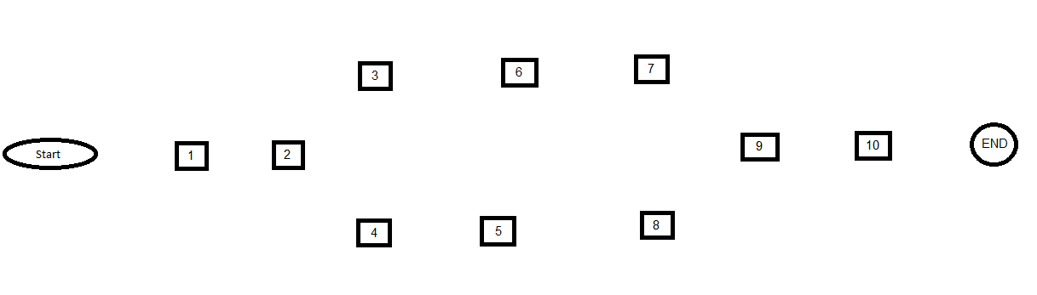Figure: PERT chart of project

Project Implementation Plan
For this project to be accomplished, the following transformation process management system following the PRINCE2 themes and processes will be maintained:
Starting Up a project (SU): At this stage, the project was sanctioned by the organisation and the project team was selected alongside the project manager. So, the team build a brief project plan, strategized initiation stages and build a business case around the project aim and objective.
Initiating a Project (IP): The project finally starts rolling as basic project initiation activities such as the essentials of PID planning and implementation like project scope statement, background analysis, etc. alongside communication plan, quality and risk management plan, etc. will be outlined at this stage.
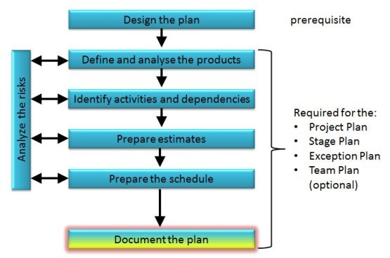
Figure: Project planning (Hodgson, 2006)

Directing a Project (DP): This is the longer running stage of the project process as includes pre-project activities to final delivery after closing of the project (Cleland, 2002).

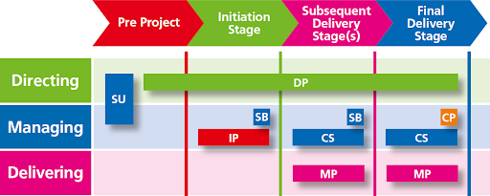
Figure: PRINCE2 Processes (Wysocki, 2009)

Managing a Stage Boundary (SB): Clear boundary among different project stages need to be established and needs to be approved for implementation. A contingency plan is also required to be created and risk, quality and communication strategy documents need to be in continuous updating.
Controlling a Stage (CS): During this stage, the project acceleration is monitored and brought under control in case of digressing form actual project aim and scheduling. The main idea is to keep up with the estimated Earned Money Value (EMV) of the project.
Managing Product Delivery (MP): During this process, the project plan is to be executed and the work package needs to completed, monitored, assured for quality and then approved for final dissemination.
Closing a Project (CP): When closing on the project activities, it is necessary to follow on the closing procedure including conducting a project evaluations and reporting activity. The proper storage of project documentation is also required.

From the transformation process management plan, it is evident that this project will require a lot of support and interests from stakeholders which can be collected and nurtured overtime through effective communication. There should also be a risk management plan along with effective change management focus for achieving the proposed solutions or outcome by the project (Cox, 2014). By establishing the online platform and regularising the operation process proposed by the project, the project goal will be met.

Project Communication Method
Stakeholders are the individual, groups or entities who are directly or indirectly affected or have influence over the outcome of a project or company outcome (Bourne, 2005). These people are the ones who with their involvement enrich the project or company environment to be directed in the positive directions as a whole. For example, customers, suppliers, investors, the NHS, etc. are few of the stakeholders for the existing company of Pharmacy2U. Stakeholder analysis, henceforth, provides the opportunity to identify different stakeholder according to their different needs from the organisations or the projects and directs the process of communication indicating the preferred communication technique to implement in achieving their positive involvement to the company or any projects (Winch, 2004).
The effective communication method for projects are extremely important since helps persuade and collect favour from the stakeholders and at large parts determines the success of the project (Elder, 2019). So, to establish effective project communication method, it is first and foremost important to identify the relevant stakeholders and their powers and needs relevant to the project and appeal to those specific points for achieving the ultimate outcome from the project (Laufer, 2015).

Stakeholder Mapping
Stakeholder mapping is a standard process of analysing the power and needs/interests of individual stakeholder groups in a project or organisations in a visual format to address those in the project plan and also to direct proper communication channel and contents (Bourne, 2005). In the following discussion, the stakeholder mapping for the project of Pharmacy2U is provided-
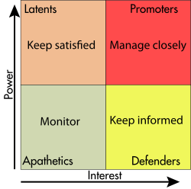
Figure: Stakeholder Mapping (Bourne, 2005)
Promoters: These are the people who are needed to be managed closely as the communication needs to be instantaneous with these people since hold the most power and interests to influence the project process (Berkun, 2008). In this project, the Project team members, marketing department of Pharmacy2U and product suppliers needs to be in continuous communication to the project team to inform and influence the project progress.
Defenders: These stakeholder are required to be informed on the project, although the extent of contents to be made public for them is limited. Customers and competitors of the business both belong in this category for their higher interest in the project outcome.
Latents: These stakeholder groups hold lesser interest, but quite higher power to influence the project outcome and processes, so needs to be satisfied throughout the project by disseminating required information. IT and finance department, general public, consultant pharmacists, regulatory authority, etc. belong in this category.
Apathetics: These stakeholder hold little interest or power in the developing products or service by the project, so requires very less communication throughout the process. For example, general public (Bourne, 2005).
Stakeholder engagement is an essential part of any project or organisational management since managing their expectations can lead to greater company performance. It is also helpful to prioritise stakeholder needs in a project or organisational process based on stakeholder needs and powers from the project or process.

Communication Method for Different Stakeholders
Communication is a key driver in project process as helps deliver effective synchronisations to the project team (Dutta, 2010). Often times, the failure to communicate properly can affect the project outcome. Also, much of the project, managers responsibilities include communicating with different stakeholders. As a result, there are various focus and methods to follow for effective project communication. Such as-
- The communication method needs to be different based on the stakeholder to contact and the content of the interactions (Winch, 2004). For example, status report, progress reports, forecasts, etc. are formal communication methods used for contacting stakeholders like the Board of Directors, top management of the company, regulatory authorities, etc. On the other hand, informal communication method is most suited for daily interactions with and delegation of tasks to project team members.
- The type of communication also depends on the type of stakeholders and their needs as identified in the stakeholder mapping. There three types of communication- Push communication, Pull communication and interactive communication (Wysocki, 2009). When stakeholders like the investors in the project, Boards of Directors, top management personnel want to know of the project status, the project manager must provide pull information through appropriate communication channels like websites, newspapers, formal reports, etc. On the other hand, report of project completions posted on the website is an example of push communication which is basically making information available whether or not the stakeholders ask for it. Interactive communications occurs between team members, project team to top management, etc. of a company for successful progression of the project.
- The appropriate communication method in the project also needs to understand different communication barriers as can affect the perceptions and preference of the defined stakeholder groups in contact. Hence, the project is required to follow on the language barrier, cultural norm affects and different work hours, etc. of the stakeholders to establish different kinds of communication with appropriate style of communication. For example, this project will communicate in Standard English language for all the stakeholders to understand the message equally.
- Finally, the project manager is required to identify the actual number of communication channel in the initial stage of the project to establish communication with relevant parties. The equation [n*(n+1)/2], where n is the number of stakeholder groups to consider in a project is a helpful technique for measuring and then maintaining these communication channels (Wysocki, 2009). Depending on these knowledge, the use of technology and software such as cloud storage, websites, emails, etc. for continually updated information distributed should be key concern of the project manager as well.

Project Risk Management
Risk management: Risk management in projects reflect to the process of identifying, analysing and creating a response plan for future uncertainties (Dutta, 2010). This is great essential for project management in organisations as enables achievement of project objectives better, developing realistic estimates for the project process and so on. This project of Telemedicine consultations for OTP drug prescriptions by pharmacists will follow the following steps for risk management:
Identification of risk: Different processes like brainstorming, Delphi technique and SWOT analysis, etc. are effective methods that I as a project manager is required to follow for identifying possible occurrence of uncertainties and their possible impacts on the project (Abrahamson, 2000). For example, this project have the risk of customer dissatisfaction if the customer service following the consultations is planned weak in operational processing.
Registering risk: After identifying possible risks, it is essential to document those along with their counter measures. In this project, the risk management plan will include this risk registry with information of the risk priority, root causes, steps for solving the risk, etc.
Qualitative risk analysis: Then, this project will also need to conduct a qualitative risk analysis for forecasting the probability of the risk occurrence and its subsequent magnitude of effect. This project will be using the Probability/impact risk matrix as well as interview experts on the qualitative analysis of possible risks to occur in the project and using these tools and techniques assign risk factor to help prioritise among all the risks in case of simultaneous occurrence (Naybour, 2015).
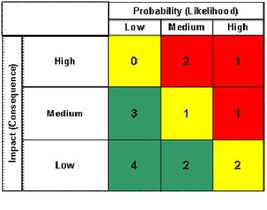
Figure: A sample probability-impact risk matrix (Dutta, 2010)
Quantitative risk analysis: Along with the qualitative risk assessment, quantitative risk analysis will be also considered for managing the project risk management process. For this section of the risk management process, the project will include decision tree analysis for selecting best action plan in the face of uncertainties in future. For this matter MS Excel and MS Project will be utilised.
Risk response planning: Then, a response strategy/planning will accompany the risk management plan where the possible risk response whether to avoid the risk, mitigate it, accept it or transference of the risks should be planned.in this project, the possible course of actions for managing positive risks through risk exploitations, acceptance and enhancement will be considered.
Risk control: Finally, risk management requires management of uncertainties regardless of tis response planning beforehand (Dutta, 2010). This project will consider workarounds to respond to unplanned risk issues by continually updating information on project process progress and changes to accommodate new risk management strategies throughout project life cycle.

Change Management of Projects
Change management: Change is an inevitable truth of life. Hence, change management is the process of accommodating regular processes with minimal afflictions due to uncertain or even planned changes in the environment or components within an environment (Cox, 2014). Change Management Models are the structures way for individuals and groups to manage and maintain the positive outcomes while undergoing change processes. Some of these include-

Kotter’s change management model
Kotter’s change management models follows 8-consequetive steps for managing change in organisations (Abrahamson, 2000). Creating the urgency to change and then building a focused team for managing the change with a specific vision in mind is deemed as essential in this recommended change management model. Other steps of the model also induces greater efficacy in deriving positive outcome from change in organisations which allows for successful business performance at the end.
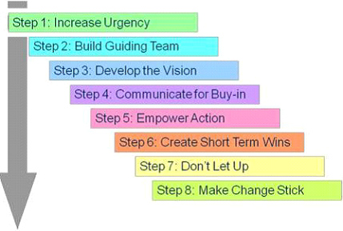
Figure: Kotter’s change management model (Abrahamson, 2000)

ADKAR change management model
ADKAR model is a lasting change implementation tool as well as coaching tool for enabling change in organisations. The five tangible outcomes- Awareness of the need of change, Desire for the change, Knowledge for implementing the change, Ability to demonstrate required skills and behaviours for attaining change and Reinforcements- all direct to better and efficient change management (Berkun, 2008).
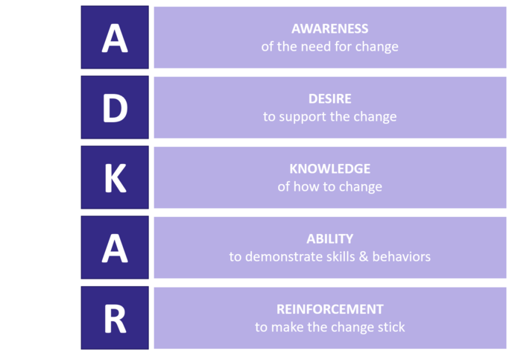
Figure: ADKAR model (Cox, 2014)

Change Management in this Pharmacy2U’s Project
In this project for the Pharmacy2U the urgency for the project has been already created by the increased awareness and current stream of e-commerce shopping solutions for various products of daily usage. From this desire, a project team has been created with the vision to create a platform for interactions consultation sessions with the pharmacists of the company for OTP drug prescriptions replacing physical meeting. The actions of the project are empowered using different relevant knowledge, skills and actions by stages and communicating the process sot relevant parties/stakeholders. Short term wins are planned during the planning stage by deliberating on time limit for each task completion. Finally, risk management, plan is provided alongside reinforcement plan for the project process in future integrated into the operational system of Pharmacy2U for sticking in the change longer with due outcome to be achieved.

Reflection of the Project

SWOT Analysis of My Project Management Skills
Strength  - I have good communication skill which is effective quality of a project manager.  - I also possess strong morals and values leading me to become responsible and accountable for my actions as a project manager. | Opportunity  - If I can be proactive in identifying project essentials and able to estimate on different aspects of the project, my project management would be better equipped to withstand long term goals easily.
Weakness  - I sometimes struggle with managing multiple tasks and lag behind in time need me to have better time management skill.  - As a novice project manager, I lack essential project management experience which means my problems solving skills needs increased attention to be effective in varying contexts. | Threat  - My current leadership skill level needs huge improvements for me to become confident and proactive in my project management process.

Reflection on My Project Manager skills
My skills as a project manager enabled me to plan out the project management process for this specific project for Pharmacy2U. Hence, it can be said that my skills have been adequate as a project manager. However, there could be some identified shortcoming which can inform my professional development by assessing the needs of personal development using a SMART PDP. So, my reflections using the Kolb’s reflective learning model is provided below-
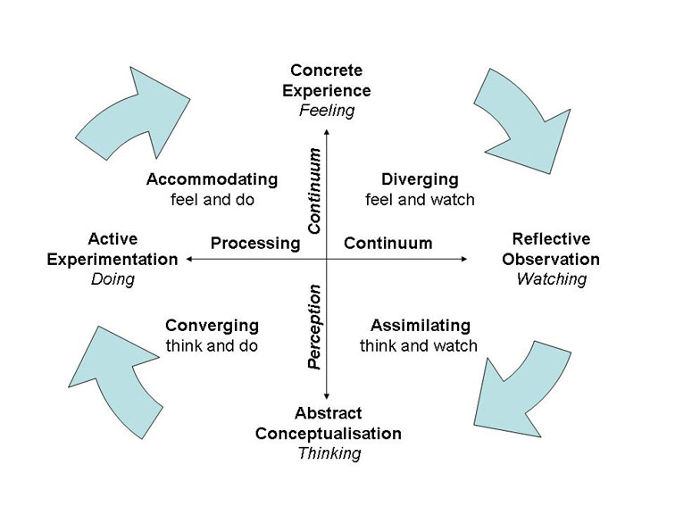
Figure: Kolb’s Reflective Model (Kolb, 2005)
Concrete Experience: My experience as the project manager is that I was able to complete project planning phase accurately with detailing on each relevant topics. I was able to plan the step-by-step process of project management process for a UK-based organisation with realistic expectation and achievements.
Reflective Observation: My reflection over the experience as the project manager for this project relays that I often feel lower confidence in commanding team members while delegating tasks. My planning process is good through with effective steps for practical project management with project objective achievement. However, my experience with the different project management software were still lacking, although sufficed for this project.
Abstract conceptualisation: From my reflection of skills as a project manager, I have found that I am required to develop better time management skills to accommodate for even through planning process, while my leadership skill needs a lot of knowledge and experience to be effective at this point of my career. I have also found the need for learning new technological skills to accommodate my project management processes better in future.
Active Experimentation: For developing my required skillsets as a successful project manager, I have planned to undertake a SMART PDP process where I will delineate on my skills development process.

My Personal Development Plan (PDP)
To become a successful project management going ahead in my professional career, the following is the plan for improving my skills as an effective project manager:

Goals | Action Steps | Resources | Measure of Success | Time Scale
Time management skill development | Need to create bullet journal and weekly scheduling of appointments and tasks and manage those appropriately | Internet  Stationaries  Guidance of supervisors & colleagues, etc. | Above average performance score on quarterly performance review | 3 months
Problem-solving skill development | - Learning on effective steps to problem-solving online  - Proactive participation in situations requiring this skill | Internet  Books  Journals  Practical situations  Guidance and opportunity from supervisors | Better feedback on self-appraisals from colleagues and superiors | 6 months
Improving leadership Skill | - Taking online course  - Searching texts and research articles | Financial resources,  internet | Certification of course completion | 6 months to 1 year

Conclusion
This report discussed the effective way of managing projects for organisational objective achievements. For this matter, firstly, the essential discussion on project management, its benefits, and project managers required quality, etc. were discussed. Then, project scope was identified and project implementations plan was developed through the PID process following the PRINCE2 model. Then, the communication and risk management plan for effectuating the project execution phase where the implementation plan to be implemented is discussed followed by a brief discussion on the project change management process relevant with the project. Finally, a self-reflection of myself as the project manager of this project was analysed by firstly conducting a SWOT analysis of my skills as a project manager, reflecting on it following the Kolb’s reflections cycle to induce learning from the reflections and then designing a PDP with the derived information for my professional improvement as project manager.

References
Abrahamson, E., 2000. Change without pain. Harvard Business Review (July-August): 75-79.
Baldenius, T. and Michaeli, B., 2019. Integrated ownership and managerial incentives with endogenous project risk. Review of Accounting Studies 24(4): 1450-1485.
Berkun, S., 2008. Making Things Happen: Mastering Project Management, revised edition. O'Reilly Media.
Bourne, L. and Walker, D. H. T., 2005. Visualising and Mapping Stakeholder Influence. Management Decision. 43 (5): 649-660.
Cleland, D. and Ireland, L., 2002. Project Management: Strategic Design and Implementation. McGraw-Hill Professional. ISBN-10: 0071393102.
Cox, J., D. Houle, D. and Cole, H., 2014. Hanging Fire: Achieving Predictable Results in an Uncertain World. A Business Novel. CreateSpace Independent Publishing Platform.
Dutta, S. K., Caplan, D. and Lawson. R., 2010. Lehman's shell game: Poor risk management. Strategic Finance (August): 22-29.
Elder, J. H., 2019. Disaster preparation basics. Journal of Accountancy (September): 16.
Hodgson, D. and Cicmil, S., 2006. Making Projects Critical. Basingstoke, UK: Palgrave MacMillan.
Kolb, A.Y., & Kolb, D.A. (2005). The Kolb Learning Style Inventory – Version 3.1: 2005 Technical Specifications. Haygroup: Experience Based Learning Systems Inc.
Laufer, A., Hoffman, E. J., Russell, J. S. and Cameron, S. W., 2015. What successful project managers do. MIT Sloan Management Review (Spring): 43-51.
Naybour, P., 2015. How To Deal With Project Risks Effectively | APM. [online] Apm.org.uk. Available at: https://www.apm.org.uk/blog/dealing-with-project-risks-effectively/
Pharmacy2U., (2020). About Us. Pharmacy2U Website. Available at: https://www.pharmacy2u.co.uk/whoarepharmacy2u.html
Venhuis, B. J., de Voogt, P., Emke, E., Causanilles, A. and Keizers, P. H. J., 2014. Success of rogue online pharmacies: sewage study of sildenafil in the Netherlands. BMJ. 349: g4317.
Winch, G. M., 2004. Managing Project Stakeholders. The Wiley Guide to Managing Projects. Morris P. W. G. and J. K. Pinto. New York. Wiley: 321-339.
Wysocki, R. K., 2009. Effective Project Management: Traditional, Agile, Extreme, 5th edition. Wiley.

