MARKETING PLAN

Student Name: Sharmin Akter Miah
Student number: 2209262
Name of hotel: Ibis
Module name:Marketing Essentials BMIH405
Name of lecturer:Ruth Taylor

Introduction
It's no secret that the tourism industry has taken a beating in recent years. The global pandemic of Covid-19, the UK's vote to leave the European Union, and other factors have all contributed to a decline in bookings and visitors at hotels around the world. Ibis hotel is looking to attract new guests with an imaginative marketing campaign that focuses on the reassurance and safety aspects of its services. This report will outline Ibis’s marketing plan, as well as identify any contemporary influences that could impact success.
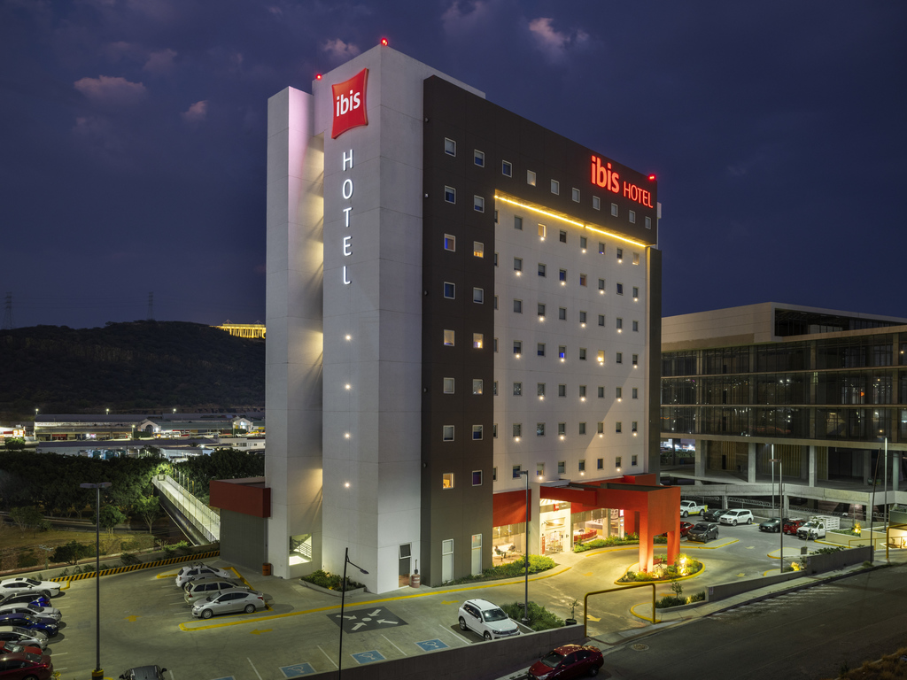

Situational analysis: Micro (SWOT)
Strengths | Weaknesses | Opportunities | Threats
The key strengths of Ibis are its affordability. | Weakness of the company is its reliance on online booking platforms such as Expedia and Booking.com. | they could look into expanding into new markets in order to tap into an unexplored customer base or create more incentives for potential clients; | one of the threats facing IBIS Hotel is strong competition from other hotels offering similar services at lower costs. (Mamahit, 2019)
The company offers competitive rates that appeal to budget-conscious travellers. | Ibis Hotel often has to pay high commissions to these sites, which can eat into profits. | this would help cultivate relationships between the hotel chain and its customers. | Another potential threat to the company is the rise of Airbnb.
In addition, Ibis has a strong loyalty program that helps to keep customers coming back. | their rooms can be slightly smaller than competitors  (Riana, 2020) | there are also opportunities for Ibis to capitalize on trends such as eco-tourism and digital nomads. | other home-sharing services.  (Nelwan, 2020)
consistency, customer satisfaction and cost-efficiency.  (Senior, 2019) | their prices may not always be competitively priced in certain markets. | For example, the company could focus on marketing itself as a sustainable option for travellers who are looking to reduce their carbon footprint | These companies are offering travellers alternatives to traditional hotels, which could lead to decreased demand for Ibis Hotel rooms.

Porters 5 forces: Macro
Bargaining power of supply | Threats of substitute | Industry rivalry | Bargaining power of the buyer | Threat of Entrents
Low. Suppliers have a lot of bargaining power in the hotel industry because they provide essential services that hotels need in order to operate. | High. There are many substitutes for hotels, such as Airbnb and other vacation rental websites.  (Mamahit et al., 2019) | High. The hotel industry is very competitive and there are many companies that offer similar products and services (Senior, 2020).  Hilton, Marriott, Holiday Inn, Hyatt Place, Aloft, and Courtyard by Marriott. | High. In the hotel industry, buyers have a lot of bargaining power because there is a lot of competition and companies are constantly competing for business. | High. The hotel industry has high barriers to entry, which makes it difficult for new companies to enter the market.  (Borza, 2008)

PESTEL analysis: Macro
Political | Economic | Social | Technology | Environmental | Legal
The political environment in which Ibis Hotel operates is stable. | The current state of the economy is favourable to Ibis Hotel. | There has been a shift in social norms towards increased leisure travel. | Online booking platforms have made it easier for consumers to compare prices and find deals. | Climate change is a major environmental issue that is impacting the hotel industry.  . (Raina, 2020) | New data protection laws could have an impact on Ibis Hotel as the hotel collects and stores personal information about guests.
However, potential changes to government regulations could have an impact on the hotel's business | Rising disposable incomes and increased consumer confidence are driving demand for hotel rooms.  (Borza, 2008) | This trend is beneficial for Ibis Hotel as more people are taking holidays and business trips. | In addition, mobile apps and websites have made it possible for guests to book rooms and access hotel services without talking to a human agent.  (Obelenyte, 2018) | As weather patterns become more erratic and extreme weather events become more common, guests are increasingly interested in staying in hotels that are prepared for such eventualities | In addition, changes to employment law could impact the hotel's ability to recruit and retain staff. (Rahayu, 2019)
 |  |  | Finally, new developments in energy efficiency are helping hotels to reduce their environmental impact and operating costs (Obelenyte, 2018).
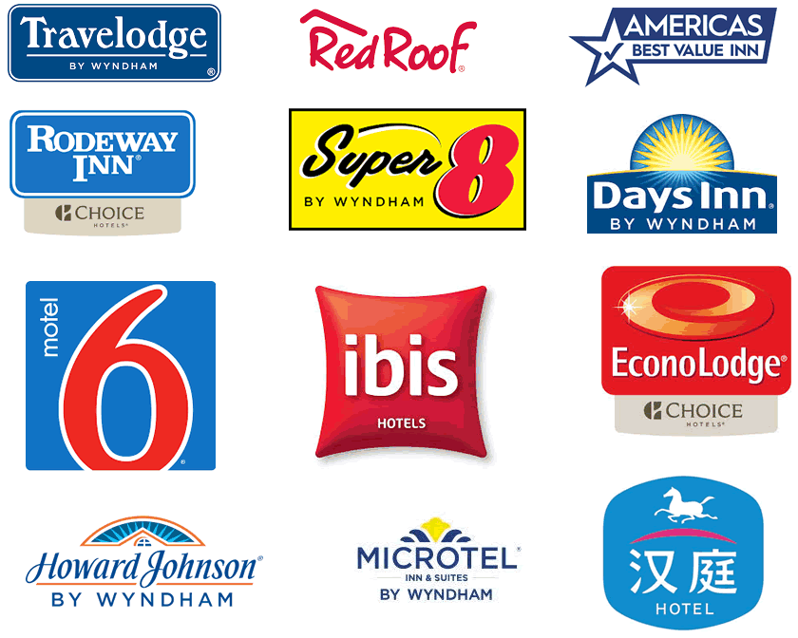
Competitors of IBIS

SMART Targets
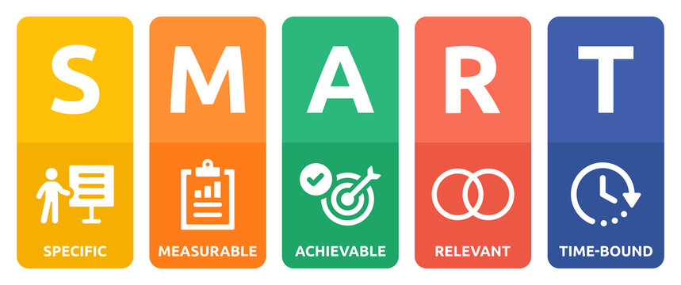
The IBIS Hotel is committed to improving customer experience and is dedicated to meeting the highest standards in hospitality. To this end, they have set several SMART Targets that they strive to achieve. By monitoring their performance with these targets, they can achieve their goal of providing exceptional service. This includes setting customer satisfaction goals by tracking feedback collected from their guests (Nelwan, 2020). They also strive to increase brand recognition and attract new customers by consistently promoting themselves across different media platforms and participating in trade shows and conferences related to the hospitality industry. Additionally, they also track operational objectives such as reducing costs while increasing returns on investments through efficient supply chain management strategies.
Some possible SMART targets for Ibis Hotel post-Covid could be:
-Increase in bookings by 5% within the first 3 months of reopening
-Maintain an occupancy rate of 80% or higher throughout the year
-To create a social media campaign which generates 1000 new followers within 6 weeks

Marketing Mix
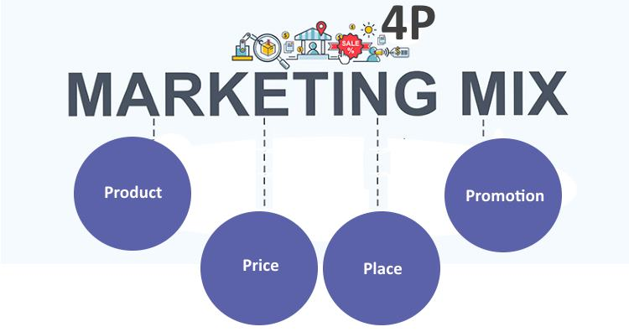
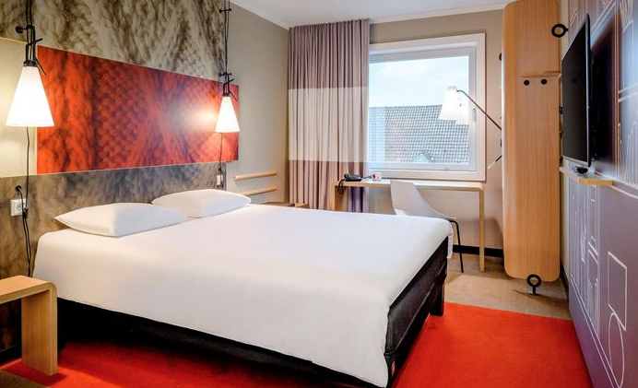
Product: In terms of product, the Ibis hotels will need to focus on offering a safe and clean environment for guests. This will involve strict hygiene protocols and a commitment to providing a clean and comfortable stay. they provide a unique experience for each guest by offering comfortable accommodations and an enjoyable stay.
Price: In terms of price, the Ibis hotels will need to be competitive with other similar establishments. costs between $80 and $120 per night. guests are given discounts when booking large groups or long-term stays; this ensures their customers get the best value for their money.
Place: in terms of place, the Ibis hotel chain will need to ensure that its hotels are easily accessible and convenient for potential guests. This could involve partnering with airports or train stations, as well as offering convenient online booking options (Nelwan, 2020). They take into account convenience for customers - from easy access for check-in/check-out procedures to providing various payment options like Apple Pay, debit/credit cards and cash at their receptions desk
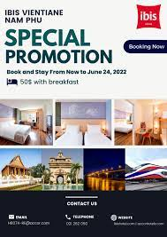
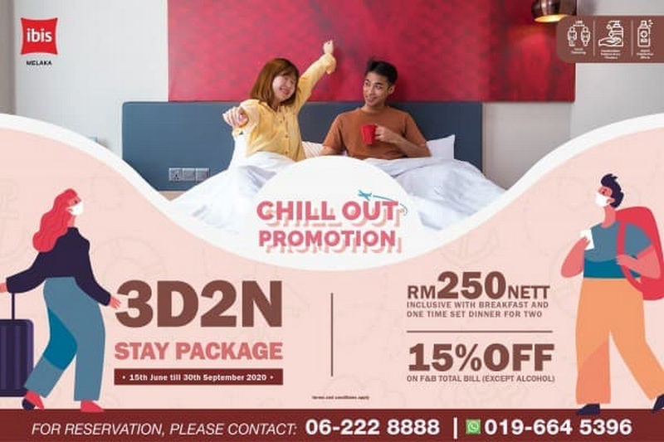
Promotion: In terms of promotion, the Ibis hotel chain will need to make use of various channels to reach potential guests. This will include online and offline advertising, as well as PR and social media campaigns. Promotion is an area IBIS excels at - whether its keeping guests informed with emails about special offers or using social media to reach new customer demographics, IBIS is always creating innovative ways to advertise their hotel's cuisine, amenities and services.

Promotion on medias of IBIS

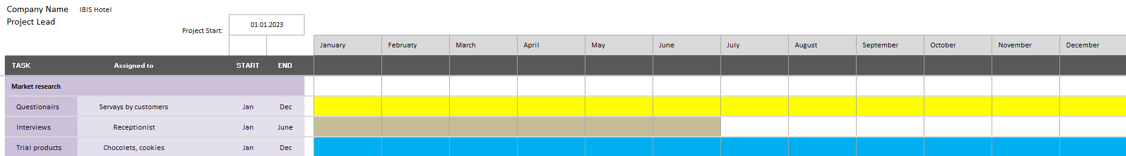
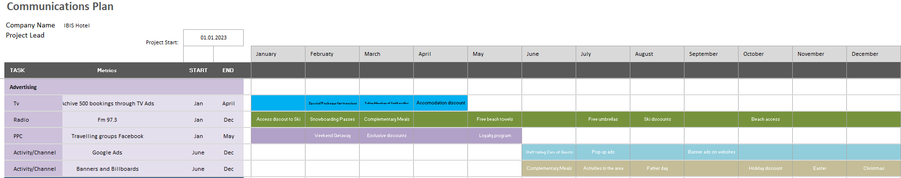
Gannt Chart of activities

Conclusion
Any changes to the business model could impact revenue and customer loyalty. In light of these challenges, Ibis Hotel should consider the following recommendations: Develop a communication strategy for addressing Covid-19. This should include both general messaging and specific plans for dealing with customer queries. Review its marketing plans for Europe in light of Brexit. This may involve reallocating resources or adjusting targeting strategies. Ensure that its branding and messaging are aligned with government guidelines on responsible tourism. This will help to avoid any confusion among customers about what is and is not safe to do.

References
Borza, A. and Bordean, O., 2008, June. Implementation of SWOT analysis in Romanian hotel industry. In An Enterprise Odyssey. International Conference Proceedings (p. 1623). University of Zagreb, Faculty of Economics and Business.
DP, N. and Riana, I.G., 2020. The influence of physical work environment and organizational culture on work motivation and employee performance at Ibis Styles Bali Denpasar Hotel. American Journal of Humanities and Social Sciences Research (AJHSSR), 4(8), pp.43-51.
Mamahit, N.I., Worang, F.G. and Rumokoy, F.S., 2019. Factor analysis on employee retention at Ibis Hotel Manado. Jurnal EMBA: Jurnal Riset Ekonomi, Manajemen, Bisnis dan Akuntansi, 7(1).
Nelwan, J.C., 2020. ANALYZING LOGISTICS MANAGEMENT AT IBIS HOTEL MANADO. Jurnal EMBA: Jurnal Riset Ekonomi, Manajemen, Bisnis dan Akuntansi, 8(4).
Obelenytė, R., 2018. Impact of Social Media on Marketing Activities on case of Hotel Ibis Kaunas Centre.
Rahayu, D.D., 2019. Analysis of customer satisfaction level on service quality of three-star hotel in Pekanbaru. International Journal of Scientific and Technology Research, 8(10), pp.592-98.
Senior, M. and Morphew, R., 1990. Competitive strategies in the budget hotel sector. International Journal of Contemporary Hospitality Management.
Sofyanty, Y.R., Hamid, D. and Dewantara, R.Y., 2017. Analisis Penerapan CSR dan Dampaknya Terhadap Kehidupan Sosial Ekonomi Masyarakat (Studi Kasus Pada Hotel Ibis Surabaya City Center) (Doctoral dissertation, Brawijaya University).

