Student name: Ruth Bevis
Number: 2404385
Programme of study: design craft
Module: ways of thinking (ADDA4022)

Tasks in order I receive them:
Task 1: Manifesto writing: 453 words
Task 2: Observational writing: 548 words
Task 3: Practice-Based writing: 454 words

Task 1 – Manifesto writing

Here is my 8 point Manifesto:-

1. Be bold with Colours
2. Experiment with Materials
3. Be Authentic
4. Be Silly and Be Absurd
5. Don’t be Afraid to Unsettle People
6. Don’t be Afraid to Follow that Thought
7. Take Inspiration from Things Around You
8. Use your Mistakes as Learning Opportunities

I am choosing to expand on the following points from my manifesto;

Point 4 - Be Silly and Be Absurd:

I think it is important to be slightly absurd, as I find ‘normal’ can be boring, and looses my attention. I enjoy making rat skate parks, the cuteness of frogs bums, making slugs and snails to decorate my room with, and the whimsy of dinosaurs and dogs riding horses. I love all of these things because they make me happy, and they are unusual. I want to bring this absurdity into my art in ways that make other people smile or laugh, and to inspire positivity. I know that I am slightly odd, and am happy to be, because as it says in one of my favourite books ‘So I'm different. F**k it.’ (Parkin & Pollini, 2009).

Point 5 - Don’t be afraid to unsettle people:

It is important to be honest in your work and not to be afraid if it makes other people uncomfortable. I want to challenge people’s views on things by making art outside of the normal, I don’t want to try and fit in and don’t want to follow trends, I intend to create a unique identity for myself. As Terry Pratchett says in his Foreword for David Pringle’s book ‘It’s not worth doing something unless someone, somewhere, would much rather you weren’t doing it.’ (Pringle, 1998, p.7).
James Victoire says in his book ‘Feck Perfunction ‘Knowing you don’t fit in is your first glimpse of greatness.’ (Victore, 2019, p.05)
I think that by accepting and embracing your difference and making things challenging and weird you will be more memorable. Even if people don’t like your work, they will know you are great and remember your name.

Point 8 - Use your mistakes as learning opportunities:

Mistakes are part of life and try as you might, you cannot escape them, so the best thing to do is embrace and learn from them. If you get hung up on every part of life you struggle with, then you won’t find success. Mistakes can be tough to accept but an amazing way to learn. James Victore in his book ‘Feck Perfuction’ says ‘Failure is a teacher – just not always the kindest teacher.’ He goes on to say ‘The path to success is marked by failure. Not just once, but again and again. Accept it and learn. Reject it and … well, fail.) (Victore, 2019, p.12). When you’re learning a new process or trying a new idea you won’t get it right the first time, and you might fail, but you can learn things from those failures that you might never learn anywhere else. Failure is just as important as success.

Bibliography:

‘So I'm different. F**k it.’
John C. Parkin & Gaia Pollini. (2009). the way of f**k it. London: Hay House

James Victore. (2019). Feck Perfuction. San Francisco: chronicle books. p.12

James Victore. (2019). Feck Perfuction. San Francisco: chronicle books. p.05

David Pringle. (1998). the ultimate encyclopaedia of fantasy. London: Welbeck. p.7.

Task 2 – observational writing

Semiotics is the study of signs and symbolism. Charles Pierce suggests that Semiotics can be split into three sections Icon, Index, and Symbol.
Icon is when an object (the signifier) bears a direct resemblance to the signified (eg a photograph), explained by Charles pierce as 'every picture (however conventional its method)' is an icon (pierce, 1931-58, 2.279).
Index refers to a 'genuine relation' between the 'sign' and the object which does not depend purely on 'the interpreting mind' (pierce, 1931-58, 2.92,298) explaining that index is when the signifier does not look exactly like the signified but it does have a direct connection. For example, Fire could be the object, and the image could be of flames, there is a direct connection between to two that would be obvious to everyone, without needing any other information.
Symbol is when the signifier has no connection to the signified except cultural and social meanings as Pierce explains 'a sign which refers to the object that it denotes by virtue of a law, usually an association of general ideas, which operates to cause the symbol to be interpreted as referring to that object' (Pierce, 1931-58, 2.249) for example, how a green light means ‘go’, or how a silhouette of a man means ‘men’s toilets’. We only know the relationship because we have learned it.

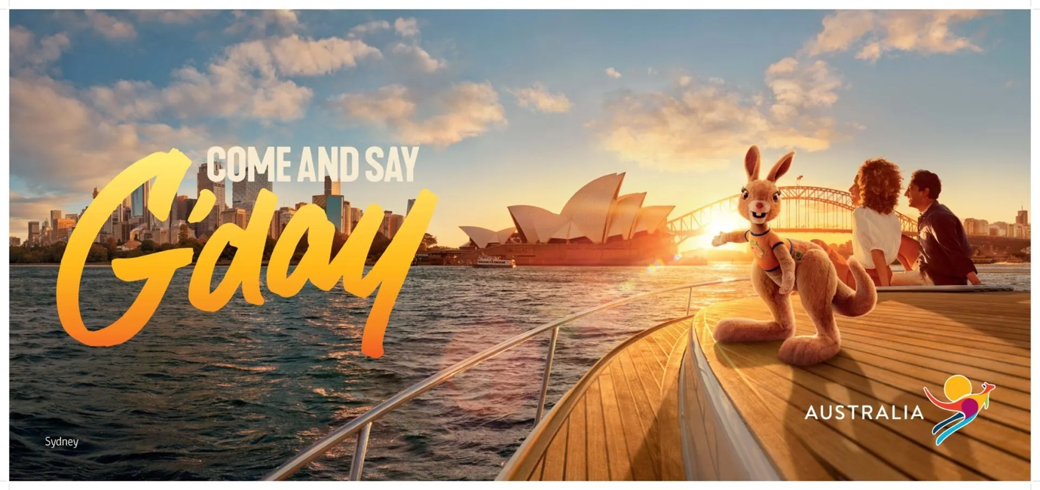
On a denotative level they are telling us to come and visit Australia by showing a nice location, activity and day. On a connotative level they are suggesting Australia is bright, sunny, and welcoming all the time and that it has lots of luxury places to visit, and would be a good romantic getaway. The message that they want us to visit Australia is clear, and the composition suggests that they are showing off their best sites and that you should visit their landmark locations.
My first impression of this ad was that its welcoming, sunny, and bright, almost blinding, it stood out massively from everything else on my screen and I noticed it straight away. It grabbed my attention and the brightest part draws attention to where the kangaroo is pointing – at Sydney Opera House, a key location in Australia. Most of the colours are yellows and oranges, basking everything in a golden glow, with bright light blues in the background. There are multiple fonts used, most being plain white with blocky shapes and on the smaller side, however one is much bigger than the rest and looks like it’s made up of pen strokes and is a yellow/orange ombre, making it stand out and seem kinder and explosive. The typeface shows me that they are excited for people to visit their country. The ‘main character’ of this ad is the kangaroo teddy that is wearing a yellow shirt with the map of Australia on it, clearly showing that it loves the country, pointing to the city, the yellow shirt shows that the kangaroo is joyful and energetic.
This advert uses a mixture of the three types of semiotics to get its message across. Icon is shown with the Sidney Opera house and scene in the background, Index is used with the Kangaroo , and Symbol is used with the text G’day which is a phrase that we associate with Australia because we have learned the connection.

Bibliography:
Peirce, Charles Sanders (1931-58): Collected Writings (8 Vols.). (Ed. Charles Hartshorne, Paul Weiss & Arthur W Burks). Cambridge, MA: Harvard University Press,

Task 3 - practice-based writing

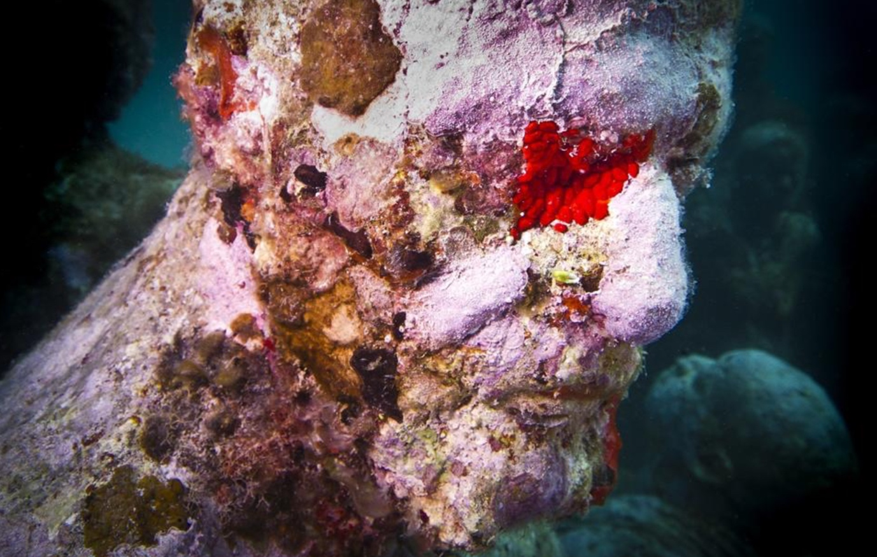

Object – The object that I have chosen is the Sculpture called ‘silent evolution’ by Jason deCaires Taylor. The sculpture is part of an underwater museum in Mexico, that is home to over 500 statues, deCaires Taylor says ‘What’s interesting under water is that you can repeat the same design, but because it’s colonized differently, each piece is still unique’ (deCaires Taylor, 2021). people can visit via scuba diving or snorkelling. The underwater museum has thousands of visitors per year

Keyword – The Keyword that I feel clashes with this object is Industrial, because the sculpture looks organic, and appears to blend into the surrounding coral reef environment.

Link – Even though the sculptures look organic they are actually made of a specially mixed PH neutral cement ,they are then placed downstream of a coral reef to encourage the growth of corals in the area. Although the statues are made of cement, once they are submerged ,within days they start to grow life until every part of the surface is covered, creating a beautiful yet slightly horrifying piece of art that becomes home to hundreds of aquatic organisms, plant and animal alike. This takes a material which is industrial in nature, and creates an organic, living environment.
This sculpture along with others made in the same way, is part of an underground museum which people can visit. It is not only beautiful art, but encourages respect and protection of the surrounding coral reef. deCaires Taylor said ‘every day we dredge, pollute and overfish our oceans, while museums are places of preservation, of conservation, and of education.’ (deCaires Taylor, 2021)

If I were to combine these contrasting ideas of Industrial with Organic sealife in my own design, I would cast the sculptures of people and corals as one, maybe adding some of the sea creatures that have made homes on deCaires Taylor’s sculptures, and make metal statues of them. I would cast using bronze as its more resilient to erosion ‘Bronze is generally more physically robust and more resistant to corrosion than other metals.’ (historic England, 2022) I would only put a wax patina on parts of the statues, selected depending on textures and patterns made by the coral, and I would let the rest develop a natural green patina. These two different finishes would show a distinct contrast.
I would put these statues on industrial sites, factories and warehouses, maybe standing at the doors to create a strong contrast with the environment around them. I would do this to unsettle the people working there. I would also put them at docks and ship yards near the water where they would be more part of the environment. I would do this to inspire people and capture their imaginations.

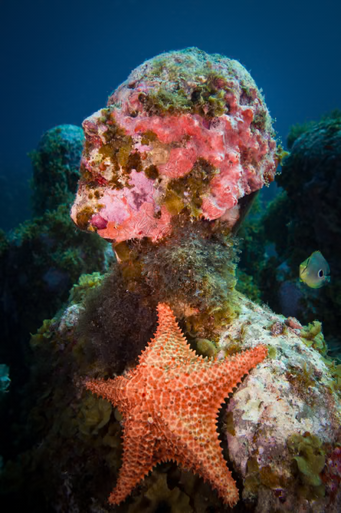

Bibliography:

Liz Publika. (2021). Jason deCaires Taylor On Underwater Sculpture, Scuba Diving & Saving the World's Coral: An interview. [Online]. ARTpublika. Last Updated: 15 March 2021. Available at: https://www.artpublikamag.com/post/jason-decaires-taylor-on-underwater-sculpture-scuba-diving-saving [Accessed 2 January 2025].

johnny wood. (2021). This underwater sculpture park is helping rewild marine ecosystems. Here's how. [Online]. World Economic Forum. Last Updated: 31 August 2021. Available at: https://www.weforum.org/stories/2021/08/rewilding-ocean-sculpture-park-marine-conservation/ [Accessed 2 January 2025].

N/A. (2022). Bronze Statuary. [Online]. Historic England. Last Updated: 24 June 2022. Available at: https://historicengland.org.uk/advice/technical-advice/buildings/maintain-and-conserve-metals/bronze [Accessed 2 January 2025]

