Speaker Notes

Farhan Ahmed
Id 2406518

Slide 1
Hello everyone, thank you for being here today. My name is Farhan and along with my teammates is Ajizur, jayed, and Zihad, Samir, we’ll be discussing a pressing issue in the retail industry the rise of shoplifting.
Over the past few years, retailers have seen a significant increase in theft, and today, we’ll explore the reasons behind this trend, its impact on businesses, and potential solutions. I’ll start by giving an overview of the problem, and then my teammates will dive deeper into the causes, effects, and strategies and the root cause of analyses to address it. Let’s get started.

Slide 2
Shoplifting is an act of stealing goods from retail stores. Shoplifting has become a growing concern for retailers, with increasing incidents affecting businesses of all sizes. Economic struggles, organized retail crime, and even advancements in self-checkout technology have contributed to this rise. Many stores are experiencing significant financial losses, leading to higher prices for consumers and stricter security measures. Additionally, the increase in theft has impacted staff, creating a more stressful work environment. To combat this issue, retailers are investing in improved surveillance, anti-theft devices, and collaboration with law enforcement. However, balancing security with customer experience remains a challenge as businesses strive to reduce losses without deterring genuine shoppers.

Slide 3 Key Causes in rise of shop lifting
- Economic Factors: inflations job less, financial

- Organised Retail Crime (ORC): Gangs stealing in bulk for resale.

- Lax Consequences: Reduced penalties embolden repeat offenders.

- Self- checkout loopholes: Easier to explicit than traditional checkout.

- Lack of security imputes: Surveillance, CCTV and security guards.

Slide 4 Graph
Graph Number of shoplifting offences in England and Wales from 2002/03 to 2023/24

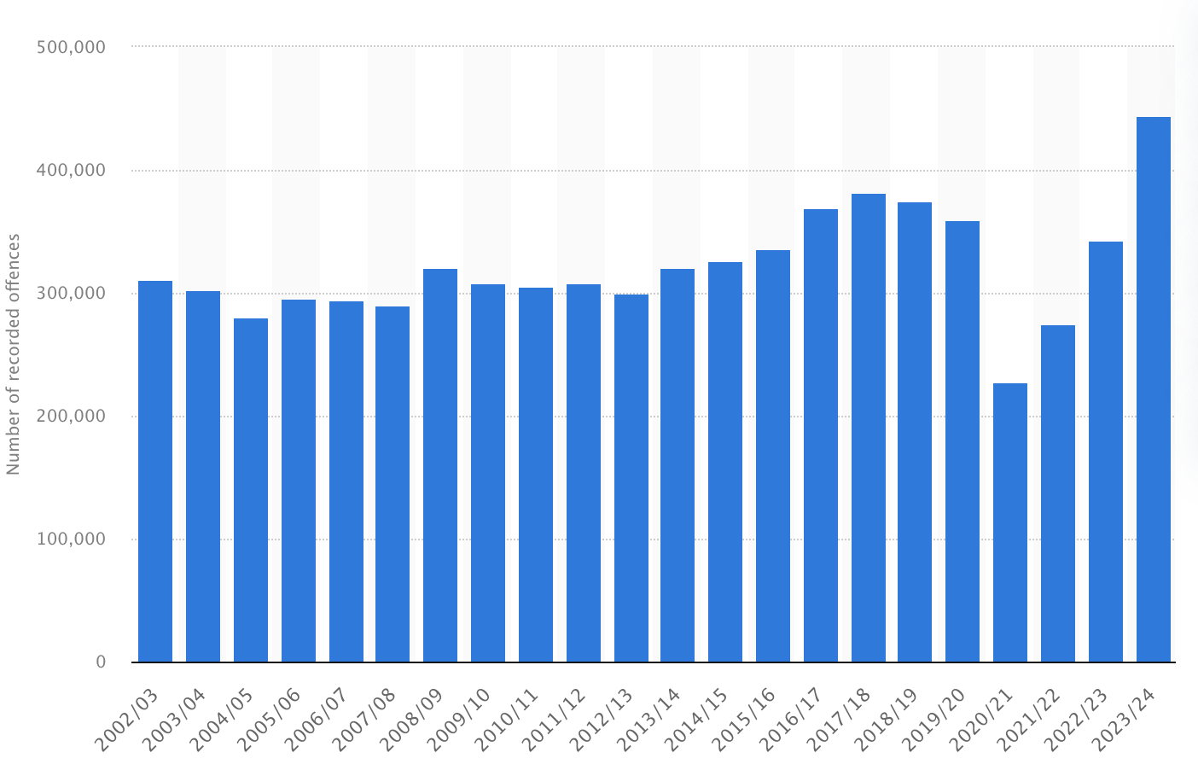

Slide 5 Shoplifting Findings

- Shoplifting has reached unprecedented levels in England and Wales, with 492,914 offences recorded in the year leading up to September 2024—a 23% increase from the previous year.
- In Wales, the situation mirrors this upward trend. Shoplifting incidents saw a 33% rise in the year leading to June 2024, marking the highest level in two decades.
- In response, authorities have initiated measures to address retail crime. The Labour Government has pledged to tackle the rise in retail crime through stronger measures, including removing the £200 threshold for 'low-level' theft and introducing a standalone offence for assaulting retail workers.

