Critical essay based on health questionnaire

The aim of this study was to devise a health questionnaire to establish the health and well-being of anonymous participant; whom had previously given consent and understands all data will be anonymized and non-identifiable through-out the study the individual is also aware of their right to withdraw at any point; and will therefore be referred to as participant 0001 (P0001) Consent forms (copy only original available on request to authorised personnel) and questionnaire will be attached as appendix 1 and appendix 2 at the end of the report. Data collected will then be analysed evaluated, and discussed against government guidelines and recommendations, from this the researcher will make suggestions for P0001 to improve living on a physical intellectual social, emotional and spiritual level.
P0001 is a white British male aged between 56-65, with a BMI of 48, this was established by using an online calculator which also showed the metabolic rate at 2512 (Grimsley, Elizabeth ;, 2018). P0001 is currently 142.8kg which is considerably overweight. The height/weight chart demonstrated on the National Health Service (NHS) website suggest that P0001 is “very obese” (National Health, 2018). At first review of the questionnaire P0001 has many long-term health issues as well as mobility difficulties, neither of these being supported as P0001 shows poor diet, excess alcohol and a heavy smoker. These factors will be discussed, and recommendations will be made to help P0001 to take steps to improve his health and well-being.
The ideal weight for P0001 suggested by NHS guidelines (2018) is between 65 and 85kg which is half the current weight. Persons with limited activity over the age of 30 should consume between 1600-2400 calories per day (Krans, 2016). Having asked for a fluid and food intake diary which shows P0001 has a significantly poor diet, eating limited beneficial calories from varied sources; yet consumes a large calorized amount of alcohol, Since starting the diary P0001 had entered a diet eating less calories however not changing the alcohol intake so although consumption was between 1658 and 1395 calories a day only 498-765 calories were of good nutritional value. Krans (2016) reports the importance of a varied and balanced diet, increase the amount of correct nutrients to aid a healthy lifestyle; also discussed is the key to eat the right type of calories, for example fresh fruit and vegetables, nuts and lean proteins, by eating high sugar “empty calories” such as pizza or energy drinks these will have little if not any nutritional value. Dow (2018) explains not only will a balanced diet assist with weight loss it will also aid to improve or prevent many other health conditions, as poor diet is a large factor to illnesses such as heart disease cancer, stroke, diabetes and even osteoporosis.
P0001 has the breathing condition emphysema, in which makes it difficult to lay flat in a bed to sleep, causing difficulty breathing; this then leads to sleepless and restless nights. Added weight also affects the condition; Cleveland Clinic (2017) advise gentle exercise can be hugely beneficial to COPD patients as can improve circulation in turn improving airflow, not only lowering body fat but increasing upper body strength which also greatly improves respiratory muscles therefore helping to make the heart stronger, increasing endurance, strengthening bones and improving sleep quality. After research was conducted Kirby, et al., (2015) emphasise the capacity of COPD patient’s ability to exercise is limited. O’Sullivan (2016) confirms sleep has a huge impact on health, people who have little, poor or broken sleep are at higher risk of illness and poor health; Similarly, those of ill health often have issues sleeping. P0001 has been unable to sleep in a bed for several years due to breathing issues or pain and therefore resigned to sleep in a recliner chair. It is suggested regular sleep in a recliner chair can cause hip and knee contractures, this is the tightening of the muscles in the joint areas which hinder the ability to stand or walk properly and can affect their balance. It was also added sleeping long term in a recliner chair can put pressure on the spinal cord allowing fluid to build up in the discs which causes pain and discomfort, however it’s also argued a person with breathing difficulties may be relieved from their symptoms by sleeping in a reclined position yet adds the importance of feet to be elevated (Zielinski, et al., 2018).
NHS (2018) explain a normal blood pressure (BP) is between 90/60mmHg and 120/80mmHg, P0001 BP is 140/85mmHg which is classed as high or hypertension. This is more of an issue amongst the population with unhealthy lifestyles, (those who smoke or drink alcohol heavily, are obese or lack in exercise) left un-treated can progress into heart or kidney disease. The British Heart Foundation (2018) suggest by increasing physical activity, eating a balanced diet, having a lower salt intake and being a healthy weight are all recommended methods to lower or prevent high BP. P0001 has already been diagnosed with high blood pressure and is on medication to prevent further illness.
P001 drinks on average of 12-16 units of alcohol per day this is what Media team (2019) suggest is the weekly quota; and recommends this level of alcohol should be spread over a three day period, it warns that drinking more than this on a regular basis dramatically increases risk of illnesses such as mouth, throat or breast cancers. Although, risk can be reduced by having two or three alcohol free days. There are also links to suggest alcohol consumption has added risk and can worsen health conditions Harada, et al, (2015) studies revealed those who have regular high alcohol intake are at higher risk of liver disease, high cholesterol, high blood pressure, have poorer diet and health. In 2012 the UK government introduced a new strategy to try to discourage excess alcohol intake or binge drinking (HM Govenment, 2012).
P0001 is also a heavy smoker. Smoking on average of 30 cigarettes daily and goes in-between shop bought, rolling tobacco and e-cigarettes research shows no amount of tobacco products are safe whether smoke is first or second hand, carbon dioxide in the blood stream will reduce oxygen from getting to vital organs and limbs (Smoke free, 2019). Which makes this even more of a risk to a person like P0001 who disclosed information confirming existing long term conditions of asthma and emphysema, smoke free (2019) adds not only does smoking affect breathing, but also circulation blood pressure, heart disease and cancer. NHS (2018) offer a free quit smoking survey to help each individual get the support and plan based on personal needs. (West, Robert;, 2018).
P0001 has muscle pain extremity numbness, limited mobility causing him to struggle to walk, stand for any length of time, getting in and out of baths or showers and therefore unable to get adequate exercise; this is following a car accident more than 15 years ago. NCHPAD (2019) review the importance of exercise in terms of health as it can improve cardiac and pulmonary function, minimise anxiety or depression, lower cholesterol and blood pressure as well as improving mobility to have the ability to carry out day to day tasks, although P0001 has physical limitations there are now many exercise regimes designed for the upper body that can be carried out from a wheelchair or seated position which still offer all the benefits from a full work out in terms of improving lung and heart function.
P0001 admits to having poor social interaction during the winter months being semi-retired, he mentions having a café on his property in-which he prepares food during the summer for tourists from the comfort of his wheelchair. However in quieter months he spends most of his time alone or just with his wife. Cacioppo & Patrick (2008) explain human interaction is a huge part of life, without socialisation people get lonely and it is at this point it is possible to become withdrawn which in turn lowers the immune system leaving them to become more susceptible to illness or depression.
P0001 is in extreme need to lose weight, however the diet he has put himself on has little nutritional value and therefore would recommend a healthy eating plan such as the NHS weight loss plan (NHS, 2019) which has a 12 week menu available to download which aids safe maintainable weight loss and offers an education in healthy eating, instead of cutting out nutritional calories. It should also be recommended that P0001 should reduce alcohol consumption dramatically in order to promote better health from high cholesterol, high blood pressure and risks of cancer however it was presented that P0001 has no desire to cut alcohol down in his diet so it will therefore be suggested that P0001 tries to take alcohol free days in-between drinking to allow internal organs time to recuperate. Giving up smoking is something P0001 was willing to take into consideration however is sceptical after trying and failing many other methods before, the toolkit on NHS (2019) allows the person to enter their personal details and requirements allowing a strategy to be recommended based on their needs.
Due to pressure the spine as well as hip and knee joints from sleeping in a recliner chair it would be recommended that P0001 requires a motorised adjustable bed in which he can still sleep in a seated position but is also capable to elevate his legs and get into more comfortable positions to aid blood flow keep air ways open and promote restful sleep it may also be advised to be checked for sleep apnoea as this may also prevent sustainable sleeping positions. As P0001 has been un-active for a long period of time it may be required to seek professional advice before setting a vigorous exercise regime although wheelchair fitness and exercises are available on the NHS website which are suitable for wheelchair users of all different fitness levels (NHS, 2019). There are no religious or spiritual beliefs for P0001 but would recommend more social interaction during the winter months in particular maybe a date night with his wife or look into local social groups in the community.
In conclusion, P0001 is a middle aged white British male with many pre-existing medical conditions such as high blood pressure and high cholesterol which are already controlled by medication, nonetheless by cutting down alcohol consumption quitting smoking, losing weight by eating a more varied diet and becoming more active will all have a positive effect on these conditions. This said P0001 is in a vicious circle in the fact his weight loss is stunted by immobility yet mobility is hindered due to extra weight and breathing difficulties as well as an almost constant pain and discomfort. After gathering information assessing the results and discussing strategy and causes, recommendations have been made for P0001 to start to make positive improvements to his life and health and well-being.

References
British Heart foundation, 2018. Heart Matters. [Online]
Available at: https://www.bhf.org.uk/informationsupport/heart-matters-magazine/research/blood-pressure/blood-pressure-tips
[Accessed 08 01 2019].
Cacioppo, J. T. & Patrick, W., 2008. Loneliness: Human Nature and the Need for Social Connection. 1st ed. united states: W.W Norton and compant.
Cleveland Clinic, 2017. Cleveland Clinic. [Online]
Available at: https://my.clevelandclinic.org/health/articles/9450-copd-exercise--activity-guidelines
[Accessed 08 01 2019].
Dow , C., 2018. The Center for science in public interests. [Online]
Available at: https://cspinet.org/eating-healthy/why-good-nutrition-important
[Accessed 06 01 2019].
Grimsley, Elizabeth ;, 2018. Active. [Online]
Available at: https://www.active.com/fitness/calculators/calories
[Accessed 03 01 2019].
Harada, S. et al., 2015. Metabolomic profiling reveals novel biomarkers of alcohol intake and alcohol-induced liver injury in community-dwelling men. BCM Environmental Health and Preventive Medicine, Volume 21, p. 494.
HM Govenment, 2012. The Government’s alcohol strategy. 1st ed. London: The Stationary office LTD.
Kirby, M. et al., 2015. COPD: Do imaging measurements of emphysema and airway disease expain symptoms and exercise capacity. RSNA Radiology, 277(3).
Krans, B., 2016. Health Line. [Online]
Available at: https://www.healthline.com/health/balanced-diet
[Accessed 06 01 2019].
Media team, 2019. Drink Aware. [Online]
Available at: https://www.drinkaware.co.uk/alcohol-facts/alcoholic-drinks-units/latest-uk-alcohol-unit-guidance/
[Accessed 10 01 2019].
National Health Service, 2018. NHS-blood pressure. [Online]
Available at: https://www.nhs.uk/conditions/high-blood-pressure-hypertension/
[Accessed 01 01 2019].
National Health, 2018. NHS. [Online]
Available at: https://www.nhs.uk/live-well/healthy-weight/height-weight-chart/
[Accessed 02 01 2019].
NCHPAD, 2019. NCHPAD. [Online]
Available at: https://www.nchpad.org/14/74/Exercise~Guidelines~for~People~with~Disabilities
[Accessed 10 01 2019].
NHS, 2019. NHS weight loss. [Online]
Available at: https://www.nhs.uk/live-well/healthy-weight/start-the-nhs-weight-loss-plan/
[Accessed 10 01 2019].
NHS, 2019. NHS wheelchair users. [Online]
Available at: https://www.nhs.uk/live-well/exercise/wheelchair-users-fitness-advice/
[Accessed 10 01 2019].
O'sullivan, C., 2016. Mental health foundation. [Online]
Available at: https://www.mentalhealth.org.uk/blog/importance-sleep
[Accessed 08 01 2019].
Smoke free, 2019. Smokefree.gov. [Online]
Available at: https://smokefree.gov/quit-smoking/why-you-should-quit/reasons-to-quit
[Accessed 10 01 2019].
West, Robert;, 2018. Smoke free NHS. [Online]
Available at: https://www.nhs.uk/smokefree
[Accessed 10 01 2019].
Zielinski, K., Noethen, S. & Ozamoto, M., 2018. Healthy Living News, Toledp: Healthy Living News.

Appendix 1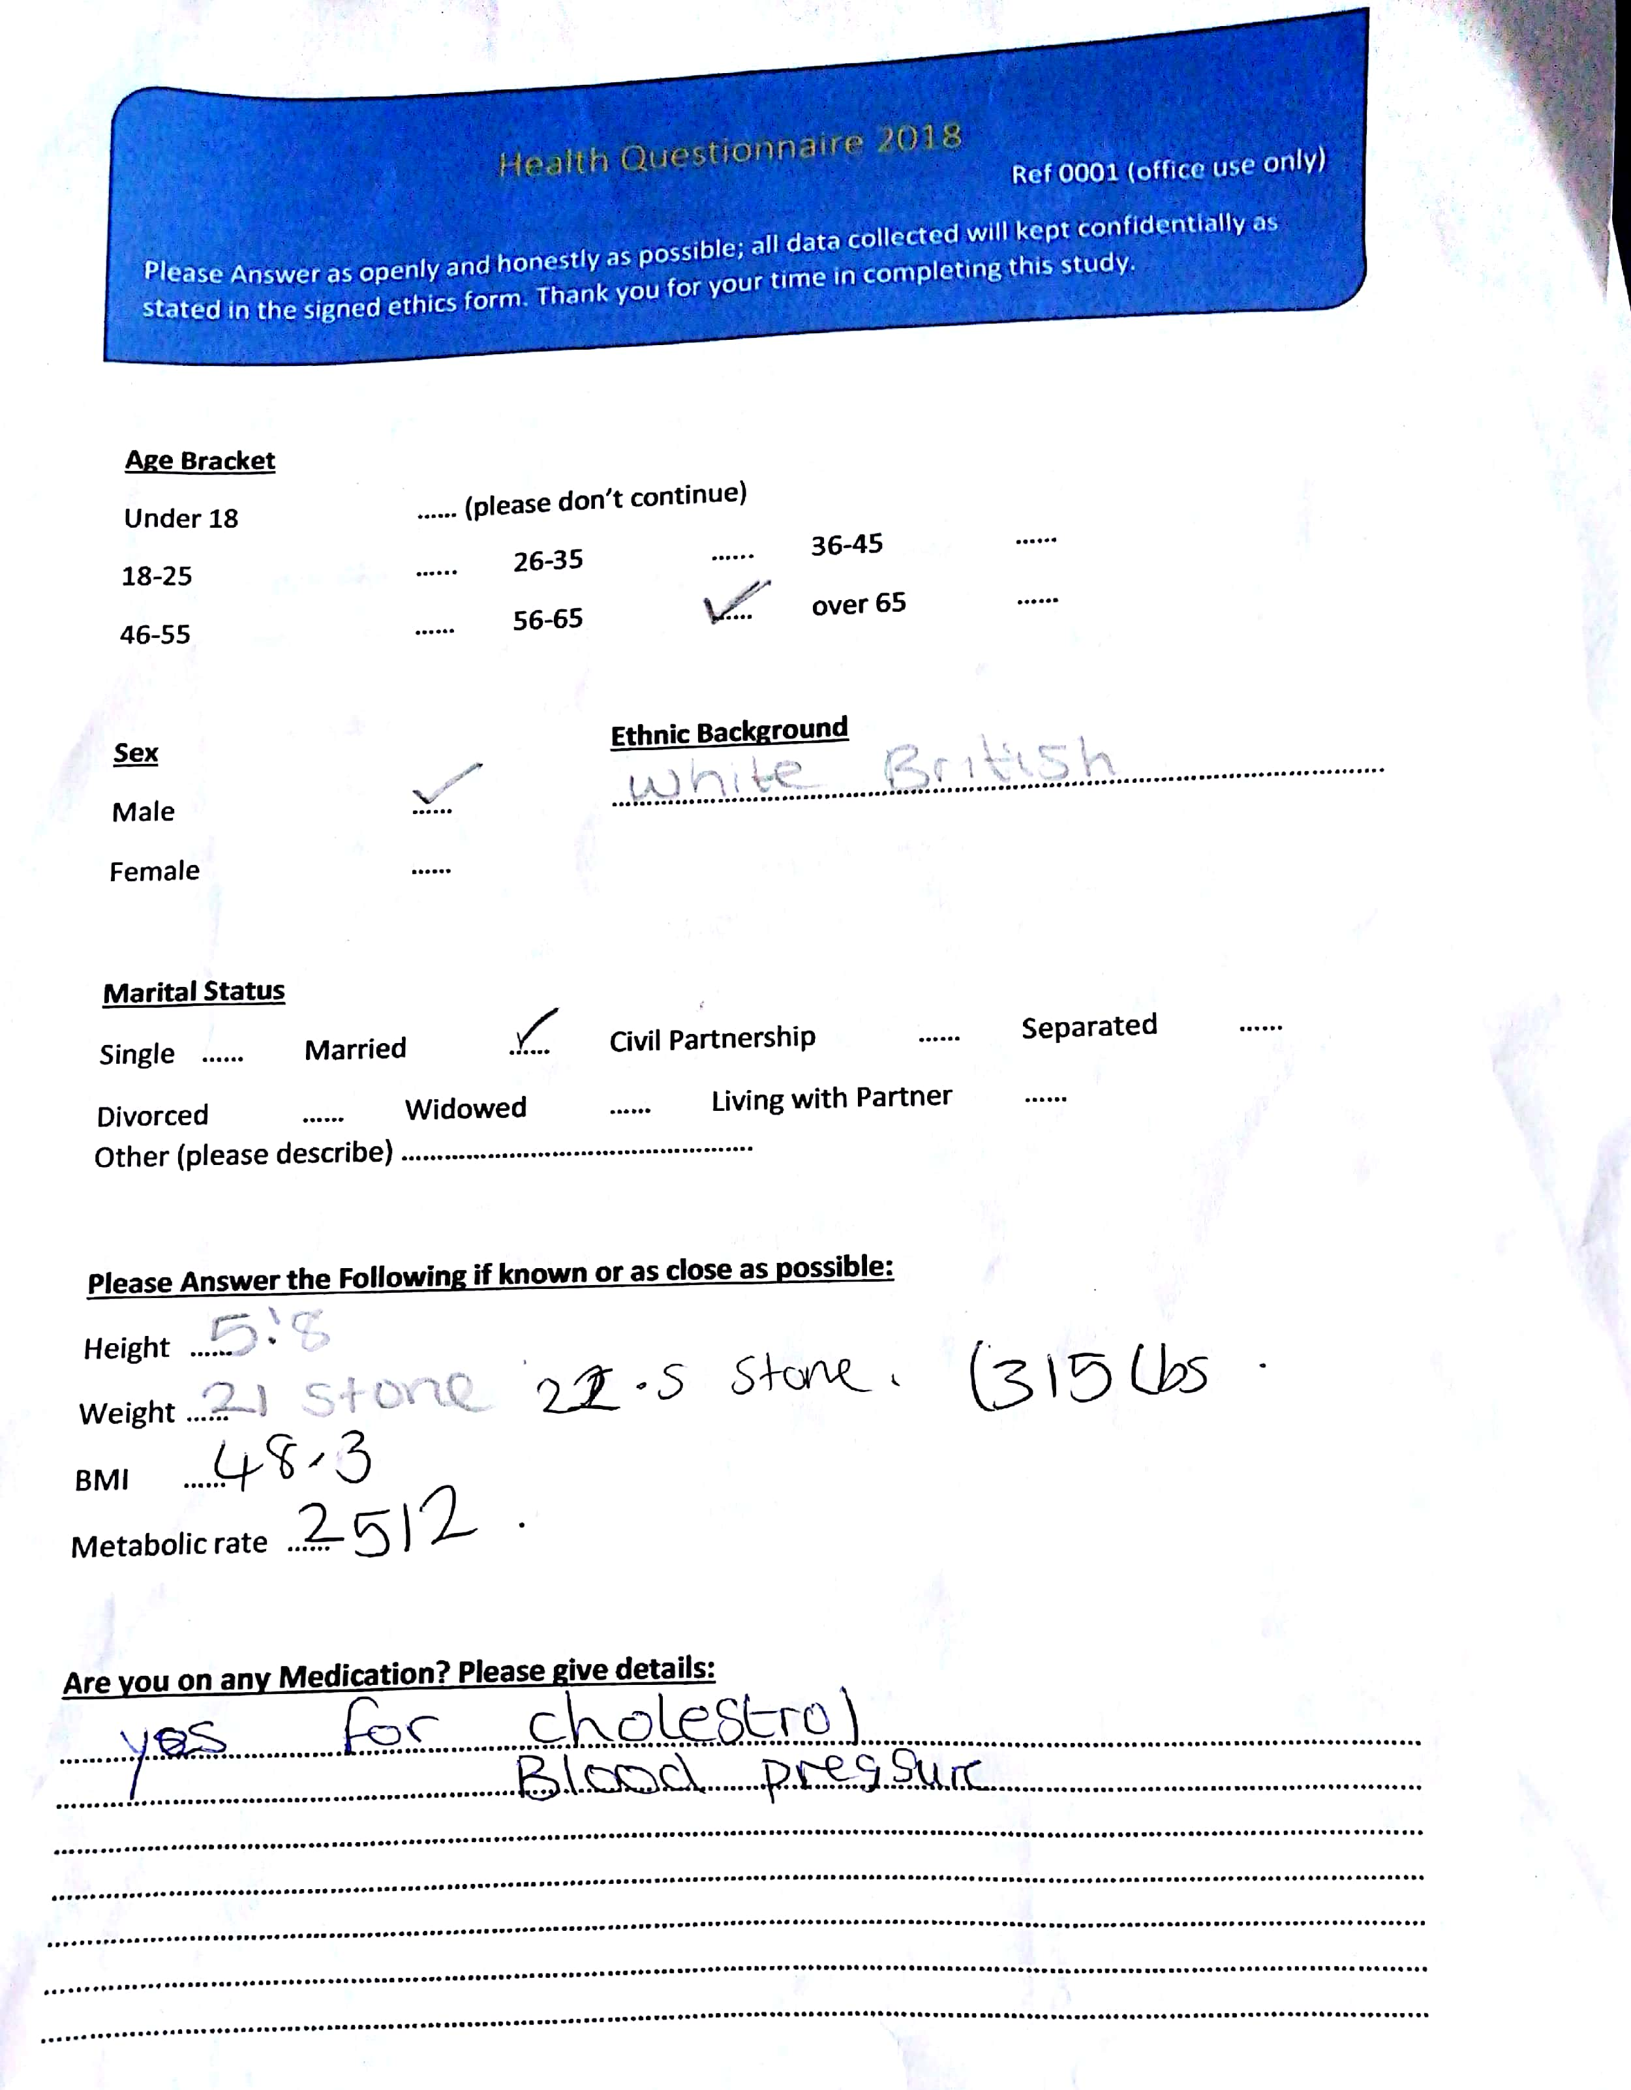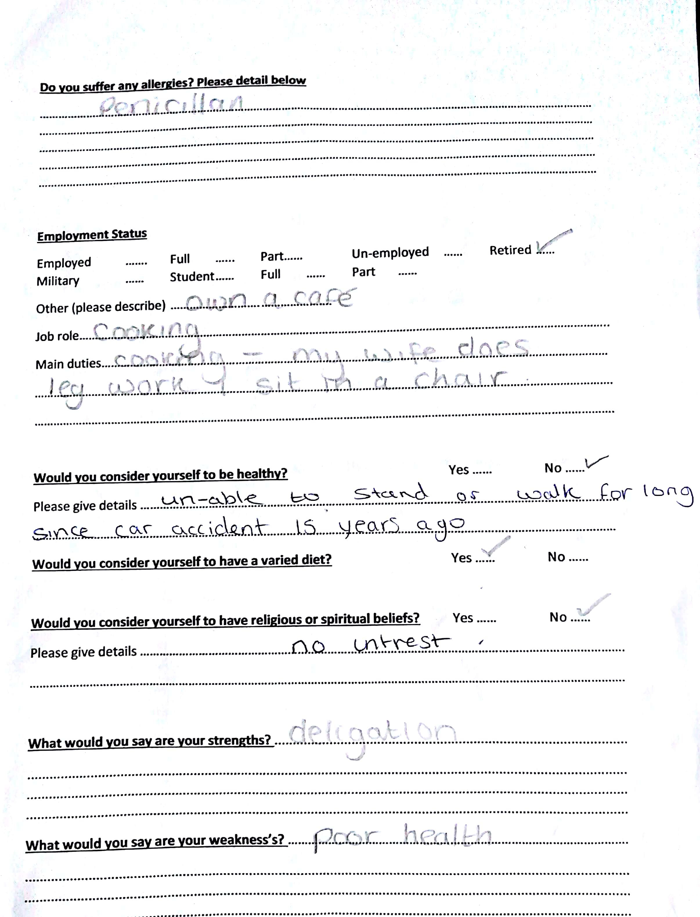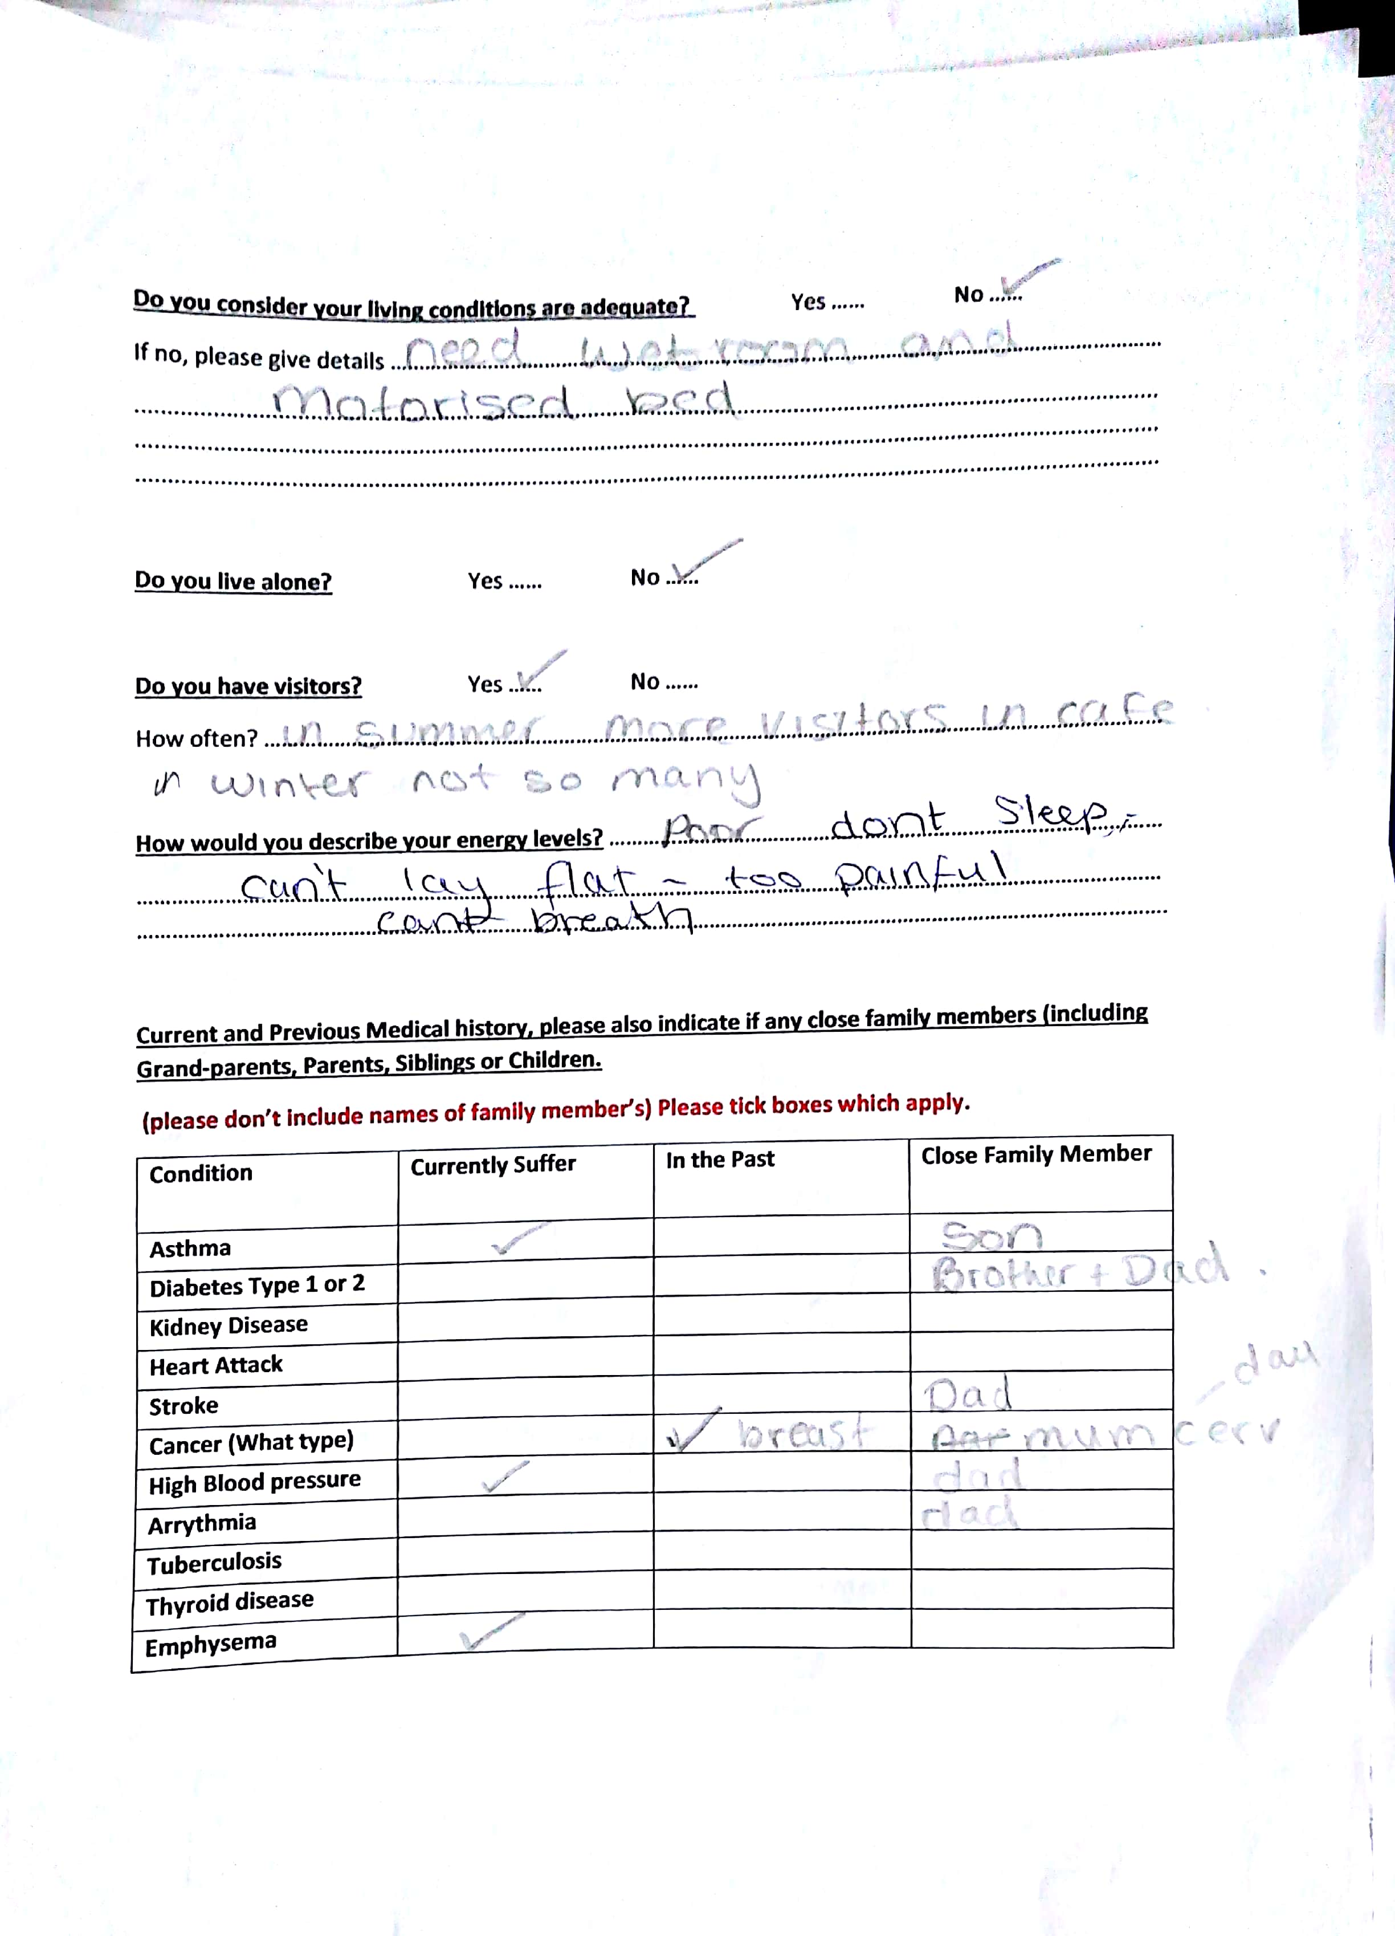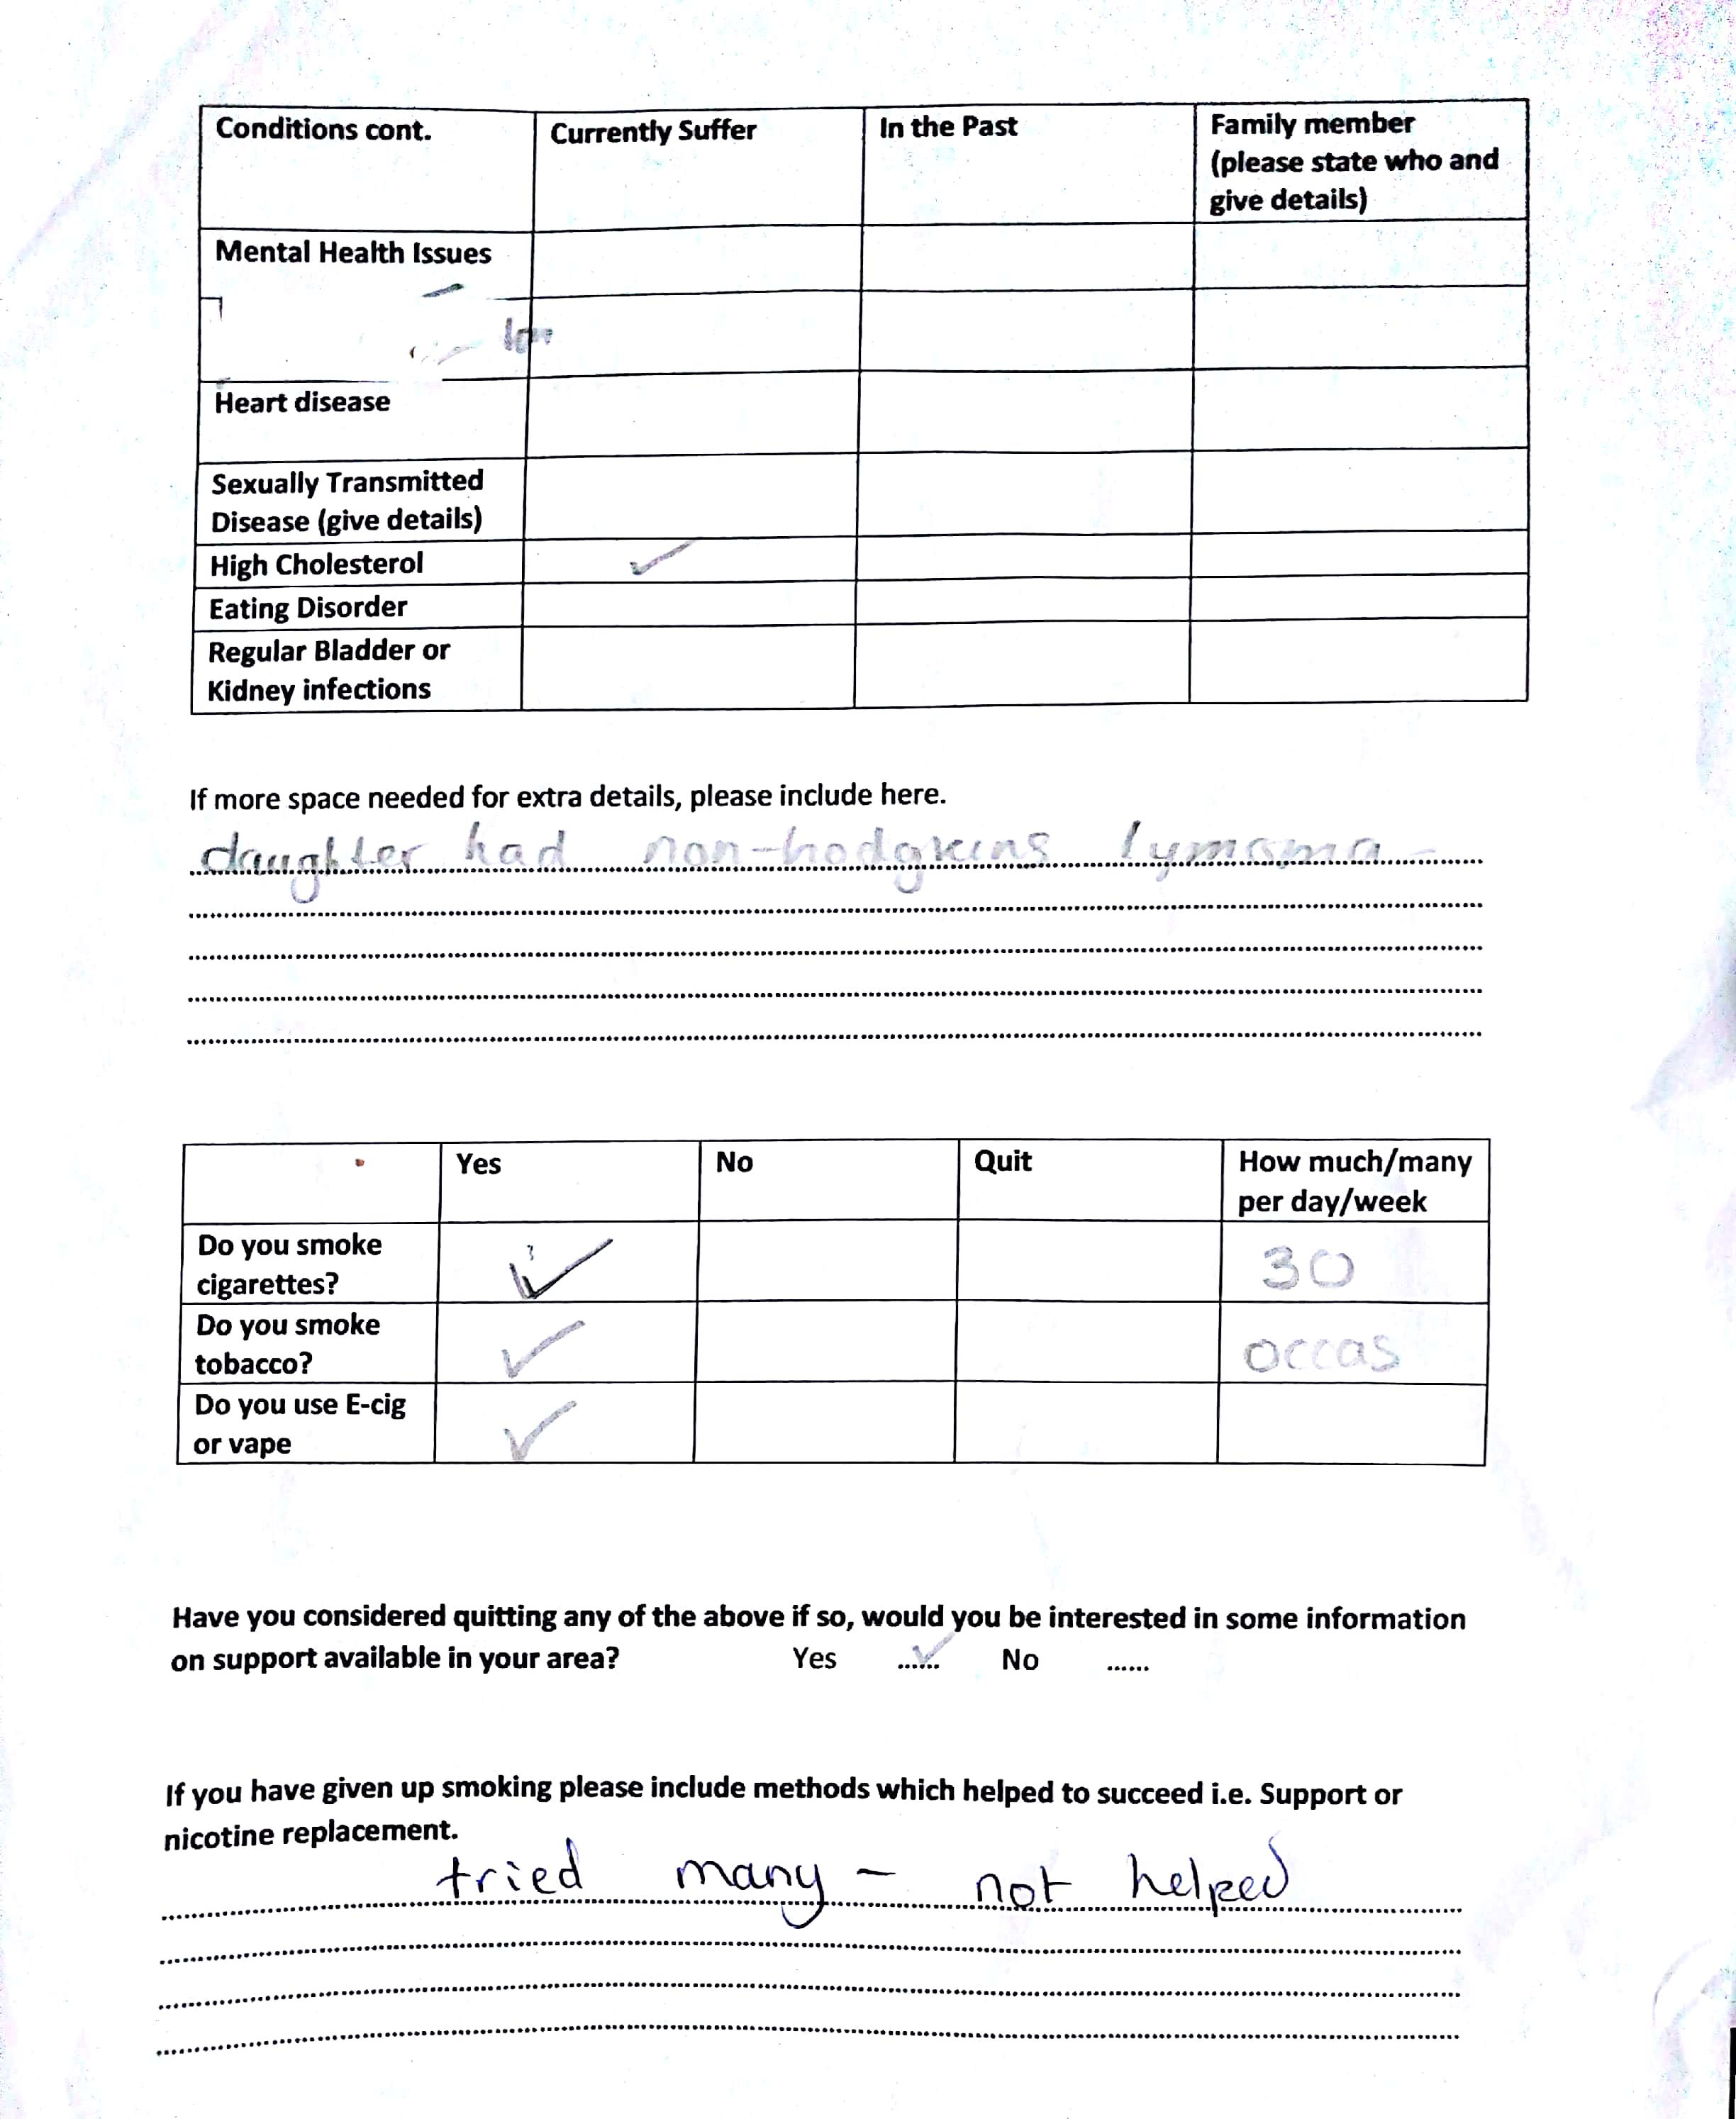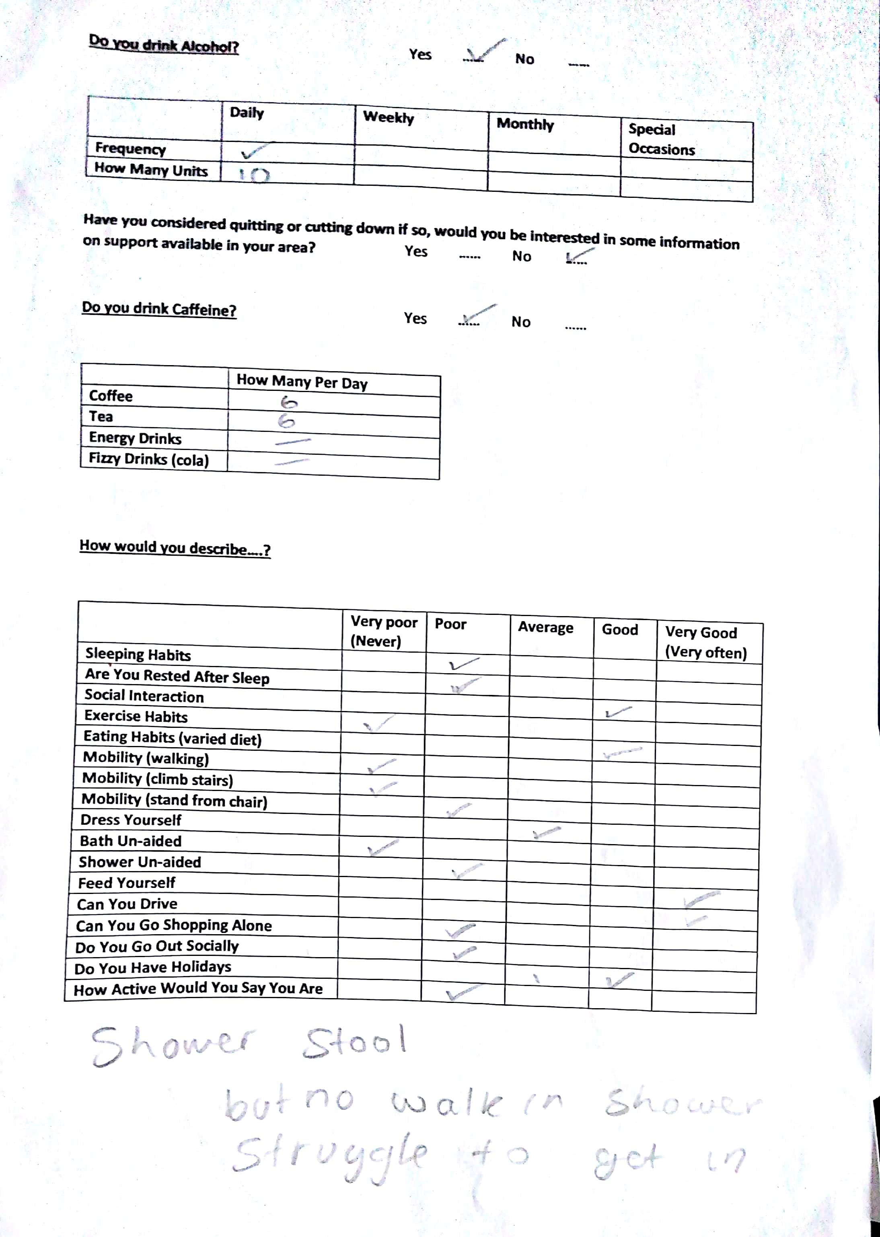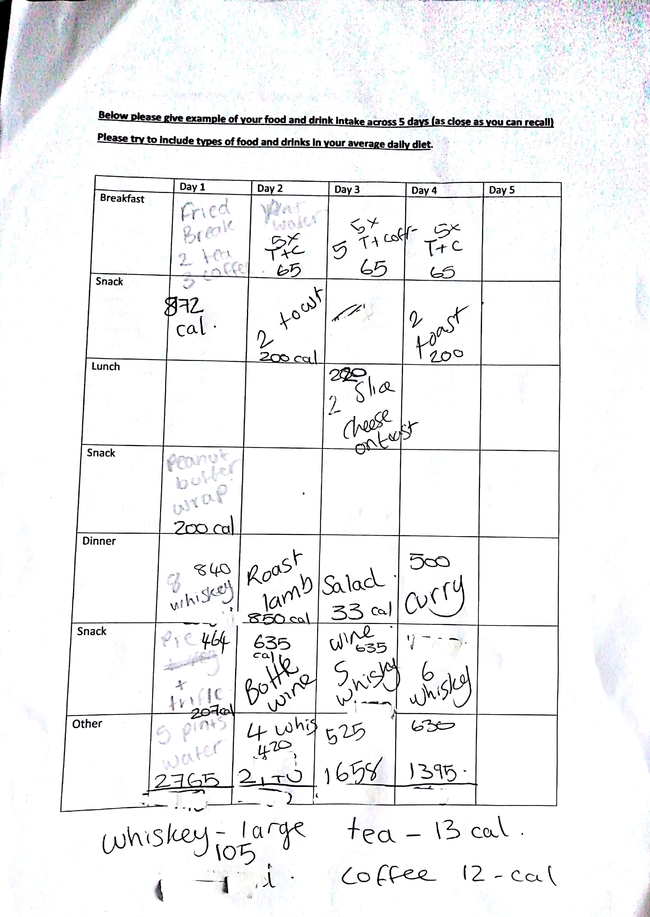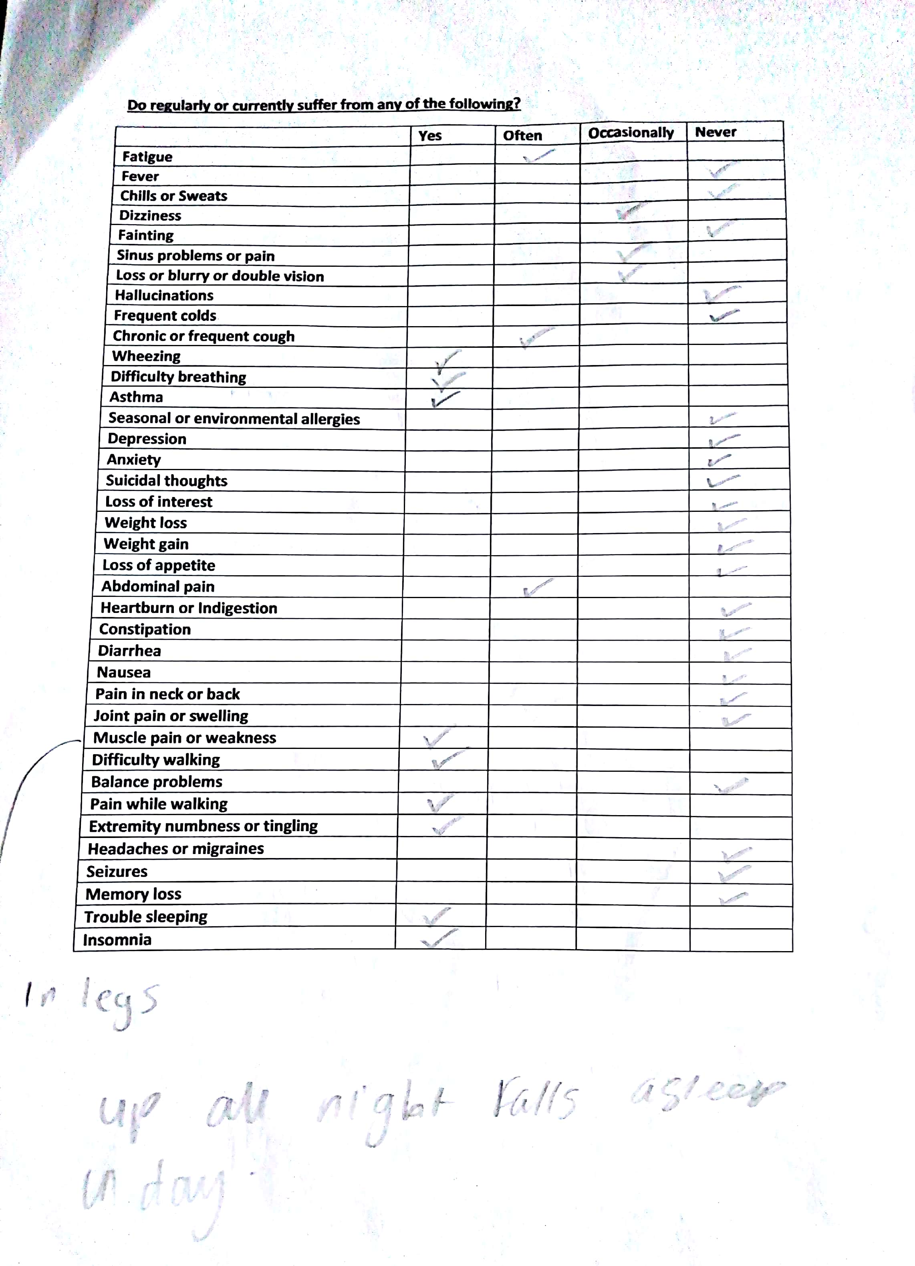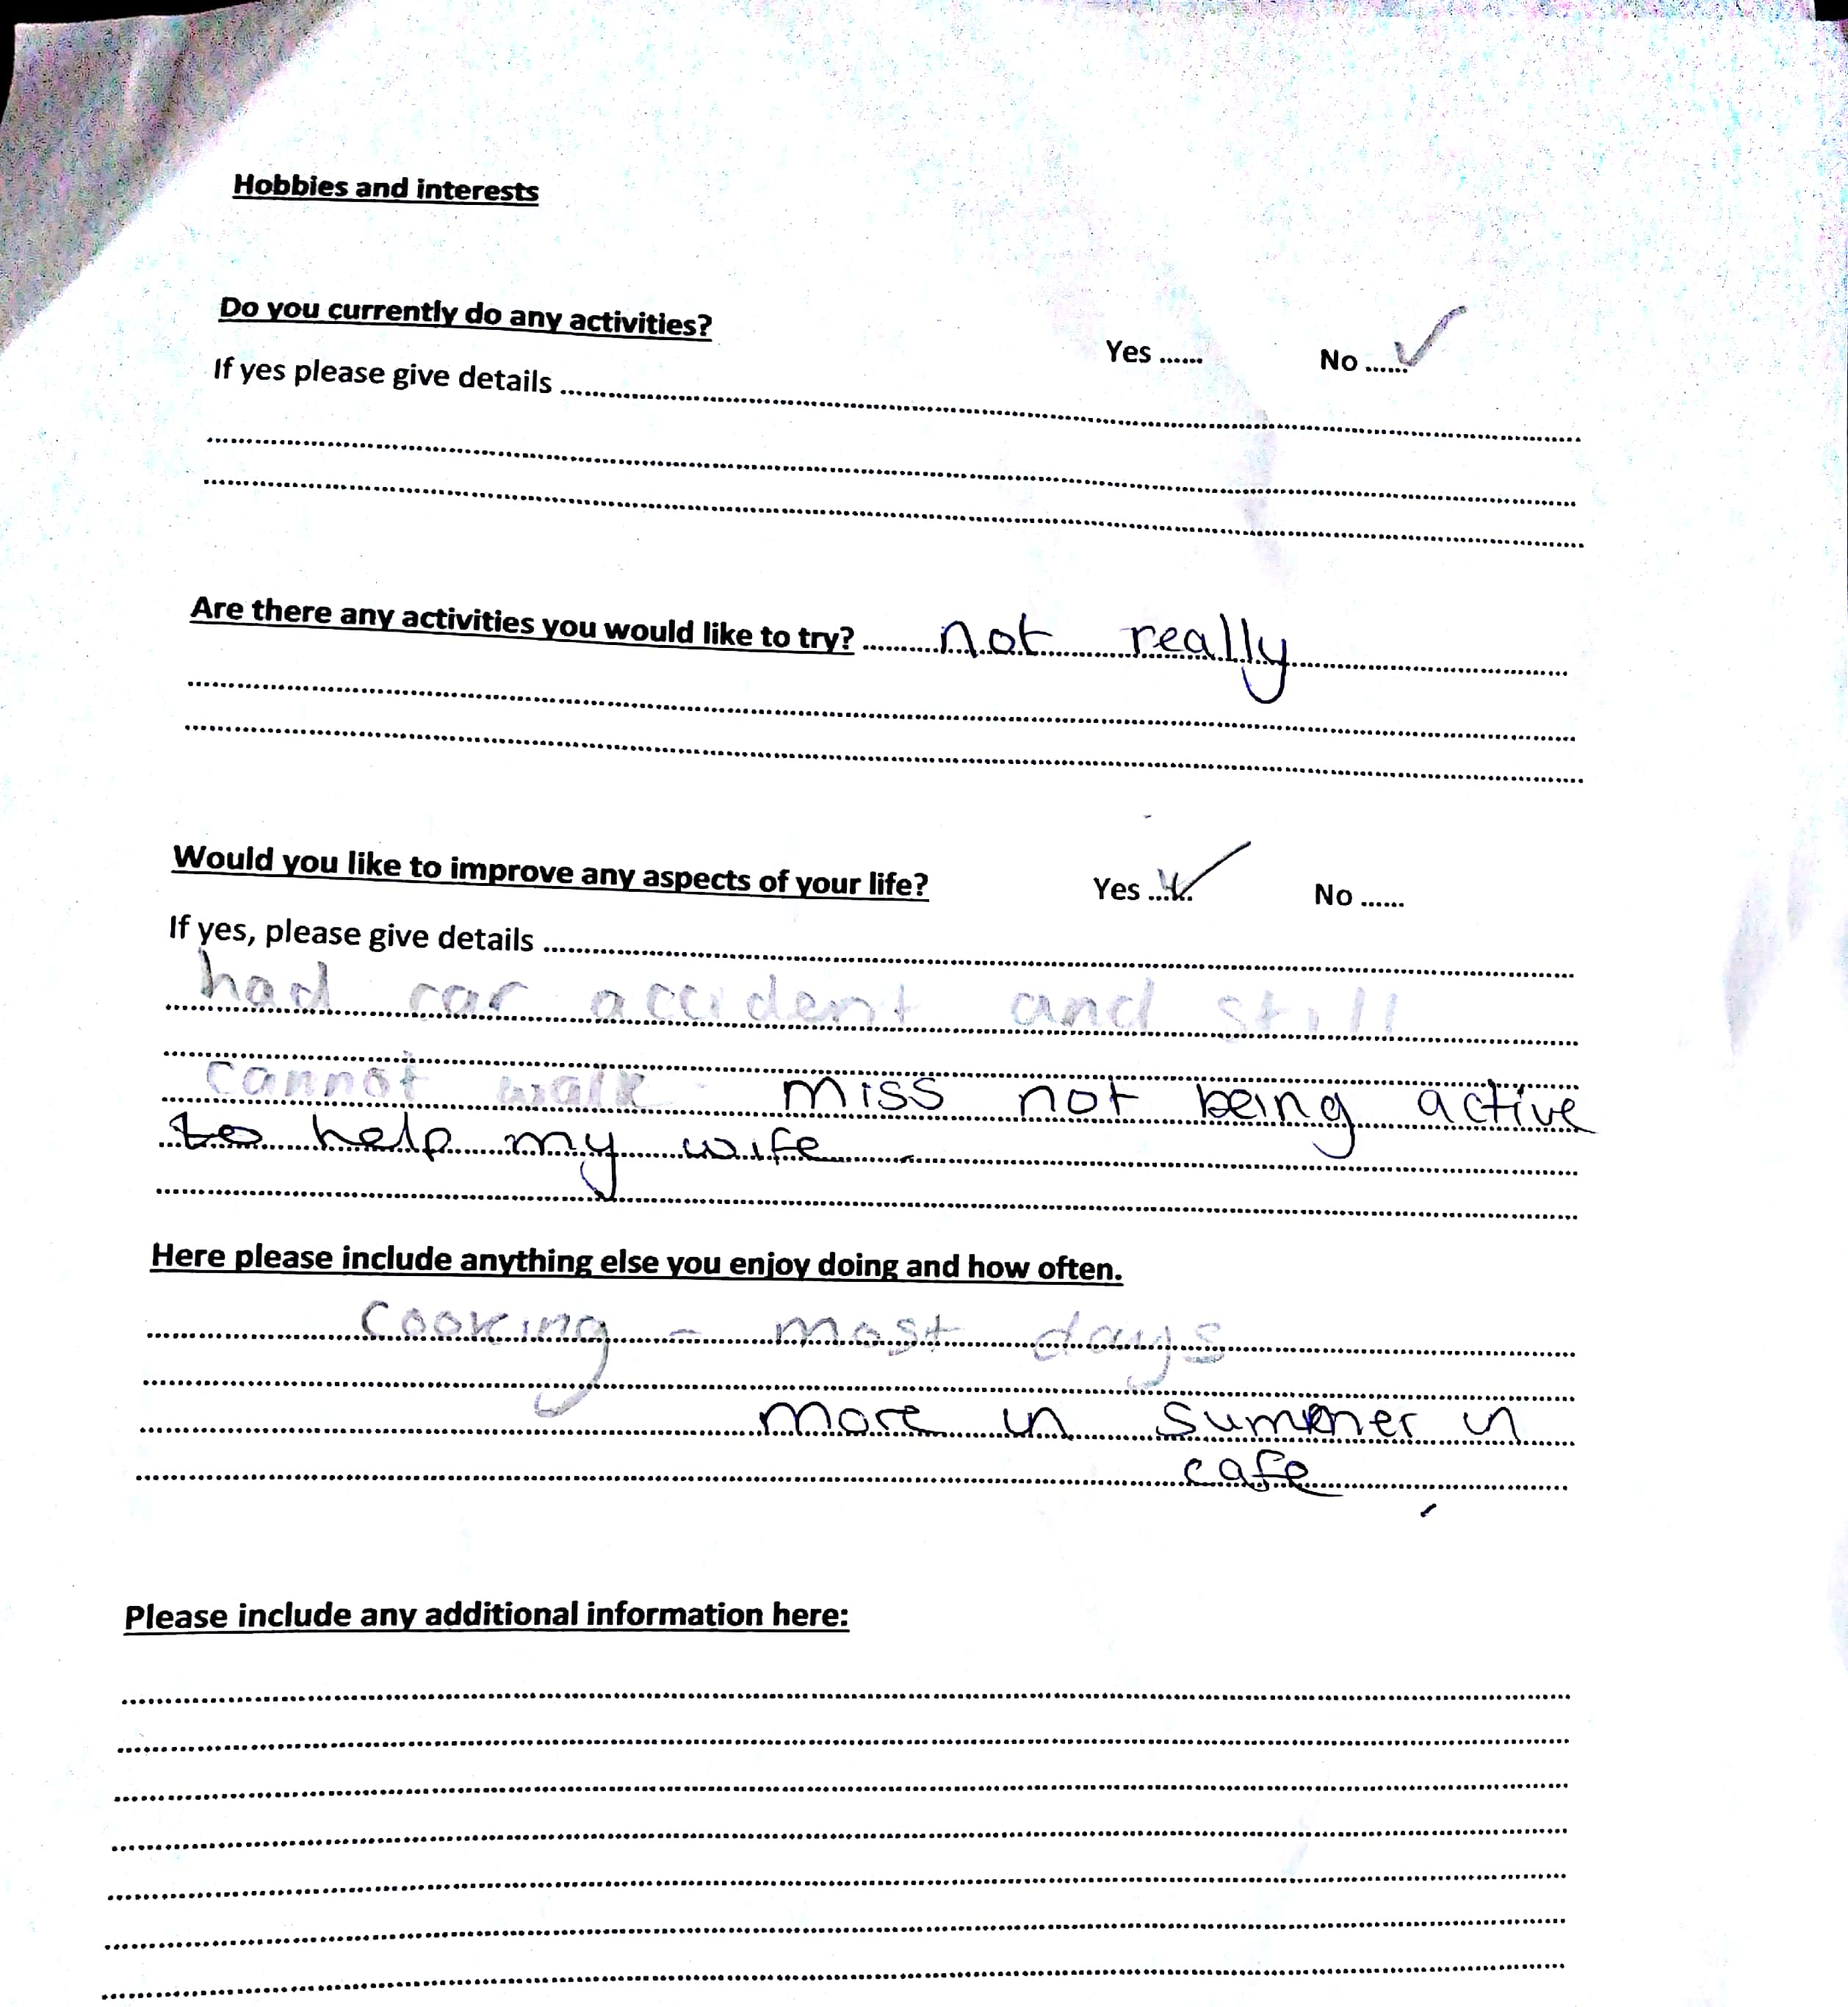
Appendix 2

