

Caspar Thurston-Smith

Systems engineering technical report

University of Wales Trinity St David
Systems engineering

Beng
Academic Year: 2025-2026

Supervisor: Jenni Steen and Dave Holly April 2026

University of Wales Trinity St David
Ordnance Munitions and Explosives

Beng

Academic Year 2025 - 2026

Caspar Thurston-Smith

Systems engineering technical report

Supervisor: Jenni Steen and Dave Holly April 2026

This thesis is submitted in partial fulfilment of the requirements for the degree of Ordnance Munitions and Explosives
(NB. Remove if the degree award is based solely on examination of the thesis)

© UWTSD year. All rights reserved. No part of this publication may be reproduced without the written permission of the copyright owner.

Academic integrity declaration
I declare that:
- The thesis submitted has been written by me alone.
- The thesis submitted has not been previously submitted to this university or any other.
- That all content, including primary and/or secondary data, is true to the best of my knowledge.
- That all quotations and references have been duly acknowledged according to the requirements of academic research.
I understand that to knowingly submit work in violation of the above statement will be considered by examiners as academic misconduct.

Contents
Introduction 5
Requirements 5
Functionality 9
Concept 11
Potential failure modes 13
Critical design features 16
Manufacturing 17
Critical processes 18
Process control measures 23
Disposal 26
Conclusion 27
Bibliography 28
Annex A 28

Table of Figures:

Figure 1 6
Figure 2 6
Figure 3 7
Figure 4 8
Figure 5 9
Figure 6 10
Figure 7 11
Figure 8 12
Figure 9 12
Figure 10 13
Figure 11 14
Figure 12 14
Figure 13 14
Figure 14 15
Figure 15 15
Figure 16 16
Figure 17 16
Figure 18 17
Figure 19 17
Figure 20 17
Figure 21 18
Figure 22 19
Figure 23 19
Figure 24 20
Figure 25 21
Figure 26 21
Figure 27 22
Figure 28 23
Figure 29 23
Figure 30 24
Figure 31 24
Figure 32 25
Figure 33 25
Figure 34 26

Introduction

Systems engineering (SE) is a methodology that uses several processes to design and manage a system or set of systems through its whole life cycle [1]. This includes the entire concept, assessment, demonstrator, manufacture, integration and disposal (CADMID cycle) [2]. This assignment will seek to use the tools provided to solve an OME based challenge. Through the SE based module a design book was referenced and used as a worked example. This book contained several tools/processes that come together to form a SE based approach; by using these tools Group 1 was able to enact the teaching of the module into a functioning system. This report will look to examine the tools/processes used, why each process matters, what each process achieved and how it ultimately impacted the solution proposed.

The task required a team to clear a path through a mine field so that medical supplies could transfer through. This task had limitations as a result a SE approach was taken to solve this challenge.

The team carrying out this task was made up of seven engineers with different backgrounds. They split themselves into seven roles based on their experiences that would allow them to complete the workbook. The roles were split out as follows: Will Critchley was responsible for research and development, Shaun Malone (trials and evaluation(T&E)), James Cawte (T&E), Theo Dunning (manufacturing), Euan Kelly (safety of manufacturing), Caspar Thurston-Smith (safety of the operation) and Arron Simpson (disposal).

SE dates to at least the 1940s [3] with some sources putting it earlier. This report focuses on a waterfall model of SE, this is due to this report being entirely theoretical in nature, a V model would link the approach to a series of tests which cannot be undertaken. The design book given to Group 1 meant that this approach was the most obvious. At each stage of the model, the group reviewed the work that was completed. This validated the information that was being put down. This peer review also allowed for the team to spot mistakes within the work.

Requirements
The SE approach dictates that the first step to designing a solution is to identify the requirements of the solution. The idea is to break down the challenge into its key issues and come up with requirements that if met will solve the issue. The term ‘solutionising’ is used when the engineers already have a solution in mind. As a result engineers do not follow a SE approach leading to mistakes.

The team originally came up with 18 requirements. Given the time frame and the goal 18 requirements were deemed too many. The team had to develop these requirements into 8 succinct requirements. Less, more concise requirements help to reduce solutionising. In a project team, splitting a major project into its requirements helps to understand what the key requirements are. Figure 1 shows the table of 18 original requirements.

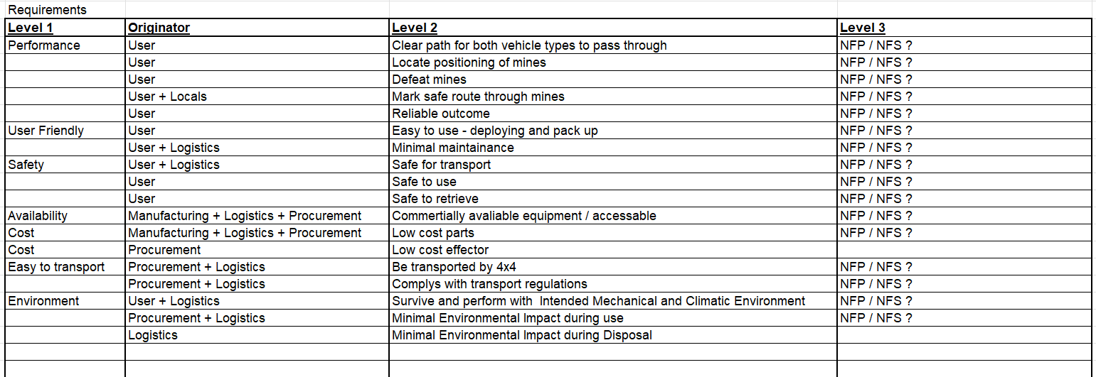
Figure 1

Figure 2 shows the amalgamated eight final requirements. These requirements take in aspects of the original three safety requirements.

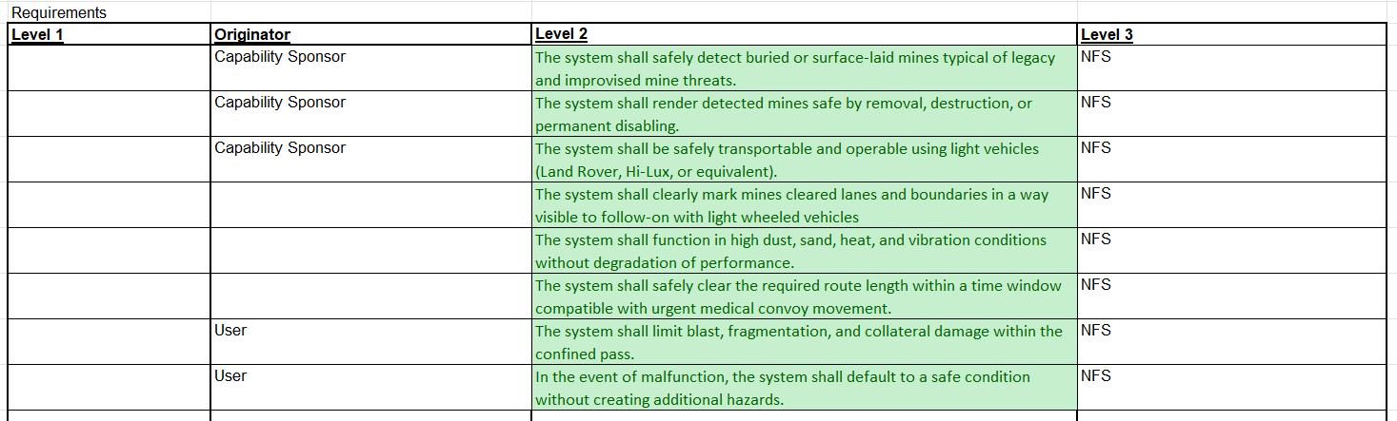
Figure 2

Once requirements have been set, the next process is rationalising requirements. This is done by comparing each requirement in a matrix, see figure 3. This allows the most important requirements to be identified.
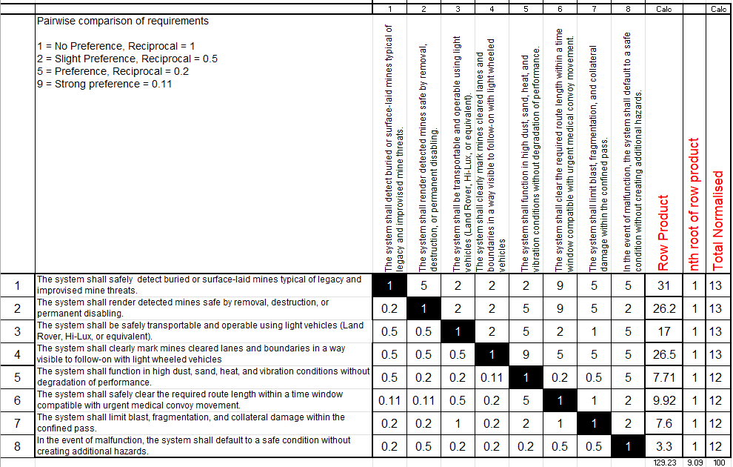
Figure 3
Figure 4
Figure 4 shows the results of using this tool graphically, the three most important requirements in order of importance top down were:

- The system shall safely detect buried or surface-laid mines typical of legacy and improvised mine threats
- The system shall clearly mark mines cleared lanes and boundaries in a way visible to follow-on with light wheeled vehicles
- The system shall render detected mines safe by removal, destruction, or permanent disabling

By applying critical thinking, if these results do not align with the challenge, it is likely that there was a mistake in the pairwise comparison or in the requirements. Regular analysis of the tools output allows the results to be verified. The results of the comparison align with the challenge and so prove the results to be valid.

Functionality

To ensure that all key functions of the systems have been identified, the ‘required functionality’ tool is used. This takes the original required functions and breaks them down into how the system shall carry out each function. See figure 5. Quality function deployment 1 (QFD 1) compares the required functions to the requirements.
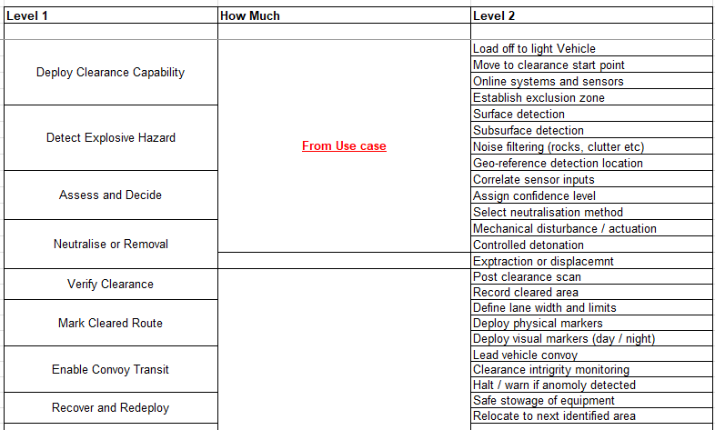
Figure 5
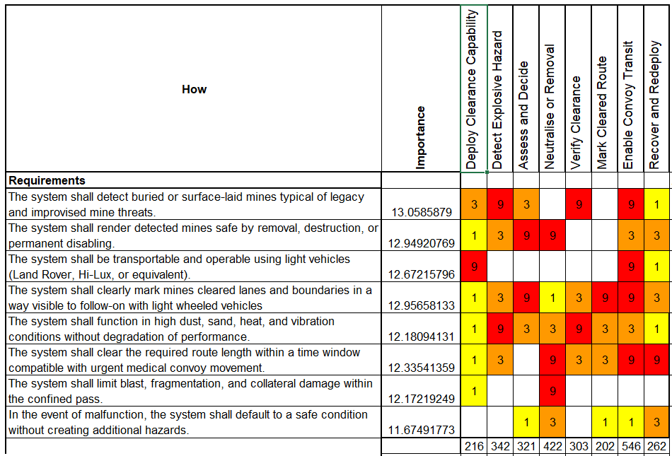
Figure 6

QFD 1 (see figure 6) is designed to identify the key functions of the system. The functional importance graph is used to display how the required functions compare and can be seen in figure 7.

QFD 1 helps to ensure that all the requirements cover the required functions. This tool has a significant impact on the design; it ensures that the system can deliver on the required functions.

Figure 7
As can be seen in figure 7, the key function is that the convoy can transit the mine field. This is the goal of the system and as a result all requirements should have some relationship with this function. One method to verify the results of each tool is to cross reference them, making sure they align with the original task.

Concept

To develop a concept in relation to this functionality the functions means analysis (FMA) tool was used, see figure 8. These suggestions were then analysed using the red, amber and green colour coding system. Figure 8 shows the tool with the RAG colours. Based on this table, with green ideas identified as the best and red ideas as the worst/not feasible, three concepts were developed.
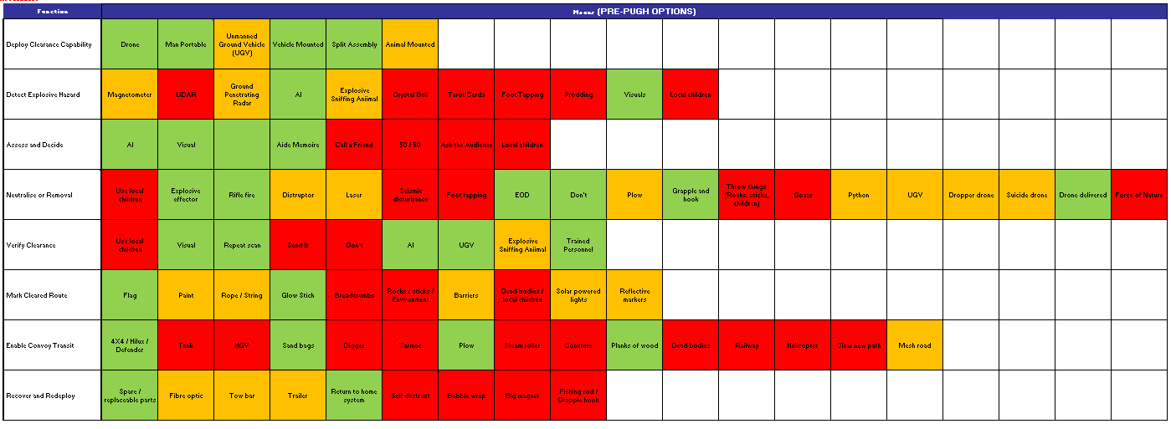
Figure 8

As a result of completing the function means analysis process, three concepts were developed, each incorporated different proposed solutions to form three different concepts.

These three concepts were evaluated using the system Pugh process, see figure 9. This required the concepts to be compared against the requirements and a control system. If the concept exceeded the requirement, it was given a positive number, zero for equal and negative for worse than the control.

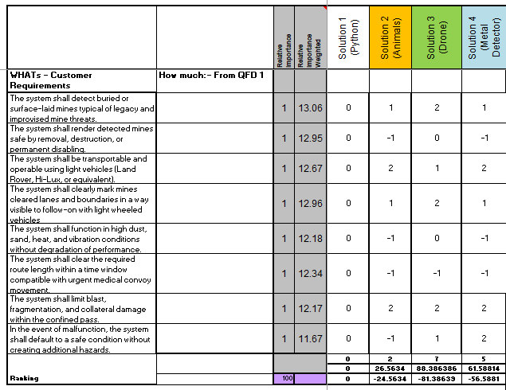
Figure 9

See Annex A for detail on the control solutions and 3 alternatives.

As a result of the system Pugh process, solution 3 was deemed the most successful solution and so was chosen for further development. Comparing concepts to requirements is key for identifying an effective solution and has a major impact on the final design. In a major project context, this ensures that the competition between concepts is fair.

Potential failure modes

Once a concept had been chosen, the potential failure modes of the system needed to be identified. Of particular interest is the failure modes that impact safety. Failures that cause the system to be unsafe mean the system cannot be operated and as a result the system cannot solve the challenge.

A P diagram and ‘what why’ table are two tools that identify noises and controls for the noises. These tools used together can categorise the noises and identify which controls apply to which noise. The P diagram helps to identify these control factors but the ‘what why’ table verifies them. The ‘what why’ tables seen below compare the control parameters to the noise factors and identify how important their relationship is. It is important that at least one of the control factors relates to at least one of the noise factors. This ensures that all the noise factors are mitigated.
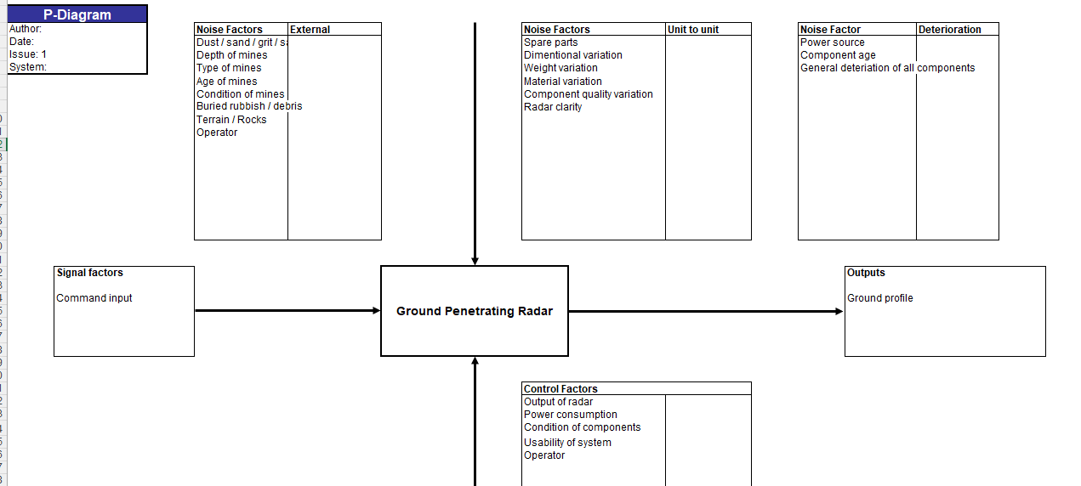
Figure 10

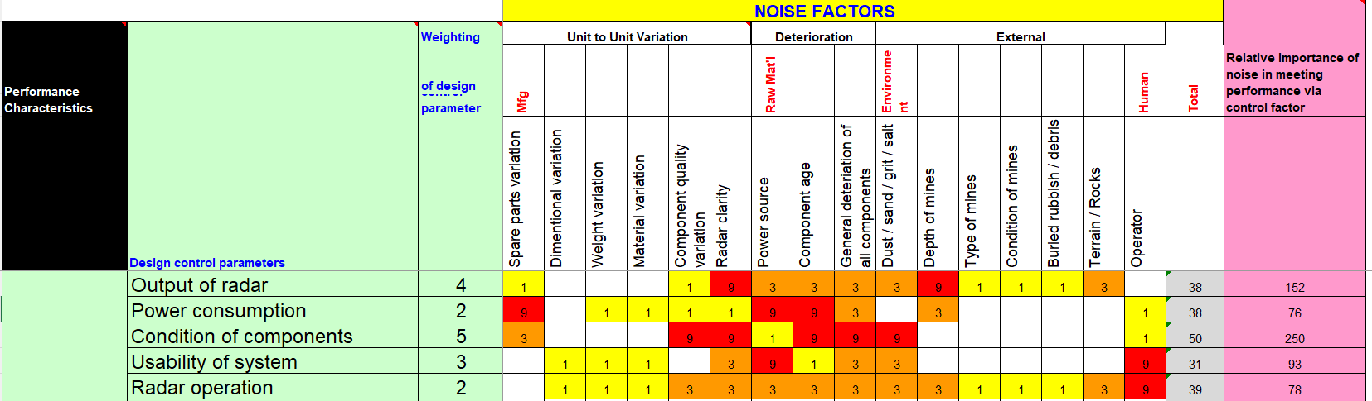
Figure 11
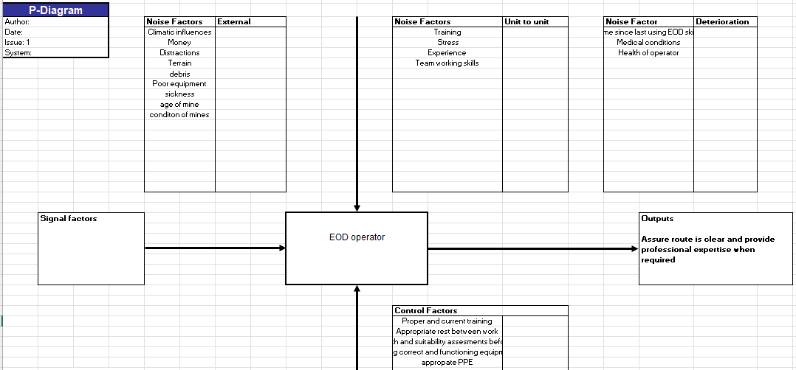
Figure 12
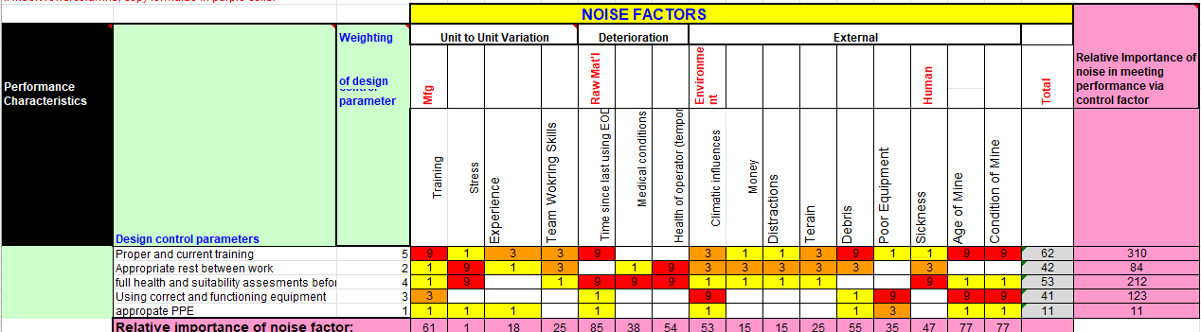
Figure 13
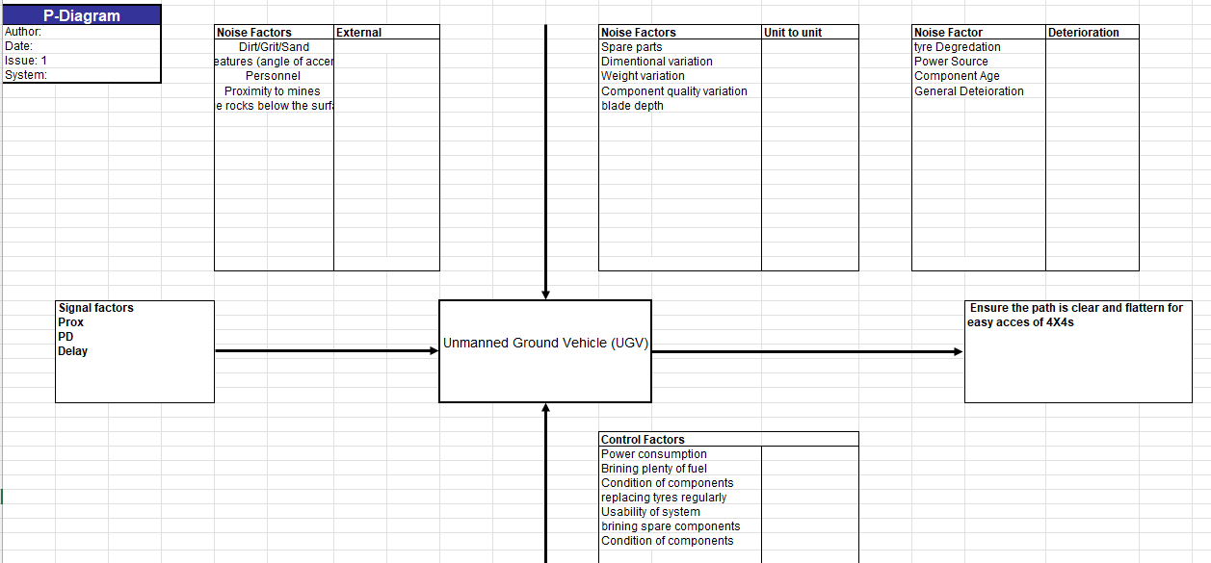
Figure 14
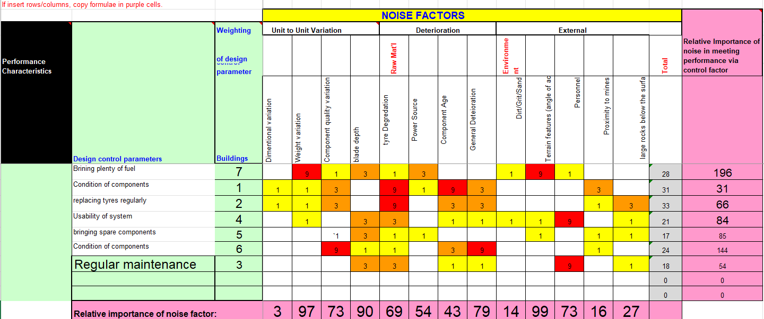
Figure 15
A total of three P diagrams and ‘what why’ tables were used, to understand the factors impacting three critical parts of the system; the drone, the unmanned ground vehicle and explosive ordnance disposal (EOD) personnel. Figures 10 - 15 show the P diagrams and their associated ‘what why’ tables.

As can be seen in figures 10 – 15 all the noise factors have been mitigated.

This report only uses P diagrams and ‘what why’ tables; however, a failure mode evaluation and analysis (FMEA) tool could also have been used. This tool looks at the five possible methods of failure. These five failures (functional, degraded, intermittent, unintended and incorrect function) to form the basis of how a system fails. This is an effective tool and could have been useful to understand how the failures of the system impact safety.

Critical design features

Once the design has been finalised, see Annex A, QFD2 can be completed to identify the critical design features. QFD 2, seen in figure 16, compared the required functionality to the design feature. This was to ensure that the features enabled all the required functionality, as a result the feature importances graph was created. This graph displayed the relative importance of each feature, compared to functionality.

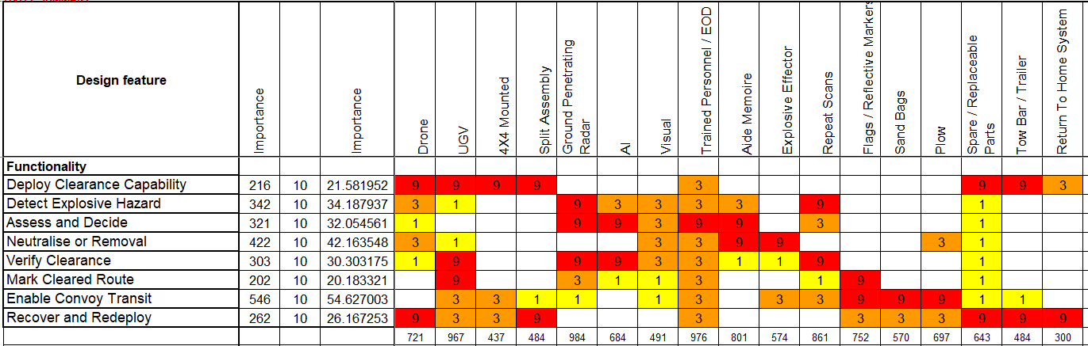
Figure 16

Figure 17
Looking at the feature importance chart, the critical design features are; the UGV, the GPR and the EOD personnel.

Manufacturing

Figure 18 shows the six most important requirements of manufacturing broken down into lesser requirements. This list was given to group 1 as a guide and assisted in understanding, in a manufacturing context, what the requirements were and how to meet them.
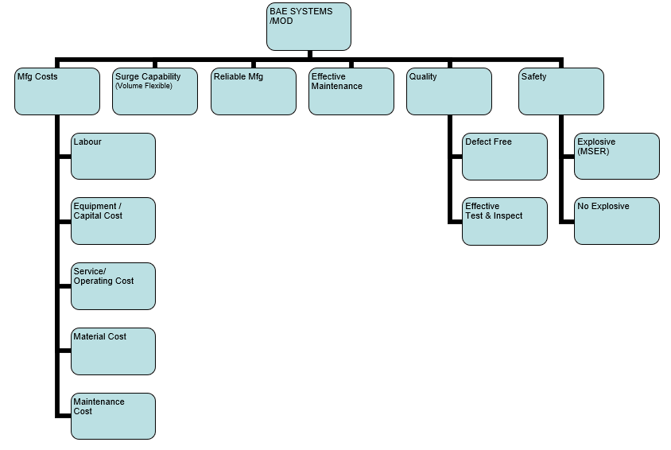
Figure 18

Figure 19 shows the process map generated by Group 1 for manufacturing. This process map was deemed too large and complex to develop within the time frame in relation to the task. As a result, a segment of the process, see figure 20, was chosen to act as an example for the entire process.
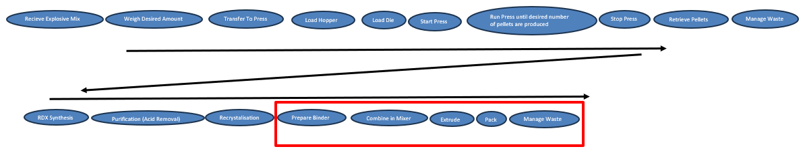
Figure 19
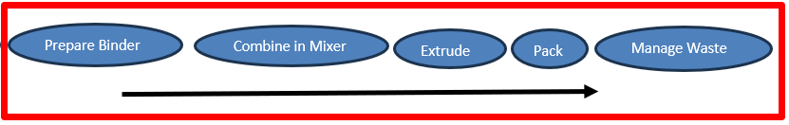
Figure 20

Critical processes

Manufacturing QFD1, figure 21, is completed to understand which processes are most important. This tool compares the manufacturing requirements to the manufacturing processes. Once this matrix is complete the design book generates the process importance chart, figure 22.
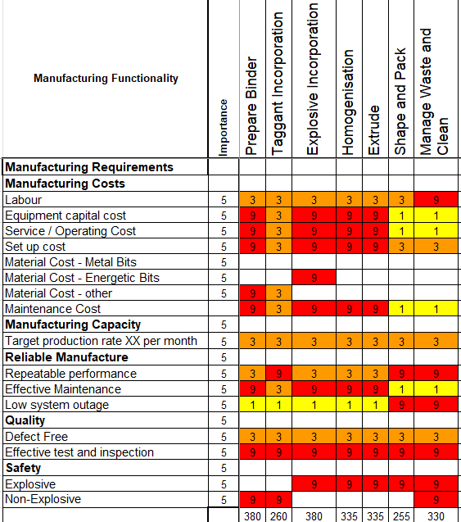
Figure 21

Figure 22
Figure 22 empirically demonstrates that explosive incorporation, preparing the binder and managing the waste/cleaning of the material are the three most important processes.

From a system safety perspective, the explosives are on paper the most dangerous part and that is reflected in the chart.

The FMA tool was used to propose methods of manufacturing for each function, figure 23 shows the proposed functions. The proposed solutions that were taken forward to the system Pugh are highlighted green. Those not highlighted were abandoned due to either, the process being not suitable, deemed unsafe or deemed too expensive

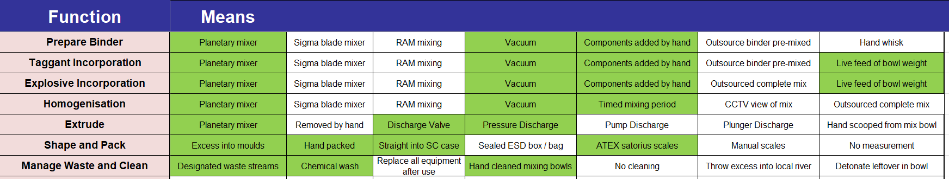
Figure 23

The system Pugh compared three ideas for manufacturing, like the original system Pugh, there was a baseline idea, and two alternatives. The control was, buying commercial explosives and packing them into the system by hand. There were also two alternatives, one was filling the shaped charge cavity with an explosive in the manufacturing process, through pressing [4]. The other alternative idea involved cast moulding the explosive fill of the shaped charge [5].

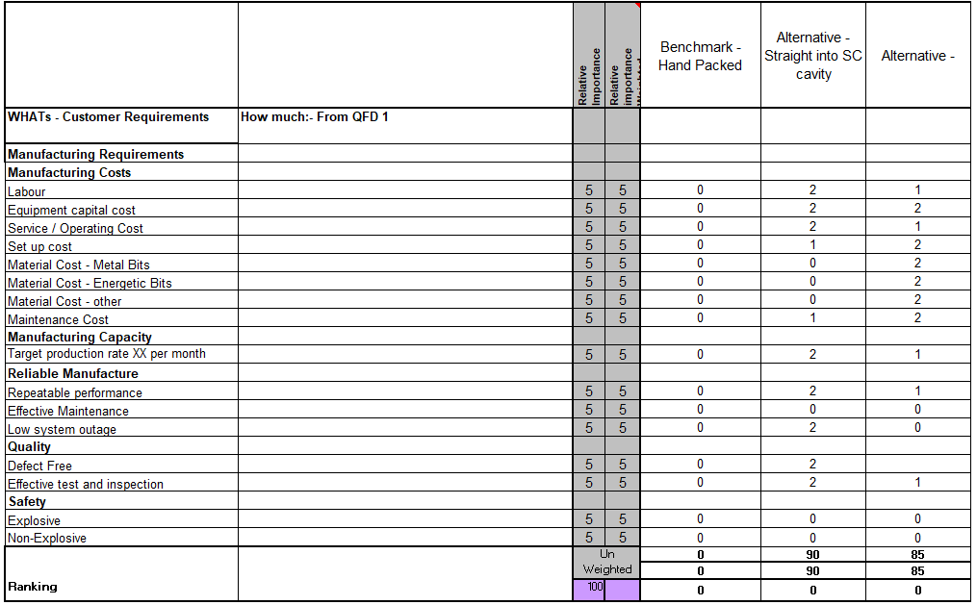
Figure 24
Figure 24 showed that alternative 1 met/exceeded the requirements better than the other solutions. As a result, QFD 2 was used to check all the required functionality was covered by at least one of the design features, see figure 25.

This tool also produces the means importance graph seen in figure 26. This graph identifies which design feature is most important. The planetary mixer is the most important design feature, this is followed by the timed mix period and mixed under a vacuum.
By applying the groups knowledge, it was identified that these processes help to ensure that the quality of the explosive is high and consistent in every batch of production. This is critical from a safety perspective.

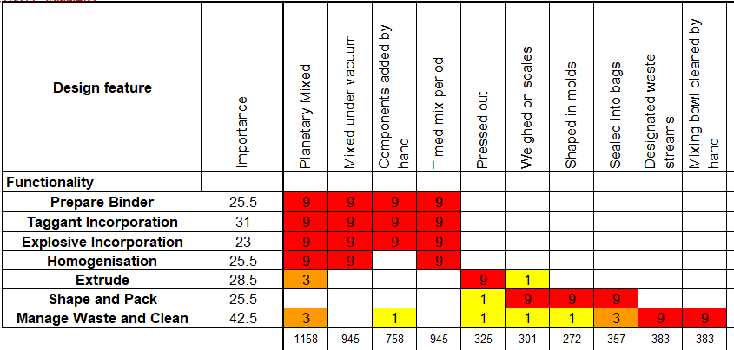
Figure 25

Figure 26

QFD3 compares the design features to the process features. This tool produces the process techniques graph that identifies how important each process is and assists in recognising the critical processes.

Figure 28 shows that preparing the binder is the most critical process. Through using the tools in the design book it is mathematically proven the binder is the most critical process. As discussed, the values in each matrix were assigned by Group 1. Figure 27 shows the relationship between design features and process features. If these relationship values were assigned incorrectly this would have a severe impact and lead to the critical process identification being wrong. This is an obvious weakness with the methodology and relies upon the team filling out the matrix to do so accurately. To ensure the group can do this accurate one way to validate the result is to have subject matter experts review the documentation and offer insight into if they agree with the proposed relationships.

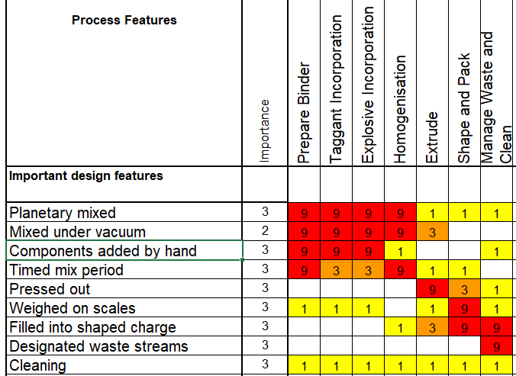
Figure 27

Figure 28

Process control measures
To ensure appropriate control measures were identified, all noises need to be identified. This was done using the P diagram and ‘What why’ matrix tool. Figure 29 shows the P diagram that was generated by group 1. This contains all the noises and the associated control factors.
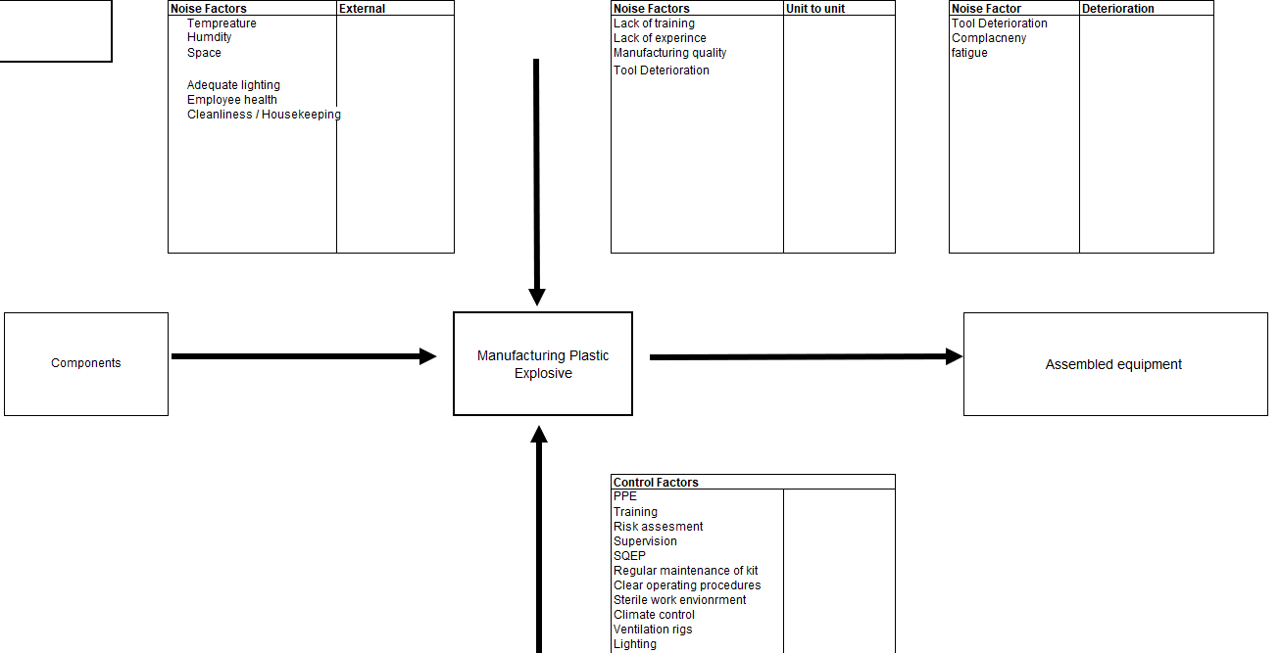
Figure 29

Figure 30 shows each noise and the relationship between it and the control factors. Completing the ‘what why’ matrix generates the key controls chart, Figure 31, and shows that training has the most important relationships with the most noises. This means it will reduce impact/likelihood of multiple noises. It is important that when allocating funding for a system appropriate funds are given to these control factors. Inadequate training will not be an effective control.

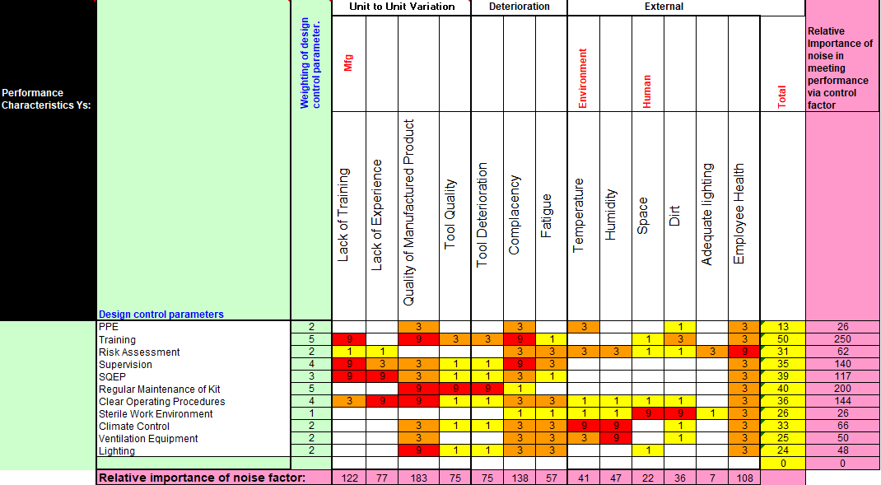
Figure 30

Figure 31
QFD4 is used to understand the relationship between process controls and the process steps. From this process, QFD4 Importances chart is generated. This displays the importance of each control measure through the entire process chain.
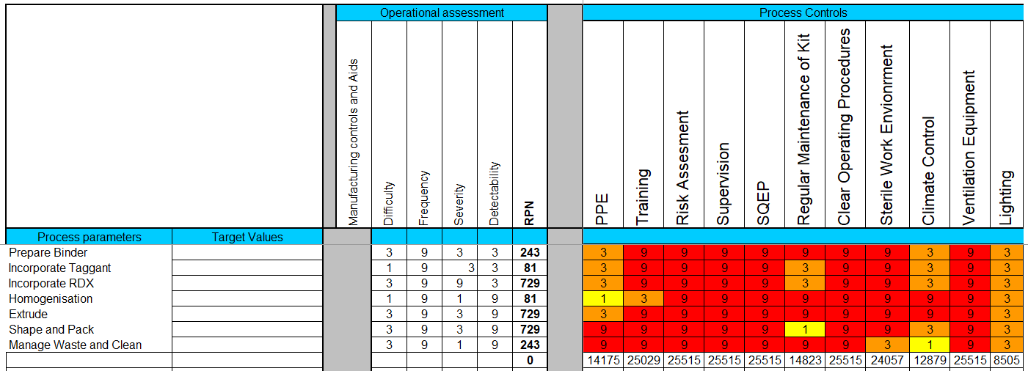
Figure 32

Figure 33
There are multiple important process control measures. The relatively high relationship between processes and process control measures demonstrates how a single control can be used across multiple processes. However, it is central that the controls which are deemed less important are still implemented as displayed in the ‘what why’ table in figure 30, it takes all the controls to properly control every noise factor.

Disposal
There was only one disposal requirement in Group 1’s original set of requirements: minimal environmental impacts during disposal. No consideration was given that the system should be safe to dispose of and is reflected in the lack of requirements. This was identified late in the design process and demonstrates that, if the people filling in these tools make mistakes, the mistake may have a large impact on the final product. As a result, an additional requirement was generated by the group: The system shall be designed to enable safe, compliant breakdown and disposal of all system components, including explosive payloads, electronic subsystems and structural elements in accordance with applicable environmental, explosive safety, and hazardous waste regulations at end of life.

This requirement better reflects the wider aspects of disposal. Based on this requirement the disposal process can be split into safety, compliance, segregation, traceability and operational availability. The initial requirements did not reference disposal, so no aspects of the system have been designed for disposal. This problem demonstrates why it is important to consider all aspects from the outset and the impact of not using the tools correctly.

QFD1 was used to compare this single requirement to the five functions generated. Figure 34 shows the five functions ranked.
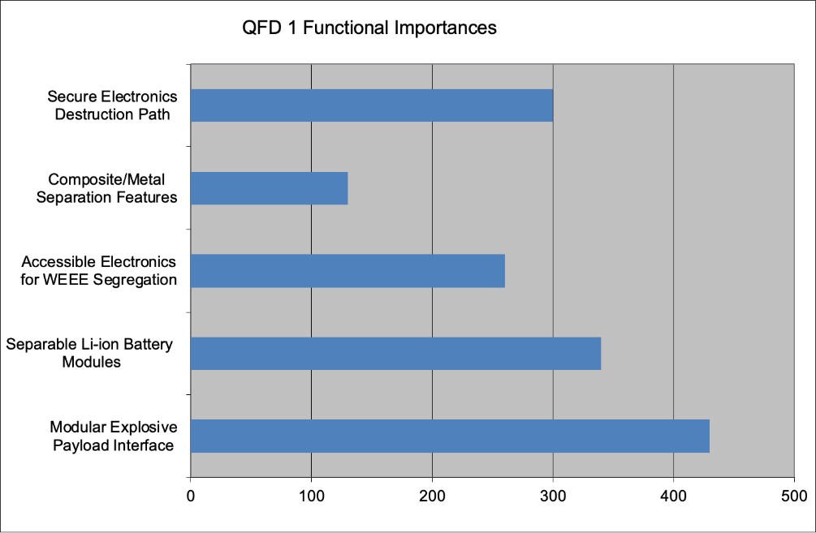
Figure 34

As a result, to ensure disposal meets the requirements, the system must have: a modular explosive payload interface, separate lithium-ion batteries, accessible electronics, secure electronics destruction path and clear material separation pathways/plans.

When comparing these features to the original design we can see the two most critical disposal features are designed into the system, a modular explosive payload interface and separate lithium-ion batteries. By coincidence the system incorporates these features and as a result the system is safe to dispose of. This demonstrates how requirements can relate and link with one another. Once materials have been selected a clear plan to safely dispose of the systems should be generated.

Conclusion

Using a SE approach the team generated a solution that can meet all the specified requirements. The tool set from the design book ensured a specific approach was taken. This approach first identified requirements, then ensured the required functionality. The process then proposed solutions and analysed them prior to any prototype being developed. This reduces the cost and time for designing a system, a valuable benefit in a major project.

The follow-on tools, help to ensure that the finalised design still meets the original requirements and that noises that could impact the system are controlled from the outset. This also applies to the tools used in the manufacturing process. These tools, although focused on one step of the process, given more time, can be expanded to the entire process and used to ensure a high-quality product is produced safely.

Without these tools there is a significant risk that the designed system may not be capable of safely solving the problem.

Group 1’s requirements lacked disposal requirements meaning it was a coincidence that the system is broadly safe to dispose of. This exemplifies that requirements should be validated by subject matter experts prior to continuing the process. Having a larger group with more experience would likely have mitigated this failure.

Using alternative tools such as the FMEA would have been a useful tool to understand the possible failures of the system. Equally, using a different SE model would have involved different processes but should have led to the same result. Ultimately by using the waterfall model the team was able to create a solution that is safe to manufacture, operate and dispose of, while also meeting the required functionality.

Bibliography

[1] | International Council of systems engineers, “About Systems Engineering,” International Council of systems engineers, [Online]. Available: https://www.incose.org/about-systems-engineering/. [Accessed 28 April 2026].
[2] | O. Bankole, R. Roy, E. Shehab and P. Wardle, “Affordability Assessment of Industrial Product-Service System in the Aerospace,” in Proceedings of the 1st CIRP Industrial Product-Service Systems (IPS2) Conference, 2009.
[3] | International council of systems engineering , “A (Breif) history of syststems engineering,” International council of systems engineering , [Online]. Available: https://www.incose.org/about-systems-engineering/. [Accessed 28 April 2026].
[4] | A. Kumar, 5. Samudre, N. Waghmare and J. Gharia, “New pressing technique for preperation of small-calibre shaped charge,” Explosives Research & Development Laboratory, vol. 21, p. 411.
[5] | Ç. Susantez, A. B and C. b, “Natural convection effects on TNT solidification inside a shaped charge mold,” Defence Technology, vol. 18, no. 9, pp. 1653-1611, 2022.
[6] | International Mine Action, “Marking explosive ordnance hazards (IMAS 08.40),” International Mine Action, 2023.
[7] | International Mine Action , “Battle area clearence,” International Mine action , 2020.
[8] | International Mine action , “Clearence requirements 09.10,” International mine action , 2020.
[9] | International mine action , “Marking explosive ordnance hazards 08.40,” International mine action , 2023.

Annex A

To generate a concept, the system Pugh tool was used. As part of this tool a control system and three alternative concepts were generated.

The control system used was BAE system’s python. This is the current system used by the British army and as a result was considered a real system that is effective at clearing a path through a mine field.

The control solution and three other solutions developed are seen below:

Solution 1(control solution):
Python – Is a rocket propelled tube that explodes and clears a path through sympathetic detonation
Solution 2:
Animal - Sniffer animal and human digging out mine to disarm / charge.
Solution 3:
Drone – A drone that has a ground penetrating radar (GPR) system mounted, scans a programmed route, marks out mines, places charges that defeat mines and a unmanned ground vehicle (UGV) that smooths over the path once the mines have been detonated.
Solution 4:
Metal Detector – A person walks through the mine field scanning for mines beneath them. When found a grappling hook is used to trigger the mines

As per figure 9, solution 3 was deemed the best solution. As a result the solution has been expanded on for the benefit of the reader. Below is the initial process/design features of concept 3.

- arrive at mine field
- Once at mine field send UAV with ground penetrating radar (GPR) forwards to scan the entire mine field
- Map out mine field
- Plot path of least resistance
- Change UAV payload and add shaped charge to clear path 8 meters wide
- Send UGV forward to flatten out path and act verification & validation.
- UGV will create a hump on edges of path with a plough on the front as it flattens the terrain
- Suitably qualified and experienced personnel walk within path placing regulation flags at intervals of 10m
- Convoy pack up equipment
- Travel through mine field

