20-40% of Police time is spent dealing with mental health calls. Are police equipped to deal with these calls and what impact does this have on the mental health of the responding officers?


The Police Federation of England and Wales (2020)

Sadie-May Mason
2204171
BMCP5003

Contents
Task 1-Mind Map 3
Task 2-Proposal Form 4
Task 3-Applicaton for Ethical Approval 6
Task 4- Justification of chosen research methods 19
Task 5- Draft of Survey Questions 20
Task 6- Evaluation of Data analysis method 21
Reference list 23

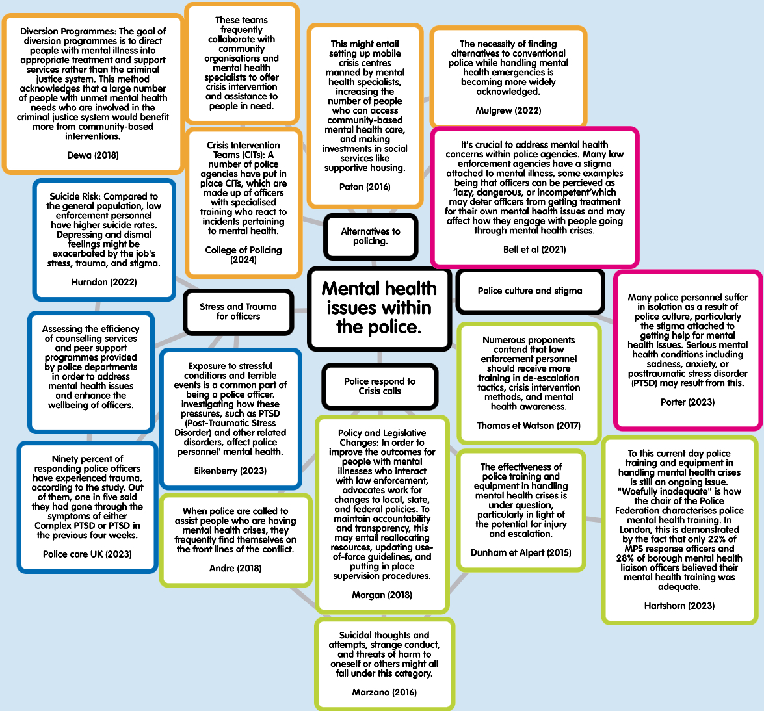
Task 1-Mind Map

Task 2-Proposal Form



UNDERGRADUATE DISSERTATION
RESEARCH PROPOSAL FORM

NAME: Sadie-May Mason | ID No.: 2204171
DRAFT RESEARCH TITLE QUESTION:

The proposed title for this research is: 20-40% of Police time is spent dealing with mental health calls. Are police equipped to deal with these calls and what impact does this have on the mental health of the responding officers?

SUMMARY OF RESEARCH AIM & OBJECTIVES:

Aim: -Critically analyse the role of police officers in supporting people in mental health crisis.
Objective 1:- Explore existing literature to identify how the police respond to issues regarding mental health.
Objective 2:- Evaluate the impact that responding to mental health incidents has on serving police officers.
Objective 3:- Critically examine the support available to the police in relation to dealing with mental health incidents.
Objective 4:- Analyse the benefit that an alternative organisation who are correctly trained to respond to mental health calls would have on the police
THEORETICAL CONTEXT:
After much debate over the article released by the guardian, regarding “Met Police to stop attending emergency mental health calls” Police have recently set the record straight regarding this. Under article 2 ‘the right to life’ local authorities should always consider a persons right to life when making decisions, and appropriate measures should be tasked in order to safe guard a life. An incident that puts someone's life in actual and immediate risk is referred to as a Threat To Life (TTL).In response, law enforcement agencies are required by Article 2 of the Human Rights Act of 1998 to take necessary measures to safeguard an individual whose life is in "real and immediate danger. “The above information means that all emergency services will always attend a call where there is threat to life, however, what the Metropolitan police were trying to state was that calls will be filtered through a stage of emergency. Not all crisis calls mean immediate risk to the
person, and some calls are of a higher severity to others.

From the 1st March 2020 to 24th January 2021, 79 officers within Dyfed Powys police service were off on ‘Mental health leave’ (this is 7% of the whole force) this is in accordance with Dyfed Powys Police (2022), in comparison with Gwent police with only 1.7 % of their officers being off due to mental health leave over the same period of time, this is an extensive number and shows that mental health is a vast issue within the police service particularly within Dyfed Powys Police. All officers that have attended a crisis, suicide or any trauma-based call are immediately referred to TRIM, TRIM stands for Trauma risk management, who an internal body within the police. Dyfed Powys Police state that:

“TRiM is reserved specifically for a peer-led programme called Trauma Risk Management, they aim to recognise traumatic stress reactions in people who have been involved in significant events and refer them for additional psychological interventions if necessary. Following an incident, employees are called by the Force Counsellor to determine their needs for counselling and/or support. This process is known as post-incident management (PIM). At this point, mental health counsel is given, and after two weeks, a follow-up assessment is conducted. Workers who find their circumstances changing at any point can self-refer to the service” Dyfed Powys Police (2021)

Over the past few years there has been and still is national UK role out within police forces called ‘Right Care, Right person’ this is according to College of policing, (2023) With this being said, it is clear that current programmes such as Oscar Kilo are clearly ineffective due to new initiatives such as Right Care Right Person being introduced. The way that police currently deal with mental health is going to change. RPRC is a police initiative that was originally formulate by Humberside police back in 2019, it is a tool kit that allows police to deal with mental health correctly in partnership with other agencies. This toolkit has been told out in 4 different phases, with North Wales police having already rolled out phases one and Dyfed Powys police expected to beginning rolling this initiative out during October 2024.
SUMMARY OF RESEARCH –SURVEY METHOD:
.Summary of quantitative methods
A quantitive research method will be used during this research as a form of a survey. Mixed methods will also be introduced into this research using both qualitative and quantitive data. Qualitative and Quantitive data will be collected by including open and closed questions within the survey. The survey will be designed by using Microsoft forms and shared via Dyfed Powys Police’s internal intranet system.



PG2 / E1 FORM

Task 3-Applicaton for Ethical Approval

RESEARCH STUDENTS
This form is to be completed by the student within SIX months for full-time students and TWELVE months for part time students, after the commencement of the research degree or following progression to Part Two of your course.

Once complete, submit this form via the MyTSD Doctoral College Portal at (https://mytsd.uwtsd.ac.uk).

This document is also available in Welsh.

RESEARCH STAFF ONLY
All communications relating to this application during its processing must be in writing and emailed to pgresearch@uwtsd.ac.uk , with the title ‘Ethical Approval’ followed by your name.

STUDENTS ON UNDERGRADUATE OR TAUGHT MASTERS PROGRAMMES should submit this form (and receive the outcome) via systems explained to you by the supervisor/module leader.

In order for research to result in benefit and minimise risk of harm, it must be conducted ethically. A researcher may not be covered by the University’s insurance if ethical approval has not been obtained prior to commencement.

The University follows the OECD Frascati manual definition of research activity: “creative work undertaken on a systematic basis in order to increase the stock of knowledge, including knowledge of man, culture and society, and the use of this stock of knowledge to devise new applications”. As such this covers activities undertaken by members of staff, postgraduate research students, and both taught postgraduate and undergraduate students working on dissertations/projects.

The individual undertaking the research activity is known as the “principal researcher”.

Ethical approval is not required for routine audits, performance reviews, quality assurance studies, testing within normal educational requirements, and literary or artistic criticism.

Please read the notes for guidance before completing ALL sections of the form.

This form must be completed and approved prior to undertaking any research activity. Please see Checklist for details of process for different categories of application.

SECTION A: About You (Principal Researcher)
1 | Full Name: |  | Sadie-May Mason
2 | Tick all boxes that apply: |  | Member of staff: | ☐ | Honorary research fellow: | ☐
 | Undergraduate Student | ☒ | Taught Postgraduate Student | ☐ | Postgraduate Research Student | ☐

3 | Institute/Academic Discipline/Centre: | University of Wales Trinity Saint David: Blue Light Academy
4 | Campus: | Swansea Business Campus
5 | E-mail address: | Sadiemaymason@gmail.com
6 | Contact Telephone Number: | 07582 297503
 | For students:
7 | Student Number: | 2204171
8 | Programme of Study: | Criminology and Policing BSc
9 | Director of Studies/Supervisor: | Laura Knight

1 | Has the research activity received approval in principle?  (please check the Guidance Notes as to the appropriate approval process for different levels of research by different categories of individual) |  | YES | ☐ | NO | ☒
 |  |  |  |  | Date
2 | If Yes, please indicate source of approval (and date where known): Approval in principle must be obtained from the relevant source prior to seeking ethical approval | Research Degrees Committee |  | ☐
2 |  | Institute Research Committee |  | ☐
2 |  | Other (write in) |  | ☐
SECTION B: Approval for Research Activity

SECTION C: Internal and External Ethical Guidance Materials
 | Please list the core ethical guidance documents that have been referred to during the completion of this form (including any discipline-specific codes of research ethics, location-specific codes of research ethics, and also any specific ethical guidance relating to the proposed methodology). Please tick to confirm that your research proposal adheres to these codes and guidelines. You may add rows to this table if needed.
1 | UWTSD Research Ethics & Integrity Code of Practice | ☒
2 | UWTSD Research Data Management Policy | ☒
3 | [List any other relevant documents here] | ☐

SECTION D: External Collaborative Research Activity
If there are external collaborators then you should gain consent from the contact persons to share their personal data with the university. If there are no external collaborators then leave this section blank and continue to section E.
1 | Institution | Dyfed Powys Police
2 | Contact person name | Sian Bamford
3 | Contact person e-mail address | Sian.Bamford@dyfed-powys.police.Uk
4 | Is your research externally funded? |  | YES | ☐ | NO |  | ☒
5 | Are you in receipt of a KESS scholarship? |  | YES | ☐ | NO |  | ☒
6 | Are you specifically employed to undertake this research in either a paid or voluntary capacity? | Voluntary | YES | ☐ | NO | ☒
7 |  | Employed | YES | ☐ | NO | ☒
8 | Is the research being undertaken within an existing UWTSD Athrofa Professional Learning Partnership (APLP)? | If YES then the permission question below does not need to be answered. | YES | ☐ | NO |  | ☒
9 | Has permission to undertake the research has been provided by the partner organisation? | (If YES attach copy)  If NO the application cannot continue | YES | ☒ | NO |  | ☐
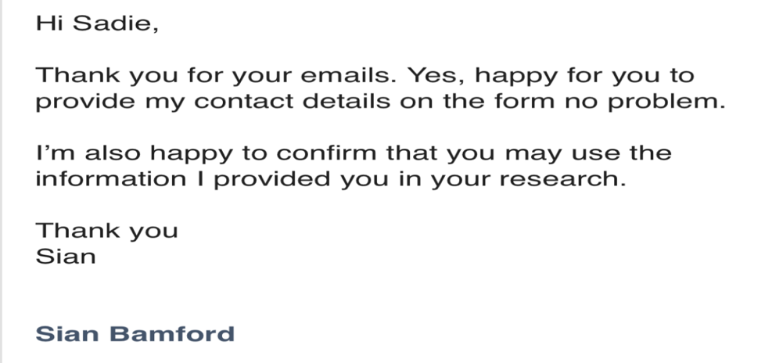

Where research activity is carried out in collaboration with an external organisation
10 | Does this organisation have its own ethics approval system? | YES | ☐ | NO | ☒
 | If Yes, please attach a copy of any final approval (or interim approval) from the organisation (this may be a copy of an email if appropriate).

SECTION E: Details of Research Activity
1 | Indicative title: | 20-40% of Police time is spent dealing with mental health calls. Are police equipped to deal with these calls and what impact does this have on the mental health of the responding officers?
2 | Proposed start date: | 30/09/24 | Proposed end date: | 05/25
3 | Purpose of Research Activity  As a general subject, mental health is something that many people feel extremely passionate about. This research is something that most definitely needs more awareness. It is heard a lot in the media that both police services and the NHS are struggling with the demand that the issue of mental health opposes upon these organisations. According to Foster (2020), the West Midlands Police and crime commissioner, 20-40% of Police time, is spent dealing with mental health calls. A specific area under this topic that this research will show is what impact and input do the police service have:  - When attending calls  - What is the effect of officers personally after attending traumatic calls.  Is there support for officers who perhaps are not trained correctly within the mental health field, but due to such high demand of mental health calls they have to attend under Section 2 of the Human rights act according to Horan (2021).
4 | Research Question  20-40% of Police time is spent dealing with mental health calls. Are police equipped to deal with these calls and what impact does this have on the mental health of the responding officers?
5 | Aims of Research Activity  Critically analyse the role of police officers in supporting people in mental health crisis.
6 | Objectives of Research Activity  Objective 1:- Explore existing literature to identify how the police respond to issues regarding mental health.  Objective 2:- Evaluate the impact that responding to mental health incidents has on serving police officers.  Objective 3:- Critically examine the support available to the police in relation to dealing with mental health incidents.  Objective 4:- Analyse the benefit that an alternative organisation who are correctly trained to respond to mental health calls would have on the police
 | Proposed methods (maximum 600 words)
7 | Proposed methods of research for this study will include both primary and secondary research. However, secondary research will only be slightly touched upon with this just making up a small part of the research, that being a literature review. Primary research will take its form through questionnaires and interviews. The questionnaire method of research will include mixed methods, due to open and closed questions. Interviews that take place should collect qualitative data. Data analysis will also be used when looking at the small amount of quantitive data received from the questionnaires. The use of methods such as calculating median, mode etc These proposed methods may face some limitations however, due to issues such as access to participants, participant completion and participant numbers.
 | Location of research activity
8 | Wales-Dyfed Powys police service.
Research activity outside of the UK
If research activity will take place overseas, you are responsible for ensuring that local ethical considerations are complied with and that the relevant permissions are sought. Specify any local guidelines (e.g. from local professional associations/learned societies/universities) that exist and whether these involve any ethical stipulations beyond those usual in the UK (provide details of any licenses or permissions required). Also specify whether there are any specific ethical issues raised by the local context in which the research activity is taking place, for example, particular cultural and/or legal sensitivities or vulnerabilities of participants. If you live in the country where you will do the research then please state this.
9 | N/A

10 | Use of documentation not in the public domain: Are any documents NOT publicly available? | NO | ☒
10 |  | YES | ☐

 | Does your research relate to one or more of the seven aims of the Well-being of Future Generations (Wales) Act 2015? | YES | NO
12 | A prosperous Wales | ☐ | ☒
13 | A resilient Wales | ☒ | ☐
14 | A healthier Wales | ☒ | ☐
15 | A more equal Wales | ☐ | ☒
16 | A Wales of cohesive communities | ☐ | ☒
17 | A Wales of vibrant culture and thriving Welsh language | ☐ | ☒
18 | A globally responsible Wales | ☒ | ☐
19 | If YES to any of the above, please give details:
 | The goal of the Well-being of Future Generations (Wales) Act is to enhance Wales's cultural, social, economic, and environmental well-being- The research will relate to this aim as it will raise awareness of social well-being. The research conducted will do this by looking into the reasons why mental health within a profession is so stigmatised and what steps and interventions are available to prevent this.

SECTION F: Scope of Research Activity

 | Will the research activity include: | YES | NO
1 | Use of a questionnaire or similar research instrument? | ☒ | ☐
2 | Use of interviews? | ☒ | ☐
3 | Use of focus groups? | ☐ | ☒
4 | Use of participant diaries? | ☐ | ☒
5 | Use of video or audio recording? | ☐ | ☒
6 | Use of computer-generated log files? | ☐ | ☒
7 | Participant observation with their knowledge? | ☐ | ☒
8 | Participant observation without their knowledge? | ☐ | ☒
9 | Access to personal or confidential information without the participants’ specific consent? | ☐ | ☒
10 | Administration of any questions, test stimuli, presentation that may be experienced as physically, mentally or emotionally harmful / offensive? | ☒ | ☐
11 | Performance of any acts which may cause embarrassment or affect self-esteem? | ☐ | ☒
12 | Investigation of participants involved in illegal activities? | ☐ | ☒
13 | Use of procedures that involve deception? | ☐ | ☒
14 | Administration of any substance, agent or placebo? | ☐ | ☒
15 | Working with live vertebrate animals? | ☐ | ☒
16 | Procedures that may have a negative impact on the environment? | ☐ | ☒
17 | Other primary data collection methods. Please indicate the type of data collection method(s) below. | ☒ | ☐
 | Details of any other primary data collection method:  An interview will include high rank officers within the police, as well as a questionnaire aimed at frontline officers that will be based on police perception. | ☒ | ☐

If NO to every question, then the research activity is (ethically) low risk and may be exempt from some of the following sections (please refer to Guidance Notes).

If YES to any question, then no research activity should be undertaken until full ethical approval has been obtained.

SECTION G: Intended Participants
If there are no participants then do not complete this section, but go directly to section H.

 | Who are the intended participants: | YES | NO
1 | Students or staff at the University? | ☐ | ☒
2 | Adults (over the age of 18 and competent to give consent)? | ☒ | ☐
3 | Vulnerable adults? | ☐ | ☒
4 | Children and Young People under the age of 18? (Consent from Parent, Carer or Guardian will be required) | ☐ | ☒
5 | Prisoners? | ☐ | ☒
6 | Young offenders? | ☐ | ☒
7 | Those who could be considered to have a particularly dependent relationship with the investigator or a gatekeeper? | ☐ | ☒
8 | People engaged in illegal activities? | ☐ | ☒
9 | Others. Please indicate the participants below, and specifically any group who may be unable to give consent. | ☐ | ☒
 | Details of any other participant groups:  (this box should expand as you type) | ☐ | ☒

Participant numbers and source
Provide an estimate of the expected number of participants. How will you identify participants and how will they be recruited?
10 | How many participants are expected? | Around 50-100 participants regarding the questionnaire  Around 3 high rank officers to interview.
11 | Who will the participants be? | Frontline officers from Dyfed Powys Police  High ranked Officers from Dyfed Powys Police
12 | How will you identify the participants? | Anonymity of the frontline officers will be kept when dealing with the questionnaire, the participants will be recruited through Dyfed Powys Police posting a survey onto their internal software called Intranet  Participants of the interview will be identified by requesting to speak to officers through the director of mental health within Dyfed Powys police.

 | Information for participants: | YES | NO | N/A
13 | Will you describe the main research procedures to participants in advance, so that they are informed about what to expect? | ☒ | ☐ | ☐
14 | Will you tell participants that their participation is voluntary? | ☒ | ☐ | ☐
15 | Will you obtain written consent for participation? | ☒ | ☐ | ☐
16 | Will you explain to participants that refusal to participate in the research will not affect their treatment or education (if relevant)? | ☐ | ☐ | ☒
17 | If the research is observational, will you ask participants for their consent to being observed? | ☐ | ☐ | ☒
18 | Will you tell participants that they may withdraw from the research at any time and for any reason? | ☒ | ☐ | ☐
19 | With questionnaires, will you give participants the option of omitting questions they do not want to answer? | ☒ | ☐ | ☐
20 | Will you tell participants that their data will be treated with full confidentiality and that, if published, it will not be identifiable as theirs? | ☒ | ☐ | ☐
21 | Will you debrief participants at the end of their participation, in a way appropriate to the type of research undertaken? | ☒ | ☐ | ☐
22 | If NO to any of above questions, please give an explanation
 | (this box should expand as you type)

 | Information for participants: | YES | NO | N/A
24 | Will participants be paid? | ☐ | ☒ | ☐
25 | Is specialist electrical or other equipment to be used with participants? | ☐ | ☒ | ☐
26 | Are there any financial or other interests to the investigator or University arising from this study? | ☐ | ☒ | ☐
27 | Will the research activity involve deliberately misleading participants in any way, or the partial or full concealment of the specific study aims? | ☐ | ☒ | ☐
28 | If YES to any question, please provide full details

SECTION H: Anticipated Risks

Outline any anticipated risks that may adversely affect any of the participants, the researchers and/or the University, and the steps that will be taken to address them.

If you have completed a full risk assessment (for example as required by a laboratory, or external research collaborator) you may append that to this form.
1 | Full risk assessment completed and appended? |  | Yes | ☒
1 |  |  | No | ☐
2 | Risks to participants  For example: sector-specific health & safety, emotional distress, financial disclosure, physical harm, transfer of personal data, sensitive organisational information
 | Risk to participants:  Sensitive content within the questionnaire such as mention of suicide. | How you will mitigate the risk to participants:  Ensure that a warning is also posted as a blurb to the questionnaire, to ensure that participants are aware of the sensitive content before opting to complete it.
3 | If research activity may include sensitive, embarrassing or upsetting topics (e.g. sexual activity, drug use) or issues likely to disclose information requiring further action (e.g. criminal activity), give details of the procedures to deal with these issues, including any support/advice (e.g. helpline numbers) to be offered to participants. Note that where applicable, consent procedures should make it clear that if something potentially or actually illegal is discovered in the course of a project, it may need to be disclosed to the proper authorities
Procedures to deal with these issues if anyone is affected by the questionnaire, will include a helpline : Samaritans: 116 123

Or text SHOUT to 85258

4 | Risks to the investigator  For example: personal health & safety, physical harm, emotional distress, risk of accusation of harm/impropriety, conflict of interest
 | Risk to the investigator:  Due to sensitive content, it may have an impact on the emotional welfare of the investigator. | How you will mitigate the risk to the investigator:  Ensure that if the content of the research affects the investigator, professional help is received.
5 | University/institutional risks  For example: adverse publicity, financial loss, data protection
 | Risk to the University:  Data Protection | How you will mitigate the risk to the University:  Ensure that all data collected is kept securely and confidentially using encrypted folders on secure devices.
6 | Environmental  risks  For example: accidental spillage of pollutants, damage to local ecosystems
 | Risk to the environment:  Use of paper could risk the environment due to deforestation | How you will mitigate the risk to environment:  Ensure that surveys are filled out online where possible, however in some circumstances, a paper copy maybe needed.

 | Disclosure and Barring Service
 | If the research activity involves children or vulnerable adults, a Disclosure and Barring Service (DBS) certificate must be obtained before any contact with such participants. | YES | NO | N/A
7 | Does your research require you to hold a current DBS Certificate? | ☐ | ☒ | ☐

SECTION I: Feedback, Consent and Confidentiality

1 | Feedback  What de-briefing and feedback will be provided to participants, how will this be done and when?
 | Feedback will include a helpline to the Samaritans in search the content of the questionnaire has affected the participants. This will be done through a social media post (Social media account will be active and personal)
2 | Informed consent  Describe the arrangements to inform potential participants, before providing consent, of what is involved in participating. Describe the arrangements for participants to provide full consent before data collection begins. If gaining consent in this way is inappropriate, explain how consent will be obtained and recorded in accordance with prevailing data protection legislation.
A disclaimer will be attached to the post including that fact that participants can withdraw from the questionnaire at any time by closing the tab before submitting.

Regarding the interview, officers will generate a ‘false identity’ so if participation of an interview/information given in the interview is no longer wanting to be shared, the ‘false identity’ will allow for the correct information to be removed from the research.

3 | Confidentiality / Anonymity  Set out how anonymity of participants and confidentiality will be ensured in any outputs. If anonymity is not being offered, explain why this is the case.
Regarding the questionnaire, they will be completed with no mention of Names only age ranges.

Regarding the interview, officers are to give ‘false identity’s’ so that personal names are not used.

SECTION J: Data Protection and Storage

 | Does the research activity involve personal data (as defined by the General Data Protection Regulation 2016 “GDPR” and the Data Protection Act 2018 “DPA”)? | YES | NO
1 | “Personal data” means any information relating to an identified or identifiable natural person (‘data subject’). An identifiable natural person is one who can be identified, directly or indirectly, in particular by reference to an identifier such as a name, an identification number, location data, an online identifier or to one or more factors specific to the physical, physiological, genetic, mental, economic, cultural or social identity of that natural person. Any video or audio recordings of participants is considered to be personal data. | ☐ | X
 | If YES, provide a description of the data and explain why this data needs to be collected:
2 | (this box should expand as you type)
 | Does it involve special category data (as defined by the GDPR)? | YES | NO
3 | “Special category data” means sensitive personal data consisting of information as to the data subjects’ –  (a) racial or ethnic origin,  (b) political opinions,  (c ) religious beliefs or other beliefs of a similar nature,  (d) membership of a trade union (within the meaning of the Trade Union and Labour Relations (Consolidation) Act 1992),  (e) physical or mental health or condition,  (f) sexual life,  (g) genetics,  (h) biometric data (as used for ID purposes), | X | ☐
 | If YES, provide a description of the special category data and explain why this data needs to be collected:
4 | Physical or mental health condition, participants of the questionnaire and interview may disclose that they have/are suffering with mental health problems. This data needs to be collected in order to see how the work officers are conducting on the frontline is affecting them mentally.

 | Will data from the research activity (collected data, drafts of the thesis, or materials for publication) be stored in any of the following ways? | YES | NO
5 | Manual files (i.e. in paper form)? | ☒ | ☐
6 | University computers? | ☐ | ☒
7 | Private company computers? | ☐ | ☒
8 | Home or other personal computers? | ☒ | ☐
9 | Laptop computers/ CDs/ Portable disk-drives/ memory sticks? | ☒ | ☐
10 | “Cloud” storage or websites? | ☒ | ☐
11 | Other – specify: | ☐ | ☒
12 | For all stored data, explain the measures in place to ensure the security of the data collected, data confidentiality, including details of backup procedures, password protection, encryption, anonymisation and pseudonymisation:
 | (this box should expand as you type)

 | Data Protection
 | Will the research activity involve any of the following activities: | YES | NO
13 | Electronic transfer of data in any form? | ☒ | ☐
14 | Sharing of data with others at the University outside of the immediate research team? | ☐ | ☒
15 | Sharing of data with other organisations? | ☐ | ☒
16 | Export of data outside the UK or importing of data from outside the UK? | ☐ | ☒
17 | Use of personal addresses, postcodes, faxes, emails or telephone numbers? | ☐ | ☒
18 | Publication of data that might allow identification of individuals? | ☐ | ☒
19 | Use of data management system? | ☐ | ☒
20 | Data archiving? | ☐ | ☒
21 | If YES to any question, please provide full details, explaining how this will be conducted in accordance with the GDPR and Data Protection Act (2018) (and any international equivalents, where appropriate):
 | Electronic transfer of data will be made between myself (The researcher) and the University for marking and grading purposes, however, this will all be conducted under GDPR and Data Protection Act (2018), by ensuring that all sensitive and confidential data is handled within password code/protected files.
22 | List all who will have access to the data generated by the research activity:
Sadie Mason- Researcher (myself)
UWTSD- Upon request
23 | List who will have control of, and act as custodian(s) for, data generated by the research activity:
 | Sadie Mason (myself)
24 | Give details of data storage arrangements, including security measures in place to protect the data, where data will be stored, how long for, and in what form. Will data be archived – if so how and if not why not.
 | Password protected documents, data held on one device only, data will be stored for as long as required (this will be in the disclosure of questionnaire and interview)
25 | Please indicate if your data will be stored in the UWTSD Research Data Repository (see https://researchdata.uwtsd.ac.uk/ ). If so please explain. (Most relevant to academic staff)
 | N/A
26 | Confirm that you have read the UWTSD guidance on data management (see https://www.uwtsd.ac.uk/library/research-data-management/) | YES | ☒
27 | Confirm that you are aware that you need to keep all data until after your research has completed or the end of your funding | YES | ☒

SECTION K: Declaration
The information which I have provided is correct and complete to the best of my knowledge. I have attempted to identify any risks and issues related to the research activity and acknowledge my obligations and the rights of the participants.

In submitting this application I hereby confirm that I undertake to ensure that the above named research activity will meet the University’s Research Ethics and Integrity Code of Practice which is published on the website: https://www.uwtsd.ac.uk/research/research-ethics/
1 | Signature of applicant: |  | Date: 26/02/24

For STUDENT Submissions:
2 | Director of Studies/Supervisor: |  | Date:
3 | Signature: |  | Date:

For STAFF Submissions:
4 | Academic Director/ Assistant Dean: |  | Date:
5 | Signature: |  | Date:

Checklist: Please complete the checklist below to ensure that you have completed the form according to the guidelines and attached any required documentation:
☒ | I have read the guidance notes supplied before completing the form.
☒ | I have completed ALL RELEVANT sections of the form in full.
☒ | I confirm that the research activity has received approval in principle
☒ | I have attached a copy of final/interim approval from external organisation (where appropriate)
☒ | I have attached a full risk assessment (where appropriate) ONLY TICK IF YOU HAVE ATTACHED A FULL RISK ASSESSMENT
☒ | I understand that it is my responsibility to ensure that the above named research activity will meet the University’s Research Ethics and Integrity Code of Practice.
☒ | I understand that before commencing data collection all documents aimed at respondents (including information sheets, consent forms, questionnaires, interview schedules etc.) must be confirmed by the DoS/Supervisor, module tutor or Academic Director.

Task 4- Justification of chosen research methods

For several reasons, a questionnaire is among the greatest methods for research. First, confidentiality and anonymity when using questionnaires, police officers might feel more comfortable sharing private information about their mental health, especially if they can stay anonymous. This may result in more truthful responses and a clearer picture of the actual extent of mental health problems among the force's personnel. Also, a questionnaire can be scaled up or down to accommodate a big number of police officers at once, which makes it an effective method of collecting data from a sizable sample. When researching mental health concerns that could affect a sizable section of the police force, this scalability is essential.

Furthermore, consistency in the data collection process can be maintained by employing standardised questionnaires. This makes it simpler to compare outcomes over time inside the police force as well as between various police departments or geographical areas. Additionally, questionnaires provide useful data for quantitative analysis. Police officers' mental health problems can be quantified by questionnaire responses, which makes it possible to use statistical analysis to find patterns, correlations, and trends. Evidence-based initiatives and policies can benefit from the useful insights obtained from this quantitative approach. Finally, a questionnaire offers good accessibility as well. In contrast to alternative techniques like focus groups or interviews, questionnaires can be sent and completed more easily. This accessibility can guarantee that a wide range of viewpoints are represented in the research and can raise participation rates.

Although questionnaires have their advantages, it's possible that they don't fully reflect the complexity of mental health problems among police personnel. Thus, in order to obtain a more comprehensive picture of officers' experiences and viewpoints, it may be beneficial to supplement questionnaire data with qualitative techniques like focus interviews. When utilising questionnaires to explore sensitive areas like mental health, it ought to additionally consider ethical factors into account, such as securing informed consent and safeguarding participant privacy and confidentiality.

Task 5- Draft of Survey Questions – Please click on the photo for access to the survey


This Photo by Unknown Author is licensed under CC BY-SA

Task 6- Evaluation of Data analysis method
The best suited data analysis method for this research is that of Thematic analysis of data. One of the benefits of thematic analysis is its adaptability. It lets you investigate the depth and complexity of your study issue without imposing predetermined categories or assumptions on the data. Regarding mental health support in law enforcement, this flexibility allows you to document a broad spectrum of experiences, viewpoints, and difficulties that officers and support worker’s encounter. The researcher will be able to include personal narratives, like John's experience, which was published by Mind Mental Health Charity (2019), in the research thanks to this data analysis method.

Thematic data analysis facilitates comprehensive investigation. Mental health support in law enforcement is a complex and multidimensional matter. A thorough examination of the data is made possible by thematic analysis, which enables the researcher to identify several themes, patterns, and sub-themes pertaining to mental health support. This approach promotes a thorough comprehension of the intricacies involved, encompassing cultural norms, organisational structures, personal experiences, and systemic obstacles. This advantage will be useful in the analysis of survey data and in connecting the gathered information to fulfil the goals and objectives of the study.

The inductive methodology of thematic analysis means that topics are not forced by pre-existing theories or frameworks, but rather arise naturally from the data. Researching a subject like mental health support inside the police force is especially beneficial because the realities on the ground may not be fully captured by current theories or models. Thematic analysis guarantees that your findings are based on the real-world experiences of police officers and support staff by letting themes naturally emerge from the data. This can then be used to potentially help with the development of new police programmes like Right Care, Right Person, which is being implemented by the Police Federation of England and Wales (2020).

Researchers with varied degrees of experience and competence can benefit from thematic analysis because it is simple to understand and apply. Because it doesn't involve sophisticated statistical or technical knowledge, it's especially appropriate for qualitative research in fields like criminology, sociology, and psychology. This accessibility guarantees that a wide audience may access your research on mental health support provided by the police department and that it will contribute to well-informed conversations on the subject.

For instance, Trauma Risk Management, or TRiM, is a welfare-led process created to assess an employee's (including members of specific related groups such as special constables) response to a potentially traumatic incident, according to The Kent Police Service (2023). But it has been evident from study that there is a lack of information about the services and training that law enforcement officials have access to before an incident. The researcher can freely examine data acquired from quantitative (surveys) and qualitative (interviews and target groups) sources by employing the theme approach of data analysis, as it does not impose a formal framework that would restrict study in particular areas.

Reference list

Andre , C. (2018) Policing and mental health: Picking up the pieces, HMICFRS. Available at: https://assets-hmicfrs.justiceinspectorates.gov.uk/uploads/policing-and-mental-health-picking-up-the-pieces.pdf (Accessed: 17 April 2024).
Bell , S., Palmer-Conn, S. and Kealy , N. (2021) Mental illness-related stigma in healthcare: Barriers to access and care and evidence-based solutions - Stephanie Knaak, Ed Mantler, Andrew Szeto, 2017, Sage Journals . Available at: https://journals.sagepub.com/doi/full/10.1177/0840470416679413 (Accessed: 17 April 2024).
College of Policing (2024) Crisis intervention teams (CITS), College of Policing. Available at: https://www.college.police.uk/research/crime-reduction-toolkit/crisis-intervention-teams-cits (Accessed: 17 April 2024).
College of Policing , T. (2023) Right care right person (RCRP) national guidance launched | college ..., Right Care Right Person (RCRP) national guidance launched. Available at: https://www.college.police.uk/article/rcrp-national-guidance-launched (Accessed: 19 February 2024).
College of Policing , T. (2024) Services overview, Oscar Kilo. Available at: https://www.oscarkilo.org.uk/services-overview#:~:text=Oscar%20Kilo%2C%20the%20National%20Police,needs%20of%20officers%20and%20staff . (Accessed: 17 April 2024).
Dewa, C.S. et al. (2018) Evidence for the effectiveness of police-based pre-booking diversion programs in decriminalizing mental illness: A systematic literature review, PLOS ONE. Available at: https://journals.plos.org/plosone/article?id=10.1371%2Fjournal.pone.0199368 (Accessed: 17 April 2024).
Dodd, V. (2023) Met police to stop attending emergency mental health calls, The Guardian. Available at: https://www.theguardian.com/uk-news/2023/may/28/met-police-to-stop-attending-emergency-mental-health-calls (Accessed: 19 February 2024).
Dunham, R.G., Alpert, G.P. and McLean, K.D. (2021) Critical issues in policing: Contemporary readings. Long Grove, IL, United Kingdom : Waveland Press, Inc.
Eikenberry, J. (2023) Stress and trauma among police officers: Implications ... - sage journals, Stress and trauma among Police officers . Available at: https://journals.sagepub.com/doi/full/10.1177/14733250231214512 (Accessed: 12 February 2024).
Foster , S. (2020) Predicting the volume of demand from mental health related police incidents, West Midlands Police and Crime Commissioner . Available at: https://www.westmidlands-pcc.gov.uk/wp-content/uploads/2021/02/14122020-EC-Agenda-Item-5c-Mental-Health-Deman-Investigation.pdf?x53331 (Accessed: 13 February 2024).
Hartshorn , S. (2023) Written Evidence Submitted By Police Federation , Committees Parliament UK. Available at: https://committees.parliament.uk/writtenevidence/18359/html/ (Accessed: 17 April 2024).
Horan , J. (2021) Article 2: Right To Life, Article 2: Right to life | EHRC. Available at: https://www.equalityhumanrights.com/human-rights/human-rights-act/article-2-right-life (Accessed: 13 February 2024).
Hurndon , J. (2019) ‘International Criminal Police Organization (INTERPOL)’, The SAGE Encyclopedia of Criminal Psychology [Preprint]. doi:10.4135/9781483392240.n220.
Jackman , P. (2020) The relationship between psychological wellbeing, social support, and personality in an English police force, Sage Journals . Available at: https://journals.sagepub.com/ (Accessed: 04 March 2024).
Kent Police Service , T. (2023) Trauma risk incident management (TRIM) protocol (L11260) | Kent police, Kent Police UK. Available at: https://www.kent.police.uk/foi-ai/kent-police/Policy/human-resources/trauma-risk-incident-management-trim-protocol-l11260 / (Accessed: 15 April 2024).
Marzano, L. (2016) Police and suicide prevention, Crisis. Available at: https://econtent.hogrefe.com/doi/abs/10.1027/0227-5910/a000381?journalCode=cri (Accessed: 12 February 2024).
Mind mental health charity (2019) How support for Mental Health makes a difference in the police service - john’s story, YouTube. Available at: https://youtu.be/NK8gy02dpjE?si=cHq684aIHxmuJ_SQ (Accessed: 19 February 2024).
Morgan, M. and Paterson, C. (2017) ‘it’s mental health, not mental police’: A human rights approach to Mental Health Triage and section 136 of the mental health act 1983, OUP Academic. Available at: https://academic.oup.com/policing/article-abstract/13/2/123/4096708?redirectedFrom=PDF&casa_token=68rX5GeU4okAAAAA%3AeNgO5imyxQeCfc8p6H7l8RgvniXUTwTBBHdPHCiqwvRVbaCtEb7puBxFuQMeiHD_huE3uJa0s9c2dow (Accessed: 17 April 2024).
Mulgrew, L. (2022) Co-responding police and mental health service models: an exploration of how effective collaborative models are in responding to individuals experiencing a mental health crisis, MAG Online library . Available at: https://www.magonlinelibrary.com/doi/abs/10.12968/bjmh.2015.4.5.206 (Accessed: 17 April 2024).
Paton, F. et al. (2016) Improving outcomes for people in mental health crisis: A rapid synthesis of the evidence for available models of care, Improving outcomes for people in mental health crisis: a rapid synthesis of the evidence for available models of care. Available at: https://openaccess.city.ac.uk/id/eprint/14163/ (Accessed: 17 April 2024).
Police care UK, T. (2023) The job the life - police care UK, The job life . Available at: https://www.policecare.org.uk/research-article/the-job-the-life/ (Accessed: 12 February 2024).
Police Federation of England and Wales , T. (2020) Police officers’ mental health focus of new campaign, Police Federation. Available at: https://www.polfed.org/news/latest-news/2020/police-officers-mental-health-focus-of-new-campaign/ (Accessed: 13 February 2024).
Porter , C. and Lee, R. (2023) (PDF) The policing culture: An exploration into the mental ..., Research Gate . Available at: https://www.researchgate.net/publication/369116485_The_policing_culture_an_exploration_into_the_mental_health_of_former_British_police_officers (Accessed: 17 April 2024).
Thomas, S. and Watson, A. (2017) A focus for mental health training for police, Journal of Criminological Research, Policy and Practice. Available at: https://www.emerald.com/insight/content/doi/10.1108/JCRPP-01-2017-0005/full/html (Accessed: 17 April 2024).
West Midlands Police force , T. (2020) Westmidlands-PCC, Predicting the Volume of Demand from Mental Health Related Police Incidents. Available at: https://www.westmidlands-pcc.gov.uk/wp-content/uploads/2021/02/14122020-EC-Agenda-Item-5c-Mental-Health-Deman-Investigation.pdf (Accessed: 04 March 2024).

