Empire State Building

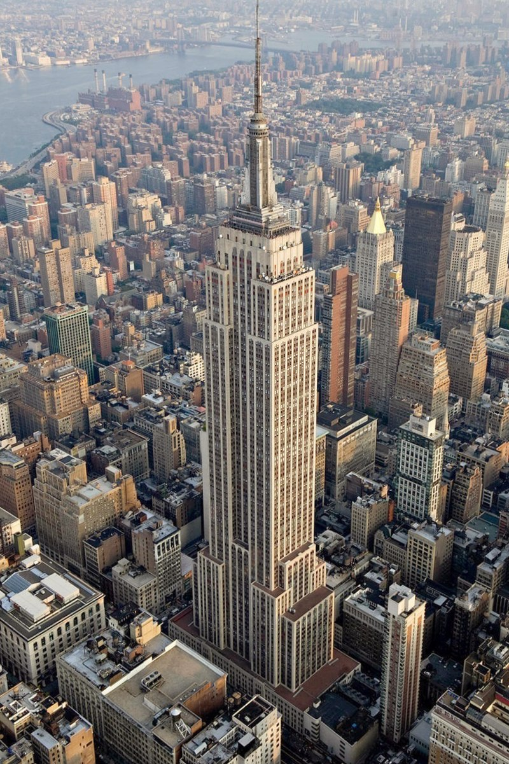
By Joseph Lewis 2414282

Introduction
In this report I will be talking about the Empire State Building located in Midtown, New York. I will cover various aspects of the building such as history of the building, construction methods and significance of the building in the modern world. I have chosen to do this building because it is recognisable worldwide and has become a national symbol of the United States since its construction in 1931. The purpose of this report is to make people aware of the impact of the building and explain its significance in terms of technology and culture.

What is the Empire State Building?
The Empire State Building is an art-deco style building constructed in the heart of New York City in the United States. It was completed in 1931 and at the time of its construction was the tallest building in the world. The building has 102 floors and was the first structure to surpass 100 floors. Since its construction, it has been visited yearly by millions of people and continues to be a global symbol of New York.
(Empire State - Wikipedia, nd)

Design & Construction
The building was designed by Shreve, Lamb & Harmon, an architectural company best known for this building, and contracted to Starrett Brothers and Eken for the construction.
Construction of the Empire State Building was a significant engineering feat at the time that combined new technologies with precise planning and traditional craftsmanship. The building utilises a steel frame skeleton with Limestone, granite and polished metal covering it. Set on a solid bedrock foundation, which allows the building to be the size and weight that it is, the building sits on a series of large concrete boxes that are sunk into the ground to bedrock level, helping keep the buildings stability. The buildings design allows a very high wind resistance which is unusual for a building of this height. This is due to the steel frame having diagonal bracing. Construction had begun before the design phase had been completed due to the tight schedule that was proposed to construct the building
Between floors 86 and 102 there is a spire which is the main piece of the building. This effectively allowed the building to become a broadcasting hub for radio stations. The spire was planned to be a mooring mast for zeppelins and airships but, because of the building’s height, wind speeds were very high, so this became impossible and was scrapped. (Empire State - Wikipedia, nd)

Construction Methods
Construction of the Empire State Building started in March 1930 and would continue until May 1931. Advanced building techniques and a highly skilled workforce allowed the building to open 45 days before projection. Large cranes were constructed to be able to lift the steel frame up to the required heights and manual methods of fixing them together were implemented. Concrete floors are present inside the building on all floors and were all constructed in sections alongside the steel frame surrounding them.
The building is also famous for its elevator system. It has 73 elevators located in a central lift core and each go to various levels of the building, the longest reaching from ground level to the 80th floor. (Empire State – Wikipedia, nd)

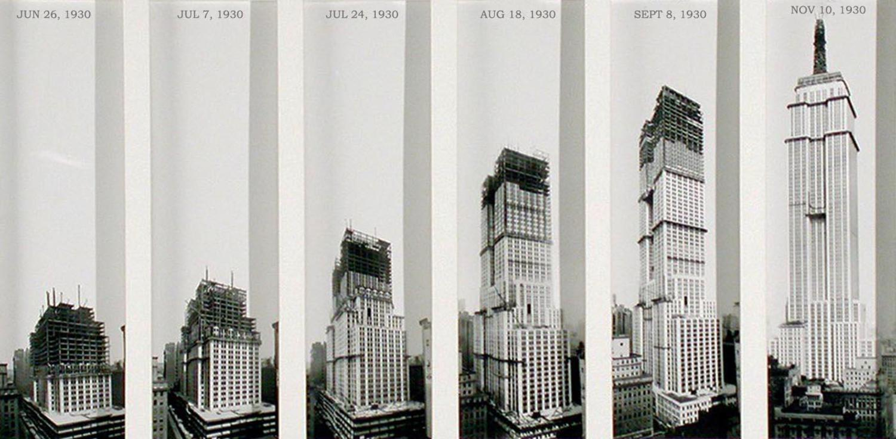
Figure 1 - Timelapse of construction of the empire state building

Challenges of Construction
There were many challenges encountered when constructing the Empire State Building for example, The Great Depression had just begun in the United States after the Wall Street Crash and there was a massive economic downturn just before the building was due to begin construction but, the completion of the building in these hard times was a sign of hope for people in the USA.
There were also many challenges during construction; there were many health and safety concerns for the workforce expected to construct it mainly because of the height they would be working at. Organising this workforce, which peaked at 3,500 people, was also a very hard task. Five workers were killed during construction which is a relatively low number considering the scale of the project but still significant in the development of modern safety standards.

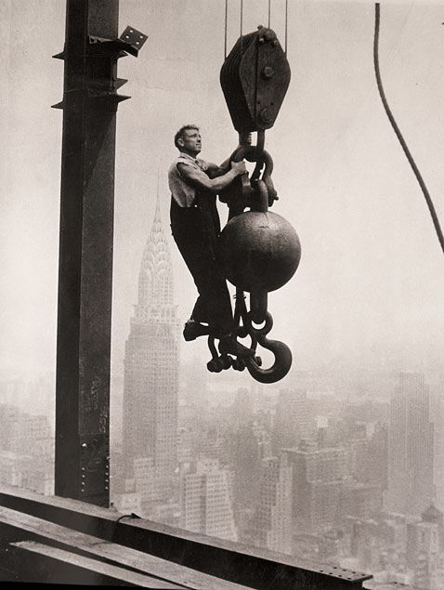
Figure 2 - Construction Worker at the empire state building

Due to the expenditure of the constructing the building, it only broke even for the first time in the 1950’s (almost 20 years after completion) and from there on, its reputation managed to attract more companies to rent space in the building.
(Empire state – Wikipedia, nd)

Current Use of the Building
Today, the building is widely recognisable around the world and millions of people each year flock to New York to see it. There are three observation decks in the Empire State Building, including one right at the top on the 102nd floor, which each provide stunning views all over New York. Although, the height record of the building has now been surpassed and it currently sits as the 59th tallest building in the world.
The main occupancy of the building is office space. It is currently home for around 28 different businesses and has previously housed around 1000 businesses.
Due to its iconic status, the building has featured in many films and television series’. For example, it was part of the very first King Kong film not long after its opening in 1933. Its iconic spire has also been used for promotion of various films and tv shows with inflatable objects being mounted to it for the whole of New York to see.
(Empire state - Wikipedia, nd)
Conclusion
In conclusion to this topic, the Empire State Building remains an iconic building all over the world and is widely recognisable. Its iconic features such as the spire, lifts and overall looks make it very appealing to tourists from all over the world. The building also stands as a sign of hope for many people because of the era it was built in. The Great Depression was a very hard time for the United States and the construction effectively put people to work when there wasn’t much money around.
Although the building has lost its ‘tallest building’ status, it remains as one of the largest tourist attractions around the world, showing off the incredible views of New York City.
References
Empire State (nd) The Empire Ste Building (Online) Available at:
Empire State Building - Wikipedia
[accessed on 12/12/2024]

Figure 1. TIMELAPSE OF CONSTRUCTION OF THE EMPIRE STATE BUILDING
Empire State Building, construction progress, 1930 | Viewing NYC

Figure 2. Construction Worker at the empire state building
Empire State Building: The 8th World Wonder (Photos) - ABC News

