 | Student No: | 2408856
 | Module Title: | Business Skills for the International Hotel Industry
 | Module Code: | BMIH4007
 | Lecturer: | Daniel Payne

Component One: Reflective Journal 1000 words
EXPERIENCE
During the second week of the Business abilities course, we discussed the management of time as well as transferable abilities. Due to the fact that I typically struggle to keep track of my time, this week stood out to me as particularly interesting. There is no way that I am organised. Because I believe that something will take less time than it actually does, I frequently put things off until the very last minute, hurry through them, and even occasionally arrive late. It seemed to me that this class was a little bit for me.
In our conversation, we discussed the concept of time as a "finite resource" and how preparation may significantly impact the way you spend your day. I was thinking about how many times I start things too late and then stress myself out for no reason when the speaker stated that. It made me think about how many times I do that.
One of the things that has remained in my thoughts for a very long time is the concept of "Eat the Frog." I had never heard the expression before I started taking this class. On the other hand, when the professor explained it to me, it made a great deal of sense. I always begin with the simpler activities and ignore the more challenging ones. As a result, the challenging one will continue to grow and become more burdensome in my mind throughout the day. Upon hearing this, I had the experience of thinking, "This is exactly what I do." That particular aspect was of great assistance to me.
We also went through a Vevox inquiry in which we evaluated how well we managed our time. I wrote "OK," but to tell you the truth, it's probably not okay. It's possible that "Poor" is more accurate. I came to the realisation when the instructor stated that one of the primary reasons individuals have trouble managing their time is because they procrastinate, and yeah, that is absolutely true of me.
UWTSD Careers also provided us with a quick time management course, which we watched as well. Simple things like how to plan my week and how to break down jobs into smaller pieces were among the things that I learnt from it. However, despite the fact that I don't typically engage in any of these activities, I found that they were quite beneficial to me.
The presentations also discussed the significance of planning in the hospitality industry, which brought to mind my previous experience in the workplace. In the workplace, if one individual is slow or unprepared, the entire team is affected.
The second week of the course helped me gain a better understanding of my routines, particularly the issue of putting things off till later, and 'Eat the Frog' provided me with something that I could put into practice.

REFLECTION
Now when I go back to Week 2, I see why this session was so significant for me, both in school and in my personal life. I had never truly thought about how I spent my time every day until this seminar. I often put off doing things till the last minute and told myself that I worked better under pressure. This belief made sense and even seemed helpful at the time. But after the lecture, I started to see that this method didn't work at all. Instead of making me do better, it often made me feel worried, mentally drained, and unhappy with the quality of my job.
The idea of "Eat the Frog" really stuck with me. It was uncomfortable to hear the instructor explain this theory because it sounded so much like how I usually work. I often avoid starting with the hardest or most boring activity and instead prefer to start with something easier or less significant. This helps me feel better for a short time, but it makes me think about the chore I'm putting off for the remainder of the day. Being aware of this all the time makes me anxious and makes it harder for me to fully focus on other things. I learnt from this conversation that procrastination isn't just being lazy; it's a habit that makes you more stressed and less productive.
Cottrell (2021) talks about how important it is to plan, set priorities, and split big jobs into smaller, easier-to-handle pieces. This explanation really hit home for me. I tend to put off tasks when they seem too big or ambiguous. On the other hand, breaking it up into smaller parts makes it seem more doable and less stressful. This lesson made me recognise that managing my time efficiently is important for more than just doing well in school.
I also thought about how my time management affects not only me but also the people I work with, especially in the hospitality industry. Mullins (2019) stresses that effective teamwork requires strong planning and management. In hospitality, all of the tasks are linked together. If one individual is late, unprepared, or disorganised, it can throw off the whole team. I've seen this happen in my own professional life: when people aren't ready, it can put more stress on their coworkers and make service worse and customers less happy.
After this session, I have begun to rethink how I manage my time. I'm starting to notice my habits more and am more inclined to question them. Learning about useful tactics like prioritising and doing hard tasks first has made me want to be more organised in both my schoolwork and my job. This workshop helped me understand that managing my time is an important ability that I would need in school and in my future job in the hospitality business.

Word count: 957

Component Two: Action Plan, SMART OBJETIVES
Objective 1: Implement the “Eat the Frog” approach daily
My first goal is to apply the “Eat the Frog” method consistently to improve my productivity and reduce procrastination.
- Specific: each morning or the night before, I will identify one high-priority task that I find most challenging (the “frog”) and start my day by working on it.
- Measurable: I will complete this task first at least four times per week.
- Achievable: if the task feels too overwhelming, I will break it into smaller, manageable steps, as suggested by Cottrell (2021).
- Relevant: completing difficult tasks early will reduce stress, mental pressure, and procrastination throughout the day.
- Time-bound: I will apply this strategy consistently over the next six weeks of the module.

Objective 2: Improve weekly planning and organisation
My second objective is to improve my weekly planning to better manage academic, work, and personal commitments.
- Specific: at the start of each week, I will write down all key tasks, deadlines, work shifts, and study time in a simple weekly planner.
- Measurable: a completed weekly plan will be prepared every Sunday evening.
- Achievable: I will use a straightforward planner or list without complex systems.
- Relevant: improved organisation will reduce last-minute stress and missed tasks.
- Time-bound: This strategy will begin immediately and be reviewed after four weeks.

Objective 3: Improve punctuality
My third objective is to improve punctuality for university and work commitments.
- Specific: I will finish getting ready 10–15 minutes earlier than usual and avoid starting new tasks before leaving.
- Measurable: I will arrive on time for at least 90% of my shifts and classes.
- Achievable: this requires only minor adjustments to my morning routine.
- Relevant: punctuality is essential in hospitality to support teamwork and professionalism (Mullins, 2019).
- Time-bound: punctuality will be monitored over the next month.

Objective 4: Reduce procrastination using the 10-minute rule
I aim to reduce procrastination by using a short-timer technique.
- Specific: when feeling unmotivated, I will start tasks by setting a 10-minute timer instead of postponing them.
- Measurable: this technique will be used at least once per day when procrastination occurs.
- Achievable: the method requires minimal effort and lowers resistance to starting tasks.
- Relevant: it helps maintain productivity during periods of stress or fatigue.
- Time-bound: this strategy will be applied throughout the current academic term.

Objective 5: Reflect on progress weekly
My final objective is to regularly reflect on my time-management habits.
- Specific: at the end of each week, I will write a short reflection on what worked well and what needs improvement.
- Measurable: I will complete one brief reflection per week.
- Achievable: reflections will be limited to a few lines to ensure consistency.
- Relevant: reflection supports self-awareness and continuous personal and professional development.
- Time-bound: weekly reflections will continue for six weeks.
Word count: 455
Total word count: 1,412
Component Three: Professional development: build a personal brand and promote a professional identity. (700 words)

Canva Document
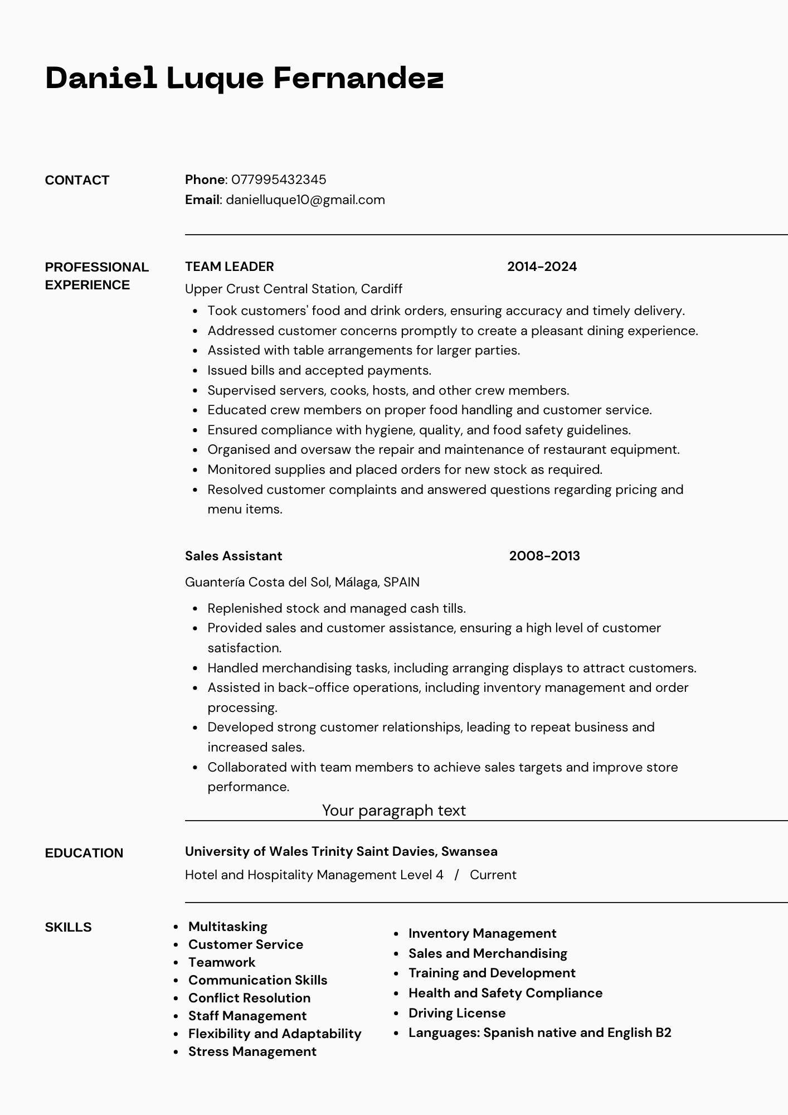
Linkedin Screenshot
www.linkedin.com/in/daniel-luque-2a8919371
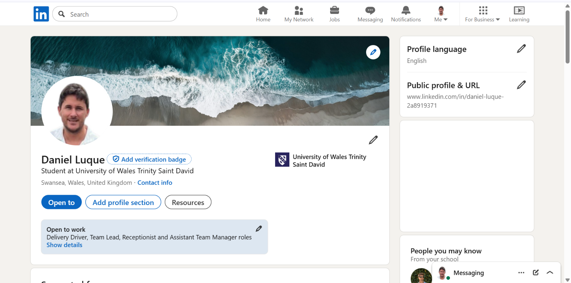
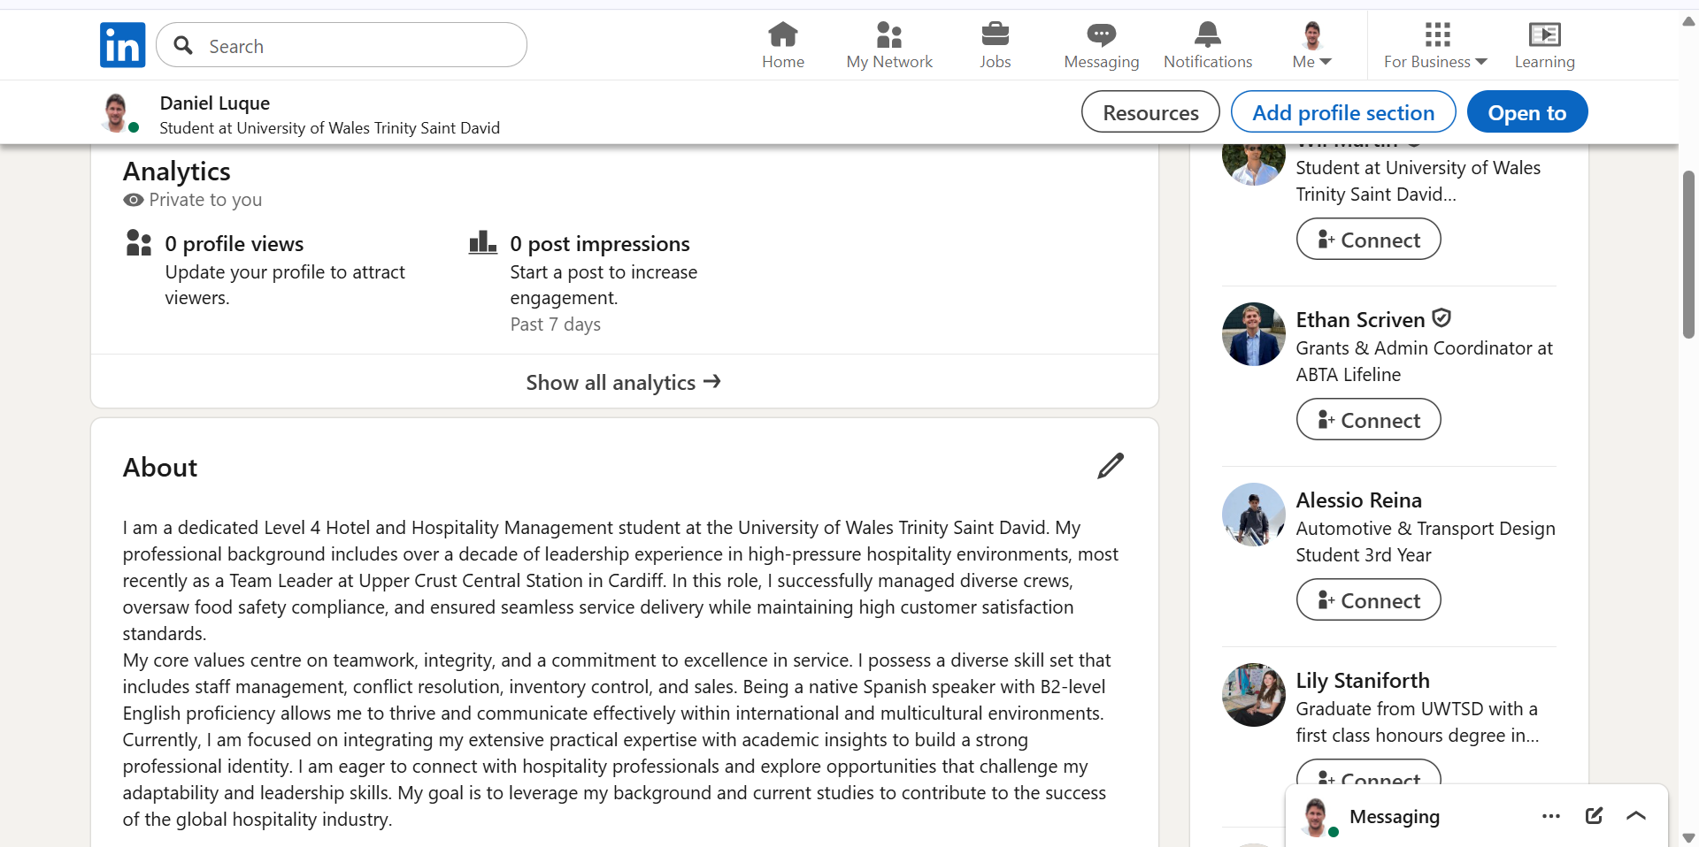
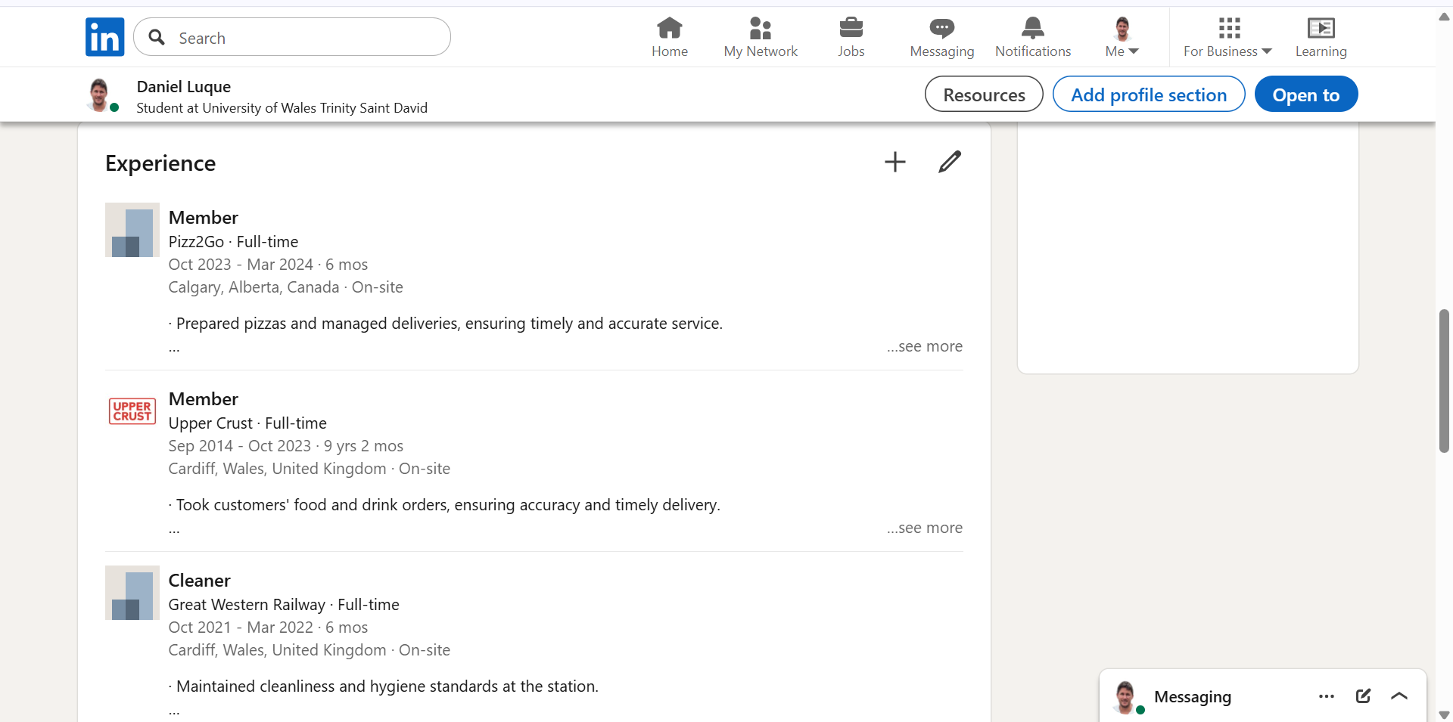
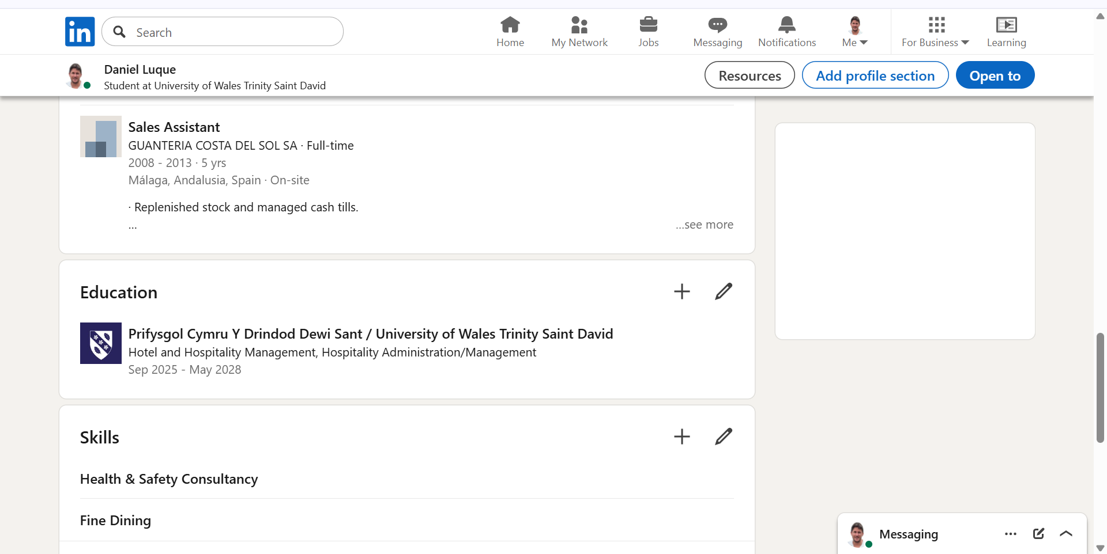
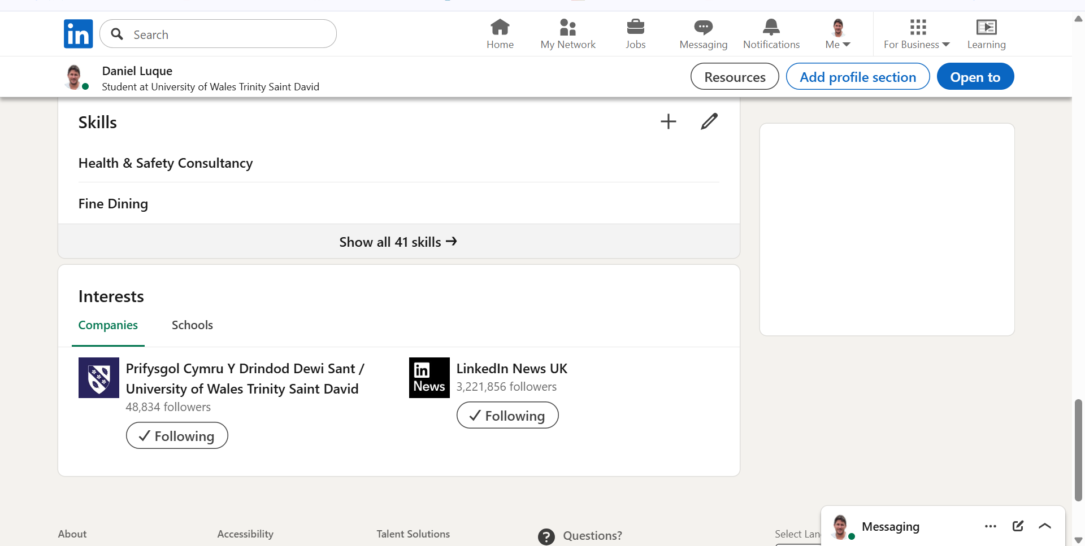

Component Four: Using the information prepared for your CV, present a 5 minute presentation on the key attributes that a person working within the hospitality industry should possess.
This Presentation will be completed in erson on site.
Place your presentation time below.
Timeslot: 13:20

