Student Name: Katie Leah Baugh
Student ID Number: 2000620
Programme of Study: BA Illustration
Module: ADAD5004 Research in Practise
Tutor Name: Delyth Lloyd-Evans
Word Count: 2694
Three Keywords: Engagement, Morals and Fables

Beasts with Morals
An exploration of how illustrators have used anthropomorphism in children’s books.

Anthropomorphism is described as attributing human characteristics to anything non-human (Salisbury, 2004, p.68), this essay will focus upon giving human qualities to animal characters. Lefkowitz explains,
It is a commonplace to assert that the anthropomorphic animals of fable have nothing in common with real animals…fable’s tendency to project human instincts and responses onto animal protagonists with little concern for naturalism or genuine animal behaviour.
(2014)
Lefkowitz focusses on the idea that animals have been given human instincts and emotions in literature. Anthropomorphism is mainly seen through children’s literature, both historically and the present day (Burke and Copenhaver, n.d.). There are many reasons why children’s books tend to have animal characters, the main reason seeming to be engagement. According to an article in The Guardian, “publishers said that 38% of their books featured animals or inanimate objects as main characters” (Flood, 2020). As the main purpose for children’s books is to instruct children on lessons that they may use later in life, it is also interesting to explore how animal characters have been used to portray complex human morals in the many renditions of ‘Aesop’s Fables’. These will be explored in this proposal.
The first idea that this proposal will explore is the notion that anthropomorphic characters increase engagement in children’s books. One of the purposes for children’s books, historically, was to teach children about the world around them. In Burke and Copenhaver’s essay Animals as People in Children’s Literature (n.d.), they discuss the notion that before the mid-eighteenth century, children were seen as “short adults”, thus there was no room for play and recreation. With the emergence of the middle class, opinion changed, and the concept of childhood was developed. The new attitude was that children required more time to develop and learn before they were given the full responsibilities that came with adulthood and it was discovered that children learned through play and through reading story books about the world around them (Burke and Copenhaver, n.d.). According to Burke and Copenhaver, “Children’s books exist for several purposes: mainly literacy education, moral education and pleasure” (n.d.). Hadjer and Manal (2017) state that children’s literature “rose unexpectedly at the end of the nineteenth century and was characterized by fantasy, humour, fairy tales, and animal characters”.
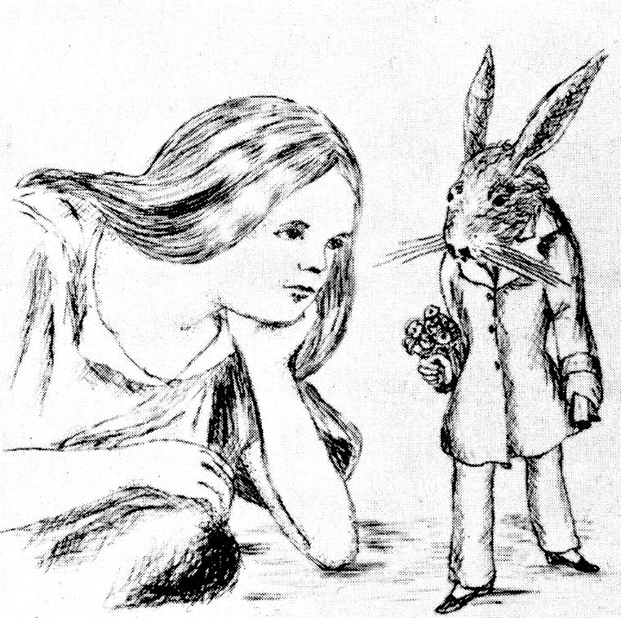
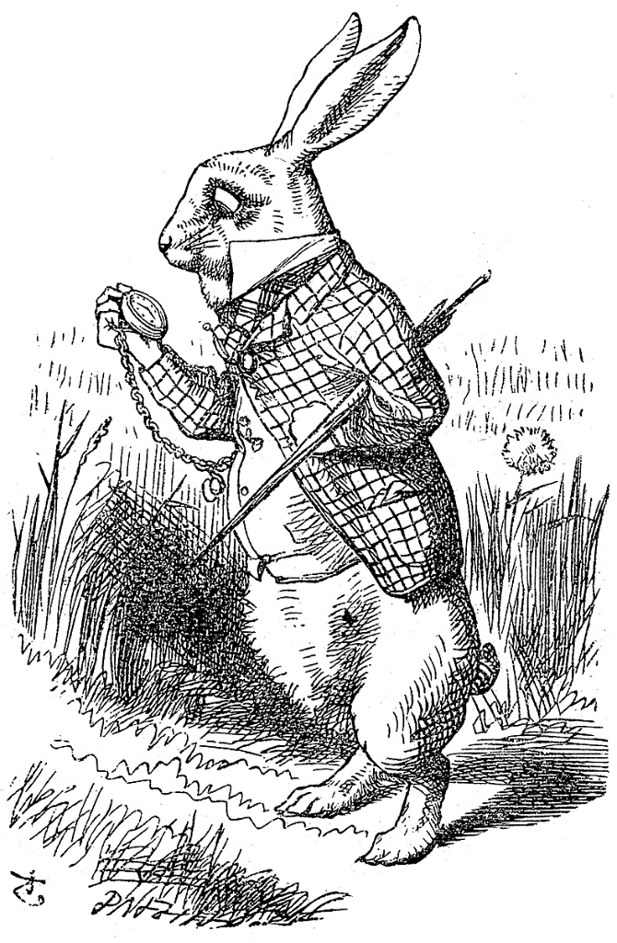
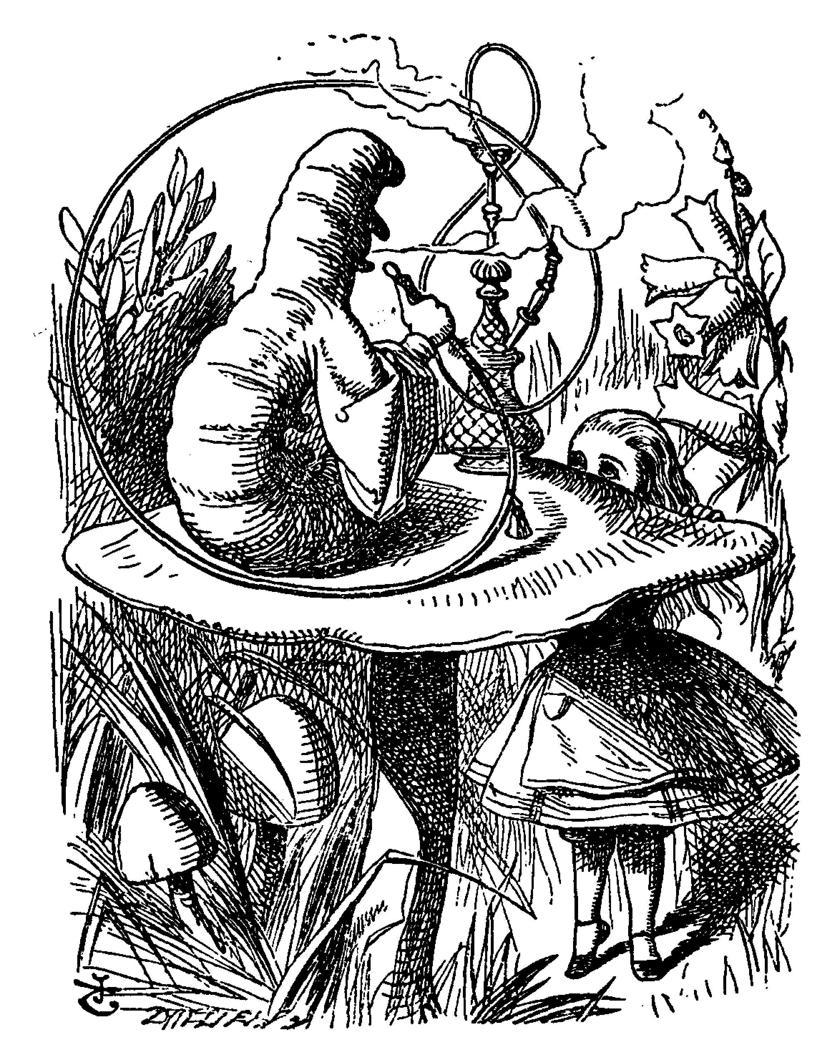
One of the leading authors in the Victorian era was Lewis Carroll, who is most known for his book Alice’s Adventures in Wonderland (1865). Carroll used anthropomorphism consistently in this novel, and he used this technique to educate children about society and life in a manner that was imaginative. According to Hadjer and Manal, Carroll used Alice’s Adventures in Wonderland (1865) to explore “humanizing the non-human” (2017), and to assert that everything has a right to speak, including both flora and fauna. It was John Tenniel who Carroll chose to illustrate his book. In the book A History of Children’s book illustration (Whalley, 1988), who points out how iconic the Alice in Wonderland illustrations have become, that they have almost set in stone the look for every character. He states “Tenniel’s illustrations gave visible form to a series of fantastic creatures emanating from the author’s imagination” (Whalley, 1988, p.81). According to Chandler in Semiotics the basics (2002), “denotation is what is photographed, and connotation is how it is photographed”, and this can also be applied to illustration, where denotation can be seen as what is drawn, and connotation is how it was drawn. The way Tenniel drew was integral to how the illustrations for Alice’s Adventures in Wonderland developed. Tenniel was distinctive from other illustrators of his time as he claimed to never draw from life, which set him apart from the pre-Raphaelites of that era, who insisted that “drawing from nature was the only way to produce truthful art” (Kosik, 2018). Tenniel and Carroll had a strained relationship as illustrator and author throughout the creation of Alice’s Adventures in Wonderland (Kosik, 2018), due to Tenniel wanting more creative freedom. Tenniel insisted to Carroll that the animals found in the story should “not look like real animals, but should instead be fanciful creations” (Kosik, 2018). An example of this can be seen below in Tenniel’s illustration of the White Rabbit. Although there was contention between author and illustrator over the illustrations, there are very little differences between Carroll’s original illustrations and Tenniel’s illustrations. The anatomy and proportions of the White Rabbit are not quite true to life, since Tenniel refused to draw using models and reference. The White Rabbit has many features that would make it an anthropomorphic character, both in text and its design. The character stands on its hind legs, which immediately gives it human-like abilities that a natural rabbit would not have. Its stance is also human-like, with his cane tucked under his arm and gazing at his pocket watch in a paw that is more opposable than what would be natural for a rabbit. Perhaps the most characteristic design element that deems it anthropomorphic is the clothes that the rabbit is wearing. The patterned suit jacket paired with the waistcoat and cravat hint at a distinguished gentleman, not at all what would be expected to be found on a rabbit. Another character where anthropomorphism is heavily used is the caterpillar. According to Hadjer and Manal (2017), “He serves as an example of wisdom and helps the hero to see the world objectively”. This can be seen in the composition of the illustration. The caterpillar is placed in the top half of the illustration sat on his mushroom, and Alice is in the lower half. She is quite literally looking up at him, showing him to be a source of wisdom and help. In the text itself, Hadjer and Manal discuss that Alice’s repeated use of the word “sir” when addressing the caterpillar shows that she respects this character. This is important as in nature, caterpillars are prey and are often overlooked. Typically, they are not connoted with ideas of wisdom and respect, but both in Carroll’s writing and Tenniel’s illustration, this caterpillar is to be revered. The shadow over the caterpillar’s face also adds to this mystery and intrigue. The caterpillar has many anthropomorphic qualities, such as its exaggerated size and the action of smoking a hookah pipe. Similar to the White Rabbit, the caterpillar’s hand is also quite human-like. It is clear to see from looking at Tenniel’s illustrations for ‘Alice in Wonderland’ that making key characters anthropomorphic increased engagement from children when it was first published.
Figure 1- The White Rabbit by John Tenniel
Figure 2- The White Rabbit by Lewis Carroll
Figure 3- The Caterpillar and Alice by John Tenniel
With children’s literature on the rise in the Victorian era, many of these books contained fables, which leads into this proposal’s second main idea- the idea of fables and morals working side by side. “A fable or apologue is a narrative in which beings irrational, and sometimes inanimate, are for purposes of moral instruction, feigned to act and speak with human interests and passions” (Mather, 1942). According to Mather, fables are not restricted to narratives with animal characters, but their purpose is primarily to teach morals. Brittanica points out that “The importance of fables lay not so much in the story told as in the moral derived from it” (n.d.). There are many reasons why writers of fables chose to have anthropomorphic characters. Ash and Higton (1990) suggest that because early man and animal lived in such close proximity to each other, it was inevitable that animals should appear in early art and stories. Another idea is proposed by Burke and Copenhaver (n.d.) “Having animals do the acting and mistake-making allows the face-saving emotional distance often needed to be able to join the conversation”. This is an interesting theory, insinuating that it is easier for people to learn from stories when they themselves are not being presented as the ones making the mistakes. Perhaps the most widespread fables come from Aesop. Aesop’s Fables were not the only books that contained fables from that time, as children’s literature tended to have morals integrated into the stories to encourage learning (Burke and Copenhaver, n.d.). However, Aesop’s Fables were widespread. Interestingly, according to Ash and Higton (1990, p.4), there is little information on Aesop himself, and even his existence is questionable. However, there are countless versions of Aesop’s Fables, with the earliest being written in third century AD. The third English illustrated book to be printed was an edition of Aesop’s Fables in 1484 (Ash and Higton, 1990, p.6). It could be said that the only distinguishing feature between each Aesop’s fables book is the illustrations partnered with each fable. Ash and Higton add that “there is no definitive version-traditionally each writer retells his selection of fables, adapting them to suit his own style” (1990, p.8).
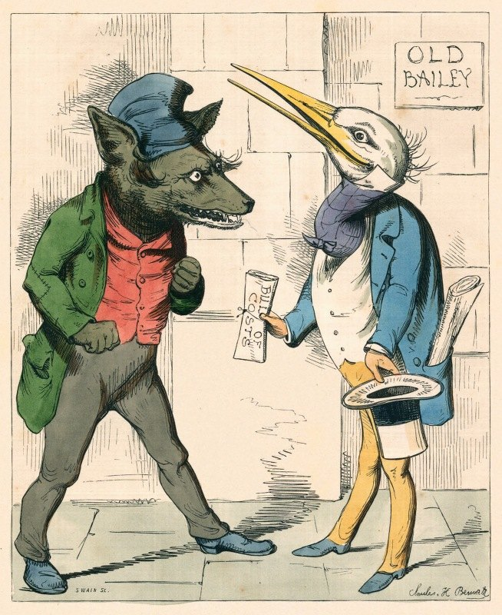
Aesop’s Fables Classic Illustrated edition (Ash and Higton, 1990) features works from a vast number of illustrators who have chosen to illustrate Aesop’s Fables over the last 150 years. One prominent illustrator that will be focussed on is Charles Henry Bennett. He did his own rendition of the fable The Wolf and the Crane. In this fable, the wolf character has a bone stuck in its throat and promises a reward to any who will remove it. A crane decides to undertake the task, and removes the bone successfully, only to find that the wolf will not give any reward, stating “you have had your head in my mouth, and instead of biting it off, I have let you pull it out unharmed” (Ash and Higton, 1990 p.16). Ash and Higton state that moral of this fable is “Expect no gratitude if you show charity to an enemy” (1990, p.16). Charles Henry Bennett’s illustration has very much anthropomorphic characters. Illustrated in 1857, Bennett created an illustrated version of Aesop’s Fables (The Fables of Aesop and Others Translated Into Human Nature, 1857). Bennett was primarily a graphic satirist, but only had twelve years as an active illustrator before passing away at a young age (Baker, 2004). M. H. Spielmann remarks in her 1895 history of Punch, his “career was short, though not too short for fame” (p.76). Because of Bennett’s limited achievements due to his untimely death, it is difficult to place him in the history of illustration. However, his illustrations for Aesop’s fables show his unique sense of humour towards the fables, revealing him to be a satirist. According to O’Cinneide, in the Victorian era “Cartoons and caricatures, especially of political issues or public figures, were popular”, and he claims that satire not only served as a form of protest against current issues, but also had a tendency to reinforce class (2013). In Bennett’s illustration of The Wolf and the Crane, these elements of satire can be seen. The illustration itself is more vague to the story itself, and focusses more on the characters themselves. There is a clear difference in class shown by the clothes that the characters are wearing. Class is a strictly human only issue, so to see animals being presented as being of different classes shows its anthropomorphic nature. The wolf is wearing much plainer clothes to the crane. His jacket has a patch on the elbow, indicating that he is from a lower class. He has a confrontational stance, which is contrasted with the crane’s much more genial pose. The crane is holding a ‘bill of costs’, which refers back to the fable, where the crane is waiting expectantly for his reward from the wolf. This is a very anthropomorphic prop for the character to be drawn with. Another detail that Bennett includes in the illustration is a signpost for Old Bailey. The Old Bailey could refer to the Central Criminal Court of England and Wales, which is commonly referred to as the Old Bailey after the street it is on (City of London, n.d.). This firmly sets the illustration in our world, and parallels can be drawn between the character and real-world issues. Perhaps Bennett used the signpost for Old Bailey to show how the wolf is a criminal. It makes the fable much more applicable to the time that it was created, making the morals much more direct to the audience.
Figure 4- The Wolf and the Crane by Charles Bennett
The practise-based project that is proposed to go along with this essay is an illustrated version of ‘Aesop’s Fables’. After reading some of the many Aesop’s fables in Aesop’s Fables Classic Illustrated edition (Ash and Higton, 1990), the following four fables have been chosen to illustrate: The Hare and the Tortoise; The Lion in Love; The Two Playmates; The Leopard and the fox; The Wolf and the Crane; and the Wolf and the Kid. All these fables have animals portraying complex human emotions to teach the morals, such as love, nature and nurture, vanity and trust. The concept of animal stereotypes will also be explored through this project. For example, in ‘Illustrating Children’s Books’, Salisbury writes,
Animals can be used to represent most of the extremes of human characteristics and behaviour. The cunning fox, the cruel wolf, the imperious lion and the lowly worm are familiar stereotypes.
(2004, p.68)
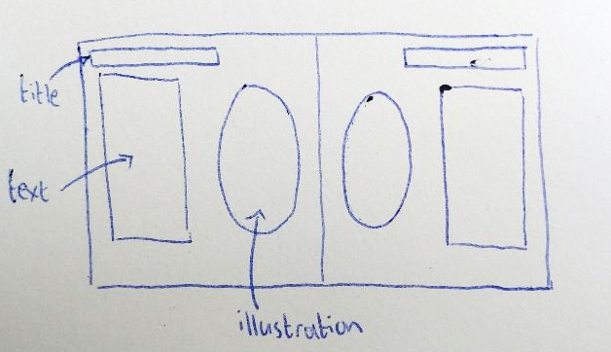
Books such as Aesop’s fables have created animal stereotypes that may not be true to the nature of the animal at all. This is something the practise-based project will focus on. Below is a brief thumbnail sketch for a proposed layout of a double page spread for this version of Aesop’s Fables. The text will sit alongside the illustration, and there will be one fable per page. Traditional techniques will be used in the creation of the book. Experimentations with letterpress to print the title and the fables will hopefully help to create an authentic and traditional looking version of Aesop’s Fables.
Figure 5- Thumbnail illustration by Katie Baugh
After studying various ways that illustrators have used anthropomorphism in children’s literature, the proposed title for the extended essay is as follows: Beasts with Morals- How have illustrators used anthropomorphism in children’s literature to discuss important issues? Over the course of this proposal, the theme of morals has been a common idea shared by artists who have used anthropomorphism. The extended essay will explore this in more detail and look at a wider range of children’s literature. Other books that could be studied are Judith Kerr’s ‘A Tiger who came to tea’ (1968), ‘Fox’ by Margaret Wild (200) and Ayano Imai’s illustrated version of ‘Aesop’s Fables’ (2012). Methods of primary research could also be employed in the extended essay. Children of primary school age could be read several of Aesop’s Fables, perhaps the ones selected to be illustrated in the practise-based project, and then be asked about the morals that they teach. This will provide primary research to decide whether fables are an adequate teaching tool for morals and lessons in story form.
To findings of this proposal are that illustrators have used anthropomorphism to portray human issues in a way that is interesting for children to engage with. It is important to come back to this quote by Lefkowitz that was brought to attention at the beginning of this essay “It is a commonplace to assert that the anthropomorphic animals of fable have nothing in common with real animals” (2014). Fables are works of fantasy, and it is important to remember this. Animals do not think and act the way they do in fables in reality. It is an ongoing debate whether animals should have rights that would be similar to the rights that humans have. Gruen states,
In eating animals or using them in other harmful, violent ways, we do not display the traits of character that kind, sensitive, compassionate, mature, and thoughtful members of a moral community should display.
(2021)
What this perhaps shows is that though people give human attributes to animals in works of fiction, humans themselves are not quite so different from the morally lacking animals that they think they are. The morals that are placed on animals in fables are perhaps unreachable for everyone, and they form an ideal version of human characteristics.

Bibliography
Aesop (1990) Aesop’s Fables. Chronicle Books LLC, United States.
Aesop and Imai, A. (2013) Aesop’s Fables. Michael Neugebaur Publishing, Hong Kong.
Artists & Illustrators. (2019) The 90-year-old German-born children’s illustrator is famed for her Mog series and The Tiger Who Came to Tea. Available at: https://www.artistsandillustrators.co.uk/news/a-life-in-art-judith-kerr/ (Accessed 22nd March 2022)
Baker, A. (2004) Bennet, Charles Henry. Available at: https://www.oxforddnb.com/view/10.1093/ref:odnb/9780198614128.001.0001/odnb-9780198614128-e-2118 (Accessed 13th April 2022)
Burke, C and Copenhaver, J (n.d.) Animals as People in Children’s Literature. Available at: https://cdn.ncte.org/nctefiles/store/samplefiles/journals/la/la0813animals.pdf. (Accessed 15 March 2022)
Carrol, L. (2014) Alice in Wonderland. Unlimited Publishing, UK.
City of London (n.d.) Central Criminal Court. Available at: https://www.cityoflondon.gov.uk/about-us/law-historic-governance/central-criminal-court (Accessed 13th April 2022)
Flood, A. (2020) Children’s books eight times as likely to feature animal main characters as BAME people. Available at: https://www.theguardian.com/books/2020/nov/11/childrens-books-eight-times-as-likely-to-feature-animal-main-characters-than-bame-people#:~:text=But%20the%20publishers%20said%20that,character%20who%20isn't%20white. (Accessed 22nd March 2022)
Geerdts, M. et al. (2015) Learning about real animals from anthropomorphic media. Available at: https://journals-sagepub-com.ezproxy.uwtsd.ac.uk/doi/full/10.1177/0276236615611798 (Accessed 20th March 2022)
Gruen, L. (2021) The Moral Status of Animals. Available at: https://plato.stanford.edu/cgi-bin/encyclopedia/archinfo.cgi?entry=moral-animal (Accessed 23rd April 2022)
Hadjer, B and Manal, B (2017) Personification in Lewis Carrol’s Alice in Wonderland. Masters Degree Thesis, University of Mohamed Boudiaf, M’sila.
Heller, S. (2008) In Praise of the Anthropomorphic. Available at: https://designobserver.com/feature/in-praise-of-the-anthropomorphic/7537 (Accessed 20th March 2022)
Jones, K (2009) Animals in Human Clothing. BA (Hons) Dissertation, Swansea Metropolitan University, Swansea.
Kerr, J (1968) The Tiger who came to tea. William Collins Sons and co, Great Britain.
Kerr, J (1970) Mog the forgetful cat. William Collins Sons and co, Great Britain.
Kosik, C. (2018) Sir John Tenniel. Available at: https://www.illustrationhistory.org/artists/sir-john-tenniel (Accessed 13th April 2022)
Leftkowtz, J. (2018) Listening to Aesop’s Animals. Available at: https://iai.tv/articles/listening-to-aesops-animals-philosophy-auid-1105#:~:text=According%20to%20our%20ancient%20sources,boring%20or%20insulting%20an%20addressee. (Accessed 14th March 2022)
Mann, J. (2009) From Aesop to Reynard: Beast Literature in Medieval Britain. Available at: https://oxford.universitypressscholarship.com/view/10.1093/acprof:oso/9780199217687.001.0001/acprof-9780199217687-chapter-2 (Accessed 20th March 2022)
Markowsky, J. (1975) Why Anthropomorphism in Children’s Literature? National Council of Teachers of English, United Kingdom.
Marther, M (1942) Animal stories for children and the use of animal characters in children’s literature. Degree Thesis, Boston University Graduate School, Boston.
O’Cinneide, M. (2013) Satire. Available at: https://www.oxfordbibliographies.com/view/document/obo-9780199799558/obo-9780199799558-0111.xml#:~:text=The%20preeminent%20satirist%20of%20the,of%20Victorian%20drama%20and%20morality . (Accessed 20th March 2022)
Oxford (2014) The Oxford Handbook of Animals in Classical Thought and Life. Oxford University Press, Oxford..
Salisbury, M. (2004) Illustrating Children’s Books. A&C Black Publishers, London.
Whalley, J. et al (1988) A History of Children’s Book Illustration. John Murray Publishers, London.
Wild, M. (2000) Fox. Cat’s Whiskers, London.
Wimpenny, Jo. (2021) Aesop’s Fables: The Science behind what the stories got wrong. Available at: https://www.sciencefocus.com/nature/aesops-fables-science/ (Accessed 20th March 2022)

Reference List
Aesop (1990) Aesop’s Fables. Chronicle Books LLC, United States
Baker, A. (2004) Bennet, Charles Henry. Available at: https://www.oxforddnb.com/view/10.1093/ref:odnb/9780198614128.001.0001/odnb-9780198614128-e-2118 (Accessed 13th April 2022)
Burke, C and Copenhaver, J (n.d.) Animals as People in Children’s Literature. Available at: https://cdn.ncte.org/nctefiles/store/samplefiles/journals/la/la0813animals.pdf. (Accessed 15 March 2022)
Carrol, L. (2014) Alice in Wonderland. Unlimited Publishing, UK.
City of London (n.d.) Central Criminal Court. Available at: https://www.cityoflondon.gov.uk/about-us/law-historic-governance/central-criminal-court (Accessed 13th April 2022)
Flood, A. (2020) Children’s books eight times as likely to feature animal main characters as BAME people. Available at: https://www.theguardian.com/books/2020/nov/11/childrens-books-eight-times-as-likely-to-feature-animal-main-characters-than-bame-people#:~:text=But%20the%20publishers%20said%20that,character%20who%20isn't%20white. (Accessed 22nd March 2022)
Gruen, L. (2021) The Moral Status of Animals. Available at: https://plato.stanford.edu/cgi-bin/encyclopedia/archinfo.cgi?entry=moral-animal (Accessed 23rd April 2022)
Hadjer, B and Manal, B (2017) Personification in Lewis Carrol’s Alice in Wonderland. Masters Degree Thesis, University of Mohamed Boudiaf, M’sila.
Kosik, C. (2018) Sir John Tenniel. Available at: https://www.illustrationhistory.org/artists/sir-john-tenniel (Accessed 13th April 2022)
Leftkowtz, J. (2018) Listening to Aesop’s Animals. Available at: https://iai.tv/articles/listening-to-aesops-animals-philosophy-auid-1105#:~:text=According%20to%20our%20ancient%20sources,boring%20or%20insulting%20an%20addressee. (Accessed 14th March 2022)
Marther, M (1942) Animal stories for children and the use of animal characters in children’s literature. Degree Thesis, Boston University Graduate School, Boston.
O’Cinneide, M. (2013) Satire. Available at: https://www.oxfordbibliographies.com/view/document/obo-9780199799558/obo-9780199799558-0111.xml#:~:text=The%20preeminent%20satirist%20of%20the,of%20Victorian%20drama%20and%20morality . (Accessed 20th March 2022)
Oxford (2014) The Oxford Handbook of Animals in Classical Thought and Life. Oxford University Press, Oxford..
Salisbury, M. (2004) Illustrating Children’s Books. A&C Black Publishers, London.
Whalley, J. et al (1988) A History of Children’s Book Illustration. John Murray Publishers, London.

List of Figures
Figure 1- Tenniel, J. (2014) Alice in Wonderland. United Kingdom, Unlimited Publishing
Figure 2- Carroll, L. (1987) Alice’s Adventures in Wonderland. London, Marshal Cavendish Partworks Ltd.
Figure 3- Tenniel, J. (2014) Alice in Wonderland. United Kingdom, Unlimited Publishing
Figure 4- Bennett, C. (1857) The Wolf and the Crane. [Online Image] Available at: https://artvee.com/dl/the-wolf-and-the-crane. (Accessed 13th April 2022)
Figure 5- Baugh, K. (2022) Thumbnail Illustration. [pen on paper] United Kingdom

