Student name: Yasmin Bibi (1808879)
Tutor: Mumtaz Goolum
Module: Introduction to Physiology (BMHP 5003)
Part 1. Academic Poster of Digestive System
University of Wales, Trinity Saint David. (Sparkhill, Birmingham group)

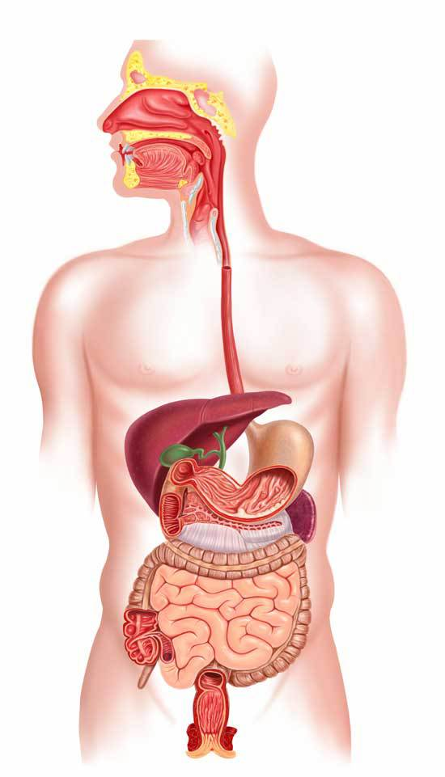
3- Oesophagus.
Oesophagus is a pipe which joins the throat and the stomach. This tube is approximately 8 inches long. The Oesophagus is not a meaningless part of the body that food or water just slips down but is made of muscles which help moving solids and liquids to the stomach area. This procedure is known as peristalsis. There are many muscles joint together on the top of the oesophagus which are known as the upper oesophageal sphincter and the other bunch of muscles are situated at the bottom of the tube, just above the stomach, known as lower oesophageal sphincter. These sphincters work smoothly as food enters the stomach once its swallowed. These close down if they not being used, in order to stop the stomach acids to come back up towards the oesophagus.
(Bradford, 2016a)
.
7- Gallbladder.
The gallbladder is situated under the liver. This is a pear-shaped sack which is 7 to 10 cm long and up to 5 cm wide. The gallbladder gathers and thickens the bile from the liver and then distributes it into the small intestine, where it aids the body to break down food and attract fats from it. Bile is yellow, greenish liquid, which helps digest food. The liver cells produce the bile into tiny canals which lead towards the common bile vessel. It enters a further smaller tube with many branches and heads towards the gallbladder
(InformedHealth, 2018).
6- Liver.
Liver is the main organ which weighs up to 2.3 kg. It is located in the space at the top of the stomach. Liver plays important role in keeping plasma glucose levels in control. After consumption of food, if the levels go up, glucose is transformed to glycogen with the aid of the hormone insulin and when glucose level drops, the hormone glucagon changes glycogen back into glucose, making the levels normal again.
(Waugh and Grant, 2014a, p. 308)
8- Small intestine.
The small intestine plays a key role in the digestive system by breaking down the food and absorbing vital nutrients which helps the body to function on a high level. The small intestine achieves this task by the aid of all blood vessels, muscles and nerves working together to attain the task. This organ plays a major role in our immune system as it acts as a hurdle to a multitude of flora that occupies the stomach and also helps in stopping any harmful bacteria from entering the body. This is a huge part of the body as the length is approxiamatelty 3 to 5 meters. This is divided in 3 parts as duodenum. Jejunum and ileum (Collins et al, 2020).

5- Pancreas.
Pancreas is a gland, which is six inches long and is situated in our abdomen by the liver and small intestine. Pancreas plays a twin role in bodily functions. (1) Endocrine system. Pancreas balances hormones such as blood sugar-regulating hormones, glucagon, and insulin. (2) Exocrine system. Pancreas distributes enzymes in and out of digestive system through a pipe and into duodenum (Jewell, 2018).

4- Stomach.
The stomach looks like a bag, shaped as a bean, and is situated at the back of the lower ribs. As soon as the food enters this sack, muscles which are located at the front of the stomach and towards the end, next to the small intestine, shut down. The stomach lining creates enzymes and hydrochloric acids which breaks down the food. Stomach plays a very important role in digestive system. Not only it digests the food but stores it too (Bradford, 2015b).
2- Pharynx.
The Oropharynx, which is known as throat too, leads the way from mouth and nose, up to the oesophagus and voice box. The Oropharynx allows the pathway of swallowed food and water in the throat and then handles the air from and to the windpipe through breathing in and out. The Oropharynx is a flat looking pipe. It is very loose and is linked with other joints which work together in swallowing the food (Hightower et al, 2020).
- Mouth.
Mouth is also known as oral cavity or buccal cavity. This is a human structure where food and air travel through a hole into the body. The process starts in the mouth as food is chewed by the teeth and then mixed with saliva, which shapes it into a ball, known as bolus. With the help of the tongue, food is pushed down towards the oesophagus the surrounding parts are known as lips, hard and soft palates, and cheeks (Encyclopaedia Britannica, 2020; Daniel, 2019)
9- Large intestines.
The large intestine is approximately 1.5 metres in length and is located deep within the pelvis. It is 6.5 in diameter and is larger than the small intestine. It is shaped as an arch around the small intestine. The main job of large intestine is to absorb minerals, leftover nutrients, and water from the food. It will transform remaining waste into bowel movement which is known as a stool.
(Waugh and Grant, 2014b. p. 305; University Hospitals, 2020).

10- Rectum and Anus.
These are the last parts of the system. As the stool reaches the rectum, a signal from the brain makes the person realise of the need to go to the bathroom. Our control on the anal sphincter lets us hold the stool up to how long we want (Balentine, 2020).
Constipation occurs when digested food is left in the colon for too long and also when the colon attracts too much of the fluid which leaves the stool dry resulting in the rectal muscles finding it hard to pass it out of the body. Main causes can be not drinking enough water, not moving around, or doing exercise and not eating healthy food with lots of fibre. If constipation is not treated on time, then it can lead to develop haemorrhoids (Derrow, 2020).

(ModernHeal, 2020).

References List (1).
0- ModernHeal (2020) ‘The Digestive System without labels’. Available at: https://www.modernheal.com/digestive-system-problems/the-digestive-system-without-labels/. Accessed on 8th October 2020.
1- Encyclopaedia Britannica (2020) ‘Mouth Anatomy’. [Online] Available at: https://www.britannica.com/science/mouth-anatomy. (Accessed on 11th October 2020).
1- Daniel, C. (2019) ‘A Look Inside Your Digestive System: The mouth’. Verywellhealth. [Online] Available at: https://www.verywellhealth.com/tour-the-digestive-system-4020262. Accessed on 15th October 2020.
2- Hightower, N. C., Dworken, H. J., Sircus, W., Keeton, W. T., et al (2020). ‘Human Digestive System’. Encyclopaedia Britannica. [Online]. Available at: https://www.britannica.com/science/human-digestive-system/Pharynx. Accessed on 3rd October 2020.
3- Bradford, A. (2016a) Oesophagus: Facts, Functions and Diseases. Live Science. [Online] Available at: https://www.livescience.com/52045-esophagus.html. Accessed on 4th October 2020.
4- Bradford, A. (2015b) ‘Stomach: Facts, Functions and Diseases’. Live Science. [Online] Available at: https://www.livescience.com/52046-stomach-facts-functions-diseases.html. Accessed on 5th October 2020.
5- Jewell, T. (2018) ‘What is the pancreas’? Healthline. [Online]. Available at: https://www.healthline.com/health/what-does-the-pancreas-do?c=1423623898122. Accessed on 6th October 2020.
6- Waugh, A. and Grant, A. (2014a) ‘Digestive System’. Ross and Wilson, Anatomy and Physiology in health and illness: (12th Edition) London: Churchill Livingstone. [Online]. P 308. Accessed on 13th October 2020.
7- InformedHealth, (2018) ‘How does the gallbladder work’. Institute for Quality and Efficiency in Health Care. Cologne, Germany. [Online]. Available at: https://www.ncbi.nlm.nih.gov/books/NBK279386/. Accessed on 16th October 2020.
8- Collins, J. T., Nguyen, A. and Badireddy, M. (2020) ‘Anatomy, Abdomen and Pelvis, Small Intestine’. StatPearls. [Online] Treasure Island. Available at: https://www.ncbi.nlm.nih.gov/books/NBK459366/. P 1. Accessed on 9th October 2020.
9- Waugh, A. and Grant, A. (2014b) ‘Digestive System’. Ross and Wilson, Anatomy and Physiology in health and illness: (12th Edition) London: Churchill Livingstone. [Online]. P 305. Accessed on 16th October 2020.

9- University Hospitals, (2020) ‘The Digestive Process: The Large Intestine’. [Online] Available at: https://www.uhhospitals.org/health-information/health-and-wellness-library/article/adult-diseases-and-conditions-v1/the-digestive-process-the-large-intestine. Accessed on 18th October 2020.
10- Balentine, J. R. (2020) ‘The Digestion Process Parts, Organs, and Functions: The colon, rectum, and anus’. MedicineNet. [Online] Available at: https://www.medicinenet.com/the_digestion_process_organs_and_functions/article.htm. Accessed on 18th October 2020.
11- Derrow, P. (2020) ‘What is Constipation? Symptoms, Causes, Diagnosis, Treatment, and prevention.’ EveryDayHealth. [Online] Available at: https://www.everydayhealth.com/constipation/guide/. Accessed on 21st October 2020.

References list (2).
Balentine, J. R. (2020) ‘The Digestion Process Parts, Organs, and Functions: The colon, rectum, and anus’. MedicineNet. [Online] Available at: https://www.medicinenet.com/the_digestion_process_organs_and_functions/article.htm. Accessed on 18th October 2020.
Bradford, A. (2016a) Oesophagus: Facts, Functions and Diseases. Live Science. [Online] Available at: https://www.livescience.com/52045-esophagus.html. Accessed on 4th October 2020.
Bradford, A. (2015b) ‘Stomach: Facts, Functions and Diseases’. Live Science. [Online] Available at: https://www.livescience.com/52046-stomach-facts-functions-diseases.html. Accessed on 5th October 2020.
Collins, J. T., Nguyen, A. and Badireddy, M. (2020) ‘Anatomy, Abdomen and Pelvis, Small Intestine’. StatPearls. [Online] Treasure Island. Available at: https://www.ncbi.nlm.nih.gov/books/NBK459366/. P 1. Accessed on 9th October 2020.
Daniel, C. (2019) ‘A Look Inside Your Digestive System: The mouth’. Verywellhealth. [Online] Available at: https://www.verywellhealth.com/tour-the-digestive-system-4020262. Accessed on 15th October 2020.

Derrow, P. (2020) ‘What is Constipation? Symptoms, Causes, Diagnosis, Treatment, and prevention.’ EveryDayHealth. [Online] Available at: https://www.everydayhealth.com/constipation/guide/. Accessed on 21st October 2020.
Encyclopaedia Britannica (2020) ‘Mouth Anatomy’. [Online] Available at: https://www.britannica.com/science/mouth-anatomy. (Accessed on 11th October 2020).
Hightower, N. C., Dworken, H. J., Sircus, W., Keeton, W. T., et al (2020). ‘Human Digestive System’. Encyclopaedia Britannica. [Online]. Available at: https://www.britannica.com/science/human-digestive-system/Pharynx. Accessed on 3rd October 2020.
InformedHealth, (2018) ‘How does the gallbladder work’. Institute for Quality and Efficiency in Health Care. Cologne, Germany. [Online]. Available at: https://www.ncbi.nlm.nih.gov/books/NBK279386/. Accessed on 16th October 2020.
Jewell, T. (2018) ‘What is the pancreas’? Healthline. [Online]. Available at: https://www.healthline.com/health/what-does-the-pancreas-do?c=1423623898122. Accessed on 6th October 2020.
ModernHeal (2020) ‘The Digestive System without labels.’ Available at: https://www.modernheal.com/digestive-system-problems/the-digestive-system-without-labels/. Accessed on 8th October 2020.
University Hospitals, (2020) ‘The Digestive Process: The Large Intestine’. [Online] Available at: https://www.uhhospitals.org/health-information/health-and-wellness-library/article/adult-diseases-and-conditions-v1/the-digestive-process-the-large-intestine. Accessed on 18th October 2020.
Waugh, A. and Grant, A. (2014a) ‘Digestive System’. Ross and Wilson, Anatomy and Physiology in health and illness: (12th Edition) London: Churchill Livingstone. [Online]. P 308. Accessed on 13th October 2020.
Waugh, A. and Grant, A. (2014b) ‘Digestive System’. Ross and Wilson, Anatomy and Physiology in health and illness: (12th Edition) London: Churchill Livingstone. [Online]. P 305. Accessed on 16th October 2020.

