Worksheet 4

Network Operating Systems ACCA5023
Neil O’Mahoney 0351709
Cyber Security Networks

Table of Contents
Task 2: Deploy core services (FTP Server) 3
Task 3: Installing and configuring the Routing and Remote Access Service 5
Task 4: IP Packet Filtering 9
Task 5: Failover Clustering for high availability systems/services 11
Task 6: Observational Tasks 14
References 22

Task 2: Deploy core services (FTP Server)

Figure 1 – Although tested as wrong user for FTP command.
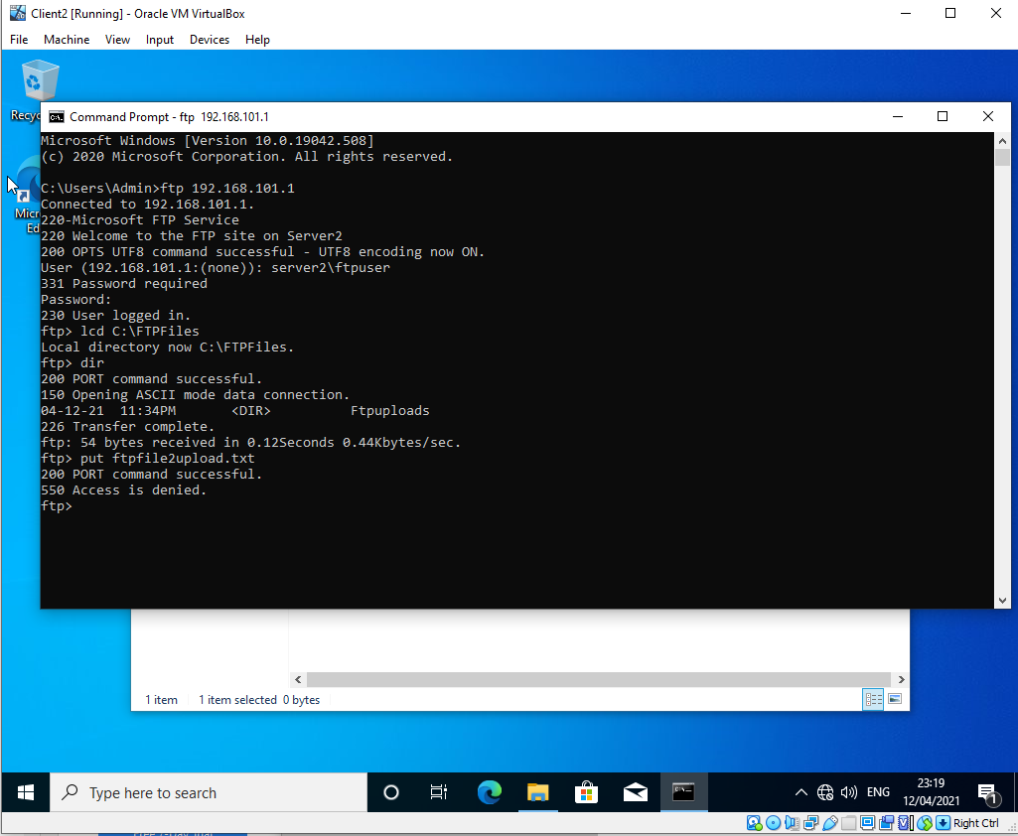

Figure 2 - Realised error and changed permissions and logged in as ftpuser2
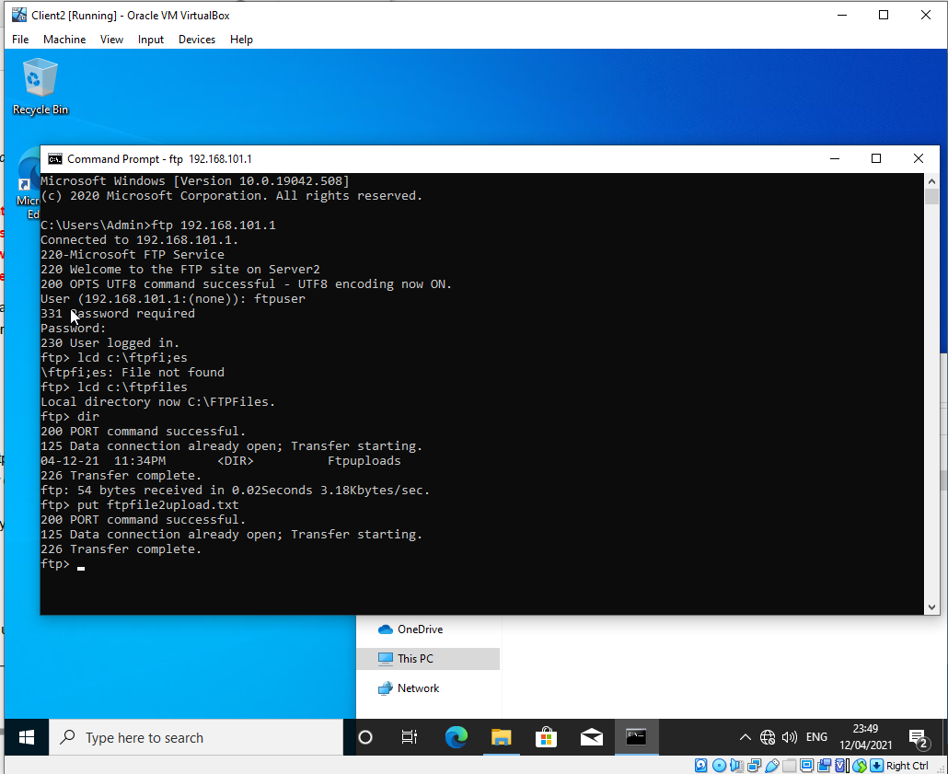

Figure 3- Folder now successfully contains moved file
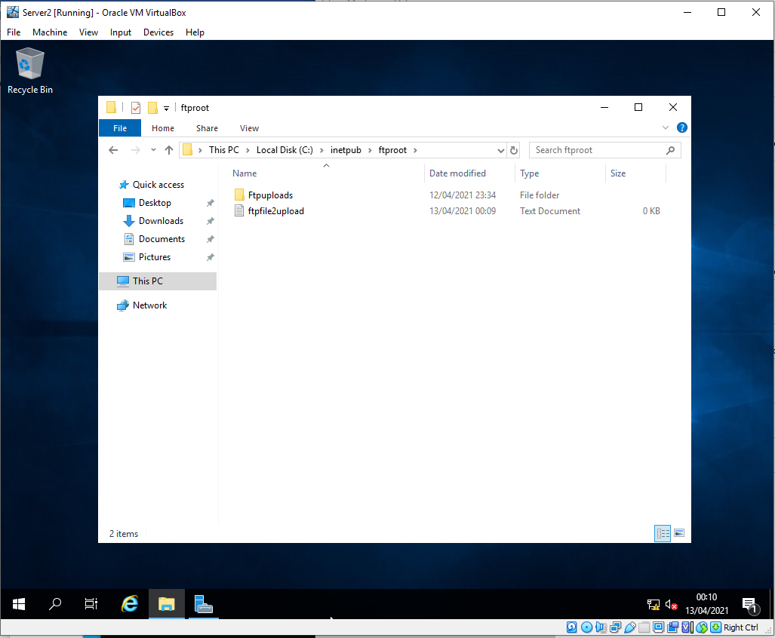

Task 3: Installing and configuring the Routing and Remote Access Service
Figure 4 - Unable to ping client 2 from client 1
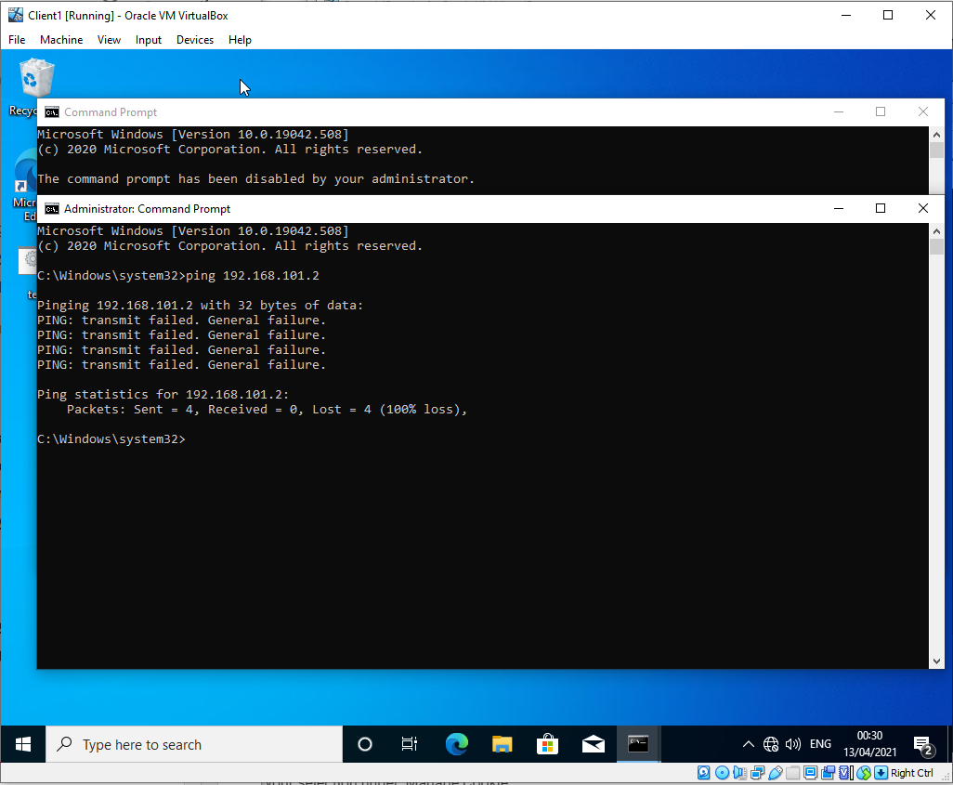

The author then conducted a series of sequential [pings between the device sand their gateways until I could get no further from client 1 to its gateway. Then to server 2 then to client 2 and visa versa.

Figure 5- I concluded that I could not get from client 2 to client 1’s IP address. I suspect that there is an issue with server 1 routing.
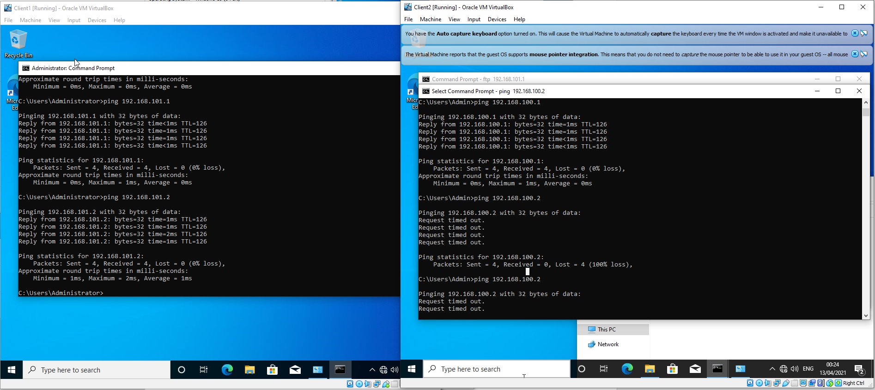

Figure 6 – Check firewall is not blocking something as per Lee’s notes.
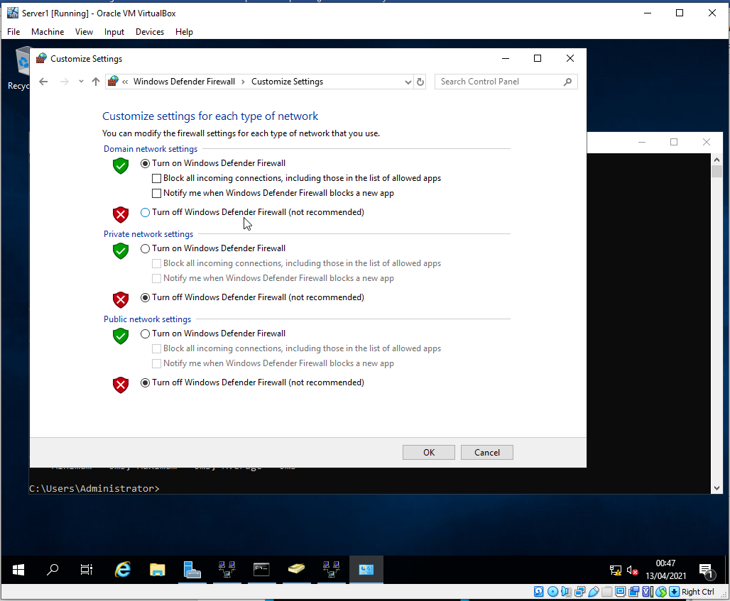

Figure 7 – Noticed that I had not inputted the DNS addresses in
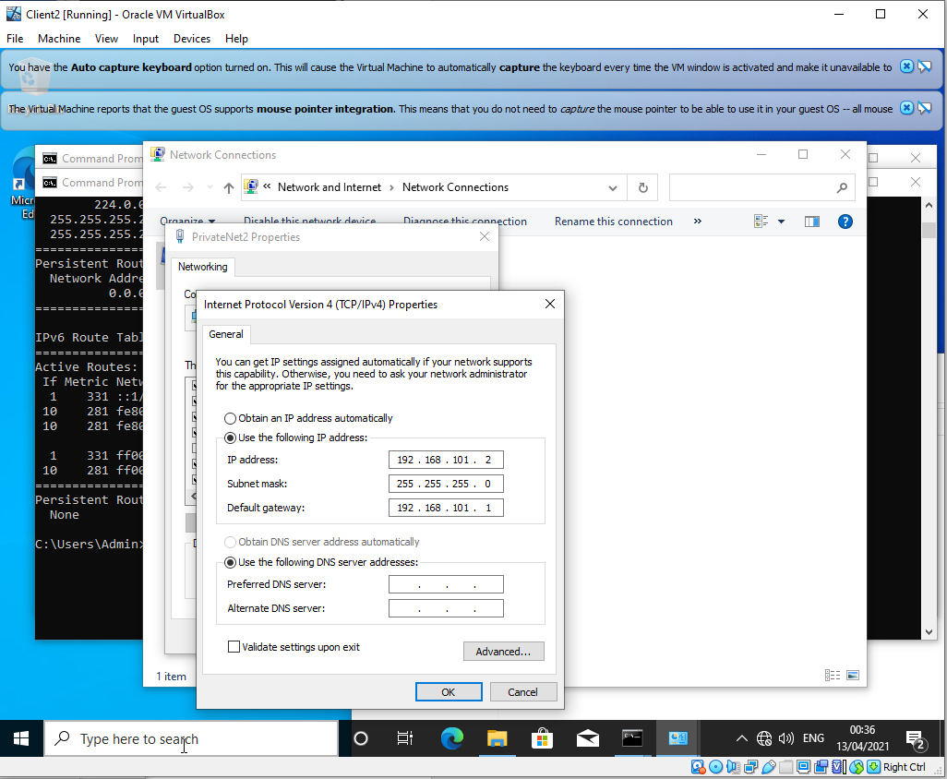

Figure 8 - Suspect DNS issue.
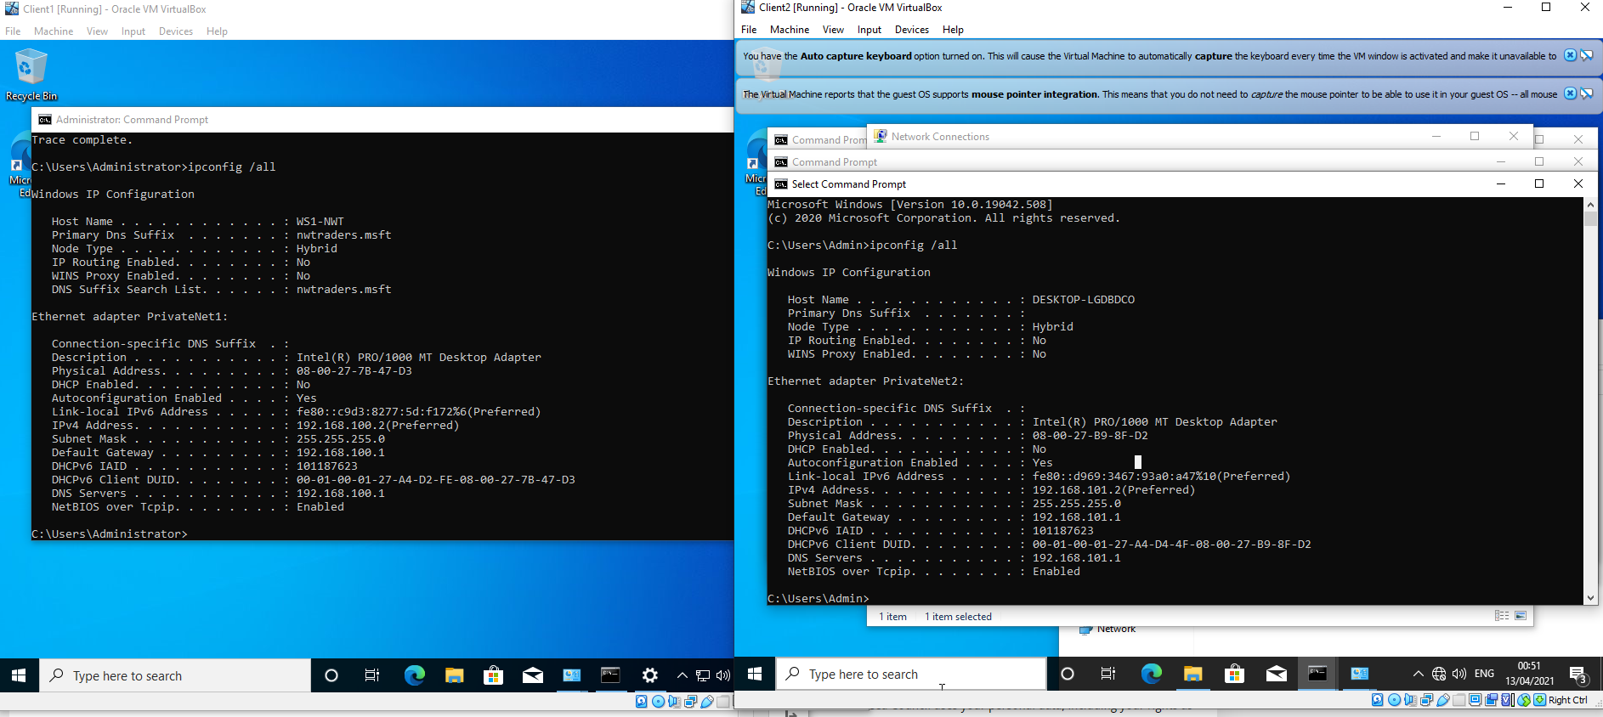
Figure 9 - Finally now pinging after a lot of testing ping tests to the NIC: 127.0.0.1 the author had not been set as DNS address as it had on server 1.
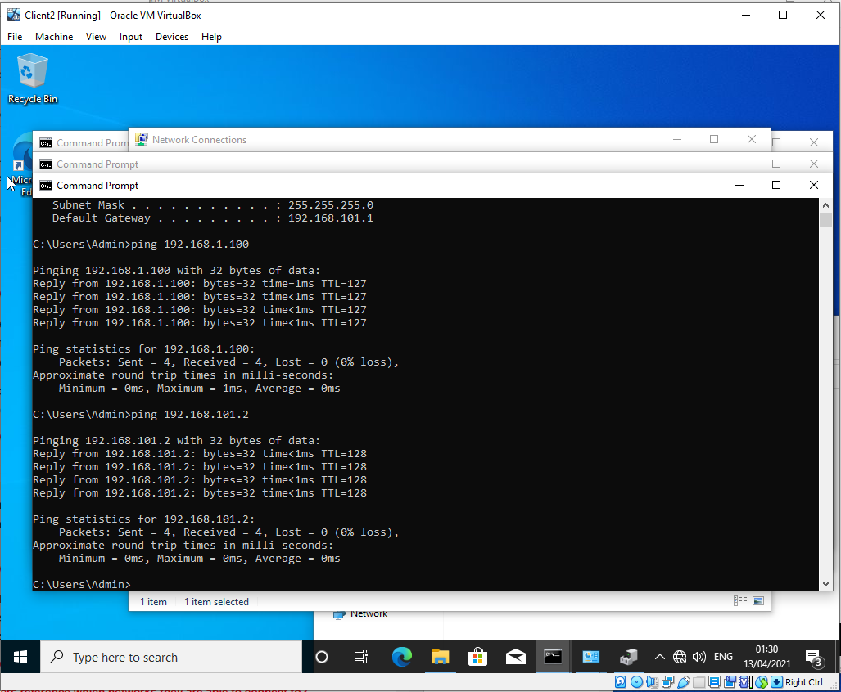

Figure 10 - As shown below: server 2 did not have a DNS entry. Inputted one and now works fine.
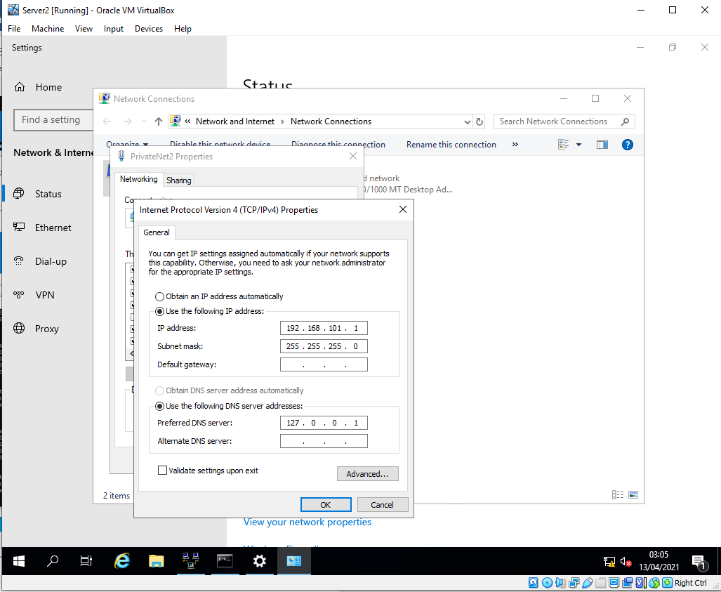

Task 4: IP Packet Filtering

Figure 11 – Filter 1 - Unable to ping 192.168.100.1 but able to ping 192.168.1.100
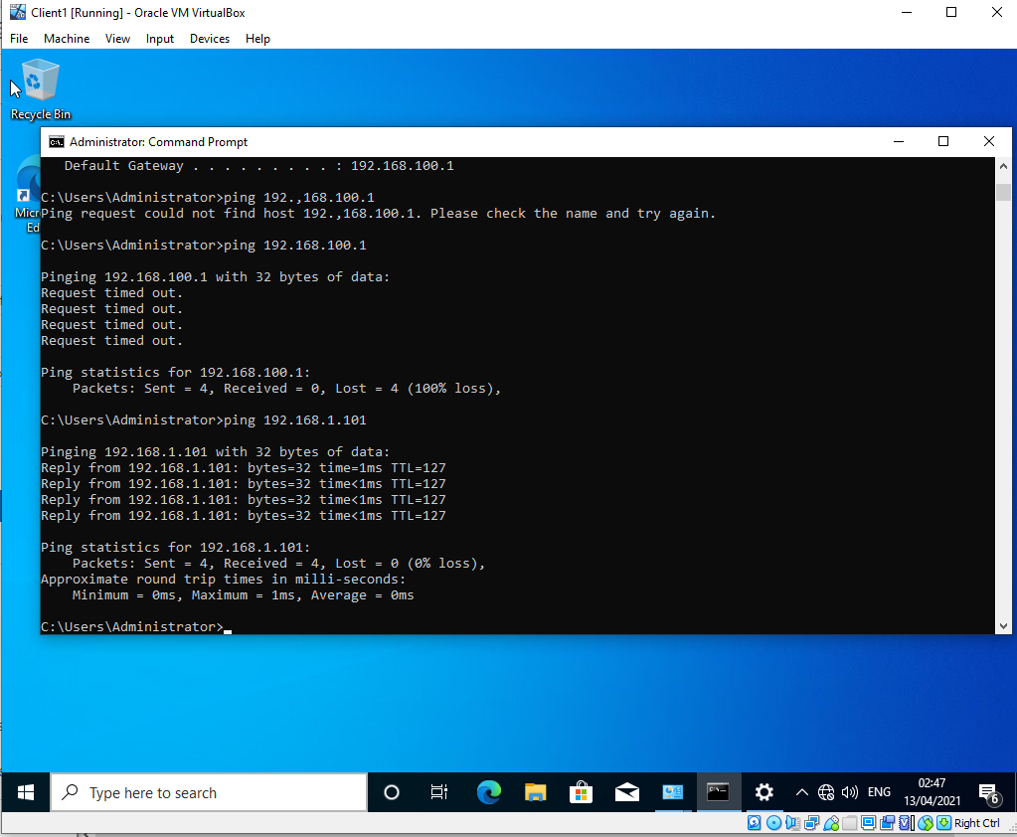

Figure 12 – Filter 2- Had to construct a rule to test the ftp on 20 AND 21
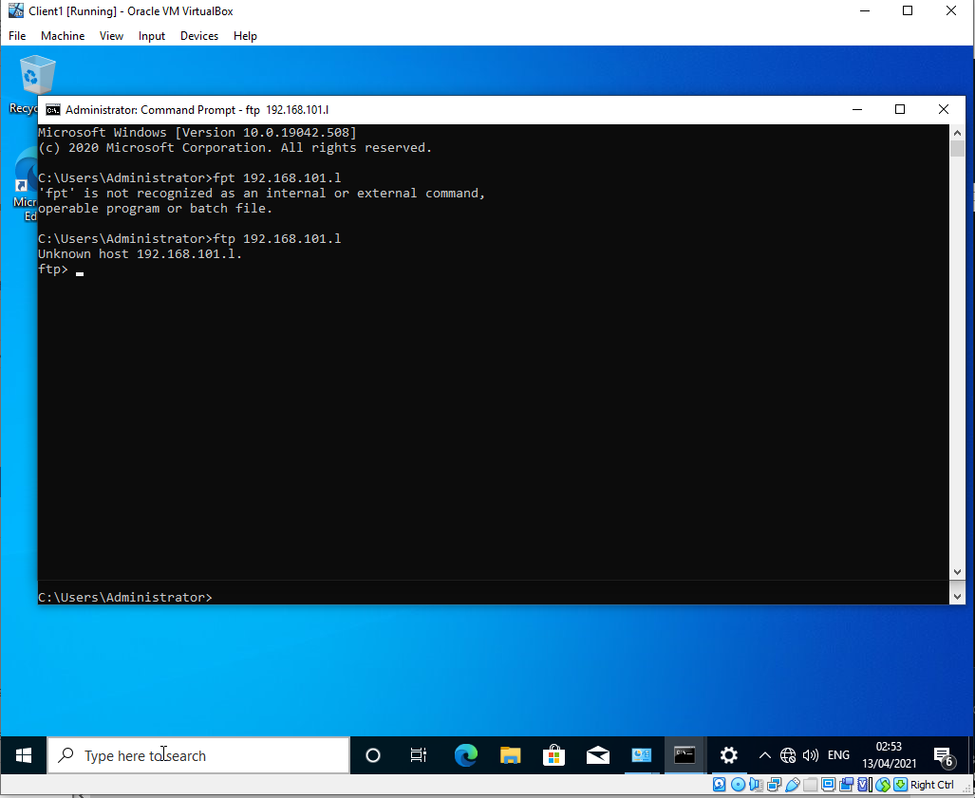

Figure 13 - Server 1 rules
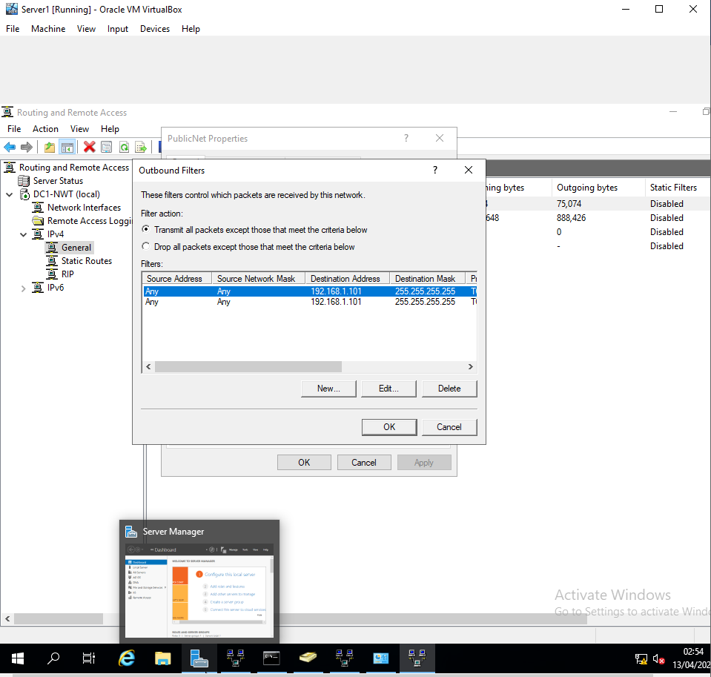

Figure 14 - Filter 3 - working on outbound rules.
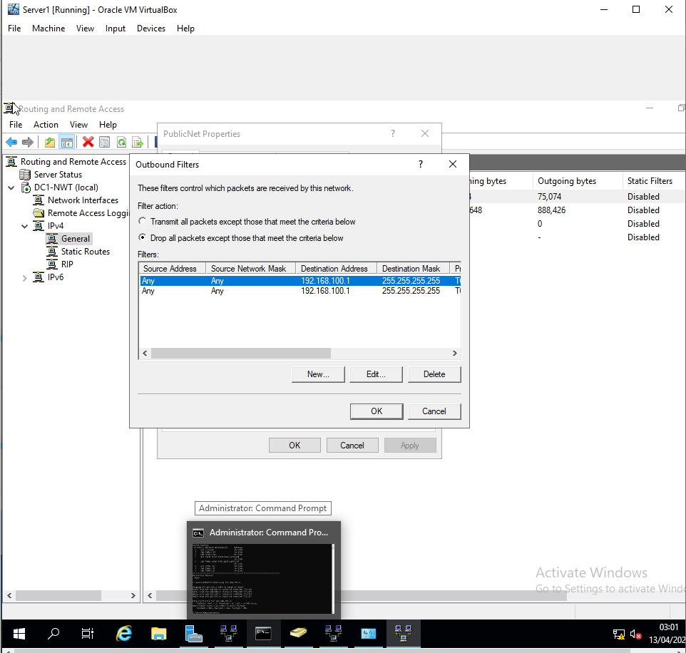

Task 5: Failover Clustering for high availability systems/services

Continuous availability (CA) is an IT system which makes sure users are connected to their workspace (docs, files and applications) protecting against the term known as downtime (a period of resource non-availability).
There are varying degrees of availability characterised, a term used in this context is called high availability. Represented as a percentage of availability 99.9% for a whole year equates to 8.77 hours of downtime. If this is during a critical time it could have a massive effect on a company’s operation or if monitoring a nuclear reactor or a transport vehicle it would require a much higher level of availability due to the stresses it is placed under.
‘High availability protects companies from lost revenue when access to their data resources and critical business applications is disrupted.’ [1]
This definition focuses on a financial aspect of availability however it should also be note that there are instances when availability can come at a critical moment too: ‘High Availability refers to a system (a network, a server array or cluster, etc.) that is designed to avoid loss of service by reducing or managing failures and minimizing planned downtime.’ [2]
It is important to remember that there is always going to be some downtime, it is just when this is being planned that issues occur, during the middle of the day for a bank for example would annoy a lot of customers but giving advanced warning and doing a change at 3am would not affect as many users.
Scheduled downtime for maintenance, hardware and software upgrades are not included in this and should fall outside of normal daily business hours wherever possible.
According to IBM there are 4 requirements of a highly available architecture:
- Load balancing – the distribution of client requests between cluster nodes and the balancing mechanism must specify the process should there be a failure.

- Data scalability – centralising or replication partitioning ensuring an application can maintain their own data storage.

- Geographical Diversity – resilience to disaster in a physical location failover to another location

- Backup and recovery – restoring an entire system within a Recovery Time Objective (RTO)
[1]

In order to maintain a high level of availability within an environment there are 3 basic principles:
Single points of failure so that no one component is relied upon or potential failure of the whole computer system. If there is a single component in the network (say an ISP’s router) perhaps adding additional power or supplying a Uninterrupted Power Supply (USP) or perhaps even requesting a higher service Level Agreement (SLA) can turn it into a source of power.
‘…a powerful network design should prevent a case in which … a single device failure can disrupt the network as a whole. As a consequence, we believe that the very first requirement is to avoid or mitigate the presence of an SPoF in the network.’ [3]
Detection of failure and a reliable crossover, this is sometimes a piece of cable which is called a heartbeat cable which connects the clustered servers together. Pulses signals are sent between the servers followed by a set of instructions programmed to takeover in the event of a failure.’ It is of great importance to enable a running VM to be moved to another physical machine (host) seamlessly.’ [4]
In one instance it could be an exchange server moving between hosts, in another it could be a self-driving car switching between primary and secondary computer seamlessly.
Microsoft offers a clustering service that combines availability, parallel computing and failover through more than one server to work together. Microsoft calls these technologies Microsoft Cluster Service (MSCS), Component Load Balancing CLB and Network Load Balancing (NLB).
MSCS is hidden in the back-end (behind the scenes) service which tries to mitigate the effect of a system fail on a particular node if it is unserviceable or taken offline. It does this by providing high availability for databases, print and email services.
CLB provides dynamic balancing of load across multiple servers running across a site. CLB acts as a middle man between the NLB and the MSCS on up to 8 servers within a business’s estate. COM+ (Component Object Model) or language-neutral objects which are ran within an environment can be ran across other servers.
NLB acting as a doorman it works by sharing IP packets across the clustered servers. In Server 2003 this can be up to as many as 32 computers and allows for scalability and unrivalled availability for ecommerce platforms. NLB provides automatic server failure detection and can divert the traffic to other servers within 10 seconds providing a seamless service to the users.

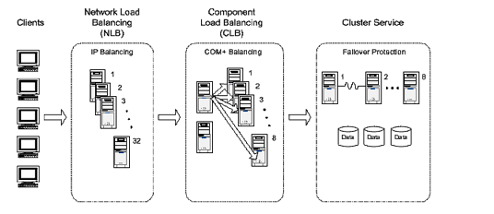
Figure 16 - Microsoft Server Technology providing a cluster support: [5]
One such example of deploying high availability and site resilience is Microsoft Exchange it is called incremental deployment. This concept is whereby two or more mailboxes are installed as standalones and then incrementally configured for the high availability and resilience as required.
After the initial network planning and addressing database Availability group must be created, both running the same version of Exchange. Servers running 2012 versions of Server will require something called pre-state cluster name object (CNO). Add the mailbox servers to the DAG then configure. At this point compression and encryption should be considered also. Datacentre Activation Co-ordination should now be enabled to prevent a split brain scenario. Final add the mailbox copies into the servers.
Following the successful setup of the exchange server there are several tests that should be conducted, replication is working, failover, health and various other fail scenarios.
The health and status of the deployment should continue to be monitored.

Task 6: Observational Tasks
Theoretical Network Policy for ‘SmartBank’
Abstract
SmartBank is a new global banking system that spans across the whole of the UK. The author is head Network Administrator for this network. A new draft network policy is required to be written to ensure that standards are followed and procedures are adhered to. The list is not exhaustive and certain scenarios will call for additional support or “best efforts” to secure the network from potential threats.
An enterprise network ‘…Consists of physical and virtual networks and protocols that server the dual purpose of connecting all users and systems on a local area network to applications in the data and cloud…’ [6] By utilising this method of network SmartBank can benefit from reduced costs of estate (reduction in server room footprint). By mitigating the risk in the security policy it is entirely possible
Network Policy Document
Critical business applications
In the first instance it is important to identify how business applications and how users can continue their day to day working.
Domain Controller, Domain Name Server, Dynamic Host Configuration Protocol, Email, File and Application Servers are all designated as critical servers of the network. In addition to this, at the main site the firewalls and core switches, Network Termination Unit, Router and Rear Link router(s) are designated as key also. The servers are clustered and virtualised 4 key servers at the main site, they also have a replication to the cloud. At the main site the servers are duplicated across 2 main sets of servers so should one fail then it will move to the other, this is kept alive by a heartbeat cable so within 10 seconds of a failure the other cluster will move to its secondary server providing an almost seamless transfer.
Coming into the site there are two sets of firewalls. This is called a walled garden and is explained further on in the document. The reason for sets of 2 firewalls is for redundancy and aggregation of links. By aggregation of the links this allows more through put and processing power in the network. From the exit point router to rear-link router and all the way through from the core, distribution to access layer switches there are high spec fibre cables. This is including to the key servers of the network to provide the best possible speeds to the users. Again all of these will have dual network cards to eliminate the point of failure.
High Availability Practices
By utilising cluster monitors and having a sensible but relatively low failover time to detect a failure.
Coming into the site there are two sets of firewalls. This is called a walled garden and is explained further on in the document. The reason for sets of 2 firewalls is for redundancy and Aggregation of links. By aggregation of the links this allows more through put and processing power in the network. From the exit point router to rear-link router and all the way through from the core, distribution to access layer switches there are high spec fibre cables. This is including to the key servers of the network to provide the best possible speeds to the users. Again all of these will have dual network cards to eliminate the point of failure.
RAID 6 (also known as dual drive protection) is a method of storing data in a striping and parity method (parity being a type of checksum to ensure the data is mathematically correct). This method of storing data to be stored across the disks and allows for recovery from 2 drive failures. It is slightly slower than RAID 5 (which only has 1 parity disk) however more reliable.
Load Balancing to ensure that the servers are working efficiently there is a requirement for a load balancer on the network. This can take the form of Round Robin (sequential), least connections and fastest response. There are variations on these, the method that has been selected in this instance is weighted least connections to allow the efficient timely processing of requests.
Failover should the load balancer detect that one of the heartbeats to the servers is not functioning after a set period of around 10 seconds, it will send traffic to an alternative location.
Cloud computing - in the event that the main site should be knocked offline, there is also cloud server availability. At the current time the bulk of the computing is conducted from the office at the main site however a dual cloud and fixed site approach is required. All users are equipped with laptop computers so they can work from home or in the office. Direct Access allows them access to continue their work from both locations. Should the computer not detect an office environment within 10 seconds of loading it will default to sending the users to Multi Factor Authentication and then access via the Direct Access method. A default script is also placed on the computer that if the user cannot access the main site within 10 seconds of login it will send traffic to the cloud servers instead. This will also poll the main site every 5 minutes thereafter to see if it has regained a connection.
SPOF Single Points of failure
There will be key areas over which we will have no control such as the rear link to internet. It is up to the service provider to give us a robust method of connectivity. It could be considered that an alternative method of connectivity such as a 5G connection point be installed or subscription to a higher level of service along with a fast response time. As it stands SmartBank would be able to function if the network went down as it has a method of cloud computing. Therefore, a secondary method of connection would be undesired and an increased level of service would be more desired from the ISP. Whereby there are duel power supplies in the router or core switches, the second should be connected and put into alternative power sources. An Uninterrupted Power Supply (UPS) should be used in case of power failure and should last at least an hour for a graceful shutdown of the system if necessary.
Disaster Recovery & Business Continuity Plan
A detailed and yearly practiced disaster recovery and business continuity plan should be developed and discussed. Yearly drills should be conducted to test the quality of the documentation and it should be thoroughly reviewed every 2 years. Key servers and services should be identified along with key workers to enable to company to function on a skeleton basis if necessary.
Downtime
Ideally there would be 100% availability and no downtime at all. However, it is entirely reasonable to expect there will be a downtime. Ideally, we should be aiming for 99.99% uptime which is equivalent to around 52 mins downtime per year. Where banking is concerned (savings, mortgages etc) anything more than this is unacceptable.
If the time the network is unavailable is during a key accounting time or something similar this is unacceptable. Routine maintenance should be scheduled at least 4 weeks in advance with warning to the users, this should fall outside of the daily business schedule. Changes should go through the Change Board and scrutinised in detail including if the plan should fail. Emergency downtime is unavoidable and should be authorised only if necessary. Warnings should be sent to users via various methods and users should involve their business continuity plans immediately.
Architecture of NW
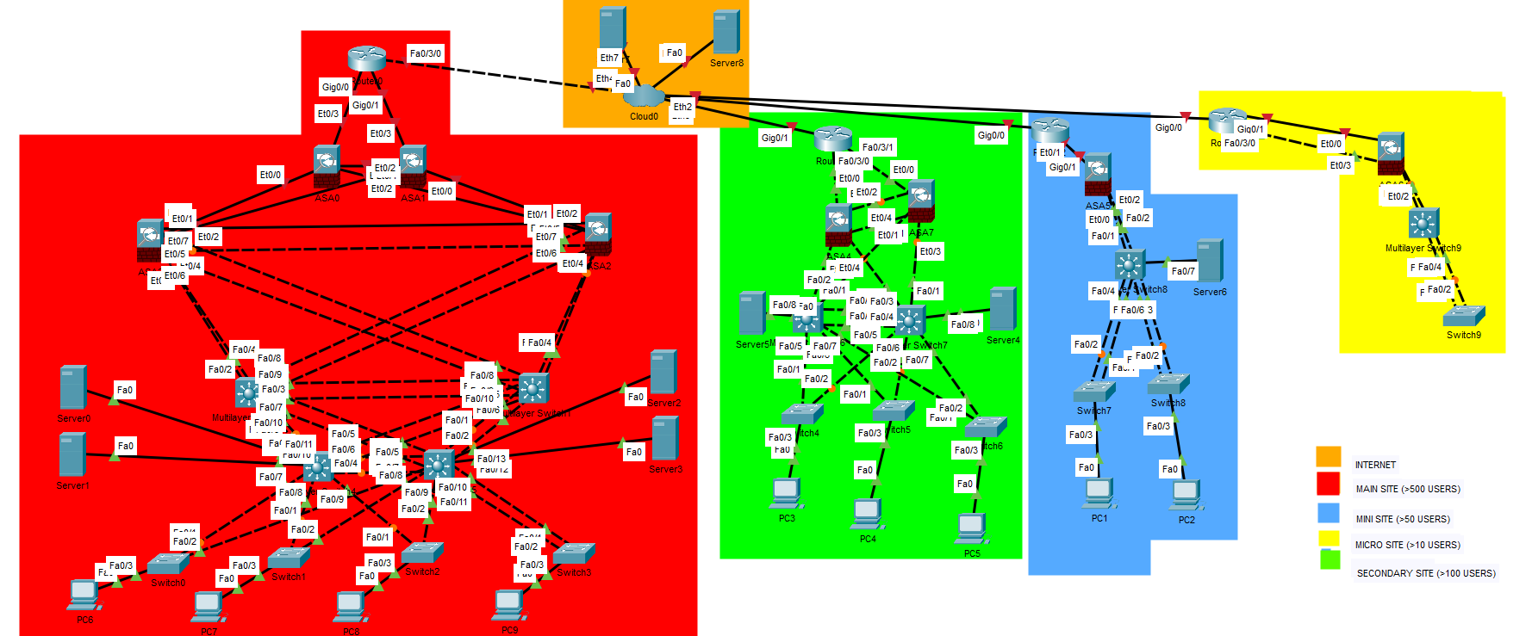
Figure 17 - Depicting Cloud based, main, secondary, mini and micro sites within SmartBank
The above figure depicting the nationwide architecture within SmartBank’s operations.
High redundancy at the main site (red), while reduced at green, blue and yellow sites.
It should be noted that users can also reach into each site if they are working from home. All data is replicated and synchronised nightly with the cloud-based servers. The method of topology is discussed later on as to why it has been chosen.
Encryption between all of the sites exists due to security which is discussed later on.

Topology
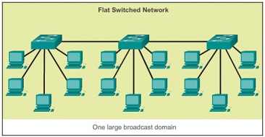
Figure 18 - Flat switched network structure [7]
This method of network design points to multiple single points of failure. To add or remove devices from the network can be difficult however the costs are considerably lower in this instance. The cost in terms of outages however could be far more. This is an undesirable method of connectivity.

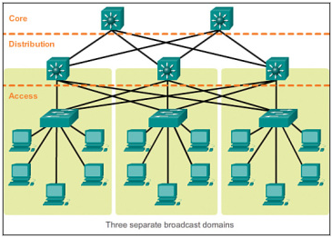
Figure 19 -Hieratical network structure [7]
By dividing the network into a hierarchal method, it is easily more scalable and redundant/ aggregate links are introduced increasing throughput and providing an alternative should the worst happen. By adopting this method of network, it easily dictates where the higher-powered equipment should be placed on the network. By placing fibre (or equivalent) cabling at the core and distribution of the network, performance in the access layer should also see an improvement. This is a more costly method however the benefits far outweigh the negatives.

SmartBank Security Policy
To define a Network Security Policy, it is important to understand what the scope and definition of what one is. According to Cisco.com ‘A network policy is a collection of rules that govern the behaviours of network devices.’ [8]
An independent security team are located at the main site and at each of the satellite sites to ensure compliance of policy.
Policy Aim
The aim of this policy is to educate the administrators and users of the system as to the standards and expectations that they require. It is not exhaustive and it is designed to educate users of the system and guide them to the security team where they are unsure.
Security Team
The security team is headed by a suitably qualified manager in network security and design. Below him/ her is a firewall administrator, server administrator and a desktop administrator as well as a programmer. They are independent of all other teams and answerable to the head of digital services. The team runs 24 hour operations. They have full control of all devices on the network. They are audited by a 3rd party also.
Environment & Physical
Access to buildings, all buildings are to be locked, access to IT rooms are particularly more secure due to the sensitive nature of their contents. No 3rd parties are to be left on their own under and circumstances, badges and key codes are to be used to access the rooms, allowing single persons into the room at one time (preventing a walk through).
Access to computers - all devices are to be under lock and key when users have finished for the day. Screens should not be left unattended if they are open. If the device has to be taken home it should be put into a secure bag and kept out of site from car windows (kept in the boot for example).
Verification & validation of staff members all staff are to be criminally checked, security vetted, completed the necessary security modules and training for their job before access to the system is granted. Annual security compliance is to be kept up to date or their accounts are locked out.
Visitors & contractors to SmartBank are to be pre-booked and their passes to be validated and sent over prior to arrival. This process can take a few days and needs to go via the security team.
No installation of equipment unless approval from SCIDA and a written statement of works outlining what they are doing when they are doing it and what cab etc they are working on.
Servers and Network
Servers and switches should be housed in their own independent cabinet which is locked. Adequate light, heat and airflow should be given to allow their manufacturers advised optimum operation. Monthly maintenance (cleaning etc) should take place also.
Unused ports on servers (such as USB, CD etc) are to be physically detached and disabled in the BIOS. In Switches and routers these should be put into a shutdown state so they cannot be simply plugged into along with power-over-ethernet.
On installation of the network, a reading of each fibre and ethernet cable’s tolerance should be taken. If suspected at a later date it can be retested to ensure no bugging device has been added to the network.
Mobile Phones are to be kept away from computers at all times, these are to be placed into lockers outside the place of work. This is due to the sensitive nature (bank details etc) that are being worked on).
WI-FI there is WI-FI within the building to connect for day-to-day use of the network, but for maintenance and management of the system it would have to be in a locked office through a cabled connection due to the consequences of exposure. This would also be subnetted in a totally different IP class to clearly identify it from all other ranges.
Software Security
All devices are subject to monitoring at all times. Bitlocker is to be installed on each laptop, antivirus, malware as well as non-essential ports being disabled. Users will not be allowed to install their own software and will be given accounts that are restricted in accordance with their role (ie admin and domain accounts are not given to all users all of the time).
Accounts will be created for specific roles. The admins such as domain, DHCP etc are to be created in the initial setup but once done should be placed in a sealed envelope and put into a fireproof safe. From this point onwards users should have names etc associated with their roles to assist with auditing. Hours of operation perhaps should be restricted depending on their critical role to the network. 2 Factor authentication is to be used when logging on from home via Microsoft authentication app as well as in the office.
Passwords - Minimum password standards to be used, passwords to be changed on 6 monthly basis. Passwords cannot be shared. Resetting of passwords can only take place physically within set times and ID must be provided to identify correct person.
VLAN’s Virtual Local Area Networks, separate departments and security areas should be separated so that the traffic does not disrupt or present a security issue. Logical separation between public facing services, management of the network as well as internal communications is paramount.
MAC and IP security users with roles will only be able to use certain desks. This is to prevent users walking in an using a management VLAN for example. MAC port sticky is used in this instance.
Firewalls should be installed at entry and exit point of the network. This includes on each user's device to include when they are working from home and not on gambling or pornography sites. A ‘deny any any’ rule is to be placed at the bottom of the Access Control List as a ‘capture all’ method. Trained staff only should be using this system. Daily updates should take place with all the latest viruses. Whitelist of site visited.
There is a walled garden which is a double set of firewalls between the outside world and the inside servers and services. Ideally this would be a variation in manufacturer incase of potential breaches in one firewall’s firmware etc. It will make administration more difficult but worth it for a better defence.
VPN’s virtual Private Networks are designed so that companies can login to the system. This should be done on a case-by-case basis and for as long as the job is required – no longer than 24 hours. Connections between sites should use Diffie Heiman group 19 security when connecting between.
Policies are to be rolled out to computers, should a device not attached to a domain to get the latest updates within a defined period it will be tombstone from the network and will be required to be updated to be re-joined.
Permissions no one user is to be added to a resource, they should be added to the local user group for that device.
Breaches of Data
If data is suspected to have been lost then in accordance with training procedures are in place to report the breach, if in doubt contact the security team: Infosec@smartbank.com
Auditing and Monitoring
Software to monitor the users on the network is to be employed, this will include such software as SolarWinds or something along similar lines.
Annual external auditing should take place, this is a tendered contract which will involve a full penetration test vulnerability, exploitation along with a summary report and recommendations which must be acted on within the specified time.
Intrusion Detection System (IDS)/ Intrusion Prevention System – an IDS is designed to sit on the network and to monitor for suspicious or malicious activity on a network. Activity that is deemed as suspicious or malicious should be sent to the security team who will take appropriate actions. IPS is similar idea but works to prevent this happening in the first instance by closing ports/points of weakness whilst reconfiguring the firewall.
Enforcement of Policy
Regular auditing of the system and logs will be collected and monitored. Devices will be subject to minimum policy standards and updates, should they fall outside of these boundaries the devices will be blocked and then needed to be brought back in for updates before being allowed back on the network. Accounts will be allowed onto a network on a yearly basis and a register of security training undertaken. Accounts which fall foul of this will be denied access similarly people who abuse their privileges, share passwords etc will be denied access. Training and education of the user community is paramount in preventing unauthorised access to the network.
Education through emails, workshops and annual training against the latest types of cyber-attacks and threats we maybe facing will further bolster the arsenal against potential breaches.
Mitigation in Event of Violation
It has to be recognised that no matter how good your security is that people will always find a way into the network given enough time. Should this happen the problem device should be isolated from the network. It may be necessary to disconnect the system for a period of time to prevent (say a worm virus) from spreading. If a user’s device is compromised in an attack it should have been flagged in the first instance to the security team likewise a server. All efforts should be made to establish what has happened and a specific set of instructions issued from the disaster recovery or business continuity plan. At this point snapshots and backups should be located for the previous few days as it they may be required to provide a recovery.

Threat | Vulnerability | Asset and Consequences | Risk | Solution
Insider threat | Permission configuration | All servers and network equipment |  | Permissions on accounts, auditing, IDS.
Virus | Loss of data | Servers but potentially network equipment |  | Daily backups of data
Power Failure | Total loss of comms at site | All devices | High potential loss of £300,000 per hour | Migrate to the cloud and work from home on laptops
Equipment Failure | unable to access certain or all services | One or two devices | Medium loss of some but hopefully not all data | Should failover to another device carry on working.
Accidental Deletion | Data Loss | Servers | Medium loss of some but hopefully not all data | Use backup tapes to restore data.
Ransomware | All files are locked out | Servers (file) | Medium all files are locked down unable to access them.
Air Conditioner Failure | System failure, devices turn off | Servers and network equipment | Medium servers shut themselves off to protect equipment | Open windows to vent room, hire portable appliance

References

[1] | IBM, “IBM High Availability Overview,” Jan 2018. [Online]. Available: https://www.ibm.com/docs/en/ssw_ibm_i_72/rzarj/rzarjpdf.pdf. [Accessed 15 April 2021].
[2] | Impervia, “High Availability Solutions,” Imperva, 2020. [Online]. Available: https://www.imperva.com/learn/availability/high-availability/. [Accessed 05 March 2021].
[3] | A. Rashid, T. Pecorella and F. Chiti, “Toward Resilient Wireless Sensor Networks:,” Sensos, vol. 20, no. 14, p. 3902, 2020.
[4] | X. W. H. W. Binbin Zhang, “Virtual machine placement strategy using cluster-based genetic,” Neurocomputing, vol. 5, no. 1, pp. 310-316, 2020.
[5] | Microsoft, “Introducing Microsoft Cluster Service (MSCS) in the Windows Server 2003 Family,” Microsoft, 10 Oct 2016. [Online]. Available: https://docs.microsoft.com/en-us/previous-versions/windows/server-2003/ms952401(v=msdn.10)?redirectedfrom=MSDN. [Accessed 28 March 2021].
[6] | VMWare, “What is Enterprise Networking?,” VMWare, 20 March 2021. [Online]. Available: https://www.vmware.com/topics/glossary/content/enterprise-networking#:~:text=An%20enterprise%20network%20consists%20of,to%20network%20data%20and%20analytics.. [Accessed 5 April 2021].
[7] | W. Odomel, CCNA Official Cert Guide 200-301, Olkahoma: Pearson, 2018.
[8] | Cisco, “What Is Network Policy?,” Cisco, 2021 Jan 2021. [Online]. Available: https://www.cisco.com/c/en/us/solutions/enterprise-networks/what-is-network-policy.html#:~:text=Network%20policy%20is%20a%20collection,follow%20to%20achieve%20business%20objectives.. [Accessed 2021 Apr 2021].

