Proposal Title

AI Governance and Predictive Risk Analytics in Banking Cybersecurity: A Supervised Machine-Learning Decision-Support System Using the UNSW-NB15 Dataset.

Student Name: Jervis Alexis Payne
Student Number: 2127853
Course Name: MSc Data and AI
Module Name: Master Dissertation
Module Code: ACCA7003
Assignment Title: Data Analysis
Submission Date: 12th June 2026
14:00 (2 PM)

Table of Figures

Figure 1: CYBER RISK AS A THREAT TO FINANCIAL STABILITY 13
Figure 2: Evolution of Cyberattacks, 2010–20 14
Figure 3: Proposed System Architecture for AI-Enabled Cybersecurity Risk Decision-Support in Banking. 15
Figure 4: AI Governance Decision-Support Workflow for Cyber-Risk Classification 16
Figure 5: Gantt Chart showing plans and implemented tasks 17

List of Tables
Table 1: Summary of UNSW-NB15 Training and Testing Sets 8
Table 2: Summary of Model Features and Target Variable 9

Abstract
This research proposes developing a cybersecurity risk decision-support system using Artificial Intelligence (AI) based on the UNSW-NB15 dataset [1]. As the intrusion detection dataset for the banking sector. This research aims to meet the growing need for responsible predictive analytics in financial services, where cyber incidents or responses can affect operational resilience, customer trust and confidence, regulatory compliance, and organisational decision-making [2]. The goal is to explore the integration of AI governance and supervised machine learning to improve cyber-risk classification and human-centric decision-making.
The methodology ranged from investigating the data using Google Colab and Python to preprocessing the data and building models to comparing the efficacy of the Logistic Regression, Decision Tree, and Random Forest classifiers. The result will be a Streamlit dashboard that provides risk predictions, reliability metrics, explainability outputs, an audit trail, risk thresholds, compliance mapping, and recommendations for human review. Supervised machine learning, plus transparent governance functions, is expected to enable efficient prioritisation of cyber risk.
Based on the findings from this study, it is suggested that the impact of AI on bank cybersecurity should be evaluated in terms of predictive accuracy, explainability, accountability, and value in supporting decision-making.

Introduction
Digital banking has become an essential part of current financial services, enabling clients and organisations to perform banking functions, access accounts, manage payments, and operate in a connected digital world. But at the same time, this reliance on digital infrastructure has put the banking environment more at risk than ever to cyber security threats, including unauthorised access, malware, denial of service attacks, reconnaissance, attacks based on exploits, suspicious network traffic and other attacks or disruptions to the global operation of the bank. Business continuity, regulatory compliance, financial stability, enterprise risk management, and customer confidence are all affected by these incidents, which also pose technical security issues. As such, the sensitive topic of cyber security risk detection and prioritisation is extremely relevant to the banking industry.
This paper sheds light on a constant challenge for banking groups: how to find effective ways to detect and prioritise cyber-risk incidents and to acknowledge that, in highly regulated markets, confidence in AI prediction systems must be underpinned by good governance. Supervised machine learning can be used for intrusion detection to learn detection patterns from labelled network traffic and classify time as normal or malicious. However, predictive models that fail to explain, audit, or involve the human brain may not be appropriate for making cybersecurity decisions in the banking sector. The main problem with machine learning isn't just the technology's ability to detect; it's how predictive analytics can be combined with AI governance controls to enable transparent, accountable, and human-led cyber-risk decisions.
Given the financial sector's requirements for cyber resilience and responsible AI adoption, this research is both relevant and necessary. Financial authorities in the UK have recognised the impact of cutting-edge AI models on cyber resilience, and sector-wide cyber resilience frameworks supported by the Bank of England (BOE), Financial Conduct Authority (FCA), and HM Treasury have been called on to continuously monitor the cyber risks associated with AI and to develop and put into practice cyber resilience measures [3], [4].
Similarly, the Financial Conduct Authority has recognised the significance of secure and sensible usage of AI in the UK financial markets [5], [6]. In addition, the Cyber Assessment Framework by the National Cyber Security Centre aids organisations in assessing and improving their cyber security and resilience, as well as in managing cyber risk on essential services [7], [8]. These sources suggest that the battle against AI risks will be more profoundly interwoven with cybersecurity and governance in enterprise risk management.
The motivation and desire for this dissertation are both professional and private, with a professional path that includes goals and career aspirations in Cyber Security, Governance, Risk & Compliance, Banking & Decision Making with Data. Individually, the ordeal of having been a victim of debit and credit card fraud in the United Kingdom as well as in Antigua, during a period of card cloning in Antigua in summer 2025. Though these samples don't come from banks' internal banking data or from analyses of individual bank fraud cases, they do illustrate how relevant banking cybersecurity and risk-monitoring systems can be. This personal motivation consequently motivates solving another issue in enterprise cybersecurity.
Extensive research has been conducted on the application of machine learning techniques in intrusion detection, using Logistic Regression, Decision Tree, and Random Forest models. Much of the literature, however, focuses on predictive metrics (such as accuracy and detection rates) and often ignores governance, explanation, auditing, and the use of model outputs by human decision-makers [9]. This oversight creates a gap in research and practice. In the banking industry, technical filtering performance alone is insufficient, as cybersecurity decisions can have operational, regulatory, and reputational consequences. Thus, there is a need for more research to integrate machine learning-based intrusion detection with AI governance mechanisms, including explainability, transparency, accountability, audit logs, risk thresholds, and human supervision [10].
The focus of this dissertation is to fill this void by developing a supervised machine-learning model based on an intrusion detection dataset called UNSW-NB15 to act as a decision support system. Logistic Regression, Decision Tree, and Random Forest classifiers will be compared to classify network traffic as normal or attack traffic in a binary classification problem. The final system will be deployed as a Streamlit dashboard, where the models' predictions will be broken down into risk levels and confidence scores, then explained or audited, with actionable points suggested for human review. The envisioned project is a development-based solution that demonstrates how predictive analytics and AI governance can help banks make cyber-risk decisions.

Objectives
This research aims to develop a cybersecurity risk decision-support system for banking environments that incorporates supervised machine learning techniques and AI governance principles and to evaluate its design. The goals of the research are as follows:
1. Review and analyse the existing literature in banking and financial services in relation to AI governance, cybersecurity risk analytics, intrusion detection and operational resilience.
2. Analyse and argue the appropriateness of the UNSW-NB15 dataset for cyber-risk supervised classification.
3. Implement pre-processing of the data, splitting input features and target labels, encoding categorical variables, scaling numeric variables, and taking steps to avoid target leakage.
4. Build and compare three different models: Logistic regression, Decision Tree, and Random Forest model to classify normal vs malicious traffic.
5. Create a Streamlit dashboard to visualise the predictions, risk scores, confidence scores, interpretability results, audit trail, and user feedback suggestions.
6. Measure system performance based on performance metrics and governance criteria such as accuracy, precision, recall, F1 score, explainability, auditability, and, more importantly, value of decision support.

Importance of Research
The research is significant both in terms of its impact on academic understanding and on applied decision-making within cybersecurity. From a scientific perspective, the implementation of supervised machine learning on intrusion-detection data and its evaluation will be explored beyond typical accuracy measures. The analysis of the different models (Logistic Regression, Decision Tree, and Random Forest) will help understand the effectiveness and explainability of the models for Cyber-risk classification, as well as each model's suitability. Additionally, it creates the first standard for explainability, auditability, risk thresholds, and human monitoring to be incorporated into a technical system, all of which are key elements of the emerging field of AI governance [11].
In practice, the study is applicable to banking and financial institutions that rely on digital infrastructure and need to respond promptly to digital threats. Documenting risk-based responses and understanding model forecasts could be achieved by a dashboard for decision support, which could also assist in prioritising suspicious activity. This project is thus useful for positions that involve cybersecurity, governance, risk and compliance, and require a technical understanding along with accountable decision-making.

Literature Review
Bank groups all have a footprint in digital platforms, online transactions, payment systems, and customer data and technology providers interconnected with bank systems and services, have made cybersecurity risk management a major issue in banking and financial services [12]. IT and cyber incidents can lead to loss of productivity, data loss, loss of customer trust and regulatory liability. In this context, intrusion detection is a critical technical control, as it assesses network traffic to alert on suspicious or malicious activity before it becomes critical [13]. Rule-based and signature-based IDS are among the traditional methods used to detect intrusions, but these techniques are often ill-suited to handling novelty, evolution, or complex attack behaviour. This restriction has motivated researchers to seek patterns in traffic to classify normal and malicious behaviour using machine learning [14].
It has been a popular dataset for intrusion detection research because it contains both normal network traffic and a range of modern synthetic attack techniques. There are nine types of attack families: Fuzzers, Analysis, Backdoors, Denial of Service, Exploits, Generic, Reconnaissance, Shellcode and Worms [15]. This makes it more appropriate for the latest intrusion-detection experiments than previous datasets like KDD99, which have been criticised for containing outdated traffic and redundancies. But UNSW-NB15 is not a flawless dataset, as shown in the literature [16].
However, other studies argue that it is necessary to address the challenges of class imbalance and class overlap before building classifiers. Because the preliminary exploration of the datasets revealed that the training distribution was uneven, with both the attack and normal datasets having more attack data records. Hence, the evaluation strategy should not rely solely on accuracy; a mix of precision, recall, F1 score, and confusion matrix analysis should be included [17], [18].
Supervised machine learning has been widely used in intrusion detection due to the availability of labelled data sets, which enable supervised models to learn the relationship between the data's feature space and the attack label space [19]. Different levels of complexity and interpretability are available for this project. Logistic Regression, Decision Tree and Random Forest are appropriate models for this project. Logistic Regression works well as a baseline model because it is flexible, efficient, and interpretable, but it has the drawback that the relationship between features and attacks is not linear [20].
Another advantage of the Decision Tree model is its ease of interpretation, as the decisions can be followed visually through the presented splitting rules. But if not controlled through pruning or parameter tuning, they can be prone to overfitting. To overcome this disadvantage of the single tree, multiple decision trees should be combined [21]. Random Forest does it by combining many of them, which affords better classification performance and is more stable for prediction than a single tree. Unlike a Decision Tree, Random Forest is not transparent and would require explainability techniques or feature-importance analysis to help process the outputs [22].
Several recent studies have shown that ensemble-based models can perform well in intrusion detection, although factors such as preprocessing, feature selection, class distribution, and evaluation design also significantly impact their performance. This reflects that accuracy alone does not imply proper use of a model for operational decisions in cybersecurity [23], [24]. For instance, when a model performs well on the majority class but fails to capture minority attack classes, it may not be "safe" for cyber-risk prioritisation. This is especially true for banking, where an incorrect negative could result in failing to detect malicious traffic, and an incorrect positive could overload analysts and undermine trust in the system. It is thus important to do a critical evaluation which considers the balance between detection performance and operational usefulness [25].
Elevating the relevance of XAI for cybersecurity is the fact that many AI models can be seen as ‘black boxes' and are therefore hard for analysts to interpret due to insufficient information about the reasoning behind the model's predictions. Without explanation, in a risky environment, it can lead to decreased trust, decreased accountability, and limited adoption. In the field of cybersecurity, the literature claims that explainability can facilitate security analysts' understanding of model decisions, support the verification of security decisions, or help identify anomalies in the training data [26], [27].
Methods such as SHAP and LIME are often discussed because they can identify which aspects were most influential in the prediction. But there are also several drawbacks to explainability methods. Explanations from SHAP and LIME may differ from model to model and with changes in data structures and relationships between features, and should complement, but not substitute for, human judgement. This is also necessary for the sake of the proposed project, as it requires explaining that the evidence and feature importance presented in the dashboard are not automatic proof of a malicious case, as they would be if the case is malicious [28], [29].
AI governance offers a broader framework for the responsible use of predictive systems. The AI Risk Management Framework defines the following dimensions for managing AI-related risks: Validity, Reliability, Safety, Security, Accountability, Transparency, and Explainability [30]. In the financial services sector, these issues are particularly relevant, as the generation of AI content can impact customer protection, fraud mitigation, operational resilience and regulatory compliance. AI has the potential to reshape financial services but also poses potential pitfalls that need to be evaluated and managed, as the Bank of England noted [31]. The Bank of England (BoE), Financial Conduct Authority (FCA), and HM Treasury have also recently stated their positions on frontier AI and cyber resilience, noting that AI may pose a cybersecurity risk to financial sector resilience. This underscores the relevance of a banking dissertation topic that links predictive analytics to governance controls [32], [33].
Although research has made considerable efforts to implement machine learning for intrusion detection, a gap remains between model development and the implementation of model-guided decision support. While numerous studies focus on the performance metrics of algorithms, fewer show how predictions should be transformed into risk levels, audit trails, explanations, and human review actions [34]. This gap is important because banking cybersecurity is a predictive space, but it also requires accountability and operationally usable risk decisions. Models that indicate an attack but lack the ability to explain, log, and consider the outputs in context can be a governor's weakness [35].
This study aims to fill that gap by using supervised machine learning and an AI governance layer. The proposed system will compare the Logistic Regression, Decision Tree, and Random Forest models on the UNSW-NB15 dataset and implement the proposed model via a Streamlit dashboard. It will feature risk classification, confidence scores, feature explanations, audit logging, risk thresholds, compliance mapping, and human-review recommendations in the dashboard. Thus, it goes beyond technical classification performance, enabling the realisation of how predictive analytics can be coupled with responsible AI governance frameworks for banking cybersecurity decision-making [36], [37].

Hypothesis / Research Question
The main research question for this research is:
How to fuse the two principles of Artificial Intelligence and the predictive analytic capabilities of AI based on supervised machine learning using the 'UNSW-NB15' banking cybersecurity (IDS) dataset into a decision support system?
The research question is: given the binary classification problem of normal vs malicious traffic, how do Logistic Regression, Decision Trees, and Random Forest models perform on this dataset? Analytical and statistical techniques will be used to investigate the research question. Depending on the case, model performance will be evaluated using accuracy, precision, recall, F1 score, confusion matrix, and ROC-AUC. The governance and assessable components will involve the dashboard/explainability, audit notifications/s, risk thresholds, compliance mapping, as well as human-review suggestions.
The research hypothesis posits that supervised machine learning is superior to AI governance controls for cyber-risk classification (technical prediction). This hypothesis relates to the research problem, which isn't only about detecting attacks but also about maintaining clear, auditable records and the role of humans in decision-support mechanisms in banking cybersecurity.

Research Design and Methodology
The project will be designed and evaluated as a software program; hence, the design science research methodology will be used. The program will be an AI-powered cybersecurity risk decision-support system for the banking industry, implemented using supervised machine learning and displayed via a Streamlit Dashboard. The methodology is suitable, as the research questions require an evaluation of AI governance controls and their technical implementation [38].
UNSW-NB15 intrusion-detection dataset will be used. Upon initial inspection, it was determined that the training set has 175,341 records and the testing set has 82,332 records, with 45 columns per record in each set. Supervised classification can be performed with this data, and the sample size is sufficient. Tables 1 and 2 give summary information of the dataset and the structure of the features.
The methodology will be structured throughout the development process. exploring the data at first glance and determining whether there are missing values or duplicates, the distribution of values within each class, and the nature of each feature. Input variables will then be isolated (discretised) from the target variable. The label column will serve as a binary class (target) variable wherein 0 represents normal traffic and 1 represents attack traffic. That is because the id column will be dropped, and attack_cat will not be used to train the models, as it is said to introduce Target leakage. Lastly, categorical data such as proto, service, and state will be one-hot encoded, and numerical data will be scaled accordingly.
Modelling will compare the Logistic Regression, Decision Tree and the Random Forest classification techniques. These models are chosen to include a range of features, allowing a baseline linear model, an interpretable tree-based model, and a more elaborate ensemble model to be compared. The performance will be evaluated using appropriate metrics, including accuracy, precision, recall, F1 Score, confusion matrix, and ROC-AUC. The suggested system architecture is given in Appendix B, Figure B3.
The final development stage will involve creating a Streamlit dashboard to visualise predictions, risk indicators, certainty scores, audit logs, explainability outputs, and human-review recommendations. Appendix B, Figure B4, shows an AI governance workflow. This makes it possible to assess the system as both a predictive model and a decision-support tool for use in the banking context.
Table 1 Summary of UNSW-NB15 Training and Testing Sets
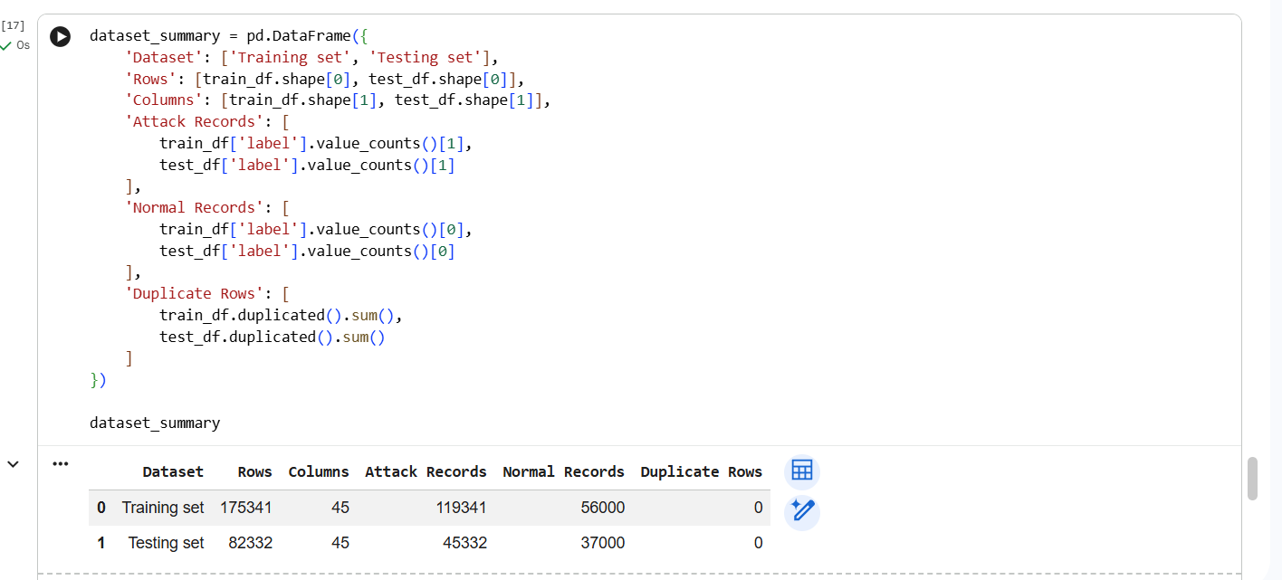
A preliminary investigation of the chosen UNSW-NB15 data indicated that it is large and well-labelled for supervised classification, as shown in Table 1.
Table 2 Summary of Model Features and Target Variable
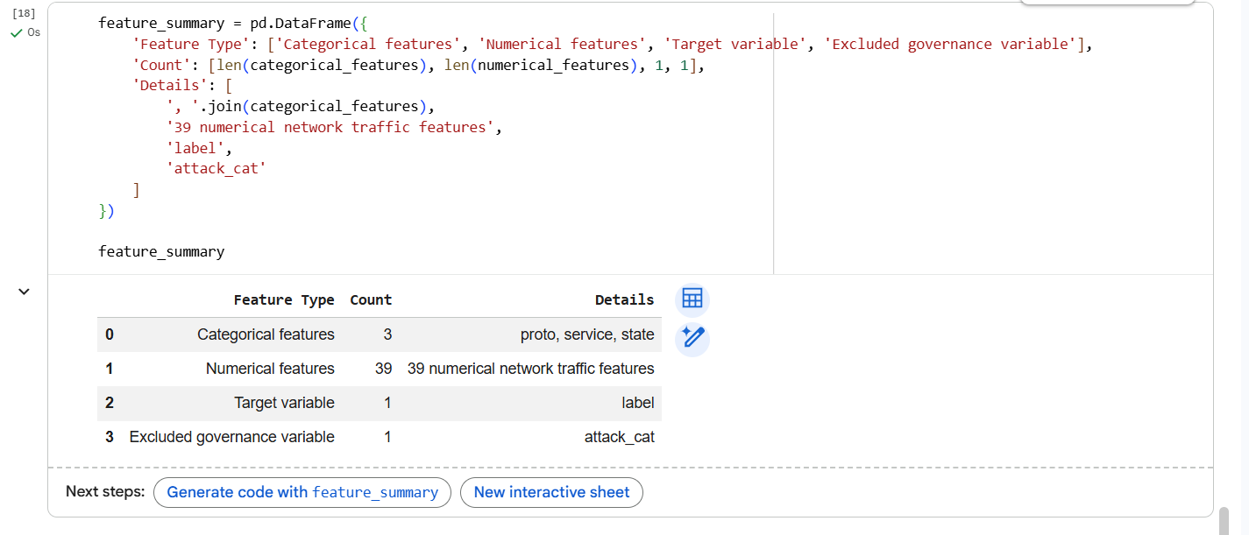
The model inputs and target variable were separated, and the feature structure was inspected to determine the categorisation of each feature, such as categorical variables, numerical variables and excluded variables, which are tabulated as shown in Table 2.

Research Limitations
There are factors that can affect the study's design and results. Firstly, the UNSW-NB15 is a publicly released intrusion detection dataset, not an actual banking network dataset. It can be used for supervised cybersecurity classification, but it does not capture the complexities, confidentiality levels, customer behaviour, infrastructure, and threat patterns found in real-world banks. Thus, the results may not be generalisable to an operational financial institution.
Second, this suggested system will be a development prototype for a cybersecurity system, but not yet ready for production. The Streamlit dashboard will reflect decision-making capabilities and won't be exposed in a real banking environment or tested by professional security analysts. In terms of methods, the model's performance will be sensitive to the quality, balance, and structure of the chosen data set. Practical applicability might also be affected by false-positive or false-negative results. These constraints will be addressed through clear marking, discussion, and the presentation of the system as an academic demonstration.

Expected findings
In the Network intrusion detection area, supervised machine learning should be useful for classifying cybersecurity risk, since it has a large, labelled dataset. It is believed that the advantages of all 3 selected models will vary. Logistic Regression appears to be an acceptable baseline approach due to its simplicity and efficiency, but may not resonate as well if the attack is non-linear. Decision Tree models are expected to provide better interpretability but can be more prone to overfitting if not controlled. Random Forest may be as efficient, as it can aggregate multiple decision trees, which may require additional explanation to ensure transparent information. However, capturing complex feature relationships is anticipated to be great.
Moreover, particularly in the e-services sector, the study's findings will confirm that metrics based solely on predictive performance are insufficient for making informed decisions about banking cybersecurity [39]. While the imbalanced class distribution in the data set means that precision, exact recall, confusion matrix analysis, and F1-score will likely be more useful than the accuracy metric, which only provides a single performance measure. As outputs from the model, the Streamlit dashboard will show how risk level, confidence scores, explanations for human consumption, audit logs, etc., can be mapped back to the model's output.
Finally, the deliverables expected to be achieved include a working prototype of a development executional program that will clearly demonstrate that Cyber Risk Analytics through AI and Governance Controls will have a stronger combined impact. Overall, this study will likely conclude that comprehensive technical detection capabilities and clear decision-making processes are vital for utilising AI in banking cybersecurity.

References

[1] | U. Sydney, “The UNSW-NB15 Dataset,” UNSW Sydney, 02 06 2021. [Online]. Available: https://research.unsw.edu.au/projects/unsw-nb15-dataset. [Accessed 01 06 2026].
[2] | R. P. a. A. D. W. a. Z. D. A. a. S. E. Buckley, “The dark side of digital financial transformation: the new risks of fintech and the rise of techrisk,” UNSW Law Research Paper, vol. 54, pp. 19 - 89, 2019.
[3] | B. o. England, “https://www.bankofengland.co.uk/,” ©2026 Bank of England, 15 05 2026. [Online]. Available: https://www.bankofengland.co.uk/news/2026/may/boe-fca-and-hm-treasury-joint-statement-on-frontier-ai-models-and-cyber-resilience. [Accessed 01 06 2026].
[4] | I. L. G. P. G. a. T. L. Aldasoro, “The Drivers of Cyber Risk,” Journal of Financial Stability, vol. 60, pp. 33- 45, 2022.
[5] | F. C. Authority, “https://www.fca.org.uk,” Financial Conduct Authority, 2026. [Online]. Available: https://www.fca.org.uk/firms/ai-financial-services. [Accessed 01 06 2026].
[6] | C. Singh, “Artificial intelligence and deep learning: considerations for financial institutions for compliance with the regulatory burden in the United Kingdom,” Journal of Financial Crime, vol. 31, no. 2, pp. 259 - 266, 2024.
[7] | N. C. S. Centre, “https://www.ncsc.gov.uk,” The National Cyber Security Centre, 18 04 2024. [Online]. Available: https://www.ncsc.gov.uk/collection/cyber-assessment-framework. [Accessed 01 06 2026].
[8] | R. Montasari, “Cyber threats and the security risks they pose to national security: an assessment of cybersecurity policy in the United Kingdom,” Countering Cyberterrorism: The Confluence of Artificial Intelligence, Cyber Forensics and Digital Policing in US and UK National Cybersecurity, vol. 101, pp. 7- 25, 2023.
[9] | F. A. Z. X. Nabi, “Enhancing intrusion detection systems through dimensionality reduction: A comparative study of machine learning techniques for cyber security,” Cyber Security and Applications, vol. 2, p. 100033, 2024.
[10] | T. Boobier, AI and the Future of Banking, Chichester: John Wiley & Sons, 2020.
[11] | B. Shneiderman, “Human-centred artificial intelligence: Reliable, safe & trustworthy,” International Journal of Human-Computer Interaction, vol. 36, no. 6, pp. 495- 504, 2020.
[12] | F. A. E. I. A. G. T. A. J. N. A. K. M. T. A. M. A. A. S. N. A. W. C. Adelmann, Cyber risk and financial stability: It’s a small world after all, International Monetary Fund, 2020.
[13] | C. a. B. M. A. Liu, “Corporate cybersecurity risk and data breaches: A systematic review of empirical research,” Australian Journal of Management, vol. 51, no. 1, pp. 62 - 92, 2026.
[14] | J. A. A. S. A. M. M. A. M. M. K. A. K. S. H. T. A. R. S. A. H. M. A. R. A. M. Lansky, “Deep learning-based intrusion detection systems: a systematic review,” IEEE Access, vol. 9, pp. 101574- 101599, 2021.
[15] | A. a. Y. M. a. M. A. A. a. S. N. Aleesa, “Deep-intrusion detection system with enhanced UNSW-NB15 dataset based on deep learning techniques,” Journal of Engineering Science and Technology, vol. 16, no. 1, pp. 711 - 727, 2021.
[16] | M. A. a. M. L. a. A. A. a. D. M. a. J. H. Ferrag, “Rdtids: Rules and decision tree-based intrusion detection system for internet-of-things networks,” Future Internet, vol. 12, no. 3, p. 44, 2020.
[17] | S. A. G. S. A. A. S. Kumar, “Research trends in network-based intrusion detection systems: A review,” IEEE Access, vol. 9, pp. 157761- 157779, 2021.
[18] | A. a. G. I. a. V. P. a. K. J. Khraisat, “Survey of intrusion detection systems: techniques, datasets and challenges,” Cybersecurity, vol. 2, no. 1, pp. 1 - 22, 2019.
[19] | P. a. S. R. a. K. G. a. C. M. a. K. T.-H. Jayalaxmi, “Machine and deep learning solutions for intrusion detection and prevention in IoTs: A survey,” IEEE Access, vol. 10, pp. 1 - 20, 2022.
[20] | Z. a. I. M. M. a. H. M. N. Azam, “Comparative analysis of intrusion detection systems and machine learning-based model analysis through decision tree,” IEEE Access, vol. 11, pp. 1- 44, 2023.
[21] | Z. A. S. K. A. A. W. S. C. A. A. J. A. A. F. Ahmad, “Network intrusion detection system: A systematic study of machine learning and deep learning approaches,” Transactions on Emerging Telecommunications Technologies, vol. 32, no. 1, pp. 1 - 29, 2021.
[22] | S. A. F. Y. A. A. K. I. Wali, “Explainable AI and random forest-based reliable intrusion detection system,” Computers & Security, vol. 157, pp. 1- 10, 2025.
[23] | A. a. G. I. a. V. P. a. K. J. Khraisat, “Survey of intrusion detection systems: techniques, datasets and challenges,” Cybersecurity, vol. 2, no. 1, pp. 1 - 22, 2019.
[24] | A. a. Z. B. a. Z. A. a. S. N. M. Aleesa, “Review of intrusion detection systems based on deep learning techniques: coherent taxonomy, challenges, motivations, recommendations, substantial analysis and future directions,” Neural Computing and Applications, vol. 32, no. 14, pp. 9827 - 9858, 2020.
[25] | A. O. a. A. M. J. Alzahrani, “Designing a network intrusion detection system based on machine learning for software-defined networks,” Future Internet, vol. 13, no. 5, p. 111, 2021.
[26] | A. D.-R. N. D. S. J. B. A. T. S. B. A. G. S. G.-L. S. M. D. B. R. a. C. R. Arrieta, “Explainable Artificial Intelligence (XAI): Concepts, taxonomies, opportunities and challenges toward responsible AI,” Information fusion, vol. 58, pp. 82 - 115, 2020.
[27] | N. H. A. a. S. A. Q. M. a. W. A. W. A. a. A. E. R. M. F. a. A. N. Mutalib, “Explainable deep learning approach for advanced persistent threats (APTs) detection in cybersecurity: A review,” Artificial Intelligence Review, vol. 57, no. 11, pp. 1 - 47, 2024.
[28] | M. a. Z. K. a. Y. Y. a. W. X. Wang, “An explainable machine learning framework for intrusion detection systems,” IEEE Access, vol. 8, pp. 1 - 15, 2020.
[29] | M. M. a. H. M. K. a. S. R. a. I. S. a. K. A. U. R. Shtayat, “An explainable ensemble deep learning approach for intrusion detection in industrial internet of things,” IEEE Access, vol. 11, pp. 1 - 15, 2023.
[30] | I. H. a. F. M. H. a. N. R. Sarker, “AI-driven cybersecurity: an overview, security intelligence modelling and research directions,” SN Computer Science, vol. 2, no. 3, pp. 1 - 20, 2021.
[31] | H. a. K. G. a. L. H. a. Z. H. a. C. X. a. L. C.-C. a. D. Y. Gao, “Machine learning in business and finance: a literature review and research opportunities,” Financial Innovation, vol. 10, no. 1, pp. 1 - 35, 2024.
[32] | C. Singh, “Artificial intelligence and deep learning: considerations for financial institutions for compliance with the regulatory burden in the United Kingdom,” Journal of Financial Crime, vol. 31, no. 2, pp. 259 - 266, 2024.
[33] | H. A. B. A. M. J. A. T. C. A. T. M. A. F. L. Roberts, “Artificial intelligence regulation in the United Kingdom: a path to good governance and global leadership?” Internet Policy Review, vol. 12, no. 2, pp. 1 - 31, 2023.
[34] | B. a. M. U. a. M. A. a. M.-A. J. Molina-Coronado, “Survey of network intrusion detection methods from the perspective of the knowledge discovery in databases process,” IEEE Transactions on Network and Service Management, vol. 17, no. 4, pp. 2451 - 2479, 2020.
[35] | G. a. L. Y. Kou, “FinTech: a literature review of emerging financial technologies and applications,” Financial Innovation, vol. 11, no. 1, pp. 1 - 34, 2025.
[36] | P. a. C. K. V. a. H. O. Weber, “Applications of Explainable Artificial Intelligence in Finance—a systematic review of Finance, Information Systems, and Computer Science literature,” Management Review Quarterly, vol. 74, no. 2, pp. 867 - 907, 2024.
[37] | S. a. Z. N. a. R. E. D. Mohseni, “A multidisciplinary survey and framework for design and evaluation of explainable AI systems,” ACM Transactions on Interactive Intelligent Systems (TiiS), vol. 11, no. 3 - 4, pp. 1 - 45, 2021.
[38] | A. a. G. S. Hevner, “Envisioning entrepreneurship and digital innovation through a design science research lens: A matrix approach,” Information & Management, vol. 59, no. 3, p. 103350, 2022.
[39] | K. A. F. P. Sokol, “Explainability fact sheets: A framework for systematic assessment of explainable approaches,” in Proceedings of the 2020 conference on fairness, accountability, and transparency, Bristol, 2020, pp. 56- 67.
[40] | F. A. E. I. A. G. T. A. J. N. A. K. M. T. A. M. A. A. S. N. A. W. C. Adelmann, Cyber risk and financial stability: It’s a small world after all, International Monetary Fund, 2020.
[41] | F. A. E. I. A. G. T. A. J. N. A. K. M. T. A. M. A. A. S. N. A. W. C. Adelmann, Cyber risk and financial stability: It’s a small world after all, International Monetary Fund, 2020.

Appendix A
Figure 1: CYBER RISK AS A THREAT TO FINANCIAL STABILITY
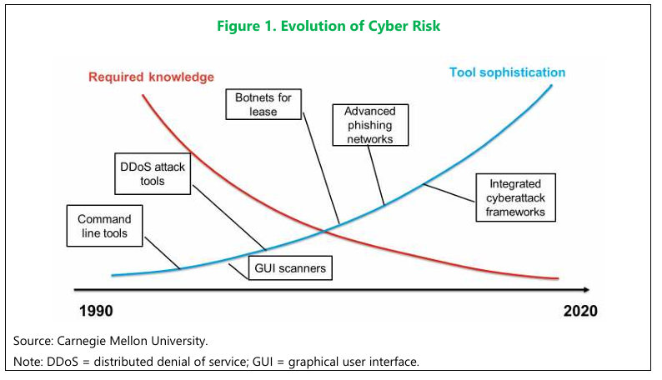
Advances in technology have provided additional opportunities for attackers as well as for financial institutions aiming to prevent and mitigate the risk. Hacking tools have evolved over the past two decades and can now be used by relatively low-skilled attackers at a fraction of the previous cost (Figure 1) [40].

Figure 2: Evolution of Cyberattacks, 2010–20
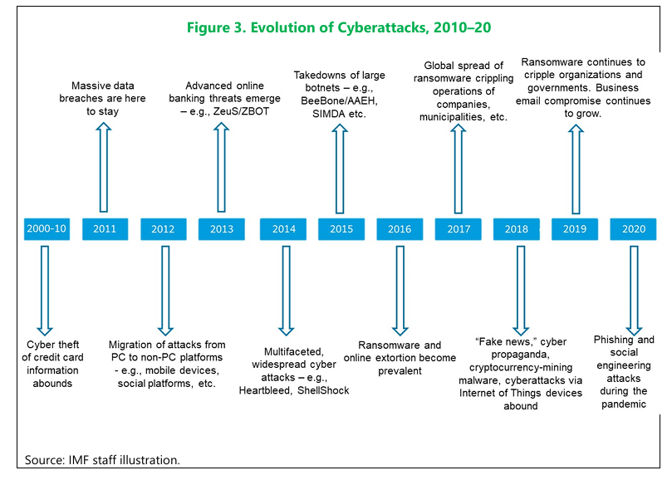
While most attacks are financially motivated, rising geopolitical tensions also increase the risk of disruption-motivated incidents. Financial services are vulnerable to a wide range of attackers, from lone hackers to sophisticated organisations and nation-state cyber warfare units (Figure 2) [41].

Appendix B
Figure 3: Proposed System Architecture for AI-Enabled Cybersecurity Risk Decision-Support in Banking.
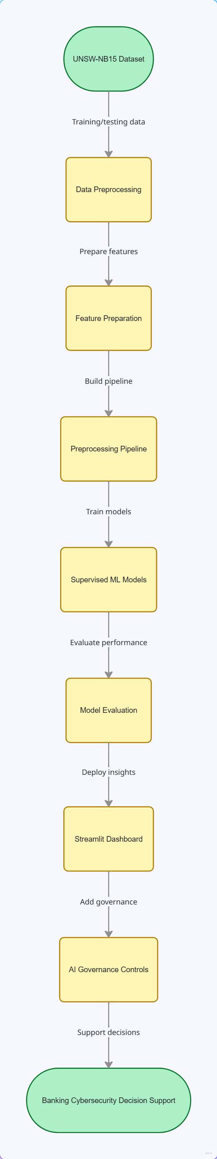
The proposed system architecture is shown in Figure 1. The UNSW-NB15 dataset is initially pre-processed, and features are handled before being used to train and test Logistic Regression, Decision Tree and Random Forest models. This model output selection is then added to a Streamlit dashboard with AI governance features such as explainability, audit logging, risk thresholds, and human-review recommendations.
Figure 4: AI Governance Decision-Support Workflow for Cyber-Risk Classification
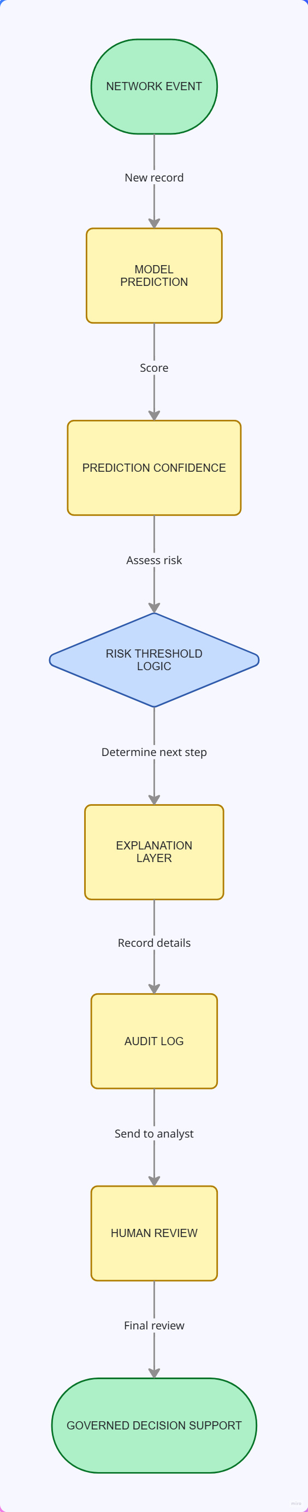
This demonstrates the application of AI governance in generating a machine-learning prediction using the proposed system. The model categorises the network event, assigns a confidence to the prediction, and uses threshold logic to assign a risk level to the event. This risk level is then explained by feature-importance outputs, documented in an audit trail, and reported to an analyst or risk officer for review. This workflow ensures the system assists with decision-making rather than taking the place of individuals.

Appendix C
Figure 5: Gantt Chart showing plans and implemented tasks
The project will be developmental in nature, with set stages from further development of the project proposal through to the consolidation of the literature, data preparation, modelling, and comparative evaluation. Next steps involve building out the Streamlit dashboard, adding in governance controls, finalising analysis and writing. The following activities include quality assurance, documentation, viva preparation, systematic planning, progress monitoring independent of the teacher and research using professional practice.

