GLOBAL BUSINESS ENVIRONMENT
Name of the student: Valentina Vintila
Student ID: 2021907
Table of Contents
Introduction 3
1. 3
a. Discussing the significance of International trade for PepsiCO 3
b. Explaining the International Strategy adopted by PepsiCO in the emerging Markets 5
2. 8
a. Explaining elasticity of Demand using two products 8
b. Explaining the scenario of a product in the market when the quality of the product is under question 10
3. 11
a. Explaining the Term Market Failure 11
b. Discussing the Four Factors contributing to Market Failure 11
Conclusion 13
References 14

Introduction
The global business environment is affected grossly by the Global Pandemic. The phenomenon affected the equilibrium between the demand and supply and consequently affected the buying propensity of the masses. According to findings observed by the World Bank, one-fourth of the companies saw sales falling 50% (Worldbank, 2021). The recorded average sales drop is 27%. About 65% of businesses were constrained to adjust payroll resulting in 11% of the company lying off workers. Positive development like the increased use of the Internet (34%) and social media is recorded (Worldbank, 2021). 17% SMEs invested upon installing new equipment internal to the Manufacturing plants. Governments in different countries offered financial stimulus to around one-fifth of the Small Medium Enterprises. The study would discuss contemporary business issues explaining the market effect critical terms surrounding Markets.

1. a. Discuss the significance of International trade for PepsiCO
To explicate and justify the importance of International Trade for PepsiCO or any other business organization a background regarding the Global business needs to be drawn upon. During the Covid-19, the volume of global Merchandise drifted to around 5.3% marking grave concerns (Wto, 2021). During the exigency, the value of export crumbled to 8% aggregating US $ 17.5 Trillion. The Commercial services exports drifted downward to 4.91 Trillion (WTO, 2021). Consequently, the Global trade recorded a sharp contraction of 3.6% marking tremulous roars in the consumer's markets.
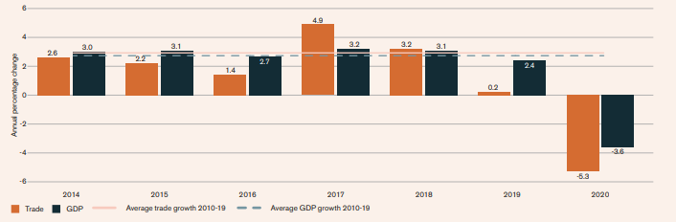
Figure 1: World Merchandise Trade Volumes and the Global GDP scenario (2014 to 2020)
(Source: WTO, 2021)
Notwithstanding the ravages hurled by the global pandemics the Global economy shows signs of recovery. On giving a close look at the Quarterly extractions of exports region-wise that drifted down to around -25.5% in North America recovered to -2.2%. In Africa, the negative projection (-21.7%) referring to a slight improvement) -4.8 %. This development, though inconsistent and inadequate, shows Positive signs. Delineating from PepsiCo’s point of view, this is the right time to take aggressive expansion policies.
PepsiCo Marketing head has addressed the need of spreading in other countries. Expansion being the need of the hour, the company is trying to inject financial injection to revive markets that observe negative growth.
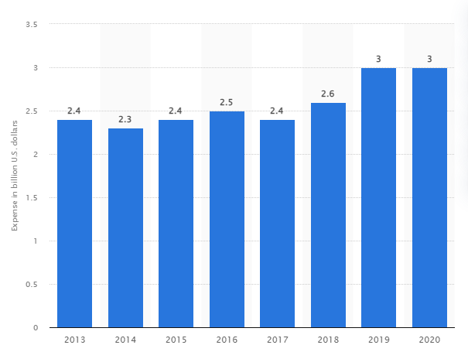
Figure 2: PepsiCo Spending on International Advertisements
(Source: Statista, 2021)
According to the projection PepsiCo, on average spends an amount between $2.3 billion to $3bn on the global advertisement. Referring to the values of 2019 and 2020 the expenditure is around $ 3 bn. This denotes the Company is keen to invest in the global present even during the pandemic. This is an aggressive decision, but compared with the spending of Coca Cola in 2019 ($ 4.25bn), it lags far behind (Spanier, 2021). This event marks the main reason why International Business bears significance for PepsiCo.

b. Explaining the International Strategy adopted by PepsiCO in the emerging Markets
There are numerous strategies that PepsiCo could take to expand quickly in Emerging Markets. The strategy most suited (in reaction to the Pandemics) for PepsiCo is Market Penetration Strategy. Through Market Penetration Strategy PepsiCo directly reaches new consumers and challenges the local players. This is suitable because during the pandemics a lot of local players are showing market presence with new products and aggressive Pricing Strategies. PepsiCo has immediately taken certain steps to implement penetration.
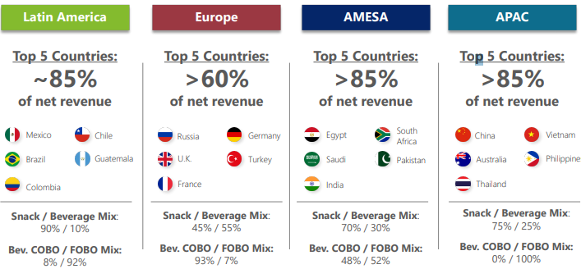
Figure 3: PepsiCo Market presence based on major and new markets
(Source: PepsiCo, 2021)
PepsiCo earns around 85% of the local market turnover from Latin American countries like Mexico, Brazil, and Guatemala. European Penetration is less than 60%. AMESA country presences constitute 86% (Saudi, India, and Pakistan Egypt) (PepsiCo, 2021).

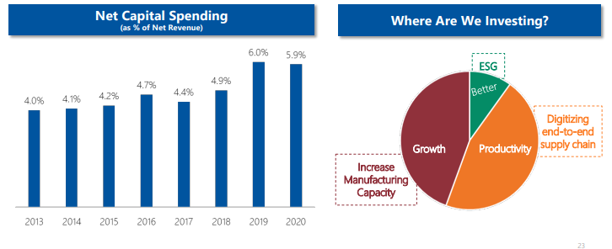
Figure 4: Increasing Spending of Net Capital
(Source: PepsiCo, 2021)
Penetration of PepsiCo is strongly reflected through Net Capital spending. In the year 2018 net capital spending constitute 4.9%. The highest spending is made in 2019 (6.0%). The spending did not decrease much in 2020 (at the pandemic time) to around 5.9%. The spending on Digitizing, end to end Supply chain, and ECG and Manufacturing capacity directly points to PepsiCo’s seriousness in marketing Presentation.
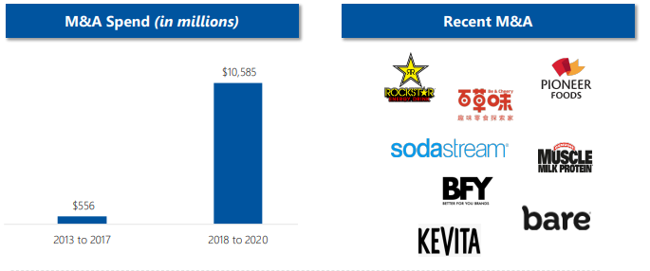
Figure 5: Recent Acquisitions
(Source: PepsiCo, 2021a)
PepsiCo in recent times has acquired quite a lot of local brands to find competitive Advantages. Examples of the local brands like Kevita, Bare, SodaStream, Muscle, Pioneer Foods, Rockstars could be cited.
PepsiCo used innovative market penetration in a newly developing market in Nigeria. In Nigeria, the people have a fascination with longer bottles. It is a perception that longer bottles contain more quantity. In order to beat Coke and Big Cola, they introduced Long Throat in a 60ml Pepsi Cola (size increased from50cl). Big Cola, a local copy of Coke, was operating with 65cl for 100 mg. PepsiCo took a counter-strategy to face the staunch competition thrown by local players. Thus it is established that global brands are forced to listen to the demands of the local market in a perfectly competitive Competition market where the consumer is the undisputed king.
Another example of Penetration could be given. In the subcontinent local players like Delhi’s City Cola, Boss Beverages, Hajoori & Sons, took over the market share of Coke and PepsiCo. The prices against the products are 20%cheaper. This defines that PepsiCo needs cheaper variants in that particular market. In the UK, PepsiCo needs to bring down the prices of its products as new companies are coming up rapidly. PepsiCo has a list of Iconic brands like Munch, Doritos, Pipers Crisps but they are all getting into the premium sections (PepsiCo, 2019a). PepsiCo needs to bring new customer-friendly variants of snacks and chips to woo customer attention.

2. a. Explaining elasticity of Demand using two products
The elasticity of demand is the change of quantity demand on a product when different market variables like price Income and others change. This primarily refers to the change in demand in a market with shifts in the entire economy (Méndez-Carbajo and Asarta, 2017). There are different determiners to change the demand for a product. These factors and economic variables include:
1. Price of a Commodity
2. Level of Income
3. Income level of Consumer
These factors play an important role in creating demand in a market. This could be mentioned.
There are different variants of price elasticity (Zhu et al. 2018). This includes Price Elasticity, Income Elasticity of Demand, and Cross Elasticity. The elasticity of a product is attained in the market where the buyers can exert direct control over the price outlay. These factors play a major role in explaining the said phenomenon and putting the discussion.
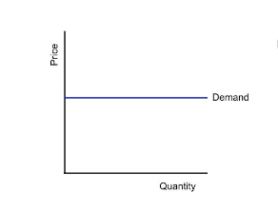
Figure 6: Price Elasticity of Demand
(Source: Zhu et al. 2018)
According to the following figure, demand rises when the price decreases. These are also opposite laws to it. The price of a product increases when demand for a product increases.
This needs to be understood that the economic projection has a direct link with the pricing of products. The sale of a car depends on different factors. If the economy is in good shape, the sales of cars will be in a good shape but if the economy isn't in good shape then the automotive industry will hamper drastically (Backer and Finger, 2017).
According to the reading, the GDP of the UK is 40, 284.64 USD (2020). In terms of purchasing parity, the UK is one of the largest in the world. The UK ranks 5th in the world in terms of purchasing parity.
Aston Martin | Sales per unit | Land Rover | Sales per unit
2017 | 2, 484 | 2017 | 315,884
2018 | 2, 296 | 2018 | 353,567
2019 | 2, 590 | 2019 | 391,190

Table 1: Comparison of Sales of Land Rover and Aston Martin
(Source: Bailey and De Propris, 2017)
In the year 2020, the Land Rover brands were sold to 2 Million. This is affected by the Propensity of buyers. Aston Martin sold around 2,590 cars in the year 2020. This is much lower in proportion to the sales in the year 2019. Here from a comparative analysis could be made. This needs to be understood that the rise in demands of a product shares a direct relationship with Propensity. It is seen that the per-unit costing starts from £94,400 whereas the price of Aston Martin is around $1Billion. The unit price of Aston Martin is somewhat comparable with the initial brands of Land Rover. But this does not have a direct relationship with propensity. This denotes people with a higher propensity to search for better brands and is ready to pay for the brand value achieved by the company. The companies, whose economic turnovers are under the scanner, need to come up with strategies for development. This needs to be tackled through better and efficient pricing. This could further be understood that the products produced by Aston Martin are on the cost incentive matter. Therefore it can be understood that company policy-making has a lot to do with the way prices and their demands and supply is considered.

b. Explaining the scenario of a product in the market when the quality of the product is under question
When a product comes under the scanner amidst allegations of being faulty it negatively impacts sales. Faulty products in the market decreased the confidence of the product. Discussing in alignment with Price elasticity it needs to be mentioned that the price of a product increases with demand (Böcker and Finger, 2017). The price of products that increase with demands is luxurious products. When the product comes under the scanner it loses its trust. Trust deficit casts a negative influence on the mind of the consumer. As a result, the demand for the product will cascade. Consequently, the demand for the products tends to fall. This results in the form of value decrease.
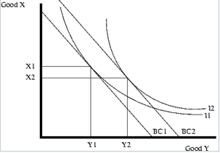
Figure 7: Inferior Goods
(Source: Bakas and Triantafyllou, 2020)
It is found out from the figure that Good Y signifies the Normal Goods and Good X signify the faulty goods X1 and X 2 are the budget and Y1 and Y2 are the income. It is found out that the high budget has increased the demand for Normal goods, but with a higher propensity the decrease in the demand for faulty goods is observed. This could be therefore observed that the demand of the good has a certain relation with increased propensity (Bakas and Triantafyllou, 2020). This is also observed that a proper regrouping of price segments needs to be drawn upon while engaging with the product segmentation. Comparative pricing depends upon different factors. These factors are responsible for obtaining the curve in this figure. The touch point for the intersection of the demands and income level (11) and the touch point (12) are marked differently. Finally, this could be addressed that demand and supply of a product vary when the product is genuine and when the product becomes faulty.

3.

a. Explaining the Term Market Failure
Market failure is a condition when there is the insufficient distribution of products and services in the market. This denotes that the allocation of goods and services in the market is not efficient owing to a net loss in the economic value of the product (Jackson and Jabbie, 2019).

A befitting example could be made in the form of Market Failure in Journalism. It is recorded that local journalism is failing in the US (Pickard, 2020). The success of the media from a moral perspective is determined by the way it catches the flaw of the Government. It is found out that the commercial imperatives of the news media do not really be compatible with media objectives. People are least bothered about the local event that has a direct link with people's interests. The media earns 80% of its revenue from Advertisements and 20 % from the consumers (Pickard, 2020). When people stop watching the news on TV and reading newspapers, automatically the media will lose on the Advertisement generated funds. Thus the media industry dies a natural death in a democracy.

b. Discussing the Four Factors contributing to Market Failure
There are four types of Market failures and they include Public Goods, Market Control, externalities and Imperfect information.
Public Goods - Public goods are those goods that are bought by the government. The people do not purchase these goods directly. Instead, the government purchases them on people's behalf and through a collection of taxes levied from people (Amosweb, 2021). Examples of Public goods include Defence, Public health and Environment Quality. If the government fails to perform strongly in economic parameters then they won't be able to procure these goods and services.
Market Control- Market control is referred to the condition when the buyers of a market have a strong influence in setting the price of a product. On the other hand, Market Control is directly accessed by a company that is virtually a monopoly (Amosweb, 2021). This is on the demand side. From the point of view of supply side, Market Control is accessed by the Market where the goods are intended for one supplier only (monopsony). Employment in a company township is the best example of the condition.
There are reasons for market failure and they include Externalities, Asymmetric, Public Goods, Natural Monopoly, Imperfect Competition and Business Cycles.
Externalities
Externalities could be referred to the case of Market failure which actually relates to activities of the market players resenting irregularities excluded from transaction or operation. This even needs to be analysed that the suffering of the stakeholders impacts the market in a negative manner. Under the following circumstances, the Government can neither control the pricing nor be able to save money for public benefits. This failure emerges from irregularity. Under the circumstance the prices cannot capture e social costs involved with the following and consequently irregularity and inefficient level of consumption.
Imperfect information
Inefficient decision making on the part of the government results in market failure. During this condition the business organisations as well as the Government. Inefficient decisions on the part of the government lead a nation to make wrong economic decisions (Amosweb, 2021). This might result in dire consequences. For example a government imposes taxes on some imports. It was later found out that the tax increase negatively impacted the market under such circumstances the thing becomes costly (Pickard, 2020). The import became too costly that the concerned importers found it extremely hard to collect them. This definitely makes the product too costly for the buyers to collect. Hence the market collapses.

Conclusion
It could therefore be concluded that the Global business environment is not friendly enough for the local businesses operating presently. In response to the Covid-19 pandemic the business entities are forced to take different measures to fight existence in a highly competitive market. At the same time this is found out that companies like PepsiCo are resorting to a penetration strategy to mark its presence in the emerging markets. This is also found out from the readings that the success and failure of a market depends on different factors like Buyers buying power, Market price, Demand and Supply in the market. Business entities as well as the Government of a nation try its level best to take necessary steps so as to prevent markets from facing Market Failure.

References
Amlung, M., Reed, D.D., Morris, V., Aston, E.R., Metrik, J. and MacKillop, J., 2019. Price elasticity of illegal versus legal cannabis: A behavioral economic substitutability analysis. Addiction, 114(1), pp.112-118.
Amosweb, 2021. Maket Failures. Available at: https://www.amosweb.com/cgi-bin/awb_nav.pl?s=wpd&c=dsp&k=market+failures [Accessed 31 November 2021].
Bailey, D. and De Propris, L., 2017. Brexit and the UK automotive industry. National Institute Economic Review, 242(1), pp.R51-R59.
Bakas, D. and Triantafyllou, A., 2020. Commodity price volatility and the economic uncertainty of pandemics. Economics Letters, 193, p.109283.
Böcker, T.G. and Finger, R., 2017. A meta‐analysis on the elasticity of demand for pesticides. Journal of Agricultural Economics, 68(2), pp.518-533.
Jackson, E.A. and Jabbie, M., 2019. Understanding market failure in the developing country context. In Decent Work and Economic Growth: Encyclopedia of Sustainable Development Goals (pp. 1-10). Cham: Springer Nature Switzerland.
Méndez-Carbajo, D. and Asarta, C.J., 2017. Using FRED data to teach price elasticity of demand. The Journal of Economic Education, 48(3), pp.176-185.
Pepsico, 2019a. About. Available at: https://www.pepsico.co.uk/about/about-the-company#:~:text=We're%20committed%20to%20reducing,day%20through%20our%20juice%20portfolio. [Accessed 31 November 2021].
Pepsico, 2021. EMERGING STRONGER [online] Available at: <https://www.pepsico.com/docs/album/investors/2021_webdeck_final_cagny_fm2lu4dkaztxswti.pdf> [Accessed 31 November 2021].
Pickard, V., 2020. Journalism’s Market Failure is a Crisis for Democracy. Harvard Business Review.
Spanier, G., 2021. Coca-Cola eyes more efficiency after 35% adspend plunge in 2020 | Advertising | Campaign India. [online] Campaign India. Available at: <https://www.campaignindia.in/article/coca-cola-eyes-more-efficiency-after-35-adspend-plunge-in-2020/468320> [Accessed 19 November 2021].
Statista, 2021. PepsiCo: advertising spending 2020 | Statista. [online] Available at: <https://www.statista.com/statistics/286547/pepsico-advertising-spending-worldwide/> [Accessed 1 December 2021].
Worldbank, 2021. Homepage. Available at: https://www.worldbank.org/en/news/feature/2020/06/08/the-global-economic-outlook-during-the-covid-19-pandemic-a-changed-world[Accessed 19th November 2021].
Wto, 2021. World trade and economic growth, 2020-21 [online] Available at: <https://www.wto.org/english/res_e/statis_e/wts2021_e/wts2021chapter03_e.pdfhttps://www.wto.org/english/res_e/statis_e/wts2021_e/wts2021chapter03_e.pdf> [Accessed 1 December 2021].
Zhu, X., Li, L., Zhou, K., Zhang, X. and Yang, S., 2018. A meta-analysis on the price elasticity and income elasticity of residential electricity demand. Journal of Cleaner Production, 201, pp.169-177.

