Graveyard Report

Introduction
Graveyards are a rich form of information as they are a form of document similar to a birth and death certificate but more on a personal level. Gravestones are now also decaying whether naturally or unnaturally, so there is a need to record and capture the data before it’s gone for good. St Peter’s Church is located on top of the hill in Lampeter, (Llanbedr Pont Steffan) Ceredigion in the Middle of the Welsh countryside (See in Figure 1 & 2). St Peter’s Church Graveyard was built in the 13th century. The Original Church was then knocked down and the new Church was then erected in the 1870’s and is still the one there today (W.J.Lewis, 1997). Meaning there are graves there from the late 1800’s to the Present Day. This report will look at the different Languages used on the gravestones, which are in St Peter’s Church. Especially, which language dominates the graves, English or Welsh? In addition, other languages that are included in the Graveyard, for example, Polish.

Methodology
Gaining the date needed for this report I heavily relied on Primary data. Data of St Peter’s Church Graveyard was collected as a group with Matthew Cowley, Evan Fray, Nadia Seale and Sam Smith. Altogether as a group we collected data of 149 graves from different sections of the graveyard. All of us collected different types of data and used different programs, for example, some people just created a Word document other created an Excel sheet. Others in the group collected different types of data, for example, data on the shapes of gravestones, any symbolisms on it, or specific symbols on the graves, like different flowers and different crosses. Other data collected included profession, any relationships. For my data collecting, I put the data into a Database by using Microsoft Access. As it stores a large amount of different data and in different forms. It also makes it easier to see a certain number of records that meet a set description with Queries and Report. Access also allowed me to enter data easily as for certain fields I could use drop down menu. In my database it held data on the languages used any symbols on the grave that contradicts what’s written. Other data I collected included, where the grave was located in the grave, the language on the gravestone and what the inscription said, this included information on the graves’ occupant from names, age, date of birth, and death, address, interests and the starting sentence of the grave. Data was collected by either entering data straight onto the database through my laptop, which proved difficult with the weather. Other ways I collected data was writing down the inscription of the grave into a notebook or taking photos of the graves and then transcribing data later (Seale, et al., 2018).
Information on the graveyard was also collected from Lectures and Practical’s with Quentin Drew (Drew, 2018). This included an in-depth lecture on Gravestone overall, talking about different types of material used, the types of grave, is the grave in an enclosure and other things. The other lectures with Quentin were two tours of St Peter’s Graveyard, one from the history perspective and the second tour was the archaeological side of the Graveyard. This was and in depth discussion of certain and particular grave, some of the graves mentioned in the lecture were recorded in the database.

Languages
Memorials offer different ways of communication to the reader. Whether that’s its size and the type of memorial, or its actual inscription. The inscription in question normally speaks to the readers directly with the dead person, making a statement from the grave to the present day (Mytum, 1994). The inscriptions depending on the deceased individual can be in different languages. St Peter’s Church is in the middle of the welsh countryside, in the U.K. where the predominant language is English, but that hasn’t always been the case, being in the countryside the welsh would have been dominant at different times of history die to other factors. Other Languages are contained in the St Peter’s Graveyard as there are thousands of languages and England and Wales being a Multi-Cultural Society, so there will be more languages than just English and Welsh the main other language was Polish but not in comparison to English and a couple of other languages, that weren’t to be expected. As out of the 149 graves 10 of the graves weren’t English or Welsh. Graves are also valuable indicators of trends in history, especially the preferred language and chart the changes with the use of Welsh as a primary language (Mytum, 1994).
On Gravestones there normally is an introductory phrase placed at the beginning of the inscription on the gravestones. This is also shows an indicator for the individual’s preferred language use. These all fit into two different categories, one of them is where the body of the deceased lies and the second one emphasis on memory (Mytum, 1994) (See Figure 6 and 7).

English
English being one of the most dominant languages in the U.K. Therefore, you would think English Graves would be popular in the U.K. However, this maybe slightly different for St Peter’s Church in the middle of Wales, as it would contain Welsh graves. With the introductory phrase on the inscription tend to emphasise the memory of the deceased, as well for Graves written in English.
The data recorded as group shows that English graves outnumber the welsh graves. This is seen that out of the 149 graves recorded 86 were inscribed in English (Seale, et al., 2018). Though 3 of the graves that had English had also contained Welsh on the graves, in the forms of quotes or other phrases to do with the individual.
One grave stands out as it’s inscribed in English but has Welsh symbolisms. The Inscription on the gravestone is all in English, ‘Loving Memory of Benjamin Davies…’, this shows a sense of authority as in the 1870’s only the educated classes could read and speak English. This is due to the fact that English was for the use of Official records, this was because in 1536 when the ‘act of union’ was passed by Henry VIII, banning the use of Welsh in Public administration and Law making (Welsh Government, 2009). And at this time most people were monolinglot and so only spoke Welsh. This shows authority as to know English you had to be well educated, therefore showing authority, as it was used for official means (Drew, 2018). However, on this grave there are symbols of Welsh and Celtic Heritage. For example, this Grave has on the side two female figure. The Celtic Heritage is seen in the figure through the fact the female eyes are similar to other Celtic figurine but also the clothes that she is wearing suggests a Celtic heritage (See Figure 8) (Drew, 2018) (Seale, et al., 2018) (Mytum, 1994). This clearly shows that he is trying to show off his Welsh and Celtic Heritage to those of lower society in Lampeter that he is very much a Welsh man even though his grave is in English.
Some Tombstone in St Peter’s Graveyard has quotes or phrase, some of based on their faith. One Phrase is on three recorded graves, one of which is the bilingual one with English and French.
‘'Blessed are the dead which die in the lord”
This comes from the Bible, in Revelation 14:13. This means that when they left this world they believed they died in the lord and not in their sins. Another phrase that is mentioned is ‘Thy Will be Done’. This is again from the Bible as prayer called the Lord’s Prayer, this means that they believe that they are asking God to handle their deaths in the way that he deems fit (Mytum, 1994) (Seale, et al., 2018).
With the English Graves in St Peter’s Graveyard all but one grave’s introductory sentence is are to do with the memories of their loved ones (See Figure 6 and 7). With the Memory introductory phrase there are many different ways that it is said from ‘In (the) Memory of…’ to ‘Sacred to the Memory...’ (See Figure 6 and 7) (Seale, et al., 2018). The only grave that doesn’t follow this trend is the grave that says;
‘Leith the body of Anne
Daughter of John and Anne Price
Of Ship Inn in this Town, who
Departed this life February 24th
In the year 1853, Aged 4 months’
This is due to the fact that this grave is dedicated to a child that died at four months old. The reason this maybe because they had very little memories with the child. Especially as the gravestone was a second hand grave as it has the alphabet on the back (See Figure 9) (Drew, 2018) (Seale, et al., 2018).

Welsh
St Peter’s Church’s’ Graveyard being in the middle of Wales, there would be a sense of the Welsh Language. One of the problems I came to with this section is that due to the fact that I don’t speak fluent Welsh I heavily relied on Nadia Seale in our group who is actually welsh, to translates the graves (Seale, et al., 2018).
The Data recorded of the graves in the Cemetery out of the 149 graves, 53 were written in Welsh. There is also another trend when it comes to Language with the fact that due to the Government at the time Welsh would have been more popular than English and the opposite (Seen in Figure 5) (Seale, et al., 2018). One thing clearly seen is when in 1847, the government barred people from speaking Welsh. However, though very few graves were recorded at this time the amount of graves went up a sign of rebellion from the welsh populace. And even up to the early 1900’s the welsh language and the Government worked on ways to decrease of the use of Welsh. This is seen as in 1900- 49 there were 14 welsh graves in the cemeteries (See Figure 5). However, this had decreased as ‘Adult monolinglot speakers has virtually disappeared.’ (Mytum, 1994) (Davies, 1995, p. 55). And the decrease in the use is seen in the census with the amount of people speaking welsh decreased from 28.9 % in 1951 to 20.9% in 1961 (Mytum, 1994). This can be seen in the decrease of Welsh graves and the rise of English Graves in the 1950’s- 1999.

Other Languages
Lampeter being in a multicultural society there are going to be different languages contained in the Cemetery. Languages that take up the last 10 graves recorded were French, Latin and Polish.
The 8 Polish graves in the graveyard are from the migration of the polish after the Second World War when they moved away from Europe, however most of these graves don’t give much detail on the deceased. Another element that is different is the fact these Graves say ‘Tu spoczywa’ which means ‘Here Lies’ following a different trend with the introductory phrase on the Gravestones (Seale, et al., 2018) (Drew, 2018).
The French grave is also unusual as it’s not just in French but also in English. It is also dated 1855, meaning this person is well educated for knowing English, in addition to the French (See Figure 11) (Seale, et al., 2018).
A la memoire de
Felix Pauline De Rovere, ce
Qui est Mort La 27 mars 1855
Age de 35 ans.
Blessed are the dead which die in the lord. Even so saith the sprit
For they rest from their labour.

Translation-
In memory of
Felix Pauline De Rovere, this
Who's Dead March 27, 1855
35 years old.

The Latin grave as seen below is unusual for it being in St Peter’s Cemetery. This shows how religious the person was as they not only wrote his grave in Latin and mentioning the fact that this person was baptized (See Figure 11) (Seale, et al., 2018).
Sacral memoriae Reginaldi Carlandi Jayne, FILII Septemi, Francisci et Emiliae Jayne, ecolis Davidis apud Lampeter. Oui Natus die nono mensis. JV LII Baptizatus die decimo in requium christi perceptus fuit die undecimo elusdem mensis. An in arc. MDCCLXXXVI. Vt ouid perditio ista facta est? Uod ego facio. Tu nescis modo scies autem pustea.
Translation –
Sacral memory Reynold Garland, Jayne, SON septeme Francis and Jayne Emiliae ecolis David in Lampeter Born out on the ninth month. N 52 Baptized on the day of the submission of Christ elusdem was perceived on the eleventh month. Aninarc. 1786. That affair was this taken? That will do. You do not know now Pustet.

Conclusion
In Conclusion, English dominates the gravestones more than the Welsh. However, there are times where the Welsh Graves were more common than the English Graves at certain times in history. Even though at times when the Welsh Language barred there were symbols of Welsh heritage and some graves are still written in Welsh as a form of Rebellion. In the data in the Language you can see that there are trends in the data, for example when the English became more popular than Welsh as the amount of people that knew welsh decreased. Though it seems now as cultural are more integrated than ever with migration, trends in cemeteries will show this as different languages will appear in the cemeteries, like Polish in St Peter’s.

Bibliography
Baker, J. L., 2012. The Funeral Kit: Mortuary Practices in the Archaeological Record. 1st ed. London: Routledge.
Davies, J., 1995. The Welsh Language. In: T. Herbert & G. Elwyn Jones, eds. Post- War Wales. Cardiff: University of Wales Press, pp. 55-77.
Drew, Q., 2018. Lecture Notes and Recordings from Lectures. Lampeter: s.n.
Hockey, E. H. &. J., 2001. Death, Memory & Material Culture. 1st ed. Oxford: Berg.
Jones, J., 1979. How to record graveyards. 2nd ed. London: Council for British Archaeology.
Mytum, H., 1994. Language as symbol in Churchyard monuments: The use of Welsh in nineteenth- and twentieth-Century Pembrokeshire. World Archaeology, 26(2), pp. 252-267.
Mytum, H., 2002. Recording and Anaylysing Graveyards. 2nd ed. s.l.:Council for British Archaeology in Association with English Heritage.
Mytum, H., 2006. Popular attitudes to memory, the body, and social identity: the rise of external commemoration in Britain, Ireland and New England. Post-Medieval Archaeology, 40(1), pp. 96-110.
Ordanace Survey, 2018. Ordance Survey Roam- Lampeter. Lampeter: Digimaps.
Rogers, J., 1997. The Basic Bible. 2nd ed. London: Hutchinson of London.
Seale, N. et al., 2018. St Peter's Church Graveyard Data. Lampeter: s.n.
Tarlow, S., 2005. Death and Commemoration. Industrial Archaeology Review, XXVII(1), pp. 163- 169.
W.J.Lewis, 1997. A History Of Lampeter. 1st ed. s.l.:Cyngor Sir Ceredigion County Council.
Welsh Government, 2009. Welsh Language: History, Facts and Figures, Cardiff: Welsh Government.

Appendix

Figure 1- Ordanance Survey Map of Lampeter - (Ordanace Survey, 2018)
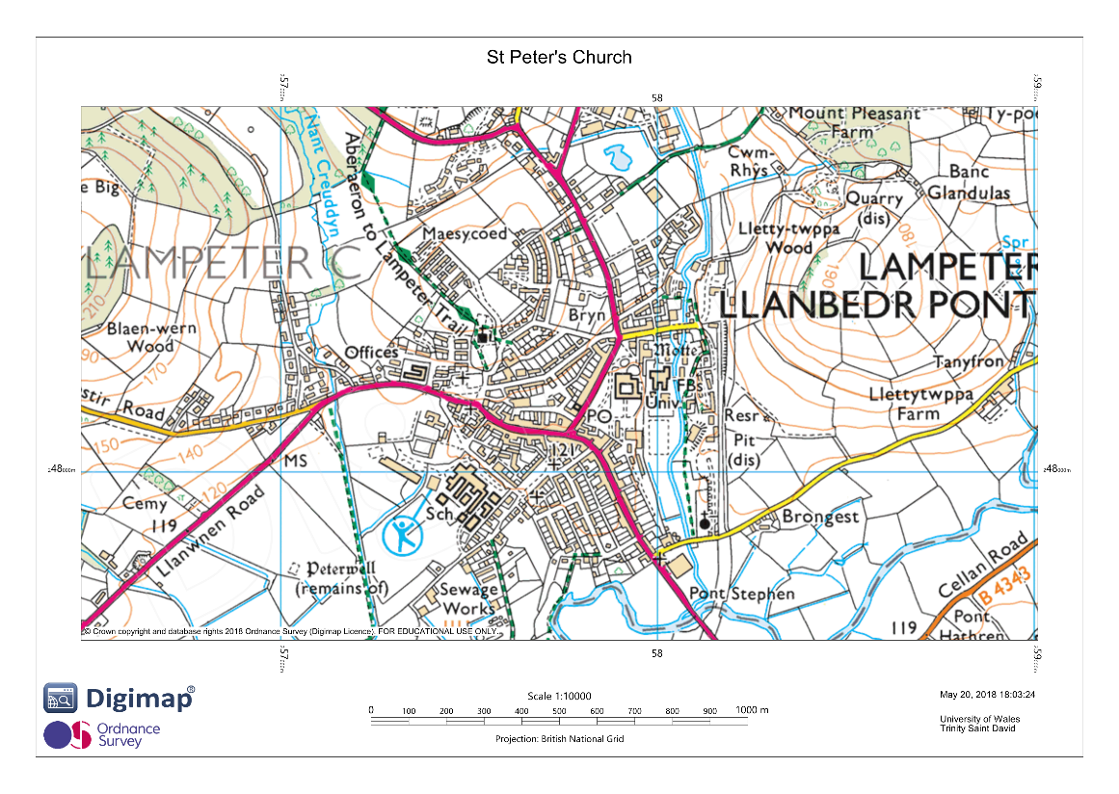
Figure 2- Ordanance Survey Map (Ordanace Survey, 2018)
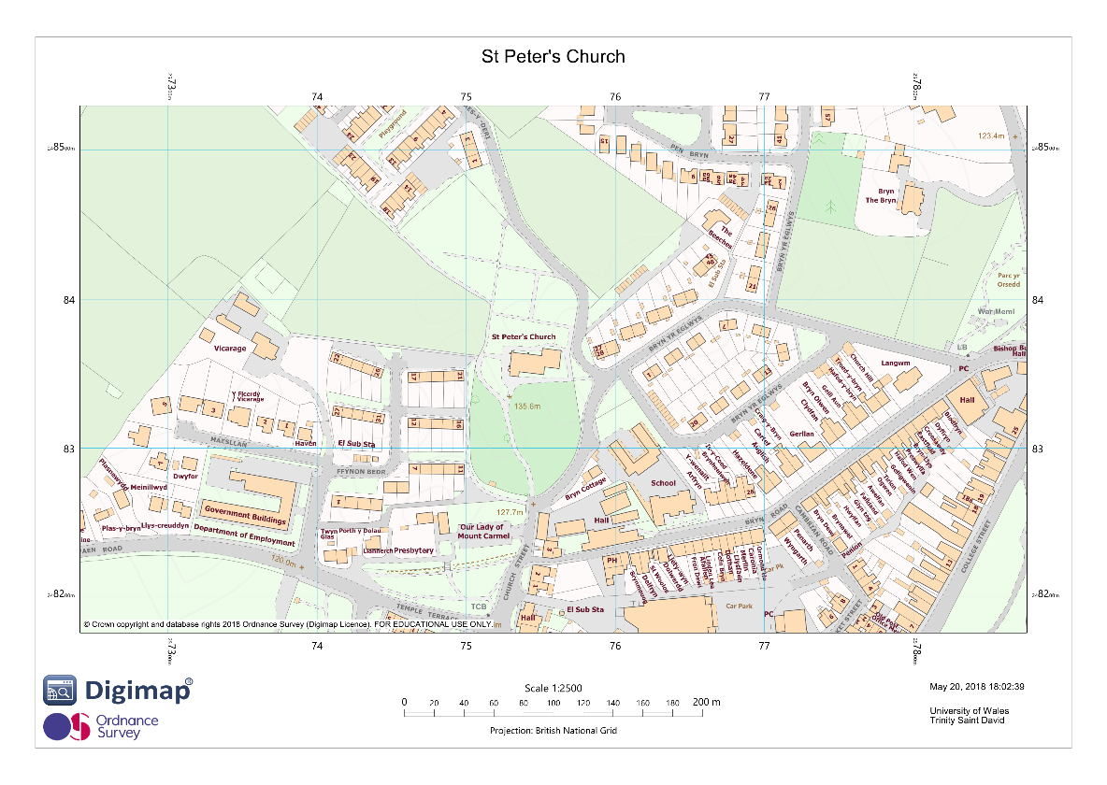

Figure 3- The Amount of Graves in a Particular Language table and Pie Chart of the Percentage of each Language of those that was recorded (Seale, et al., 2018).
Language | Amount of Graves in that Language
English | 86
Welsh | 53
Polish | 8
French | 1
Latin | 1

Figure 4- The amount of Bilingual Graves compared to Monolingual (Single Language) and Pie Chart with the percentage of how many are Monolingual or Bilingual (Seale, et al., 2018).
English and Welsh | 6
English and French | 1
English and Polish | 1
Single Language | 141

Figure 5- Graves written in Welsh and English in each time period (out of the ones that had dates) and a bar chart, showing the trends (Seale, et al., 2018).
Dates | Welsh | English
1800-1849 | 3 | 2
1850-1899 | 5 | 7
1900-1949 | 14 | 9
1950-1999 | 10 | 21
2000 + | 9 | 13

Figure 6- The introductory phrase by different type in a table and pie chart (Seale, et al., 2018).
Memories | 138
Where the Bodies lie? | 1

Figure 7- Introductory Phrase the types of phrase for memories table and bar chart (Seale, et al., 2018).
Introductory Phrase
Leith the Bodies | 1
Sacred to the memory | 8
In (the) Memory of | 10
With the Thanksgiving to God for the Life of | 1
In Ever/ Most Loving memory of | 13
In God's Keeping | 2
Affectionate Remembrance | 1
With Love we Remember | 1
Treasured/ Cherished Memories | 5
In Glad memory of | 1
Always Together | 1
Nothing just names | 8

Figure 8- Image of Grave (Seale, et al., 2018).
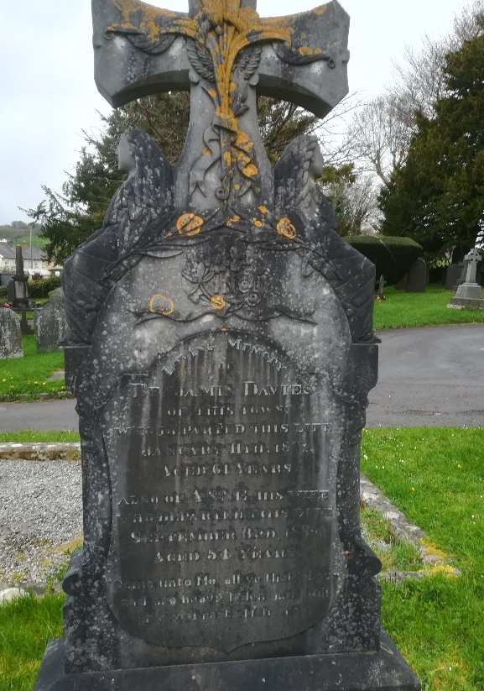
Figure 9- Image of Grave (Back and Front) (Seale, et al., 2018)
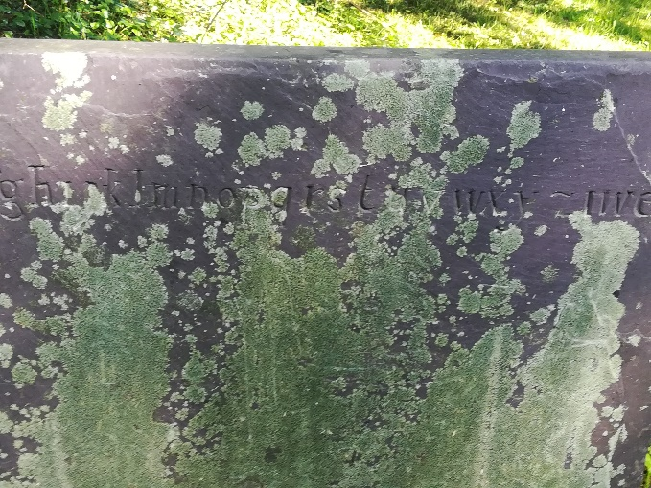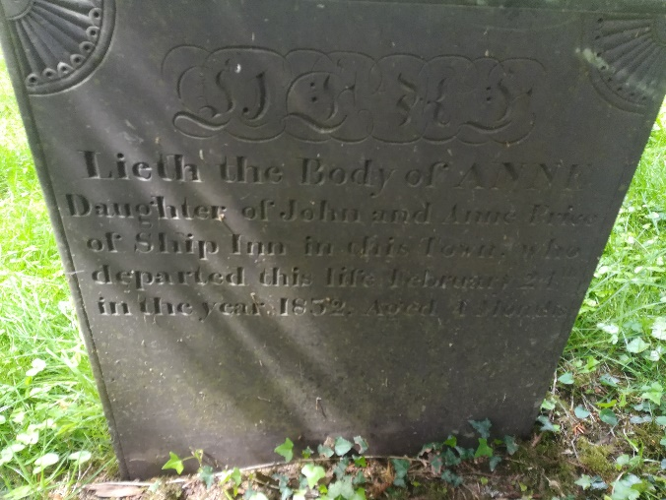

Figure 10 – the Latin Grave (Seale, et al., 2018).
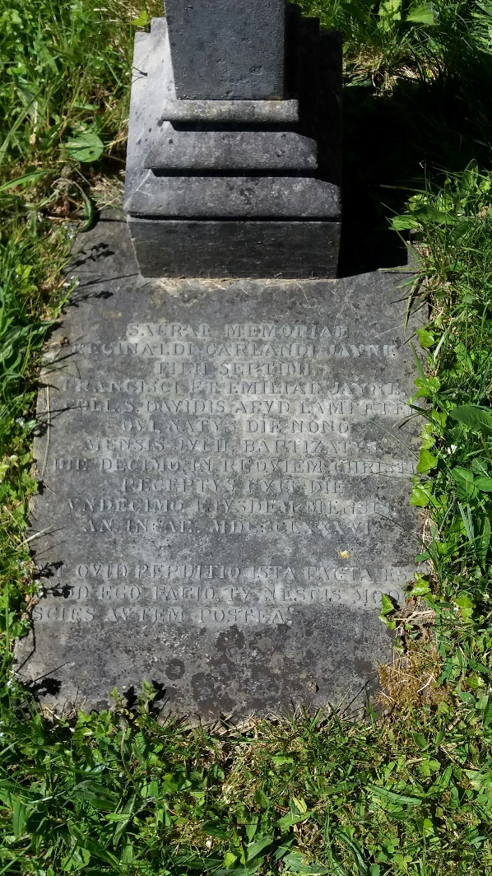
Figure 11- The French Grave (Seale, et al., 2018).


