Title of Essay: Workplace Culture and its Context
Module: BMSK5005_SWAN
Name/Student Number: Samad Uddin/1710009

Introduction
This report will analyses the workplace culture and context and how the ethical stance of the organisation affects the values, beliefs and attitude of the company and its customers. The workplace culture is shaped by the individuals and their values, beliefs and attitude. Within a workplace, leadership and strategic organisational and management directions have an enormous impact on the culture of the workplace. A successful workplace culture enhances teamwork, increases morale, productivity and effectiveness, and increases workforce retention and mainly diminishes stress. (Agarwal, P. 2018).
The organisation that will be analysed in this essay is Amazon. Amazon was founded in 1994 by its owner Jeff Bezos the company started of as an online bookstore however as time went by it quickly expanded by adding other essential items which included clothing, homeware, books, films etc. Amazons considers themselves to be a customer centric company. Their workplace culture is described as corporate, innovative and peculiar. (Schneider, 2019).

Findings

Task 1: Analysing Amazon using PESTEL
Political: The British and American governments are presently conducting debates on prospective trade deals amongst two countries in the context of Brexit negotiations. This could help to alleviate Amazon's activities in the UK as an American company, possibly lowering import taxes and resulting in lower legislation. (GilChrist, 2017).
Economical: Economies such as the UK's. Their capitalist buildings have traditionally been admired, but the growing study suggests that traditional model capitalism no longer suits the objective of the current company framework. The Amazon manner of capitalism has lately been lauded by analysts as the gateway to potential development productivity, considering that this is focused on reinvesting profits away into fresh, market-building development and study. (Denning, 2017).
Social: Increasing rates of obesity influence individuals around the globe, with overweight classified as 711 million people all over the world and growing stress on governments to encourage physical exercise and a healthy lifestyle. It could be asserted that Amazon is promoting the non-active lifestyles that result in the obesity pandemic by expanding its distribution facilities to the point that clients can even have their groceries supplied to their fingertips. (Bedard, 2017).
Technological: Research and Development are of growing significance for companies wanting to stay creative and maintain their competitive advantage in terms of the greatest level of technology. In an effort to increase their UK workers to 24,000 by 2018, Amazon lately announced that they will double the number of employees they hire at their London Research and Development Centre, meaning that the firm is concentrating on expanding their technological proposition. (Ruddick, 2017).
Environmental: With growing stress from authorities on big organisations to decrease organisational pollution, the issue can also be questioned how Amazon can conform with emission level legislation, considering that a big portion of its company depends on logistics and the same-day delivery of products.
Up until 2016, Amazon has never released a sustainable study, contributing to issues regarding the current environmental consequences of the comprehensive global operations of the organisation on the wider climate. (Gunther, 2016).
Amazon has started installing large-scale rooftop solar systems on fulfilment centres across the nation. their objective is to have more than 50 fulfilment centres worldwide with solar rooftops mounted by 2020. 15 sites are scheduled to be completed by the end of 2017. The initial installation, solar systems could produce as much as 41 MW of energy. (Staff, 2019).

Legal: Amazon has been investigated by the U.S. Federal Trade Commission for making a false accusation on price reductions on around 1000 goods. (Bartz, 2017).
Currently, growing stress is put on global corporations to evaluate their customer’s danger and any politically delicate customer or customers on terrorist watch lists must be approved. Amazon is presently under the national inquiry for supplying products to people on suspected terrorist watch list and breaking US sanctions, demonstrating neglect for international law and security. (Reporter, 2017).

Task 2: Cultural web
In 1992 Gerry Johnson and Kevan Scholes developed a method to analysis workplace culture called the Culture Web. Cultural Web Study is a template in which the organisational framework, beliefs as well as expectations within an organisation are explained through a consistent set of six components. The framework, the organisational culture, operates within the web. (Janse, 2019).
Stories: in 1994 Jeff Bezos the founder Amazon first established as a simple and straightforward online book store. Whereas today Amazon is one of the largest online retailers in the world with more than 27 million active accounts. Amazon’s main goal is to meeting their customers demand by offering a verity of different products and services rather than focusing on their competitor’s action. (Hartmans, 2019).
As a new employee’s point of view Amazon is a place where working hours never ends and also on their first day of work, they have to sign a form where it states that no minimum working hours applies.
Rituals and Routines: One of Amazons routine or rituals that are unique from its competitors mainly when they recruiting their employees for fulfilling a higher post when it’s vacant. Therefore, the organisation involves people within the business as “bar raisers” who perform the crucial role in hiring such as interviewing or even to refuse any candidate although they may not well be from the same department as potential employee is applying for. In addition to Amazons routine is to employ people without any previous work experience, without any inherited organisation culture, in order to train their employees according to Amazon’s business policy.
Symbols: Amazon is an online retailer keeping that in mind, the brand name and its logo is very essential that it is visually attractive as well as its graphic represents the company. Jeff Bezos intended to have his company’s name to appear first in alphabetical order in the search engine keeping that thought and vision in mind he decided its company to start with the letter “A”. Ever since 2000, the logo of Amazon has a curved arrow which represents a smile, leading from A to Z as well as the new logotype communicates customer satisfaction. Amazon shops and warehouses are described as not physically operating as such, but as a

software equipment that appears to do so, serving several times more goods and clients than the actual one.
Organisation structure: According to Hierarchy structure (2013) Amazons organisational structure is described as a corporate and complex structure indicating that they function independently in various different countries. Amazon as an organisation has a total number of seven segments responding to the above instructions and encouraging rather than rivalry competition. (Hierarchy Structure, 2019).
Control systems: Amazon has created important metrics to preserve the highest quality and efficiency among its delivery centres. These metrics evaluate employee performance, products picked for every hour and accuracy of stock. Amazon accomplished development in 1999 but at a huge expense owing to its aim to deliver at whatever price. Amazon then carefully measured the number of hours from verification to shipment as well as the price per item delivered to prevent potential losses. (Selmani, 2019)
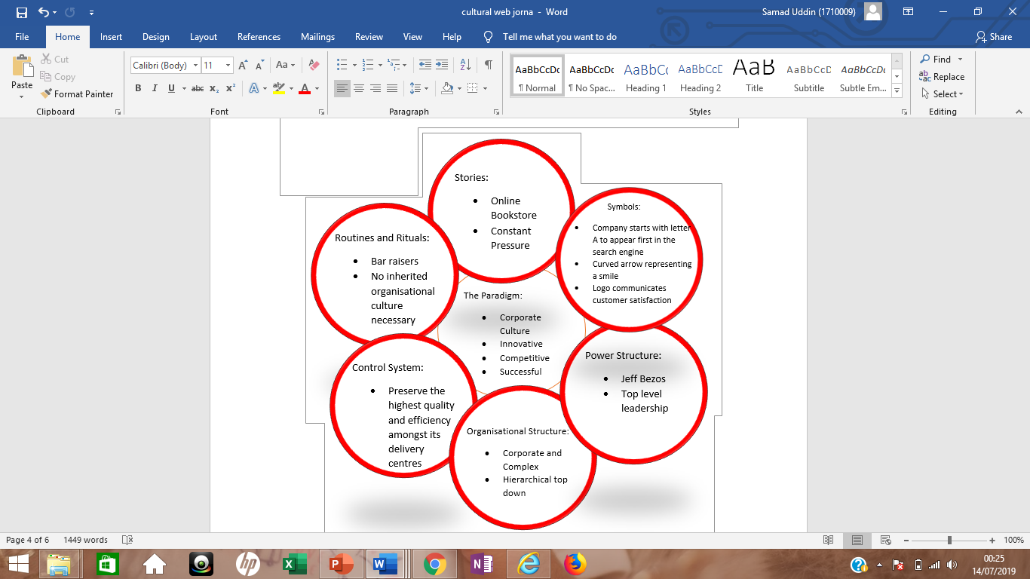
Power structures: Amazon's power is spread from top-level leadership. Especially authority emerges from its CEO, Jeff Bezos, who is unwilling to communicate his authority. Therefore, yet now Amazon has no Chief Operation Officer, and among other positions such as president, CEO, and chairman, Bezos maintained this position for himself. Bezos could experience problems during transition stages as a firm charismatic leader due to his reluctance to give his personal control. (Business Balls, 2019).

Charles Handy Model
In 1999 another cultural model, introduced by Charles Handy and preceding Harrison (1972)'s research also introduces organizational structures as divided into four main kinds: the power culture, the role culture, the task culture, and the person culture. The strategy of Handy can assist them to recognise why in some organisations they have been more satisfied than others. Remarkably, while Handy chooses to speak about culture, he demonstrates the constructions connected with his kinds of culture. This may be due to the trouble of depicting something as diffuse as culture, but it also reinforces the interrelationship between culture and composition.
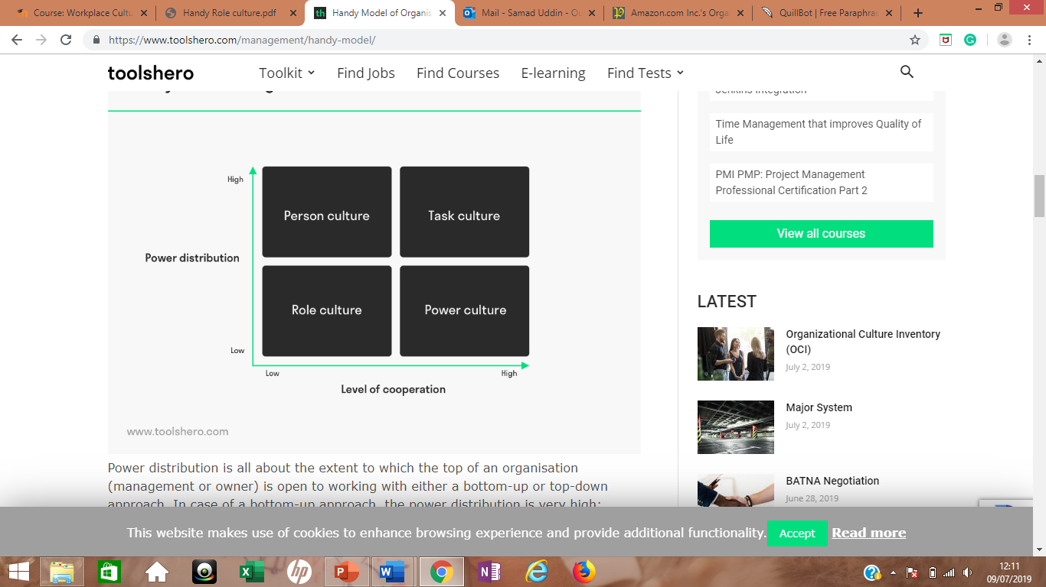
Role Culture: Amazon culture fits into the Role Culture as it’s classified as a hierarchical structure. Its approach to manage employee’s performance implementing exacting standards and metrics set by the management. Employees are always facing incredible stress, trying to maintain up with Amazon's intense speed, failure to do so will be fired from the job role. According to Yohn Amazon culture is known for strict rules and not warm and fuzzy. (Yohn, 2018).
Power Culture: Amazon also fits into the Power culture due to the authority its founder and CEO Jeff Bezos holds. Although Amazon has a hierarchical organisational structure the organisation remains extremely versatile to adjust to regular internal market changes. The authority of Amazon is distributed from top-level management. In particular, power arises from its CEO, Jeff Bezos, who is reluctant to express his power. (Dudovskiy, 2018)

Organisational Efficiency
Amazon has an organisational culture that allows the company’s ability to react to e-commerce market requirements. The organisational culture of a company establishes the traditions and principles that affect the behaviours of individuals. For instance, the corporate culture of Amazon drives staff to go further than traditional boundaries and discussions to create bright ideas and alternatives. As the top-performing online retailer in the world, the organisation remains to explore new skill. However, to retain competent workers, Amazon needs to strengthen its organizational culture to form human resource development for long-term strategic advantage. (Meyer, 2017).

At Amazon full-time employees at their fulfilment centres benefits from a highly competitive salary, health insurance, disability insurance, retirement savings schemes, and business shares. Business shares only for the permanent employees which they call it a blue badge holder and does not apply to temporary employees which are the green badge holders. The firm also offer their employees to have up to 20 weeks of paid leave and innovative advantages for example Leave Share and Ramp Back, which allows the new parents the flexibilities that they need with their rising families. Leave share allows Amazons employees to share their paid leave with their spouse if the organisation that they are working in doesn’t offer paid leave. Ramp Back allows new mothers to take control over the pace at which they return to work. Just as Amazon’s health care scheme, all of these advantages are equal for all employees at amazon it doesn’t matter if you work in their fulfilment centre or their customer service team its even same for the Amazon’s most senior executives. (Cain, 2017).
Amazon believes that by offering all the advantages above will make their employees self-motivated and more responsible towards their job role as well as making them more efficient this in turn creates organisational efficiency as employees are contributing and are motivated to perform better.

Task 3: Organisations Ethical Stance
Amazon’s ethical policy outlines the belief, values and results that help reinforce the environment and help the organisation in decision making. One of the aims of Amazon is to increase the number of employment accessible to the workforce. The organisations primary objective is to guarantee transparency and honesty and to meet the needs and specifications of their customers.
Amazons leadership principles are also known as their core values which everyone has to abide by. They are:
- Customer Obsession
- Ownership
- Invent and Simplify
- Are Right, A Lot
- Hire and Develop the Best
- Insist on the Highest Standards
- Think Big
- Bias for Action
- Frugality
- Vocally Self-Critical
- Earn Trust of Others
- Dive Deep
- Have Backbone; Disagree and Commit
- Deliver Results
(Amazonjobs, 2019).

Amazon thrives on low prices and convenience, as for some people who have less income or who are busy at work this can be useful. Amazon prime, kindle and audible are tools which their customers can use on the go and is convenient and easily accessible online. According to Irene from the Eluxe Magazine she has stated that Amazon is the world’s largest retailer. (Sodenko, 2019).
Amazons ethical policy states that they are a customer centric retailer and work around their customers to make sure they are serving them in an ethical way. They are committed to make the working environment fit for their employees and workers around the world. (Amazon.co.uk, 2019).
According to their code of conduct and ethical policy they want their employees to always act lawfully and ethically towards the organisation and its best interest. (Amazon, 2019).
Although Amazon sates that they are ethical according to Eluxe magazine Amazon refuses long term contacts for their warehouse employees as well as all the benefits and advantages. Employees are being seriously monitored to meet their targets to the point that employees are afraid to take breaks. There are reports from pregnant woman that they were afraid to take toilet breaks due to the fear of not meeting their unrealistic targets as well as the fear of getting fired. (Sodenko, 2019).
According to Glassdoor reviews one of the warehouse employee sated that managements of Amazon warehouse always ignore and sweep off any concerns under the table rather than solving the problem. It also states that Amazon workplace culture is not suitable for the people with developmental disabilities. (Glassdoor, 2018).
Another co-incidence, even though Amazon says that they source their products ethically a report by the Ethical Unicorn where it stated that Amazon force the sellers who uses Amazons website to sell products to store the products in the warehouse and then charge them the storage and postage. The charge may vary from 10 – 20 % of sales. Resulting small business losing money and customers are getting exploited. Afterwards when an item become best-selling on their list, Amazon known to uses the data to remove any third party seller from their website and be the only seller for that item and increase the price of the same item as well as using their personal software to influence and control power and earn more money. (Ethical Unicorn, 2019).
CSR: According to the University of Edinburgh CSR seeks to guarantee that businesses operate in an ethical manner taking into account all the aspects including their cultural, financial and environmental effect. (University Of Edinburgh, 2019).
The stakeholders of Amazon have wide array of interests taking into account the organisations global reach. This situation requires a wide scope for the organisations corporate social responsibility policies and plans. By satisfying the interests of the stakeholders of the organisation it helps retain Amazons position in the market as the world’s largest internet retailer. Amazon reacts to the concerns of their stakeholders through a thorough approach on corporate social responsibility. Although the organisations

CSR programs and strategies are evolving, Amazon requires to enhance their attempts to meet the evolving interests and requirements of their stakeholders in the worldwide e-commerce business. (Fergusion, 2017).

Task 4: Value, Beliefs and attitude
Amazon constantly monitoring their customers to enhance the changes required as well as improving customers experience. It also involves a complete alteration in the way an organisation considers customer relationship, while customer service is the main purpose of how a business operate. (Amazonjobs, 2019).
Jeff Bezos the founder of Amazon believes that by keeping their product prices low as possible it attracts customers and they can feel more comfortable to shop at Amazon. Executing this type of dual mission is very difficult for a single company. Every business faces price and product quality-related trade-off decisions according to Jeff Bezos. He used Wal-Mart for an example stating that the only reason why people shop there is because of the low price and there is nothing special that customer can experience.
Amazon believes that an essential measure of their success is the stakeholder value that they created over the long term. The direct outcome of this will increase the ability and strengthen their present market leadership stance. The firmer they can keep their market leadership the economic model will be more controlling.
Amazon also believes that outstanding employees make an outstanding organisation. They believe that the first five individuals that will be hired for the organisation are the most important because their quality and talent will influence the other individuals that will be hired afterwards. (Cannivet, 2018).
Amazon recruits’ individuals according to their values for the organisation. According to their website, Amazon has the core strategy of a people that they pursue when hiring. They employ individuals with compliant beliefs and individuals who can show those characteristics in day-to-day operations. As Amazon has established itself worldwide, employing people in different countries means adhering to different cultural and social norms as well as adhering to that country's laws and legislation. Amazon trains individuals to create principles and transmit principles effectively to their staff through instruction and meetings. (Hopping, 2019).
People who want to operate with Amazon need to be creative, safe and frank in order to suit in with social norms. The environment of the workforce is comfortable and an honest attitude to the position of the workforce is crucial. To be effective a worker requires to take action and accountability, have great work ethics and the capacity to be a good team player.

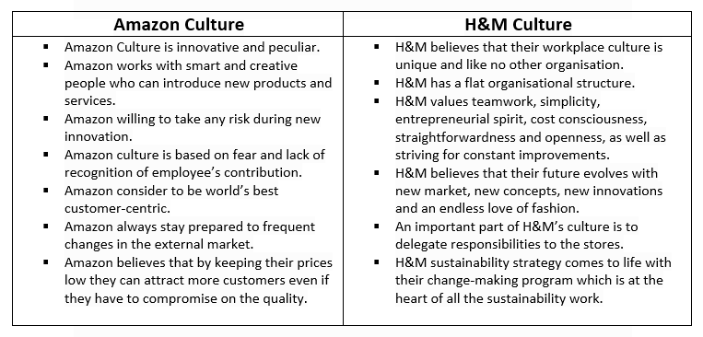
Task 5 Comparison of Amazon and H&M Culture
(Amazon, 2019), (The H&M Way, 2019).

By analysing both the organisations H&M has a flat organisational structure whereas Amazon structure is corporate and bureaucratical. H&M believe in teamwork and simplicity whereas Amazon prefer their workers to work individually where there is a culture of fear and lack of recognition. H&M believe in delegating responsibilities which makes their workplace culture stronger and more durable as everyone takes their own decisions independently and openly however, Jeff Bezos the owner of Amazon hold the authority of taking all the decisions for the company and for the employees which inflict the employees with fear.

Conclusion
Organisational workplace culture is the personality of a company which describes the values, beliefs and traditions. It summarises the whole company and its objective. This essay has critically assessed the various elements of an organisation using relevant models. Values, beliefs, and attitudes clarify a company's intention and objectives. Overall, this essay analytically evaluates the cultural and ethical stance of the organisation and how it enables to enhance organisational effectiveness as well as fit in with an organisation's cultural values.

Recommendation
Customers shop in organisations who they deem to be ethical and abide by their values and beliefs. Exploiting their workers and the working environment is the culture of Amazon. The following recommendations have been suggested by looking at the above analysis.
- Amazon is one of the top companies when it is about being innovative and technology. However, the working environment in Amazon needs improvements. So, it is recommended that Amazon improve their employee feedback system through which the employees can work on their personal development which will not only benefit themselves but will also benefit the company as they will be more productive.
- It is recommended Amazon implement employee engagement surveys, Performance reviews which are done annually or quarterly where personal development plans are discussed, 360 reviews.
- Although Amazon are known for low prices, quick delivery and convenient to shop their employees are suffering with inadequate pay, overly long hours and dismissals on the spot. So, it is recommended Amazon workers, unions and their customers work together to increase salaries and to enhance the workplace culture within Amazon.

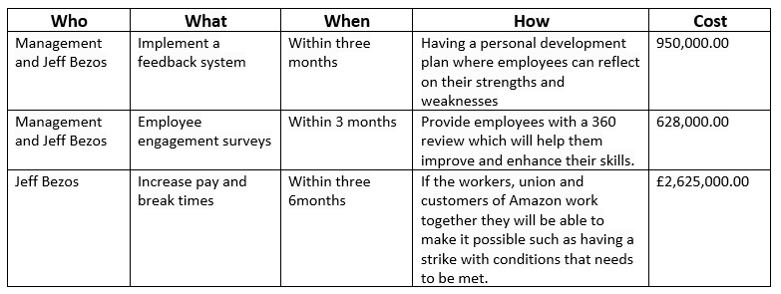
Action Plan

References
Amazon.co.uk, (2019). Modern Dy Slavery Statement. [Online]
Available at: https://www.amazon.co.uk/gp/help/customer/display.html/?nodeId=202151760
[Accessed 11 07 2019].
Amazon, (2019). Code of Business Conduct and Ethics. [Online]
Available at: https://ir.aboutamazon.com/corporate-governance/documents-charters/code-business-conduct-and-ethics/
[Accessed 11 07 2019].
Amazon, (2019). Inside our innovative and peculiar culture. [Online]
Available at: https://blog.aboutamazon.com/working-at-amazon/a-look-at-glamazon-through-the-years
[Accessed 13 07 2019].
Amazonjobs, (2019). Leadership Principles. [Online]
Available at: https://www.amazon.jobs/en/principles
[Accessed 11 07 2019].
Bartz, D. (2017). Deceptive Amazon discounts under investigation by Federal Trade Commission. [Online]
Available at: https://www.independent.co.uk/news/business/news/amazon-discounts-deceptive-federal-trade-commission-whole-foods-buy-out-prices-online-a7852516.html
[Accessed 06 07 2019].
Bedard, P. (2017). Obesity becomes worldwide epidemic, US is the fattest. [Online]
Available at: https://www.washingtonexaminer.com/obesity-becomes-worldwide-epidemic-us-is-the-fattest
[Accessed 06 07 2019].
Business Balls, (2019). Cultural Web - Johnson and Scholes, 1992. [Online]
Available at: https://www.businessballs.com/strategy-innovation/cultural-web-johnson-scholes/
[Accessed 06 07 2019].
Cain, A. (2017). Amazon VP says warehouse workers get the exact same benefits as he does. [Online]
Available at: https://www.businessinsider.com/amazon-employee-benefits-2017-8?r=US&IR=T
[Accessed 10 07 2019].
Cannivet, M. (2018). 3 Secrets Of Amazon's Success Anyone Can Emulate. [Online]
Available at: https://www.forbes.com/sites/michaelcannivet/2018/02/02/3-secrets-of-amazons-success-anyone-can-emulate/#1db3ae224826
[Accessed 12 07 2019].
Denning, S. (2017). Apple, Google And Amazon: How To Understand Capitalism's Future. [Online]
Available at: https://www.forbes.com/sites/stevedenning/2017/07/31/apple-google-amazon-how-to-understand-capitalisms-future/#24009dbc3fa0
[Accessed 06 07 2019].
Dr. Agarwal, P. (2018). Forbes - How To Create A Positive Workplace Culture. [Online]
Available at: https://www.forbes.com/sites/pragyaagarwaleurope/2018/08/29/how-to-create-a-positive-work-place-culture/#435e56e44272
[Accessed 13 07 2019].
Dudovskiy, J. (2018). Amazon Organizational Structure. [Online]
Available at: https://research-methodology.net/amazon-organizational-structure-2/
[Accessed 09 07 2019].
Ethical Unicorn, (2019). The Ethical Issues With Amazon. [Online]
Available at: https://ethicalunicorn.com/2019/01/12/how-ethical-is-amazon/
[Accessed 12 07 2019].
Fergusion, E. (2017). Amazon.com Inc. Stakeholders, Corporate Social Responsibility (An Analysis). [Online]
Available at: http://panmore.com/amazon-com-inc-stakeholders-corporate-social-responsibility-analysis
[Accessed 12 07 2019].
GilChrist, K. (2017). Here’s what could come out of the UK trade secretary’s meeting with Wilbur Ross. [Online]
Available at: https://www.cnbc.com/2017/07/21/wilbur-ross-liam-fox-trade-us-uk-deal-brexit.html
[Accessed 06 07 2019].
Glassdoor, (2018). Amazon. [Online]
Available at: https://www.glassdoor.com/Reviews/Employee-Review-Amazon-RVW19771380.htm
[Accessed 11 07 2019].
Gunther, M. (2016). The Guardian: Can Amazon's new 'dream team' fix the company's sustainability reputation?. [Online]
Available at: https://www.theguardian.com/sustainable-business/2016/feb/02/amazon-sustainability-edf-epa-best-buy-walmart-apple-microsoft-csr-child-labor
[Accessed 06 07 2019].
Hartmans, A. (2019). 15 fascinating facts you probably didn't know about Amazon. [Online]
Available at: https://www.businessinsider.com/jeff-bezos-amazon-history-facts-2017-4?r=US&IR=T
[Accessed 06 07 2019].
Hierarchy Structure, (2019). Amazon Corporate Hierarchy. [Online]
Available at: https://www.hierarchystructure.com/amazon-corporate-hierarchy/
[Accessed 07 06 2019].
Hopping, C. (2019). Take Your Recruitment Tips From Amazon and Hire the Best. [Online]
Available at: https://www.launchpadrecruits.com/insight-articles/amazon-recruitment-tips
[Accessed 12 07 2019].
Janse, B. (2019). Cultural Web Analysis. [Online]
Available at: https://www.toolshero.com/management/cultural-web-analysis/
[Accessed 06 07 2019].
Meyer, P. (2017). Amazon.com Inc.’s Organizational Culture Characteristics (An Analysis). [Online]
Available at: http://panmore.com/amazon-com-inc-organizational-culture-characteristics-analysis
[Accessed 09 07 2019].

Reporter, D. (2017). REVEALED: Amazon is under federal investigation for selling goods to someone on the terrorism list and possible US sanctions violations. [Online]
Available at: https://www.dailymail.co.uk/news/article-4743386/Amazon-investigated-selling-possible-terrorist.html
[Accessed 06 07 2019].
Ruddick, G. (2017). The Guardian: Amazon to double number of R&D staff in London. [Online]
Available at: https://www.theguardian.com/technology/2017/jul/25/amazon-double-number-research-development-staff-london
[Accessed 06 07 2019].
Schneider, L. (2019). Overview of Amazon.com's History and Workplace Culture. [Online]
Available at: https://www.thebalancecareers.com/amazon-com-company-research-2071316
[Accessed 13 07 2019].
Selmani, A. (2019). Amazon Case Study. [Online]
Available at: https://www.academia.edu/9004433/Amazon_case_study
[Accessed 07 06 2019].
Sodenko, I. (2019). Is Amazon Ethical – Or The Nastiest Place To Shop On Earth?. [Online]
Available at: https://eluxemagazine.com/magazine/is-amazon-ethical/
[Accessed 11 07 2019].
Staff, A. (2019). Amazon: Our global operations footprint. [Online]
Available at: https://www.aboutamazon.co.uk/sustainability/energy-and-environment/our-global-operations-footprintremove
[Accessed 06 07 2019].
University Of Edinburgh, (2019). What is corporate social responsibility?. [Online]
Available at: https://www.ed.ac.uk/careers/your-future/options/occupations/csr/what-is-csr
[Accessed 12 07 2019].
Yohn, D. L. (2018). Company culture doesn’t need to be “warm and fuzzy” to be effective. [Online]
Available at: https://qz.com/work/1227352/amazon-proves-company-culture-doesnt-need-to-be-warm-and-fuzzy-to-be-effective/
[Accessed 09 07 2019].

