Mark Price
1501759 SBUS6104
Contemporary themes in e-business Assignment 2

Contents
Introduction ……………………………………………………………………………………Page 2
E-Commerce and E-Business …………………………………………………………………Page 3
Types of E-Commerce …………………………………………………………………………Page 4
Models for E-Commerce ………………………………………………………………………Page 5
Business Model Canvas ………………………………………………………………………..Page 6
Supply Chain Management ……………………………………………………………………Page 8
Value Chain ……………………………………………………………………………………..Page 8
ERP ……………………………………………………………………………………………...Page 9
CRM ……………………………………………………………………………………………Page 10
Conclusion and Recommendations………………………………………………………….. Page 11
References ……………………………………………………………………………………...Page 12

Introduction
In the decades since its birth, the internet has flourished into an international metropolis; an international community of over four billion active users. 54.4% of the world’s population regularly accesses the internet for a variety of reasons; to shop, socialise, game, watch movies; the list goes on and on. Naturally, over time, business has evolved and entered cyberspace as people have slowly taken advantage of this sprawling ecosystem; converting some or in many cases, all of our business into virtual enterprises. What once would have been only possible by large, multinational corporations, ‘E-business has introduced new opportunities for small and large organisations to compete in the global marketplace.’ (Chaffey, 2007). The aim of this report is to discuss key issues with E-business whilst assessing and evaluating opportunities and challenges for a business of choice.
For the purpose of this report, the company that will be used is Amazon.com. Amazon was founded by Jeff Bezos in 1994; a time when the internet began to exponentially grow in its momentum, spreading across the world at great speed. It began as an online book store, but over the period of a few years, quickly began to grow and diversify, adding more items such as games, DVD’s, electronics and clothing. According to Statista.com, Amazon is the third biggest internet-based company, following Apple and Google; it has a revenue of $177 billion (USD) and employs 566,000 people.

E-business and E-commerce
The rapid expansion of technology and its influence on business has given way to a variety of terminology. By far, arguably the most important definitions that require clarity are E-business and E-commerce; two definitions that are commonly used one and the same but have clear definitions between them.
E-business – E-business is defined ‘as the use of electronic means to conduct an organisations business internally and/ or externally’. (Jelassi et al, 2014, p4). Internal activities include connecting an organisations’ employees to each other through the use of intranet to increase information sharing. Chaffey (2007) states that the term ‘e-business’ is used in two main ways:
- Use as a concept which can be applied to strategy and operations.
- As an adjective, describing businesses that operate primarily online, mainly through enabling self-service.
In a nutshell, E-business is an umbrella term describing all operations, both internally and externally of a business as a whole.
E-Commerce – Contrary to e-business, e-commerce is a more specific term and is commonly described as a subset of e-business. It is simply referred to as buying and selling using the internet, however, Jelassi et al (2014) state that e-commerce encompasses all trading steps, including online marketing, ordering, e-payment and for digital goods (such as subscription services like Netflix) distribution. A broad definition was provided by the British Government to explain the scope of e-commerce:
‘E-commerce is the exchange of information across electronic networks, at any stage in the supply chain, whether within an organisation, between businesses, between businesses and consumers, or between the public and private sector, whether paid or unpaid.’ (Cabinet Office, 1999, cited in Chaffey, 2007, p9)

Types of E-commerce
There are a variety of ways in which e-commerce can be conducted. However, there are arguably most commonly three types that are used overall, including:
- Business-to-business (B2B) – As previously mentioned, there are a plethora of ways in which e-commerce can be conducted, however ‘Business to business (B2B), the electronic exchange of information, digital products, and services between companies and across the supply chain, is by far the most significant.’ (Davis and Benamati, 2002, p22). According to Iqbal (2013), businesses use e-commerce to lower transaction costs and make savings. This is backed up by Davis and Benamati (2002) who state that supply orders, distribution, bills all involved significant paperwork; the processing of which would be costly, error prone and slow.
- Business-to-consumer (B2C) – B2C is arguably the best-known category but according to Davis and Benamati (2002), it is only a small piece of the e-commerce scale. B2C ‘involves retailing products and services to individual shoppers.’ (Laudon and Laudon, 2015, p352). Iqbal (2013) suggests that B2C models are common amongst companies such as Amazon.com.
- Consumer-to-consumer (C2C) – C2C e-commerce is the direct exchange of information between consumers, According to (Davis and Benamati, 2002). Examples of this kind of model include companies such as eBay and Craigslist.

Chaffey (2007) states that in many cases, companies such as Dell or BP have products that appeal to both consumers and businesses (B2B and B2C); different parts of their site will appeal to these audiences. This applies to Amazon who also use both B2B and B2C e-commerce types. Examples of Amazon’s B2B operations include amazon’s online retail system that allows businesses to sell their products through Amazon for a fee; as well as a self-publishing site that allows people to sell their books, music and movies online. B2C is also strong with Amazon; for instance, Amazon offers its own streaming service, as well as its own range of products including its Kindle e-reader and a selection of e-books, as well as the Amazon Fire TV box and Fire TV Stick.

Models for E-Commerce
Laudon and Laudon (2015) state that changes in economies of information have given way to new business models to appear whilst simultaneously destroying old ones. Several of these categories are listed as:
E-tailier – These are online retail stores and are similar to the traditional “bricks and mortar” storefront, except it comes with the convenience of only having to connect to the internet. The value proposition of this store according to Laudon and Laudon (2015) is that it provides convenience, low-cost shopping 24/7 offering lots of choice and selection. Obviously, Amazon uses this model very successfully, making up, according to Zaczkiewizc (2017) 70% of Amazon’s revenue as of 2017.
Content provider – Laudon and Laudon (2015) state that what began as purely a product channel has since become a global content channel and is defined to include all forms of intellectual property. The value from this is that consumers can find a wide range of content at inexpensive cost to be used on a wide range of providers. iTunes, YouTube and Netflix are examples of these, as well as, of course, Amazon, who as well as being an “E-tailer” has diversified into providing its own streaming service with licensed and original content.
Market Creator – Creates a digital environment for buyers and sellers to meet, search, display and establish prices for products. It can be used to serve both B2B and C2C generating revenue from transaction fees. Amazon also embraces this model with the use of its Merchants Platform, allowing merchants to sell their goods at aa fixed price.
Portal – Described as gateways to the web and often defined as sites set as a user’s homepage, some portals include search engines such as Google and Bing. Traditionally, portals were just “gateways”, ‘today, however, the portal business model provides a destination site where users start their web searching, and linger to read news, find entertainment, meet other people and, of course, ne exposed to advertising which provides the revenues to support the portal.’ (Laudon and Laudon, 2015).
Transaction Broker – Travel and Financial industries are most common of transaction brokers. Value is gained from saving money and time, as well as an inventory of financial products and travel packages.
Community Provider – These are sites that create communities so that people with similar interests can, for example, share photos, videos; buy and share items. Sites such as Facebook, Google+, Tumblr, LinkedIn and Twitter.

Business Model Canvas
Osterwalder and Pigneur (2009, cited in Stefan and Richard, 2014) define a business model as having nine components that can be organised into a canvas, a powerful visualisation tool that clearly shows the components and their interconnections. The canvas consists of:
- Customer segments – Are categorised into five types of markets; mass, segmented, niche, diversified and multi-sided. Amazon quite obviously applies to a mass market segment with the almost virtual “super-store” they have created, as well as massive book and streaming content available.
- Customer relationships – Means the human interaction between an employee, such as a salesperson and customer throughout the sales process. Much of Amazon’s customer relationships are automated or self-checkout. However, human-based assistance is available in the form of call centre support.
- Distribution channels – Can be made up of either a company own sales network (store, salesman, website) or outsource sales (indirect). Most of Amazon’s distribution is through its affiliated businesses, however in terms of prime, distribution comes through its applications.
- Value proposition – Defined by Hudadoff (2009) as ‘a description of the experiences a target user will realize upon purchase and use of a product.’ Value proposition is probably the corner stone of Amazon. Because of the resources they have built, Amazon are able to offer a 24/7 virtual shop of millions of items, at low cost and fast delivery, as well as deals on subscriptions and instant purchase of millions of books.
- Key Resources – Includes Production facilities, buildings, vehicles and equipment as well as intellectual resources, such as brand, knowledge, patents, copyrights, partnerships and customer databases. Key resources for Amazon mainly include the distribution warehouses, and licensed content.
- Key Activities – Describes the most important activities in the creation of value and includes activities such as production, marketing, delivery, design selling. Amazon’z key activities include the online merchandising of their products, development of products as well as video streaming and original video content.
- Key Partners – Is defined as the most important companies, or individuals in cooperation with the company. ‘Optimization and economies of scale lead to partnerships that serve for cost reducing. Sharing of know-how, finance or technology motivates companies to join the activities in a partnership.’ (Osterwalder and Pigneur (2009). Much of Amazon’s partners are traditionally based around suppliers, logistics and authors but have expanded into studios and digital content providers.
- Cost structure – Cost structure is Defined by Bragg (2017) as the proportions of cost, whether it be fixed or variable that a business incurs and can be sub-divided into smaller units, such as product, service, product line. Amazon’s cost structure revolves mainly around marketing, infrastructure and order fulfilment; however, an increasing amount is devoted to its video streaming service, of which, according to investor.com spent $4.5 billion (USD) on content in 2017.
- Revenue streams – Describes cash flows. The sale of goods and services are most commonly defined, though revenue can also be achieved via rental and leasing rights to assets, licensing IP for licensing fees and advertising. Amazon’s main revenue streams would be from the sales margins from products, as well as subscriptions and e-books.

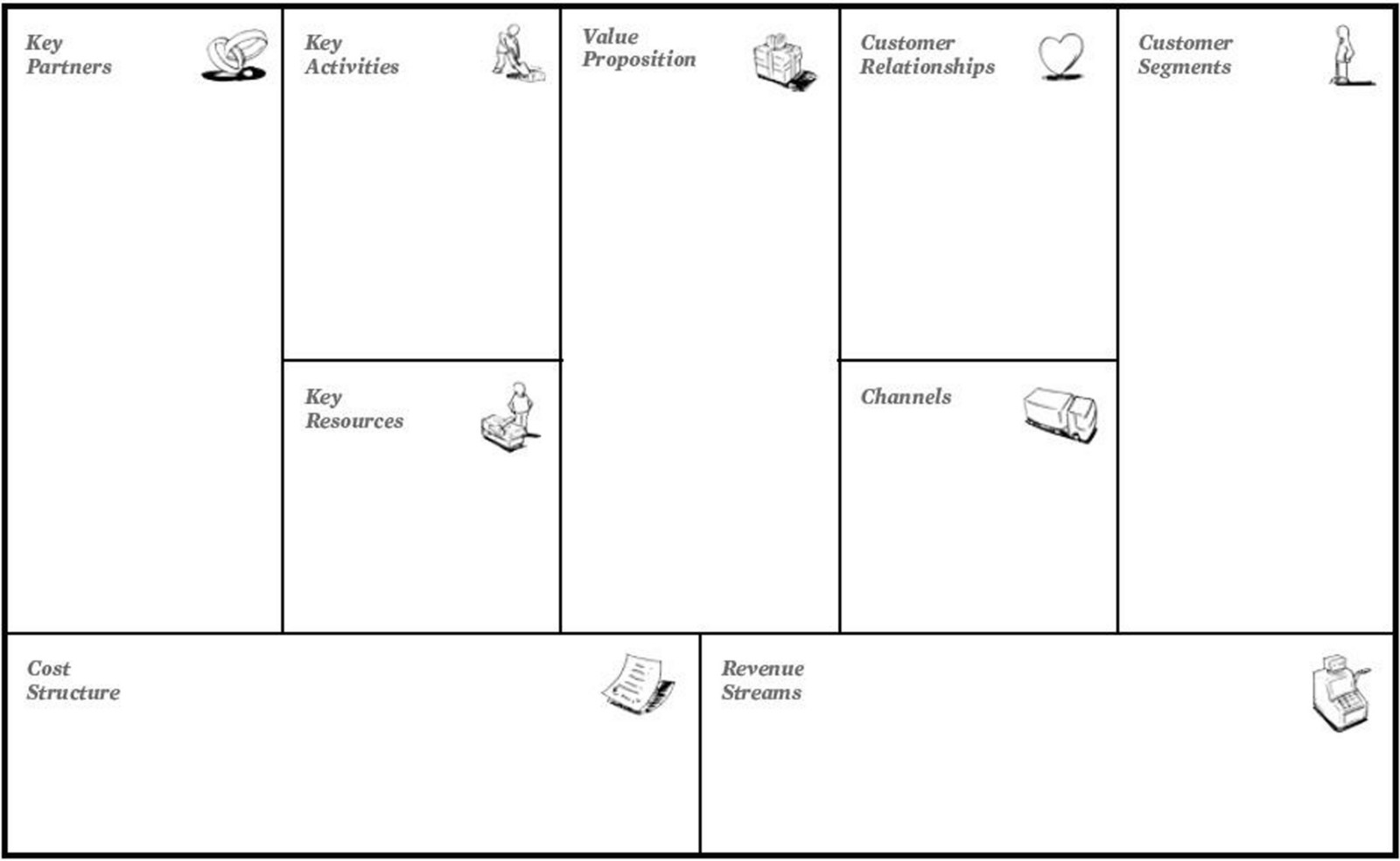
Amazon Business Model Canvas
Online merchandising
Product Development
Video Streaming
Affiliated businesses
Applications
Amazon.com
E-books
Amazon Prime Subscriptions
Sales margin
Mass Market
Self-service
Automation
Human customer service
Content licensing purchases
Original Content
Marketing
Infrastructure
Order fulfilment
Suppliers
Logistic partners
Affiliates
Authors, Publishers
Digital content providers
Original Content
Warehouses
ICT Developers
Large selection
Convenience
Low prices
Fast delivery
Options on subscription deals
Instant acquisition of a large selection of e-books.

Supply Chain Management
‘A firm’s supply chain is a network of organisations and business processes for procuring raw materials, transforming these materials into intermediate and finished products, and distributing the finished products to customers’ (Laudon and Laudon, 2015). Chaffey (2007) states that most commercial and not-for-profit organisations use either upstream supply chains; activities which are equivalent to buy-side e-commerce and downstream supply chains; activities which correspond to sell-side e-commerce.
Amazon’s supply chain management is arguably something of perfection; at heart, Amazon could arguably pin its success on this factor. Leblank (2017) states that the combination of sophisticated IT systems, networks of warehouses, multi-tier management and transport system working in synchronicity with each other have made Amazon one of the most efficient companies ever. Some of the evidence for this is provided by Leblank (2017) below:
Outsourcing logistics – Though Amazon has a wide array of warehouses, Leblank (2017) states that products that are not frequently bought are not housed in amazon warehouses and up to 82 percent of its sales are third party sellers, however Amazon has developed its own logistics, not relying on third party.
Value Chain
The Value Chain, established by Michael Porter is a ‘well-established concept for considering key activities that an organisation can perform or manage with the intention of adding value for the customer as products and services move from conception to delivery to consumer (Porter, 1980, cited in Chaffey, 2007) it is suggested by Chaffey (2007) that electronic communications can be used to make the value chain more efficient. Traditionally, Value chains were made up of primary activities (activities that directly concern goods and services to the customer) and Support activities (activities that provide infrastructure that allow primary activities)
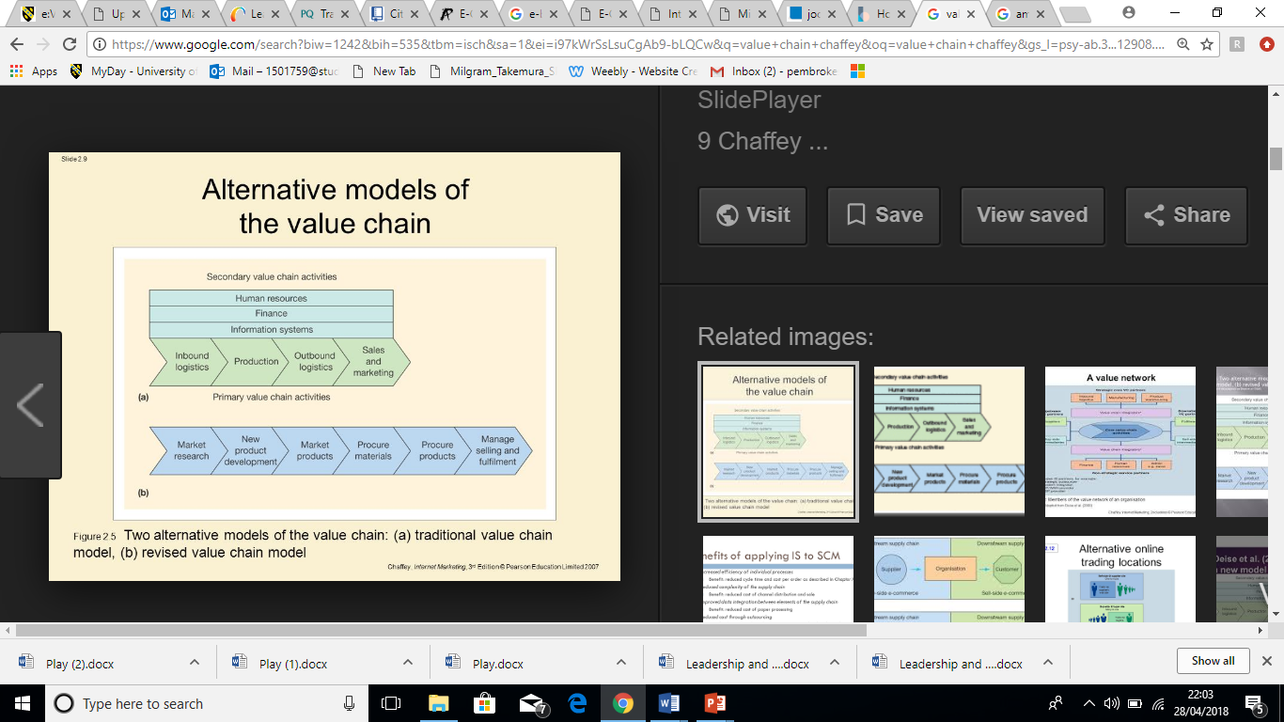
Figure 1 Chaffey (2007)

However, it is suggested by Chaffey (2007) that the advent of e-business means that support activities offer much more, arguing that these activities are critical to primary activities. A revised value chain by Deise et al (2000) integrates what would have been sperate, support activities into the value chain
Figure 2 Chaffey (2007)
In regards to Amazon’s value chain, Amazon are one of the few technology companies that have created new core revenue outside of its original core business. Engebretsen (2017) states that Amazon’s ability to generate massive new revenue from diversification stands in contrast to other technology companies, such as Google, who still rely heavily on advertising as their core model at 90%, despite attempts to diversify into other products and services.

ERP
Enterprise Resource Planning systems (ERP) are used ‘to integrate business processes in manufacturing and production, finance and accounting, sales and marketing and human resources into a single software system’. (Laudon and Laudon, 2015). According to Al Imran (2015) Amazon use a system by Oracle; ‘This system fastens the order fulfillment process with the order tracking and reduces any distribution mistakes. By this system the company reduced 50% of its customer service contacts since 1999 because of fewer mistakes.’ (BusinessWeek, 2003, cited in Al Imran, 2015)

CRM
Customer Relation Management (CRM) is described by Chaffey (2007) as being a key element of e-business. ‘Building long-term relationships with customers is essential for any sustainable business.’ (Chaffey 2007). Failure to do so is credited for largely being responsible for the failure of dot com era business. Due to its size, Amazon must obviously have a vast and comprehensive CRM system, though the principle is very much the same as any other organisation. Amazon’s CRM system is all in-house, meaning they can tailor their system to their own needs, using it in several ways. Al Imran (2015) states that amazon’s databases collect credit card, transaction, and order records, profiles and past purchase history. Information collected from feedback, wish lists and reviews can be collected by amazon to tailor to a customers’ needs through all stages of selection, acquisition, retention and extension.
Chaffey (2007) states that there are four activities that comprise CRM, involving the following:
- Customer Selection – The types of customers an organisation will market to. Groups of customers are identified on which to target. Amazon’s early selection were around people looking for books; this system is still the same in principle but on a vastly larger scale to account for all Amazon products and services.
- Customer Acquisition – refers to the marketing activities intended to form relationships with customers whilst minimising cost and targeting high value customers. For Amazon, in a world increasingly using the web to purchase products and services, customer acquisition is seemingly easy as customers who inevitably shop more and more on Amazon must have their own profile with personal details that Amazon keeps on their databases. The advent of 1-click ordering and speedy delivery is a seemingly powerful tool that also helps acquisition.
- Customer Retention – This refers to marketing activities by an organisation to keep existing customers. Identifying individual needs and position in customer lifecycle is key. According to Al Imran (2015) Amazon prioritises retention over acquisition, of which 40% of Amazon customers are frequent users. Amazon prides itself on dealing with customer queries, issues and complaints, dealing with them efficiently, based on experience.
- Customer Extension – Refers to increasing the depth of products that a customer purchases from a company, otherwise known as customer development. Even though Amazon clearly has massive reach, the market is still very aggressive especially when faced with such competition such as eBay. Amazon’s strategy for extending business is arguably through algorhithms that offer complimentary products to products already bought as well as motivation towards Amazon products and services such Amazon Prime and streaming.

Conclusion and Recommendations
Amazon are a clear example of a company who mastered e-business and have continued to innovate throughout its lifecycle, almost to a point that it seems untouchable. It competes with a multitude of different industries from retail to video streaming and leads the way in many of these industries. This is evidently due to Amazon’s continued understanding of e-business and commerce and continued efforts to refine itself and make customer experience more efficient and enjoyable. Unbeatable prices, efficient and quick delivery, convenience, as well as various deals, services and options have put Amazon into an almost unmatchable lead, leading even to the question of whether this will ever change, and if not, could Amazon’s continued dominance over multiple industries and continued innovation spell the end for more traditional high street retailing. Recommendations are as follows:
Continue to compete – Amazon, though almost untouchable, are still subject to disruption. In a world where technology seemingly changes the game every few years, it is important that Amazon do not lose touch of that fact and continue to innovate on their business, keeping the customers’ needs satisfied. This has been seen many times through history, where a company feels complacent within the status quo, becoming ignorant to major changes in technology, only to be disrupted and killed off; Blockbuster being a famous example, killed off quickly by Netflix.
Keep up with technology – Amazon must continue to monitor and adapt to technological advancements. This has of course been acted upon with such things like Amazon’s drone delivery service. However, arguably, there are more to reveal themselves. For example, the increasing use of such technology such as virtual reality opens opportunities such as possible “virtual” high streets, where products can be viewed and explored on a virtual plane.
Continue to explore new markets – Amazon has strived confidently into new markets throughout its history with high success rates; arguably, one that comes to mind is its streaming service. Continued exploration into these markets is imperative. For example, YouTube has been struggling lately with monetization of its content; continuous changes to algorithms and policies (otherwise named the “adpocalypse”) mean that many people have their videos and therefore, their revenue demonetised, leading many of its users who once relied heavily on advertising from YouTube as their income to have to find other ways of revenue, such as through merchandise or funding. Industries such as these present opportunities for major corporations such as Amazon to disrupt and ultimately see a shift from users from businesses such as YouTube, to an equivalent possible service by Amazon. Arguably, Amazon has proved this already possible with their streaming service, where shows and celebrities have moved from traditional TV and movies to Amazon.

References
AL IMRAN, A. (2015). 1 A STUDY ON AMAZON: INFORMATION SYSTEMS, BUSINESS STRATEGIES AND e-CRM. pp.4-7.
Anon, (2018). [online] Available at: https://www.statista.com/statistics/23 [Accessed 15 Apr. 2018].
Bragg, S. (2018). Cost structure. [online] AccountingTools. Available at: https://www.accountingtools.com/articles/what-is-cost-structure.html [Accessed 17 Apr. 2018].
dollars), M. (2018). Top internet companies: global market value 2017 | Statista. [online] Statista. Available at: https://www.statista.com/statistics/277483/market-value-of-the-largest-internet-companies-worldwide/ [Accessed 15 Apr. 2018].
dollars), N. (2018). Amazon: annual revenue 2017 | Statista. [online] Statista. Available at: https://www.statista.com/statistics/266282/annual-net-revenue-of-amazoncom/ [Accessed 15 Apr. 2018].
Expert Market. (2018). Amazon CRM Case Study. [online] Available at: https://www.expertmarket.co.uk/crm-systems/amazon-crm-case-study [Accessed 1 May 2018].
Hudadoff, P. (2009). The Customer Value Proposition Differentiation through the Eyes of Your Customer. [online] Engr.colostate.edu. Available at: http://www.engr.colostate.edu/~marchese/stese/reading2.pdf [Accessed 17 Apr. 2018].
Internetworldstats.com. (2018). World Internet Users Statistics and 2018 World Population Stats. [online] Available at: https://www.internetworldstats.com/stats.htm [Accessed 13 Apr. 2018].
Iqbal, P. (2013). E-COMMERCE VS MOBILE COMMERECE. International Journal of Applied Research, 2, pp.3-24.
KRAUSE, R. (2018). Cash-Rich Apple Ramps Up Original Content Spend Vs. Netflix, Amazon | Investor's Business Daily. [online] Investor's Business Daily. Available at: https://www.investors.com/news/technology/cash-rich-apple-ramps-up-original-content-spend-vs-netflix-amazon/ [Accessed 17 Apr. 2018].
Medium. (2017). Leveraging the Value Chain — Amazon case study – Travis Engebretsen – Medium. [online] Available at: https://medium.com/@TEngebretsen_/leveraging-the-value-chain-amazon-case-study-9bf52c2365e3 [Accessed 29 Apr. 2018].
millions), G. (2018). Global digital population 2018 | Statistic. [online] Statista. Available at: https://www.statista.com/statistics/617136/digital-population-worldwide/ [Accessed 13 Apr. 2018].
Oracle.com. (2018). ERP Cloud | Oracle United Kingdom. [online] Available at: https://www.oracle.com/uk/applications/erp/index.html [Accessed 29 Apr. 2018].
Plunkett, J. (2018). Top Gear's Clarkson, Hammond and May sign Amazon deal. [online] the Guardian. Available at: https://www.theguardian.com/media/2015/jul/30/top-gear-clarkson-hammond-may-amazon-deal-bbc [Accessed 1 May 2018].
Slávik, Š. and Bednár, R. (2014). Analysis of Business Models. Journal of Competitiveness, 6(4).
Smallbusiness.chron.com. (2018). How Amazon Uses E-Business for B2B. [online] Available at: http://smallbusiness.chron.com/amazon-uses-ebusiness-b2b-34155.html [Accessed 15 Apr. 2018].
The Balance. (2018). Understanding Amazon.com's History and Corporate Culture. [online] Available at: https://www.thebalance.com/amazon-com-company-research-2071316 [Accessed 16 Apr. 2018].
Tubefilter. (2018). Here’s How The YouTube ’Adpocalypse’ Is Affecting Top Creators - Tubefilter. [online] Available at: https://www.tubefilter.com/2017/05/04/how-youtube-adpocalypse-affected-top-creators/ [Accessed 1 May 2018].
Worldometers.info. (2018). World Population Clock: 7.6 Billion People (2018) - Worldometers. [online] Available at: http://www.worldometers.info/world-population/ [Accessed 13 Apr. 2018].
Zaczkiewicz, A. (2018). Amazon, Wal-Mart and Apple Top List of Biggest E-commerce Retailers. [online] WWD. Available at: http://wwd.com/business-news/business-features/amazon-wal-mart-apple-biggest-e-commerce-retailers-10862796/ [Accessed 16 Apr. 2018].

