
HTML & CSS Web development
ACCA4023

select the date you will be submitting
stephen jones (2440121)
LECTURER: SADHANA JHA

Contents
Introduction 2
Requirements 3
Purpose: 3
Subject matter 3
Intended audience 3
Implementation 4
Screenshots of the Webpages 4
Validation 6
HTML Validation 6
CSS Validation 7
Evaluation 8
Part A 8
Website usability- 8
Website accessibility: 8
Search engine optimisation (SEO) 8
Part B 8
Usefulness (Usability and Utility) 9
Search Engine Optimisation (SEO) 9
Accessibility: 9
Part C 9
References: 9
Appendix 10
Index (Welcome Page) 10
About the Band Page 11
Discography Page 14
CSS Style Sheet 27

Introduction
This report details the stages of building a webpage using HTML and CSS. There will be a brief explanation of the website I have chosen to build as well as images of the pages. I shall also cover the validation and evaluation process that follows building the website.

Requirements

Purpose:
The purpose of this website is to show if I can build a functional and visually appealing website using a basic knowledge of HTML and CSS.

Subject matter
I decided to build a fan site for my favourite band, Megadeth. They have recently announced their last goodbye, so they are very much on my mind lately.
On the site, I wanted to share some information on the band, their origins and their music.

Intended audience
I think casual fans of the band, or people that are curious about them would be the best people to aim the website towards

Implementation

Screenshots of the Webpages

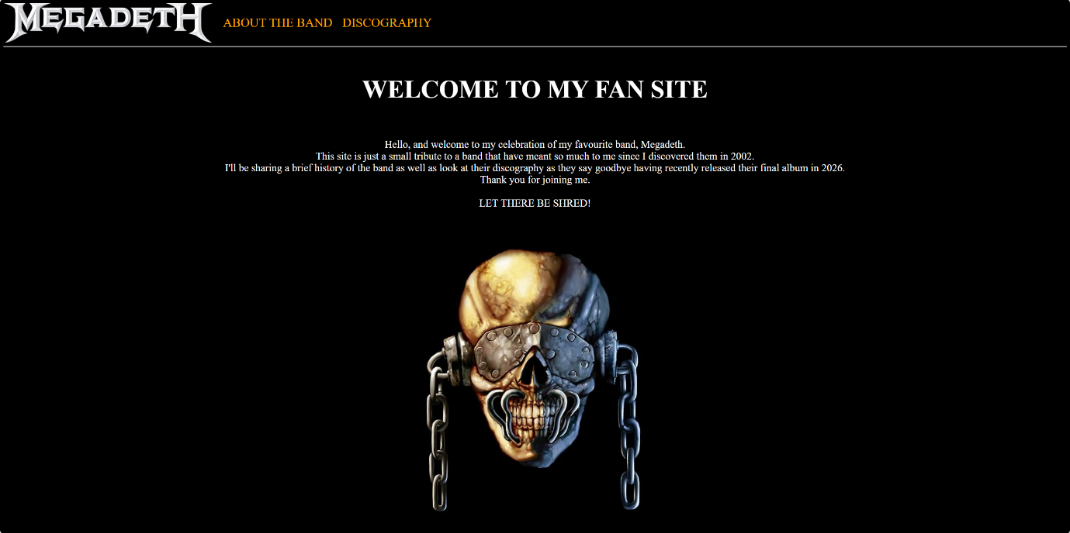
Figure 1: Home Page

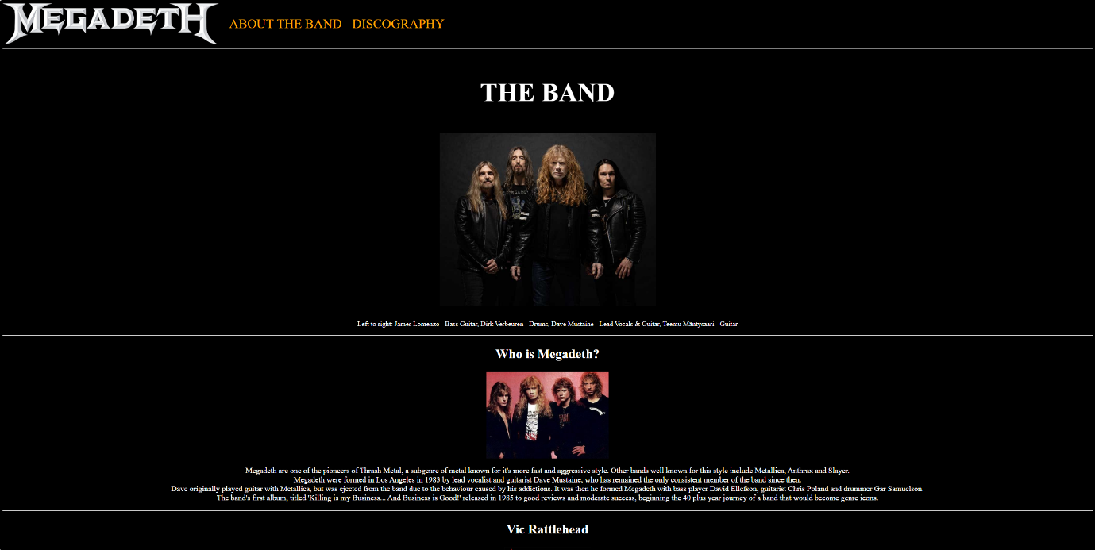
Figure 2: About the Band Page
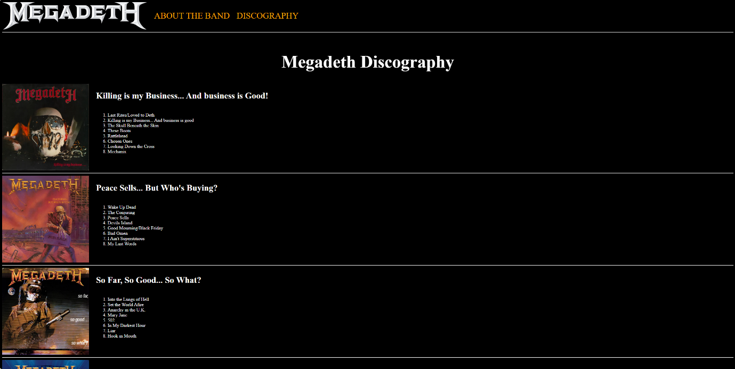
Figure 3: Discography Page

Validation

HTML Validation
My HTML Validation came up with some warnings and errors. The image below shows the first five items on the list.
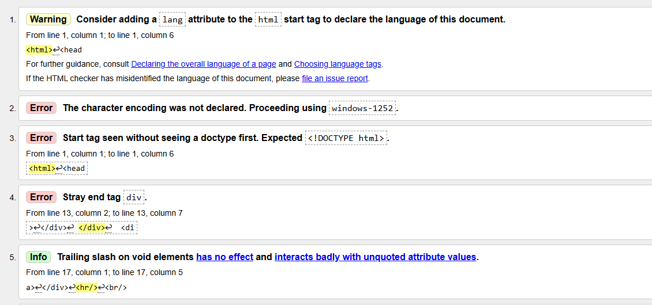
Figure 4: HTML Validation result 1
I decided to fix numbers 1, 3 and 4, since they were quickly and easily fixed by making amendments at the top of the code. I had to add <!DOCTYPE html> to the very top, add an attribute to the <html> tag, changing it to <html lang="en">, and finally deleting a stray </div> tag I’d put in by mistake. The image below shows the second validation with these errors fixed.
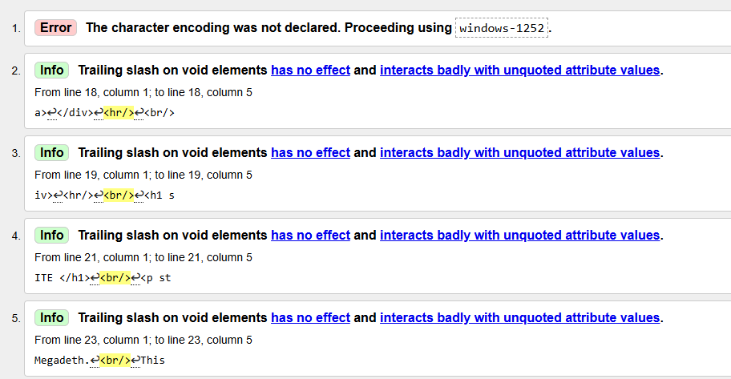
Figure 5:HTML Validation result 2

CSS Validation
My CSS Validation came back with no errors, meaning my style sheet is perfectly acceptable.
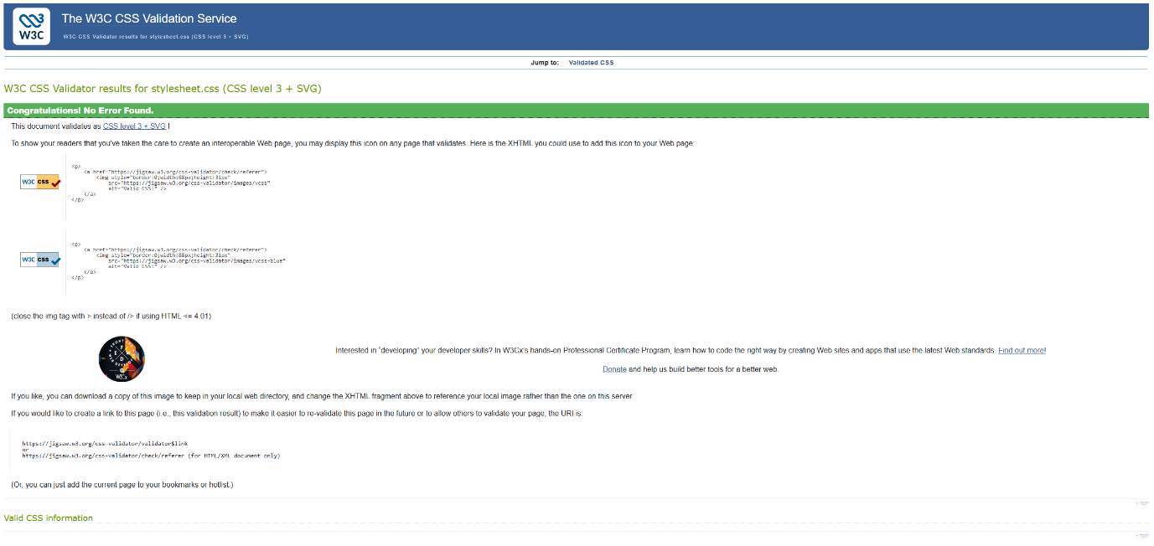
Figure 6: CSS Validation result

Evaluation
Part A

Website usability-
For a website to be successful, one of the most important things it needs to accomplish is good usability. This means that the main functions of the site, such as navigation, forms and search bars should be as simple as possible for ease of use [1].

Website accessibility:
Accessibility refers to how useable your website is for people who suffer with disabilities that may affect their browsing experience, such as sight or hearing loss [2]. Designers can refer to the Web Content Accessibility Guidelines (WCAG), however, implementing these guidelines can be complicated [3].

Search engine optimisation (SEO)
SEO involves improving the visibility of a website for search engines. Implementing the right design choices and keywords into the development and publication will make it easier to find on search engines as Google or Bing, therefore increasing the traffic to your website [4]
Part B

Usefulness (Usability and Utility)
Since my websites layout is very simple, I don’t think usability will be a problem for most people. However, I haven’t included put a labelled link to return to the welcome page. Instead, I’ve opted to make the logo at the top left a clickable image to return here, and this may be confusing for some.

Search Engine Optimisation (SEO)
To optimize my website for search engines, I used meta tags to add a description and keywords relating to the content on my index page. I also added titles and alt attributes on all of my pages.

Accessibility:
I tested some of the keyboard commands on my website, such as zooming with ctrl & +/-, scrolling down with the space bar and up with shift & spacebar. I also tried the MS Edge screen reader with ctrl, shift & U. All of these worked perfectly, making my website at least accessible on a basic level. I also used the Wave Evaluation Tool on all the pages and received high scores on all three, with the only error being that the language wasn’t present on the band and discography pages
Part C
Area | Website 1 | Website 2
Weblink of the Website | Amazon | Zavvi
Usability | Layout is well designed, but a little busy. There are plenty of navigation links to help the user find what they’re looking for, but the amount of text and images could be overwhelming. It is easy to find what you’re looking for, however. There is a large, centralised search bar as well as the aforementioned navigation links. I found finding and purchasing items easily. | Sleek look without too much visual noise. A clear search bar and neat, detailed hover links make finding what you want easy enough, however, the hover links present a lot of extra text to read through in the form of more specific sections of the site. Adding items to the basket is easy.
Accessibility | AIM Score 5.8. Lots of long alternative text flags and contrast errors and 138 features. Amazon is very slightly above average in terms of accessibility | AIM Score 8.1. More errors with 5, and less features with 180, however there are zero contrast errors and only 1 long text flag. Zavvi is very good in terms of accessibility
SEO | The title was flagged for having the domain name within it.  The meta description is too long by 1250 too long  4 images have no alt attribute | The title was flagged for being too large.  The meta description is 100 pixels too long  6 images have no alt attribute
Mobile Friendliness | The site translates to mobile perfectly, but the visual clutter issues carry across meaning you have to slide across for all the navigation options and featured items at the top, leaving some of them hidden if you aren’t aware. | Very neat mobile layout, with navigation options tucked neatly in the corner with an icon. All featured items displayed neatly without the need for sliding left or right to see hidden content.
Conclusion | Amazon is a good site that’s easy to use, but the home page feels like it’s shoving a bit too much in my face, so much so that it overextends the normal view on mobile. It scored average on the accessibility checker, but the SEO was good enough. | I think Zavvi is the better website. The layout is less cluttered, making the home page less overwhelming. It has better accessibility, and it stayed very close to the more popular amazon in terms of SEO.

References:

[1] N. S. Aziz, N. S. Sulaiman, W. N. I. T. M. Hassan, N. L. Zakaria, and A. Yaacob, “A Review of Website Measurement for Website Usability Evaluation,” Journal of Physics: Conference Series, vol. 1874, no. 1, p. 012045, May 2021, doi: https://doi.org/10.1088/1742-6596/1874/1/012045.

[2] M. Campoverde-Molina, S. Luján-Mora, and L. Valverde, “Accessibility of university websites worldwide: a systematic literature review,” Universal Access in the Information Society, vol. 22, Jul. 2021, doi: https://doi.org/10.1007/s10209-021-00825-z.

[3] J. Muzaffar and N. Mazher, “Web Accessibility Standards: Implementing WCAG Guidelines for Inclusive Design”, prjcs, vol. 1, no. 3, pp. 62–70, Sep. 2024.

[4] F. Alfiana et al., “Apply the Search Engine Optimization (SEO) Method to Determine Website Ranking on Search Engines,” International Journal of Cyber and IT Service Management, vol. 3, no. 1, pp. 65–73, Mar. 2023, doi: https://doi.org/10.34306/ijcitsm.v3i1.126.

Appendix

Index (Welcome Page)
<!DOCTYPE html>
<html lang="en">
<head>
<meta name="description" content="A Fansite for Metal icons Megadeth">
<meta name="keywords" content="Megadeth, Metal, Thrash, Mustaine">
<meta name="viewport" content="width=device-width, initial-scale=1.0">
<link rel="stylesheet" href="stylesheet.css">
<title> Welcome </title>
</head>
<body>
<div style="display: inline-block; vertical-align: top;">
<img src="md-white-logo2.webp" style="width: 500px; height: auto;" alt="Megadeth Logo">
</div>
<div style="display: inline-block; vertical-align: top; margin-left: 20px;margin-top: 30px;">
<a href="theband.html" style=font-size:30px;>ABOUT THE BAND</a>
</div>
<div style="display: inline-block; vertical-align: top; margin-left: 20px;margin-top: 30px;">
<a href="discog.html" style=font-size:30px;>DISCOGRAPHY</a>
</div>
<hr/>
<br/>
<h1 style=font-size:60px> WELCOME TO MY FAN SITE </h1>
<br/>
<p style=font-size:25px;text-align:center;>Hello, and welcome to my celebration of my favourite band, Megadeth.
<br/>
This site is just a small tribute to a band that have meant so much to me since I discovered them in 2002.
<br/>
I'll be sharing a brief history of the band as well as look at their discography as they say goodbye having recently released their final album in 2026.
<br/>
Thank you for joining me.
<br/> <br/>
LET THERE BE SHRED!</p>
<br/> <br/>
<img src="vic.jpeg" alt="Vic Rattlehead"; class="center">
</body>
</html>

About the Band Page
<html>
<head>
<meta name="viewport" content="width=device-width, initial-scale=1.0">
<link rel="stylesheet" href="stylesheet.css">
<title> The Band </title>
</head>
<body>
<div style="display: inline-block; vertical-align: top;">
<a href="index.html"><img src="md-white-logo2.webp" style="width: 500px; height: auto;" alt="Megadeth Logo"></a>
</div>
<div style="display: inline-block; vertical-align: top; margin-left: 20px;margin-top: 30px;">
<a href="theband.html" style=font-size:30px;>ABOUT THE BAND</a>
</div>
</div>
<div style="display: inline-block; vertical-align: top; margin-left: 20px;margin-top: 30px;">
<a href="discog.html" style=font-size:30px;>DISCOGRAPHY</a>
</div>
<hr/>
<br/>
<h1 style=font-size:60px> THE BAND </h1>
<br/>
<img src="megadeth.jpg" alt="Current Lineup" style=height:400px; class="center">
<br/>
<p style=font-size:16px;text-align:center;> Left to right: James Lomenzo - Bass Guitar, Dirk Verbeuren - Drums, Dave Mustaine - Lead Vocals & Guitar, Teemu Mäntysaari - Guitar </p>
<hr/>
<h2 style=text-align:center> Who is Megadeth? </h2>
<img src="firstlineup.jpg"; style=height:200px; alt="Original Lineup"; class="center">
<p style=text-align:center> Megadeth are one of the pioneers of Thrash Metal, a subgenre of metal known for it's more fast and aggressive style. Other bands well known for this style include Metallica, Anthrax and Slayer.
<br/>
Megadeth were formed in Los Angeles in 1983 by lead vocalist and guitarist Dave Mustaine, who has remained the only consistent member of the band since then.<br/>
Dave originally played guitar with Metallica, but was ejected from the band due to the behaviour caused by his addictions. It was then he formed Megadeth with bass player David Ellefson, guitarist Chris Poland and drummer Gar Samuelson.<br/>
The band's first album, titled 'Killing is my Business... And Business is Good!' released in 1985 to good reviews and moderate success, beginning the 40 plus year journey of a band that would become genre icons.</p>
<hr/>
<h2 style=text-align:center> Vic Rattlehead </h2>
<img src="concept.jpg"; style=height:200px; alt="Vic Concept"; class="center">
<p style=text-align:center>Vic Rattlehead, an idea conceived by Mustaine, has become known as the bands mascot. He is a skeleton with a steel visor across his eyes, staples on his mouth and metal caps with chains hanging from where his ears would be. Vic has appeared on almost every
Megadeth albom cover, as well as countless t-shirts and other merchandise. Vic has also joined the band on stage for some shows. Also, on a personal note, Vic is my one and only tattoo as of writing. </p>
<hr/>
<h2 style=text-align:center> The End... </h2>
<img src="gravestone.png" alt="gravestone" style="height:200px;"; class="center">
<p style=text-align:center>In 2025, Megadeth officially announced that the band was coming to an end with one final album and a world tour. <br/>
In February 2026, the final, self titled album was released and plans and dates are starting to roll out for the farewell tour. Megadeth have been a part of my life for almost 25 years and seeing it all end has been an emotional experience for me. I've only managed to see them live a
few times so I hope I can get tickets to be there and say goodbye to my favourite band in person. </p>
<hr/>
<h1 style=font-size:50px> Links </h1>
<div style="text-align: center;">
<a href="https://www.megadeth.com/">Official Megadeth Website</a><br/>
</div>
<div style="text-align: center;">
<a href="https://www.youtube.com/megadeth">Official Megadeth YouTube Channel</a><br/>
</div>
<div style="text-align: center;">
<a href="https://www.facebook.com/Megadeth/">Official Megadeth Facebook Page</a><br/>
</div>
<div style="text-align: center;">
<a href="https://www.instagram.com/megadeth/">Official Megadeth Instagram Page</a><br/>
</div>
<div style="text-align: center;">
<a href="https://x.com/megadeth">Official Megadeth X Page</a><br/>
</div>
<br/>
</body>
</html>

Discography Page
<html>
<head>
<meta name="viewport" content="width=device-width, initial-scale=1.0">
<link rel="stylesheet" href="stylesheet.css">
<title> Discography </title>
</head>
<body>
<div style="display: inline-block; vertical-align: top;">
<a href="index.html"><img src="md-white-logo2.webp" style="width: 500px; height: auto;" alt="Megadeth Logo"></a>
</div>
<div style="display: inline-block; vertical-align: top; margin-left: 20px;margin-top: 30px;">
<a href="theband.html" style=font-size:30px;>ABOUT THE BAND</a>
</div>
</div>
<div style="display: inline-block; vertical-align: top; margin-left: 20px;margin-top: 30px;">
<a href="discog.html" style=font-size:30px;>DISCOGRAPHY</a>
</div>
<hr/>
<br/>
<h1 style=font-size:60px> Megadeth Discography </h1>
<div style="display: inline-block; vertical-align: top;">
<img src="KIMB.webp" style="width: 300px; height: auto;" alt="Killing is my business cover">
</div>
<div style="display: inline-block; vertical-align: top; margin-left: 20px;">
<h2>Killing is my Business... And business is Good!</h2>
<ol class=myOL>
<li>Last Rites/Loved to Deth</li>
<li>Killing is my Business... And business is good</li>
<li>The Skull Beneath the Skin</li>
<li>These Boots</li>
<li>Rattlehead</li>
<li>Chosen Ones</li>
<li>Looking Down the Cross</li>
<li>Mechanix</li>
</ol>
</div>
<hr/>
<div style="display: inline-block; vertical-align: top;">
<img src="PeaceSells.webp" style="width: 300px; height: auto;" alt="Peace Sells cover">
</div>
<div style="display: inline-block; vertical-align: top; margin-left: 20px;">
<h2>Peace Sells... But Who's Buying?</h2>
<ol class=myOL>
<li>Wake Up Dead</li>
<li>The Conjuring</li>
<li>Peace Sells</li>
<li>Devils Island</li>
<li>Good Mourning/Black Friday</li>
<li>Bad Omen</li>
<li>I Ain't Superstitious</li>
<li>My Last Words</li>
</ol>
</div>
<hr/>
<div style="display: inline-block; vertical-align: top;">
<img src="SoWhat.webp" style="width: 300px; height: auto;" alt="SFSGSW cover">
</div>
<div style="display: inline-block; vertical-align: top; margin-left: 20px;">
<h2>So Far, So Good... So What?</h2>
<ol class=myOL>
<li>Into the Lungs of Hell</li>
<li>Set the World Afire</li>
<li>Anarchy in the U.K.</li>
<li>Mary Jane</li>
<li>502</li>
<li>In My Darkest Hour</li>
<li>Liar</li>
<li>Hook in Mouth</li>
</ol>
</div>
<hr/>
<div style="display: inline-block; vertical-align: top;">
<img src="RIP.webp" style="width: 300px; height: auto;" alt="RIP cover">
</div>
<div style="display: inline-block; vertical-align: top; margin-left: 20px;">
<h2>Rust in Peace</h2>
<ol class=myOL>
<li>Holy Wars... The Punishment Due</li>
<li>Hangar 18</li>
<li>Take No Prisoners</li>
<li>Five Magics</li>
<li>Poison was the Cure</li>
<li>Lucretia</li>
<li>Tornado of Souls</li>
<li>Dawn Patrol</li>
<li>Rust in Peace... Polaris</li>
</ol>
</div>
<hr/>
<div style="display: inline-block; vertical-align: top;">
<img src="countdown.jpg" style="width: 300px; height: auto;" alt="Cowntdown cover">
</div>
<div style="display: inline-block; vertical-align: top; margin-left: 20px;">
<h2>Countdown to Extinction</h2>
<ol class=myOL>
<li>Skin O' My Teeth</li>
<li>Symphony of Destruction</li>
<li>Architecture of Aggression</li>
<li>Forclosure of a Dream</li>
<li>Sweating Bullets</li>
<li>This Was My Life</li>
<li>Countdown to Extinction</li>
<li>High Speed Dirt</li>
<li>Psychotron</li>
<li>Captive Honour</li>
<li>Ashes in your Mouth</li>
</ol>
</div>
<hr/>
<div style="display: inline-block; vertical-align: top;">
<img src="Youthanasia.webp" style="width: 300px; height: auto;" alt="Youthanasia cover">
</div>
<div style="display: inline-block; vertical-align: top; margin-left: 20px;">
<h2>Youthanasia</h2>
<ol class=myOL>
<li>Reckoning Day</li>
<li>Train of Consequences</li>
<li>Addicted to Chaos</li>
<li>A Tout Le Monde</li>
<li>Elysian Fields</li>
<li>The Killing Road</li>
<li>Blood of Heroes</li>
<li>Family Tree</li>
<li>Youthanasia</li>
<li>I Thought I Knew it All</li>
<li>Black Curtains</li>
<li>Victory</li>
</ol>
</div>
<hr/>
<div style="display: inline-block; vertical-align: top;">
<img src="CrypticWritings.webp" style="width: 300px; height: auto;" alt="Cryptic Writings cover">
</div>
<div style="display: inline-block; vertical-align: top; margin-left: 20px;">
<h2>Criptic Writings</h2>
<ol class=myOL>
<li>Trust</li>
<li>Almost Honest</li>
<li>Use the Man</li>
<li>Mastermind</li>
<li>The Disintegrators</li>
<li>I'll Get Even</li>
<li>Sin</li>
<li>A Secret Place</li>
<li>Have Cool, Will Travel</li>
<li>She-Wolf</li>
<li>Vortex</li>
<li>FFF</li>
</ol>
</div>
<hr/>
<div style="display: inline-block; vertical-align: top;">
<img src="Risk.webp" style="width: 300px; height: auto;" alt="Risk cover">
</div>
<div style="display: inline-block; vertical-align: top; margin-left: 20px;">
<h2>Risk</h2>
<ol class=myOL>
<li>Insomnia</li>
<li>Prince of Darkness</li>
<li>Crush 'Em</li>
<li>Breadline</li>
<li>The Doctor is Calling</li>
<li>I'll Be There</li>
<li>Wanderlust</li>
<li>Ecstasy</li>
<li>Seven</li>
<li>Time: The Beginning</li>
<li>Time: The End</li>
</ol>
</div>
<hr/>
<div style="display: inline-block; vertical-align: top;">
<img src="World.webp" style="width: 300px; height: auto;" alt="TWNAH cover">
</div>
<div style="display: inline-block; vertical-align: top; margin-left: 20px;">
<h2>The World Needs a Hero</h2>
<ol class=myOL>
<li>Disconnect</li>
<li>The World Needs a Hero</li>
<li>Moto Psycho</li>
<li>1000 Times Goodbye</li>
<li>Burning Bridges</li>
<li>Promises</li>
<li>Recipe for Hate... Warhorse</li>
<li>Losing my Senses</li>
<li>Dread and the Fugitive Mind</li>
<li>Silent Scorn</li>
<li>Return to Hangar</li>
<li>When</li>
</ol>
</div>
<hr/>
<div style="display: inline-block; vertical-align: top;">
<img src="TSHF.webp" style="width: 300px; height: auto;" alt="TSHF cover">
</div>
<div style="display: inline-block; vertical-align: top; margin-left: 20px;">
<h2>The System has Failed</h2>
<ol class=myOL>
<li>Blackmail the Universe</li>
<li>Die Dead Enough</li>
<li>Kick the Chair</li>
<li>The Scorpion</li>
<li>Tears in a Vial</li>
<li>I Know Jack</li>
<li>Back in the Day</li>
<li>Something That I'm Not</li>
<li>Truth Be Told</li>
<li>Of Mice and Men</li>
<li>Shadow of Deth</li>
<li>My Kingdom</li>
</ol>
</div>
<hr/>
<div style="display: inline-block; vertical-align: top;">
<img src="UnitedAbominations.webp" style="width: 300px; height: auto;" alt="United Abominations cover">
</div>
<div style="display: inline-block; vertical-align: top; margin-left: 20px;">
<h2>United Abominations</h2>
<ol class=myOL>
<li>Sleepwalker</li>
<li>Washington is Next!</li>
<li>Never Walk Alone... A Call to Arms</li>
<li>United Abominations</li>
<li>Gears of War</li>
<li>Blessed are the Dead</li>
<li>Play for Blood</li>
<li>A Tout Le Monde (Set Me Free)</li>
<li>Amerikhastan</li>
<li>You're Dead</li>
<li>Burnt Ice</li>
</ol>
</div>
<hr/>
<div style="display: inline-block; vertical-align: top;">
<img src="Endgame.webp" style="width: 300px; height: auto;" alt="Endgame cover">
</div>
<div style="display: inline-block; vertical-align: top; margin-left: 20px;">
<h2>Endgame</h2>
<ol class=myOL>
<li>Dialectic Chaos</li>
<li>This Day We Fight!</li>
<li>44 Minutes</li>
<li>1,320</li>
<li>Bite the Hand</li>
<li>Bodies</li>
<li>Endgame</li>
<li>The Hardest Part of Letting Go... Sealed with a Kiss</li>
<li>Head Crusher</li>
<li>How the Story Ends</li>
<li>The Right to Go Insane</li>
</ol>
</div>
<hr/>
<div style="display: inline-block; vertical-align: top;">
<img src="13.webp" style="width: 300px; height: auto;" alt="Thirteen cover">
</div>
<div style="display: inline-block; vertical-align: top; margin-left: 20px;">
<h2>TH1RT3EN</h2>
<ol class=myOL>
<li>Sudden Death</li>
<li>Public Enemy No. 1</li>
<li>Whose Life (is it Anyways?)</li>
<li>We the People</li>
<li>Guns, Drugs, & Money</li>
<li>Never Dead</li>
<li>New World Order</li>
<li>Fast Lane</li>
<li>Black Swan</li>
<li>Wrecker</li>
<li>Millenium of the Blind</li>
<li>Deadly Nightshade</li>
<li>13</li>
</ol>
</div>
<hr/>
<div style="display: inline-block; vertical-align: top;">
<img src="SuperCollider.webp" style="width: 300px; height: auto;" alt="Collider cover">
</div>
<div style="display: inline-block; vertical-align: top; margin-left: 20px;">
<h2>Super Collider</h2>
<ol class=myOL>
<li>Kingmaker</li>
<li>Super Collider</li>
<li>Burn!</li>
<li>Built for War</li>
<li>Off the Edge</li>
<li>Dance in the Rain</li>
<li>Beginning of Sorrow</li>
<li>The Blackest Crow</li>
<li>Forget to Remember</li>
<li>Don't Turn Your Back</li>
<li>Cold Sweat (Thin Lizzy Cover)</li>
<li>All I Want (Bonus Track)</li>
<li>A House Divided</li>
</ol>
</div>
<hr/>
<div style="display: inline-block; vertical-align: top;">
<img src="Dystopia.webp" style="width: 300px; height: auto;" alt="Dystopia cover">
</div>
<div style="display: inline-block; vertical-align: top; margin-left: 20px;">
<h2>Dystopia</h2>
<ol class=myOL>
<li>The Threat is Real</li>
<li>Dystopia</li>
<li>Fatal Illusion</li>
<li>Death from Within</li>
<li>Bullet to the Brain</li>
<li>Post American World</li>
<li>Poisonous Shadows</li>
<li>Conquer or Die</li>
<li>Lying in State</li>
<li>The Emperor</li>
<li>Foreign Policy</li>
</ol>
</div>
<hr/>
<div style="display: inline-block; vertical-align: top;">
<img src="SDatD.webp" style="width: 300px; height: auto;" alt="SDATD cover">
</div>
<div style="display: inline-block; vertical-align: top; margin-left: 20px;">
<h2>The Sick, The Dying... And the Dead!</h2>
<ol class=myOL>
<li>The Sick, The Dying... And the Dead!</li>
<li>Life in Hell</li>
<li>Night Stalkers</li>
<li>Dogs of Chernobyl</li>
<li>Sacrifice</li>
<li>Junkie</li>
<li>Psychopathy</li>
<li>Killing Time</li>
<li>Soldier On!</li>
<li>Celebutante</li>
<li>Mission to Mars</li>
<li>We'll Be Back</li>
</ol>
</div>
<hr/>
<div style="display: inline-block; vertical-align: top;">
<img src="NewAlbum.webp" style="width: 300px; height: auto;" alt="Final cover">
</div>
<div style="display: inline-block; vertical-align: top; margin-left: 20px;">
<h2>Megadeth</h2>
<ol class=myOL>
<li>Tipping Point</li>
<li>I Don't Care</li>
<li>Hey, God?!</li>
<li>Let There Be Shred</li>
<li>Puppet Parade</li>
<li>Another Bad Day</li>
<li>Made to Kill</li>
<li>Obey the Call</li>
<li>I Am War</li>
<li>The Last Note</li>
<li>Ride the Lightning (Metallica Cover)</li>
</ol>
</div>
<hr/>
</body>
</html>

CSS Style Sheet
body {background-color:black}
h1 {color: white;text-align:center}
P {color:white; font-size:18px}
.center {display: block;margin-left: auto;margin-right: auto;}
h2 {color:white;font-size:30px}
.pleft {margin-right:900px}
.pright {margin-left:900px}
ol {color:white;}
div.container {text-align: center;}
ol.myOL {display: inline-block;text-align: left;}
a:link{color:orange;text-decoration:none}
a:hover{color:red;text-decoration:none}
a:visited{color:grey;text-decoration:none}

