Janine Dixon_1600982
How effective were medieval representations of the differences between hell and purgatory?
An unprepared death, without the opportunity to confess all sins committed and receive the last rites, was a common fear amongst many people during the middle ages. The church taught that the fate of a person’s soul was determined by their behaviour in life and the manner of their death. Therefore, many feared that the inability to be sufficiently prepared for death would lead to a perpetual cycle of torture in hell. It was widely believed that hell was the destiny for those guilty of mortal sins and various sources state that the punishments the soul would receive within hell would specifically relate to the sins that were committed during life. The idea of purgatory was accepted as a doctrine of the Catholic church in the 1200s. This was believed to be a place for moderately bad sinners to be purified before being allowed into heaven. Similarly, to hell, it was often documented that the punishment would relate to the sins committed by the living. However, it was believed that these punishments would become less severe as the soul progressed through purgatory and there was an opportunity to be cleansed of these sins and progress onto heaven. This differs from the beliefs held about hell, which were that the punishments do not lessen in severity and the soul will endure everlasting torture. To lessen the time in purgatory, the living was encouraged to pray for dead souls. Many books of hours contained offices of the dead which were a series of prayers to be said in remembrance of the dead, as well as. in anticipation of death and at funerals. This essay explores the effectiveness of medieval representations of the differences between hell and purgatory.

Descriptions of hell were given in various popular texts such as the Inferno portion of Dante Alighieri’s 14th century epic poem Divine Comedy. In the poem, hell is depicted as nine concentric circles of torment. Alighieri writes,
I understood that all such torments are
Destined for those whose sins are of the flesh,
Those who subject their reason for desire…
They are not comforted by thoughts of rest,
Or even diminution of their pain. ( Inferno V, 37-44)
This reflects the belief that hell was a place for those who had committed mortal sins where they would face an eternity of unyielding punishment. Hell was also described in detail by Marcus who was a monk and wrote Tundale’s Visions of Heaven and Hell for Gisila the abbess of Saint Paul in Regensburg. The tale describes the visions of the knight Tundale who is guided through hell by an angel and experiences various torments that are inflicted on the sinful souls. Marcus describes how the torture is reflective of the sin and Tundale is taught the value of penitence. The angel comforts Tundale by saying, ‘the Lord is the one who leads toward and away from the depths… For he does not desire the death of the sinner, but he desires that the sinner convert and live.’ (Marcus, Tundale’s Vision) In addition to providing entertainment to the reader, this text acts as spiritual instruction and as a warning of what awaits the sinner if they do not live a pious life.
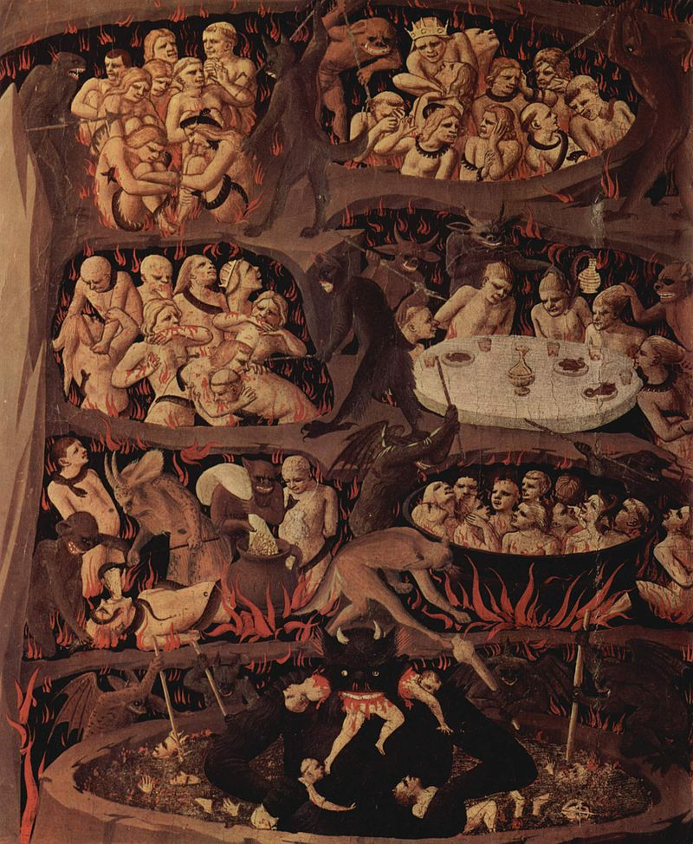Fig.1 Hell by Fra Angelico, 1431.
Figure 1 is a depiction of punishments in hell that are reflective of the seven deadly sins: pride, greed, lust, envy, gluttony, wrath and sloth. This image echoes the previously mentioned texts descriptions of the idea that specific sins will result in certain punishments. This image is one of many depictions of hell that were produced during the middle ages. The popularity of this imagery suggests that the existence of hell was a firmly held belief amongst many medieval people. The sheer quantity of primary sources containing hell imagery suggests that it was effective in warning people of the consequences of living a sinful life.

The idea of purgatory developed between the 1160s and 1180s. This was believed to be a place where moderate sinners could be cleansed to their sins through punishments in order to secure their place in heaven after the last judgement. It was believed that in order to deal with purgatory certain actions needed to be completed by a person during their life which included confession. It was deemed important for a person to confess, in detail, all the sins they had committed prior to their death in order to avoid or lessen their time in purgatory. Penance was also an important step to avoid purgatory. Many handbooks were produced which provided specific instructions in the art of confession and penance. Ars Moriendi are two texts produced around 1415 and 1450 which offer advice on procedures and protocols for a good death. The first is a longer version where death is shown as a public ceremony. The second version is briefer and illuminated which dramatizes moral conflict. Purgatory, itself is described in texts and depicted in a variety of images. In the Revelation of the Monk of Eynsham purgatory is described and the punishments that were inflicted on the sinners there were described,
Sinners set to the punishments that fitted their deeds and their characters…being so beaten and broken and inwardly burnt, still they managed to free themselves again, and as I have said, the further they went, the lesser their pains became. ( Revelation of the Monk of Eynsham, ‘The First Place of Purgatory’)
This differs to hell in that there is hope of escape from purgatory, although sinners will still have to endure torment.
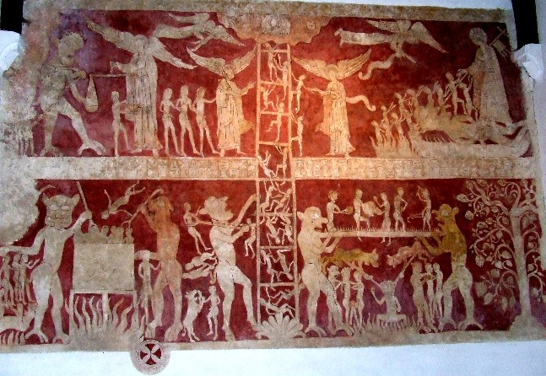
Fig.2 Purgatorial ladder with Bridge of Souls. Chaldon, Surrey

Figure 2 depicts souls receiving various forms of torture at the hands of demons and their ascension towards heaven after being purged to their sins. All the representations of purgatory act as a cautionary tale to those viewing them to encourage them to confess and be repentant of their sins.

The representations of the differences between hell and purgatory are effective in warning the people of the middle ages of the consequences of their actions on earth and what will face them in the afterlife if they do not live in accordance to the word of God. The popularity of these representations suggest that the existence of hell and purgatory were widely believed. Therefore, this adds to the effectiveness and, perhaps, provided an element of fear for the people of the middle ages which acted as encouragement for a pious existence.

