

Module Title: | Dissertation
Module Code: | LCMB7020_LON
Course: | MBA HUMAN RESOURCE MANAGEMENT
Dissertation Topic: | ANALYSIS OF THE IMPACT OF FRINGE BENEFITS ON EMPLOYEE PRODUCTIVITY IN THE FAST FOOD SECTOR - A CASE OF PIZZA HUT IN UK
Lecturer: | Dr. Jaya Gopalkrishnan

Master’s Degrees by Examination and Dissertation
Declaration Form.
1. This work has not previously been accepted in substance for any degree and is not being concurrently submitted in candidature for any degree.
Signed : 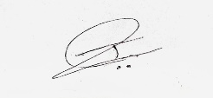
Date : 14/06/2023

2. This dissertation is being submitted in partial fulfilment of the requirements for the degree of Master in Business Administration.
Signed :
Date : 14/06/2023
3. This dissertation is the result of my own independent work/investigation, except where otherwise stated.
Other sources are acknowledged by footnotes giving explicit references.
A bibliography is appended.
Signed candidate :
Date: 14/06/2023

4. I hereby give consent for my dissertation, if accepted, to be available for photocopying, inter- library loan, and for deposit in the University’s digital repository
Signed (candidate) :
Date : 14/06/2023

Supervisor’s Declaration.
I am satisfied that this work is the result of the student’s own efforts.
Signed : Dr Jaya Gopalkrishnan
Date: 14/06/23

University of Wales: Trinity Saint David
E-Thesis Deposit Agreement

Details of the Work
I would like to deposit the following item in the digital repository maintained by the University, and/or in any other repository authorized for use by the University:

Title: ANALYSIS OF THE IMPACT OF FRINGE BENEFITS ON EMPLOYEE PRODUCTIVITY IN THE FAST FOOD SECTOR – A CASE OF PIZZA HUT IN UK

This item is a product of my own research endeavours and is covered by the agreement below in which the item is referred to as “the Work”. It is identical in content to that deposited in the Learning Resources Centre, subject to point 4 below.
I agree that the University of Wales: Trinity Saint David may electronically store, copy or translate the Work to any approved medium or format for the purpose of future preservation and accessibility. The University is not under any obligation to reproduce or display the Work in the same formats or resolutions in which it was originally deposited.
UW: TSD Digital Repository
I understand that work deposited in the digital repository will be accessible to a wide variety of people and institutions, including automated agents and search engines via the World Wide Web.
I understand that once the Work is deposited, the item and its metadata may be incorporated into public access catalogues or services, such as national databases of electronic theses.

I agree as follows:
- That I am the author or have the authority of the author/s to make this agreement and do hereby give the University of Wales: Trinity Saint David the right to make available the Work in the way described above.
- That the electronic copy of the Work deposited in the digital repository and covered by this agreement, is identical in content to the paper copy of the Work.
- That I have exercised reasonable care to ensure that the Work is original, and to the best of my knowledge, does not breach any laws including those relating to defamation, libel and copyright.
- That I have, in instances where the intellectual property of other authors or copyright holders is included in the Work, gained explicit permission for the inclusion of that material in the Work, and in the electronic form of the Work as accessed through the open access digital repository, or that I have identified and removed that material for which adequate permission has not been obtained and which will be inaccessible via the digital repository
- That University of Wales: Trinity Saint David does not hold any obligation to take legal action on behalf of the Depositor, or other rights holders, in the event of a breach of intellectual property rights, or any other right, in the material deposited.
- That I undertake to indemnify the University of Wales: Trinity Saint David against all actions, suits, proceedings, claims, demands and costs occasioned by the University in consequence of any breach of this agreement

Signature :
Date : 14/06/2023

Abstract
Background
The satisfaction level of a worker as well as the productivity at the workplace, are in direct relation with the employees’ performance level. The fringe benefits that are provided besides salaries are a prime reason for the satisfaction of employees with their jobs.
Objectives
The objectives of the present research were To explore the way by which fringe benefits could affect the workers of Pizza Hut, the challenge that Pizza Hut came across in the incorporation of fringe benefits and the strategic measures related to the application of fringe benefits to the employees to boost productivity
Methodology
The research involves the use of a mixed method approach which involves an interview that was conducted with 3 managers of pizza hut and a survey which consisted of 100 employees. The data analysis process used was thematic analysis and SPSS, respectively.
Findings
The survey and interview results provided that fringe benefits have a significant impact on the factor of motivation in the employees and satisfaction levels which has been a massive cause for the increase in productivity of employees. The challenge related to fringe benefit allocation was the high cost of the benefits. Pizza Hut provides benefits to employees, such as maternity leaves.

Acknowledgement

I like to convey my deepest appreciation to my supervisor Dr Jaya Gopalkrishnan for guiding and providing feedback throughout this study.
I am indebted to my colleagues and friends who supported me and assist me in gathering prerequisites for my study. Finally, I am grateful to my family for helping me complete my education and supporting me throughout the journey.
Your Signature:
Date:14/06/2023

Table of Contents
Chapter 1: Introduction 10
1.1 Chapter Overview 10
1.2 Contextual Analysis 10
1.3 Rationale 12
1.4 Aim 13
1.5 Objectives 13
1.6 Research Questions 13
1.7 Research Significance 14
1.8 Structure of the Dissertation 14
1.9 Summarisation of the Chapter 15
Chapter 2. Literature Review 16
2.1 Chapter Overview 16
2.2 Impact Of Fringe Benefits On The Productivity Of The Employee In The Fast Food Sector 16
2.3 Herzberg’s Motivation Theory 19
2.4 Obstacles Faced By Companies Of The Fast Food Industry Due To The Lack Of Fringe Benefits In Relation To Employee Productivity 21
2.5 Strategies That Are Applied By the Fast Food Companies for Application Of Fringe Benefits To Improve Employee Productivity 23
2.6 Conceptual Framework 26
2.7 Literature gap 27
2.8 Chapter Summary 27
Chapter 3: Research Methodology 28
3.1 Introduction 28
3.2 Research Onion 28
3.3 Research Philosophy 29
3.4 Research Approach 29
3.5 Research Design 30
3.6 Research Strategy 30
3.7 Sampling Technique 30
3.8 Data Collection Process 31
3.9 Data Analysis 32
3.10 Ethical Considerations 33
3.11 Research Limitations and Accessibility Issues 33
3.12 Conclusion 33
Chapter 4: Data Analysis and Findings 35
4.1 Chapter Overview 35
4.2 Thematic Data Analysis 35
4.3 Survey Data Analysis 38
4.4 Correlation and Descriptive Statistical Analysis 79
4.5 Critical Interpretation of Data 82
4.6 Chapter Summary 85
Chapter 5. Conclusion and Recommendations 86
5.1 Overview 86
5.2 Linking With Objectives 88
5.3 recommendations 89
5.4 Future Research Scope 90
Reference list 91
Appendix 96

Chapter 1: Introduction

1.1 Chapter Overview
The preliminary section of this research leads to the introductory section of the study. This section is segmented in order to develop some of the most crucial aspects as well as reflect light on the dominion of the facets that are inclusive to the research arenas. Therefore a thorough study on the analysis of the necessity of the fringe benefits within the organisation of the fast food sector as well as the necessity of these elemental facets within the section of the chosen industry, with emphasis on the organisation of Pizza Hut, will be assessed. Moreover, the realisation of the justification regarding the chosen industry is also one of the major factors. Moreover, in this section, they are also various other elements that will be presented, such as the systemic structure that will be followed along with the domain of locating the importance of this research. Moreover, the motive of the research will also be mentioned in this section, along with the significant question that will be later taken to justification in the process of investigation.

1.2 Contextual Analysis
The direct salaries that are given to the employees on a monthly as well as a weekly basis are one of the facets is considered to the most significant facet that is celebratory to the employees. The importance of salary is that is monetises the work that the employees are doing towards the organisation. However, along with the financial and momentary needs of an employee, there are several other aspects that the employees are required to be covered in order to gain a satisfactory facet in their jobs (Teoh et al., 2021). It has been realised through the research that the satisfaction level of an employee as well as the productivity rise at the workplace, is in direct proportion with the domain of making the employees rise and elevate their performance level (Arokiasamy, 2019). Moreover, the bonuses they receive from the organisation also boost their level of engagement with the other employees in the company. It is being identified that these are the benefits that tend to make the workers more focused and also make an effective contribution in the domain of advantageous returns in terms of the financial and portability of the organisation as a whole. The customer service that is provided by an organisation to the customers tends to be gained to an elevated level with the benefits that are provided to the employees. As the employees are satisfied with their organisational culture and their needs are being sufficed, it can be noticed that the employees provide better an efficient services to the customers (Runtuwene and Lapian 2019). This leads to a rise in their profitability along with the scalability of the company to a great extent. Some of the preliminary benefits are subsidised meals during their work hours as well as a pension after the tenure of their work, along with facets like paid holidays (Teoh et al., 2021). Moreover, it can be seen that the domain of establishing health insurance is one of the greatest relief to employees. With the rise of the cost of healthcare in several parts of the globe, the monetary benefits in the domain of healthcare as well as medical insurance, have resulted in becoming the primary requirements of employees (Awang and Yusuf 2020). Thus this realm is one of the factors that cause job satisfaction engagement among the workforce. The fast food sector is customer-centric, and therefore to provide advantageous services to the customers and in order to gain the loyalty of the customers, it is the sole responsibility of the company to provide fringe benefits to the employees. Thus the services that will be given to the employees also upgrade their level, and customer satisfaction is received. Therefore the retention of customers is being strategized with employee satisfaction in an organisation. PTO (Paid Time Off) is one of the major facets that is considered as a fringe benefit, along with the fact that the coverage for health and the gym membership is also one of the most comply given benefits to the employees. Free meals are seen to be a basic requirement (Runtuwene and Lapian 2019). There are organisations that provide free allowances in the organisation, and it can be seen that free houses as well as free cars as an allowance is one of the facets that will be considered for the benefit of the employees (Teoh et al., 2021). These provided fringe benefits are also regarded to be voluntary benefits in the organisation and are also identified as a supplement to the regular salary structure of the employees in the organisation. The aspects that are being provided to them are generally non-taxable in nature. Moreover, as these benefits do not suffice the monetary valuation, therefore, it is realised that the taxation policy is not workable under this realm. Moreover, the companies that provide these advantages to their employees also tend to suffice the expectations of the employees, and therefore the boost in the motivation level of the workforce as a whole is gained through this process. It can also be seen that there are several organisations in the section of the fast food industry, and organisation that these essential remunerations are considered compulsory (Teoh et al., 2021). As a part of the employee retention strategy and policy, the companies are inclining towards making these facets mandatory in nature. Moreover, it also takes into account the fact that it helps and provides assistance to an organisation in providing a competitive advantage in the market. The industry of fast food is comprehensive of several global and large-scale organisation, and thus, the assimilation of the various benefits that boost productivity and has employees who are satisfied with their jobs gives the conn ay gain an advantage in the competition with the rival organisation in the international market (Awang and Yusuf 2020). The company of Pizza Hut is seen to provide a variety range of fringe benefits to the employees of the company. Some of the most crucial benefits that these companies provide are health insurance and medical coverage that benefits the employees and provides all-around protection considering the rising expenses in the domain of healthcare (Awang and Yusuf 2020). Moreover, vision insurance is also one of the factors that area counted for in this segment, along with the fact facets like separate dental insurance, accidental death coverage, savings account in financial institutions or banks, as well as benefits like life insurance. Leave as per the need of the family and also monetary relief in terms of compensation along with the fact that paid vacations, as well as retirement plans, are some of the major and the most prominent domains that are to be covered in this section (Arokiasamy, 2019). The competitive edge that a form attains through these facets is that they are able to attract the top talents in the company. It can be seen that the employees who are willing to get themselves hired in the organisation tend to make compare the benefits that they are likely to receive, and comparison with the other companies is being initiated. Therefore organisations like Pizza Hut that set a higher standard for their benefits also make it most likely to gain an advantage and make themselves capable of hiring suitable and talented workers in the company.

1.3 Rationale
There are several skills that are inclusive in the realm of the fast food industry. Therefore, the inclusion of talented workers, along with the boost in the morale of the employees in these companies that are associative with the concerning sector, is one of the most concerning arenas in the market. As the fast food sector and its work require multi tasking, therefore, it is one of the primary elements that is needed to be accounted for (Souiden, Chaouali and Baccouche 2019). Thus providing fringe benefits to make the implication of the skills of the employees relevant at the workplace and also sustain the organisational culture is one of the essential segment s that is being taken under scrutiny as well as practise in the organisation. As the work that is required to be facilitated within these companies are also needed for an exponential amount of commitment as well as handwork, therefore the need to cater to the motivation of the employees and invest in the necessary requirements of the employees is in direct relationship with the rise in the level of performance as well as the motivation (Uddin 2019). Thus, gaining the commitment and dedication of the employees is a factor that makes distinguishable changes in the organisation. Therefore to gain benefits tin, the results in terms of profit margin expansion are one of the elements that are being focused on in this segment (Rhou and Singal 2020). There are also several viable approaches that are enunciated in the companies in order to incorporate these aspects. It is realised that each employee has a different need as well as expectation from the organisation, and thus to suffice these needs, there are organisations that tend to gain feedback from the employees. Therefore as a following step, the fringe benefits are being granted. This also resorts to employee recognition.

1.4 Aim
The motive of this specific investigation is to assess the impact of the fringe benefits on the employees and their productivity within the industry of fast food. To assess the facets in an intricate manner, the organisation of Pizza Hut will be considered.

1.5 Objectives
The objectives that will cater to the regulation of the investigation are-
- To determine the effect of fringe benefits on the workers of Pizza Hut
- To assess the challenges that are faced by Pizza Hut in the incorporation of fringe benefits for the employees
- To analyse the strategic measures implemented by Pizza Hut regarding the fringe benefits to the employees to boost productivity
- To recommend feasible approaches to Pizza Hut pertaining to the enhancement of their employee engagement and productivity through fringe benefits

1.6 Research Questions
- What is the effect of fringe benefits on the workers of Pizza Hut?
- What are the challenges that are faced by Pizza Hut in the incorporation of fringe benefits for employees?
- What are the strategic measures implemented by Pizza Hut regarding the fringe benefits to the employees to boost productivity?

1.7 Research Significance
As the research contributes to the assimilation of analysing the benefits of the employees that makes an impression of the rising as well as the declining productivity of the employees is seen to be considered in this section. Moreover, this investigation is not only reflective of the benefits that are to be given or are beneficial in their traits bit also located the issues that are prevalent in the domain of lack of these advantages. Moreover, the strategies that Pizza Hut, as well s the rival organisation, provide are also stated in this segment, along with the fact that these strategies also cater to the rise of the organisation. Thus this paper will contribute to the firms in the concerning and associated sectors to evaluate employee management. A suitable contribution will also be made in the field of academics.

1.8 Structure of the Dissertation
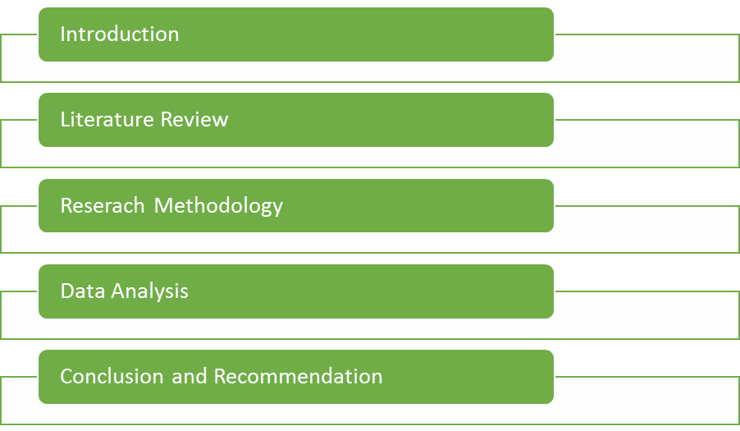
Figure 1: Structure of the Research
(Source: Created By Author)
The above-given representation is that of the systemic pattern that will be followed till the completion of the study. The primary chapter will include the introductory elements along with the main motive of the research. This section will be followed by a review of the previous studies and the location of the breach in the data. Moreover, the third segment will present the chosen methodologies, and the forth chapter will be comprehensive of the data analysis and the obtained results. In the ultimate section, the concluding statement, along with the establishment of the objects, will be stated.

1.9 Summarisation of the Chapter
This chapter has been representative of the basic and contextual elements. Thus the background study on the chosen arena has been presented along with the fact that justification for the choice of the sector and the organisation is also presented. Moreover, the purpose that carries this project is also stated, and the facilitation of the pattern that will be followed is also stated.

Chapter 2. Literature Review

2.1 Chapter Overview
Kulikowski and Sedlak (2020) have critically assessed in their research that fringe benefits refer to the rewards and compensations that are provided to employees alongside their salaries. These added benefits are provided to the employees on the performance of specific services. Moreover, while some fringe benefits are mandatory to be provided to the employees as per law, such as social security and health insurance, others are voluntary options provided by the companies.
Through this chapter of this research, the researcher has attempted to provide a clear understanding of the research area. The chapter will include data on the impact caused by fringe benefits on employee productivity, the challenges of lack of fringe benefits and the strategies used for the application of fringe benefits. The literature gap that will be discovered will also be mentioned in this segment.

2.2 Impact Of Fringe Benefits On The Productivity Of The Employee In The Fast Food Sector
Okpara (2021) was of the view that employees are a vital resource of the organisation, and their productivity determines the business performance that is achieved by the organisation. Due to this reason, the application of fringe benefits becomes imperative for organisations as they are highly effective towards maintaining the productivity of employees in the fast-food organisation. These fringe benefits act as facilitators of the enhancement of employee well-being in organisations. In fast food firms, employees are needed to work long shifts under highly stressful conditions that impact their health and resultantly reduce their productivity. The employees needed to take more sick leave and time off while they could have been able to contribute their time and skill towards the organisation to meet their goals. Due to this, absenteeism is increased in the organisations, because of which they have to face major losses in revenues. The application of fringe benefits increases the well-being of employees, because of which absenteeism is reduced, and consequently, the productivity of the workers of the fast food firms grows substantially. Agbonna, Oluyod. and Yakubu (2023) have added that the companies that recognise the employees that are more satisfied with work are more likely to be more efficient as well as more committed towards the job. It also ensures their wellness. As a reason, the employees are no longer needed to spend time away from work seeking treatment. Organisations have to lose large sums of money when they are unable to come to work.
Adjeikwame (2019) was of the view that Fringe benefits can be an effective measure towards providing workers with incentives in addition to the standard pay that they deserve. Such benefits are usually non-wage compensations or additional incentives that are given to employees beyond their usual salaries. Companies tend to indulge in Fringe benefits so that the employers can make work more rewarding for the employees while also maintaining that they are provided with the essential resources to improve the quality of life for the employees. This way, the organisations ensure that the organisation can maintain a healthy workforce.
Author | Title of the Paper | Main Findings
Singh et al. (2019) | Job satisfaction among health care providers: A cross-sectional study in public health facilities of Punjab, India | Fringe benefits do not have a positive impact on the motivation levels of the employees.
Reza and Dzarrand Khazani (2021) | Fringe Benefit and Job Satisfaction in SME: An Empirical Experience among SMES in Selangor. | Fringe benefits give employees a greater sense of achievement and recognition, improving their productivity.
Table 2.1: Main Findings
(Source: Author)
Fringe benefits are regarded as one of the key drivers of competitive advantage of the organisations, which supports the expansion of business. Reza and Dzarrand Khazani (2021) have provided in their research papers that fringe benefits increase the motivation of employees as they are it gives them a greater sense of achievement and recognition. Workers’ productivity is dependent to a large extent on their motivation towards work. It is also seen that employers demand that they are treated in a fair manner. By providing them with fringe benefits, the necessary motivation that is needed to continue working at their peak potential can be generated. Employees that are self-motivated are seen to be more efficient and better capable of contributing towards the accomplishment of organisational goals. This is the main cause for the prominence of the application of the fringe benefits that are provided to the employees. Because of this, the capability of the employees to earn higher revenues is increased. Singh et al. (2019) have argued that fringe benefits are seen to have no apparent effect on the motivation levels of the employee’s motivation towards their work as it is dependent on a number of different factors, such as the needs of the workers.
Fringe benefits are considered to be a key driver of employee efficiency. The organisations that applied fringe benefits were witnessed to be able to achieve more revenues. Plachá (2020) explained in their work that fringe benefits increase the urge in employees to develop their skills, which increases their productivity. In the organisations wherein the employees were given added benefits, the other employee was inspired to use the technical support so that the skills of the workers were enhanced. This is seen to be beneficial towards the attainment of better higher productivity.
Adjeikwame (2019) has mentioned in his work that fringe benefits also have a significant impact on the aspect of employee engagement. They lead to improvement of the perception of the employees towards the organisation. The employees are seen to appreciate when the organisational recognises their efforts. This enhances the overall performance of the workers and satisfaction as well as their engagement towards their work. Employee engagement is crucial to the success of organisations because of the reason it affects organisational performance. They prevent employee burnout and make sure that they are able to focus on their work. The fringe benefits are presented in the form of employee education and knowledge management.
It is seen that there lies a strong relationship between employee satisfaction and fringe benefits that are provided. Zirra, Mambulaand Anyatonwu (2019) have added that employee productivity is contingent on employee satisfaction is enhanced through the application of fringe benefits and other related awards and added benefits because recognition is considered an intrinsic need of humans.
Author | Title of the Paper | Main Findings
Zirra, Mambulaand Anyatonwu (2019) | Impact of fringe benefits on employee performance: A study of Nasco Group, Jos Plateau State | Fringe benefits provide employees with a sense of recognition leading to an increment in their productivity by inspiring them to be more engaged.
Adjeikwame (2019) | The Impact that Fringe Benefits have on Job Satisfaction and Employee Engagement at Sinapi Aba Savings and Loans Limited (SASL) | Fringe benefits lead to an improvement in the perception of the employees towards the organisation. This enhances the overall performance of the workers and satisfaction as well as their engagement towards their work.
Table 2.2: Main Findings
(Source: Author)

2.3 Herzberg’s Motivation Theory

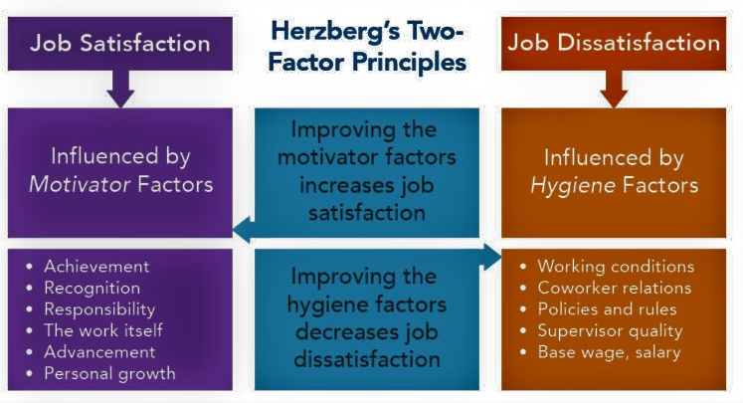
Figure 2: Herzberg’s motivation theory
(Source: Mitsakisand Galanakis, 2022).
Mitsakisand Galanakis (2022) critically explained in their work that Herzberg’s motivation theory provides the determinants of motivation in individuals by the identification and satisfaction of their individual needs. It refers to 2 main determinants of employee motivation. These are divided into 2 main categories that are referred to as collectively as the hygiene factors and the motivation factors. This is referred to as the two-factor content theory.
Mehrad (2020) has seen to be consisting 2 different categories of needs that are posited in the model, which include needs to avoid unpleasantness, which are placed at one end of the motivational scale, while the needs that are presented at the other end refer to needs for personal development. The model postulates that a shortage in the factors that cause a positive encouragement in the employees is most likely to compel the employees to pay more attention towards work that is not job-related. The most important factor in the model was that the research had focused more on the intrinsic rather than the extrinsic factors that are related to the motivation of the employees in organisations. This posits that motivation and satisfaction were derived from the job itself. Due to this, in order to achieve employee satisfaction, the Jon that is provided to them also had to be challenging so that satisfaction could be derived from them. The model helps in the comprehension of the employees’ attitudes and drive towards their work. Peramatzisand Galanakis (2022), the motivating factors that are provided by the model include achievement, recognition, work, job advancement opportunities and the growth opportunities that are available to the employees. Employees that are self-motivated to achieve the goals that are set for them and excel at work are seen to be more willing to take a risk and show more involvement to that they can achieve success. Recognition is considered important as they ensure that the employees feel recognised and provides a feeling of accomplishment. It reinforces good practices in the employees so that they are encouraged to repeat good behaviour that increases their productivity. Job advancement opportunities ensure that all employees have a clear understanding of the processes that are involved in the workplace. Chiatand Panatik (2019) has again added that the hygiene factors that are seen in the model are relationships with peers, company policies, physical workspace, working conditions, salary, status, job security and supervision. These factors refer to the policies of the companies that can cause dissatisfaction among the employees. Encouraging the maintenance of proper relations between the employees is necessary for proper collaboration between the employees so that they can work with satisfaction.
The salary of the employees, including the other benefits that are offered to them, is another major factor in employee satisfaction. However, Peramatzisand Galanakis (2022) mentioned that Herzberg's theory is criticised for being limited to focusing only on the internal factors and disregards that the environmental and external factors also have a significant effect on the satisfaction of the employees. However, the model is used widely in fast-food companies for the regulation of employee satisfaction. It also posits that the fringe benefits make for both motivating and hygiene factors. As a hygiene factor, insufficient fringe benefits can lead to dissatisfaction in the employees as they might feel that they are neglected.

2.4 Obstacles Faced By Companies Of The Fast Food Industry Due To The Lack Of Fringe Benefits In Relation To Employee Productivity
Good benefits are crucial to attracting as well as retaining good workers. Okpara (2021) has provided in their work that human capital is a vital resource for any company. For this reason, it is imperative that the companies make full utilisation of the resources that are available to them. Fast food companies lose a substantial part of their profits every year because of the lack low productivity of their workers. This indicates negligence on the part of the management, because of which the skills of the employees are not utilised in a proper manner for the achievement of the organisational goals. The low productivity in an organisation leads to the wastage of the resources of the fast food firms, which in turn also increases the resources cost of the organisations. In turn, it lowers the profitability of the organisation as then the organisations require more people to get all the tasks done. Kulikowski and Sedlak (2020) have added that excessive work pressure hampers the mental health of the workers, which can become a major cause for the depreciation of the productivity of the employees while at work. As a result, the employee’s ability to focus on work is lowered. Moreover, this has been noticed to be a major facilitator of the depreciation of accidents are the workplace.
According to the data that has been incurred from the research papers of Zirra, Mambula and Anyatonwu (2019), the lack of productivity in workers poses a major challenge to the growth of the business of the companies. Poor performance of the staff impacts the quality of the deliverables that are acquired by an organisation in a negative manner. This impacts customer satisfaction as the products that are provided to them will not be of the expected quality. This occurs when the management is inadequate to develop any new employee management systems that can help to monitor the performance of the staff and regulate them in a proper manner. Owing to this, the organisations faced difficulty in attaining enhanced employee productivity. Because of the competitive nature of the international market, it is vital for companies to provide the best quality products to the customers to maintain high customer loyalty. However, because of the lack of support of the employees because of a drop in employee performance, the organisations were not able to deliver quality goods to the people leading to the loss of loyal employees. It caused impediments in maintaining customer relations, because of which the sales of the organisation are affected in a negative manner, and consequently, the profitability of the organisation is diminished. Retaining employees solely because of salary is a difficult task. It has been perceived from the information that has been put forth by Agbonna, Oluyode and Yakubu (2023) in their work that fringe benefits are closely related to the brand perception of the organisations. Fast-food companies face heavy competition in the market and are required to maintain a good brand perception in order to attract new talent. It is witnessed that organisations that have failed to provide fringe benefits to their workforce have struggled to attract new employees. This was because they preferred to rather work with companies that provided better benefits to the employees.
Author | Title of the Paper | Main Findings
Plachá (2020) | Do fringe benefits affect job satisfaction?. | The lack of skills of the employees hinders the performance of the fast food companies.
Agbonna, Oluyode and Yakubu (2023) | Assessment of the Relationship Between Fringe Benefits and Staff Job Satisfaction in Public Universities in Ogun State. | Fringe benefits are closely related to the brand perception of fast-food companies.
Table 2.3: Main Findings
(Source: Author)
It was comprehended from the work of Singh et al. (2019) that the lack of leadership and the availability of funds in organisations gives rise to issues in providing compensation to the employees. It affects employee engagement and employee morale. This causes a problem in meeting project goals due to the delays that are caused by low employee engagement. This is seen to eventually affect entire teams with a reduction in the performance of the entire teams. Plachá (2020) have added that the lowering in employee performance affects an aspect of creativity and innovation in firms. It is witnessed that the organisation that due to the lack of proper management and the necessary technological infrastructure, the performance management of fast food organisations is hampered severely. As a result, the creativity and innovation of organisations are massively decreased. Moreover, the lack of motivation also diminishes the ability of the workers of the organisation to come up with creative ideas. Creativity and innovation are major drivers of the growth of organisations. It is needed to respond needs of the customers and also to be able to adjust to the changing trends in the market so that the sustenance of the organisations is confirmed. The reduction in the creativity of the employees because of poor productivity leads to delays in the completion of tasks as well as degradation in the quality of the projects. Consequently, the profitability of the organisations is affected. It was stated by Kulikowski and Sedlak (2020) in their work non-productive or low productivity in organisations impacts the organisational cultures in a negative manner when the management itself possesses a negative attitude towards employee management. Negative organisational culture is linked with high employee turnover rates in fast food firms. It causes the organisation to deal with an increased financial burden when they have to hire employees.
Author | Title of the Paper | Main Findings
Kulikowski and Sedlak (2020) | Can you buy work engagement? The relationship between pay, fringe benefits, financial bonuses and work engagement. | The mental health of the workers can become a major cause for the depreciation of the productivity of the employees, which cannot be changed through additional benefits.
Okpara (2021) | Fringe Benefits and Employees’ Performance in the Bank of Industry Limited, Lagos | Enabling fringe benefits can become an expensive affair for fast-food companies.
Table 2.4: Main Findings
(Source: Author)

2.5 Strategies That Are Applied By the Fast Food Companies for Application Of Fringe Benefits To Improve Employee Productivity
Fringe benefits are widely used in organisations as a key management tool as they affect the effectiveness of the firms by influencing individual behaviour and also enhance the motivation of the employees at work. Mabaso and Dlamini (2021) have mentioned in their work that health and wellness funds are an effective way to increase employee productivity. These include benefits such as gym memberships, subscriptions to mental health apps, and compensation for expenses on health and wellness activities. Such benefits promote the health of the employees by encouraging and supporting them to prioritise their mental health as well as physical health. This acts as an enables to maintain the health and wellness of the workers, also in terms of the mental health of the employees. This directly affects the overall performance of the workers. Health and wellness benefits employees in maintaining an optimum health condition, which in return causes a massive diminishing of the absenteeism rates of the organisations, which increases their productivity. As a result, the ability of the organisation to achieve its goals and growth in business is reduced.

Author | Title of the Paper | Main Findings
Mabaso and Dlamini (2021) | Recent study on the impact of compensation and benefits on job satisfaction. Insights into Economics and Management. | Focusing on the health and wellness of the employees through fringe benefits is a viable tactic.
Kulikowski and Sedlak (2020) | Can you buy work engagement? The relationship between pay, fringe benefits, financial bonuses and work engagement. | Providing housing allowance for employees is also a viable strategy in terms of fringe benefits.
Table 2.5: Main Findings
(Source: Author)
Kulikowski and Sedlak (2020) have added that many organisations have adopted the strategies like providing housing allowance for employees. This supports the employees in managing finances in a better manner. This increases the satisfaction of the employees, which leads to an increase in their productivity. Abbas (2020) has mentioned the information in their papers through the study of which it is seen that all fast food companies take a keen interest in employee productivity since they define the performance of the organisations. With consideration of this, many organisations have embraced the strategy of providing educational reimbursement to employees who are willing to pursue further studies after taking a job. This helps the employees to improve their skills and gain experience so they can be better equipped to handle difficult situations that arise. It increased the productivity of the employees because they were provided with the necessary knowledge to fulfil their roles in a better manner. As a result of that, organisations are enabled to meet their business goals as they gain a more productive workforce.
The fringe benefits are a beneficial way to make it known to the employees so that their contributions to the organisations are appreciated. Plachá (2020) stated in their research papers that companies provide financial bonuses to employees as rewards for their service to the company. Non-financial benefits are also provided, such as paid vacations. However, these benefits are bestowed upon the employees based on their performance. The employee benefits motivate the employees to perform better and develop their skills so that they can increase their productivity. Mtatiro (2021) added that another kind of benefit that is provided to employees consists of maternity leaves. Maternity leaves are bestowed upon a female for a period of time before giving birth and after that for some time during the time when she is the main caregiver of the newborn.
Author | Title of the Paper | Main Findings
Abbas (2020) | Service quality in higher education institutions: qualitative evidence from the students’ perspectives using Maslow hierarchy of needs. | A key tactic regarding the use of fringe benefits is related to developing effective training programs for the workers.
Mtatiro (2021) | The Significant of Fringe Benefits in Employee Retention in Public Sector in Tanzania: Case Study of Ministry of Water | Maternity and paternity leave acts as an effective strategy regarding fringe benefits.
Table 2.6: Main Findings
(Source: Author)

2.6 Conceptual Framework
Fringe benefits
- health and wellness funds
- subscriptions to mental health apps
- housing allowance
- educational reimbursement
- paid vacations

impact of fringe benefits for employee productivity
impact on employees
- increase employee motivation
- increase employee satisfaction
- lower absenteeism
- support improvement of employee skills
- improves employee wellness and mental health

Figure 3: Conceptual Framework
(Source: Author)
The figure that is presented above head showcases the conceptual framework that was created for this research so that the concepts and key findings related to the different parts of the literature are explained to the observer so that a better understanding of the research topic is generated. The conceptual framework provides that the main impact of fringe benefits for employee productivity in fast food companies was that it helped to increase employee motivation and well-being. Motivated employees are seen to be more committed towards the organisation, so the organisation’s ability to achieve goals was attained. The main issue that is faced in managing organisations because of a deficiency of employee benefits is that it leads to the wastage of valuable resources, such leads to lowered profitability.

2.7 Literature gap
A thorough exploration was undertaken involving different aspects related to the importance of fringe benefits for the enhancement of employees’ productivity using pre-existing data. It has led to the realisation that there was only limited information that could be attained regarding the main strategies that were used by the fast food companies that have helped in the augmentation of employee productivity. This was considered as the gap in the research. This gap will be analysed in the later stages of data collection in the research so that the gap is fulfilled.

2.8 Chapter Summary
It was summarised from this chapter that the maintenance of employee productivity could be effectively managed through fringe benefits as they cause employee motivation is increased, which consequently improves the profitability of the firms. It is seen that fringe benefits are an effective measure to increase the well-being of the workers that have to work in highly stressful conditions in fast food companies. Consequently, it improves the satisfaction of the employees with their firms. Moreover, the lack of employee productivity results in organisations losing their creative and innovative qualities. Employee productivity also aids fast food companies in the attainment of competitive advantage.

Chapter 3: Research Methodology

3.1 Introduction
This chapter, which is recognised as “research methodology”, is significantly concerned with selecting the most applicable research methods that are useful in order to bring about the results that are essential for accomplishing the research aim and its associated research objectives. Furthermore, this section will showcase the “research onion” framework that is viable for the researcher to effectively conduct the research processes by choosing accurate research methods as per the requirements of this investigation. In addition, there will also be a presentation of the philosophy that will be used along with the approach that would be preferred for carrying forth the research. The most suitable strategy that is elected for undertaking this specific research exploration will be highlighted here in this portion, which is followed by choosing the best method for enabling the processes regarding data collection as well as data analysis. The limitation that would be faced while executing this very research will be provided alongside the ethical considerations that were made during this research exploration.

3.2 Research Onion
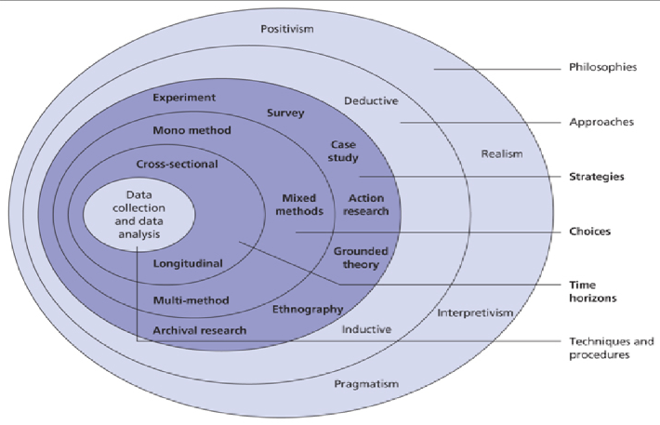
Figure 4: “Research Onion”
(Source: Al-Ababneh, 2020)
From the diagram that could be identified in Figure 3, it was known that the “research onion” functions like a model or framework that assists the researcher in undertaking effective decision-making for carrying out the research in an appropriate manner (Al-Ababneh, 2020). Furthermore, it could be noticed from the respective figure that the research methods are segregated into various layers, which have been represented in a chronological manner. This ensures conducting the research investigation in a very systematic fashion and facilitates gaining pertinent research results. The consideration of the “research onion” was vital for this study in order to select the most practical research methods for enabling the completion of the research without any complications.

3.3 Research Philosophy
The philosophy in research acts as the foundation for the entire research, as choosing the right philosophy sets the stage for choosing appropriate research methods for reaching desired outcomes (Säfsten and Gustavsson, 2020). This research investigation was executed using the pragmatism philosophy, as the utilisation of this very philosophical paradigm facilitated answering the research questions in a proper way leading to the accomplishment of the research. Furthermore, the implementation of this specific philosophical stance was useful for conducting the research in an innovative manner and further facilitated gathering both types of research data that is qualitative and quantitative. The other philosophies were rejected from this study as they would not yield appropriate results from the research.

3.4 Research Approach
The most suitable approach that was elected for undertaking the research was the deductive approach, as the application of this approach enabled the researcher to effectively collect as well as interpret the data. Moreover, the incorporation of this approach assisted in obtaining the right information regarding the challenges that are faced by the business of Pizza Hut with respect to employee productivity due to inadequate fringe benefits. In addition, this precise approach was viable for efficiently answering the questions that were proposed in the research, which is pivotal for coming across conclusions that were initially anticipated from the research. Furthermore, the research approach, except deductive, was not preferred, for it would not benefit the researcher in gaining the right results from this investigation.

3.5 Research Design
The design of a research study is understood to be the blueprint of the research, which helps in the execution of the investigation in an appropriate way, which is useful for enabling the answering of the research problems that are recognised during the research. There has been selection of the descriptive research design, as this particular design has enabled ensuring that accurate and right data is collected in a consistent and systematic manner. Furthermore, it is also assisting the researcher with respect to the processes that are entailed within the collection and data analysis for providing meaningful conclusions and insights regarding fringe benefits for the employees in Pizza Hut.

3.6 Research Strategy
3.6.1 Type of Investigation
This particular research is carried out based on both qualitative and quantitative types of investigation, as a result of which the choice of mixed research strategy had been essential for facilitating the procurement of both kinds of research data that are in relation to fulfilling the research.
3.6.2 Choices
The mixed method research choice was undertaken by the researcher while carrying out this research, as this particular investigation deals with qualitative and quantitative data, which enabled in obtaining information and insights pertaining to the topic as per the expectations of the researcher (Timans, Wouters and Heilbron, 2019).
3.6.3 Time Horizon
The time horizon that was utilised for carrying on with this exploration was the cross-sectional time horizon (Spector, 2019). This very time horizon was duly preferred for this research, as it allows obtaining the research data within a pre-specified period of time, which is mostly used in surveys; as a result, choosing this time horizon was essential for the completion of the research.

3.7 Sampling Technique
3.7.1 Sample Type
The samples that were considered for taking part in the research were the employees who are working in the business of Pizza Hut. Moreover, the researcher also considered the managers of the respective company in order to facilitate the process of data collection through an interview and survey.
3.7.2 Sample Size
The sample size pertaining to this very research investigation was 100 employees who had been elected for the facilitation of the entire survey process. In addition to that, the researcher for carrying out the interview process in this exploration was the 3 managers who are working for the company of Pizza Hut. The preference of the respective samples has allowed for the attainment of the results that were anticipated from this investigation.
3.7.3 Sampling Method
The sampling method that has been applied for undertaking this specific research investigation was the simple random sampling technique (Hennink and Kaiser, 2022). Furthermore, the researcher utilised Linkert Scale to facilitate the formulation of survey questions, which has been beneficial for the accomplishment of the research.

3.8 Data Collection Process
The process that is concerned with data collection is known to be the collection of the right information regarding the variables that are important to the researcher for meeting the research requirements (Sileyew, 2019). In this specific investigation, the researcher chose the “primary data collection” technique, which enabled the gathering of both qualitative as well as quantitative data pertaining to the research subject area. The researcher had implemented an interview method between the 3 managers of Pizza Hut, which was essential for obtaining extensive insights into this very research exploration. This has enabled the researcher to gather qualitative information, which has been relevant for fulfilling research requirements. In addition to that, the researcher also used a survey session that was executed among 100 employees who are associated with Pizza Hut to obtain their first-hand perception of the influence of fringe benefits on their productivity (Mishra and Alok, 2022). The extensive amount of information that was delivered by the employees benefitted in properly meeting the research objectives that have been essential for achieving this entire research study. Apart from that, the researcher formulated 4 open-ended questions for undertaking the interview session, which was distributed among the chosen participants to gain their responses from their overall experience while working in the respective company about the research subject (Archibald et al., 2019). Furthermore, to facilitate the survey process, there has been the determination of 20 close-ended questions were dispersed among the selected employees to accomplish the survey process and gather viable responses for undertaking the research investigation in a proper manner. The selection of these two methods for collecting data was viable in this research due to the fact that it enabled obtaining both quantitative and qualitative data, which are highly essential for appropriately meeting the research obligations (Pandey and Pandey, 2021). In addition, the researcher did not utilise other processes for enabling data collection, as those methods would not be useful in terms of fulfilling the research.

3.9 Data Analysis
The extraction of useful and viable insights or information from the raw data that is obtained from the research investigation is concerned with data analysis. In order to acquire anticipated results from this dissertation paper, there has been a preference for the thematic analysis method along with the SPSS analysis tool for evaluating both kinds of research data that are qualitative and quantitative, that were procured from the research study. Through proper evaluation of the research data, the researcher is able to procure detailed and topic-specific insights, which are essential for achieving the requirements of this very research exploration for the effects that are brought about by fringe benefits towards the productivity of employees in Pizza Hut. The consideration regarding the respective data analysis processes that have been made in this study supported gaining substantial information pertaining to the concepts that are being explored through the research. In addition, the usage of the thematic analysis enabled the creation of themes that are relevant to the research topic, which is useful for obtaining desired results and outcomes, while the SPSS analysis tool assisted in quantitatively analysing the data for bringing out meaningful information from the complex survey data. However, the researcher did not prefer other analysis techniques, as they would not be supporting the accumulation of viable conclusions from this very investigation.

3.10 Ethical Considerations
Research ethics are comprehended to be those principles that enable the research processes to be conducted in a responsible manner while accounting for all the ethical standards that are maintained in the research (Hasan et al., 2021). The University guidelines concerning research ethics have been sufficiently maintained throughout the entire course of this research investigation, which has assisted in retaining high ethical standards while dealing with this research. Additionally, the guidelines that were present in the GDPR of 2018 were followed during this research exploration, which supported ensuring confidentiality and anonymity for the research participants by using pseudonyms. Apart from that, the data that was amassed in this research investigation was safely stored in an electronic USB device, which was protected with a password.

3.11 Research Limitations and Accessibility Issues
Limitations that are seen in a research investigation are referred to as flaws that might be present in the design or methodology that is chosen for the research, which could influence the overall findings of the research in a negative manner (Cooper, Hedges and Valentine, 2019). During this research, the investigator encountered some limitations regarding the lack of adequate time for finishing the research, as the entire research study needed to be accomplished within the scheduled time frame. In addition, this research is conducted using both survey and interview methods for gathering the data, which requires significant time for collecting desired responses for fulfilling the purpose of this research. Apart from that, insufficient resources were another limitation that was witnessed by the researcher, as those literature sources that could have delivered further insights into the respective topic were not accessible for insufficient financial resources.

3.12 Conclusion
The conclusion that was obtained from this precise chapter duly states that the chosen philosophy was positivism, as it is useful for obtaining quantitative data based on research requirements for the aspect of fringe benefits and its influence towards the productivity of employees for the fast food business of Pizza Hut. In addition, the preferred approach and strategy were deductive approach and mixed strategy, respectively, which had duly supported procuring pertinent outcomes. The design that was elected for this research is descriptive design, which was crucial for facilitating the researcher to effectively answer the research questions that were formulated. After the selection of the above research methods, the researcher could carry out the primary data collection process through survey and interview sessions while the collected data were analysed by considering the SPSS analysis method as well as the thematic analysis process for deriving accurate information from the raw data that was collected during the investigation. In addition, it could be understood that the researcher had utilised the necessary steps and properly followed the ethical guidelines for ensuring that the research was conducted in an ethical way while accounting for all the limitations that were witnessed during the exploration process for the research.

Chapter 4: Data Analysis and Findings

4.1 Chapter Overview
This segment of the investigation will entail an elaborate discussion of the distinct data assessments based on both qualitative and quantitative data assimilated by means of a survey and an interview, respectively. The key findings of each of the assessments will be highlighted by ensuing a comparative analysis of the key elements observed in the qualitative as well as the quantitative assessments with the literature reviewed to determine the co-dependency of the factor of employee productivity and the other pivotal factor of fringe benefits which are provided by Pizza Hut.

4.2 Thematic Data Analysis
4.2.1 Theme 1: Impact
The main motive for the creation of this theme is to understand the viewpoint of three managers of Pizza Hut regarding the effect of fringe benefits on the productivity of workers in the organisation.
“Workers have turned to put in efforts and do their utmost best at the time they have felt that their hard work has been noticed as well as is rewarded by the employer. Hence, to motivate employees to work hard, we, managers, have been trying to provide a significant amount of fringe benefits to our workers”- Manager 1
The evaluation of the reaction of manager 1 disclosed that, with the application of significant fringe benefits and rewards, the employer has been attempting to motivate their workers and with such rewards, employees have felt recognised and therefore, their productivity has improved, and with that, the performance of the firm is also enhanced.
“With the utilisation of fringe benefits, we have been able to retain our employees more effectively as their demands and requirements have been fulfilled by the authority and as a result of that, they have become loyal to the firm. In addition to that, such loyal workers have the capability to collaborate with other workers and motivate them to work hard towards the organisational goals”- Manager 3
The assessment of the reaction of the manager has led to the understanding that, with the implementation of proper fringe benefits, the managers and the employer of Pizza Hut are able to retain their workers as, with such rewards, their requirements have been fulfilled by the company, and thus, they are more engaged with the company. Furthermore, with such benefits, they have been able to motivate other workers as well, and it has boosted the productivity of each of the workers in the organisation.
“The benefits are for the advantage of the workers and therefore through providing those benefits, workers are engaged with the organisation for longer period of time, and it is helpful for the company to retain such capable workers in an effective way”- Manager 2
The analysis of the reaction of manager 2 disclosed that benefits are advantageous for workers, and as a result of that, the workers have remained associated with the company for a longer period of time, and it has enhanced the productivity of the organisation.
4.2.2 Theme 2: Challenges
The key purpose of this theme is to evaluate the reaction of the managers of Pizza Hut concerning the barriers encountered by the firm with respect to productivity due to the shortage of fringe benefits.
“We generally provide medical insurance to our employees as fringe benefits. However, increasing healthcare costs like medical processes are more expensive as compared to previous times, and it has been hard to imagine in the upcoming future” – Manager 2
The assessment of the viewpoint of managers has stated that the employer of Pizza Hut has desired to support their workers as well as their families in times of medical and personal requirements, but the incredible prices connected with certain long-time courses of treatment have been resulting the company to feel anxious regarding the monetary effect of providing understandable coverage.
“In modern times, shared cultural understanding of wellbeing has changed a great deal, and due to that reason, simply taking care of workers has not been longer adequate. Mental health has just been as significant to effectiveness at work as well as away from the workplace as our conventional comprehension of physical health, and sometimes we are unaware of the gap of therapy and medication related to the mental health of employees”- Manager 1
The assessment of the opinion of the manager has led to the understanding that there has been a gap in the context of mental wellness therapy in the organisation. The organisation is mainly focused on the physical health of the employees as compared to mental health, and it is a huge challenge for the company to retain mentally exhausted workers in an effective way.
“One of the significant spaces of needless expenditure for the organisation is unused benefits, and the main reason for this abandonment is frequently a shortage of awareness, either as workers do not know the advantages exist as well as they do not acknowledge the way they would profit from them”- Manager 3
The examination of the opinion of managers has led to the comprehension that the managers are unable to provide significant education to their workers related to their benefits, and due to that reason, certain employees have no understanding related to benefits that have been provided by them, and it has affected negatively on the resources of the firm.
4.2.3 Theme 3: Strategies
The fundamental cause for developing this theme is to understand the standpoint of the managers of Pizza Hut concerning the strategies that have been integrated by them to improve employee productivity through fringe benefits.
“We have our maternity leave program, which is for eighteen weeks, and it is an entirely paid leave program for women, and it has provided the employees the peace and freedom of mind to enjoy such valuable initial months with their babies”- Manager 3
The evaluation of the response of the manager has led to the realisation that one of the significant strategies that have been included by the organisation is the maternity leave program, which has helped the female employees to spend their time with their new-born babies in an effective manner and it has affected positively on the mental health of the workers, and it has boosted their productivity.
“The authority of Pizza Hut trusted that each of the employees deserves the scope for a superior education as well as due to that reason, we offer an assortment of educational resources like scholarships, tuition reimbursement” – Manager 1
Assessing the reaction of the manager led to the realisation that the leadership of the firm understood the importance of employee training and development, and due to that reason, they have been providing sufficient scope for the employees to educate themselves and work towards the organisational goals.
“We have been providing year-round half day Friday as well as four weeks of vacation for our employees”- Manager 2
The assessment of the response of managers has led to the comprehension that to motivate employees, the ownership of Pizza Hut is providing half days as well as vacation programs.

4.3 Survey Data Analysis
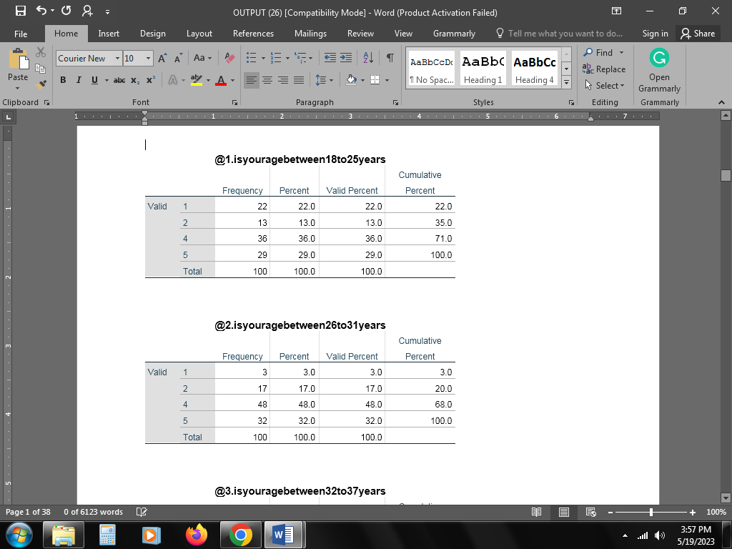
Table 1: Age (18-25)
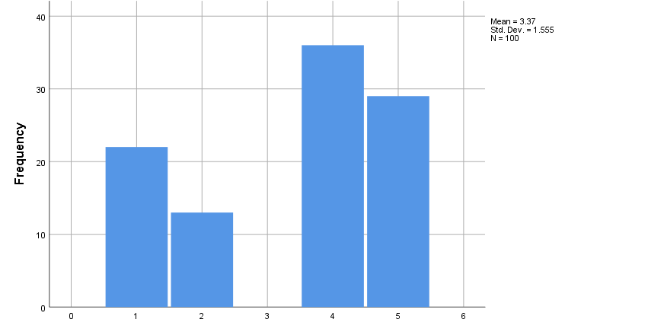
Figure 5: Age (18-25)
While considering the employee demographics, 35 employees affirmed to be within this age group, with additional employees affirming that they are within the age of 18-25 years, and the rest of the employees who did not belong to this category which comprise more than 60 of the total employees do not belong to this age group.
Table 2: Age (26 to 31)
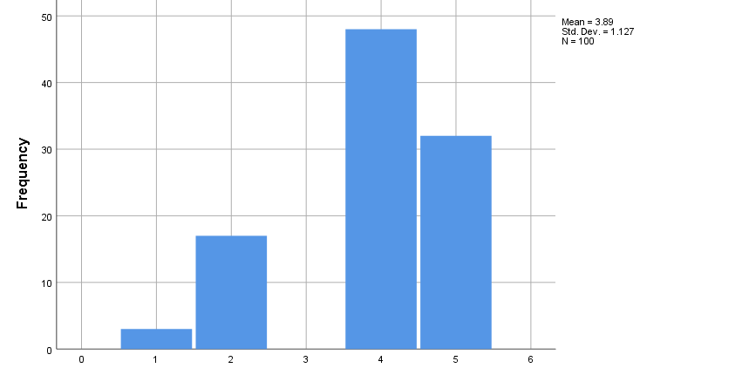
Figure 6: Age (26 to 31)
While considering this age group, out of the total sample, 20 employees have agreed to be of this categorisation, and the others have rejected to be identified in this age category.
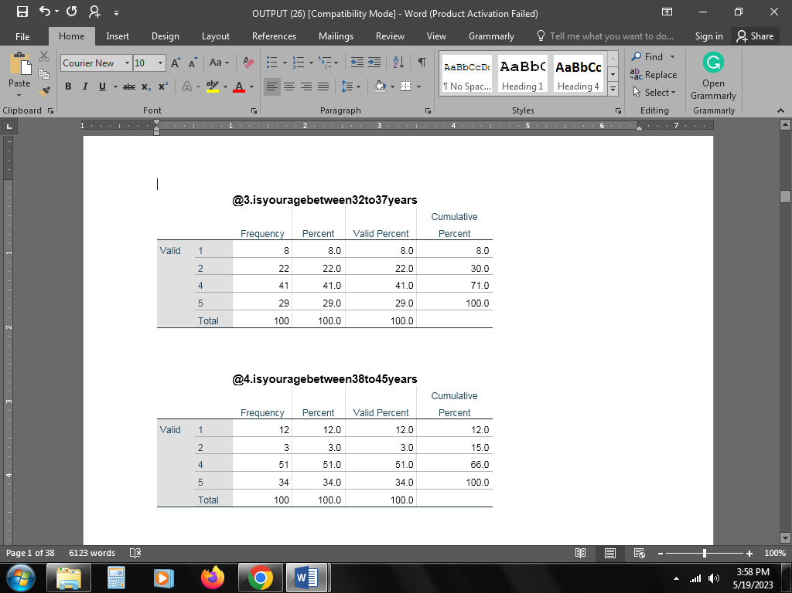
Table 3: Age (32 to 37)
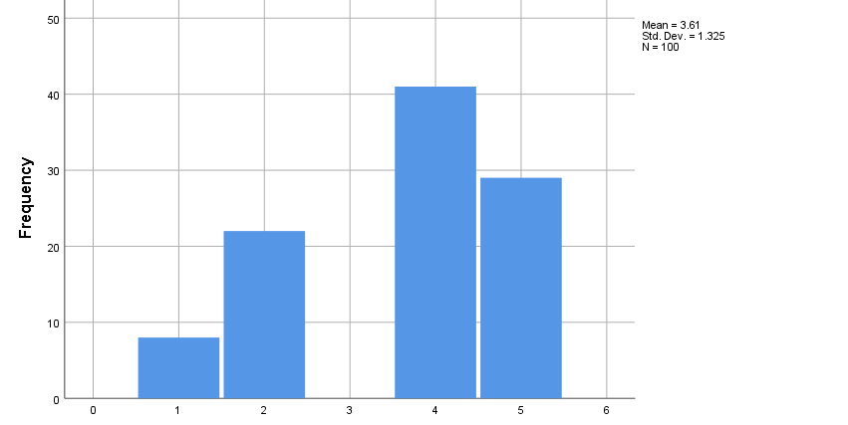
Figure 7: Age (32 to 37)
Assessment of the survey data has showcased that 30 employees have identified within the age group, and the rest have identified with the other age categories mentioned in the questionnaire.
Table 4: Age (38 to 45)
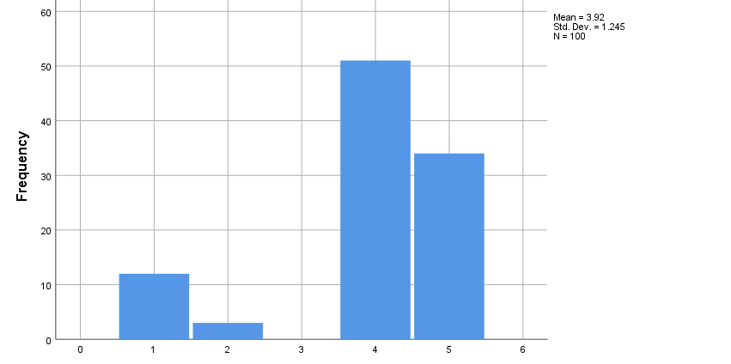
Figure 8: Age (38 to 45)
Specifying the question, 15 employees have identified to be within this group of 38-45, and the rest have selected the option specifying not belonging to this age group.
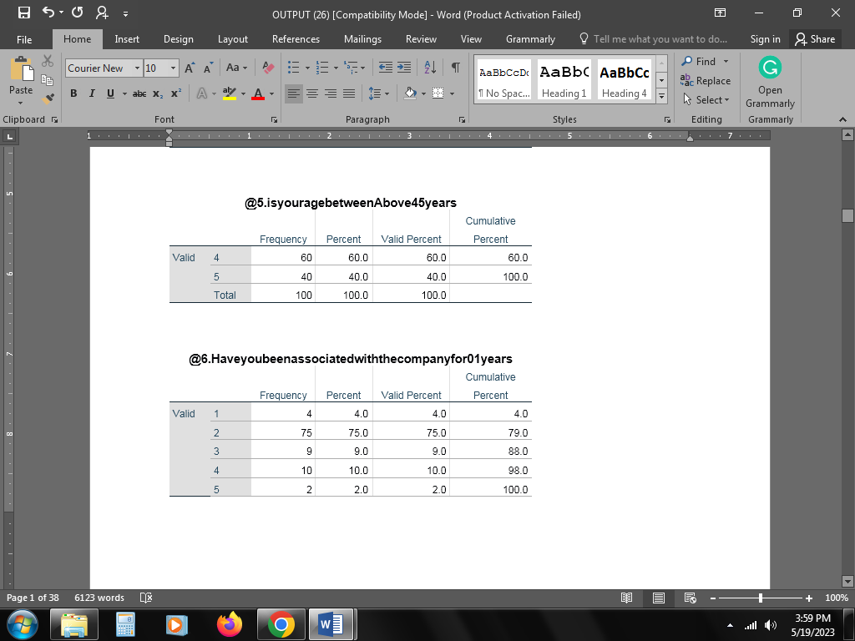
Table 5: Age (Above 45)
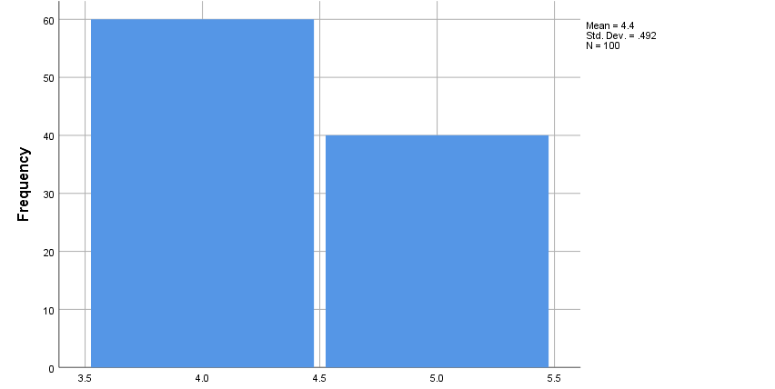
Figure 9: Age (Above 45)
In this category the evidence has showcased that none of the employees who participated in the survey fit into this category.
Table 6: Period serve of 0-1 years
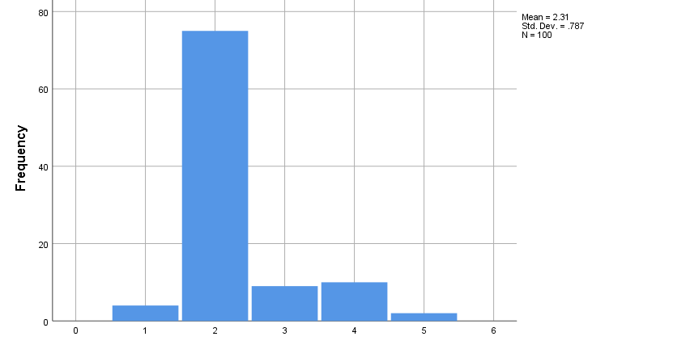
Figure 10: Period serve of 0-1 years
In this category, more than half of the total participants have identified being associated with the company for a period of less than 1 year.
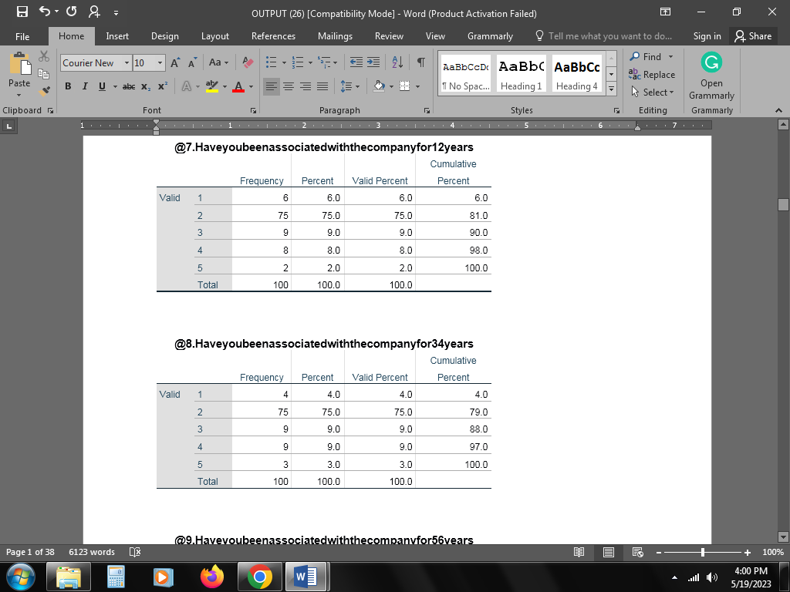
Table 7: 1-2 years’ service
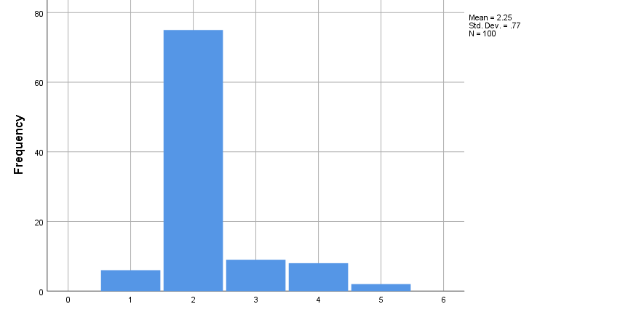
Figure 11: 1-2 years’ service
The survey data has shown that most of the employees have been serving Pizza Hut for the period of 1-2 years, and this depicts good recruitment as well as retention capabilities.
Table 8: 3 – 4 years’ service
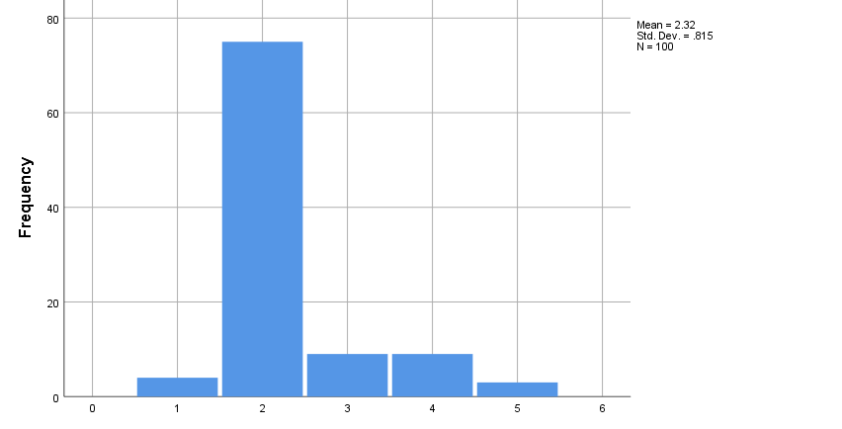
Figure 12: 3 – 4 years’ service
With reference to this question, there has been a record of a strong response in employee counts who have been associated with Pizza Hut for 3-4 years, which discloses employee retention via fringe benefits.
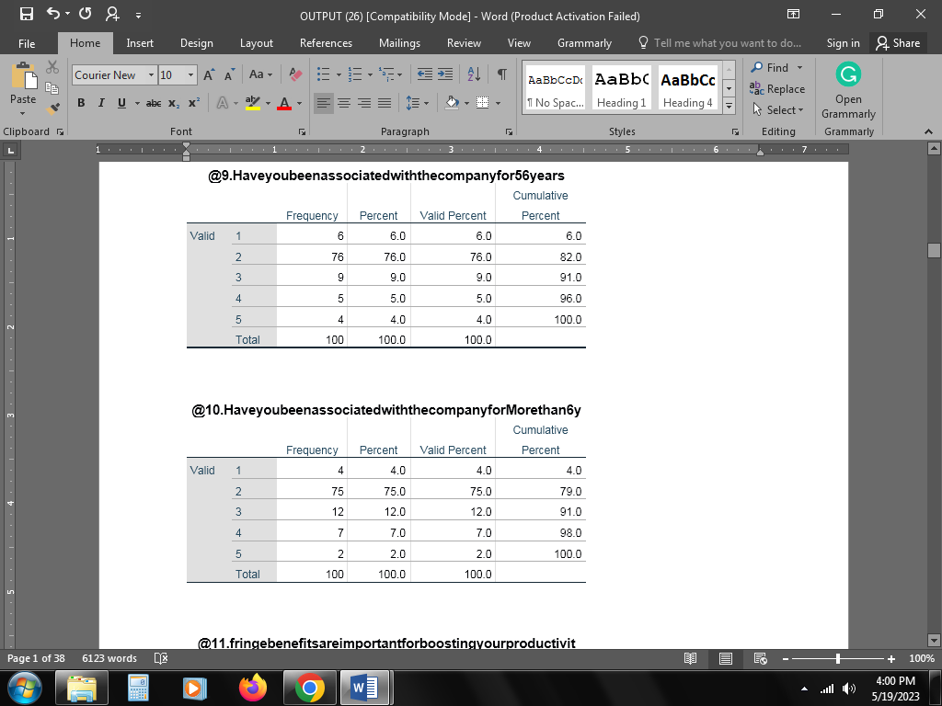
Table 9: Association for 5-6 years
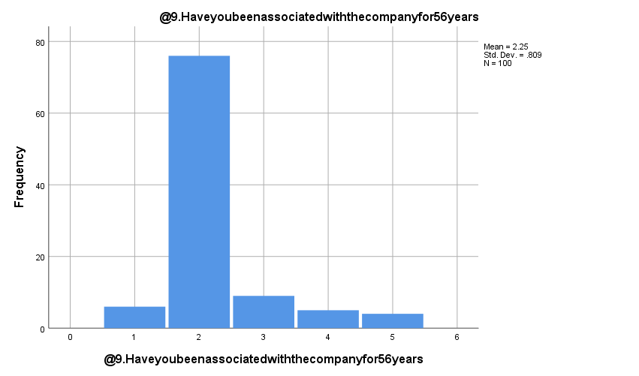
Figure 13: Association for 5-6 years
In this context, a fair response in terms of employee count in this category has surfaced in the survey, which depicts the high employee retention capabilities of Pizza Hut.
Table 10: More than 6 years of service
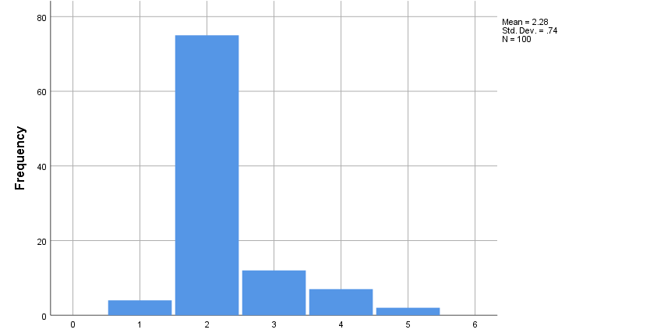
Figure 14: More than 6 years of service
With reference to responses recorded shows that Pizza Hut has considerable employees who have been associated for more than 6 years, which showcases high employee retention at Pizza Hut.
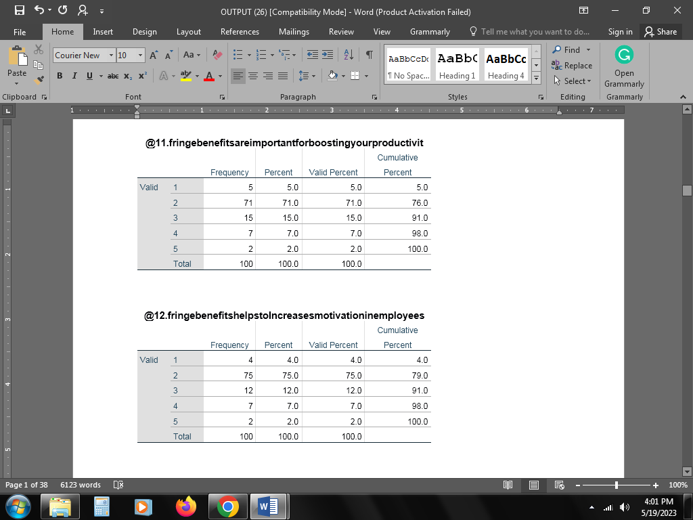
Table 11: Fringe benefits foster productivity
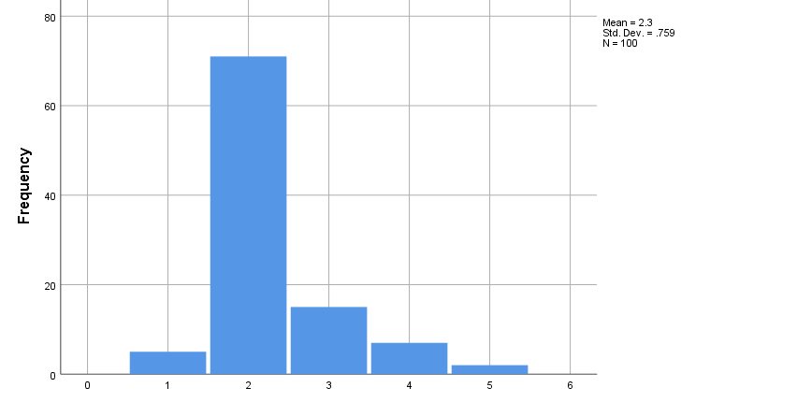
Figure 15: Fringe benefits foster productivity
In this context, the majority of the employees, comprising a total of 76 percent of responses, have affirmed that benefits generate higher employee productivity and have been contradicted by limited responses, which constitute 9 percent of the sample.
Table 12: fringe benefits enhancing motivation
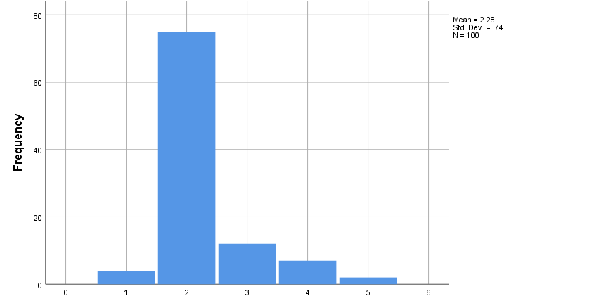
Figure 16: fringe benefits enhancing motivation
In response, a strong majority of. 80% of the total sample has resonated with this statement and therefore highlighted their agreement. 9% of the employees shared their disagreements. This observation highlighted some noticeable differences in opinion
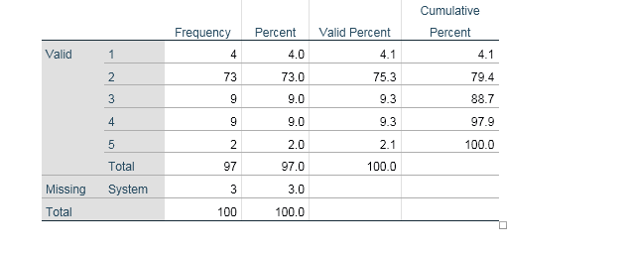
Table 13: fringe benefits activating productivity
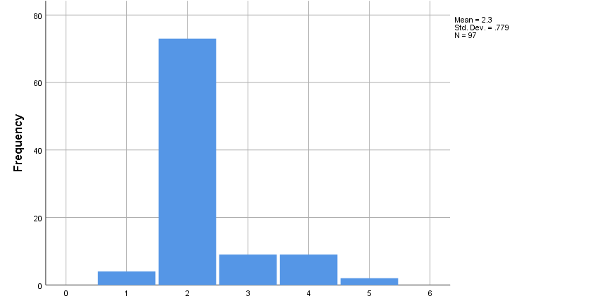
Figure 17: fringe benefits activating productivity
In this context, most of the employees have opined that appropriating the right fringe benefits aids in enhancing productivity, with a strong count of 77 percentage of agreements and only 11 percentage of noted disagreements. The study conducted by Agbonna, Oluyode and Yakubu (2023) has also suggested the fact that fringe benefits and employee productivity in an organisation are correlated.
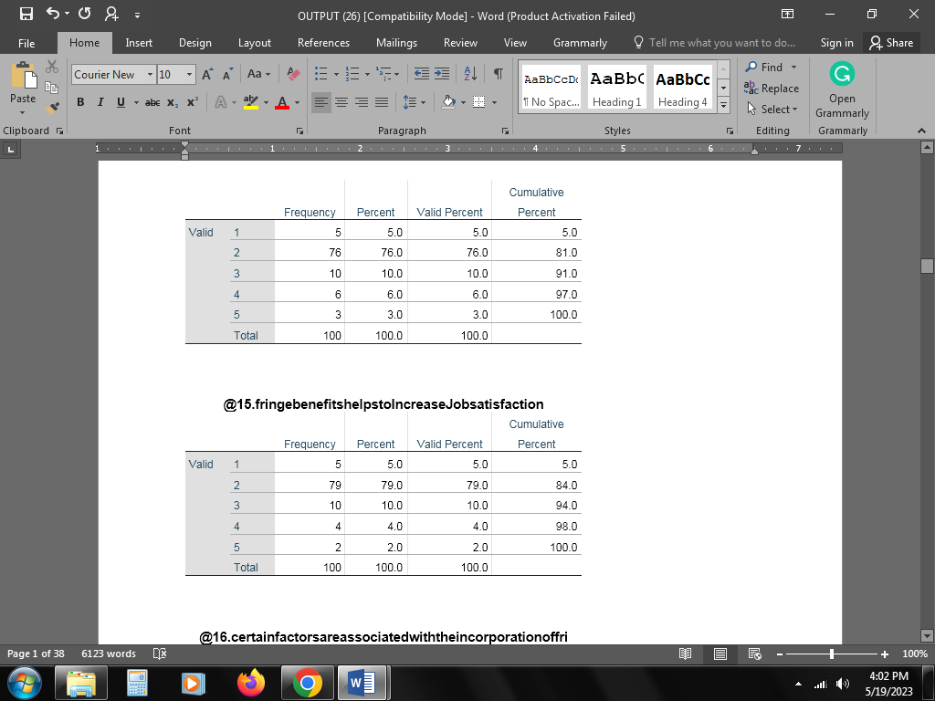
Table 14: boosting employee engagement
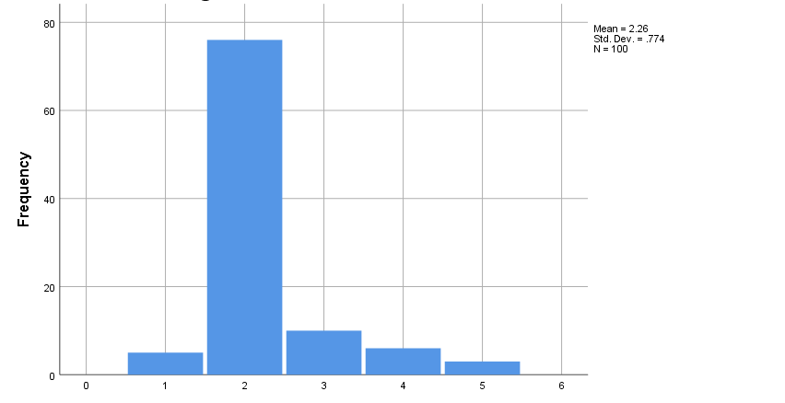
Figure 18: boosting employee engagement
The responses recorded that more than 80 percent of the population significant population of the cindered sample have approved that fringe benefits work in enhancing employee engagement levels with the minimum negation of the statement while the rest 20 percent disagreed. The study carried out by Plachá (2020) has also discovered that fringe benefits usually boost the level of employee engagement.
Table 15: Boosting job satisfaction
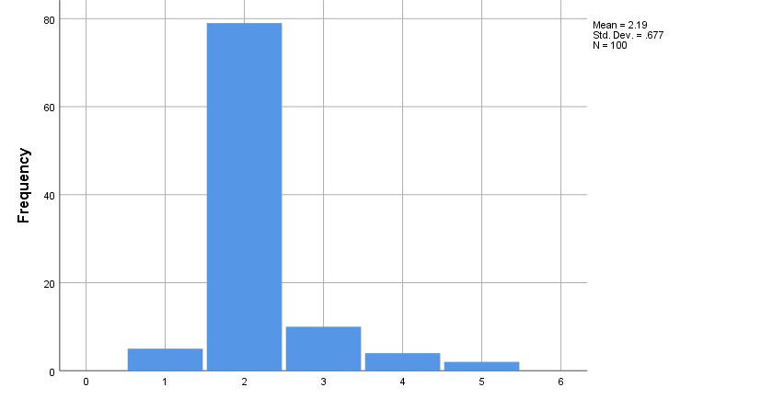
Figure 19: Boosting job satisfaction
For this question, a strong agreement from. 86 percentage of the employees has highlighted that the employees consider fringe benefits as motivators for job satisfaction, and the low disagreement of 6 percent further has proved this statement
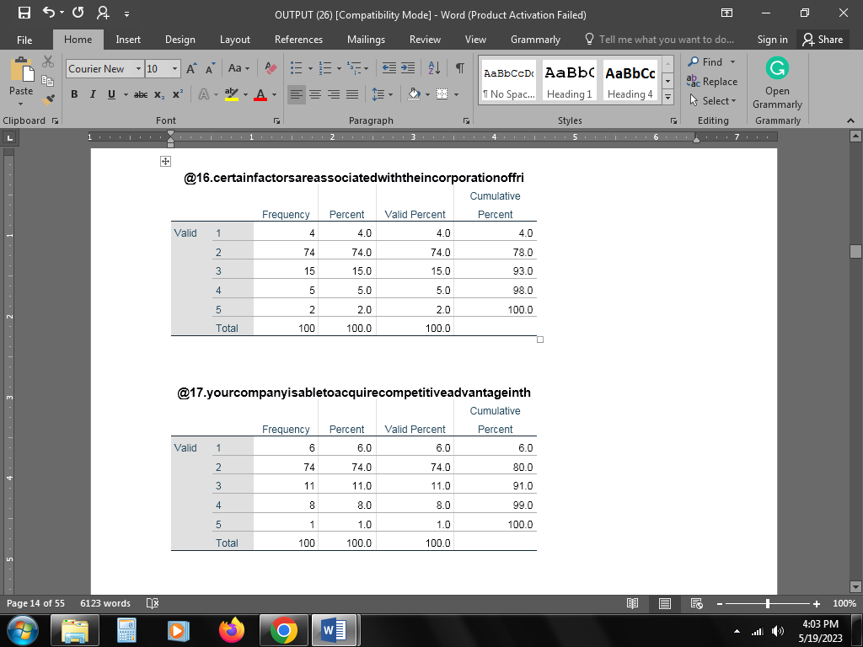
Table 16: factors influence fringe benefits
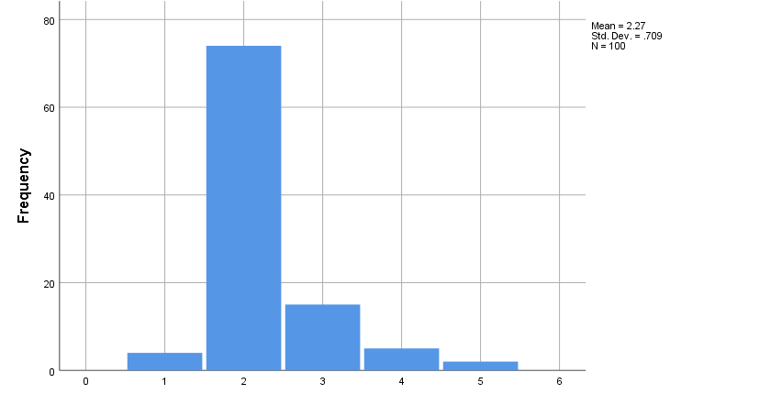
Figure 20: factors influence fringe benefits
In this context, again, a strong agreement from 78% of employees has projected that a number of factors play a role in structuring the design of fringe benefits at Pizza Hut, and the minor contradictory statements highlighted by 7% of the sample signify that there is room for improvement for Pizza Hut.
Table 17: Acquisition of competitive advantage
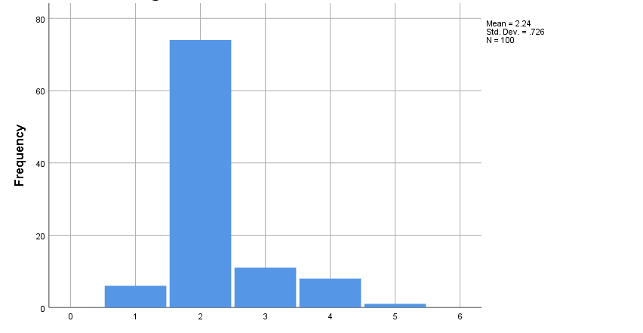
Figure 21: Acquisition of competitive advantage
With reference to the survey responses and the approval attained from more than 80% of the employees, they have highlighted that fringe benefits have provided Pizza Hut with a competitive advantage as the motivation of the employees aided in boosting the organisational productivity, while 9% shared contradictory responses. The survey conducted by Reza, Dzarr and Khazani (2021) has provided similar insight that fringe benefits do lead to the formation of a competitive edge.
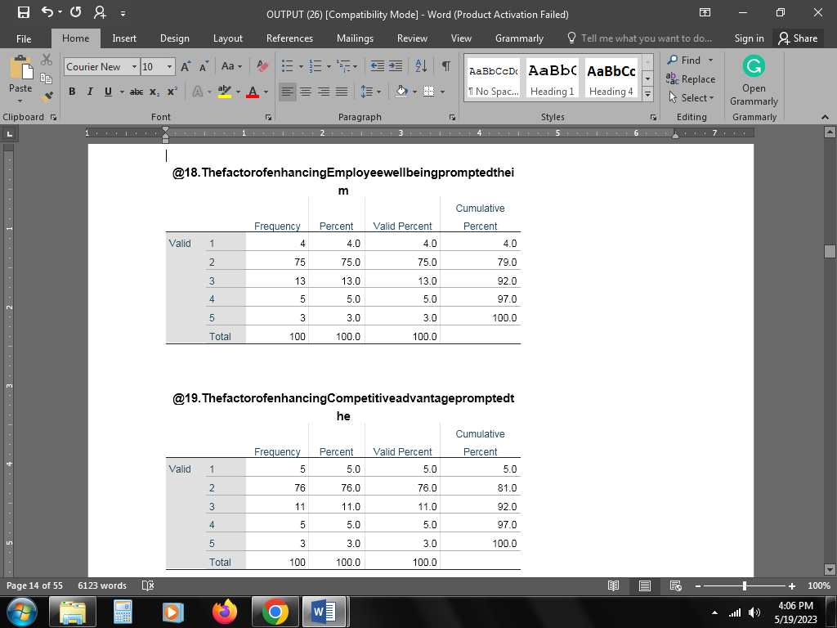
Table 18: employee well-being
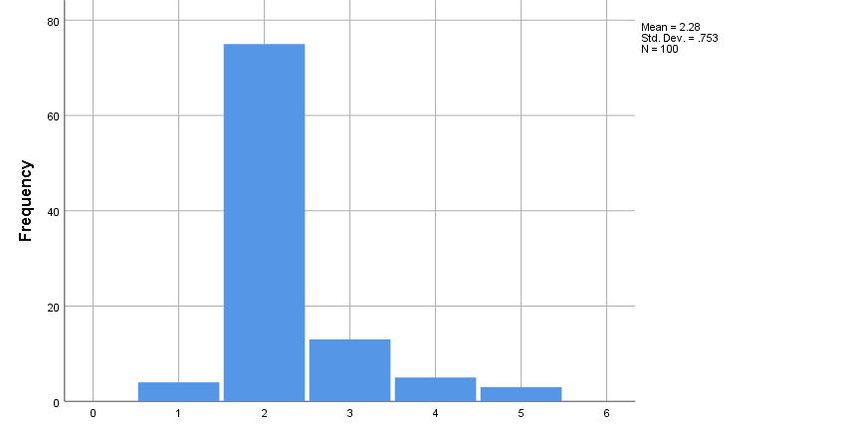
Figure 22: employee well-being
It has been gathered from the responses that the factor of employee well-being is one of the considered factors for the implementation of the fringe benefits, and the agreement of more than 80% of the employees in this respect has proved this assumption. Only 8% of the employees disagreed.
Table 19: competitive advantage
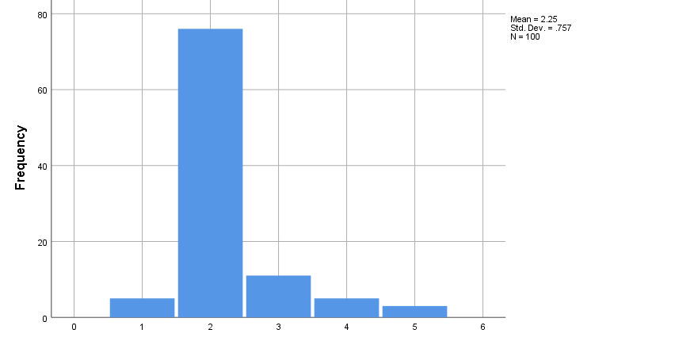
Figure 23: competitive advantage
As per the strong employee responses and the high level of agreement with the question, which results in 80%, it has been highlighted that Pizza Hut has leveraged fringe benefits to attain competitive advantage, as only 8 percent have not confirmed this statement.
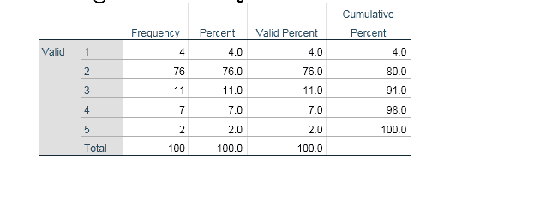
Table 20: medical insurance
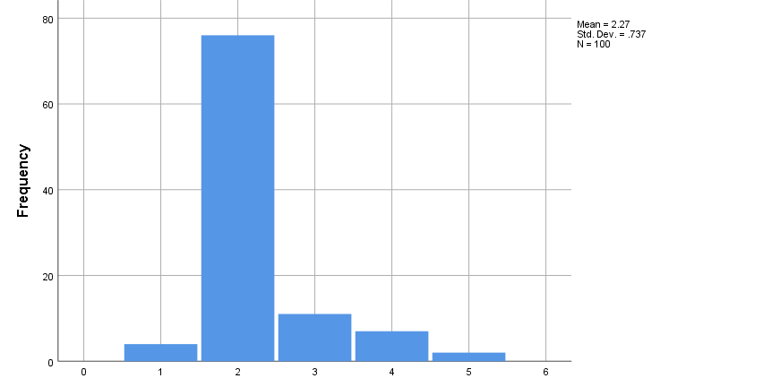
Figure 24: medical insurance
With reference to this question, the approval of a maximum number totalling more than 80 percent of the participants out of the total population has highlighted that the aspect of medical insurance is one of the major motivators for attaining higher employee satisfaction, while 9 percent of the population disagreed. The survey conducted by Adjeikwame (2019) has also led to a similar understanding, medical insurance does act as an effective fringe benefit.
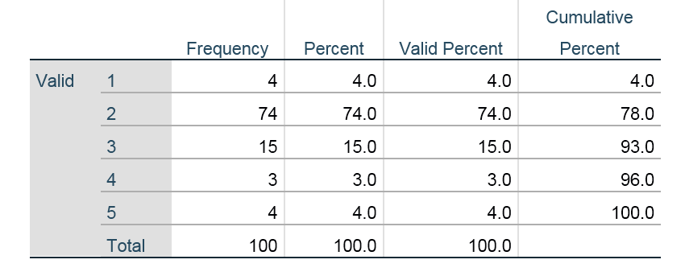
Table 21: Prompting Fringe Benefits
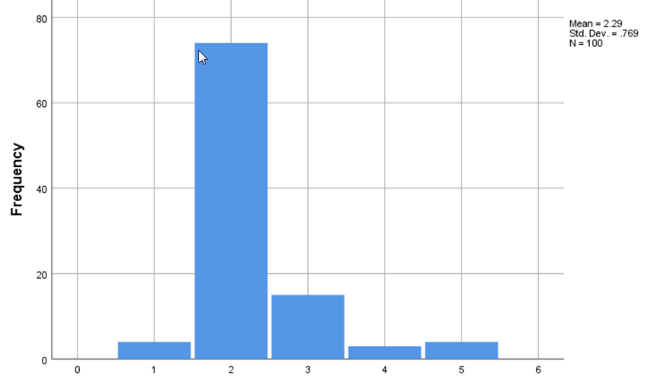
Figure 25: Prompting Fringe Benefits
Pizza Hut is a company that has imparted focus on its employees. They have taken a number of initiatives that have prompted the implementation of various forms of fringe benefits. 78% of employees in the company who have taken part in the research gave agreed that they have prompted various steps towards the betterment of the quality of life for the employees.
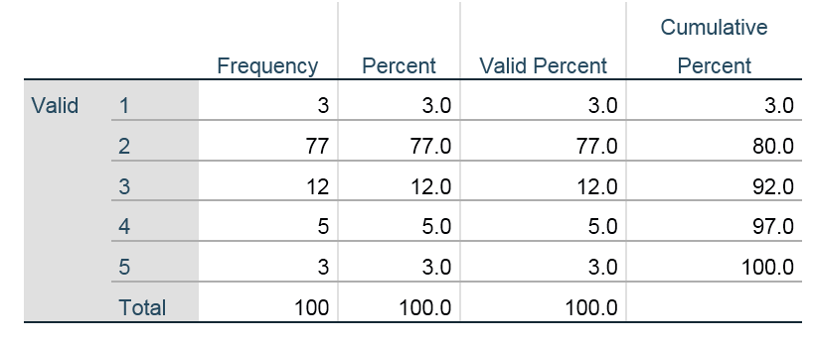
Table 22: Talent Responsible for Fringe Benefits
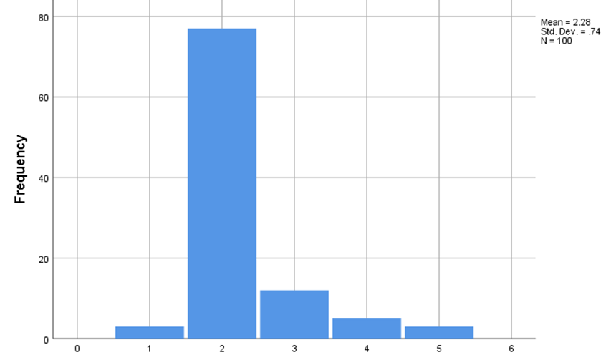
Figure 26: Talent Responsible for Fringe Benefits
The company has also taken the initiative to hire new talents within the company, which has increased the overall propensity of the company to provide new forms of benefits to the employees. This has been agreed by 80% of the participating employees, which has suggested that the company continues to strive for better forms of management of the fringe benefits.
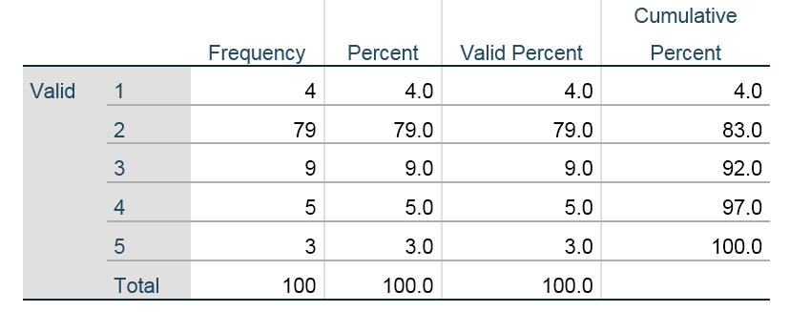
Table 23: Challenges of Inadequate Fringe Benefits
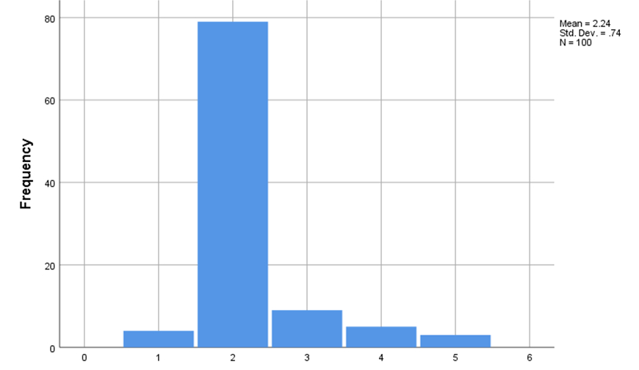
Figure 27: Challenges of Inadequate Fringe Benefits
83% of the employees have stated that the companies believed that the company has often faced issues in terms of fringe benefits as they have often been inadequate and ineffective. This has had an effect on the productivity of the employees throughout the departments, and it has also affected the overall growth of the company in the competitive market.
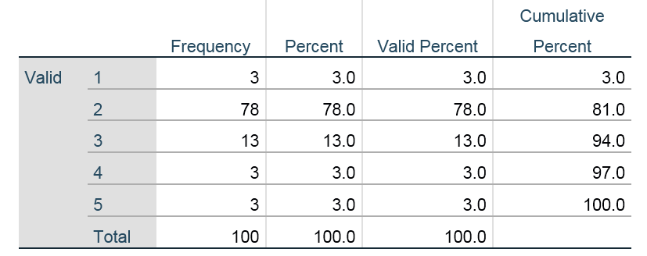
Table 24: Challenges of Reduced Productivity
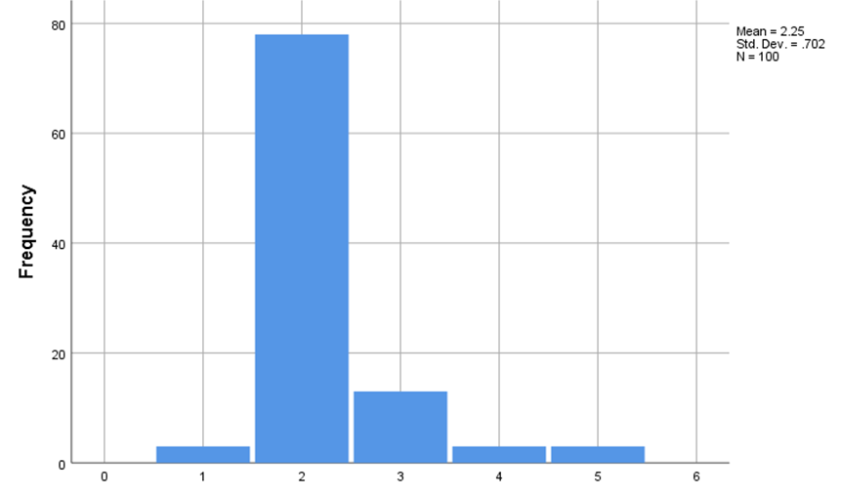
Figure 28: Challenges of Reduced Productivity
Through the means of the survey, it has come to the forefront that Pizza Hut has also struggled due to the reduced productivity of the employees in terms of the profitability and growth of the company. 81% of the employees have agreed to this, and 6 of them have disagreed. It has been evident that the effects of low productivity have been evident within the company.
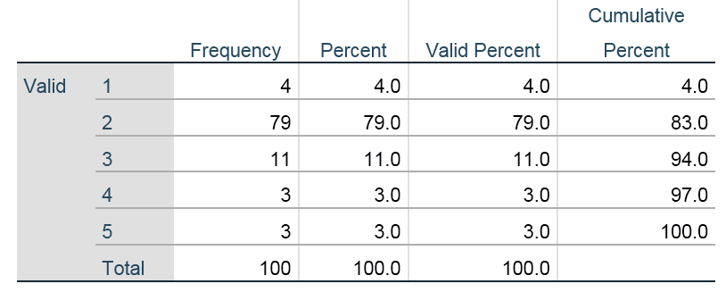
Table 25: Challenges of Decreased Competitive Edge
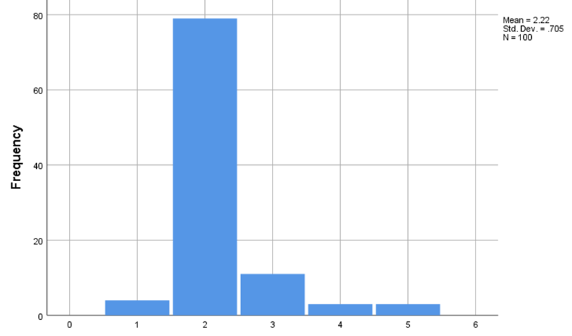
Figure 29: Challenges of Decreased Competitive Edge
The survey has also revealed that the companies have also faced struggles due to a reduction in the competitive edge within the market. This has caused the company to fall back in terms of market share and has undergone challenges in maintaining the trust of the customers. 83% of the participating employees agreed with this, and 6 of them believed that the lack of competitive edge had not been a major factor. The study carried out by Runtuwene and Lapian (2019) mentioned that the absence of fringe benefits could lead to a decrease in competitive advantage.
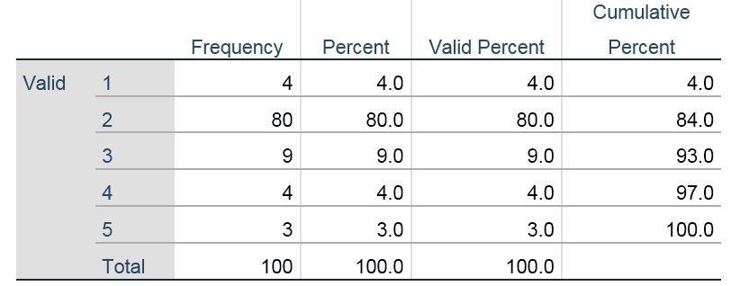
Table 26: Challenges of Employee Dissatisfaction
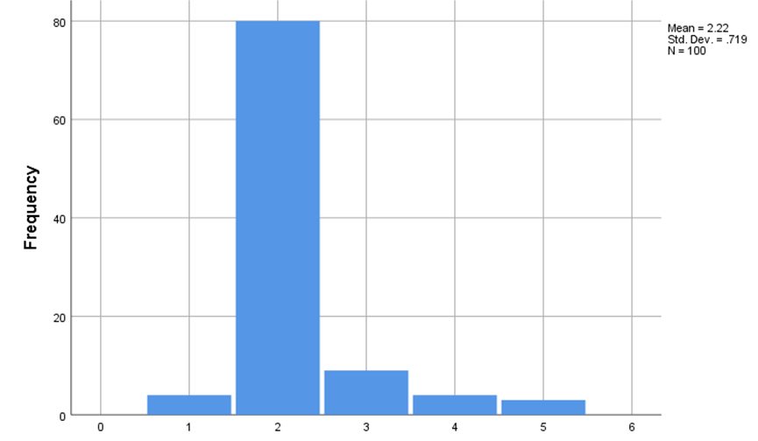
Figure 30: Challenges of Employee Dissatisfaction
84% of the employees within Pizza Hut believe that the dissatisfaction among the employees has had an impact on the company and its productivity in the long term. This has encouraged the company to take new initiatives towards the formation of new fringe benefits for its employees.
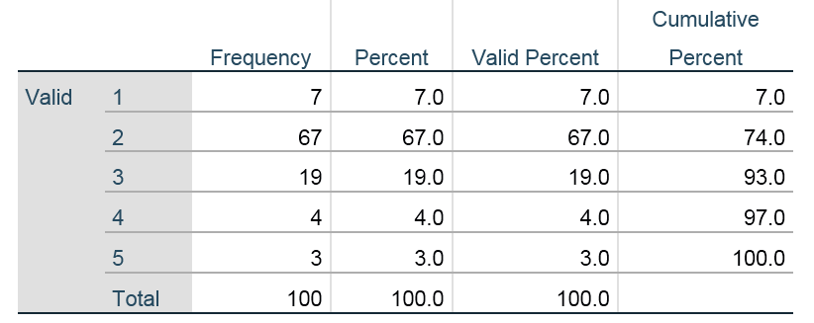
Table 27: Challenges of Low Business Profitability
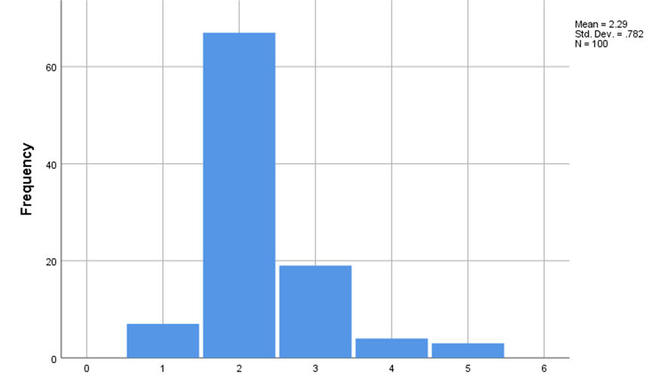
Figure 31: Challenges of Low Business Profitability
73% of the total participating employees of Pizza Hut had opined that the company had struggled from a financial perspective when the profitability dropped. This can lead to a number of issues, such as the procurement of necessary food items and the transportation of food items to its customers.
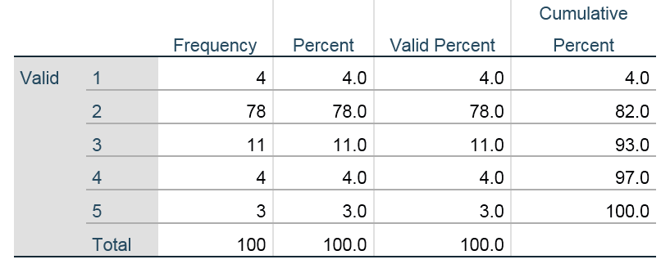
Table 28: Productivity Increase through Fringe Benefits
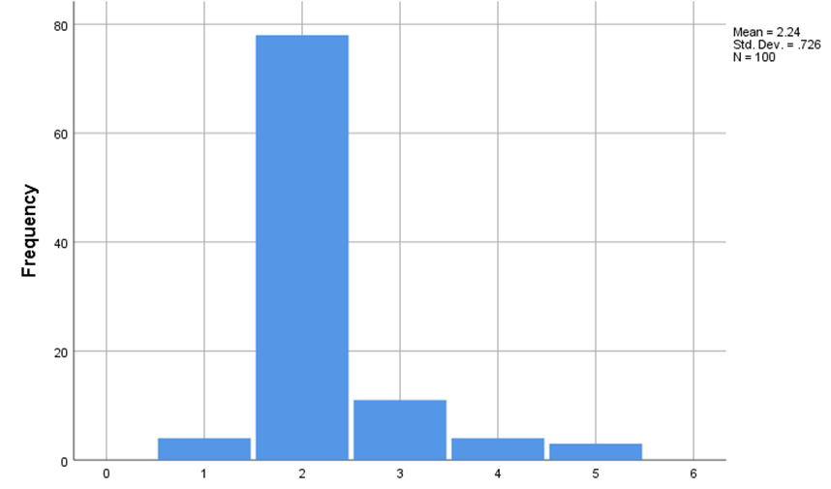
Figure 32: Productivity Increase through Fringe Benefits
The fringe benefits within the company have been a major asset which has been used by Pizza Hut to increase the overall productivity of the workforce, as agreed by 82% of the employees. These assets have been inexpensive and have been profitably utilised by the company. The survey by Singh et al. (2019) has also presented the findings that fringe benefits improve workers’ productivity.
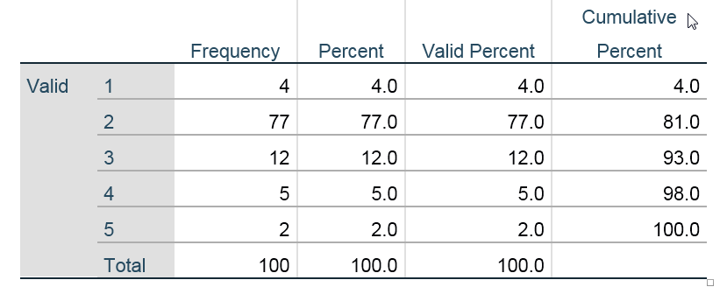
Table 29: Recognition through Fringe Benefits
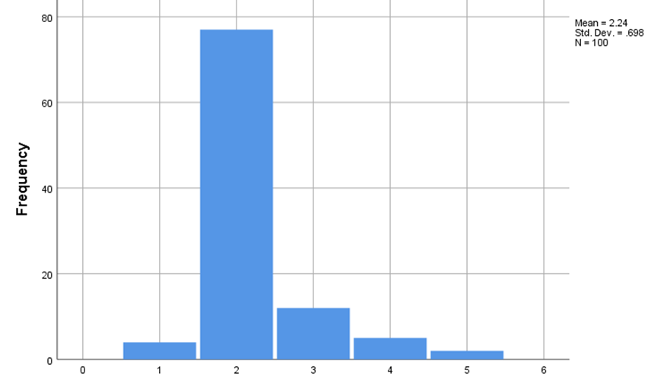
Figure 33: Recognition through Fringe Benefits
81% of the employees believe that the recognition provided to them through the usage of fringe benefits has been valuable to them, and it has motivated them to work harder. However, 7 employees have also believed that the recognition through fringe benefits has not been effective in terms of motivating them. Teoh et al. (2021) have concluded that recognition acts as an effective fringe benefit, similar to this survey's findings.
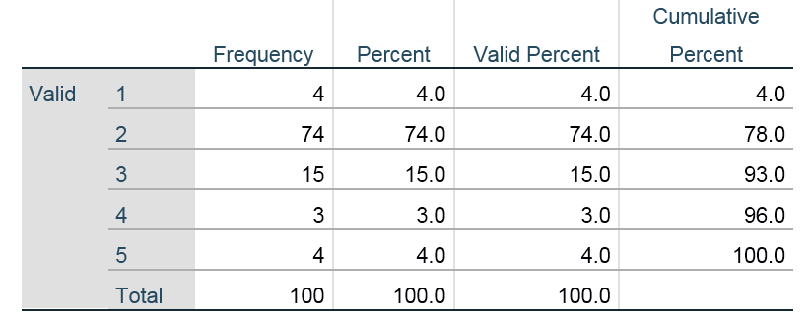
Table 30: Incentives and Rewards through Fringe Benefits
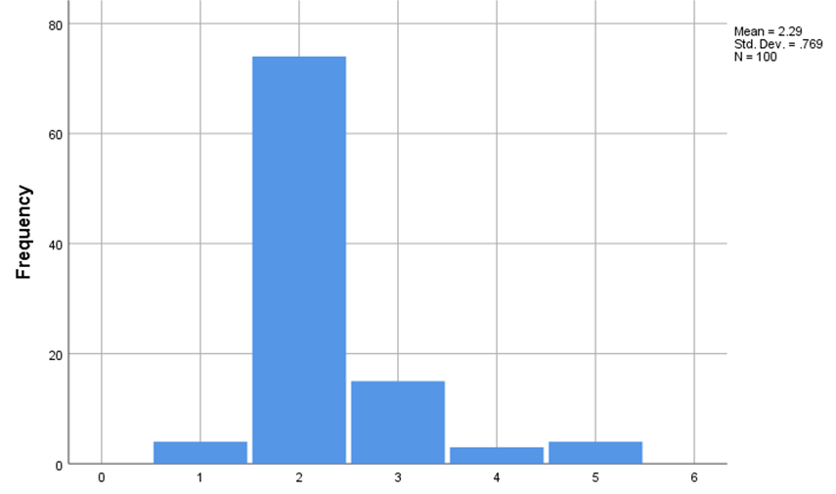
Figure 34: Incentives and Rewards through Fringe Benefits
78% of the employees within Pizza Hut have believed that they have often been rewarded with benefits for their work in the company, and this has motivated them to put their best efforts within the company during working hours. 7% of the employees have, however, believed that the fringe benefits have not been valuable to the companies in terms of incentives and rewards. The main findings of Arokiasamy (2019) supported this survey results that employee rewards as fringe benefits motivate them to put in their best efforts.
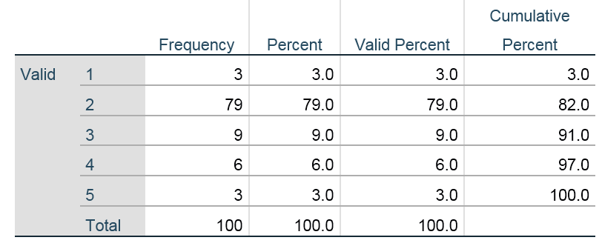
Table 31: Flexible Working Hours as a Fringe Benefit
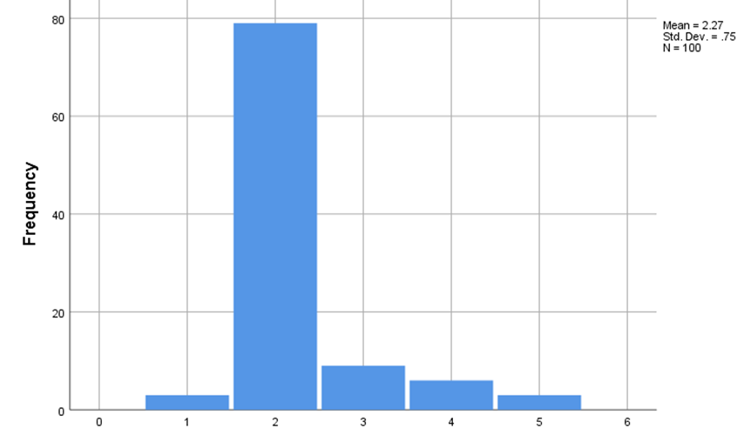
Figure 35: Flexible Working Hours as a Fringe Benefit
82% of the employees within the survey believed that the flexible working hours within the company had been a potent fringe benefit, and it has helped them to take care of their family while being employed.
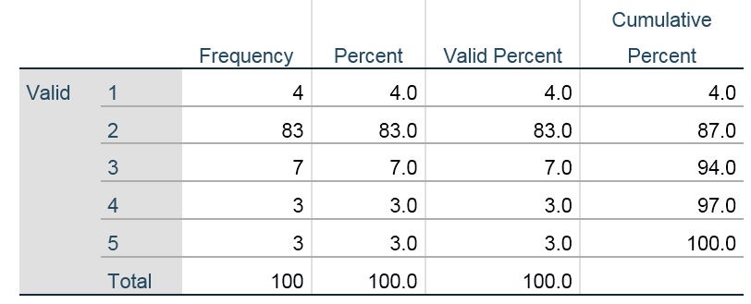
Table 32: Effectiveness of Training and Development as Fringe Benefits
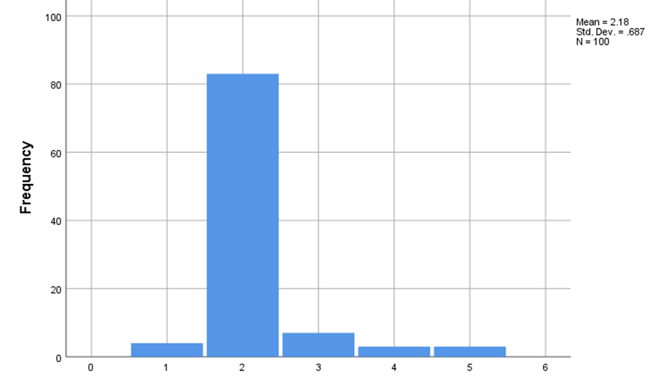
Figure 36: Effectiveness of Training and Development as Fringe Benefits
87% of the employees have appreciated the training and development through the means of fringe benefits since these have meant that the employees have got the opportunity to upskill themselves in a consistent manner. The survey conducted by Awang and Yusuf (2020) has led to similar information that training and development programs act as effective fringe benefits, encouraging workers to perform at their best level.
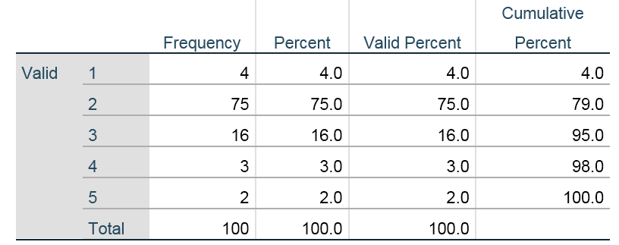
Table 33: Mandating Fringe Benefits
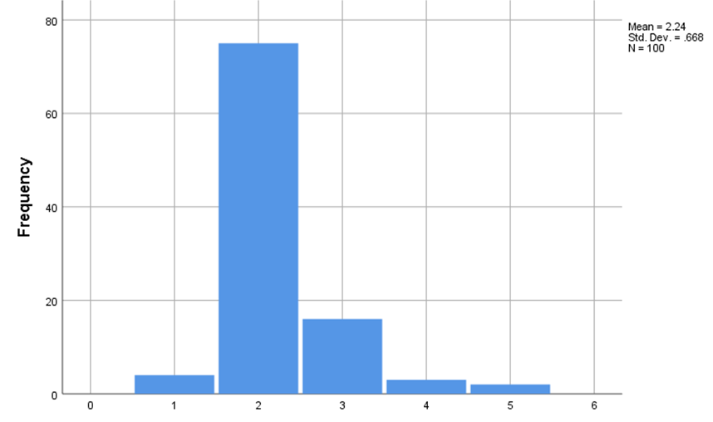
Figure 37: Mandating Fringe Benefits
79% of the employees have valued the fringe benefits that have been provided by the company since these have helped them to increase their motivation.
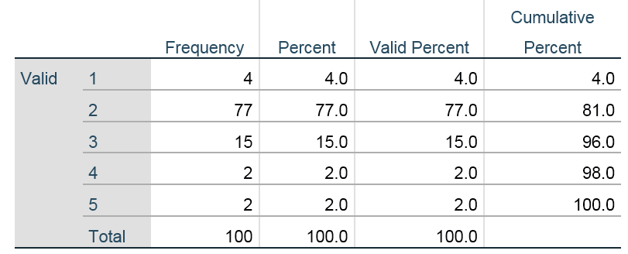
Table 34: Compensation as Fringe Benefits
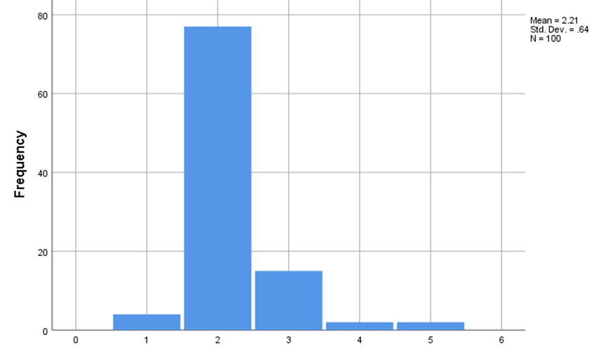
Figure 38: Compensation as Fringe Benefits
Through this question, it has been understood that 81% of the employees have valued the compensation that they have received from Pizza Hut because of better performance. The outcomes of Okpara (2021) have also suggested the fact that direct monetary compensation works as effective fringe benefits.
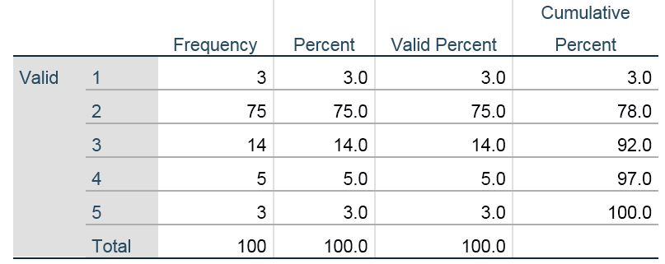
Table 35: Positive Workplace Culture through Fringe Benefits
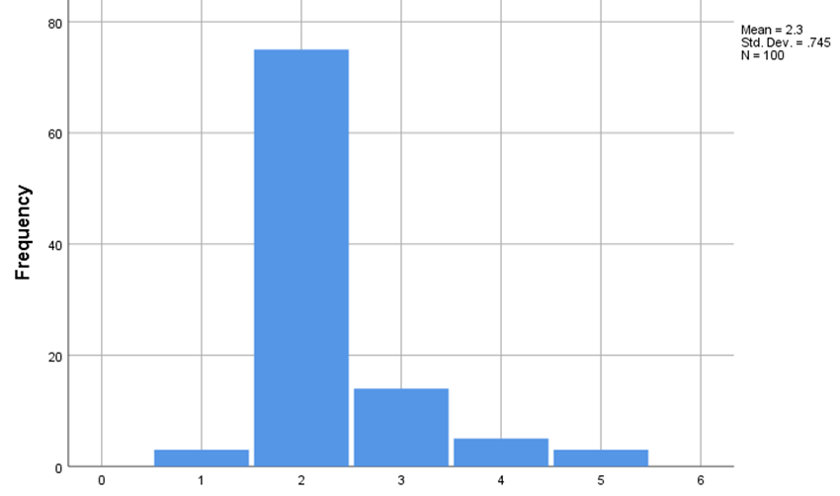
Figure 39: Positive Workplace Culture through Fringe Benefits
A positive workplace culture that has been formed as a result of fringe benefits within the company of Pizza Hut has been appreciated by 78% of the total employees who have taken part in the research. Kulikowski and Sedlak (2020) have also found that positive workplace culture usually improves the willingness of the employees to perform.
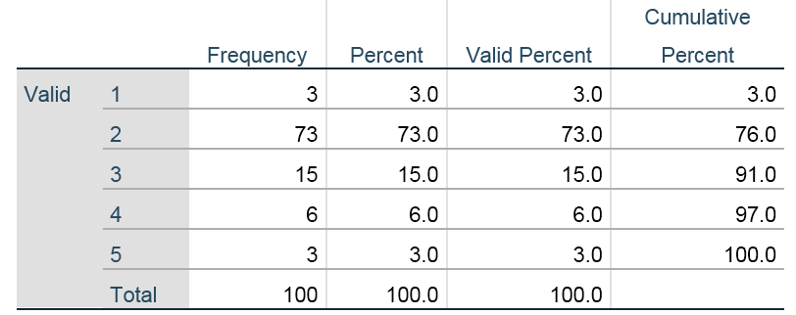
Table 36: Attraction of New Employees through Fringe Benefits
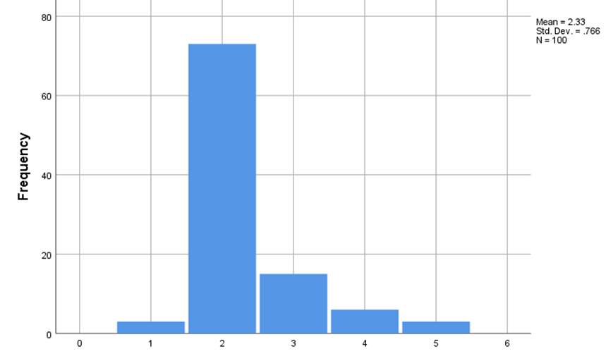
Figure 40: Attraction of New Employees through Fringe Benefits
76% of the employees believed that fringe benefits had attracted new candidates towards the company. Similarly, the studies of Zirra, Mambula and Anyatonwu (2019) have identified the fact that fringe benefits assist in attracting new employees.
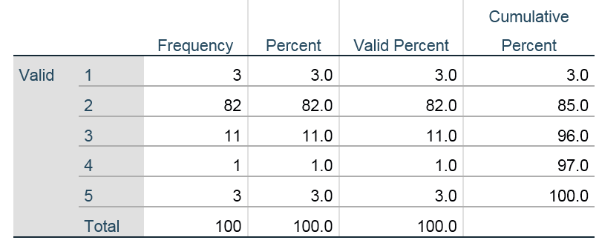
Table 37: Better Efficiency through Fringe Benefits
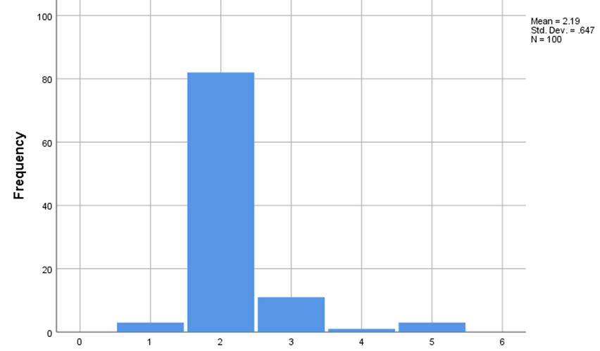
Figure 41: Better Efficiency through Fringe Benefits
85% of the participating employees have opined that fringe benefits have increased the efficiency of the companies. The survey arranged by Uddin (2019) has provided information that fringe benefits improve the efficiency of fast food companies.
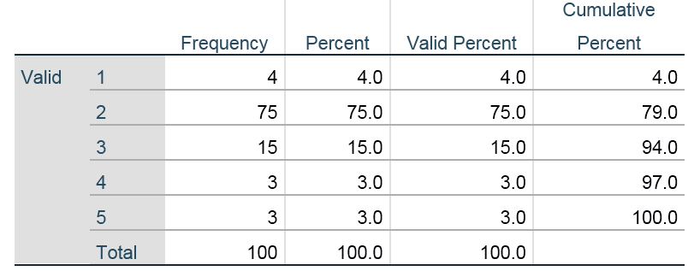
Table 38: Betterment of Relationship through Fringe Benefits
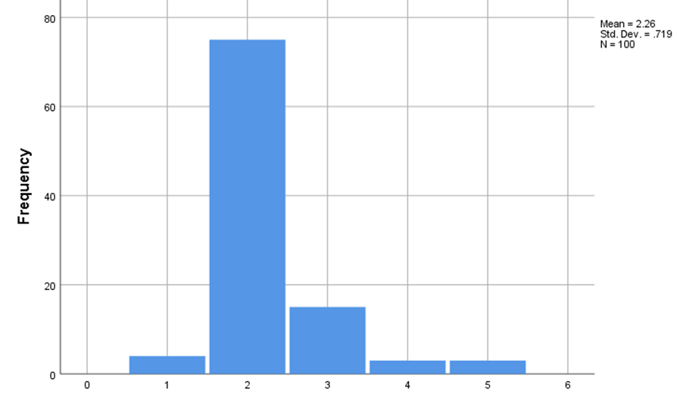
Figure 42: Betterment of Relationship through Fringe Benefits
The relationships between the employees and the leadership have improved through fringe benefits. 79% of the employees agreed with this statement.
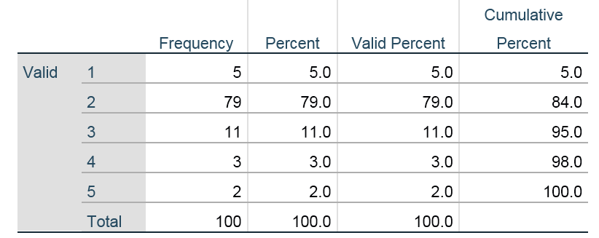
Table 39: Improving Overall Productivity
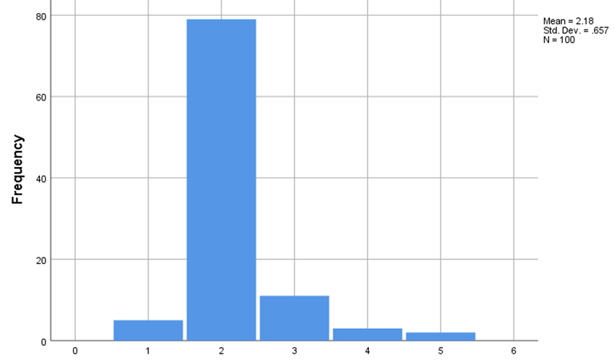
Figure 43: Improving Overall Productivity
84% of the employees have agreed that productivity has improved through fringe benefits, and this has helped the company to grow in the market.
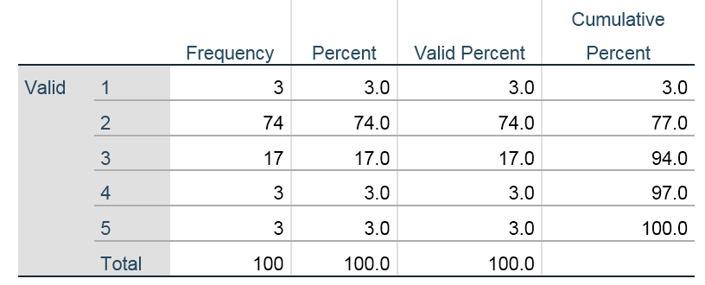
Table 40: Business Expansion through Fringe Benefits
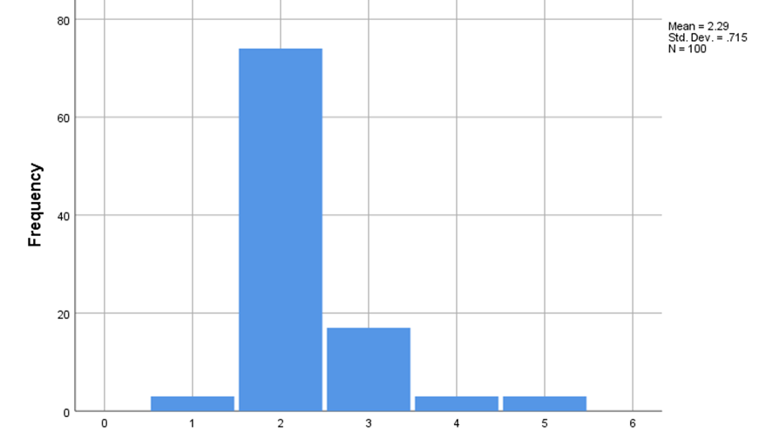
Figure 44: Business Expansion through Fringe Benefits
77% of the employees have agreed Pizza Hut has been able to expand its market in the global domain by providing fringe benefits to its employees and moderating their productivity. The survey conducted by Mabaso and Dlamini (2021) has also led to similar results; fridge benefits assist in business expansion.
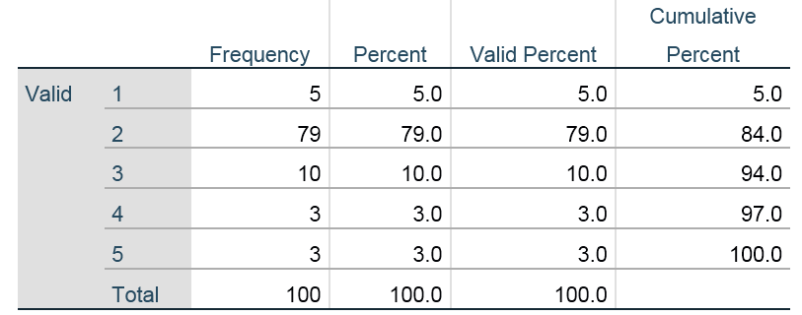
Table 41: Emphasis on Health and Well-being through Fringe Benefits
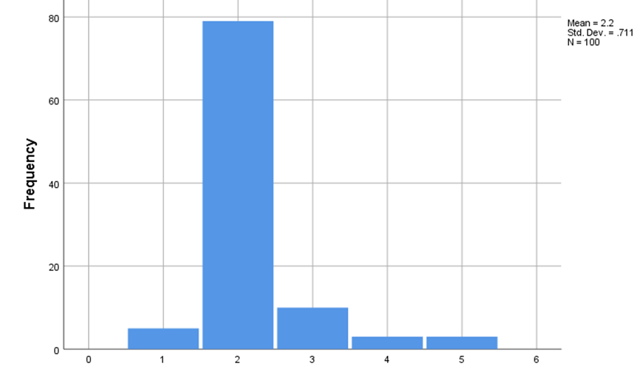
Figure 45: Emphasis on Health and Well-being through Fringe Benefits
84% of the employees have been satisfied with the fringe benefits of Pizza Hut as they have been provided with health and well-being coverage. The research of Mtatiro (2021) has supported the fact that emphasizing employee well-being does improve the motivation of the workers.

4.4 Correlation and Descriptive Statistical Analysis
4.4.1 Correlation Analysis
The depiction of the “correlation analysis” (refer to appendix) illustrates the relationship between the “dependent variable” (DV) and “independent variable” (IV). In this context, while classifying the variables which are integral in this study, the DV which has been recognised as “fringe benefits being important for boosting employee productivity within Pizza Hut”. The “correlation value” observed between the DV and all the other IVs are 0.749, 0.731, 0.731, 0.640, 0.773, 0.606, 0.580, 0.601, 0.559, 0.607, 0.540, 0.576, 0.515, 0.500, 0.408, 0.574, 0.581, 0.431, 0.546, 0.645, 0.507, 0.438, 0.633, 0.326, 0.536, 0.488, 0.459, 0.355, 0.519, 0.397, and 0.450. All the values are positive in magnitude, which depicts a relationship of “positive correlation”, which highlights that any modification made in any of the IVs will bring a change of the same magnitude in the DV as they exist in a linear relationship.
4.4.2 Descriptive Statistical Analysis
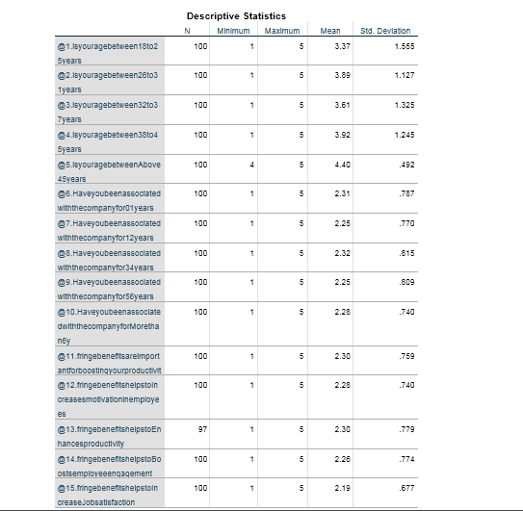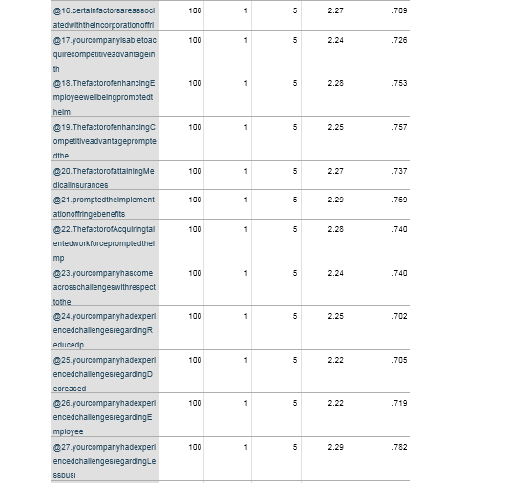
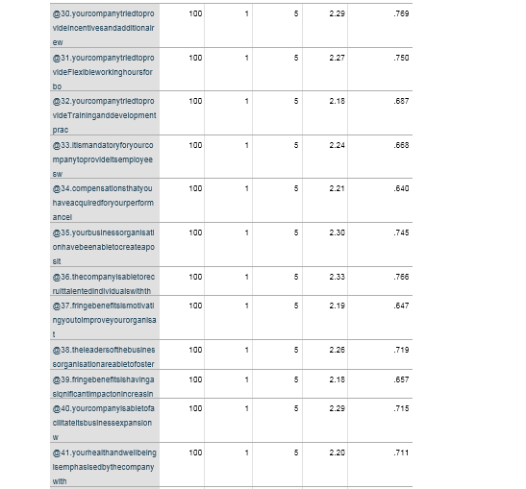
This “descriptive statistics table” showcases the identified variables' values of the “mean” and the “standard deviation (SD)”. With respect to this survey assessment, the values determined have highlighted that all the values of the SD are lower than the “Mean”. This relationship suggests that all the variables are assembled around the “Mean”, which demonstrates that there exists no variance in variables, which implies that all the identified variables are reliable.

4.5 Critical Interpretation of Data
4.5.1 Effect of fringe benefits on the Performance of Workers in Pizza Hut
The percentage of employees who have agreed to the notion that the fringe benefits are beneficial for their productivity boost is 76 per cent. While the amount of employees who have disagreed with the notion is 9 per cent. The following question that enquired regarding the effect of fringe benefits on the employees regarding the rise and decrease in their motivation level has been placed. According to the statistics that have been derived through the process, it can be seen that 79 per cent of the chosen subjects are inclined towards an agreement on the notion provided to them. Moreover, 9 per cent of the employees disagree with the notion. The questionnaire that has been developed in the research has been significantly developed in a way that it emphasises two major facets, such as the motivation level of the employees as a result of the benefits that are provided by the organisation. Therefore, the question of enhancing productivity and its relation to productivity. 79.4 per cent of the respondents agreed with the fact, while at the same time, 11.4 per cent of the employees disagreed to the dominion that there is no or negligible impact on the aspect of fringe benefits impacting on the enhancement or the rise in the productivity levels of the employees. The impact of employee engagement has been the next aspect, and through the analysis of the data that has been derived from the analysis of the primary empirical information, it is realised that 81 per cent of the employees are agreeing to the notion that employee engagement has been rising as a result of the beneficial factors given to the employees. The disagreement with this notion ranges to about 9 per cent. The impact is also measured in the realm of managing the level of satisfaction that these subjects have towards their jobs, and it is identified that 84 per cent of the employees have agreed to the notion that their satisfaction towards their jobs has increased as a result of the benefits that they are receiving through their organisation. The researcher’s motive is inclined towards the derivation of the data regarding the association of the various facets that cater to the fluctuations and the vulnerabilities in the realm of their organisation. It is thus evident that the majority of the subjects, that is, 78 % of the employees, are in inclination toward the stance that they agree to the fact that the factors are responsible for the changes in the benefits they attain that caused the fluctuations in the dominion of their improvement regarding the productivity level. Providing some of the advantages as well as necessary benefits from the organisation is needed for the purpose of gaining a competitive advantage in the organisation. This has been asked of the subjects, and 80% of the responses that are accumulated result in this that the benefits help the organisation to gain a competitive edge in the market because of the rise of the productivity of the employees to a great extent. While 9 per cent has also disregarded this analogy and denied the relationship between the both. The question was further associated with the well-being of the employees and the implementation of these benefits. 79% of the respondents will be agreed to the fact that their well-being is one of the benefits that they receive from the company that caters to their advantage. While 8% have denied the stance. Medical insurance is a health-oriented benefit that is one of the prime requisites for the workforce of the organisation, and therefore the association with medical and healthcare insurance results in 81%, while 9% disagree with this facet. The fraction of employees that have prompted the need and facilitation of fringe benefits is 78%, and the number of employees that refrain from this particular instance is 7% disagreement. Moreover, there is an established relationship between the appropriate talent acquisition and the fringe benefits, and it ranges to about 80% of the statistics from the survey. In the domain of establishing the need for fringe benefits for attaining the rise in the level of performance of the workforce of Pizza Hut, these are the necessary statistical pieces of evidence that have been incurred. The assessment of previously published literature led to the comprehension that workers have been a significant resource of companies, and their performance has determined the productivity of the company, and as a result of that, companies have been providing fringe benefits to workers in fast-food companies. Through such benefits, companies have been able to focus on the well-being of the workers as in this sector of fast-food, employees have to work for longer shifts, and due to that reason, the leadership of fast-food companies have been focusing on offering fringe benefits in a proper way and with that the productivity and motivation of the workers have enhanced (Okpara, 2021). The evaluation of the interview data shows that the managers of Pizza Hut have stated that with the implementation of rewards and fringe benefits, the leadership of the fast-food giant has been trying to inspire the employees, and through providing such rewards, workers have understood that their hard work has been recognised by the organisation and with that the productivity of the employees has increased and with that, the profitability and revenue generation of the firm has improved. Furthermore, as per the reaction of the managers, with the integration of proper fringe benefits, employees have understood that their needs and demands have been taken care of by the organisation, and as a result of that, their overall productivity has improved. In addition to that, when employees are offered what they require, they generally stay within the firm for longer periods of time, and it has boosted their engagement with their customers and retention of employees also improved in the company.
4.5.2 Obstacles Faced by Pizza Hut in the Provision of Fringe Benefits to Employees
As per the enquiries that have been facilitated to the participants, it is realised that 83 % of the employees have agreed to the fact that they faced challenges in the declining competitive advantage. 83% of the Responses agree with the notion, while 6% disagree with the notion. Challenges regarding employee dissatisfaction are also analysed, and 84% agree with the notion, while 7% deny the stance. Fringe benefits of the workforce are also analysed with the loss made by the business, and it is analysed that 74% of the participants are inclined to agree on the fact that lack of benefits is an outcome of a lesser amount of business profitability. The low productivity of the companies within the fast food industry has been a major issue since this has provided lower opportunities to the companies for providing fringe benefits to their employees. This has been the case since the companies have needed substantial capital to initiate such ideas (Okpara, 2021). The survey has revealed that Pizza Hut has also suffered from low profitability in the market, and this has hindered the activities and initiatives that are essential for the provision of fringe benefits.
4.5.3 Strategies Implemented by Pizza Hut for Providing Fringe Benefits to Employees
The employees were asked about the application of the efficient measures that are needed for the benefit of the organisation through their individual benefits. 82% of the employee agree to the instance, and 7% of the answers on the survey showcase that they deny the notion stated to them. In terms of employee recognition and elevation of productivity as a strategy for the employees gained through fringe benefits, 81% of the respondents agree and 7% refrain from accepting. The stance for incentives that are received is 78% of the participants, and 7% disagreed. Flexibility in their shifts is agreed by 82% of the employees, while 9% do not accept the fact. Training of the employees has also been one of the facets that have been focused on by the researcher, and it is seen that 87% accept the notion while 10% differ from it. Compensation, a positive work culture as well as recruiting appropriate talent that impacts the domain of fringe benefits that is being offered to the employees of Pizza Hut. The highest amount of response that has been gained is the domain of compensation, and it ranges to 77 per cent of agreement and 4% disagreement. In the employees’ responses regarding the implication of the monetary benefits as well as the benefits that are gained in the dominion of health and well-being, the majority of the responses that are attained are inclined towards the agreement, and it is seen that 79% of the workers are satisfied and agree to the stance that they are being provided with these benefits and thus the is an increase in the performativity. While 2 per cent disagree with the aspect. One of the strategies that the companies have implemented is the provision of a number of health and wellness programs for the employees, and these have become viable fringe benefits programs for employees (Mabaso and Dlamini, 2021). In Pizza Hut, flexible working hours have been a major motivator for the employees, and this has increased the overall satisfaction of the employees and the stature of the company in the market. This has also increased their overall competitive edge within the market of fast food products.

4.6 Chapter Summary
This segment has led to the comprehension of the major causal links which exist between the strategic implementation of the fringe benefits by Pizza Hut and the higher organisational productivity attained via the effective display of employee performance. Pizza Hut has been implementing fringe benefits like flexible working hours, medical insurance, commute allowances and so on have resulted in effective employee performance, which has elevated their overall revenue generation.

Chapter 5. Conclusion and Recommendations

5.1 Overview
The study of the section introduction it was concluded that the main purpose of the research was to carry out an exploration to delve into the ways in which providing fringe benefits has impacted employee productivity in fast food companies. The research was especially focused on the case of fringe benefits that are provided by the company Pizza Hut. The objectives that had been established concerning the attainment of the research aim were the impact of fringe benefits on the products of the workers of Pizza Hut, the issues and challenges that were faced by Pizza Hut in regard to maintaining high productivity in their staff due to lack of sufficient fringe benefits, and the policies that are used for the adoption of fringe benefits to the enhancement of employee productivity in Pizza hut.
It was concluded from the literature review section that Herzberg’s motivation theory was studied in order to get a clear perception of the determinants of employee motivation that promoted the increase in employee productivity and the role of fringe benefits that are provided to the employees in their employee motivation and performance. It is a two-factor content model that includes the factors hygiene factors and the motivation factors that determine motivation n the staff. The hygiene factors are the ones that determine that unpleasantness in the employees is prevented, and motivation factors are required for positive encouragement. Fringe benefits encompass both hygiene and motivating factors. .as employees are known to be a vital resource in relation to organisational growth and competitive advantage, fringe benefits become important in terms of maintaining the performance of the workers. The employees in the fast-food sector have to constantly deal with working in highly stressful conditions, because of which they are provided with fringe benefits so as to reduce absenteeism in the organisations. This enabled the employees to contribute more time and skills towards the organisation so that organisational performance is improved. The fringe benefits also impact the productivity of the workers by providing them with a sense of recognition towards the respective companies, which motivates them towards meeting their peal capabilities. One of the biggest obstacles that are faced by fast food companies in terms of managing employee productivity because of the lack of the ability to manage employees’ productivity levels is that it affects the quality of the deliverables of the fast food firms in a negative manner. Because of this, the customer levels of the firms tend to decrease. The lack of fringe is seen to diminish the productivity levels of the workers, because of which there is seen to be a lowering in the aspects of employee engagement and employee morale. This is also seen to hamper the innovation capability and creativity in the firms while also causing delays in product delivery. Organisations that are unable to provide sufficient fringe benefits to the employees are witnesses to have suffered from high employee turnover rates as well. The Fringe benefits that were provided to the workers were wellness activities, subscriptions to mental health apps, gym memberships, and compensation for expenses on health. Some organisations were also seen to provide maternity leaves to workers so that they were able to spend time with their families.
It was concluded from the chapter on research methodology that the research methodology that was prepared specifically for this research had been developed through the use of the research onion framework. The research design consisted of the interpretivism philosophy, the inductive approach, the case study strategy, the mono-method research design and the longitudinal time horizon, respectively, for each of the different stages of the research. The researcher has also preferred the collection of the primary type of data for the execution of the research, and the data was then decided to be collected through a mixed method approach. The research includes an interview which has a sample set of 3 managers of Pizza Hut, and the survey has a sample set of 100 employees. The interview data was analysed using a thematic analysis process, and the survey data was analysed using the SPSS tool. One of the most prominent limitations that have been seen to surface while conducting the research was related to time constraints.
It was concluded from the chapter on data analysis that the interviews that were conducted among the managers of Pizza Hut have provided that when the employees feel that their work is well recognised and rewarded with fringe benefits provides them with a feeling of confidence and promotes the enhancement of employee motivation to do their best at their work. These benefits for the employees as well as the organisation as it ensures that the employees remain with the organisation for longer, thus increasing the rates of employee retention. The main barrier that Pizza Hut comes across in providing is that it needed the companies to have to spend a large sum of money, which would have been difficult to collect. The issues also included that maintaining the mental health of the workers has been an issue for the organisations and owing to which employees seemed to be unable to completely focus on work due to the lack of fringe benefits. The managers also provided that pizza hut provides maternity leave to their female workers for 18 weeks, which is entirely paid. This supported the women to spend much-needed time with their newborns, and because of this, their mental health was affected in a positive manner. Again it was assessed from the survey data that most employees agreed that fringe benefits were necessary for them in terms of maintaining motivation of the employees and also affected their job satisfaction levels. They are also seen to have a positive effect on the level of employee engagement. Fringe benefits were seen to have enhanced employee well-being and were a major reason behind its application in the research. That Pizza Hut was seen to have leveraged fringe benefits for the purpose of attaining competitive advantage. However, 83 % of the employees have mentioned that a major drawback of the absence of fringe benefits has been the lowering of the competitive advantage of the organisation. The strategies that were used by the organisations were to provide recognition to individual employees so as to motivate them to work so efficiently.

5.2 Linking With Objectives
5.2.1 Effect of fringe benefits on the Performance of Workers in Pizza Hut
It was observed from the study of the information that was provided in the section of literature of the dissertation that employees are a valuable asset to fast food organisations because the management of their productivity levels is imperative for the organisations. Due to this reason, fast food organisations have adopted the strategy of providing fringe benefits to the employees as it affects their motivation levels in a positive manner it leads to a sense of achievement and recognition in them. Because of this, they are seen to show higher productivity (Reza, Dzarrand Khazani, 2021). From the survey data, it was observed that 76 per cent of all the participants of the survey agreed that the fringe benefits enhance their motivation level because of which their productivity increased. The interview data has also supported that the fringe benefits provided a sense of achievement, because of which there was a rise in their motivation level rises. Thus this information substantiated the research aim.
5.2.2 Obstacles Faced by Pizza Hut in the Provision of Fringe Benefits to Employees
The literature review section led to the realisation that the lack of fringe benefits was seen to have a negative effect on the aspects of productivity of the workers which resulted in the depreciation of the performance of the organisations and their profitability as well. It reduces the satisfaction of workers and also causes leaders to decrease the overall quality of the deliverables of the organisations. As a result, there is a noticeable decrease in the competitive advantage of the organisations (Okpara, 2021). This data was also supported by the data that was presented in the survey data that was attained from the research. The survey data has provided that 83 per cent of the research participants agreed that the competitive advantage declined because of the challenges faced in the application of fringe benefits. The interviewees have provided that the productivity of the employees has suffered because of the lack of fringe benefits. Pizza Hut has struggled to provide fringe benefits because of increasing healthcare costs. Therefore, the research aim has been achieved through this data.
5.2.3 Strategies Implemented by Pizza Hut for Providing Fringe Benefits to Employees
It was perceived from the data retrieved from the pre-existing data from the literature review that fast-food organisations have provided health and wellness funds to respective employees for the promotion of the health of the workers. This has benefitted the organisation in terms of the betterment of the productivity of the workers and also reduced their absenteeism. As a result, it was seen that there was a growth in the performance of the organisation (mabasoand dlamini, 2021). The survey data which had been acquired from the research has also put that 79 per cent of all the survey respondents have shown agreement towards the fact that benefits that are provided with regard to the health and well-being of the workers have a positive effect on the performance of the workers. It was attained from the interview that pizza hut also provides maternal leave to employees for 18 weeks. Thus, the research objective has been met.

5.3 recommendations
Understanding the needs and preferences of the employees
In order to the achievement of maximum benefits from the fringe benefits that are given to the workers in the organisation, it is necessary that the benefits are aligned with the needs and preferences. This is because of the reason that it ensures that maximum satisfaction is reached and enables ensuring that the benefits can actually affect the motivation levels of the employees. Because of this, it is recommended that organisations make attempts to understand the demographics of the employees in their organisation. Some employees may prefer fringe benefits such as paid time off or childcare so that they can attain more time to spend with family, some may like financial benefits, and elderly employees may prefer medical insurance. As the teams become more complex, they gave accordingly become diverse. Because of this, it is necessary to keep track of the different employee demographics and provide benefits that cater to the need of all employees (mtatiro, 2021).
Ensuring that the fringe benefits are distributed equally
While providing fringe benefits, some employees may tend to develop the feeling that they are not being treated fairly and that their contributions are being neglected. Because of this, the employees can grow a sense of animosity and sadness, which has a profound effect on their productivity levels. It causes depreciation in satisfaction levels in the workers and also their commitment towards the organisation. Moreover, the idea that some employees are being discriminated against leads to the formation of tension between the employees themselves, which affects the collaboration between them and harms the productivity of the entire team. Therefore, it is recommended to the organisations that they should ensure that maximum transparency is maintained at the time of providing the benefits to the workers. This can be achieved by maintaining communication regarding the benefits and compensations of the employees (Zirra, Mambula and Anyatonwu, 2019).

5.4 Future Research Scope
In the present research, the researcher has opted to conduct mixed-method research consisting of the use of both an interview process and a survey process. However, for the purpose of betterment the advancement of the efficiency of the research that will be conducted by future researchers, it is recommended that the researcher opt to use a sample size of 100 employees for the survey and 3 managers for the interviews they use a larger sample size as it will add to the credibility of the research results. It is also recommended that in the future, the researcher can select a single process to work with as it will be more effective in terms of the time taken for the research. The researchers will also be benefitted by increasing the scope of the research. A consideration of global fast food companies can help to attain a deep understanding of the benefits of fringe benefits in terms of employee productivity.

Reference list
Abbas, J. (2020). Service quality in higher education institutions: qualitative evidence from the students’ perspectives using Maslow hierarchy of needs. International Journal of Quality and Service Sciences, 12(3), 371-384. https://www.emerald.com/insight/content/doi/10.1108/IJQSS-02-2020-0016/full/html
Adjeikwame, R. (2019). The Impact that Fringe Benefits have on Job Satisfaction and Employee Engagement at Sinapi Aba Savings and Loans Limited (SASL). International Journal of Advanced Engineering Research and Science, 6(7), 558-576. https://www.academia.edu/download/60221688/63_TheImpact20190806-46065-cspdn9.pdf
Agbonna, R.O., Oluyode, Q.N. and Yakubu, A.O., (2023). Assessment of the Relationship Between Fringe Benefits and Staff Job Satisfaction in Public Universities in Ogun State. Sapientia Global Journal of Arts, Humanities and Development Studies, 6(1). http://www.sgojahds.com/index.php/SGOJAHDS/article/view/427
Al-Ababneh, M.M., (2020). Linking ontology, epistemology and research methodology. Science & Philosophy, 8(1), pp.75-91.https://papers.ssrn.com/sol3/papers.cfm?abstract_id=3708935
Archibald, M.M., Ambagtsheer, R.C., Casey, M.G. and Lawless, M., (2019). Using zoom videoconferencing for qualitative data collection: perceptions and experiences of researchers and participants. International journal of qualitative methods, 18, p.1609406919874596.https://journals.sagepub.com/doi/pdf/10.1177/1609406919874596
Arokiasamy, A.R.A., (2019). Exploring the internal factors affecting job satisfaction in the fast food industry in Malaysia. Int. J. Adv. Appl. Sci, 6(11), pp.11-20.https://www.academia.edu/download/72924723/1021833ijaas201911003.pdf
Awang, N.N. and Yusuf, D.H.M., (2020). Rewards, Training and Development, Promotion Opportunities and Job Satisfaction of Fast Food Industry Employees.http://www.ajmbsjournal.com/uploads/1/2/7/5/127551902/20042020-ajmbs-20-28.pdf
Chiat, L.C. and Panatik, S.A., (2019). Perceptions of employee turnover intention by Herzberg’s motivation-hygiene theory: A systematic literature review. Journal of Research in Psychology, 1(2), pp.10-15. https://readersinsight.net/jrp/article/view/949
Cooper, H., Hedges, L.V. and Valentine, J.C., (2019). Potentials and limitations of research synthesis. The handbook of research synthesis and meta-analysis, pp.517-525.http://repository.universitasbumigora.ac.id/2217/1908/2019%20The%20Handbook%20of%20Research%20Synthesis%20and%20Meta-Analysis%20by%20Harris%20Cooper%2C%20Larry%20V.%20Hedges%2C%20Jeffrey%20C.s%20Valentine.pdf#page=528
Hasan, N., Rana, R.U., Chowdhury, S., Dola, A.J. and Rony, M.K.K., (2021). Ethical considerations in research. Journal of Nursing Research, Patient Safety and Practise (JNRPSP) 2799-1210, 1(01), pp.1-4.http://hmjournals.com/journal/index.php/JNRPSP/article/view/93
Hennink, M. and Kaiser, B.N., (2022). Sample sizes for saturation in qualitative research: A systematic review of empirical tests. Social Science & Medicine, 292, p.114523.https://www.sciencedirect.com/science/article/pii/S0277953621008558
Kulikowski, K. and Sedlak, P., (2020). Can you buy work engagement? The relationship between pay, fringe benefits, financial bonuses and work engagement. Current Psychology, 39(1), pp.343-353. https://link.springer.com/article/10.1007/s12144-017-9768-4
Mabaso, C.M. and Dlamini, B.I., (2021). Recent study on the impact of compensation and benefits on job satisfaction. Insights into Economics and Management, 7, pp.55-68. http://myscholar.umk.edu.my/bitstream/123456789/3013/2/Ebook%20Insights%20into%20Economics%20and%20Management%20Vol.%207.pdf#page=64
Mehrad, A. (2020). Evaluation of academic staff job satisfaction at Malaysian universities in the context of Herzberg’s Motivation-Hygiene Theory. Journal of Social Science Research, 15(1), 157-166. https://www.researchgate.net/profile/Aida-Mehrad/publication/340982953_Evaluation_of_Academic_Staff_Job_Satisfaction_at_Malaysian_Universities_in_the_Context_of_Herzberg's_Motivation-Hygiene_Theory/links/5ea869b5299bf18b95820e10/Evaluation-of-Academic-Staff-Job-Satisfaction-at-Malaysian-Universities-in-the-Context-of-Herzbergs-Motivation-Hygiene-Theory.pdf
Mishra, S.B. and Alok, S., (2022). Handbook of research methodology.https://www.nkrgacw.org/nkr%20econtent/nutrition%20and%20dietetics/PG/II.M.Sc%20N&D/BookResearchMethodology.pdf
Mitsakis, M. and Galanakis, M., (2022). An Empirical Examination of Herzberg’s Theory in the 21st Century Workplace. Organizational Psychology Re-Examined. Psychology, 13(2), pp.264-272. https://www.scirp.org/journal/paperinformation.aspx?paperid=115485
Mtatiro, R.M., (2021). The Significant of Fringe Benefits in Employee Retention in Public Sector in Tanzania: Case Study of Ministry of Water (Doctoral dissertation, The Open University of Tanzania). http://repository.out.ac.tz/3285/
Okpara, A. (2021). Fringe Benefits and Employees’ Performance in the Bank of Industry Limited, Lagos. Gusau International Journal of Management and Social Sciences, 4(3), 18-18. https://www.gijmss.com.ng/index.php/gijmss/article/view/81
Pandey, P. and Pandey, M.M., (2021). Research methodology tools and techniques. Bridge Center.http://dspace.vnbrims.org:13000/jspui/bitstream/123456789/4666/1/RESEARCH%20METHODOLOGY%20TOOLS%20AND%20TECHNIQUES.pdf
Peramatzis, G. and Galanakis, M., (2022). Herzberg’s Motivation Theory in Workplace. Psychology, 12(12), pp.971-978. https://www.davidpublisher.com/Public/uploads/Contribute/63c8ac817a47d.pdf
Plachá, V. (2020). Do fringe benefits affect job satisfaction?. https://dspace.cuni.cz/handle/20.500.11956/117975
Reza, M., Dzarr, A. and Khazani, M.Z., (2021). Fringe Benefit and Job Satisfaction in SME: An Empirical Experience among SMES in Selangor. Journal of Islamic, 6(42), pp.277-290. http://www.jised.com/PDF/JISED-2021-42-12-25.pdf
Rhou, Y. and Singal, M., (2020). A review of the business case for CSR in the hospitality industry. International Journal of Hospitality Management, 84, p.102330.https://pubs.aeaweb.org/doi/pdf/10.1257/jep.35.1.51
Runtuwene, L. and Lapian, S.J., (2019). A COMPARATIVE ANALYSIS OF SERVICE CONVENIENCE BETWEEN MALE AND FEMALE AT PIZZA HUT MANADO TOWN SQUARE. Jurnal EMBA: Jurnal Riset Ekonomi, Manajemen, Bisnis dan Akuntansi, 7(1).https://ejournal.unsrat.ac.id/v3/index.php/emba/article/download/22349/22032
Säfsten, K. and Gustavsson, M., (2020). Research methodology: for engineers and other problem-solvers.https://www.diva-portal.org/smash/record.jsf?pid=diva2:1511121
Sileyew, K.J., (2019). Research design and methodology (pp. 1-12). Rijeka: IntechOpen.https://books.google.com/books?hl=en&lr=&id=eqf8DwAAQBAJ&oi=fnd&pg=PA27&dq=data+collection+in+research+methodology+&ots=cKU-7_caUf&sig=EB0OzM6OgtHgdxB1Faz6NKs5Tm4
Singh, T., Kaur, M., Verma, M. and Kumar, R., (2019). Job satisfaction among health care providers: A cross-sectional study in public health facilities of Punjab, India. Journal of family medicine and primary care, 8(10), p.3268. https://www.ncbi.nlm.nih.gov/pmc/articles/PMC6857391/
Souiden, N., Chaouali, W. and Baccouche, M., (2019). Consumers’ attitude and adoption of location-based coupons: The case of the retail fast food sector. Journal of Retailing and Consumer Services, 47, pp.116-132.https://e-tarjome.com/storage/panel/fileuploads/2019-06-17/1560743599_E11323-e-tarjome.pdf
Spector, P.E., (2019). Do not cross me: Optimizing the use of cross-sectional designs. Journal of Business and Psychology, 34(2), pp.125-137.https://link.springer.com/article/10.1007/s10869-018-09613-8
Teoh, K.B., Cordova, M., Hasanah, N.N., Utama, A.G.S., Syazana, A., Kee, D.M.H., Azrul, A., Raziq, A. and Ang, B.L., (2021). Factors influencing customers’ purchasing behavior and satisfaction in Pizza Hut. Advances in Global Economics and Business Journal, 2(1), pp.39-56.https://agebj.org/index.php/agebj/article/download/26/17
Timans, R., Wouters, P. and Heilbron, J., (2019). Mixed methods research: what it is and what it could be. Theory and Society, 48, pp.193-216.https://link.springer.com/article/10.1007/s11186-019-09345-5
Uddin, M.B., (2019). Customer loyalty in the fast food restaurants of Bangladesh. British Food Journal.https://www.academia.edu/download/64014115/Customer%20loyalty%20in%20the%20fast%20food%20(1).pdf
Zirra, C.T.O., Mambula, C.J.I. and Anyatonwu, P., (2019). Impact of fringe benefits on employee performance: A study of Nasco Group, Jos Plateau State. International Journal of Education and Social Science, 6(1), pp.25-33. https://www.academia.edu/download/60537590/ImpactofFringeBenefitsonEmployeePerformanceAStudyofNascoGroupJosPlateau220190909-80586-13tv089.pdf

Appendix
Survey Questions
1. Please specify your age group
a. 18 to 25 years
b. 26 to 31 years
c. 32 to 37 years
d. 38 to 45 years
e. Above 45 years
2. For how long have you been associated with the company?
a. 0 – 1 years
b. 1 – 2 years
c. 3 – 4 years
d. 5 – 6 years
e. More than 6 years
3. Do you agree that fringe benefits are important for boosting your productivity within the company?
a. Strongly Agree
b. Agree
c. Neutral
d. Disagree
e. Strongly Disagree
4. What are the advantages you have witnessed with respect to the usage of adequate fringe benefits provided by your company?
a. Increases motivation
b. Enhances productivity
c. Boosts employee engagement
d. Job satisfaction
e. All of the above
5. Do you agree that certain factors are associated with the incorporation of fringe benefits by your company for improving productivity of workforce?
a. Strongly Agree
b. Agree
c. Neutral
d. Disagree
e. Strongly Disagree
6. Which of the subsequent factors are held responsible for the implementation of fringe benefits for boosting workforce productivity?
a. Employee wellbeing
b. Competitive advantage
c. Medical insurances
d. Acquiring talented workforce
e. All of the above
7. Do you agree that your company is able to acquire competitive advantage in the marketplace by using fringe benefits to enhance your productivity?
a. Strongly Agree
b. Agree
c. Neutral
d. Disagree
e. Strongly Disagree
8. Do you agree that your company has come across challenges with respect to the improving employee productivity due to inadequate fringe benefits?
a. Strongly Agree
b. Agree
c. Neutral
d. Disagree
e. Strongly Disagree
9. Which of the consequent challenges your company had experienced while boosting employee productivity with respect to inadequate fringe benefits?
a. Reduced productivity
b. Less business profits
c. Decreased competitive edge
d. Employee dissatisfaction
e. All of the above
10. Do you agree that your company had undertaken effective measures in order to facilitate productivity of employees through fringe benefits?
a. Strongly Agree
b. Agree
c. Neutral
d. Disagree
e. Strongly Disagree
11. Which of the following steps have been carried out by your company for boosting employee productivity with the utilisation of fringe benefits?
a. Recognition in the organisation
b. Incentives and additional rewards
c. Flexible working hours
d. Training and development practices
e. All of the above
12. Do you agree that it is mandatory for your company to provide its employees with additional advantages such as fringe benefits?
a. Strongly Agree
b. Agree
c. Neutral
d. Disagree
e. Strongly Disagree
13. Do you agree that the compensations that you have acquired for your performance in the company is fulfilling your expectations?
a. Strongly Agree
b. Agree
c. Neutral
d. Disagree
e. Strongly Disagree
14. Do you agree that your business organisation have been able to create a positive workplace culture with the usage of fringe benefits?
a. Strongly Agree
b. Agree
c. Neutral
d. Disagree
e. Strongly Disagree
15. Do you agree that the company is able to recruit talented individuals with the help of additional fringe benefits in the organisation?
a. Strongly Agree
b. Agree
c. Neutral
d. Disagree
e. Strongly Disagree
16. Do you agree that the fringe benefits is motivating you to improve your organisational efficiency for better productivity?
a. Strongly Agree
b. Agree
c. Neutral
d. Disagree
e. Strongly Disagree
17. Do you agree that the leaders of the business organisation are able to foster good relationship with employees through fringe benefits?
a. Strongly Agree
b. Agree
c. Neutral
d. Disagree
e. Strongly Disagree
18. Do you agree that fringe benefits is having a significant impact on increasing overall productivity of the company?
a. Strongly Agree
b. Agree
c. Neutral
d. Disagree
e. Strongly Disagree
19. Do you agree that your company is able to facilitate its business expansion with the usage of fringe benefits for boosting employee productivity?
a. Strongly Agree
b. Agree
c. Neutral
d. Disagree
e. Strongly Disagree
20. Do you agree that your health and wellbeing is emphasised by the company with respect to the fringe benefits for boosting your performance?
a. Strongly Agree
b. Agree
c. Neutral
d. Disagree
e. Strongly Disagree
Interview questions
1. What are your perceptions regarding the impact of fringe benefits on employee productivity in your company?
2. What are your views towards the factors associated with incorporating fringe benefits for increasing employee productivity?
3. What are your opinions concerning the issues faced by your company in terms of productivity due to lack of fringe benefits?
4. What are your viewpoints about the approaches used by your company for boosting employee productivity?
Correlation Table
Correlations
 |  | @10.HaveyoubeenassociatedwiththecompanyforMorethan6y | @11.fringebenefitsareimportantforboostingyourproductivit | @12.fringebenefitshelpstoIncreasesmotivationinemployees | @13.fringebenefitshelpstoEnhancesproductivity | @14.fringebenefitshelpstoBoostsemployeeengagement | @15.fringebenefitshelpstoIncreaseJobsatisfaction | @16.certainfactorsareassociatedwiththeincorporationoffri | @17.yourcompanyisabletoacquirecompetitiveadvantageinth | @18.ThefactorofenhancingEmployeewellbeingpromptedtheim | @19.ThefactorofenhancingCompetitiveadvantagepromptedthe | @20.ThefactorofattainingMedicalinsurances | @21.promptedtheimplementationoffringebenefits | @22.ThefactorofAcquiringtalentedworkforcepromptedtheimp | @23.yourcompanyhascomeacrosschallengeswithrespecttothe | @24.yourcompanyhadexperiencedchallengesregardingReducedp | @25.yourcompanyhadexperiencedchallengesregardingDecreased | @26.yourcompanyhadexperiencedchallengesregardingEmployee | @27.yourcompanyhadexperiencedchallengesregardingLessbusi | @28.yourcompanyhadundertakeneffectivemeasuresinorderto | @29.yourcompanytriedtoprovideRecognitionintheorganisati | @30.yourcompanytriedtoprovideIncentivesandadditionalrew | @31.yourcompanytriedtoprovideFlexibleworkinghoursforbo | @32.yourcompanytriedtoprovideTraininganddevelopmentprac | @33.itismandatoryforyourcompanytoprovideitsemployeesw | @34.compensationsthatyouhaveacquiredforyourperformancei | @35.yourbusinessorganisationhavebeenabletocreateaposit | @36.thecompanyisabletorecruittalentedindividualswithth | @37.fringebenefitsismotivatingyoutoimproveyourorganisat | @38.theleadersofthebusinessorganisationareabletofoster | @39.fringebenefitsishavingasignificantimpactonincreasin | @40.yourcompanyisabletofacilitateitsbusinessexpansionw | @41.yourhealthandwellbeingisemphasisedbythecompanywith
@10.HaveyoubeenassociatedwiththecompanyforMorethan6y | Pearson Correlation | 1 | .749** | .705** | .760** | .648** | .760** | .606** | .626** | .601** | .595** | .601** | .619** | .594** | .522** | .506** | .617** | .605** | .452** | .663** | .690** | .619** | .536** | .556** | .619** | .408** | .671** | .584** | .500** | .488** | .602** | .475** | .546**
@10.HaveyoubeenassociatedwiththecompanyforMorethan6y | Sig. (2-tailed) |  | .000 | .000 | .000 | .000 | .000 | .000 | .000 | .000 | .000 | .000 | .000 | .000 | .000 | .000 | .000 | .000 | .000 | .000 | .000 | .000 | .000 | .000 | .000 | .000 | .000 | .000 | .000 | .000 | .000 | .000 | .000
@10.HaveyoubeenassociatedwiththecompanyforMorethan6y | N | 100 | 100 | 100 | 97 | 100 | 100 | 100 | 100 | 100 | 100 | 100 | 100 | 100 | 100 | 100 | 100 | 100 | 100 | 100 | 100 | 100 | 100 | 100 | 100 | 100 | 100 | 100 | 100 | 100 | 100 | 100 | 100
@11.fringebenefitsareimportantforboostingyourproductivit | Pearson Correlation | .749** | 1 | .731** | .731** | .640** | .773** | .580** | .601** | .559** | .607** | .540** | .576** | .515** | .500** | .408** | .574** | .581** | .431** | .546** | .645** | .507** | .477** | .438** | .633** | .326** | .536** | .488** | .459** | .355** | .519** | .397** | .450**
@11.fringebenefitsareimportantforboostingyourproductivit | Sig. (2-tailed) | .000 |  | .000 | .000 | .000 | .000 | .000 | .000 | .000 | .000 | .000 | .000 | .000 | .000 | .000 | .000 | .000 | .000 | .000 | .000 | .000 | .000 | .000 | .000 | .001 | .000 | .000 | .000 | .000 | .000 | .000 | .000
@11.fringebenefitsareimportantforboostingyourproductivit | N | 100 | 100 | 100 | 97 | 100 | 100 | 100 | 100 | 100 | 100 | 100 | 100 | 100 | 100 | 100 | 100 | 100 | 100 | 100 | 100 | 100 | 100 | 100 | 100 | 100 | 100 | 100 | 100 | 100 | 100 | 100 | 100
@12.fringebenefitshelpstoIncreasesmotivationinemployees | Pearson Correlation | .705** | .731** | 1 | .831** | .684** | .720** | .567** | .663** | .710** | .703** | .583** | .601** | .612** | .522** | .467** | .675** | .624** | .487** | .588** | .710** | .655** | .518** | .575** | .659** | .280** | .634** | .548** | .542** | .412** | .498** | .380** | .488**
@12.fringebenefitshelpstoIncreasesmotivationinemployees | Sig. (2-tailed) | .000 | .000 |  | .000 | .000 | .000 | .000 | .000 | .000 | .000 | .000 | .000 | .000 | .000 | .000 | .000 | .000 | .000 | .000 | .000 | .000 | .000 | .000 | .000 | .005 | .000 | .000 | .000 | .000 | .000 | .000 | .000
@12.fringebenefitshelpstoIncreasesmotivationinemployees | N | 100 | 100 | 100 | 97 | 100 | 100 | 100 | 100 | 100 | 100 | 100 | 100 | 100 | 100 | 100 | 100 | 100 | 100 | 100 | 100 | 100 | 100 | 100 | 100 | 100 | 100 | 100 | 100 | 100 | 100 | 100 | 100
@13.fringebenefitshelpstoEnhancesproductivity | Pearson Correlation | .760** | .731** | .831** | 1 | .750** | .712** | .643** | .663** | .761** | .700** | .633** | .627** | .668** | .590** | .487** | .699** | .643** | .497** | .625** | .797** | .609** | .569** | .612** | .645** | .303** | .663** | .585** | .504** | .483** | .577** | .419** | .557**
@13.fringebenefitshelpstoEnhancesproductivity | Sig. (2-tailed) | .000 | .000 | .000 |  | .000 | .000 | .000 | .000 | .000 | .000 | .000 | .000 | .000 | .000 | .000 | .000 | .000 | .000 | .000 | .000 | .000 | .000 | .000 | .000 | .003 | .000 | .000 | .000 | .000 | .000 | .000 | .000
@13.fringebenefitshelpstoEnhancesproductivity | N | 97 | 97 | 97 | 97 | 97 | 97 | 97 | 97 | 97 | 97 | 97 | 97 | 97 | 97 | 97 | 97 | 97 | 97 | 97 | 97 | 97 | 97 | 97 | 97 | 97 | 97 | 97 | 97 | 97 | 97 | 97 | 97
@14.fringebenefitshelpstoBoostsemployeeengagement | Pearson Correlation | .648** | .640** | .684** | .750** | 1 | .657** | .718** | .607** | .706** | .630** | .638** | .653** | .613** | .666** | .493** | .672** | .695** | .558** | .715** | .744** | .687** | .539** | .652** | .738** | .276** | .582** | .501** | .627** | .277** | .404** | .447** | .419**
@14.fringebenefitshelpstoBoostsemployeeengagement | Sig. (2-tailed) | .000 | .000 | .000 | .000 |  | .000 | .000 | .000 | .000 | .000 | .000 | .000 | .000 | .000 | .000 | .000 | .000 | .000 | .000 | .000 | .000 | .000 | .000 | .000 | .005 | .000 | .000 | .000 | .005 | .000 | .000 | .000
@14.fringebenefitshelpstoBoostsemployeeengagement | N | 100 | 100 | 100 | 97 | 100 | 100 | 100 | 100 | 100 | 100 | 100 | 100 | 100 | 100 | 100 | 100 | 100 | 100 | 100 | 100 | 100 | 100 | 100 | 100 | 100 | 100 | 100 | 100 | 100 | 100 | 100 | 100
@15.fringebenefitshelpstoIncreaseJobsatisfaction | Pearson Correlation | .760** | .773** | .720** | .712** | .657** | 1 | .545** | .584** | .489** | .576** | .483** | .533** | .478** | .493** | .409** | .547** | .577** | .372** | .584** | .608** | .572** | .475** | .468** | .635** | .396** | .586** | .520** | .470** | .437** | .581** | .448** | .466**
@15.fringebenefitshelpstoIncreaseJobsatisfaction | Sig. (2-tailed) | .000 | .000 | .000 | .000 | .000 |  | .000 | .000 | .000 | .000 | .000 | .000 | .000 | .000 | .000 | .000 | .000 | .000 | .000 | .000 | .000 | .000 | .000 | .000 | .000 | .000 | .000 | .000 | .000 | .000 | .000 | .000
@15.fringebenefitshelpstoIncreaseJobsatisfaction | N | 100 | 100 | 100 | 97 | 100 | 100 | 100 | 100 | 100 | 100 | 100 | 100 | 100 | 100 | 100 | 100 | 100 | 100 | 100 | 100 | 100 | 100 | 100 | 100 | 100 | 100 | 100 | 100 | 100 | 100 | 100 | 100
@16.certainfactorsareassociatedwiththeincorporationoffri | Pearson Correlation | .606** | .580** | .567** | .643** | .718** | .545** | 1 | .697** | .765** | .758** | .749** | .781** | .741** | .723** | .574** | .790** | .735** | .586** | .717** | .746** | .689** | .508** | .708** | .715** | .408** | .553** | .523** | .703** | .356** | .524** | .482** | .554**
@16.certainfactorsareassociatedwiththeincorporationoffri | Sig. (2-tailed) | .000 | .000 | .000 | .000 | .000 | .000 |  | .000 | .000 | .000 | .000 | .000 | .000 | .000 | .000 | .000 | .000 | .000 | .000 | .000 | .000 | .000 | .000 | .000 | .000 | .000 | .000 | .000 | .000 | .000 | .000 | .000
@16.certainfactorsareassociatedwiththeincorporationoffri | N | 100 | 100 | 100 | 97 | 100 | 100 | 100 | 100 | 100 | 100 | 100 | 100 | 100 | 100 | 100 | 100 | 100 | 100 | 100 | 100 | 100 | 100 | 100 | 100 | 100 | 100 | 100 | 100 | 100 | 100 | 100 | 100
@17.yourcompanyisabletoacquirecompetitiveadvantageinth | Pearson Correlation | .626** | .601** | .663** | .663** | .607** | .584** | .697** | 1 | .762** | .771** | .784** | .760** | .795** | .737** | .594** | .764** | .788** | .587** | .789** | .762** | .688** | .566** | .762** | .671** | .412** | .724** | .564** | .676** | .498** | .628** | .448** | .650**
@17.yourcompanyisabletoacquirecompetitiveadvantageinth | Sig. (2-tailed) | .000 | .000 | .000 | .000 | .000 | .000 | .000 |  | .000 | .000 | .000 | .000 | .000 | .000 | .000 | .000 | .000 | .000 | .000 | .000 | .000 | .000 | .000 | .000 | .000 | .000 | .000 | .000 | .000 | .000 | .000 | .000
@17.yourcompanyisabletoacquirecompetitiveadvantageinth | N | 100 | 100 | 100 | 97 | 100 | 100 | 100 | 100 | 100 | 100 | 100 | 100 | 100 | 100 | 100 | 100 | 100 | 100 | 100 | 100 | 100 | 100 | 100 | 100 | 100 | 100 | 100 | 100 | 100 | 100 | 100 | 100
@18.ThefactorofenhancingEmployeewellbeingpromptedtheim | Pearson Correlation | .601** | .559** | .710** | .761** | .706** | .489** | .765** | .762** | 1 | .833** | .791** | .800** | .819** | .694** | .631** | .834** | .743** | .649** | .762** | .774** | .678** | .562** | .741** | .688** | .380** | .677** | .503** | .657** | .498** | .550** | .410** | .630**
@18.ThefactorofenhancingEmployeewellbeingpromptedtheim | Sig. (2-tailed) | .000 | .000 | .000 | .000 | .000 | .000 | .000 | .000 |  | .000 | .000 | .000 | .000 | .000 | .000 | .000 | .000 | .000 | .000 | .000 | .000 | .000 | .000 | .000 | .000 | .000 | .000 | .000 | .000 | .000 | .000 | .000
@18.ThefactorofenhancingEmployeewellbeingpromptedtheim | N | 100 | 100 | 100 | 97 | 100 | 100 | 100 | 100 | 100 | 100 | 100 | 100 | 100 | 100 | 100 | 100 | 100 | 100 | 100 | 100 | 100 | 100 | 100 | 100 | 100 | 100 | 100 | 100 | 100 | 100 | 100 | 100
@19.ThefactorofenhancingCompetitiveadvantagepromptedthe | Pearson Correlation | .595** | .607** | .703** | .700** | .630** | .576** | .758** | .771** | .833** | 1 | .783** | .811** | .776** | .721** | .585** | .824** | .789** | .678** | .753** | .784** | .672** | .556** | .728** | .758** | .370** | .635** | .570** | .665** | .454** | .579** | .425** | .582**
@19.ThefactorofenhancingCompetitiveadvantagepromptedthe | Sig. (2-tailed) | .000 | .000 | .000 | .000 | .000 | .000 | .000 | .000 | .000 |  | .000 | .000 | .000 | .000 | .000 | .000 | .000 | .000 | .000 | .000 | .000 | .000 | .000 | .000 | .000 | .000 | .000 | .000 | .000 | .000 | .000 | .000
@19.ThefactorofenhancingCompetitiveadvantagepromptedthe | N | 100 | 100 | 100 | 97 | 100 | 100 | 100 | 100 | 100 | 100 | 100 | 100 | 100 | 100 | 100 | 100 | 100 | 100 | 100 | 100 | 100 | 100 | 100 | 100 | 100 | 100 | 100 | 100 | 100 | 100 | 100 | 100
@20.ThefactorofattainingMedicalinsurances | Pearson Correlation | .601** | .540** | .583** | .633** | .638** | .483** | .749** | .784** | .791** | .783** | 1 | .770** | .731** | .769** | .630** | .799** | .802** | .652** | .784** | .757** | .716** | .543** | .741** | .729** | .371** | .734** | .574** | .761** | .438** | .566** | .425** | .629**
@20.ThefactorofattainingMedicalinsurances | Sig. (2-tailed) | .000 | .000 | .000 | .000 | .000 | .000 | .000 | .000 | .000 | .000 |  | .000 | .000 | .000 | .000 | .000 | .000 | .000 | .000 | .000 | .000 | .000 | .000 | .000 | .000 | .000 | .000 | .000 | .000 | .000 | .000 | .000
@20.ThefactorofattainingMedicalinsurances | N | 100 | 100 | 100 | 97 | 100 | 100 | 100 | 100 | 100 | 100 | 100 | 100 | 100 | 100 | 100 | 100 | 100 | 100 | 100 | 100 | 100 | 100 | 100 | 100 | 100 | 100 | 100 | 100 | 100 | 100 | 100 | 100
@21.promptedtheimplementationoffringebenefits | Pearson Correlation | .619** | .576** | .601** | .627** | .653** | .533** | .781** | .760** | .800** | .811** | .770** | 1 | .761** | .710** | .632** | .850** | .815** | .614** | .796** | .753** | .744** | .546** | .760** | .728** | .388** | .675** | .539** | .700** | .446** | .555** | .397** | .613**
@21.promptedtheimplementationoffringebenefits | Sig. (2-tailed) | .000 | .000 | .000 | .000 | .000 | .000 | .000 | .000 | .000 | .000 | .000 |  | .000 | .000 | .000 | .000 | .000 | .000 | .000 | .000 | .000 | .000 | .000 | .000 | .000 | .000 | .000 | .000 | .000 | .000 | .000 | .000
@21.promptedtheimplementationoffringebenefits | N | 100 | 100 | 100 | 97 | 100 | 100 | 100 | 100 | 100 | 100 | 100 | 100 | 100 | 100 | 100 | 100 | 100 | 100 | 100 | 100 | 100 | 100 | 100 | 100 | 100 | 100 | 100 | 100 | 100 | 100 | 100 | 100
@22.ThefactorofAcquiringtalentedworkforcepromptedtheimp | Pearson Correlation | .594** | .515** | .612** | .668** | .613** | .478** | .741** | .795** | .819** | .776** | .731** | .761** | 1 | .706** | .662** | .791** | .738** | .661** | .776** | .788** | .726** | .627** | .814** | .659** | .514** | .726** | .584** | .669** | .564** | .602** | .514** | .661**
@22.ThefactorofAcquiringtalentedworkforcepromptedtheimp | Sig. (2-tailed) | .000 | .000 | .000 | .000 | .000 | .000 | .000 | .000 | .000 | .000 | .000 | .000 |  | .000 | .000 | .000 | .000 | .000 | .000 | .000 | .000 | .000 | .000 | .000 | .000 | .000 | .000 | .000 | .000 | .000 | .000 | .000
@22.ThefactorofAcquiringtalentedworkforcepromptedtheimp | N | 100 | 100 | 100 | 97 | 100 | 100 | 100 | 100 | 100 | 100 | 100 | 100 | 100 | 100 | 100 | 100 | 100 | 100 | 100 | 100 | 100 | 100 | 100 | 100 | 100 | 100 | 100 | 100 | 100 | 100 | 100 | 100
@23.yourcompanyhascomeacrosschallengeswithrespecttothe | Pearson Correlation | .522** | .500** | .522** | .590** | .666** | .493** | .723** | .737** | .694** | .721** | .769** | .710** | .706** | 1 | .506** | .692** | .792** | .594** | .775** | .689** | .728** | .573** | .708** | .679** | .298** | .637** | .518** | .685** | .394** | .554** | .383** | .542**
@23.yourcompanyhascomeacrosschallengeswithrespecttothe | Sig. (2-tailed) | .000 | .000 | .000 | .000 | .000 | .000 | .000 | .000 | .000 | .000 | .000 | .000 | .000 |  | .000 | .000 | .000 | .000 | .000 | .000 | .000 | .000 | .000 | .000 | .003 | .000 | .000 | .000 | .000 | .000 | .000 | .000
@23.yourcompanyhascomeacrosschallengeswithrespecttothe | N | 100 | 100 | 100 | 97 | 100 | 100 | 100 | 100 | 100 | 100 | 100 | 100 | 100 | 100 | 100 | 100 | 100 | 100 | 100 | 100 | 100 | 100 | 100 | 100 | 100 | 100 | 100 | 100 | 100 | 100 | 100 | 100
@24.yourcompanyhadexperiencedchallengesregardingReducedp | Pearson Correlation | .506** | .408** | .467** | .487** | .493** | .409** | .574** | .594** | .631** | .585** | .630** | .632** | .662** | .506** | 1 | .643** | .611** | .400** | .634** | .619** | .594** | .427** | .660** | .581** | .219* | .550** | .484** | .584** | .410** | .493** | .337** | .527**
@24.yourcompanyhadexperiencedchallengesregardingReducedp | Sig. (2-tailed) | .000 | .000 | .000 | .000 | .000 | .000 | .000 | .000 | .000 | .000 | .000 | .000 | .000 | .000 |  | .000 | .000 | .000 | .000 | .000 | .000 | .000 | .000 | .000 | .028 | .000 | .000 | .000 | .000 | .000 | .001 | .000
@24.yourcompanyhadexperiencedchallengesregardingReducedp | N | 100 | 100 | 100 | 97 | 100 | 100 | 100 | 100 | 100 | 100 | 100 | 100 | 100 | 100 | 100 | 100 | 100 | 100 | 100 | 100 | 100 | 100 | 100 | 100 | 100 | 100 | 100 | 100 | 100 | 100 | 100 | 100
@25.yourcompanyhadexperiencedchallengesregardingDecreased | Pearson Correlation | .617** | .574** | .675** | .699** | .672** | .547** | .790** | .764** | .834** | .824** | .799** | .850** | .791** | .692** | .643** | 1 | .801** | .561** | .784** | .836** | .757** | .594** | .793** | .766** | .322** | .700** | .538** | .772** | .484** | .546** | .454** | .617**
@25.yourcompanyhadexperiencedchallengesregardingDecreased | Sig. (2-tailed) | .000 | .000 | .000 | .000 | .000 | .000 | .000 | .000 | .000 | .000 | .000 | .000 | .000 | .000 | .000 |  | .000 | .000 | .000 | .000 | .000 | .000 | .000 | .000 | .001 | .000 | .000 | .000 | .000 | .000 | .000 | .000
@25.yourcompanyhadexperiencedchallengesregardingDecreased | N | 100 | 100 | 100 | 97 | 100 | 100 | 100 | 100 | 100 | 100 | 100 | 100 | 100 | 100 | 100 | 100 | 100 | 100 | 100 | 100 | 100 | 100 | 100 | 100 | 100 | 100 | 100 | 100 | 100 | 100 | 100 | 100
@26.yourcompanyhadexperiencedchallengesregardingEmployee | Pearson Correlation | .605** | .581** | .624** | .643** | .695** | .577** | .735** | .788** | .743** | .789** | .802** | .815** | .738** | .792** | .611** | .801** | 1 | .532** | .807** | .800** | .815** | .563** | .819** | .772** | .338** | .724** | .619** | .800** | .396** | .557** | .484** | .605**
@26.yourcompanyhadexperiencedchallengesregardingEmployee | Sig. (2-tailed) | .000 | .000 | .000 | .000 | .000 | .000 | .000 | .000 | .000 | .000 | .000 | .000 | .000 | .000 | .000 | .000 |  | .000 | .000 | .000 | .000 | .000 | .000 | .000 | .001 | .000 | .000 | .000 | .000 | .000 | .000 | .000
@26.yourcompanyhadexperiencedchallengesregardingEmployee | N | 100 | 100 | 100 | 97 | 100 | 100 | 100 | 100 | 100 | 100 | 100 | 100 | 100 | 100 | 100 | 100 | 100 | 100 | 100 | 100 | 100 | 100 | 100 | 100 | 100 | 100 | 100 | 100 | 100 | 100 | 100 | 100
@27.yourcompanyhadexperiencedchallengesregardingLessbusi | Pearson Correlation | .452** | .431** | .487** | .497** | .558** | .372** | .586** | .587** | .649** | .678** | .652** | .614** | .661** | .594** | .400** | .561** | .532** | 1 | .605** | .556** | .597** | .450** | .559** | .619** | .462** | .560** | .395** | .449** | .385** | .487** | .390** | .512**
@27.yourcompanyhadexperiencedchallengesregardingLessbusi | Sig. (2-tailed) | .000 | .000 | .000 | .000 | .000 | .000 | .000 | .000 | .000 | .000 | .000 | .000 | .000 | .000 | .000 | .000 | .000 |  | .000 | .000 | .000 | .000 | .000 | .000 | .000 | .000 | .000 | .000 | .000 | .000 | .000 | .000
@27.yourcompanyhadexperiencedchallengesregardingLessbusi | N | 100 | 100 | 100 | 97 | 100 | 100 | 100 | 100 | 100 | 100 | 100 | 100 | 100 | 100 | 100 | 100 | 100 | 100 | 100 | 100 | 100 | 100 | 100 | 100 | 100 | 100 | 100 | 100 | 100 | 100 | 100 | 100
@28.yourcompanyhadundertakeneffectivemeasuresinorderto | Pearson Correlation | .663** | .546** | .588** | .625** | .715** | .584** | .717** | .789** | .762** | .753** | .784** | .796** | .776** | .775** | .634** | .784** | .807** | .605** | 1 | .722** | .778** | .566** | .843** | .671** | .368** | .743** | .600** | .741** | .479** | .691** | .468** | .689**
@28.yourcompanyhadundertakeneffectivemeasuresinorderto | Sig. (2-tailed) | .000 | .000 | .000 | .000 | .000 | .000 | .000 | .000 | .000 | .000 | .000 | .000 | .000 | .000 | .000 | .000 | .000 | .000 |  | .000 | .000 | .000 | .000 | .000 | .000 | .000 | .000 | .000 | .000 | .000 | .000 | .000
@28.yourcompanyhadundertakeneffectivemeasuresinorderto | N | 100 | 100 | 100 | 97 | 100 | 100 | 100 | 100 | 100 | 100 | 100 | 100 | 100 | 100 | 100 | 100 | 100 | 100 | 100 | 100 | 100 | 100 | 100 | 100 | 100 | 100 | 100 | 100 | 100 | 100 | 100 | 100
@29.yourcompanytriedtoprovideRecognitionintheorganisati | Pearson Correlation | .690** | .645** | .710** | .797** | .744** | .608** | .746** | .762** | .774** | .784** | .757** | .753** | .788** | .689** | .619** | .836** | .800** | .556** | .722** | 1 | .716** | .627** | .772** | .784** | .338** | .734** | .568** | .704** | .458** | .521** | .426** | .574**
@29.yourcompanytriedtoprovideRecognitionintheorganisati | Sig. (2-tailed) | .000 | .000 | .000 | .000 | .000 | .000 | .000 | .000 | .000 | .000 | .000 | .000 | .000 | .000 | .000 | .000 | .000 | .000 | .000 |  | .000 | .000 | .000 | .000 | .001 | .000 | .000 | .000 | .000 | .000 | .000 | .000
@29.yourcompanytriedtoprovideRecognitionintheorganisati | N | 100 | 100 | 100 | 97 | 100 | 100 | 100 | 100 | 100 | 100 | 100 | 100 | 100 | 100 | 100 | 100 | 100 | 100 | 100 | 100 | 100 | 100 | 100 | 100 | 100 | 100 | 100 | 100 | 100 | 100 | 100 | 100
@30.yourcompanytriedtoprovideIncentivesandadditionalrew | Pearson Correlation | .619** | .507** | .655** | .609** | .687** | .572** | .689** | .688** | .678** | .672** | .716** | .744** | .726** | .728** | .594** | .757** | .815** | .597** | .778** | .716** | 1 | .581** | .779** | .806** | .326** | .780** | .659** | .741** | .465** | .635** | .397** | .650**
@30.yourcompanytriedtoprovideIncentivesandadditionalrew | Sig. (2-tailed) | .000 | .000 | .000 | .000 | .000 | .000 | .000 | .000 | .000 | .000 | .000 | .000 | .000 | .000 | .000 | .000 | .000 | .000 | .000 | .000 |  | .000 | .000 | .000 | .001 | .000 | .000 | .000 | .000 | .000 | .000 | .000
@30.yourcompanytriedtoprovideIncentivesandadditionalrew | N | 100 | 100 | 100 | 97 | 100 | 100 | 100 | 100 | 100 | 100 | 100 | 100 | 100 | 100 | 100 | 100 | 100 | 100 | 100 | 100 | 100 | 100 | 100 | 100 | 100 | 100 | 100 | 100 | 100 | 100 | 100 | 100
@31.yourcompanytriedtoprovideFlexibleworkinghoursforbo | Pearson Correlation | .536** | .477** | .518** | .569** | .539** | .475** | .508** | .566** | .562** | .556** | .543** | .546** | .627** | .573** | .427** | .594** | .563** | .450** | .566** | .627** | .581** | 1 | .630** | .574** | .554** | .649** | .740** | .560** | .711** | .515** | .606** | .580**
@31.yourcompanytriedtoprovideFlexibleworkinghoursforbo | Sig. (2-tailed) | .000 | .000 | .000 | .000 | .000 | .000 | .000 | .000 | .000 | .000 | .000 | .000 | .000 | .000 | .000 | .000 | .000 | .000 | .000 | .000 | .000 |  | .000 | .000 | .000 | .000 | .000 | .000 | .000 | .000 | .000 | .000
@31.yourcompanytriedtoprovideFlexibleworkinghoursforbo | N | 100 | 100 | 100 | 97 | 100 | 100 | 100 | 100 | 100 | 100 | 100 | 100 | 100 | 100 | 100 | 100 | 100 | 100 | 100 | 100 | 100 | 100 | 100 | 100 | 100 | 100 | 100 | 100 | 100 | 100 | 100 | 100
@32.yourcompanytriedtoprovideTraininganddevelopmentprac | Pearson Correlation | .556** | .438** | .575** | .612** | .652** | .468** | .708** | .762** | .741** | .728** | .741** | .760** | .814** | .708** | .660** | .793** | .819** | .559** | .843** | .772** | .779** | .630** | 1 | .719** | .418** | .663** | .653** | .831** | .517** | .598** | .571** | .649**
@32.yourcompanytriedtoprovideTraininganddevelopmentprac | Sig. (2-tailed) | .000 | .000 | .000 | .000 | .000 | .000 | .000 | .000 | .000 | .000 | .000 | .000 | .000 | .000 | .000 | .000 | .000 | .000 | .000 | .000 | .000 | .000 |  | .000 | .000 | .000 | .000 | .000 | .000 | .000 | .000 | .000
@32.yourcompanytriedtoprovideTraininganddevelopmentprac | N | 100 | 100 | 100 | 97 | 100 | 100 | 100 | 100 | 100 | 100 | 100 | 100 | 100 | 100 | 100 | 100 | 100 | 100 | 100 | 100 | 100 | 100 | 100 | 100 | 100 | 100 | 100 | 100 | 100 | 100 | 100 | 100
@33.itismandatoryforyourcompanytoprovideitsemployeesw | Pearson Correlation | .619** | .633** | .659** | .645** | .738** | .635** | .715** | .671** | .688** | .758** | .729** | .728** | .659** | .679** | .581** | .766** | .772** | .619** | .671** | .784** | .806** | .574** | .719** | 1 | .306** | .685** | .593** | .758** | .436** | .521** | .402** | .557**
@33.itismandatoryforyourcompanytoprovideitsemployeesw | Sig. (2-tailed) | .000 | .000 | .000 | .000 | .000 | .000 | .000 | .000 | .000 | .000 | .000 | .000 | .000 | .000 | .000 | .000 | .000 | .000 | .000 | .000 | .000 | .000 | .000 |  | .002 | .000 | .000 | .000 | .000 | .000 | .000 | .000
@33.itismandatoryforyourcompanytoprovideitsemployeesw | N | 100 | 100 | 100 | 97 | 100 | 100 | 100 | 100 | 100 | 100 | 100 | 100 | 100 | 100 | 100 | 100 | 100 | 100 | 100 | 100 | 100 | 100 | 100 | 100 | 100 | 100 | 100 | 100 | 100 | 100 | 100 | 100
@34.compensationsthatyouhaveacquiredforyourperformancei | Pearson Correlation | .408** | .326** | .280** | .303** | .276** | .396** | .408** | .412** | .380** | .370** | .371** | .388** | .514** | .298** | .219* | .322** | .338** | .462** | .368** | .338** | .326** | .554** | .418** | .306** | 1 | .417** | .578** | .342** | .648** | .485** | .660** | .484**
@34.compensationsthatyouhaveacquiredforyourperformancei | Sig. (2-tailed) | .000 | .001 | .005 | .003 | .005 | .000 | .000 | .000 | .000 | .000 | .000 | .000 | .000 | .003 | .028 | .001 | .001 | .000 | .000 | .001 | .001 | .000 | .000 | .002 |  | .000 | .000 | .001 | .000 | .000 | .000 | .000
@34.compensationsthatyouhaveacquiredforyourperformancei | N | 100 | 100 | 100 | 97 | 100 | 100 | 100 | 100 | 100 | 100 | 100 | 100 | 100 | 100 | 100 | 100 | 100 | 100 | 100 | 100 | 100 | 100 | 100 | 100 | 100 | 100 | 100 | 100 | 100 | 100 | 100 | 100
@35.yourbusinessorganisationhavebeenabletocreateaposit | Pearson Correlation | .671** | .536** | .634** | .663** | .582** | .586** | .553** | .724** | .677** | .635** | .734** | .675** | .726** | .637** | .550** | .700** | .724** | .560** | .743** | .734** | .780** | .649** | .663** | .685** | .417** | 1 | .674** | .572** | .682** | .672** | .385** | .744**
@35.yourbusinessorganisationhavebeenabletocreateaposit | Sig. (2-tailed) | .000 | .000 | .000 | .000 | .000 | .000 | .000 | .000 | .000 | .000 | .000 | .000 | .000 | .000 | .000 | .000 | .000 | .000 | .000 | .000 | .000 | .000 | .000 | .000 | .000 |  | .000 | .000 | .000 | .000 | .000 | .000
@35.yourbusinessorganisationhavebeenabletocreateaposit | N | 100 | 100 | 100 | 97 | 100 | 100 | 100 | 100 | 100 | 100 | 100 | 100 | 100 | 100 | 100 | 100 | 100 | 100 | 100 | 100 | 100 | 100 | 100 | 100 | 100 | 100 | 100 | 100 | 100 | 100 | 100 | 100
@36.thecompanyisabletorecruittalentedindividualswithth | Pearson Correlation | .584** | .488** | .548** | .585** | .501** | .520** | .523** | .564** | .503** | .570** | .574** | .539** | .584** | .518** | .484** | .538** | .619** | .395** | .600** | .568** | .659** | .740** | .653** | .593** | .578** | .674** | 1 | .586** | .704** | .663** | .598** | .657**
@36.thecompanyisabletorecruittalentedindividualswithth | Sig. (2-tailed) | .000 | .000 | .000 | .000 | .000 | .000 | .000 | .000 | .000 | .000 | .000 | .000 | .000 | .000 | .000 | .000 | .000 | .000 | .000 | .000 | .000 | .000 | .000 | .000 | .000 | .000 |  | .000 | .000 | .000 | .000 | .000
@36.thecompanyisabletorecruittalentedindividualswithth | N | 100 | 100 | 100 | 97 | 100 | 100 | 100 | 100 | 100 | 100 | 100 | 100 | 100 | 100 | 100 | 100 | 100 | 100 | 100 | 100 | 100 | 100 | 100 | 100 | 100 | 100 | 100 | 100 | 100 | 100 | 100 | 100
@37.fringebenefitsismotivatingyoutoimproveyourorganisat | Pearson Correlation | .500** | .459** | .542** | .504** | .627** | .470** | .703** | .676** | .657** | .665** | .761** | .700** | .669** | .685** | .584** | .772** | .800** | .449** | .741** | .704** | .741** | .560** | .831** | .758** | .342** | .572** | .586** | 1 | .414** | .489** | .535** | .576**
@37.fringebenefitsismotivatingyoutoimproveyourorganisat | Sig. (2-tailed) | .000 | .000 | .000 | .000 | .000 | .000 | .000 | .000 | .000 | .000 | .000 | .000 | .000 | .000 | .000 | .000 | .000 | .000 | .000 | .000 | .000 | .000 | .000 | .000 | .001 | .000 | .000 |  | .000 | .000 | .000 | .000
@37.fringebenefitsismotivatingyoutoimproveyourorganisat | N | 100 | 100 | 100 | 97 | 100 | 100 | 100 | 100 | 100 | 100 | 100 | 100 | 100 | 100 | 100 | 100 | 100 | 100 | 100 | 100 | 100 | 100 | 100 | 100 | 100 | 100 | 100 | 100 | 100 | 100 | 100 | 100
@38.theleadersofthebusinessorganisationareabletofoster | Pearson Correlation | .488** | .355** | .412** | .483** | .277** | .437** | .356** | .498** | .498** | .454** | .438** | .446** | .564** | .394** | .410** | .484** | .396** | .385** | .479** | .458** | .465** | .711** | .517** | .436** | .648** | .682** | .704** | .414** | 1 | .690** | .559** | .688**
@38.theleadersofthebusinessorganisationareabletofoster | Sig. (2-tailed) | .000 | .000 | .000 | .000 | .005 | .000 | .000 | .000 | .000 | .000 | .000 | .000 | .000 | .000 | .000 | .000 | .000 | .000 | .000 | .000 | .000 | .000 | .000 | .000 | .000 | .000 | .000 | .000 |  | .000 | .000 | .000
@38.theleadersofthebusinessorganisationareabletofoster | N | 100 | 100 | 100 | 97 | 100 | 100 | 100 | 100 | 100 | 100 | 100 | 100 | 100 | 100 | 100 | 100 | 100 | 100 | 100 | 100 | 100 | 100 | 100 | 100 | 100 | 100 | 100 | 100 | 100 | 100 | 100 | 100
@39.fringebenefitsishavingasignificantimpactonincreasin | Pearson Correlation | .602** | .519** | .498** | .577** | .404** | .581** | .524** | .628** | .550** | .579** | .566** | .555** | .602** | .554** | .493** | .546** | .557** | .487** | .691** | .521** | .635** | .515** | .598** | .521** | .485** | .672** | .663** | .489** | .690** | 1 | .382** | .830**
@39.fringebenefitsishavingasignificantimpactonincreasin | Sig. (2-tailed) | .000 | .000 | .000 | .000 | .000 | .000 | .000 | .000 | .000 | .000 | .000 | .000 | .000 | .000 | .000 | .000 | .000 | .000 | .000 | .000 | .000 | .000 | .000 | .000 | .000 | .000 | .000 | .000 | .000 |  | .000 | .000
@39.fringebenefitsishavingasignificantimpactonincreasin | N | 100 | 100 | 100 | 97 | 100 | 100 | 100 | 100 | 100 | 100 | 100 | 100 | 100 | 100 | 100 | 100 | 100 | 100 | 100 | 100 | 100 | 100 | 100 | 100 | 100 | 100 | 100 | 100 | 100 | 100 | 100 | 100
@40.yourcompanyisabletofacilitateitsbusinessexpansionw | Pearson Correlation | .475** | .397** | .380** | .419** | .447** | .448** | .482** | .448** | .410** | .425** | .425** | .397** | .514** | .383** | .337** | .454** | .484** | .390** | .468** | .426** | .397** | .606** | .571** | .402** | .660** | .385** | .598** | .535** | .559** | .382** | 1 | .382**
@40.yourcompanyisabletofacilitateitsbusinessexpansionw | Sig. (2-tailed) | .000 | .000 | .000 | .000 | .000 | .000 | .000 | .000 | .000 | .000 | .000 | .000 | .000 | .000 | .001 | .000 | .000 | .000 | .000 | .000 | .000 | .000 | .000 | .000 | .000 | .000 | .000 | .000 | .000 | .000 |  | .000
@40.yourcompanyisabletofacilitateitsbusinessexpansionw | N | 100 | 100 | 100 | 97 | 100 | 100 | 100 | 100 | 100 | 100 | 100 | 100 | 100 | 100 | 100 | 100 | 100 | 100 | 100 | 100 | 100 | 100 | 100 | 100 | 100 | 100 | 100 | 100 | 100 | 100 | 100 | 100
@41.yourhealthandwellbeingisemphasisedbythecompanywith | Pearson Correlation | .546** | .450** | .488** | .557** | .419** | .466** | .554** | .650** | .630** | .582** | .629** | .613** | .661** | .542** | .527** | .617** | .605** | .512** | .689** | .574** | .650** | .580** | .649** | .557** | .484** | .744** | .657** | .576** | .688** | .830** | .382** | 1
@41.yourhealthandwellbeingisemphasisedbythecompanywith | Sig. (2-tailed) | .000 | .000 | .000 | .000 | .000 | .000 | .000 | .000 | .000 | .000 | .000 | .000 | .000 | .000 | .000 | .000 | .000 | .000 | .000 | .000 | .000 | .000 | .000 | .000 | .000 | .000 | .000 | .000 | .000 | .000 | .000
@41.yourhealthandwellbeingisemphasisedbythecompanywith | N | 100 | 100 | 100 | 97 | 100 | 100 | 100 | 100 | 100 | 100 | 100 | 100 | 100 | 100 | 100 | 100 | 100 | 100 | 100 | 100 | 100 | 100 | 100 | 100 | 100 | 100 | 100 | 100 | 100 | 100 | 100 | 100

