

Student Name: Muhammed Hashim
Program of study: Business Skills for the Workplace
Module Name: Enterprise and Entrepreneurship
Module Code: LCLM4006
Assignment Title: Individual Written Business Plan
Lecturer: Sujeewa Herath Mudiyanselage

Table of Contents
Executive Summary 3
Overview of the Business Idea 4
Start-Up Service 4
Management Structure 5
Target Customers 6
Legal Format 6
Market Research 7
PESTEL Framework 7
SWOT Evaluation 8
Competitor Analysis 8
Market Communication 9
Financials 9
Sources of Funding 10
Conclusion 11
Reference List 12

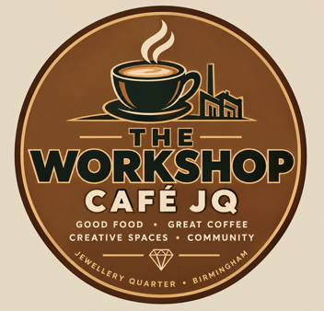

Executive Summary
The Workshop Café JQ is a planned independent café and creative community space located in Birmingham's Jewellery Quarter (JQ). It’s four primary target markets are students, young professionals, locals and senior citizens. The JQ’s creative and historic heritage draws tourists, locals and students, providing a wide target market.
The café's primary competitive edge will be combining cuisine, innovation and community. Customers will be able to join creative classes, meet friends for inexpensive meals, study daily with Wi-Fi, or take part in comfortable social gatherings. The company will collaborate with local jewellers, artists and manufacturers to organise events related to the Quarter's history.
The corporation will function as a private limited company, requiring start-up funds of approximately £70,000 for staffing, marketing, equipment, stock and premises preparation. The long-term goal is to become a well-known local attraction through its unique experiences and products it offers.

Overview of the Business Idea

Start-Up Service
The Workshop Café JQ will be located in the Jewellery Quarter of Birmingham. Speciality coffee, teas, smoothies, pastries, sandwiches, breakfast items, cakes and reasonably priced light meals will be offered by the company. The creative and social experience will be the primary distinction from current cafés, which will include several areas, such as a flexible workshop space, sociable seating and a quiet study/work room.
Beginner jewellery-making sessions, painting and drawing sessions, craft evenings, board-game nights, book clubs, study sessions, local artist exhibitions and intergenerational creative activities are some of the creative, social and educational events that can take place in the workshop area.

This idea links the company to the JQ’s identity. The school of jewels, museums, galleries and creative enterprises are all located in the region, which has a long history of producing jewels (Yong, 2024). Birmingham produces around 40% of all jewellery in the UK, which shows how strong the region's creative character is (Cankurtaran et al., 2025).

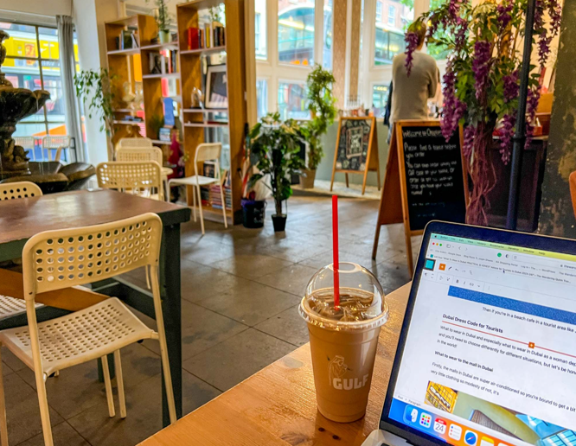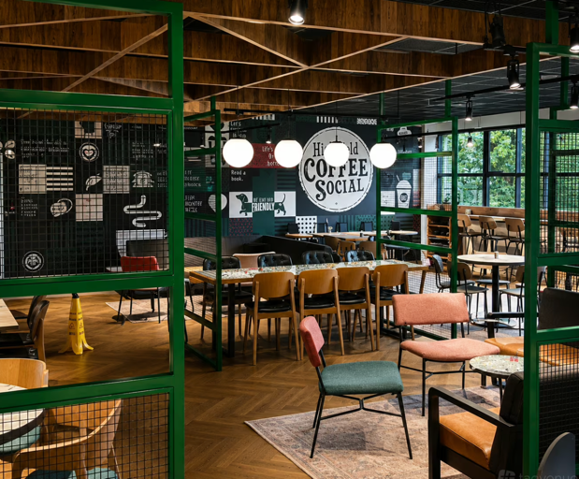

Management Structure

The business will be managed by the managing director, who will be in charge of hiring, marketing, financing and strategic decision-making. For certain workshops, hiring independent artists and makers will lower fixed employment expenses while enabling the company to provide a greater variety of activities.

The team will also include:

Employee Management Structure

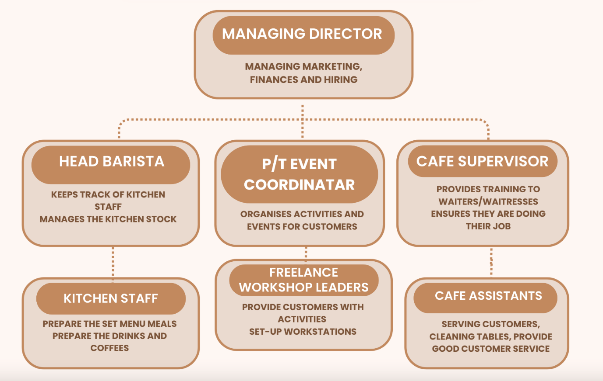

The Workshop Café JQ will feature a small but effective staff to support efficient daily operations, strong customer service and effective communication (Seva et al., 2026). To guarantee strategic growth, financial control and general company choices, the Managing Director will need to be qualified in either business management or entrepreneurship (Al-Mamary, 2025). The Head barista should have prior experience to preserve the quality of the food and beverages and assist kitchen staff (Riswanto et al., 2024). In addition to ensuring excellent customer service standards, the café supervisor will oversee and educate café helpers. In accordance with food safety regulations, kitchen staff will make meals, beverages and coffees (Segbedzi et al., 2025).

Target Customers
The Workshop Café JQ will cater to a wide range of customers, including families, tourists, young professionals, senior citizens and students. The purpose is to create a comfortable area where different age-groups can access affordable meals, free Wi-Fi, study spaces, discounts and various activities. Providing comfortable sitting, accessible facilities, traditional food and beverages, daytime events and community activities (Rosso et al., 2023). The Workshop Café JQ will be a friendly place for people of all ages and backgrounds.

Legal Format

The business will function as a private limited company, this is suitable as limited companies offer limited liability protection and are legally separate from their owners (Humphreys, 2025). Additionally, it may facilitate a purchase of corporate financing or investment. Businesses are required to register food business with the local government 28 days before selling food and beverages (GOV.UK, 2026).

However, there are disadvantages to forming an LLC as opposed to a single trader arrangement. For example, financial information must be made public, which diminishes privacy. Other disadvantages include ongoing reporting to Companies House, legal documentation and administrative costs (Asonibare, 2026). Despite these challenges, the PLC structure's benefits of legal protection, professional reputation and expansion opportunities make it suitable for The Workshops café JQ's objective of becoming a competitive and enduring café brand in Jewellery Quarters growing coffee industry (Moore, 2025).

Market Research

Market research is crucial since it helps The Workshop Café JQ comprehend its clientele, rivals and external business environment (Ausat et al., 2023). The Jewellery Quarter is located in the centre of Birmingham an appealing area. It has grown in popularity among young professionals and students and is home to independent shops, eateries, pubs, museums and creative enterprises (Visit Birmingham, 2025). While the University of Birmingham characterises the Jewellery Quarter as a popular neighbourhood for young people living and working in the city, Birmingham City University promotes the area's cafés, small shops, cultural attractions and activities (University of Birmingham, n.d). This implies that it would be challenging to compete only on coffee quality. Rather, The Workshop Café JQ will set itself apart by combining reasonably priced café goods with artistic activities and generational community gatherings. Therefore, the company will employ a PESTEL study to look at political, economic, social, technical, environmental and legal aspects that might have an impact on its operations, client demand and long-term growth in order to create a competitive edge (Bou Hatoum et al., 2023).

PESTEL Framework

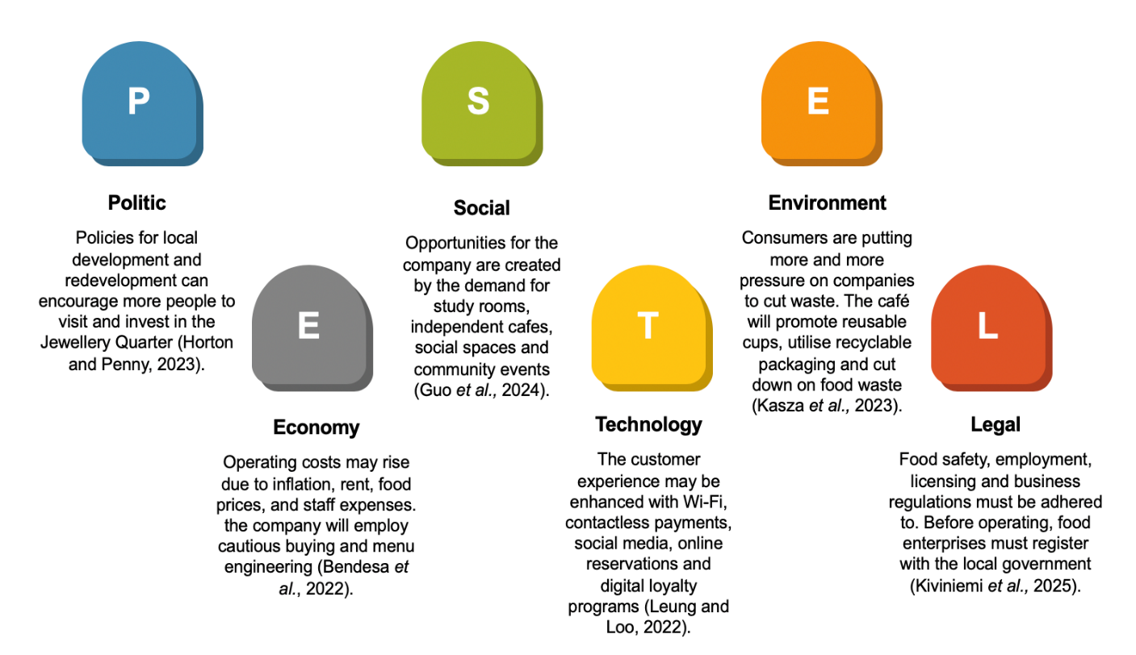

PESTEL is a method for business analysis that looks at external elements, such as political, economic, social, technical, environmental and legal impacts, that might have an impact on an organization (De Sousa and Castañeda-Ayarza, 2022). By using PESTEL it will allow to discover external dangers affecting The Workshop Café JQ and assist in making well-informed decisions, operating expenses, sustainability and regulatory needs (Ilmi et al., 2026). Additionally, The Workshop Café JQ will be able to assess its external opportunities and threats in addition to its internal strengths and weaknesses by doing a SWOT analysis (Gal, A., 2024). To promote long-term growth and corporate sustainability, this will give a better knowledge of its competitive position and aid in the development of successful marketing strategies to draw in families, young professionals, students and senior citizens (Kashif and Iqbal, 2022).

SWOT Evaluation

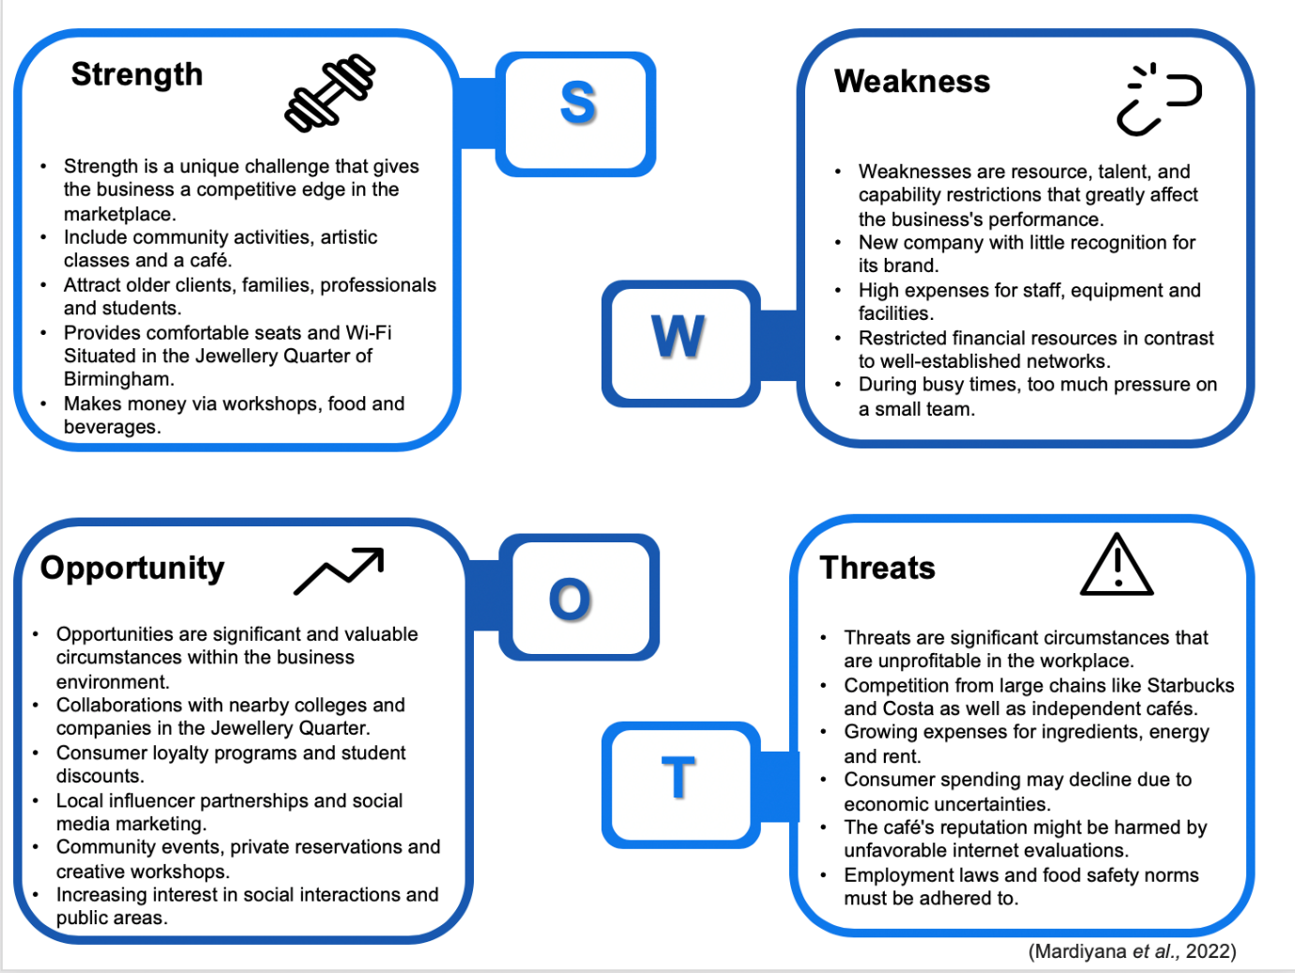

Competitor Analysis
Along with bigger chains and other culinary establishments in the Jewellery Quarter, the café will face competition from well-known independent cafés like Saint Kitchen, Urban and Besa Coffee. The Workshop Café JQ, however, will present itself in a different way. Instead of just coffee, the experience that surrounds the café will be its competitive edge. For instance, a client may buy coffee in the morning, spend two hours studying, go to a jewellery-making session in the afternoon and then come back for an evening of board games. Customers are encouraged to spend more time interacting with the firm as a result of the creation of different income sources (Nkegbe and Abor, 2023).

Market Communication

Marketing communication is crucial since it draws in target consumers, promotes services and increases brand recognition. Digital marketing, exclusive deals and community involvement will assist The Workshop Café JQ attract a variety of clientele and promote return business.

Social Media
Businesses may expand their audience by using social media video content through videos and contests by using Instagram and TikTok to advertise coffee, food, creative classes and events (Pricopoaia and Susanu, 2022). Facebook will notify locals, relatives and senior citizens about events.

Student Marketing
In order to promote student discounts and study spaces, the café will work with student associations and nearby educational institutions (Zhou et al., 2022). Student visits will be encouraged with a £6.95 Student Study Deal that includes coffee, a lunch and study space.

Community Marketing

Coffee and craft sessions, Jewellery Quarter Designers' Nights, board games, family craft days and local artist events are among the regular events is a hub for Birmingham's producers and innovators, according to the area's official tourist organisation (Nielsen et al., 2023). The café will be able to engage with the local creative community, which is a well-known aspect of the Jewellery Quarter, through partnerships with small companies and artists.

Loyalty Scheme
Recurring purchases and attendance at workshops will be rewarded through a digital loyalty program (Park, 2025). Additionally, customers may receive points for recommending friends, which promotes consumer loyalty and involvement in local activities.

Financials

Initial investment for the Workshop Café JQ will be about £70,000. With this funding, the business will be able to cover its start-up costs and operate profitably for the first month, as seen i the start-up cash flow diagram below.

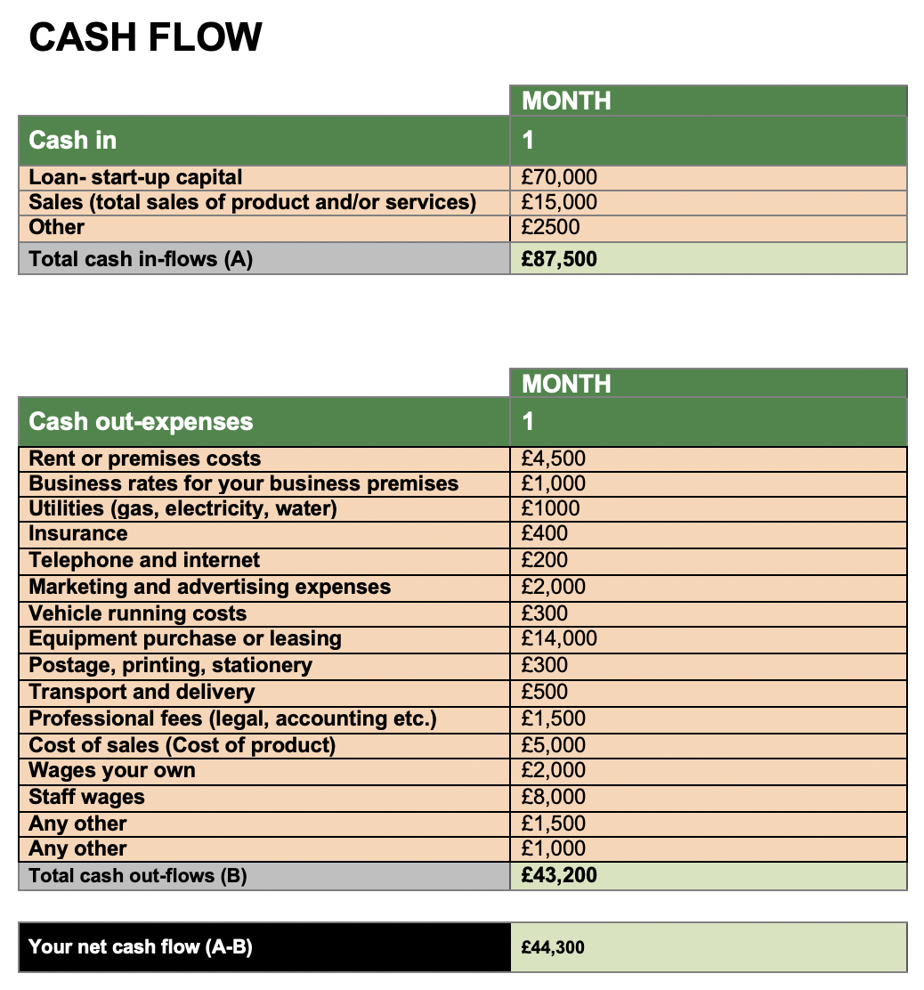

Sources of Funding
The £70,000 could be financed through:
- £20,000 founder investment
- £25,000 small-business bank loan
- £25,000 private investor funding
Private financing would be especially helpful as it would supply funds without demanding quick repayment of the whole amount (Brown and Volckmann, 2024). Investors may obtain a predetermined stock part in the business in exchange. It is crucial to obtain enough money before to launch to pay for labour, equipment, stock, facilities and marketing costs (Hussain, 2024). Through efficient marketing, devoted patrons and revenue from both café sales and innovative training, the café hopes to turn a profit in its first year of operation. Longer term, the company wants to establish a solid reputation and look for ways to grow.

Conclusion

The Workshop Café JQ presents an appealing business opportunity by combining Birmingham's unique creative culture with the café sector. Potential clients include residents, visitors, young professionals, students and creative companies. Compared to a typical café, the company will create value in three interrelated areas: experiences, workplace and food and drink. Families may engage in events, professionals can work or meet customers, students can study and interact and senior citizens can utilise the café as a comfy communal area. The creative workshop component distinguishes it from other cafés. with an estimated £70,000 investment, strong marketing and careful financial management, the business has potential to grow and open new sites.

Reference List

Al-Mamary, Y.H. (2025) ‘The transformative power of artificial intelligence in entrepreneurship: exploring AI’s capabilities for the success of entrepreneurial ventures’, Future Business Journal, 11(1), p. 104.

Asonibare, A.S. (2026) ‘Legal gaps of single shareholder companies under Companies and Allied Matters Act 2020’, LexScriptio: A Journal of the Department of Jurisprudence and Public Law, 3(1), pp. 536–551.

Ausat, A.M.A., Permana, R.M., Angellia, F., Subagja, A.D. and Astutik, W.S. (2023) ‘Utilisation of social media in market research and business decision analysis’, Jurnal Minfo Polgan, 12(1), pp. 652–661.

Bendesa, A.O., Astuti, N.N.S., Astawa, I.K., Susanto, B. and Sarjana, I.M.B. (2022) ‘Optimizing food costs through menu engineering, portion control, supplier negotiations, waste reduction, and technology integration’, Journal of Commerce, Management, and Tourism Studies, 1(1), pp. 1–13.

Bou Hatoum, M., Nassereddine, H., Musick, S. and El-Jazzar, M. (2023) ‘Investigation of PESTEL factors driving change in capital project organizations’, Frontiers in Built Environment, 9, article 1207564.

Brown, G. and Volckmann, W.M. (2024) ‘Unpacking private equity performance’, The Journal of Portfolio Management, 50(7), pp. 100–115.

Cankurtaran, P., Nielsen, B. and McCabe, S. (2025) ‘Resilience and fragility in creative industry clusters: exploring the Birmingham Jewellery Quarter’, Industrial Marketing Management, 129, pp. 66–78.

De Sousa, G.C. and Castañeda-Ayarza, J.A. (2022) ‘PESTEL analysis and the macro-environmental factors that influence the development of the electric and hybrid vehicles industry in Brazil’, Case Studies on Transport Policy, 10(1), pp. 686–699.

Gal, A. (2024) ‘Strengths, weaknesses, opportunities and threats: a SWOT analysis of a long-term outdoor environmental education program in Israel’, Journal of Outdoor and Environmental Education, 27(2), pp. 321–339.

GOV.UK (2026) Starting a food business. Available at:
https://www.gov.uk/guidance/starting-a-food-business (Accessed: 18 September 2026).

Guo, W., Wang, L. and Caneparo, L. (2024) ‘Research on the factors that influence and improve the quality of informal learning spaces (ILS) in university campus’, Buildings, 14(11), article 3458.

Horton, A. and Penny, J. (2023) ‘Towards a political economy of social infrastructure: contesting “anti-social infrastructures” in London’, Antipode, 55(6), pp. 1711–1734.

Humphreys, T.A. (2025) Limited liability companies and limited liability partnerships. Vol. 640. [Place of publication]: Law Journal Press.

Hussain, M.A. (2024) ‘A critical study of startup financing dynamics and emerging approach to attracting capital resources’, Journal of Corporate Finance Management and Banking System, 44, pp. 1–14.
Ilmi, A., Permadi, I., Lamo, M.L. and Ahmad, S. (2026) ‘External environmental analysis of coffee shop MSMEs using the PESTEL approach and managerial implications’, Indonesian Journal of Accounting, Governance, and Auditing, pp. 1–10.

Kashif, O. and Iqbal, M.N. (2022) ‘A conceptual framework on evaluating SWOT analysis as the mediator in strategic marketing planning through marketing intelligence’, Priority: The International Business Review, 1(1), pp. 1–9.

Kasza, G., Veflen, N., Scholderer, J., Münter, L., Fekete, L., Csenki, E.Z., Dorkó, A., Szakos, D. and Izsó, T. (2022) ‘Conflicting issues of sustainable consumption and food safety: risky consumer behaviors in reducing food waste and plastic packaging’, Foods, 11(21), article 3520.

Kiviniemi, K., Salmivaara, L., Vainio, A. and Lunden, J. (2025) ‘Food control strategies to support and enforce food business operators that repeatedly violate food safety legislation’, Food Control, 171, article 111042.

Leung, R. and Loo, P.T. (2022) ‘Co-creating interactive dining experiences via interconnected and interoperable smart technology’, Asian Journal of Technology Innovation, 30(1), pp. 45–67.

Mardiyana, M., Ihsan, M., Adrial, A., Parida, H., Sidiq, S. and Hidayat, T. (2022) ‘A SWOT (strength, weakness, opportunity and threat) analysis as a strategy to enhance competitiveness’, International Journal of Management Science and Application, 1(1), pp. 18–27.

Moore, A. (2025) Advantages and disadvantages of private limited companies. Available at: https://www.crunch.co.uk/knowledge/article/advantages-and-disadvantages-of-private-limited-companies (Accessed: 20 September 2026)

Nielsen, B., McCabe, S., Fattorini, G. and Fattorini, T. (2023) The Jewellery Quarter industry cluster: halting terminal decline and providing practical support to Birmingham’s original creative industry. Survey results, September 2022. Birmingham: Birmingham City University. Available at: https://www.open-access.bcu.ac.uk/14103/1/JQ-IC%20research%20results.pdf (Accessed: 23 October 2026).
Nkegbe, F. and Abor, Y. (2023) ‘The role of social media in enhancing customer engagement and brand loyalty’, Journal of Policy Options, 6(3), pp. 26–34.

Park, D.Y. (2025) ‘Enhancing customer engagement value: a comprehensive review of integrated program strategies beyond loyalty programs’, Journal of Services Marketing, 39(9), pp. 1093–1118.

Pricopoaia, O. and Susanu, I. (2022) ‘The impact of using social media platforms in business promotion’, in Proceedings of the International Management Conference, Bucharest, Romania, November, pp. 3–4.

Riswanto, H.A., Maruf, M. and Syafrizal, S. (2024) ‘Sustainable evolution: investigating the factors contributing to the transformation of coffee businesses from unplanned to well-planned, sustainable enterprises in Padang’, JMKSP (Jurnal Manajemen, Kepemimpinan, dan Supervisi Pendidikan), 9(1), pp. 711–730.

Rosso, E., Chen, J., Champion, S. and Gordon, S. (2023) ‘Outcomes of a trial of an age-friendly dining initiative: Dining Co.’, Health Promotion Journal of Australia, 34(2), pp. 379–389.
Segbedzi, C.E., Ansah, E.W. and Apaak, D. (2025) ‘Compliance to food safety standards: determining the barriers within the hotel industry’, PLOS Global Public Health, 5(11), p.e0002771.

Seva, N.N.T., Khumayah, S. and Lestari, A.D. (2026) ‘Service quality and barista communication skills in building customer relationships at Shegia Coffee & Eatery’, Asian Journal of Management, Entrepreneurship and Social Science, 6(2), pp. 860–872.

University of Birmingham (n.d) Jewellery Quarter. Available at: https://www.birmingham.ac.uk/study/birmingham/city/jewellery-quarter (26 September 2026).

Visit Birmingham (2025) A Sparkling 2 – day guide to Birmingham’s Jewellery Quarter. Available at: https://visitbirmingham.com/blog/post/a-sparkling-2-day-guide-to-birminghams-jewellery-quarter/ (Accessed: 26 September 2026).

Yong, Y.N. (2024) ‘Crafting a postcolonial (inter)national identity: Malaysian pewter company Royal Selangor’s branding strategies (1970–1992)’, Enterprise & Society, 25(1), pp. 103–133.

Zhou, J., Lam, E., Au, C.H., Lo, P. and Chiu, D.K. (2022) ‘Library café or elsewhere: usage of study space by different majors under contemporary technological environment’, Library Hi Tech, 40(6), pp. 1567–1581.

