STRATEGIC MANAGEMENT AND SUSTAINABILITY ASSIGNMENT

LIDL – German Discounter Gaining Market Share

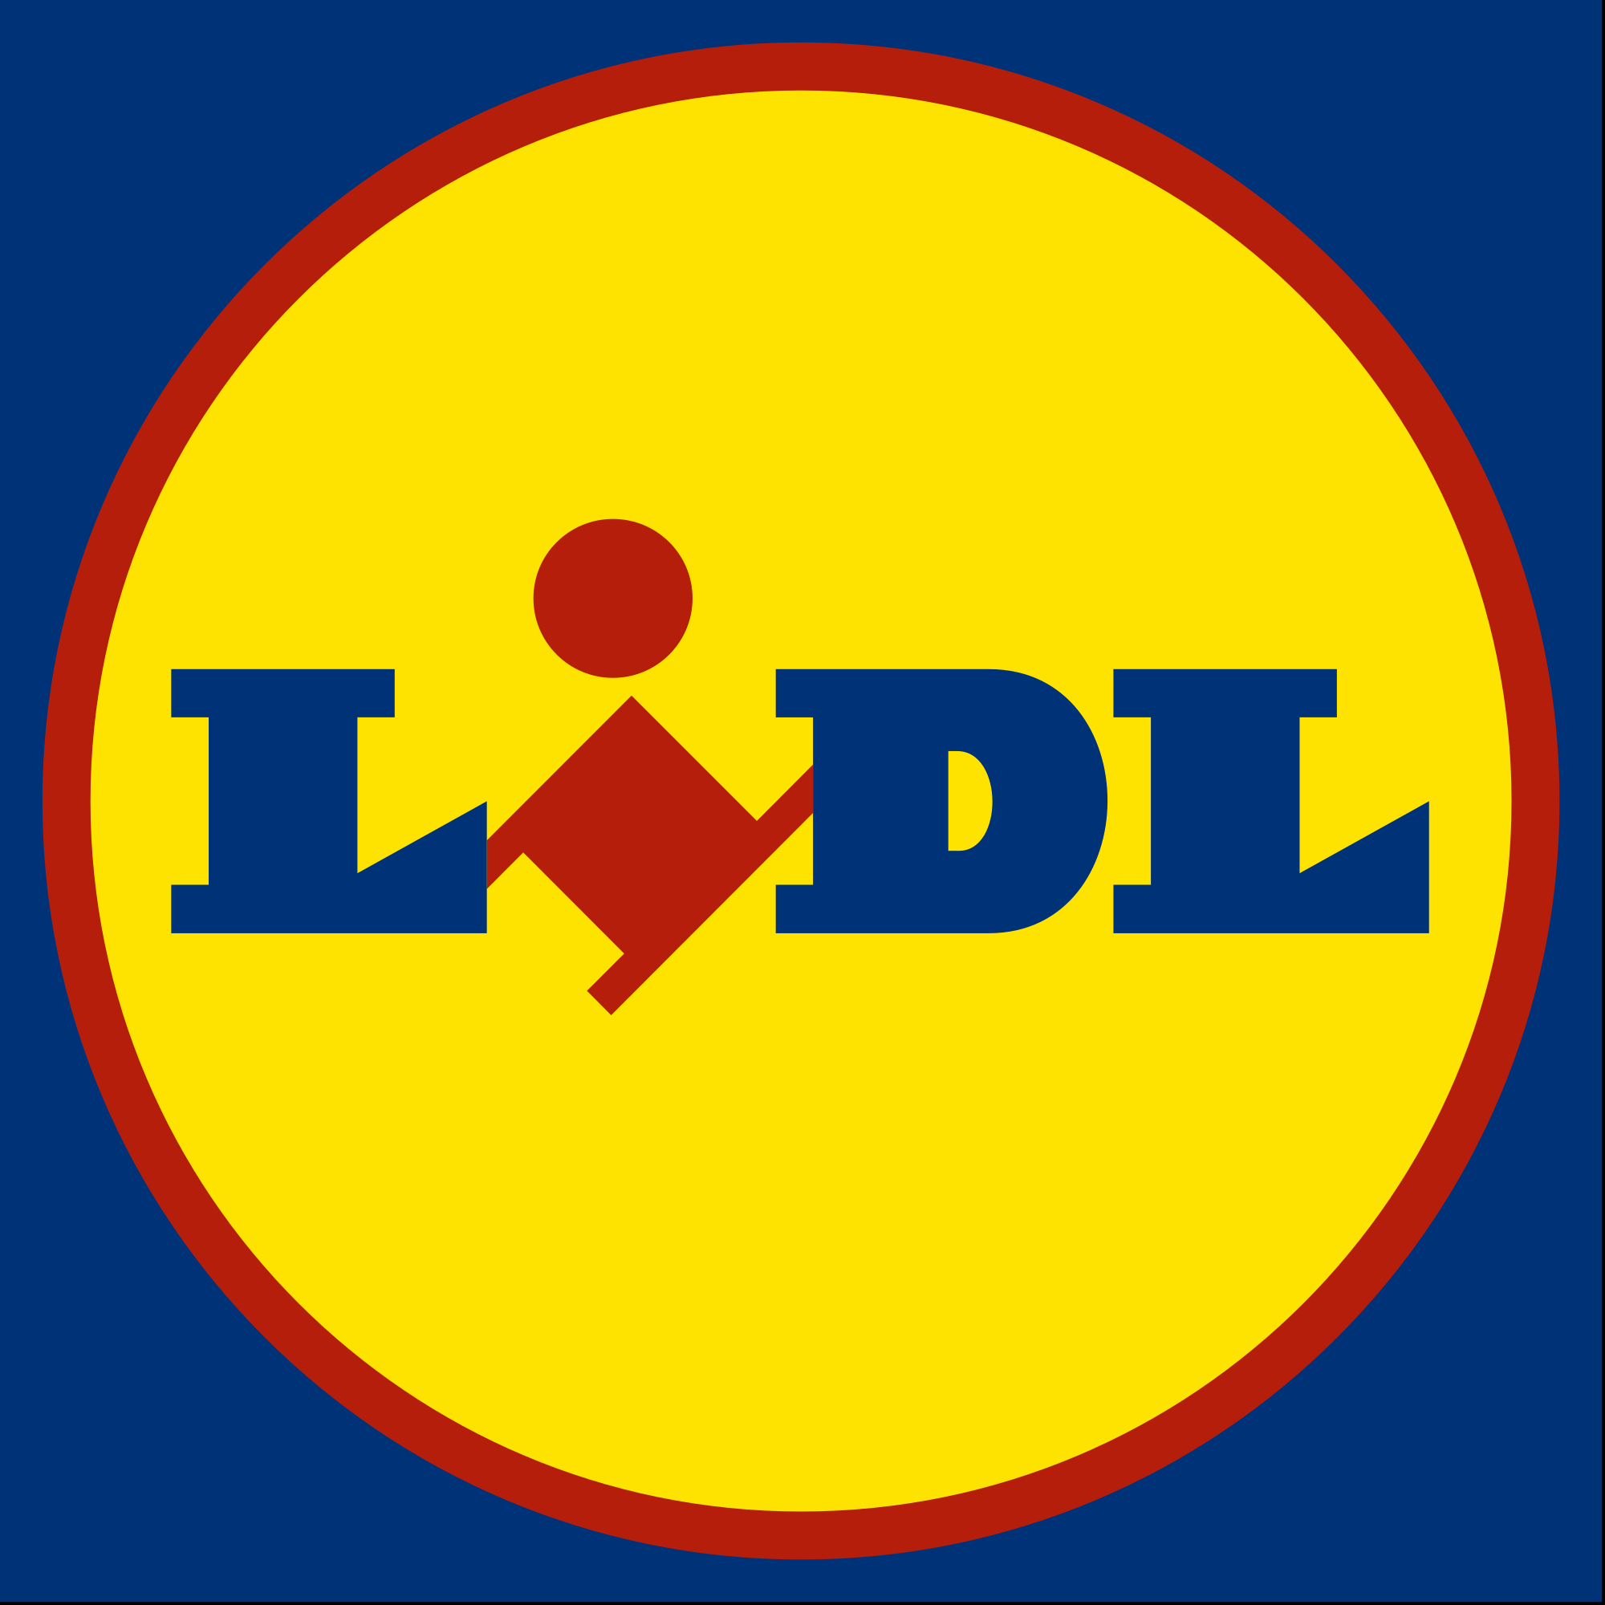

NOVEMBER 2019

MODULE NAME: Strategic Management
NAME: Seroja Ruslan
STUDENT NUMBER: 1903964
Table of Content
1.0 EXECUTIVE SUMMARY 1
2.0 INTRODUCTION 2
2.1 REPORT REMIT 2
2.2 BACKGROUND OF ORGANISATION 2
2.3 DEFINITIONS OF MAJOR CONCEPTS 3
2.3.1 Strategy 3
2.3.2 Business-level strategy 3
2.3.3 Competitive Advantage 3
2.3.4 Porter’s Generic Strategies 4
3.0 MAIN BODY 6
3.1 IMPLEMENTATION OF THE STRATEGY 6
3.1.1 Most Products are By Private-Label Brands 6
3.1.2 Low Cost Operations 7
3.1.3 Minimum Investment in Store Design and Ambience 7
3.2 ADVANTAGES OF THE COST LEADERSHIP STRATEGY 8
3.2.1 Sustainability 8
3.2.2 Erect Barriers to Entry 8
3.3 DISADVANTAGES OF THE COST LEADERSHIP STRATEGY 9
3.3.1 Possible Price Wars 9
3.3.2 Lower Customer Loyalty 9
4.0 CONCLUSION 10
4.1 RECOMMENDATIONS 10
5.0 REFERENCES 11

LIST OF FIGURES

Figure 2.1 - Competitive Advantage Model, Porter’s Generic Strategies.

EXECUTIVE SUMMARY

This report provides an analysis and evaluation of Lidl and their current competitive position. Furthermore, this report will critically evaluate the competitive strategy that Lidl has implemented in the development of their competitive standing. The model used to analyse Lidl’s competitive strategy is Porter’s Generic Strategies. Following the analysis, this report will provide recommendations to strengthen their position as a business.
Lidl is a German discount supermarket that has been around in the United Kingdom since 1994. Currently, there are over 760 Lidl stores across England, Wales and Scotland, employing more than 22,000 people (Lidl, 2019). Lidl adopts a cost leadership strategy to gain market share.
Key concepts defined in this report include strategy, business level strategy, competitive advantage and Porter’s Generic Strategies.
This report finds the implementation of strategies by Lidl as a cost leader, include selling products by private-labelled brands, maintaining low cost operations and minimising investment in store design and ambience. Some advantages on the cost leadership strategy discussed were sustainability of the business and erecting barriers of entry for competitors. Conversely, the disadvantages found to this strategy are potential price wars and lower customer loyalty.
To summarize, Lidl is in a good shape and has big potential in capturing the UK market share. Recommendations for Lidl to overcome the disadvantages of cost leadership strategy are:
- Creating a loyalty programme
- Scaling up and expanding the number of stores
- Offering online shopping

INTRODUCTION

2.1 REPORT REMIT

The purpose of this report is to explore the strategic management used by Lidl in order to develop their current competitive position. Furthermore, this report will critically evaluate the competitive strategy that Lidl has implemented in the development of their competitive position. The evaluation includes the advantages and limitations of this strategy in the current environment. Lastly, recommendations for ways forward for the organisation will be suggested based on the findings.

2.2 BACKGROUND OF ORGANISATION
Lidl is a German discount supermarket that was founded in 1973 and established in the United Kingdom in the year 1994 (Lidl, 2019). Lidl belongs to the Schwarz group. Today, Lidl has expanded with over 760 stores and employs over 22,000 people in all their stores and management all around Great Britain (Lidl, 2019).
Lidl’s vision is to enhance their customers lives by providing quality products at market leading value whilst ensuring that customer satisfaction is achieved (Lidl, 2019). Their mission is to provide exceptional customer satisfaction and to achieve market-leading quality and value by continuously innovating and improving our efficient systems, powered by technology and people (Lidl, 2019).
Approximately two thirds of their products are sourced from British suppliers, they try to source locally where possible (Lidl, 2019). About 90% of its meat and poultry are from the UK and Ireland, and when in season, lots of the fruit and vegetables are British (Schmid, 2018). By sourcing local, Lidl is able to keep prices low due to factors such as logistics.
As recently as August of this year, Lidl successfully attained a 5.9% market share of UK grocery spending. It was the fastest growing supermarket with sales up 12.6% over the summer (Makortoff, 2019). To add, Lidl has been ranked as one of the cheapest UK supermarkets, saving customers up to £21.32 on average on their weekly grocery shopping when in comparison to competitors (Cornish, 2019). BBC reports that Lidl plans to invest £1.45 billion in the next two years (BBC News, 2019).

2.3 DEFINITIONS OF MAJOR CONCEPTS

2.3.1 Strategy
Strategy is outlined as the long-term direction and scope of an organisation, which achieves advantage in a changing environment through its configuration of resources and competences with the goal of satisfying the expectations of stakeholders (Johnson, 2011).
In simpler words, a strategy is a framework for making decisions (Latham, 2017). It is about how an organisation plays the game of business. No strategy will lead to little being accomplished, minor profits and confusion and discord in an organisation.

2.3.2 Business-level strategy
A business-level strategy is about how the individual businesses should compete in their particular markets (Johnson, 2011). It is often referred as a ‘competitive strategy’. Where the businesses are units within a larger organisation, business-level strategies should clearly fit with corporate-level strategy (Johnson, 2011).

2.3.3 Competitive Advantage
Competitive advantage describes the way a firm chooses to implement a generic strategy to achieve and sustain the business (Porter, 1980). Competitive advantage is what makes an entity's goods or services superior to all of a customer's other choices (Amadeo, 2019). It is the attribute that allows an organization to outperform its competitors.
Michael Porter (1985) stated that the two ways in which an organization can achieve competitive advantage over its competition is by having a cost advantage or differentiation advantage. Competitive advantage exists when the firm is able to deliver similar benefits as competitors but at a lower cost, or deliver more benefits than those of competing products (Wang, Lin and Chu, 2011).

2.3.4 Porter’s Generic Strategies
For this report, the model that is applied is Porter’s Generic Strategies. This model was developed by Michael Porter in 1980, and is a comprehensive framework that illustrates how an organisation seeks competitive advantage across its chosen market (Porter, 1980). According to Porter (1985), competitive strategy can be understood as the activities a company undertakes to gain a sustainable competitive advantage in a particular industry. There are three generic strategies; cost leadership, differentiation and focus. The focus strategy is divided into two parts, focused cost leadership and focused differentiation. This can be seen in figure 2.1 below.
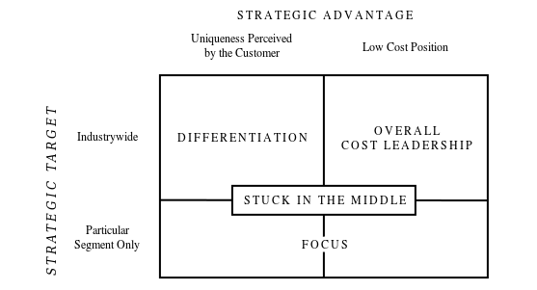
Figure 2.1, Competitive Advantage Model. Source: (Porter, 1985)

Porter argues that a firm which engages in each strategy but fails to achieve any of them is considered as “stuck in the middle” (Porter, 1985). He stresses that if a firm intends to achieve competitive advantage, they are required to make a single choice of the generic strategy they intend to follow. He claims that failure in doing so and being stuck in the middle is always associated with lower profitability and inferior market share, hence, not gaining competitive advantage.
On the other hand, criticism on the model has been made over the years. Porter has stressed that a firm has to be exclusive to one of three strategies in order to achieve competitive advantage. However, authors such as Miller (1992), have critiqued the model and the concept of being stuck in the middle. In his journal titled ‘The Generic Strategy Trap’, he contends that firms can often discover benefits and opportunities in a more comprehensive, mixed approach. He points out that there are risks to using a single generic strategy. Reasons include the possibility of leaving serious gaps or weaknesses in product offerings, ignoring significant customer needs, being easy for rivals to counter, and, in the long run, causing an inflexibility and restricting an organization's vision (Miller, 1992).
In general, the model is critiqued for its limitations and ambiguities. There has been evidence found of organisations that do succeed with a combination of two strategies. An example for a company that has obtained both cost advantage and differentiation advantage is IKEA.

MAIN BODY
In order to gain competitive advantage, Lidl utilises a cost leadership strategy and has implemented it with true effectiveness (Morschett, et al., 2006). Cost leadership can be defined as the strategy used when a company sets out to become the lowest cost producer in its industry (Porter, 1985). It is all about achieving the lowest costs and not about the lowest prices.
Cost leadership puts emphasis on efficiency and minimising costs (Wen-Cheng, 2010). The organization must be willing to discontinue any activity in which they do not have a cost advantage and may outsource activities to other organizations that have a cost advantage (Bhattarai, 2018).
This strategy highlights low costs in comparison to the costs of competitors, but it does not disregard other elements, such as service or product quality (Stankeviciute et al., 2012). If a company decides to choose a cost leadership strategy, they would have to achieve a lower cost for a product or a service than their competition. Companies may reduce costs by gaining economies of scale, optimizing manufacturing practices, securing raw materials at competitive prices and developing highly efficient technologies (Porter, 1998).

3.1 IMPLEMENTATION OF THE STRATEGY

3.1.1 Most Products are By Private-Label Brands
One of the evidences that Lidl performs a cost leadership strategy is that most of their products are by private-label brands which gives them exclusivity and safety (Tomasevic and Spasojevic, 2018). The examples of private-label brands that are sold at Lidl include Oaklands, Newgate and Milbona (Lidl, 2019). Some products also have the “Lidl Love it! Guarantee” seal of approval on the back of the packaging as well as being solely sold at Lidl (Durham, 2017).
By stocking products from private-label brands directly, Lidl is able to cut out the middle man and eliminate any additional costs from a supplier. This way Lidl has the opportunity to maximise their profit margin as well as passing on savings to consumers.
Moreover, the brands sold at Lidl are exclusive to the store, hence, Lidl has leverage when purchasing. Having few suppliers allows Lidl the ability to have higher bargaining power due to their big purchasing power. Based on a report titled “Supermarket Profitability Investigation”, it was concluded that hard discounters such as Lidl have seen rather steady profit margins, and some even profit growth during recessions (Thanassoulis, 2009).

3.1.2 Low Cost Operations
Besides that, Lidl carries out a cost leadership strategy by maintaining low cost operations. Firstly, Lidl displays products to sell in the boxes or cases that they were shipped in (Hanbury, 2017). By doing this, they are able to speed up the restocking process as the duration taken to open up each box individually and putting them up in a row on a shelf consumes time and energy. By stacking boxes of products on one another, productivity is increased as employees can put out more products per hour. Consequently, it also reduces the already minimal cost of display. At Lidl stores, most products flow directly to the display floor to be sold, with minimum time in the back room (Bishop, 2017).
In addition to that, to keep costs of operations low, Lidl employs fewer members of staff per store to reduce labour costs. They typically only have 10 employees working at any given time. Moreover, Lidl provides wages that are higher than that of other retailers (Fleming, 2017). This acts as an attractive proposition for staff and future staff, leading to lower staff turnover of Lidl than its rivals. Reducing the amount of staff leaving its company helps assist lower costs as expenditure on training and lost time due to inefficiencies of its members is minimised (Poston and Grabski, 2001).

3.1.3 Minimum Investment in Store Design and Ambience
Furthermore, Lidl has put minimum investment in their store design and ambience. The general layout of Lidl stores are relatively simple. When compared to other supermarkets such as Tesco and Sainsbury, Lidl has a more basic but functional store arrangement. To minimise costs, Lidl uses simple design and basic utilities. For example, Lidl has dim lighting in their stores in order to decrease their electricity bills (Hanbury, 2017). LED lights were installed to conserve energy and be more cost efficient.
Lidl avoids spending money on the "bells and whistles” of a store (Hanbury, 2017). When Hanbury (2017), describes “bells and whistles”, he refers to attractive additional features in the store that would make it more premium and enhance the shopping experience. They apply radical simplification in a good or service reduced to its core functionality which also means that Lidl stores lack luxury or aesthetics (Dressen and Durand, 2018).

3.2 ADVANTAGES OF THE COST LEADERSHIP STRATEGY

3.2.1 Sustainability
Companies that follow a cost leadership strategy are typically in a more sustainable business position. This means that in the long run, the firm is more likely to last. When an organisation has successfully minimised their costs, fewer financial threats are bound to come up that could put the organization out of business (Josiah and Nyagara, 2015). Additionally, in an economic downturn such as a recession, companies with the lowest cost have the upper hand and have the greatest chance of survival (Kitching et al., 2009).
Cost leadership plays a positive significant role in increasing the sustainability of a firm (Bhattarai, 2018). Maximising profit margins allow cost leaders to sustain and expand its market share. The high returns obtained from a great profit margin allows the company to reinvest into improving the company and making it last.

3.2.2 Erect Barriers to Entry
When a firm takes on a cost leadership strategy, an advantage that they can expect to achieve is that they erect barriers to entry (Porter, 1998). The presence of a cost leader usually will restrain a new firm from coming into an industry. This is because that firm would struggle to attract customers by offering lower prices than the existing cost leaders’ prices (Blees, 2003). In a cost leadership strategy, lower costs need to be achieved. This is can be by attaining economies of scale. New entrants are unlikely to enter due to the difficulties to achieve economies of scale within a short time.
Lower costs tend to repel possible competitors to enter into an industry as there is no security and guarantee for potential profit. A low-cost business can always lower the price and decrease the profit margins, so that the market is not interesting to the potential competitors (Stankeviciute et al., 2012). New entrants find it intimidating to compete with existing cost leaders who have already obtained economies of scale.

3.3 DISADVANTAGES OF THE COST LEADERSHIP STRATEGY

3.3.1 Possible Price Wars
For firm’s that apply a cost leadership strategy, one disadvantage is the possibility of price wars occurring. The Cambridge dictionary (2019) describes a price war as an instance in which multiple firms in an industry compete with each other by reducing prices. Price wars are one of the most extreme forms of competitive interplay in the market place, causing great losses to the firms (Heil and Helsen, 2001). Price wars can be motivated by rivalry between local companies that want to dominate the geographical footprint that they share with each other (Jayachandran et al., 1999).
Furthermore, price wars can lead to companies becoming loss leaders. Loss leaders are a situation when a company sells at a lost to attract customers. It is a form of marketing and advertising. However, it is a gamble used to encourage further sales (Suggett, 2018). Results of a price war reduces competition and innovation. Consumers lose diversity in the availability of products and services. In addition to that, companies lose with the forced reduction in profit margins.

3.3.2 Lower Customer Loyalty
Another disadvantage of the cost leadership strategy is that there is lack of customer loyalty (Josiah and Nyagara, 2015). The customers that purchase and subscribe to companies that practice this strategy, look for the lowest price and cheapest products. Their loyalty lies with the organization that provides the cheapest options. For instance, if competing discount supermarket company Aldi were to lower their prices for cheese, existing Lidl customers who are looking to buy the cheapest cheese in the market will head to Aldi’s for their cheese instead, as they prioritise low prices over loyalty to a brand
Customers are easily swayed by lower priced substitutes from other competitors. A company is only of value to a customer when they provide the prices to them. But once the find another cost leader with a better deal, they will shift to them instead.

CONCLUSION

In conclusion, Lidl is in a good position to capitalize on its recent successes in capturing market share in the United Kingdom through its cost leadership strategy. Lidl has implemented many strategies in order to minimise costs and be the most efficient that they can be. This report finds that there are still improvements that can be made, namely by reducing certain high-risk elements within the strategy.

4.1 RECOMMENDATIONS
A few recommendations can be made for Lidl, moving forward. The recommendations are made in order to combat the existing disadvantages of the cost leadership strategy. The first recommendation for Lidl is to create a loyalty programme. By doing this, Lidl can retain customers. Loyalty programmes like a store membership, motivates customers to return to stores in order to receive rewards such as point accumulation. This way, in the case of a price war occurring, Lidl can rely of their members to stay loyal to the brand for other benefits than just low prices.
Another recommendation is for Lidl, is to scale up their business by expanding the number of stores all across the United Kingdom. This way, Lidl will be able to take advantage of economies of scale. In addition to that, expanding the number of stores and being a prominent player in the supermarket league, gives Lidl the upper hand to their competitors because a successful expansion can provide more funds for Lidl to reinvest into the business.
The last recommendation for Lidl is to consider joining the bandwagon by allowing customers to shop Lidl groceries online. Offering online shopping will enhance Lidl’s standing in the future, that is currently moving towards a more internet savvy era. This lets Lidl stay relevant to its competition.

REFERENCES
- BBC News. (2019). Lidl opens £70m distribution centre. [online] Available at: https://www.bbc.co.uk/news/topics/c8nq32jwnplt/lidl&link_location=live-reporting-story [Accessed 10 Nov. 2019].
- BBC News. (2019). How Lidl learnt to be less German in the UK. [online] Available at: https://www.bbc.co.uk/news/business-47228817 [Accessed 20 Nov. 2019].

- Bhattarai, D. (2018). Generic Strategies and sustainability of Financial Performance of Nepalese Enterprises. Pravaha, 24(1), pp.39-49.
- Bishop, B. (2017). Why Aldi & Lidl are so successful & what this mean. [online] Brickmeetsclick.com. Available at: https://www.brickmeetsclick.com/digging-into-why-aldi---lidl-are-so-successful-and-what-this-means-for-the-future [Accessed 20 Nov. 2019].

- Cornish, N. (2019). Lidl's weekly shop is up to £21 cheaper than its supermarket rivals. [online] Prima. Available at: https://www.prima.co.uk/all-recipes/food-news/a28346159/cheapest-supermarket-lidl-the-grocer/ [Accessed 10 Nov. 2019].

- Dressen, M. and Durand, J. (2018). Introduction to Low Cost theory. La Nouvelle Revue du Travail, (12).

- Durham, C. (2017). Lidl: Inside the Private Brand Portfolio | My Private Brand. [online] Mypbrand.com. Available at: http://mypbrand.com/2017/06/19/lidl-inside-the-private-brand-portfolio/ [Accessed 20 Nov. 2019].

- Fleming, P. (2017). Wage hikes at Aldi and Lidl are welcome news. But don’t get too excited. [online] the Guardian. Available at: https://www.theguardian.com/commentisfree/2017/jan/09/lidl-aldi-national-living-wage-supermarkets [Accessed 26 Nov. 2019].

- Hanbury, M. (2017). A German grocery chain that's coming to America is already dominating Walmart on prices — here's why it's so cheap. [online] Business Insider. Available at: https://www.businessinsider.com/how-lidl-keeps-its-prices-down-2017-6?r=US&IR=T#7-it-cuts-costs-on-things-like-lighting-7 [Accessed 20 Nov. 2019].

- Heil, O. and Helsen, K. (2001). Toward an understanding of price wars: Their nature and how they erupt. International Journal of Research in Marketing, 18(1-2), pp.83-98.

- Hendry, J. (1990). The Problem with Porter’s Generic Strategies. European Management Journal, 8(4), 443–450. doi:10.1016/0263-2373(90)90104-e

- Jayachandran, S., Gimeno, J. and Varadarajan, P. (1999). The Theory of Multimarket Competition: A Synthesis and Implications for Marketing Strategy. Journal of Marketing, 63(3), p.49.

- Josiah, N. and Nyagara, N. (2015). Assessment of the effect of Cost Leadership Strategy on the performance of Liquefied Petroleum Gas Companies in Eldoret town, Uasin Gishu County, Kenya. International Journal of Business and Management Invention, 4(4), pp.01-07.

- Kitching, J., Blackburn, R. and Smallbone, D. (2009). Business Strategies And Performance During Difficult Economic Conditions. For the Department of Business Innovation and Skills (BIS). [online] Available at: https://eprints.kingston.ac.uk/5852/1/Kitching-J-5852.pdf [Accessed 20 Nov. 2019].

- Latham, A. (2017). What The Heck Is A Strategy Anyway?. [online] Forbes.com. Available at: https://www.forbes.com/sites/annlatham/2017/10/29/what-the-heck-is-a-strategy-anyway/#13db57ed8402 [Accessed 20 Nov. 2019].

- Lidl. (2019). About us. [online] Available at: https://www.lidl.co.uk/about-us [Accessed 10 Nov. 2019].

- Mashed.com. (2019). The untold truth of Lidl. [online] Available at: https://www.mashed.com/94133/untold-truth-lidl/ [Accessed 10 Nov. 2019].

- Miller, D. (1992). The Generic Strategy Trap. Journal of Business Strategy, 13(1), pp.37-41.

- Radojev, H. (2019). Lidl to spend £25m on electric vehicle charging points at stores. [online] Retail Week. Available at: https://www.retail-week.com/grocery/lidl-to-spend-25m-on-electric-vehicle-charging-points-at-stores/7033313.article [Accessed 10 Nov. 2019].

- Rawal, T. (2018). Loads of Money: Guide to Intelligent Stock Market Investing. India: Patridge Publishing.

- Porter, M. E. (1980) Competitive Strategy: Techniques for Analysing Industries and Competitors. New York: Free Press.

- Porter, M. E. (1985). Competitive Advantage. New York: The Free Press, pp.11-15.

- Porter, M. E. (1998). Clusters and the New Economics of Competition. [online] Harvard Business Review. Available at: https://hbr.org/1998/11/clusters-and-the-new-economics-of-competition [Accessed 20 Nov. 2019].

- Porter, M. E. (1998) The Competitive Advantage of Nations. London: Macmillan

- Poston, R. and Grabski, S. (2001). Financial impacts of enterprise resource planning implementations. International Journal of Accounting Information Systems, 2(4), pp.271-294.
- Schmid, S., Dauth, T., Kotulla, T., & Orban, F. (2018). Aldi and Lidl: From Germany to the Rest of the World. Internationalization of Business, 81–98. doi:10.1007/978-3-319-74089-8_4

- Suggett, P. (2018). What Is a Loss Leader and How Does It Work?. [online] The Balance Careers. Available at: https://www.thebalancecareers.com/definition-of-loss-leader-38450 [Accessed 22 Nov. 2019].

- Thanassoulis, J. (2009). Supermarket Profitability Investigation. University of Oxford, p.31.

- Tomasevic, N. and Spasojevic, M. (2018). Lidl’s Modern Business Operations in The Domestic and International Markets. 30th International Scientific Conference on Economic and Social Development, (Belgrade, 25-26 May 2018), pp.345-353.

- Wang, W., Lin, C. and Chu, Y. (2011). Types of Competitive Advantage and Analysis. International Journal of Business and Management, 6(5), pp.100-104

