

EXAMINATION PAPER
MARKS AND COMMENTS SHEET

PROGRAMME | OME Degree Apprenticeship
LEVEL | 4
MODULE | ACDB4011 Chemistry
STUDENT I.D. | 2411524
EXAMINER | Ewa Kazimierska | INTERNAL VERIFIER
Once completed marks only should be transferred onto the front of the examination paper (no comments other than ticks or crosses on the examination paper)

Question  Number | Comments | Marks available | Marks awarded | 2nd marker (sample) | 3rd marker (where necessary)
1 | 6/10 True/False answers correct. Sound understanding of chemical energetics and bonding, though some basic errors remain in redox and orbital theory. | 15 | 9
2 | Bohr model and ionic charge were correct. Lewis structure was incorrect and the bond energy concept was not explained. | 11 | 7
3 | Strong overall understanding of photon energy and emission. Orbital arrangement not shown in part b. | 10 | 9
4 | Combustion products were identified correctly, but not balanced. Good understanding of gas laws and stoichiometry. Inconsistent units. | 15 | 10
5 | OB formula and reactions well done, though impact of positive/negative OB not discussed and final part (heat of rxn vs TNT) incorrect. | 16 | 9.5
6 | Activation energy interpretation was correct, but enthalpy calculation contained errors. | 7 | 5.5
7 | Poor heating curve and incomplete phase diagram responses. Triple point values and transitions were not fully addressed. | 11 | 4
8 | Incorrect approach to molarity and no valid ionic equation provided. | 5 | 0
9 | General understanding of calorimetry was evident, but sign errors affected the final result. | 5 | 4
10 | Oxidation numbers were not calculated, and the second part was not attempted. | 5 | 1
 |  |  | 59

1st Marker Name | Ewa Kazimierska | 1st Marker Signature | 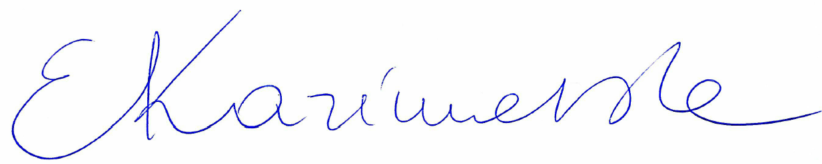
2nd Marker Name |  | 2nd Marker Signature
3rd Marker Name |  | 3rd Marker Signature
Reasons for awarding the final mark where there is more than one marker
Notes:
- The 3rd marker may be used where there is more than a 10 percentage point difference (in the TOTAL mark) between markers 1 and 2 OR when it is not possible to get agreement between markers 1 and 2. Reasons must be given where an agreed mark is given.
- This form is for internal use only and is NOT to be returned to the student. The final agreed marks must be transferred to the student feedback sheet in the assignment specification.
- The external examiner MUST be shown this form.

