
Component 2- Individual Report
Module: Developing and Managing Individuals and Teams
Module code: LCLM5002
Student Name : Meri Claudia Roua
Student ID :2245513
Table of Contents
1. Introduction 2
2. Factors Affecting HR in Tesco 2
2.1 Technological Advancement 2
2.2 Talent Acquisition and Retention 2
2.3 Diversity, Equity and Inclusion (DEI) 3
3. Evaluation of Contemporary HR Practices 4
3.1 HR Practices for Technological Advancement 4
3.2 HR Practices for Talent Acquisition and Retention 5
3.3 HR Practices for Diversity, Equity and Inclusion 5
4. Role of Departmental Managers in Implementation 5
4.1 Leadership and Communication 5
4.2 Performance Monitoring 6
4.3 Change Management 7
4.4 Critical Evaluation 7
5. Recommendations 8
6. Conclusion 8
7. References 9

Table of Figures & Tables
Table 1: Factors Affecting Talent Acquisition in Retail 3
Figure 1: DEI Framework 4
Figure 2: Performance Management Cycle 7

1. Introduction
This report is focused on critically evaluating the importance of HR management and the processes included within it. HR, or human resources, is one of the most useful resources that directly impacts the efficiency and productivity of the organisation. The discussion of this report will be developed with respect to the organisation Tesco. Tesco is one of the largest retail businesses in the UK. The organisation works with a lot of variation within the product base. The organisation also works with a large employee base that includes more than 3000,000 employees (Tesco, 2026). The large number of employees makes the organisation more relevant to be discussed in the context of the HR management evaluation. To establish a better and stronger approach with human resources, it is important for an organisation to apply a strategic HRM process (Paauwe and Farndale, 2017). The challenges faced by Tecco within their HR process will be critically evaluated in this study. On the other hand, the processes of modern HRM will also be discussed in the report.

2. Factors Affecting HR in Tesco

2.1 Technological Advancement
The retail industry's technological advances have radically changed how stores operate and how staff perform their tasks. Retail operations have been automated, resulting in automated checkout systems, digital inventory management, e-commerce (online grocery stores), and other systems to create a different way to operate compared to when businesses relied on employees to perform most activities. Now, retail HR departments need to find employees who are technologically proficient and provide ongoing digital training to their employees. Technology plays a very important role in large retail organisations like Tesco in helping them to optimise their operational efficiency as well as provide a better experience for their customers.
Tesco has implemented many systems to enhance customer convenience through the creation of an online grocery store, digital supply chain management systems, and automated checkout systems (Globaldata, 2024). These systems will require Tesco employees to develop digital skills such as handling data, data analysis, and operating advanced electronic retail technologies.

2.2 Talent Acquisition and Retention
Due to high turnover in the retail industry and competitive labour markets, obtaining and retaining talented personnel has become increasingly difficult for retailers. Retailers often have trouble filling positions requiring skilled logistics workers, as well as managers and customer service, creating challenges for retail human resource departments in developing strategies to acquire talented workers through effective recruitment initiatives, competitive pay and strong emphasis on career development to retain workers.
At Tesco, human resources focuses primarily on hiring store employees and determining the best candidates for management positions, as well as establishing a structured training programme to improve customer service and ultimately increase customer satisfaction. In addition, Tesco invests in employee development opportunities to enhance employee engagement and reduce employee turnover. There are many factors that affect the ability of Tesco to hire and retain workers, including the competition from other retailers for qualified candidates, the challenge of finding enough people to work in retail, and the fact that many retail jobs are seasonal in nature.
Factor | Impact on HR | Example in Tesco
Labour Shortage | Difficulty in hiring staff | Seasonal recruitments
Competition | High wages needed | Retail competitors

Table 1: Factors Affecting Talent Acquisition in Retail

2.3 Diversity, Equity and Inclusion (DEI)
Today's human resources function in retail is heavily influenced by the concepts of diversity, equity, and inclusion in how retail companies manage people. It is a valuable aspect of human resources that it should include diversity and variation effectively, which can be helpful in managing creativity better within the organisation. The move of Tesco with the DEI framework says that they welcome diversity within their organisation. They respect the personalities and the culture of their employees (Tescoplc, 2026). HR programs that have an emphasis on equal opportunity employment, fair management of all employees, and creating a culture that fosters inclusion. Tesco has implemented HR programs that support gender equality, multicultural diversity, and inclusive recruiting practices. The programme also includes ethical business standards and a commitment to CSR practices. With the help of promoting a workplace culture that is inclusive, Tesco creates a more engaged workforce, increases the level of satisfaction among employees and enhances the overall performance of the company.
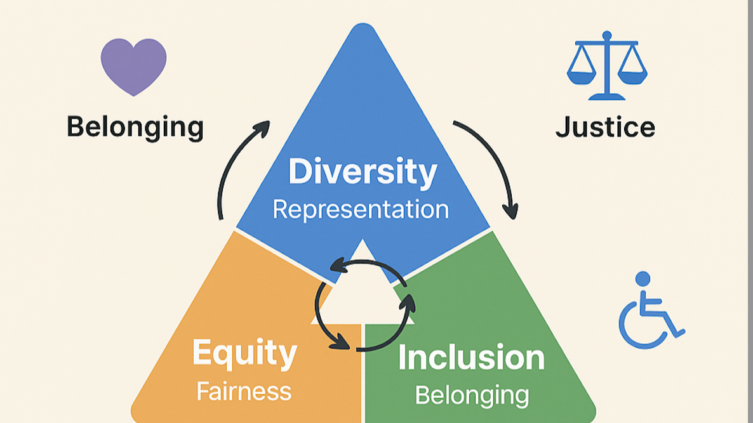

Figure 1: DEI Framework
Source: (LinkedIn, 2025)

3. Evaluation of Contemporary HR Practices

3.1 HR Practices for Technological Advancement
With technological advancement, technology has also become a part of HR management. Digital HR management is a system that is helpful to manage human resources with better efficiency (Fenech et al. 2019). Digital HR management systems, online employee training platforms and technology-driven performance evaluations are all being utilised to increase workforce efficiency, human resources, and operational coordination. For example, Tesco has enhanced the technological capabilities of its employees and has improved staffing management for its stores and warehouses through the use of digital HR training programs and workforce scheduling software.
The implementation of technology-enhanced HR management systems increases productivity, creates efficient communication channels, and provides the capability to monitor employee performance in real time. Besides that, there are also challenges associated with implementing technology-enhanced HR systems, such as the high cost of implementing and training employees on new systems, high levels of employee resistance to technology changes, and employee data privacy concerns, which could impact the effectiveness of these systems without the strategic management of these issues.

3.2 HR Practices for Talent Acquisition and Retention
Employers can face different challenges while recruiting employees. To combat these issues, many companies will develop and implement different HR strategies, including employer branding, competitive compensation, offering employees the chance to advance their careers, and using employee engagement programs (Helloteam, 2022). These talent acquisition strategies can help attract employees with true talent.
Some of the effective solutions include: structured opportunities for career advancement, employee recognition programs, and leadership development programs. However, all of these HR programs at Tesco are designed to enhance the talent of its employee population and to reduce turnover. Tesco also benefits from a strong employer brand, providing the company with an attractive organisation to work for and an increased amount of employee satisfaction and productivity through its employee engagement programs. However, managing and funding these types of initiatives will be an ongoing cost for Tesco due to the extremely volatile nature of the retail labour market.

3.3 HR Practices for Diversity, Equity and Inclusion
In contemporary practices, there is an increasing integration of DEI initiatives within HR strategies to ethically employ individuals and provide an organisation with a sustainable future. Some of the key HR practices associated with these initiatives include targeting diversity in recruitment and selecting employees, training employees to understand equal opportunity employment law concepts, and supporting inclusive leadership development programs across the business.
For example, Tesco uses its HR systems and processes to promote employee and workplace justice and to strengthen the inclusion of various cultures, genders, and backgrounds through the organisational HR practices. The implementation of these types of DEI programmes can contribute positively towards enhancing the brand image of the organisation, followed by increasing the employee engagement rate. However, it is important that DEI programmes are effectively supported through leadership, which will ensure that the programme is acting within the organisation effectively.

4. Role of Departmental Managers in Implementation

4.1 Leadership and Communication
The strategies of HR implementation require proper leadership and communication to be implemented. The departmental managers will have to make sure the HR policies, organisational goals and expectations of employees are clearly explained to the team members. Effective communication is useful in ensuring that the employees are aware of the workplace procedures, organisational values and expectations of performance.
Managers should also promote the involvement of the workers in the decisions and facilitate team working environments. This assists in enhancing the level of engagement among employees and also enhances organisational commitment. Theories of leadership require motivating employees by inspiring, supporting and having a vision (Ned and Umesi, 2023).
Transformational leaders can inspire employees to acquire new skills and accept organisational changes. In the context of big companies like Tesco PLC, employees motivated by transformational leadership behaviours of managers can also enhance alignment of individual performances with the organisational objectives.

4.2 Performance Monitoring
Effective performance monitoring systems are also implemented by the departmental managers to ensure that the HR strategy is executed. These systems enable organisations to quantify employee performance, recognise expertise deficiencies and give acceptable feedback.
Monitoring is a common performance evaluation by managers that is usually done by using a number of methods, such as performance appraisals, employee feedback systems, and productivity measures (Vuong and Nguyen, 2022). The performance appraisals allow the managers to know the contribution that the employees have made, as well as their areas of training or development. Feedback mechanisms enable workers to voice their grievances and proposals, whereas productivity measurements assist the administrators in monitoring operational effectiveness.
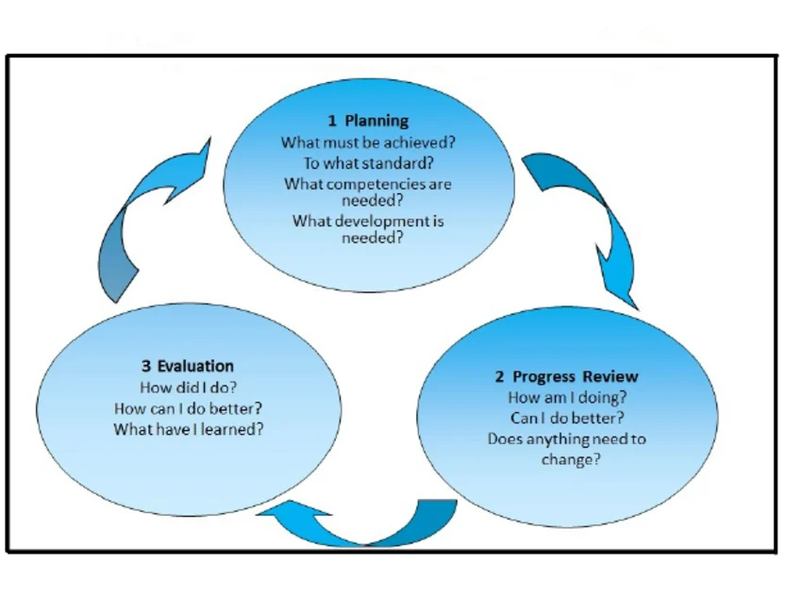

Figure 2: Performance Management Cycle
(Source: Afshan, 2013)

4.3 Change Management
Managers have to bring employees through these changes by training and supporting them with good explanations of the benefits tied to the changes. Change management provides certainty among the employees and enhances organisational flexibility.
It is possible to refer to a number of theoretical frameworks that describe organisational change management. In his Change Model, Lewin explains the three processes of change, such as unfreezing, changing and refreezing. The unfreezing phase entails making the employees accept change through resisting it and communicating the necessity of change. The changing phase is associated with the introduction of new operations or technology, whereas the refreezing phase is aimed at stabilising the new practices in the organisation (Santos et al., 2023). On the same note, the eight-step change model by Kotter also emphasises generating urgency, developing leadership momentum and integrating change into organisational culture.

4.4 Critical Evaluation
Although the roles played by the managers in the implementation of HR practices are significant, a number of challenges can inhibit their efficiency. Employee resistance to change, especially in a situation where technological progress is changing the working routines, is one of the major issues. The employees can experience the fear of job loss or the uneasiness of discovering new systems (Bellini et al., 2022). The other weakness is the cost of training and development programmes. The implementation of the HR strategies requires organisations to devote a lot of resources to training the employees. Tesco PLC is a retail organisation where operational pressure and workload can also restrict the ability of the managers to concentrate on the long-term HR development programme.

5. Recommendations
Though the organisation Tescio holds a strong position within the retail business market of the UK, to hold the position in the market strongly, it needs to bring some improvement strategies within the HR management strategy. There are some gaps in the training process of the employees. The organisation Tesco needs to carry on with a digital training process for its employees that will help to make them more efficient. In the context of the successful HR strategy, employee engagement is a vital factor to enhance the employee engagement rate of Tesco; it needs to organise an employee engagement programme. With this programme, the organisation will also be able to manage better relations with the customers. The modern HR practices include application diversity and inclusion strongly (Rani, 2023). Tesco also needs to focus on diversity and inclusion to develop a sustainable HR strategy. Tesco also needs to bring some career opportunities for employees so that they can show their growth within the company.

6. Conclusion
HR, or human resources, is one of the significant assets of a company. This asset directly contributes to the productivity and efficiency of the organisation. With the evaluation of the HR management of the organisation, Tesco, it has been derived that there are some issues related to the HR process of the organisation. This can be considered a flaw of the organisation that can also affect the business position of the market. That is why the organisation needs to bring improvement strategies within their HRM process, maintaining the contemporary trends of HR practices. The recommendation segment has highlighted some specific strategies to improve the HR process of the organisation, Tesco.

7. References
Afshan, S. (2013). Impact of Human Resource Management Practices on Teacher's Performance: A Mediating Role of Monitoring Practices. Journal of Education and Social Sciences, 1.
Bellini, D., Cubico, S., Ardolino, P., Bonaiuto, M., Mascia, M.L. and Barbieri, B. (2022). Understanding and exploring the concept of fear, in the work context and its role in improving safety performance and reducing well-being in a steady job insecurity period. Sustainability, 14(21), p.14146. https://www.mdpi.com/2071-1050/14/21/14146
Fenech, R., Baguant, P. and Ivanov, D. (2019). The changing role of human resource management in an era of digital transformation. International Journal of Entrepreneurship, 22(2), pp.166–175. https://www.academia.edu/download/78857024/The-changing-role-of-human-resource-management-in-an-era-of-digital-transformation-23-1.pdf
GlobalData (2024) Tesco Plc - Digital Transformation Strategies. Available at: https://www.globaldata.com/store/report/tesco-plc-enterprise-tech-analysis/ (Accessed: 14 March 2026).
HelloTeam (2022) Effective HR Strategies for a Competitive Advantage. Available at: https://helloteam.com/effective-hr-strategies-for-a-competitive-advantage/ (Accessed: 14 March 2026).
LinkedIn (2025) Understanding diversity, equity, and inclusion: A triad of organizational values. Available at: https://www.linkedin.com/pulse/understanding-diversity-equity-inclusion-triad-values-kavtf (Accessed: 14 March 2026).
Ned, A.E. and Umesi, C.D. (2023). Effective leadership and employee motivation for sustainable development. Journal of Education in Developing Areas, 31(2), pp.310–321. https://journals.journalsplace.org/index.php/JEDA/article/viewFile/355/284
Paauwe, J. and Farndale, E. (2017). Strategy, HRM, and performance: A contextual approach. Oxford University Press.
Rani, S.V.F. (2023). Diversity and inclusion: strategies and metrics in modern HRM. Confluence of Curiosity, 156. https://www.academia.edu/download/119306182/Confluence_of_Curiosity_Multidisciplinary_Explorations_in_Modern_Research.pdf#page=165
Santos, E., Queiroz, M., Borini, F.M., Carvalho, D. and Dutra, J.S. (2023). The journey of business transformation: unfreeze, change and refreeze–a multiple case study. Journal of Organizational Change Management, 36(1), pp.47–63. https://www.emerald.com/jocm/article-pdf/36/1/47/1662392/jocm-03-2022-0063.pdf
Tesco (2026) About Us. Tesco Plc. Available at: https://www.tescoplc.com/about (Accessed: 14 March 2026).
Tesco Plc (2026) Diversity, Equity and Inclusion. Available at: https://www.tescoplc.com/sustainability/colleagues/diversity-equity-and-inclusion (Accessed: 14 March 2026).
Vuong, T.D.N. and Nguyen, L.T. (2022). The key strategies for measuring employee performance in companies: a systematic review. Sustainability, 14(21), p.14017. https://www.mdpi.com/2071-1050/14/21/14017

