Sport and Exercise Nutrition and Metabolism:
Investigating Exercise Intensity, Substrate Use, and Nutritional Interventions

Introduction

The ability to sustain exercise performance is dependent on how efficiently skeletal muscle produces and uses energy. During exercise, ATP is supplied by the phosphagen, glycolytic and oxidative systems, and the contribution of each depends on the intensity, duration and the individual’s training abilities (McArdle, Katch and Katch, 2022). As exercise becomes more intense, the body gradually shifts from mainly using fat to relying more on carbohydrate because it can provide ATP more quickly (Achten and Jeukendrup, 2003; Hargreaves and Spriet, 2020). This change, known as the metabolic crossover point, is important for understanding fatigue and planning nutrition around training (Burke et al., 2017; Thomas, Erdman and Burke, 2016).

Although these processes are well established, people vary a lot in their metabolic responses. Factors like fitness level, diet and muscle fibre type influence how early someone switches to greater carbohydrate use and how efficiently they produce energy during exercise (Larsen and Kristiansen, 2013). Recognising this is essential for applied sport and exercise nutrition. Fuelling, hydration and recovery approaches should be personalised for each individual rather than generalised (Jeukendrup, 2017). Carbohydrates support high intensity exercise, protein supports repair and adaptation of muscle tissue, and appropriate fluid and electrolyte intake will support thermoregulation and cardiovascular stability (Sawka and Cheuvront, 2019).

This report uses data collected during a laboratory session to examine how different exercise intensities affect energy use, substrate selection and physiological responses. Measures such as respiratory exchange ratio (RER), oxygen uptake (VO2), peak power output (PPO), resting metabolic rate (RMR), total energy expenditure (TEE) and body composition are interpreted alongside current research. It will explain how these results relate to energy systems, fuelling strategies, hydration, and practical recommendations that support performance and healthy body composition.

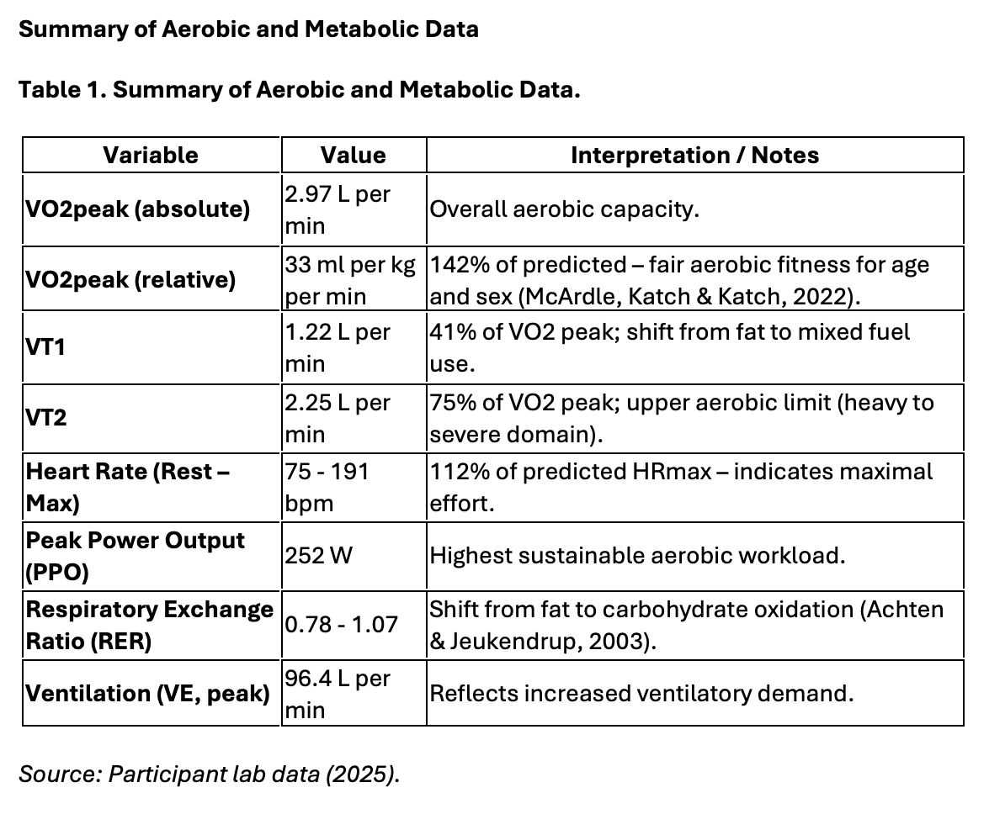

The VO2 peak of 33 ml per kg per minute represents a fair aerobic fitness level for an active female (McArdle, Katch and Katch, 2022) and is beyond the predicted value for age and sex at 142%. Values above 30 ml per kg per minute are seen in recreationally trained individuals (Brooks, Fahey and Baldwin, 2019), so this suggests a reasonable aerobic capacity despite the lower relative score. The participant also hit a maximum heart rate of 191 bpm, 112% of her predicted HR max. The traditional 220 minus age equation is known to underestimate max heart rate, especially in more active individuals (Robergs and Landwehr, 2002), so exceeding the predicted value supports that a genuine maximal effort was made.

Although VO2 peak is widely used to assess aerobic capacity, it can be influenced by factors such as motivation, pacing, protocol design and mask fit, which may affect the precision of the final value (Poole and Jones, 2017). Because of these limitations, VO2 peak is best interpreted together with additional physiological markers to confirm whether a true maximal state was achieved. In this case, reaching a high peak RER, achieving VT2 and exceeding predicted HR max all meet commonly accepted criteria for maximal testing and indicate that the participant reached a valid maximal physiological effort (Howley, Bassett and Welch, 1995).

Substrate Use and RER Response

Substrate use refers to how the body chooses between fats or carbohydrates to produce ATP, which is the immediate energy source for muscle contraction. With lower intensities most ATP is supplied through fat oxidation, but as intensity rises, ATP demand increases and the body shifts toward faster carbohydrate use (Romijn et al., 1993; Hargreaves and Spriet, 2020).

The respiratory exchange ratio (RER) tells us which fuel is being used. An RER near 0.70 reflects mainly fat oxidation, whilst around or above 1.00 show dominant carbohydrate use and extra CO2 from lactate buffering (Achten and Jeukendrup, 2003). The participant’s RER increased from 0.78 at rest to 1.07 at peak exercise, demonstrating a clear change from fat to carbohydrate as intensity entered the severe domain.

These changes are also seen in the ventilatory thresholds. VT1 marks the point where ventilation increases due to rising CO2 from greater carbohydrate oxidation, while VT2 represents rapid lactate accumulation and increased reliance on anaerobic glycolysis (Wasserman et al., 1999; Poole and Jones, 2012). The participant’s VT1 at 41% of VO2 peak and VT2 at 75% match the RER pattern and show a typical progression from fat to carbohydrate use as the exercise intensity increased.

Ventilatory Thresholds and Aerobic Efficiency

The participant’s VT1 occurred at 41% of VO2 peak and VT2 at 75%, which aligns with values generally seen in moderately trained females (Brooks, Fahey and Baldwin, 2019). The fairly low VT1 shows that the shift from mainly aerobic metabolism to more carbohydrate use, and the associated rise in CO2 and ventilation, begins early, indicating lower aerobic efficiency. Those with higher aerobic efficiency usually maintain lower ventilation and rely on aerobic pathways for a longer period before reaching VT1 (Wasserman et al., 2020).

From a performance perspective, increasing VT1 threshold would allow more work to be completed before ventilation increases sharply, reducing early carbohydrate reliance and slowing fatigue. Similarly, increasing VT2 would delay rapid lactate accumulation and the steep rise in ventilation that limits sustained high intensity exercise (Poole and Jones, 2012). Improving both VT1 and VT2 would increase the proportion of VO2 peak that the participant can sustain, showing better aerobic efficiency and endurance capacity (Joyner and Coyle, 2008).

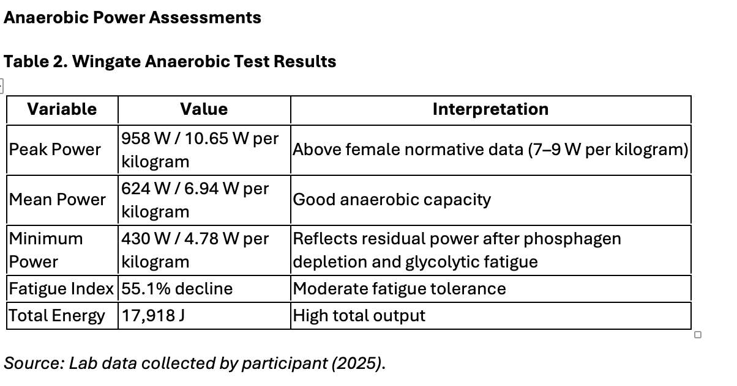

The participant had a peak power of 958 watts, equal to 10.65 watts per kg, which is higher than the typical female range of 7 to 9 watts per kg (Inbar, Bar-Or and Skinner, 1996). This indicates strong ATP PC system function, as peak power in the first few seconds of a Wingate test reflects rapid ATP resynthesis from stored ATP and phosphocreatine. Producing more than ten watts per kg suggests effective fast twitch fibre recruitment and good neuromuscular power (Haff and Triplett, 2016).

Mean power hits 624 watts, or 6.94 watts per kg, which shows good anaerobic glycolytic capacity. As the test progresses and phosphocreatine decreases, ATP production shifts toward anaerobic glycolysis, so maintaining close to seven watts per kg suggests she can sustain a high rate of glycolytic ATP production (Bar-Or, 1987).

Total energy output of 17,918 joules indicates high overall anaerobic work capacity, which is influenced by factors such as muscle mass, glycolytic enzyme activity, and buffering ability (Robergs, Ghiasvand and Parker, 2004).

Overall, the results show above average anaerobic power, strong phosphagen system function, and effective glycolytic capacity, which is consistent with the high peak and mean power values recorded in this test.

Body Composition and Energy Expenditure

The participant’s body fat percentage was 38.5%, which is higher than the expected range for active females (18–28%) (McArdle, Katch and Katch, 2022; Manore, Thompson and Russo, 2020). This has a direct impact on the interpretation of her aerobic results. The absolute VO2 peak of 2.97 litres per minute indicates fair aerobic capability, but her relative VO2 peak of 33 millilitres per kilogram per minute appears lower because excess body mass reduces relative oxygen uptake and in turn has increased the energy cost of weight bearing activity (Kenney, Wilmore and Costill, 2021).
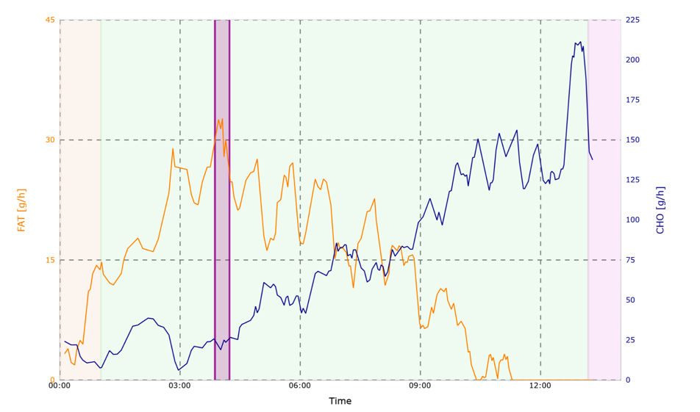
Figure 1. Fat and Carbohydrate Oxidation Rates during Incremental Exercise.
The graph shows the transition from fat to carbohydrate dominance as intensity increases, indicating the metabolic crossover point.
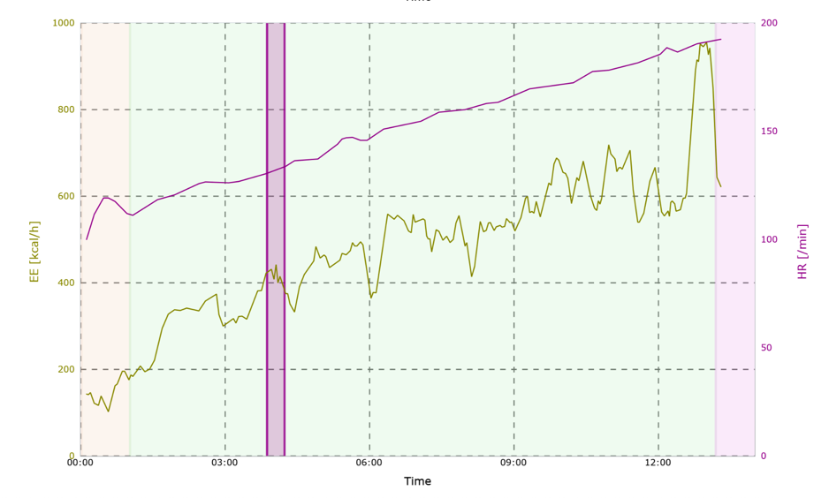
Figure 2. Energy Expenditure and Heart Rate during Incremental Exercise.
The graph shows a progressive increase in energy expenditure and heart rate with rising workload, reflecting greater metabolic and cardiovascular demand.
Figures 1 and 2 display expected responses to incremental exercise. As workload increases, fat oxidation decreases while carbohydrate use rose, showing metabolic crossover where carbohydrate becomes the dominant fuel at higher intensities (Achten and Jeukendrup, 2003; Hargreaves and Spriet, 2020). Energy expenditure and heart rate also increased steadily with intensity, reflecting greater cardiovascular and metabolic demand (Brooks, Fahey and Baldwin, 2019).
When interpreted alongside her body composition, these patterns show further insight into her physiological responses. Individuals with higher body fat typically show reduced movement economy, earlier ventilatory strain and lower fat oxidation efficiency due to increased metabolic cost and less mitochondrial density (Venables, Achten and Jeukendrup, 2005; Purdom et al., 2018). This aligns with her relatively early VT1 at 41% of VO2 peak and the rapid rise in ventilation during the test, suggesting an earlier shift to carbohydrate use and higher reliance on anaerobic metabolism at moderate intensities. This helps show why she reached her ventilatory limits sooner despite having a strong absolute aerobic capacity. The patterns are consistent with research showing individuals with more fat often demonstrate lower metabolic efficiency and an earlier transition to carbohydrate use during graded exercise (Venables, Achten and Jeukendrup, 2005).
Energy Systems and Substrate Utilisation

Exercise intensity determines how much the phosphagen, glycolytic and oxidative systems contribute to ATP production (Hargreaves and Spriet, 2020). In the early stages of the test, oxidative metabolism dominated, which is shown by the participant’s low RER of 0.78 and stable VO2, showing heavy reliance on fat oxidation. As intensity increased towards VT1 and VT2, there was a clear shift to mixed fuel use, reflected by rising ventilation, heart rate and a gradual increase in RER.

Beyond VT2 the exercise entered the severe domain, and RER rose above 1.0, showing dominant carbohydrate use and greater glycolytic activity. This also marks the point where lactate accumulation begins to exceed clearance, signalling the limit of sustainable oxidative metabolism (Brooks, Fahey and Baldwin, 2019). The Wingate results support this progression. The high peak power output reflects strong phosphagen system function during the first few seconds, while the drop in power and fatigue index shows the transition to anaerobic glycolysis (Inbar, Bar-Or and Skinner, 1996).

Together, the test data show that the participant has a well developed phosphagen system and adequate glycolytic capacity, but only moderate oxidative efficiency based on VO2 peak and relatively early ventilatory thresholds. This metabolic profile is more suited to intermittent or repeated high intensity activities rather than prolonged endurance performance, which requires a higher and more sustainable reliance on oxidative metabolism (Poole and Jones, 2012).

Role of Macronutrients in Fuelling and Recovery

Carbohydrates

Carbohydrate availability is essential for high intensity exercise because it allows rapid ATP resynthesis through glycolysis when oxidative metabolism can no longer meet energy demand (Hargreaves and Spriet, 2020). Her RER increased from 0.78 at rest to 1.07 at peak exercise, showing a clear shift to carbohydrate dominant metabolism in the severe domain. Her early VT1 at 41% of VO2 peak also suggests she moves toward carbohydrate use sooner than highly trained individuals, who typically maintain fat oxidation to higher workloads due to greater mitochondrial efficiency (Brooks, Fahey and Baldwin, 2019).

Practically, this means low glycogen availability would increase ventilatory strain and fatigue during prolonged or intense sessions. To support training demands, a daily carbohydrate intake of five to seven grams per kilogram is recommended (Thomas, Erdman and Burke, 2016), along with one to four grams per kilogram a couple of hours before high intensity work to ensure adequate glycogen stores (Burke et al., 2011). Low carbohydrate strategies may enhance some endurance adaptations (Impey et al., 2018).

Protein

Evidence based guidelines recommend 1.6 to 2.2 grams of protein per kilogram per day for active individuals to optimise muscle protein synthesis and recovery (Thomas, Erdman and Burke, 2016). Having protein in increments across the day in doses of around 0.3 grams per kilogram supports adaptation to both endurance and high intensity training (Phillips and Van Loon, 2011). High quality protein sources with essential amino acids, especially leucine, further enhance muscle repair and mitochondrial function (Tipton and Wolfe, 2020). For this participant, consistent and well timed protein intake would support her lean mass, recovery, and improvements in aerobic efficiency.

Fat

Fat is an important fuel source during rest and lower intensity exercise, and the participant’s resting RER of 0.78 indicates strong reliance on fat oxidation at low workloads. However, the rapid rise in RER with rising intensity, combined with an early VT1 at 41% of VO2 peak, shows limited fat oxidation efficiency at moderate intensities. Individuals with lower metabolic flexibility typically shift to carbohydrate use earlier, which can increase ventilatory strain and reduce endurance capacity (Achten and Jeukendrup, 2003; Hargreaves and Spriet, 2020; Brooks, Fahey and Baldwin, 2019).

Dietary fat should contribute around 20 to 35% of total energy intake, prioritising unsaturated fats to support cardiovascular and hormonal health (Manore, Thompson and Russo, 2020; Kenney, Wilmore and Costill, 2021). Regular aerobic training, combined with appropriate nutrition, can improve mitochondrial density and fat oxidation capacity, helping delay the crossover to carbohydrate reliance and reducing early fatigue in prolonged exercise (Hawley and Burke, 2010; Jeukendrup, 2017). For this participant, improving fat oxidation efficiency would likely support more stable ventilation, prolong aerobic contribution, and improve overall exercise economy.

Recovery Nutrition

Effective recovery nutrition is important for this participant because her peak RER of 1.07 indicates near complete reliance on carbohydrate use during severe intensity exercise, meaning glycogen stores were likely heavily depleted (Achten and Jeukendrup, 2003; Hargreaves and Spriet, 2020). Rapid restoration of carbohydrate is therefore necessary to maintain performance in subsequent sessions. Consuming 1.0 to 1.2 grams of carbohydrate per kilogram of body mass in the first hour after exercise, combined with around 0.3 grams of protein per kilogram, maximises glycogen resynthesis and stimulates muscle protein synthesis (Burke et al., 2017; Thomas, Erdman and Burke, 2016; Phillips and Van Loon, 2011). For this participant, this targeted approach would replace the carbohydrate used during high intensity work, support lean mass and improve readiness for training in the following 24 hours.

Fluid and Electrolyte Replacement

Hydration is essential for maintaining plasma volume, thermoregulation and cardiovascular function during exercise (Sawka and Cheuvront, 2019). Even a 2% body mass loss through dehydration can increase heart rate, raise thermal strain and impair endurance performance (Cheuvront and Kenefick, 2014). This is relevant to the participant, as her ventilation and heart rate rose quickly during the cardiopulmonary exercise test, indicating high cardiovascular load, any dehydration would likely worsen these responses and accelerate fatigue (Maughan and Shirreffs, 2010).

Sodium intake is equally important because it supports fluid retention and helps prevent exercise associated hyponatraemia (Hew-Butler et al., 2015). Current guidance recommends consuming 5 to 7 millilitres per kilogram of fluid a few hours before exercise and replacing around 150% of fluid lost afterwards, ideally with 20 to 30 millimoles of sodium per litre (Casa et al., 2010). For this participant, a structured hydration and sodium plan would help stabilise cardiovascular responses and support repeated training sessions (Maughan and Shirreffs, 2010).
Application to training and nutrition practice

The participant’s results show strong anaerobic power but only moderate aerobic efficiency. Her high Wingate peak power indicates well developed phosphagen and glycolytic systems (Inbar, Bar-Or and Skinner, 1996; Haff and Triplett, 2016), whereas her VO2 peak and early ventilatory thresholds suggest lesser ability to sustain aerobic work (Brooks, Fahey and Baldwin, 2019). Improving oxidative metabolism should therefore be a high priority.

Moderate intensity aerobic training would increase mitochondrial density and fat oxidation capacity, while interval training around VT1 and VT2 can raise both thresholds and reduce ventilatory strain during higher workloads (Joyner and Coyle, 2008; Poole and Jones, 2012). Weight training remains important to support lean mass, which contributes to movement economy (Kenney, Wilmore and Costill, 2021).

Nutritionally, her peak RER of 1.07 shows high carbohydrate dependence at severe intensities, reinforcing the need for adequate daily carbohydrate intake and appropriate fuelling pre and post workout (Burke et al., 2017; Thomas, Erdman and Burke, 2016). Protein distributed evenly across the day will support recovery and lean mass maintenance (Phillips and Van Loon, 2011). Hydration and sodium replacement are also essential, as even small fluid losses increase cardiovascular strain during heavy exercise (Sawka and Cheuvront, 2019).

Overall, her combined tests of VO2 max, Wingate and body composition results highlight strong anaerobic capability but limited aerobic efficiency. These findings provide clear evidence based foundation for training and nutrition strategies that target aerobic development while maintaining her existing strengths.

PART B
Effects Of Caffeine Gum on Performance – 20 Minute Time Trial

Introduction

Caffeine is one of the most commonly used supplements in sport because it can enhance endurance, power output and cognitive function (Spriet, 2014; Grgic et al., 2020). Caffeine’s main impact comes from blocking adenosine receptors, which increases alertness and lowers perceived effort and fatigue during exercise (Fredholm et al., 1999). Caffeine can also improve neuromuscular function and motor unit recruitment, which can help sustain power during high intensity work (Davis and Green, 2009). There is also growing evidence that caffeine supports cognitive performance under fatigue, especially reaction time and decision making (Souissi et al., 2019).

This study compared caffeine gum with a placebo gum during a 20 minute cycling time trial in adults aged 28 to 52. Both physical (peak power, mean power, distance, heart rate) and cognitive outcomes (reaction time, Stroop performance) were measured to assess whether caffeine provided any improvements in performance and fatigue resistance.

Method

Six recreationally active adults (five males, one female), aged 28–52 years, completed the study, which used a randomised, double blind, crossover design. Participants were randomised into two groups to determine the order of conditions, completing one caffeine trial and one placebo trial on two consecutive days. Each condition involved chewing either 400 mg of commercially available caffeine gum or an identical placebo gum containing no active ingredients. To control habitual caffeine intake, participants were asked to avoid consuming caffeine on the morning of each trial.

Participants chewed their assigned gum for 15 minutes. At the 5 minute mark they completed a one minute Stroop test, followed immediately by a one minute simple reaction time test. After setting up the Wattbikes, participants completed a short warm up, and the gum was removed at 15 minutes. A baseline peak power output (PPO) test was performed at 19 minutes. The main trial consisted of a 20 minute self paced cycling time trial on the Wattbike AtomX. This was followed by a 2 minute cool down, another PPO test, and repeat Stroop and reaction time assessments.

Performance and physiological variables were recorded throughout, including pre and post trial PPO, mean power every 5 minutes, heart rate, total distance, and rate of perceived exertion (RPE). Cognitive outcomes were taken from the pre and post exercise Stroop and reaction time tests, as caffeine has been shown to influence both psychomotor speed and executive function (Davis and Green, 2009). The data was analysed using paired-samples t tests, with statistical significance set at p <0.05.

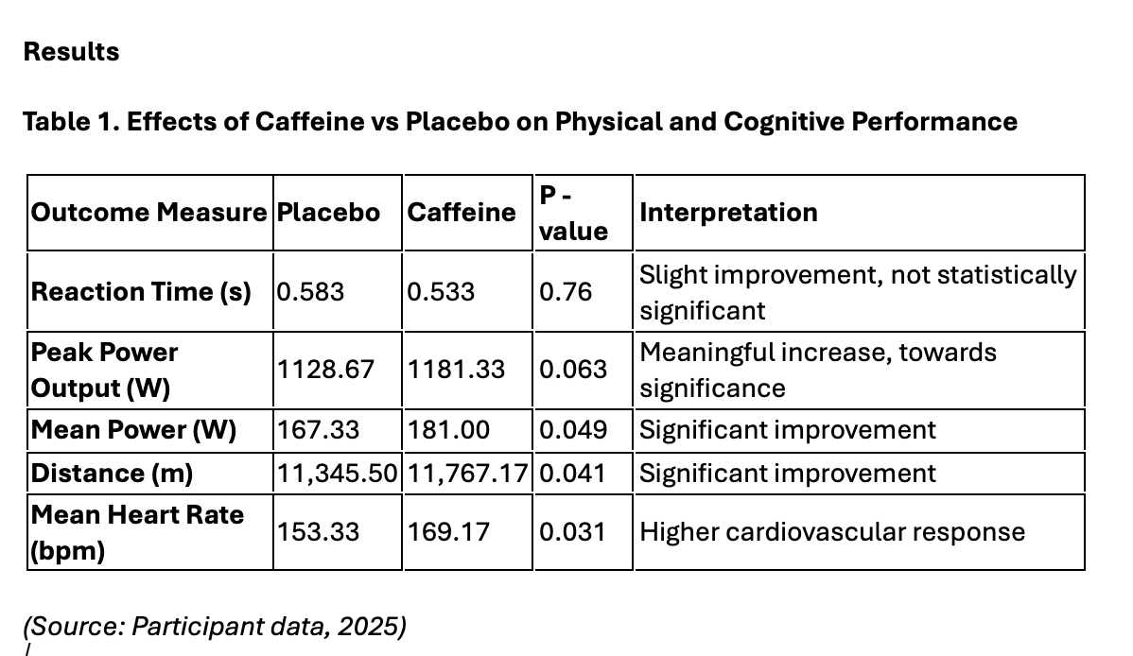

Various differences were found in the results. Mean power increased from 167.33 W in the placebo condition to 181.00 W with caffeine (p = 0.049), and total distance covered was also longer in the caffeine trial (11,767.17m vs 11,345.50m - p = 0.041). Within peak power we saw a positive trend (1128.67 W vs 1181.33 W - p = 0.063), suggesting enhanced neuromuscular output. Mean heart rate was higher in the caffeine condition (169.17 bpm vs 153.33 bpm - p = 0.031), showing greater cardiovascular activation to support higher work rates. Cognitive performance followed a similar pattern. Post exercise reaction time improved with caffeine (0.533 s vs. 0.583 s - p = 0.76), and Stroop performance showed fewer errors, suggesting reduced cognitive fatigue. Overall, the caffeine trial consistently produced higher physical outputs and better cognitive functioning compared to placebo.

The improvements observed in this study align with well established effects of caffeine, particularly its ability to enhance central nervous system stimulation and reduce perceptions of effort during exercise (Spriet, 2014; Davis and Green, 2009). These mechanisms can help maintain power output and cognitive performance under fatigue (Grgic et al., 2020).

Discussion and evaluation
Effect of Caffeine on Performance

The results showed a consistent improvement in both physical and cognitive performance after consuming caffeine gum compared to the placebo. Mean power was higher in the caffeine condition (181.00 W vs 167.33 W), which matches evidence that caffeine can help people maintain higher work rates by increasing central drive and reducing perceived exertion (Grgic et al., 2020; Davis and Green, 2009). The greater total distance covered also reinforces this, as maintaining higher power across a self paced task requires both physiological and psychological support. Peak power was higher as well, and although this was not statistically significant, the change is still practically meaningful. This fits with research showing that caffeine can enhance maximal force and power output in tasks relying heavily on fast twitch muscle fibres (Warren et al., 2010).

The mean heart rate was noticeably higher within the caffeine condition, which suggests that participants were working at a greater intensity. This would be expected as caffeine blocks adenosine receptors, leading to greater central nervous system stimulation and reducing how difficult the exercise feels (Fredholm et al., 1999). When exercise feels more manageable, people usually push harder, especially during self paced tasks like a time trial. This matches the pattern seen here, where participants produced more power and covered more distance with caffeine. Similar findings have been reported in endurance research, showing that caffeine helps individuals tolerate higher workloads and maintain effort for longer (Spriet, 2014). Overall, the heart rate response supports the idea that caffeine genuinely enhanced performance in this trial.

Effects on Cognitive Function

Caffeine also improved cognitive performance, reaction time was slightly quicker in the caffeine trial (0.533s vs 0.583s), and Stroop accuracy also improved, even though the changes were small. This pattern matches research showing that caffeine helps maintain executive function, attention, and psychomotor speed when individuals become fatigued (Souissi et al., 2019; McLellan et al., 2016). Within this trial, the combination of higher physical output and stable cognitive function tells us that caffeine may have helped reduce mental fatigue as the time trial progressed. This fits with evidence showing that caffeine can support both physical and cognitive performance through shared neural mechanisms involved in alertness and sustained focus (Guest et al., 2021).

Comparison With Existing Research

The improvements in mean power and distance in this trial are broadly similar to what previous research has reported. Grgic et al. (2020) found that caffeine typically improves endurance performance by around 3 to 7 percent, which is close to the changes seen here. This suggests that the results are realistic and fit within what would be expected when using caffeine gum. However, the lack of a statistically significant increase in peak power highlights one of the main issues with small sample sizes. Even when performance improves, it can be difficult to detect true differences with only a few participants. Individual responses to caffeine can also vary based on factors such as genetic differences in caffeine metabolism, habitual caffeine use and psychological expectations (Pickering and Kiely, 2019). None of these factors were controlled in the current experiment, so this limits how confidently we can interpret each participant’s response.

Limitations of the Experimental Design

Although the results were consistent with the known effects of caffeine, several limitations can be considered when interpreting the results. The most important limitation is the very small sample size of 6 people, which restricts statistical power and increases potential of missing genuine effects. Therefore, individual differences, such as sex, fitness level, or habitual caffeine intake can have a disproportionate influence on the outcome of the experiment (Pickering and Kiely, 2019).

The experimental design also involved completing the caffeine and placebo trials on consecutive days. Although groups were randomised, the back to back format increases the chance of accumulated fatigue, which is relevant in a 20 minute time trial. A longer period between, ideally 48 to 72 hours would have improved credibility by ensuring participants were fully recovered between trials.

Several external factors were not controlled: diet, sleep, hydration, and time of day. These can influence both caffeine metabolism and exercise performance. For example, sleep restriction and poor hydration can increase perceived exertion and impair endurance output, and inconsistent nutrition can alter glycogen availability and therefore influence pacing strategies (Burke et al., 2017). Without controlling these variables, the variability between trials is higher and the true magnitude of caffeine’s effect becomes harder to isolate.

Finally, the fixed caffeine dose of 400 mg was applied to all participants, regardless of body mass. Research generally recommends 3 to 6 mg of caffeine per kilogram of body mass for performance enhancement (Spriet, 2014). This means that some participants may have received an optimal dose, while others may have been under, or over dosed relative to their body weight. This uneven dosing could partly explain the variability observed across the participants.

Relevance to Real World Practices

Caffeine gum is already used in many competitive sports because it provides quick absorption and is easy to take during warmups or short breaks (Maughan et al., 2018). The improvements seen in this trial, including higher mean power, greater distance covered, and slightly quicker reaction time translate well to real world environments where athletes need both sustained physical output and fast decision making, such as cycling, team sports and combat sports. The participant group in this study (aged 28–52 and recreationally active) also reflects typical club level athletes who often respond well to caffeine and can see meaningful performance gains from relatively simple strategies (Grgic et al., 2020.

Key limitations, such as the small sample size, consecutive day testing, and limited control of external factors reduce the strength of the conclusions. Individual variability in caffeine responsiveness also highlights that not all individuals will experience the same degree of benefit (Pickering and Kiely, 2019).

Despite this, the consistent improvements across all test’s measures suggest that caffeine gum is a useful and accessible ergogenic aid for active adults. When applied in a real world context, caffeine can support both physical output and cognitive sharpness, particularly in sports requiring sustained effort and decision making. Future testing with larger samples, controlled dosing, and more sensitive cognitive tools would help refine these findings, but the current results provide a strong basis for recommending caffeine gum as a practical performance strategy.

References

Achten, J. & Jeukendrup, A.E. (2003) ‘Maximal fat oxidation during exercise in trained men’, International Journal of Sports Medicine, 24(8), pp. 603–608.
Bar-Or, O. (1987) ‘The Wingate anaerobic test: an update on methodology, reliability and validity’, Sports Medicine, 4(6), pp. 381–394.
Beattie, K., Kenny, I.C., Lyons, M. & Carson, B.P. (2014) ‘The effect of strength training on performance in endurance athletes’, Sports Medicine, 44(6), pp. 845–865.
Brooks, G.A., Fahey, T.D. & Baldwin, K. (2019) Exercise Physiology: Human Bioenergetics and Its Applications. 5th edn. New York: McGraw-Hill.
Burke, L.M., Hawley, J.A., Wong, S.H. & Jeukendrup, A.E. (2011) ‘Carbohydrates for training and competition’, Journal of Sports Sciences, 29(S1), pp. S17–S27.
Burke, L.M. et al. (2017) ‘Carbohydrate for training and competition’, Journal of Sports Sciences, 35(22), pp. 2201–2208.
Casa, D.J. et al. (2010) ‘National Athletic Trainers’ Association position statement: fluid replacement for athletes’, Journal of Athletic Training, 45(3), pp. 385–395.
Cheuvront, S.N. & Kenefick, R.W. (2014) ‘Dehydration: physiology, assessment, and performance effects’, Comprehensive Physiology, 4(1), pp. 257–285.
Davis, J.K. & Green, J.M. (2009) ‘Caffeine and anaerobic performance’, Sports Medicine, 39(10), pp. 813–832.
Fredholm, B.B. et al. (1999) ‘Actions of caffeine in the brain with special reference to factors that contribute to its widespread use’, Pharmacological Reviews, 51(1), pp. 83–133.
Graham, T.E. (2001) ‘Caffeine and exercise’, Sports Medicine, 31(11), pp. 785–807.
Green, H. (1997) ‘Mechanisms of muscle fatigue in intense exercise’, Journal of Sports Sciences, 15(3), pp. 247–256.
Grgic, J. et al. (2020) ‘Caffeine ingestion enhances power output but not sprint performance: a meta-analysis’, Scandinavian Journal of Medicine & Science in Sports, 30(5), pp. 856–868.
Guest, N.S. et al. (2021) ‘Caffeine, performance, and genetics’, Sports Medicine, 51(2), pp. 303–314.
Haff, G.G. & Triplett, N.T. (2016) Essentials of Strength Training and Conditioning. 4th edn. Champaign, IL: Human Kinetics.
Hargreaves, M. & Spriet, L.L. (2020) ‘Skeletal muscle energy metabolism during exercise’, Nature Metabolism, 2(9), pp. 817–828.
Hawley, J.A. & Burke, L.M. (2010) ‘Carbohydrate availability and training adaptation’, Sports Science Exchange, 23(106), pp. 1–6.
Hew-Butler, T. et al. (2015) ‘Statement of the Third International Exercise-Associated Hyponatremia Consensus Development Conference’, Clinical Journal of Sport Medicine, 25(4), pp. 303–320.
Howley, E.T., Bassett, D.R. & Welch, H.G. (1995) ‘Criteria for maximal oxygen uptake: review and commentary’, Medicine & Science in Sports & Exercise, 27(9), pp. 1292–1301.
Impey, S.G. et al. (2018) ‘Fuel for the work required: a theoretical framework for carbohydrate periodization and the glycogen threshold hypothesis’, Sports Medicine, 48(5), pp. 1031–1048.
Inbar, O., Bar-Or, O. & Skinner, J.S. (1996) The Wingate Anaerobic Test. Champaign, IL: Human Kinetics.
Jeukendrup, A.E. (2017) ‘Periodized nutrition for athletes’, Sports Medicine, 47(S1), pp. 51–63.
Joyner, M.J. & Coyle, E.F. (2008) ‘Endurance exercise performance: the physiology of champions’, Journal of Physiology, 586(1), pp. 35–44.
Kenney, W.L., Wilmore, J.H. & Costill, D.L. (2021) Physiology of Sport and Exercise. 8th edn. Champaign, IL: Human Kinetics.
Larsen, F.J. & Kristiansen, S. (2013) ‘Metabolic flexibility and substrate utilisation’, Journal of Physiology, 591(23), pp. 5805–5806.
Manore, M., Thompson, J. & Russo, M. (2020) Sport Nutrition for Health and Performance. 3rd edn. Champaign, IL: Human Kinetics.
Maughan, R.J. & Shirreffs, S.M. (2010) ‘Dehydration and rehydration in competitive sport’, Scandinavian Journal of Medicine & Science in Sports, 20(S3), pp. 40–47.
Maughan, R.J. et al. (2018) ‘IOC consensus statement: dietary supplements and the high-performance athlete’, International Journal of Sport Nutrition and Exercise Metabolism, 28(2), pp. 104–125.
McArdle, W.D., Katch, F.I. & Katch, V.L. (2022) Exercise Physiology: Nutrition, Energy, and Human Performance. 9th edn. Philadelphia: Lippincott Williams & Wilkins.
McLellan, T.M., Caldwell, J.A. & Lieberman, H.R. (2016) ‘A review of caffeine’s effects on cognitive, physical and occupational performance’, Neuroscience & Biobehavioral Reviews, 71, pp. 294–312.
Phillips, S.M. & Van Loon, L.J.C. (2011) ‘Dietary protein for athletes: from requirements to optimum adaptation’, Journal of Sports Sciences, 29(S1), pp. S29–S38.
Pickering, C. & Kiely, J. (2019) ‘Are the current guidelines on caffeine use in sport optimal for everyone?’, Sports Medicine, 49, pp. 1007–1016.
Poole, D.C. & Jones, A.M. (2012) ‘Oxygen uptake kinetics’, Comprehensive Physiology, 2(2), pp. 933–996.
Poole, D.C. & Jones, A.M. (2017) ‘Measurement of the maximum oxygen uptake...’, Journal of Applied Physiology, 122(3), pp. 598–608.
Purdom, T. et al. (2018) ‘Dietary strategies to optimise training and body composition’, Sports Medicine, 48(3), pp. 539–552.
Robergs, R.A. & Landwehr, R. (2002) ‘The surprising history of the “HRmax = 220 − age” equation’, Journal of Exercise Physiology, 5(2), pp. 1–10.
Robergs, R.A., Ghiasvand, F. & Parker, D. (2004) ‘Biochemistry of exercise-induced metabolic acidosis’, American Journal of Physiology, 287(3), pp. R502–R516.
Romijn, J.A. et al. (1993) ‘Regulation of substrate choice during endurance exercise’, Journal of Applied Physiology, 75(2), pp. 698–707.
Sawka, M.N. & Cheuvront, S.N. (2019) ‘Human water needs’, Nutrition Reviews, 78(S2), pp. 21–31.
Souissi, M. et al. (2019) ‘Caffeine improves cognitive and physical performance’, Physiology & Behavior, 204, pp. 227–233.
Spriet, L.L. (2014) ‘Exercise and sport performance with low doses of caffeine’, Sports Medicine, 44(S2), pp. 175–184.
Thomas, D.T., Erdman, K.A. & Burke, L.M. (2016) ‘Nutrition and athletic performance’, Medicine & Science in Sports & Exercise, 48(3), pp. 543–568.
Tipton, K.D. & Wolfe, R.R. (2020) ‘Protein and amino acids for athletes’, Journal of Sports Sciences, 38(11–12), pp. 1041–1050.
Venables, M.C., Achten, J. & Jeukendrup, A.E. (2005) ‘Determinants of fat oxidation during exercise’, Journal of Applied Physiology, 98(1), pp. 160–167.
Warren, G.L. et al. (2010) ‘Caffeine ingestion enhances resistance exercise performance’, Journal of Strength and Conditioning Research, 24(8), pp. 2205–2213.
Wasserman, K. et al. (1999) Principles of Exercise Testing and Interpretation. 3rd edn. Philadelphia: Lippincott Williams & Wilkins.
Wasserman, K. et al. (2020) Principles of Exercise Testing and Interpretation. 6th edn. Philadelphia: Wolters Kluwer.

