

(Image by Rachel Jones)

Rachel Jones
2308282
ECYW4006

Index
Acknowledgments 3
Practicum Supervisors Report 4
Supervision notes 6
Learning mentor Report. 17
Personal Development Plan 19

Professional Journal
Introduction 20
Community Profile 21
Placement Overview and Evaluation 31
Reflecting on own Practice 38
Reflective Journals 41
Risk Assessment 54
Log of hours face to face 56
Log of hours non face to face 57
Appendix 58
Reference list 73

Acknowledgements.

I would like to take opportunity to thank first NPT Youth Service for allowing me the opportunity to work and experience different areas of the Youth Service for the past year then supporting me through my level 4 studies at UWTSD Carmarthen.
I would like to thank Darrel Williams who’s lectures I found interesting, listening to past youth work tales I found inspiring.
Thank you to Frances Chester our fieldwork coordinator for always getting back to my emails of moments of panic with resolutions and calm.
Last but not least thank you to my family for the support and patience, especially to my Husband who is picking up more than his share of parenting duties as I juggle work, family life and University, without him and his full support I would never be able to have this opportunity.

FIELDWORK SUPERVISOR’S FINAL REPORT
This section of the report should be completed by the fieldwork supervisor. To complete the report we would like you to use the headings below giving specific examples to support your observations.
How did the student use supervision and respond to feedback?
Rachel has used supervision positively and as an opportunity to reflect on her placement and was able to express any concerns and discuss her learning. She used learning to suggest actions for further practice. This included recommendations for improving practice and applying skills to practice. Rachel has been able to use supervision positively and has been receptive to learning and developing as a youth worker.

To what extent did the student seek challenging situations, and how were these worked with?
Throughout Rachel’s placement, she has been involved in challenging situations and has been deal with situations that she has not dealt with before and that were outside of her comfort zone. From engaging within supervision, it is clear that Rachel has been able to deal with these situations in a professional manner and that she has the capacity to deal with situations that she hasn’t dealt with before. Rachel has been able to work effectively with a large amount of young people at one time in youth club and she has been able to do this and deliver activities and support the young people the best she can.

To what extent did the student show enthusiasm and commitment?
Rachel is an enthusiastic youth worker who seeks to learn within supervision. This commitment is evident in how she has been able to successfully prioritise her studying, placement, her personal family life and her job, and is evidenced by how she has bult up a positive professional relationship with the young people she works with.
How well was the student able to relate theory to practice and reflect on their own practice and that of others?
Rachel has been developing her knowledge of youth work theory. Through supervision, she has been able to unpick this theory and has a good understanding of it. As a result, Rachel is starting to get to grips with relating theory into practice and has been seeking out any other learning that she can read and learn more about. Rachel always asked relevant questions and wanted to learn more about theory and how she can use it in her own practice.

How did the student articulate their own beliefs and values and relate them to the work?
Rachel has been able to express positive beliefs and values and apply them to her practice. It is evident that this has had a positive effect on her working with young people and is able to be a positive role model to the young people that she supports within her practice.

How pro-active was the student in demonstrating anti oppressive beliefs, language, and behaviour?
Through engaging in supervision and working with her throughout her placement Rachel has shown that she is able to deal with challenging behaviour and language. Through engaging with supervision, it is evident that Rachel is aware of what language and behaviour to demonstrate when with the young people.

In your professional opinion has the student achieved the necessary standards to progress to Level 5?
In my professional opinion, Rachel has achieved the necessary standards to progress to level 5.

Student’s Provisional Grade (Please refer to the grading criteria above)
70%

Signed Supervisor | 
Signed Student | 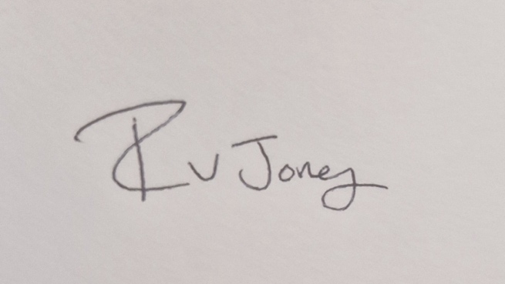
Date | 12.03.2024

Supervision Recording Format
SUPERVISION RECORDING
DATE: 02.11.2023
TIME: 6.00pm
PEOPLE PRESENT: HA & RJ
DURATION OF THE MEETING: 1HR
AGENDA/ DISCUSSION POINTS
1. Wellbeing
2. Placement
3. Contract
4. AOB
5.
6.
NOTES/ ACTION OF EACH ITEM
1. Wellbeing is okay at the moment, just a bit stressed about some university bits and placement – HA and RJ discussed about this further.
2. Placement is going well – shes doing placement that she did for her level 2 and 3 youth work course. Finding it okay. Discussed about potential placements for next year and agreed that HA would send over some information regarding both placements and statistics for community profile.
3. HA and RJ went through the supervision contract and agreed on terms and conditions of each supervision. HA to send this signed copy over to RJ to sign.
4. HA will send over resources to RJ to support with uni assignments. HA agreed to bring his portfolio to the next supervision for RJ to use as a reference.
5.
6.
PROBLEMS ENCOUNTERED
REFLECTION ANALYSIS AND LEARNING Links between theory and practice can be made here and referenced in the usual way. Also reflection on effectiveness of supervision.
QUESTIONS ARISING

DATE OF NEXT MEETING:
SIGNED:
STUDENT
SUPERVISOR

Supervision Recording Format
SUPERVISION RECORDING
DATE: 16.11.2023
TIME: 12pm
PEOPLE PRESENT: HA & RJ
DURATION OF THE MEETING: 1hr
AGENDA/ DISCUSSION POINTS
1. Wellbeing
2. Placement
3. Reflection
4. AOB
6.
NOTES/ ACTION OF EACH ITEM
1. Wellbeing is good at the moment, RJ is feeling a bit nervous and stressed at the moment and RJ noted that this is normal for this time of year. HA agreed to send over some resources and tips relating to assignments and community profile. HA has offered for RJ to send over her work for HA to look at.
2. RJ placement is going well but busy at the moment. There are members of staff leaving the club and HA and RJ discussed the dynamics of how this will work. RJ is steadily getting on with her hours and getting the hours completed. HA said that he would send over potential placements for RJ level 5 placement as it is 400 hours. HA has given RJ his level 4 portfolio to have a look at and to use as a reference.,
3. RJ reflected on a recent experience in youth club where YP were turned away as the club had reached capacity. RJ has reflected well on her feelings about how this situation made her feel. RJ has also noted about what could be put in place for the young people to know about the capacity of the club. We also discussed about the potential of being a junior and senior club, but this has already been tried and it wasn’t too successful.
4. No AOB
5.
6.
PROBLEMS ENCOUNTERED
REFLECTION ANALYSIS AND LEARNING Links between theory and practice can be made here and referenced in the usual way. Also reflection on effectiveness of supervision.
QUESTIONS ARISING

DATE OF NEXT MEETING:
SIGNED:
STUDENT
SUPERVISOR
Supervision Recording Format
SUPERVISION RECORDING
DATE: 14.12.2023
TIME: 4.30
PEOPLE PRESENT: RJ & HA
DURATION OF THE MEETING:
AGENDA/ DISCUSSION POINTS
1. Wellbeing
2. Placement
3. Reflection
4. AOB
5.
6.
NOTES/ ACTION OF EACH ITEM
1. Wellbeing is okay at the moment. RJ has been quite stressed over the past few weeks with placement, uni assignments and with work. RJ placement has finished for Christmas but still juggling with work and uni assignments. HA and RJ discussed ways to overcome this stress. HA suggested about booking a tutorial with one of the lecturers to go through some of the work. HA also reminded RJ to send through any work that she has and wants to have someone else look over.
2. Placement is going okay at the moment and she has finished for Christmas. RJ has been supporting in the local youth club. Its going okay just been busy with the lead up for Christmas. Youth club has been busy and numbers are still high from engagement from young people. RJ is getting on with her hours and has been logging them down.
3. Parent came in concerned about their son and about some young people and friends losing football. The son had been having trouble in school with with some of the other boys in school. RJ did ask the young person was but the young person kept saying that they were okay. RJ spoke to the step dad after session and she was made aware of other issues going on that she wasn’t aware of. HA and RJ discussed that she did the best she could and that she wouldn’t have been able to read their minds.
4. No AOB
5.
6.
PROBLEMS ENCOUNTERED
REFLECTION ANALYSIS AND LEARNING Links between theory and practice can be made here and referenced in the usual way. Also reflection on effectiveness of supervision.
QUESTIONS ARISING

DATE OF NEXT MEETING:
SIGNED:
STUDENT
SUPERVISOR

Supervision Recording Format
SUPERVISION RECORDING
DATE: 01.02.2024
TIME: 5.30pm
PEOPLE PRESENT: RJ & HA
DURATION OF THE MEETING: 1 hour
AGENDA/ DISCUSSION POINTS
1. Wellbeing
2. Placement
3. Reflection
4. AOB
5.
6.
NOTES/ ACTION OF EACH ITEM
1. Wellbeing is okay. Wellbeing is better than last supervision. Uni is going okay at the moment. RJ has had some marks back and RJ is pleased that she has passed but was surprised by the mark. HA & RJ discussed her feedback on the presentation. RJ and HA discussed her practice portfolio and RJ has been chipping away at her portfolio which is going well.
2. Placement has been picking up from Christmas and is going well. Activities are picking back up. RJ was talking about what is going on – they are doing accreditation work with the young people as well as cooking based activities.
3. Reflection around new senior member of staff being more relaxed around getting work done and doing activities around the youth club. Reflection was good and was detailed in its description.
4. No AOB.
5.

PROBLEMS ENCOUNTERED
REFLECTION ANALYSIS AND LEARNING Links between theory and practice can be made here and referenced in the usual way. Also reflection on effectiveness of supervision.
QUESTIONS ARISING

DATE OF NEXT MEETING:
SIGNED:
STUDENT
SUPERVISOR

Supervision Recording Format
SUPERVISION RECORDING
DATE: 01.02.2024
TIME: 5.30pm
PEOPLE PRESENT: RJ & HA
DURATION OF THE MEETING: 1 hour
AGENDA/ DISCUSSION POINTS
1. Wellbeing
2. Placement
3. Reflection
4. AOB
5.
6.
NOTES/ ACTION OF EACH ITEM
1. Wellbeing is okay. Wellbeing is better than last supervision. Uni is going okay at the moment. RJ has had some marks back and RJ is pleased that she has passed but was surprised by the mark. HA & RJ discussed her feedback on the presentation. RJ and HA discussed her practice portfolio and RJ has been chipping away at her portfolio which is going well.
2. Placement has been picking up from Christmas and is going well. Activities are picking back up. RJ was talking about what is going on – they are doing accreditation work with the young people as well as cooking based activities.
3. Reflection around new senior member of staff being more relaxed around getting work done and doing activities around the youth club. Reflection was good and was detailed in its description.
4. No AOB.
5.

PROBLEMS ENCOUNTERED
REFLECTION ANALYSIS AND LEARNING Links between theory and practice can be made here and referenced in the usual way. Also reflection on effectiveness of supervision.
QUESTIONS ARISING

DATE OF NEXT MEETING:
SIGNED:
STUDENT
SUPERVISOR

Supervision Recording Format
SUPERVISION RECORDING
DATE: 20.02.2024
TIME: 10.30AM
PEOPLE PRESENT: RJ & HA
DURATION OF THE MEETING: 1 hour
AGENDA/ DISCUSSION POINTS
1. Wellbeing
2. Placement
3. Reflection
4. AOB
5.
6.
NOTES/ ACTION OF EACH ITEM
1. Wellbeing is okay at the moment, although feeling quite stressed about upcoming seminar. HA and RJ went through what RJ has already planned and we went through some ideas of what else to put into the power point.
2. Placement has been busy over the past few weeks. Discussions were had around how chaotic and that there isn’t many staff in youth clubs. There have been a few incidents in youth club over the past few weeks and RJ feels like she is being stretched and more like staff are babysitting the young people rather than an activity worker.
3. RJ and HA went through reflection. HA and RJ also went through what needs to be done with reflections and where they go in the portfolio. HA and RJ agreed that in the last supervision we would go through RJ portfolio and put everything in the right order.
4. No AOB.
5.

P
REFLECTION ANALYSIS AND LEARNING Links between theory and practice can be made here and referenced in the usual way. Also reflection on effectiveness of supervision.
QUESTIONS ARISING

DATE OF NEXT MEETING:
SIGNED:
STUDENT
SUPERVISOR

Supervision Recording Format
SUPERVISION RECORDING
DATE: 16.03.2024
TIME: 4pm
PEOPLE PRESENT: RJ & HA
DURATION OF THE MEETING: 1 hour
AGENDA/ DISCUSSION POINTS
1. Wellbeing
2. Placement
3. Report
4. AOB
5.
6.
NOTES/ ACTION OF EACH ITEM
1. Wellbeing is okay with the moment. And has been getting along with university work. RJ just has been quite busy with uni work and placement over the past few weeks.
2. Placement has been hard work over the past few weeks. RJ discussed that she will be leaving the youth service at the end of the month. RJ confirmed that she is feeling okay with this. However she doesn’t agree with some of the decisions that are being made within the service, which is putting her off staying with the service.
3. RJ was happy with the report HA sent through. RJ had no questions about the report and was happy with it.
4. No AOB. HA reminded RJ that even though they had come to the end of supervision, RJ could reach out to HA if ever she needed any advice or guidance around her uni work.
5.

PROBLEMS ENCOUNTERED
REFLECTION ANALYSIS AND LEARNING Links between theory and practice can be made here and referenced in the usual way. Also reflection on effectiveness of supervision.
QUESTIONS ARISING

DATE OF NEXT MEETING:
SIGNED:
STUDENT
SUPERVISOR

Learner Mentor Report
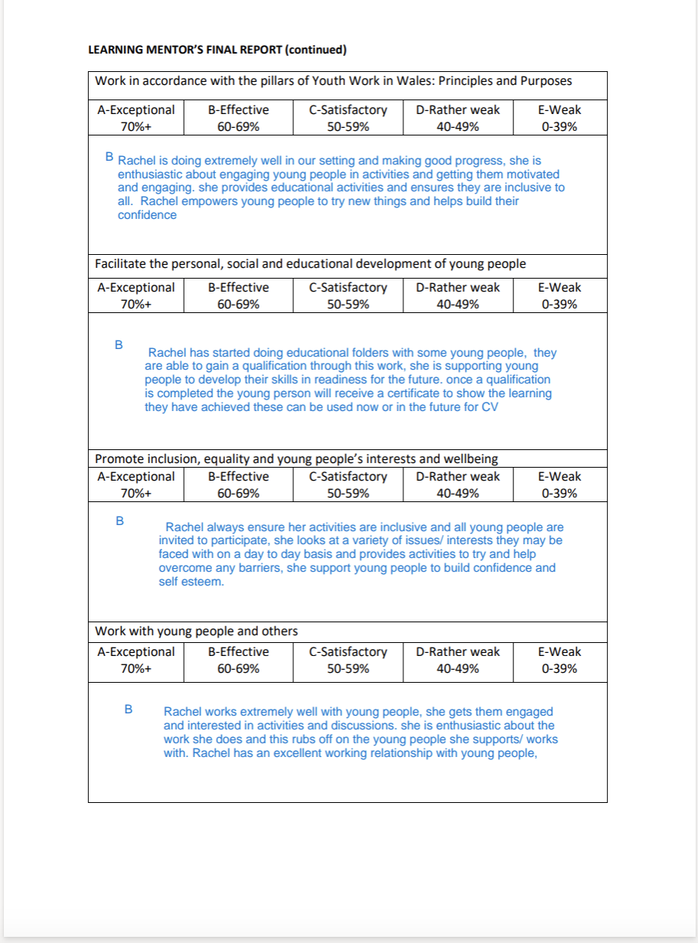
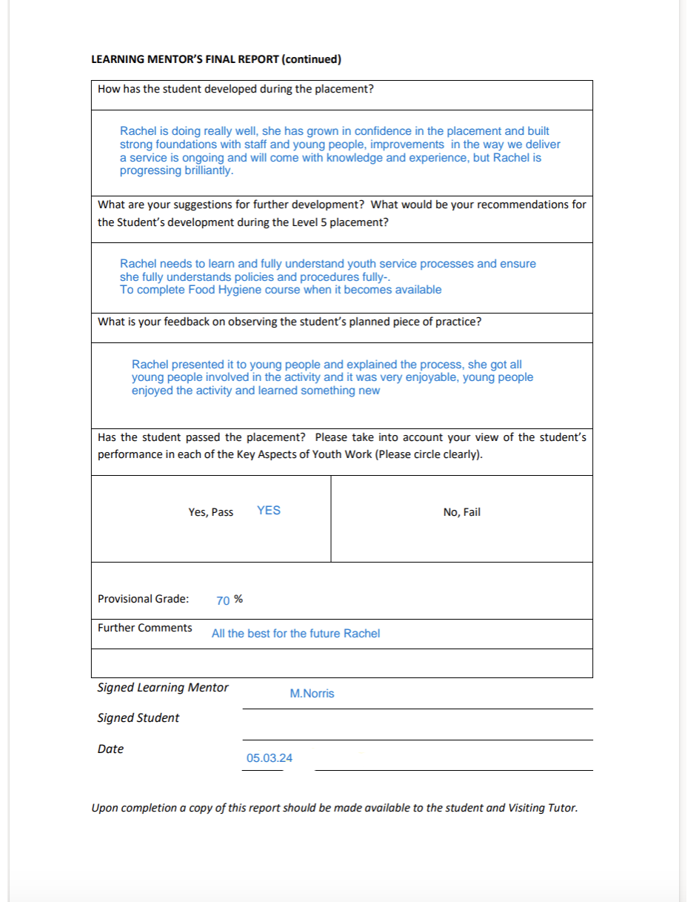

SIGNED LINE MANAGER 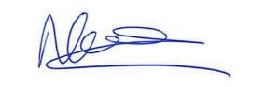

Introduction.
My name is Rachel Jones, and I am a level 4 student at UWTSD Carmarthen
studying BA Youth Work and Social Education in Carmarthen.
I will be using NPT Youth Service for my placement as well as being employed by them the past 14 months at Sandfields Youth club in an activity worker role, during this period I have had opportunities to experience different areas of the youth service in diverse settings and structures. This report looks at the area of port talbot in which I have worked in, what resources are available to young people that live within it then focuses on the youth service’s provision I for young people, its core values and outcomes for young people who engage and participate in the youth work they deliver.



(Image NPT Youth Service)

Community Profile
This community profile builds a geographical profile on the area which I live and work in, an industrial town called Port Talbot. Port Talbot classes itself as its own community situated within the wider community of Neath Port Talbot County Borough South Wales.

My research will be community focused but targeted to the young people who live within it, looking at the resources and provision available to young people, what they feel as a young people their local area offers and does well for them as young people or what they feel is lacking or unmet needs they feel they come against.

As described and written by Hawtin, Hughes, and Smith a community profile may be defined as “A comprehensive description of the needs of a population that is defined, or defines itself, as a community, and the resources that exist within that community, carried out with the active involvement of the community itself, for the purpose of the developing an action plan or other means of improving the quality of life in the community “
Hawtin and Hughes and Smith (1994, p 5).

I will be actively engaging with the young people in the local community to find out their interests, values and any key issues they feel about their surroundings and support, within their community, do they feel empowered, listened to? These are all relevant questions for the young people within our local area.

I will gather and analyse relevant and current up to date information to carry out my community profile.

The following section contains geographical information about the area.
Figure 1 map 1 Port Talbot town

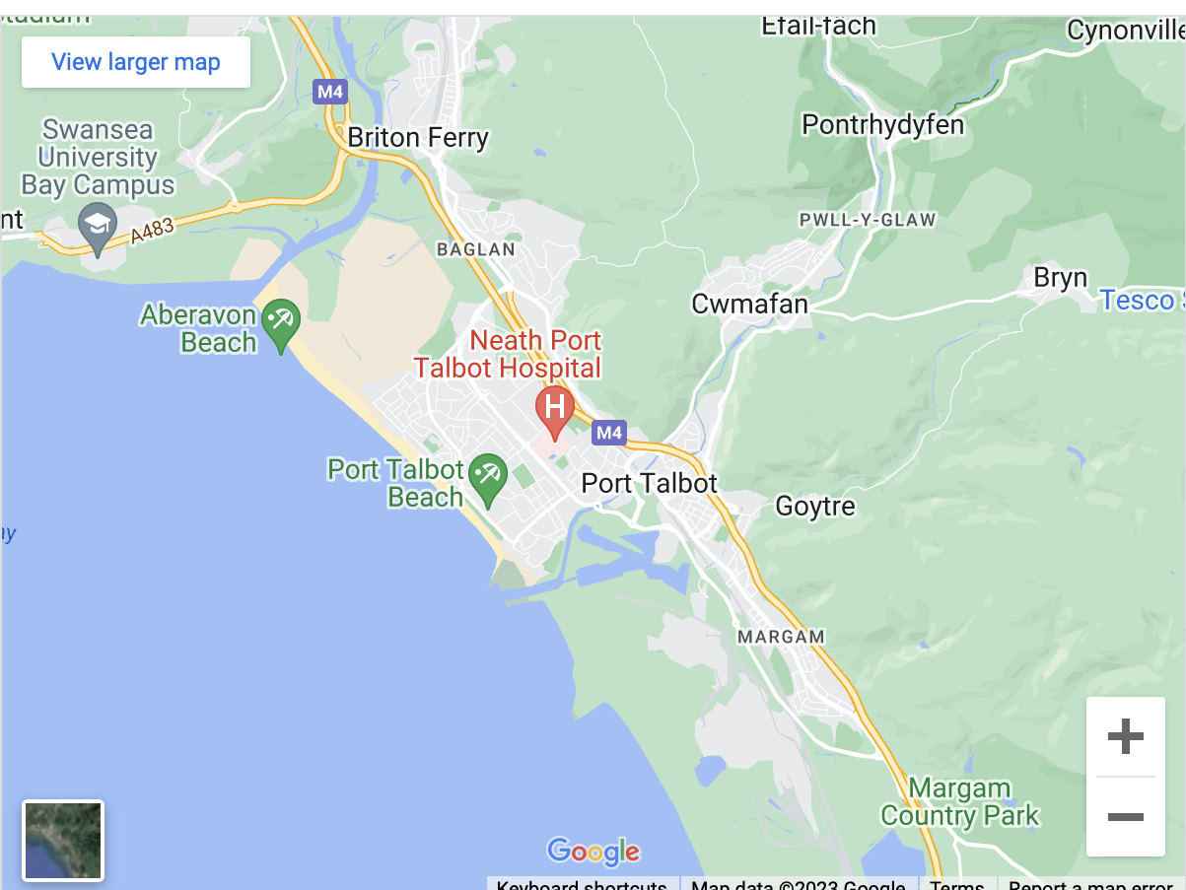

MAP 1: Port Talbot Town.
(Google maps).

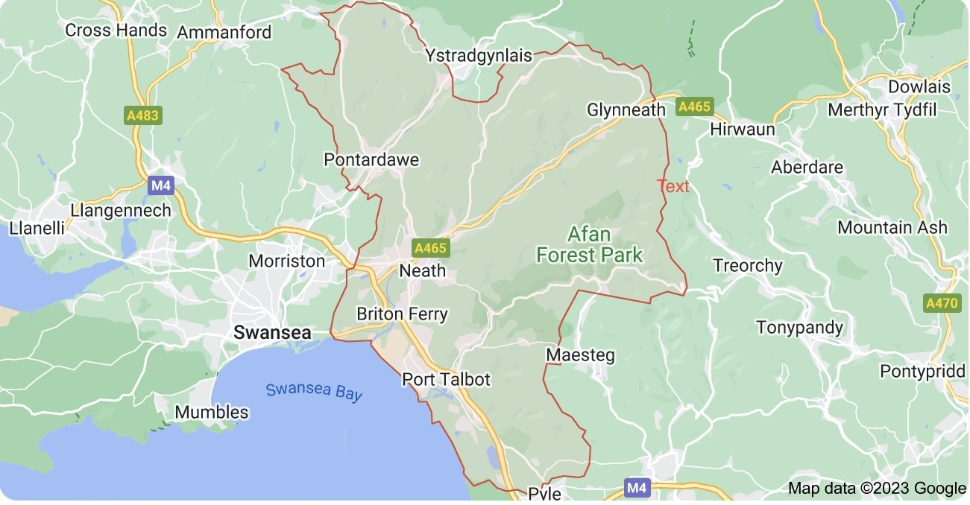

Figure 2: Neath Port Talbot County Borough.
(Google maps).

We can see from both map 1 and map 2 that Port Talbot sits right on the sea front and is a small Town situated in the wider borough of Neath Port Talbot which spans right up to the Afnan Valley.

Figure 3. population figures NPT

(CITY POPULATION, SOURCED ONS)

Figure 4. SERVICES AND RESORCES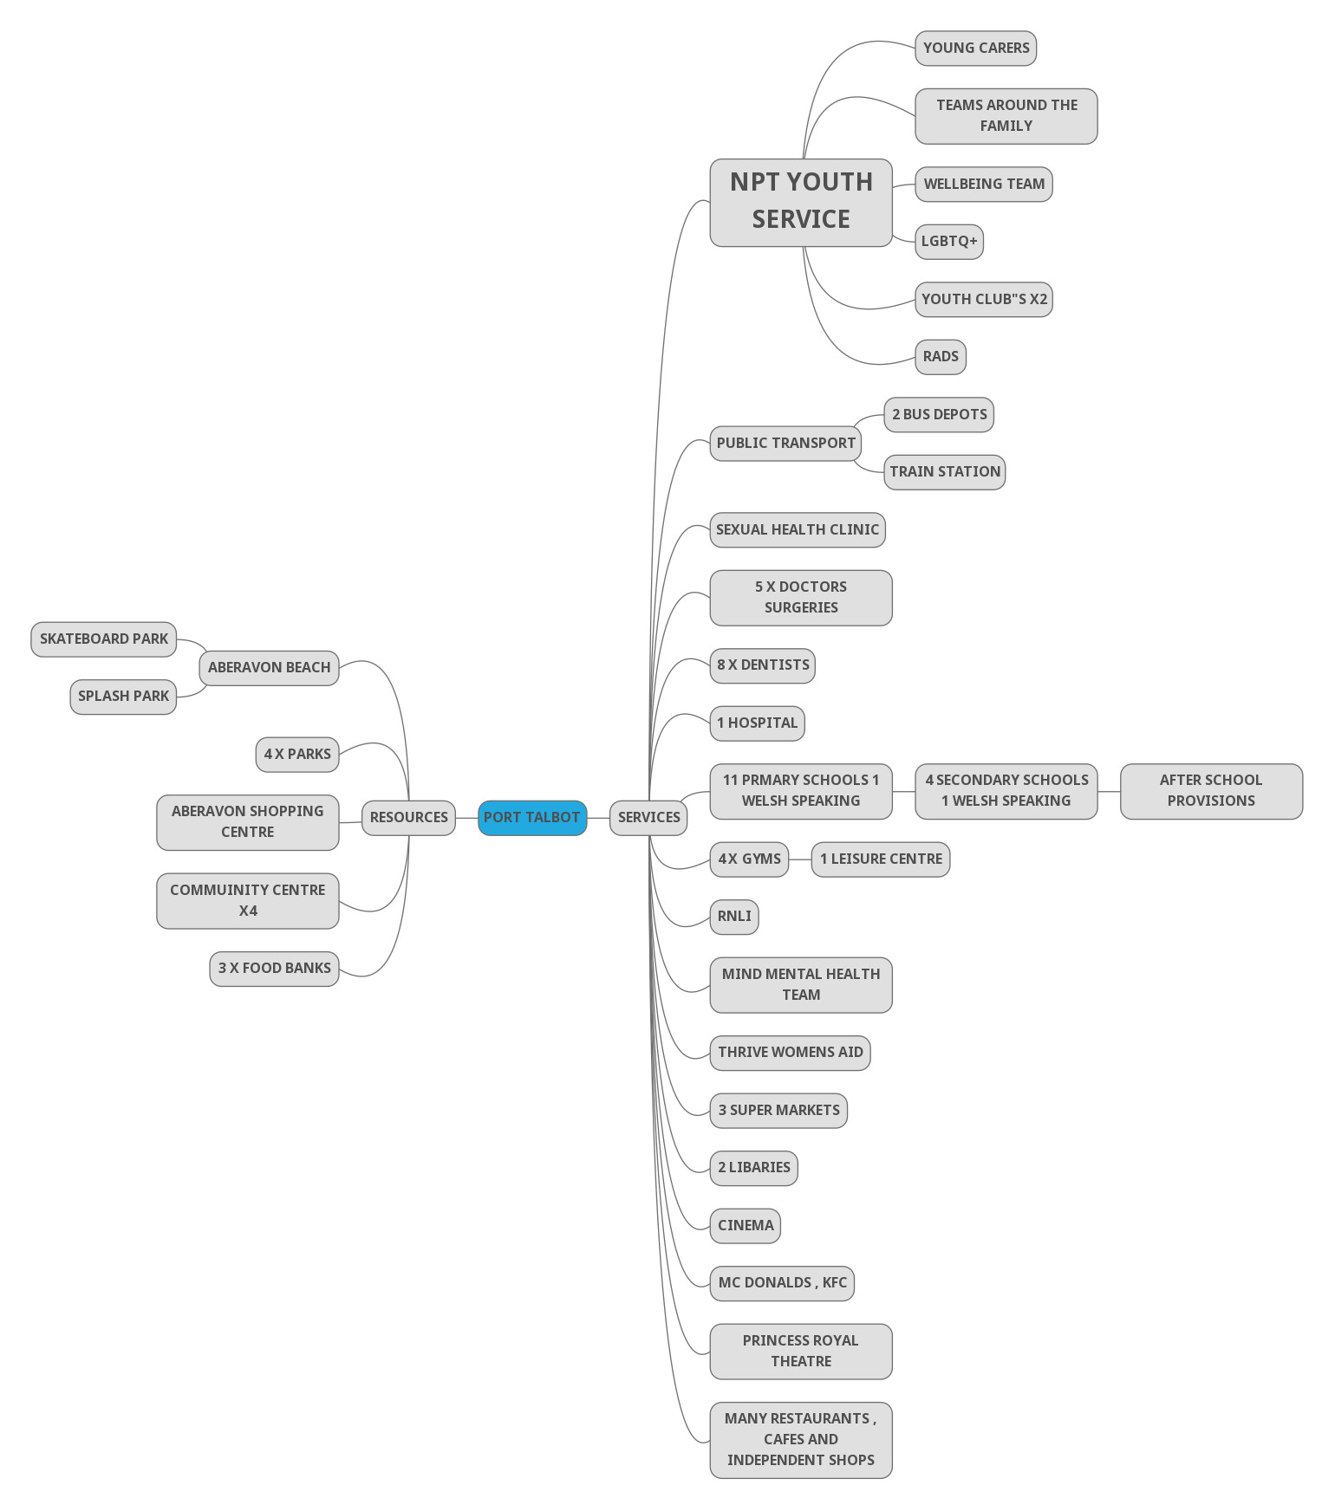 This mind map are more centred at the resources targeted mainly to young people and their lives, there are many more services and resources available in Port Talbot.

FIGURE 5; DATA OF DEPREVATION IN CHART FORM PORT TALBOT

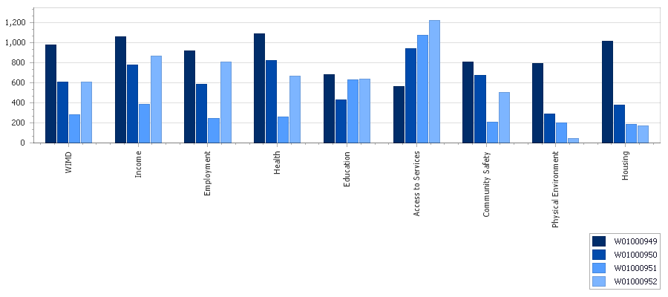
(statswales)
Figure 5.

Data taken from WIMD 2019, PUBLISHED ON STATS WALES, shows the deprivation analysis for all four wards that make up Port Talbot.
WIMD measures and ranks deprivation from 1-1,909 .1 being the least deprived 1,909 being most deprived.

It’s interesting to see that although a small area Port Talbot looks to thrive in areas such as access to services but that some wards struggle more with unemployment, community safety and health much more than others.
Port Talbot as touched on earlier is an Industrial town with TATA steel being one of the biggest employers of Neath Port Talbot.

Without the steelworks running it would have a massive effect on the employment rate within the community, as well as those directly made unemployed many small business’s such as cafes, Hairdresser’s local shops would all be affected if the threat of closure or even part closure is to really happen.

With TATA looking for investment from the Welsh government once again the community feels the pressures and stress of what might happen if the investment isn’t made and the detrimental effect this would have.

Making headlines across networks in recent weeks to go down an eco-friendlier route, which will ultimately cause job losses anyway, the impact this will have across the community will be devasting, as spoke about in this recent article below from Wales online.

(Angharad Thomas, Wales online (17/9,23).

Since starting this report further closure details have been confirmed by TATA Steel with two blast furnaces being replaced with electric more eco-friendly arcs, over 3,00 jobs cuts are expected immanently with more to follow even with huge financial support packages from UK Government. This will have a direct impact on those employed and their wider families the impact will affect surrounding businesses but also organisations such as local rugby clubs, food banks all receiving donations from TATA. Ysgol Cwm Brombil has relied on donations off TATA Steel for its Christmas present appeal for the past number of years for local families who are less fortunate so that no young person goes without.
(gov.uk)

Active Engagement
To gather research and data needed to carry out my community profile I asked a group of young people at my place of work Sandfields youth club what they liked about living in their community with discussion then turning to what they felt was lacking in the area for young people.
I explained my aims of researching the key elements of their daily values and needs as young people living within their local community.

Are they aware of services, provision or support that is offered locally, do they feel unsupported and let down by their local services.

After a group discussion I asked the young people if they could visually tell me about their community whether it be a drawing, a poster or any other form of visual expression.

See appendix 1 for evidence:

Pieces from the young people who engaged in this activity the majority expressed that if youth club was on more evenings that they would attend.
Most expressed not much to do after school and that when meeting up with friends in the local parks they sometimes are made to feel uncomfortable by people who see them maybe too old to be in the parks or a nuisance.
I questioned what a few of the young people meant by “nicer people “in their produced pieces, they all stated uncomfortableness they sometimes experience/ feel when meeting up with friends and socialising around the local community.
Youth club gives a safe space for young people to meet up with friends, socialise and engage in activities. In a safe environment.
Youth clubs used to run five nights a week which has dwindled down to just two as current.

A lot of the young people are involved in after school activities in enrichment programmes across NPT’S secondary schools which are available to all students with transport often home free of charge.

As a group we touched on the local libraries and the free sessions and activities they run such as IT sessions where young people can go and use the computers freely, maths clubs where young people can go get support with maths skills, or sessions simply for groups to meet up with friends in a safe, warm space.

Most used the free swim sessions put on Aberavon leisure centre during half term.

Evaluation

Overall, Port Talbot has good service and provision for young people living in within the community.
Young people have expressed the want for youth clubs being open more evenings as well as run through half terms especially summer.
last year all youth club provision closed 27/06/23 opened back up 19/09/23.

Although NPT pass scheme runs through the summer holidays by NPT local Authority, the provisions can range from 5-25 pounds a day or well-advertised to young people.
(NPT Council).
I plan to raise my findings with my line manager in hope of a more thorough investigation consulting young people within the local community with the help youth council to identify the need and how to action it.

Below stats from NPT youth service referring to Sandfields youth club:

(NPT youth service)

This graph shows the massive effect Covid-19 had on the youth service delivering to young people.

See appendix 2 for data evidence.

Neath Port Talbot youth service overview.

NPT youth service is a maintained service run by the local authority Neath Port Talbot County Borough. The youth Service is largely funded by the local authority, Welsh government and UK government.
The youth service covers a wide area stemming all the way up to the Neath Afan valleys.

As states on NPT youth services website the youth service work with young people aged 11-25. Its aims, values and purposes are” to give young people interesting and challenging experiences, to have fun and gain valuable skills and become an active valuable member of the community. “
(NPT youth service)

NPT Youth service has recently been awarded with a silver QMYW, A national quality award mark for youth work, and are now striving towards getting the gold quality award this coming year.

My role within the youth service for the past 14 months as an employee and now using for my level 4 placement I whilst I study Youth Work and Social Education is an activity worker at Sandfields youth club. It’s our job to plan and facilitate activities. Club is open two evenings a week Tuesday and Thursday and is free / open access to all young people.
There are vast provisions within the youth service for young people to access. Below an overview of just a few provisions as well as their main purposes, aims and outcomes for young people who actively engage in youth work provisions at Neath Port Talbot youth service.

Young Carers
A service tailored to each young person’s unique, individual circumstances and needs. Helping young people up to the age of 25 with one-to-one youth work support, opportunities and advise, help with access to other services, residential opportunities, and just as important fun, a chance to meet young people in similar circumstances, share similar life experiences.

Youth council
The youth council are a voice and representation of young people in Neath Port Talbot, they have an active role in many aspects of the local community, schools, participate in elective meetings and voice on the behalf of young people any key issues or values they feel need debating or to be heard as the rights of the young people. They empower young people to have a say and help make positive changes and decisions in and around the local community and schools.
They are a group of young people who have been voted in from various schools and colleges across Neath Port Talbot.

Neet
The NEET team are in every secondary school in the Borough. They work with Young People who are in school years 10-11 who are Not in Education, employment or training, they work one to one with young people supporting them but also have projects with aims of engaging young people in groups in various settings. I recently was able to accompany a group of 8 young people to the Down To Earth Project an eco-project that offers outdoor teambuilding activities as well as workshop woodwork skills which results in accredited level 2) ??find certificate)
Appendix put pic of certificate here!!!!!!!!

Cynnydd
Within Neath Port Talbot the project provides Youth worker engagement support in secondary schools across NPT for young people aged between 11-16 who are at risk of becoming NEET (not in Employment, Education or training). The service offers one to one support, aims to help overcome and manage issues that are contributing to the dis engagement.
Cynnydd work closely with organisations such as Npt college, skills and training services and careers Wales to help support and encourage young people onto further education or training.

Youth Club
There are 12 structured setting youth clubs in the youth service which offer a range of Informal and Non-formal education and learning opportunities for young people. A safe space to meet friends with the opportunity of participating in provision. The youth clubs offer accredited outcomes in sports, arts and crafts and Welsh with certificates on completion of individual folders personal to each young person participating.
(Appendix 3)

Sandfields youth club is one of the busiest clubs in the Borough with some sessions seeing up to 80 young people attend. The past few months has seen a high turnover of staff with as little as 3 staff members on occasion Which then makes it impossible to facilitate the planned activities. This has seen the closure of Sandfields youth club on a Thursday session with me being re deployed to Taibach Youth club which is also understaffed and struggling with anti-social behaviour which has seen the presence of PCSO” S each session.
Action is needed to employ adequate skilled staff with more than 4 needed to be working at busier youth clubs to maintain the quality of youth work being delivered.

Aside from structured settings there are Hwbs set up around the borough. Areas that report issues with antisocial behaviour being targeted. I recently attended alongside the youth council the opening of a drop in club in the middle of Neath Town Centre, there had been alarming, reported issues with knife crime around the town centre from the community so along with detached teams of youth workers the Hwb was set up to try encouraging young people to access a safe space with the offer of engaging in activities.

Detached youth work.
The detached youth work team have a bus which is converted with a seating area a TV with a PlayStation and various outdoor activities such as footballs and outdoor sporting. The team targets areas that have no structured youthwork settings or have high reports of antisocial behaviours and tensions with young people and wider community in hope of reaching and engaging with young people, finding out what they as young people need.

Duke of Edinburgh Award

As stated on Neath Port talbots youth service page “Any young person of ability, background, gender can take part in the Duke of Edinburgh award, it provides excellent opportunities and is all about setting personal challenges, discovering new interests and building new relationships”.
(Connect NPT youth).

According to the Report of the Head of Education Development for 2022 purpose report, the report states that the number of young people they worked with during 21/22 was significantly reduced due to still recovering as an organisation from the COVID19 pandemic.
With provision such as the Duke of Edinburgh award now having a backlog of young people waiting to do the award.

There are many more provisions such as LGBTQ+ groups where young people have a safe space to meet with friends, be themselves and connect with people with similar life experiences.
There is a parenting group that offers sessions for young parents to meet and socialise with people on similar journeys, there is opportunities for young parents that participate to experience fully funded trips as well as accreditation in topics such as:
•Playful parenting course
•UWTSD Parenting course
•Baby massage
•Basic food hygiene
And more.
(Connect NPT youth).

Neath Port Talbot Youth Service practices and acknowledges that delivering good youth work set by the national occupational standards as well as youth work Wales:
•Educative outcomes through styles of non-formal and informal education.
•That its expressive and allows creativity with challenging opportunities.
•Treat young people with respect and partners in their own journeys and decision
Making process.
•That all provision is inclusive to any young person of any gender, disability, background. The Youth Service promote Equality and inclusion.
•Empowering, with the vast diversity of provision within the youth service there to support and empower young people and their individual needs, championing their rights through the youth council and encouraging personal growth and opportunities.

(Wales Review Group, 2022)
(CLD Standards Council Scotland, 2019)

The youth service has strong partnership organisations to signpost young people to for extra support, working closely with organisations such as:
•skills and training, which offer further education such as apprenticeships.
•Thrive Women’s Aid.
• Dewis Port Talbot a charity organisation that supports young people to live
Independently and safely.

Reflection of own learning.

My overall reflection of my time working with the youth service and volunteering in different settings is an overall good positive experience.

The work they do to empower, support and educate young people, to listen and encourage their voice to be heard, to constantly be aware of the local need and community through things such as the youth council and more targeted provision groups such as LGBTQ+ and young carers to see first-hand is inspiring.

The relationships I witnessed between young people and the youth workers are mostly strong, trustful and respectful, meaningful relationships which transpire in the success of the youth service.
Towards the end of my placement and employment as an activity worker my experience working in Taibach as well as Sandfields youth club was not such a positive one, the feeling of frustration in some of the engagement from youth workers with young people was quite deflating and hard to see. There seems to be many staff that are not youth work educated but have worked at the clubs for a number of years and have lost the passion for the job. To some degree I can see why they are frustrated as they don’t feel supported by senior staff, have high turnover of staff with Taibach’s building also in disrepair but this frustration shows in the manner they engage with the young people, witnessing minor incidents escalate into heated situations from youth workers approaches ,young people even being banned as a result as they have reacted to the abrupt most of the time unfair manner in the way they were approached, embarrassed in front of peers, challenged and chastised.
I feel there is not enough support or involvement from senior members of the youth service, staff feel overwhelmed and more like security than youth workers there to try facilitate activities, offer opportunities and build positive relationships with young people.

I have learned the importance of the relationship between youth worker and young person is a core element of successful youth work. That the way we approach and engage, our behaviours and values all contribute to the success of the long lasting meaningful trustful relationships youth work centres its core values on. As Kate Sapin describes respecting young people’s boundaries knowing that not all young people want to go to youth club to participate in activities but just somewhere warm to meet up with friends.
(Kate Sapin, p 65. (2014).

I feel more confident in planning and facilitating activities being more informed and recognising in line with the national occupational standards “that every young person is on a unique journey, and all have different life experiences, youth work starts at whatever stage the young person is in their journey and can dis engage and re-engage at any time”.
(CLD standards council Scotland, 2019).

Using reflection by journaling with GIBBS reflection method has allowed me to measure my growth and journey through my level 4 and evaluate my strengths and weaknesses.
I feel I have good communication skills am very approachable. Also recognising written by Gerald and Gerald and Yin Foo “every young person is unique and on their own journey through adolescence with different life experiences and challenges”.
Being empathetic to these challenges young people face.

I look forward to utilising these skills in my next youth work setting on level 5 placement, experiencing different settings and styles of youth work. To develop further in my practice and deliver good youth work building on both my strengths and weaknesses.

Reflective Recordings

This chapter is made up of Reflective Recordings in the form of Reflective Journals using GIBBS Reflective Cycle Method in each journal.
Below 12 Reflective Recordings.

Tuesday 14th October
Journal 1

Young People Turned away from youth club tonight, the reason given was that we were not taking on any new members and are at capacity, I know we get high numbers of young people attend club but I feel the way it was handled was not great, sending some young people away when they have come with friends who are being let into club feels wrong also the senior worker let some in and not others which really was not good and I felt really awkward over as I felt I had no say in the situation. One young person phoned home to be picked back up others simply at least 3 others just walked off on their own into the dark cold night after being shouted at to not go until they had phoned home.
There needs to be better advertising informing young people and parents/guardians that we are at capacity and for now not accepting any new members, A poster on the door of club, social media notices and workers not picking and choosing who is in or not and if they can’t come in, they are told in a respectful appropriate manner.
It is cold and dark at 7pm. I would not feel great if my daughter who mis also a young person was left out of a group and not allowed into youth club then spoke to and shouted at in such manner.
I was shouted at that I had let someone in who hadn’t been before to which shocked me, I’m not used to being spoken to like that and didn’t appreciate it at all.
I learned once again to not speak my mind openly at the time of the situation even though I was furious as this has happened before. I suggested at the end of night brief that going forward we need clarity on how many young people are allowed into youth club and that better advertisement is needed for the young people and parents/ guardians to know what is going on also.

Thursday 16th October
Journal 2

A busy night in club tonight. I had noticed a young person had secluded himself in a corner and looked a bit lost and sad. I felt a bit concerned as this young person is usually having a laugh with friends playing basketball. I went over and asked if he wanted to go have a game of basketball which he replied he didn’t with no eye contact made so I sat down opposite to where he was sitting and asked if he was ok to which he replied no, after a few minutes he asked me if I ever missed anyone that wasn’t here anymore to which I replied yes, my grandfather. He went on to explain to me how he had recently lost his gran and missed her, we had a conversation on how its ok to be sad and miss people and they will always be in our memories and thoughts, but it does get easier.
I let him know he could talk to me if he ever needed to as he expressed, he felt nobody listens.
I feel I approached the situation gently which allowed him to feel comfortable to open and talk to me, I reassured him that everyone has down days and its perfectly fine but to always talk to someone about it whether it be a friend, family member teacher or staff at youth club that it would make him feel better than bottling everything up.
I listened and let him leads the conversation which allowed him to express his feelings and share openly.
After the conversation ended, we went to play basketball, I feel he left club much happier.
I was worried I wouldn’t say the right thing, I lack confidence worrying I could say something wrong.
I know this will ease with experience as I develop as a youth worker.

Tuesday 17th October
Journal 3

A bust night in club tonight over 70 young people attended. I was in the craft room tonight playing Uno with a group of young people. The worker who is usually in the craft room was also in there with that one of the other workers walks through and comes to show me mindful colouring pictures she thought would be good for Halloween for the young people, moments later the leader’s wife who is also a worker and started shouting abruptly why are there 3 staff members in one room in front of the young people.
I was really taken back and a little embarrassed if I’m honest I feel out of all the workers she does nothing and if she was concerned could have gone into the sports hall herself. There was no need to speak and raise her voice, I am there to gain experience and situations like this which are becoming more often are really putting me off, I am trying not to react to situations like this as well which is hard, usually I would have said something like “why are you speaking like that”.
I feel I will have to raise the issue if this behaviour continues, this member of staff clearly doesn’t want to be there and it’s affecting the whole staff. I feel deflated and angry., it’s a shame because I really get on with her and know she is abrupt by nature but to direct it at staff in front of the young people is too far.
At the de brief at the end of the session I felt so awkward and couldn’t wait to leave I couldn’t even make eye contact with the worker in question. 9pm came and I walked straight out of club.
I won’t be able to continue at the club if this keeps happening.

Thursday 19th October
Journal 4.

I was not looking forward to club tonight with everything that is happening the past few weeks and the atmosphere. I entered and said hello then went about setting everything up. The worker that last week was abrupt asked me to help her sign the young people in which I was shocked at as she usually asks the same person every week and have been shut down and told no previously when I’ve asked if I can help sign the young people in. As we walked across the sports hall she apologised for her attitude on the Tuesday and expressed that it wasn’t aimed at me she said I was doing really week and she really likes me, I appreciated her apology which I told her I was grateful for and that I was taken aback by the outburst. I felt lighter immediately.
I think I dealt with the situation well, I’m glad we both acknowledged she didn’t behave appropriately but also, I’m glad I didn’t react on the night it happened.
This conversation led to her expressing that her and the leader are handing in their notices and that they have been doing the clubs for 30 years and it’s time to go. She looked so much lighter tonight which I told her obviously making that decision ids the right choice and time for them both.
I do really like her as a person but know this is the best decision for her.
I’ve learned not to just react and jump into a situation gun blazing I’m glad I stepped back, reflected and processed my feelings which enabled an effective conversation to be had to resolve.

Thursday 26th October
Journal 5.

Tonight, I have planned hot dogs for club. I’ve been out got all the stock needed and have gone early to set everything up and prepare.
I really enjoyed tonight’s session, all the young people loved the hotdogs and as number of attendees wasn’t as high as usual the young people were able to have multiple hot dogs.
Everyone mucked in setting everything up then I took over hot dog duty and the tuck shop.
It went well as I was as prepared and organised as possible although the last-minute panic over a tin opener as I didn’t realise that the tins of hotdogs weren’t a pull ring tin was quickly resolved as we borrowed off the school.
It was a chilled night and a good team effort by all.
I need and want to do my food Hygiene course soon to deliver more food sessions I’d like to encourage club to run more sessions around cooking and baking.

Thursday 23rd November
Journal 6.

It’s the new leaders first night tonight, she has been in last week shadowing the old leader, she seems lovely.
Frustratingly we have no tuck for club tonight. This is an issue which has happened on a few occasions, the senior worker that’s duty and job is the clubs can take weeks to get the money for us. Our club sees a lot of sport and some young people can play football or basketball for the whole session, we need drinks available.
The lack of tuck especially drinks can see high numbers of young people leaving club to go to the shop then return.
We did manage to get some cups off the caretaker for the water machine in the school.
I mentioned to the leader about asking the senior staff member again for money and that I would happily go get the stock ready for the next session.

Tuesday 28th November
Journal 7.

An incident tonight by the ping pong tables, I noticed a few young people being a bit confrontational with another young person, I went over asked if everting was ok and could overheard football being spoken about. The young person this was being directed to was not engaging back in the conversation and continued to play ping pong , I asked the group being a bit loud to go back and play football, I asked the young person if he was ok and what was it about which he replied that he was nus3de to this particular group being a bit unkind to him in school and during football matches as they play on different teams , he assured me he was fine and they didn’t bother him and they were sore losers because his team had won the game of football they were referring to.
I kept an eye on the young person the rest of the session and asked numerous times if he was good.
As we packed up at end of club a man came into the hall asking to speak to the person in charge, it was the young person stepdad who went onto say that his step son was being bullied , I told him what I saw in club that night and I mentioned two names of the young people that were involves as the stepdad was stating its happening all the time everywhere he goes and it can be of a racist nature as well to which I replied I only heard the conversation of a football game.
The leader assured the stepdad she would deal with the situation and now be vigilant and let him now the young person can come to any member of staff at any time with any concerns.
I felt I didn’t have time to tell the leader about the situation before dad came in to club, I didn’t see the bigger picture and assumed it was over football, I felt bad I didn’t realise it was an ongoing issue , when the dad left my colleges also pointed out to ,me that I had mentioned two young people’s names that were involved in the situation and that I shouldn’t of .
Even though dad was aware it was those I had said.
I have learnt to pass onto the line manager however big or small a situation may seem and to be more aware of using young people’s names.

Wednesday 29th November
Journal 8.

I had to put together and present my first ever PowerPoint today at university.
This week has been hard, not only trying to suss out how to use PowerPoint and prepare the content for my presentation but juggle my fulltime job, placement has been busy and family life hectic.
I have felt overwhelmed and stressed.
Getting to grips with PowerPoint although not visually great compared to the others in the class I was really chuffed that I did it.
The actual presentation making was ok when I got into it and sussed it out, my computer skills are growing, hopefully I can build on my visual effects and not stress to much next time as I know il have many more to do.
I need to manage my time better next year around this time, Christmas is busy for the hair industry, I need to set boundaries with my time and stick to them, which I have not done this year at all, I need more balance in my life.

Thursday 30th November
Journal 9

When I arrived to set up for club asked the leader how she was going to deal with Tuesday’s incident, she firstly spoke privately to the young person who was affected by other young people Tuesday. She then asked me to separately call 2 young people to see her in a private area.
Both the young people came out of seeing the leader confused to what she was talking about asking me what she was talking about and about who.
One of the young people in particular was upset and really didn’t get what he had done wrong.
The way some young people speak is offensive which doesn’t register at all with them. I feel young people’s backgrounds and what they are surrounded by as part of their everyday lives is mirrored and normal to that individual.
I’ve learned young people’s circumstances shape who they are, the way they speak. How offensive language is offensive to some young people but others its in their everyday vocabulary.
More education is needed racial, homophobic, offensive behaviours. A workshop in club around these areas which I have raised to the leader is a good first step forward.

Tuesday 9th January
Journal 10

Tonight, was the Preterm planning meeting over Dwr Y Felin School in Neath.
I feel excited about the term going forward. The new leader is very enthusiastic, even though we a short staffed. We filled out the calendar with loads of cooking sessions which I have been trying to plan for ages.
This change of leader can be the turning point for club with more structure and opportunities for the young people.
I have agreed to work on the arts and crafts accreditation folders with the young people.
It’s refreshing to have more structure and positivity going forward into the term after what has been a rocky couple of months at club where I have not really been enjoying the experience and doubted if I even wanted to be there.
I plan to keep trying to facilitate activities, hopefully the staff issue will get better soon, it is hard to run activities when there is 3-4 staff and 80 young people.

Tuesday 6th February
Journal 11.

We had 3 injury incidents in club tonight. We hadn’t been in session for 15 minutes when one young person knocked his 2 front teeth out playing football.
It was awful he was really panicking. Leader phoned home, dad came to get him, dad didn’t react very well and was also in despair which was making the young person panic even more. Later on in club his mum had messaged an old member of staff to ask the leader to phone her.
The young person had told his parents he had slipped on wet on the sports hall floor.
What happened was he was playing football and pulled at another young person’s shirt which resulted in someone falling on top of him which he then hit his mouth on the solid gym floor. This was relayed to mum and the fact that no drinks are allowed into the sports hall.
I felt sorry for the young person it was awful, he was really panicking to which we tried to calm him down and stop him looking at his teeth on his camera on his phone.
WE had another 2 incidents with football which resulted in a bleeding nose and a bruised eye, both of which were dealt with then they both resumed playing football.
I’ve never seen so many incidents in 1 night, it was crazy.
I feel you can limit risks in certain areas but playing a game of football nobody is to know that would have happened and I don’t think anything could have been done to prevent any of it. No incidents were malicious or intended to cause harm just accidents.
Accident forms were filled in with details of each incident.

Thursday 22nd February
Journal 12.

Sandfields youth club has been shut for a Thursday session due to being short staffed. I have been asked to work in Taibach youth club which has also been short staffed and had serious anti-social behaviour issues with some young people.
The staff are lovely I have met a few when they have been deployed to our club when Taibach has had to shut due to the anti-social behaviour issues.
The building is old, I remember attending youth club here as a young person.
I took along my daughter and 2 of her friends as she used to attend regular to club but stopped as she said it was boring and there was to much bad behaviour there.
We did Pyrography in the art room. The worker with me said how nice it was to do an activity and that they have been so short staffed and had so much bad behaviour at the club that it has scared the younger young people who would usually engage with the activities being put on she referred to them as “the good ones”, the good ones are put off coming there.
It is a shame to see that this club is also struggling with staff issues also, how activities can be run when staff feel like they are just babysitting because not enough staff to run activities while they still must keep an eye on young people not participating also that’s without any known antisocial behaviours.
More staff is urgently needed for the clubs to continue to succeed.
The Pcso’s are calling into club each session, also the youth service has arranged a member from the youth prevention team to attend each session. I spoke to one and he mentioned putting on workshops on things such as gangs, bullying and so on.

SIGNED LINE MANAGER

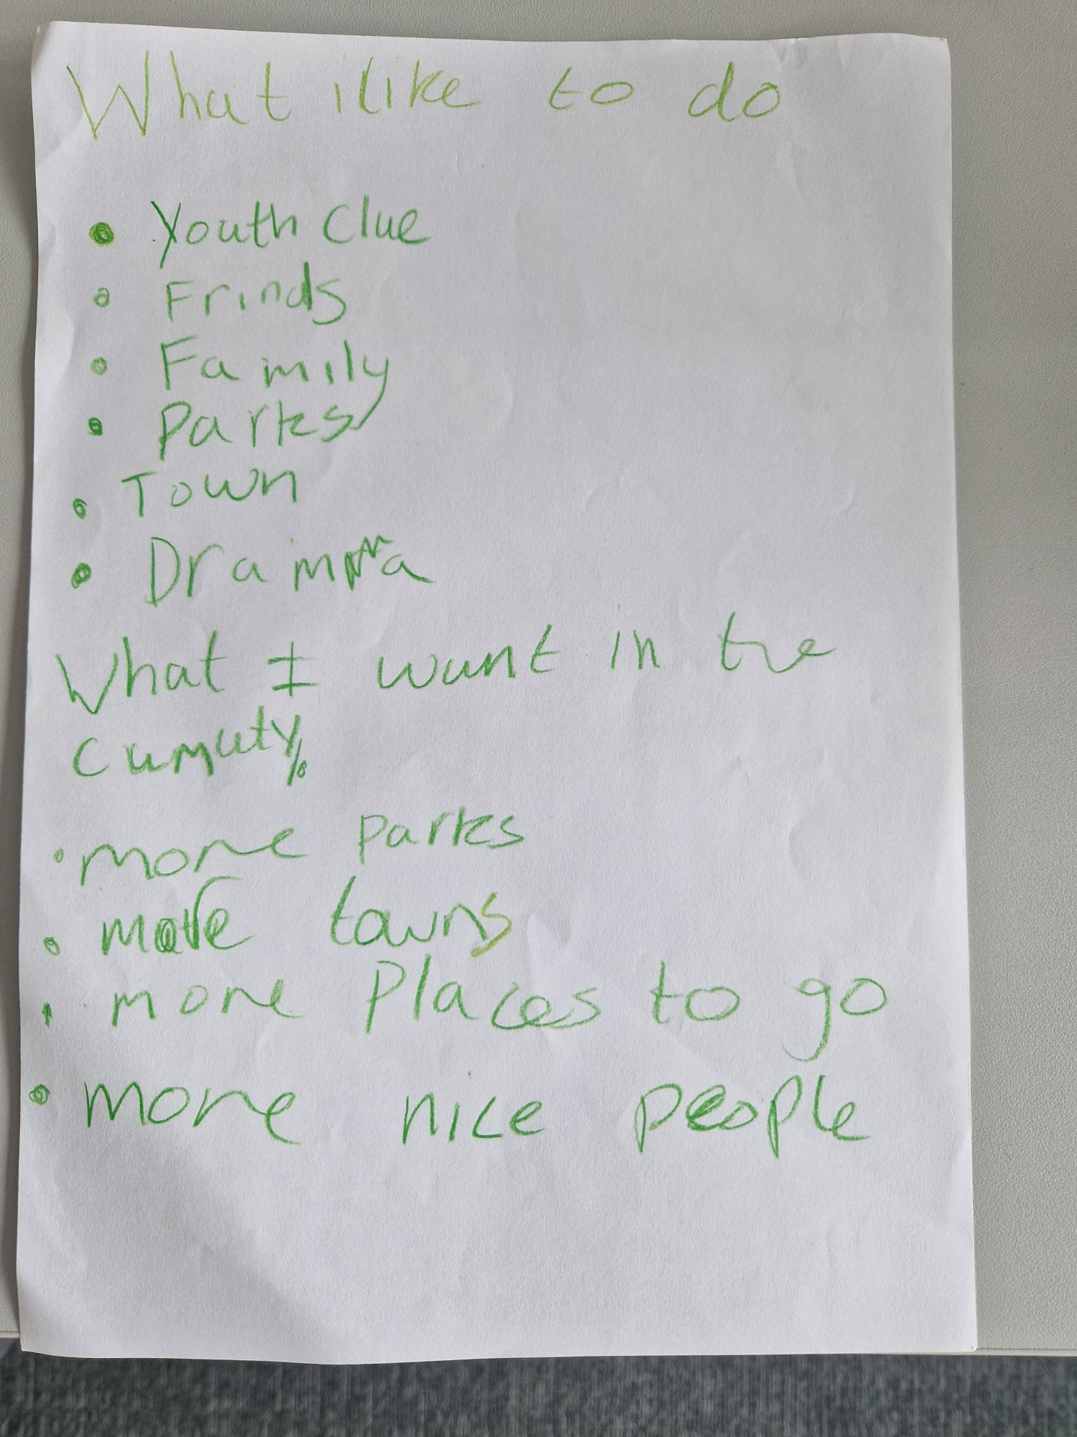
Appendix 1

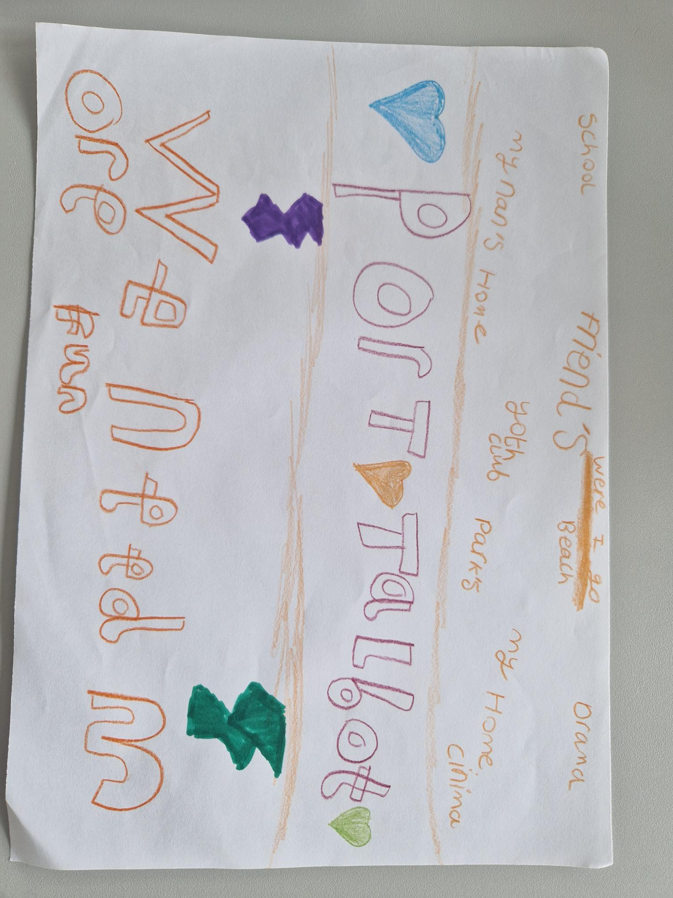

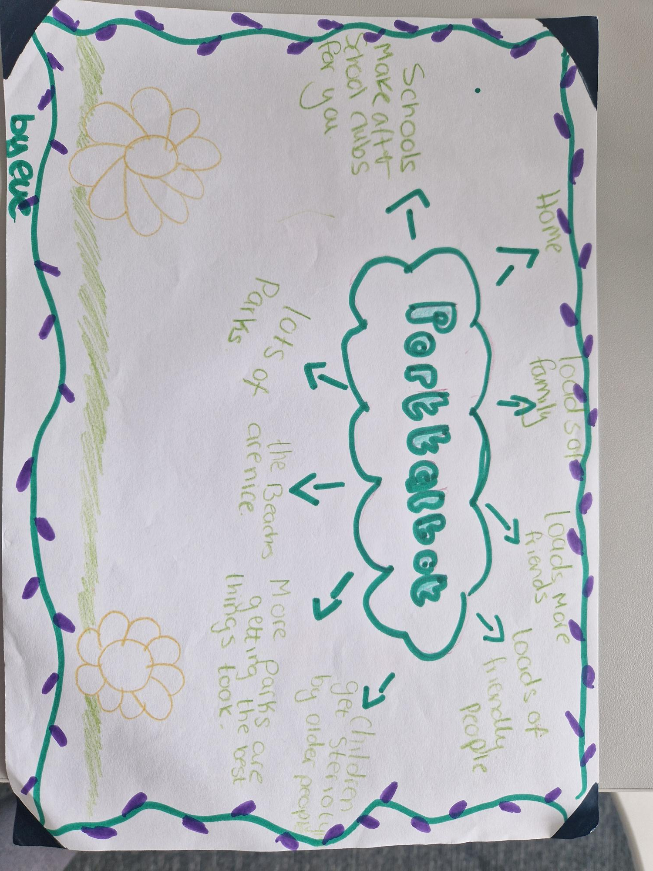

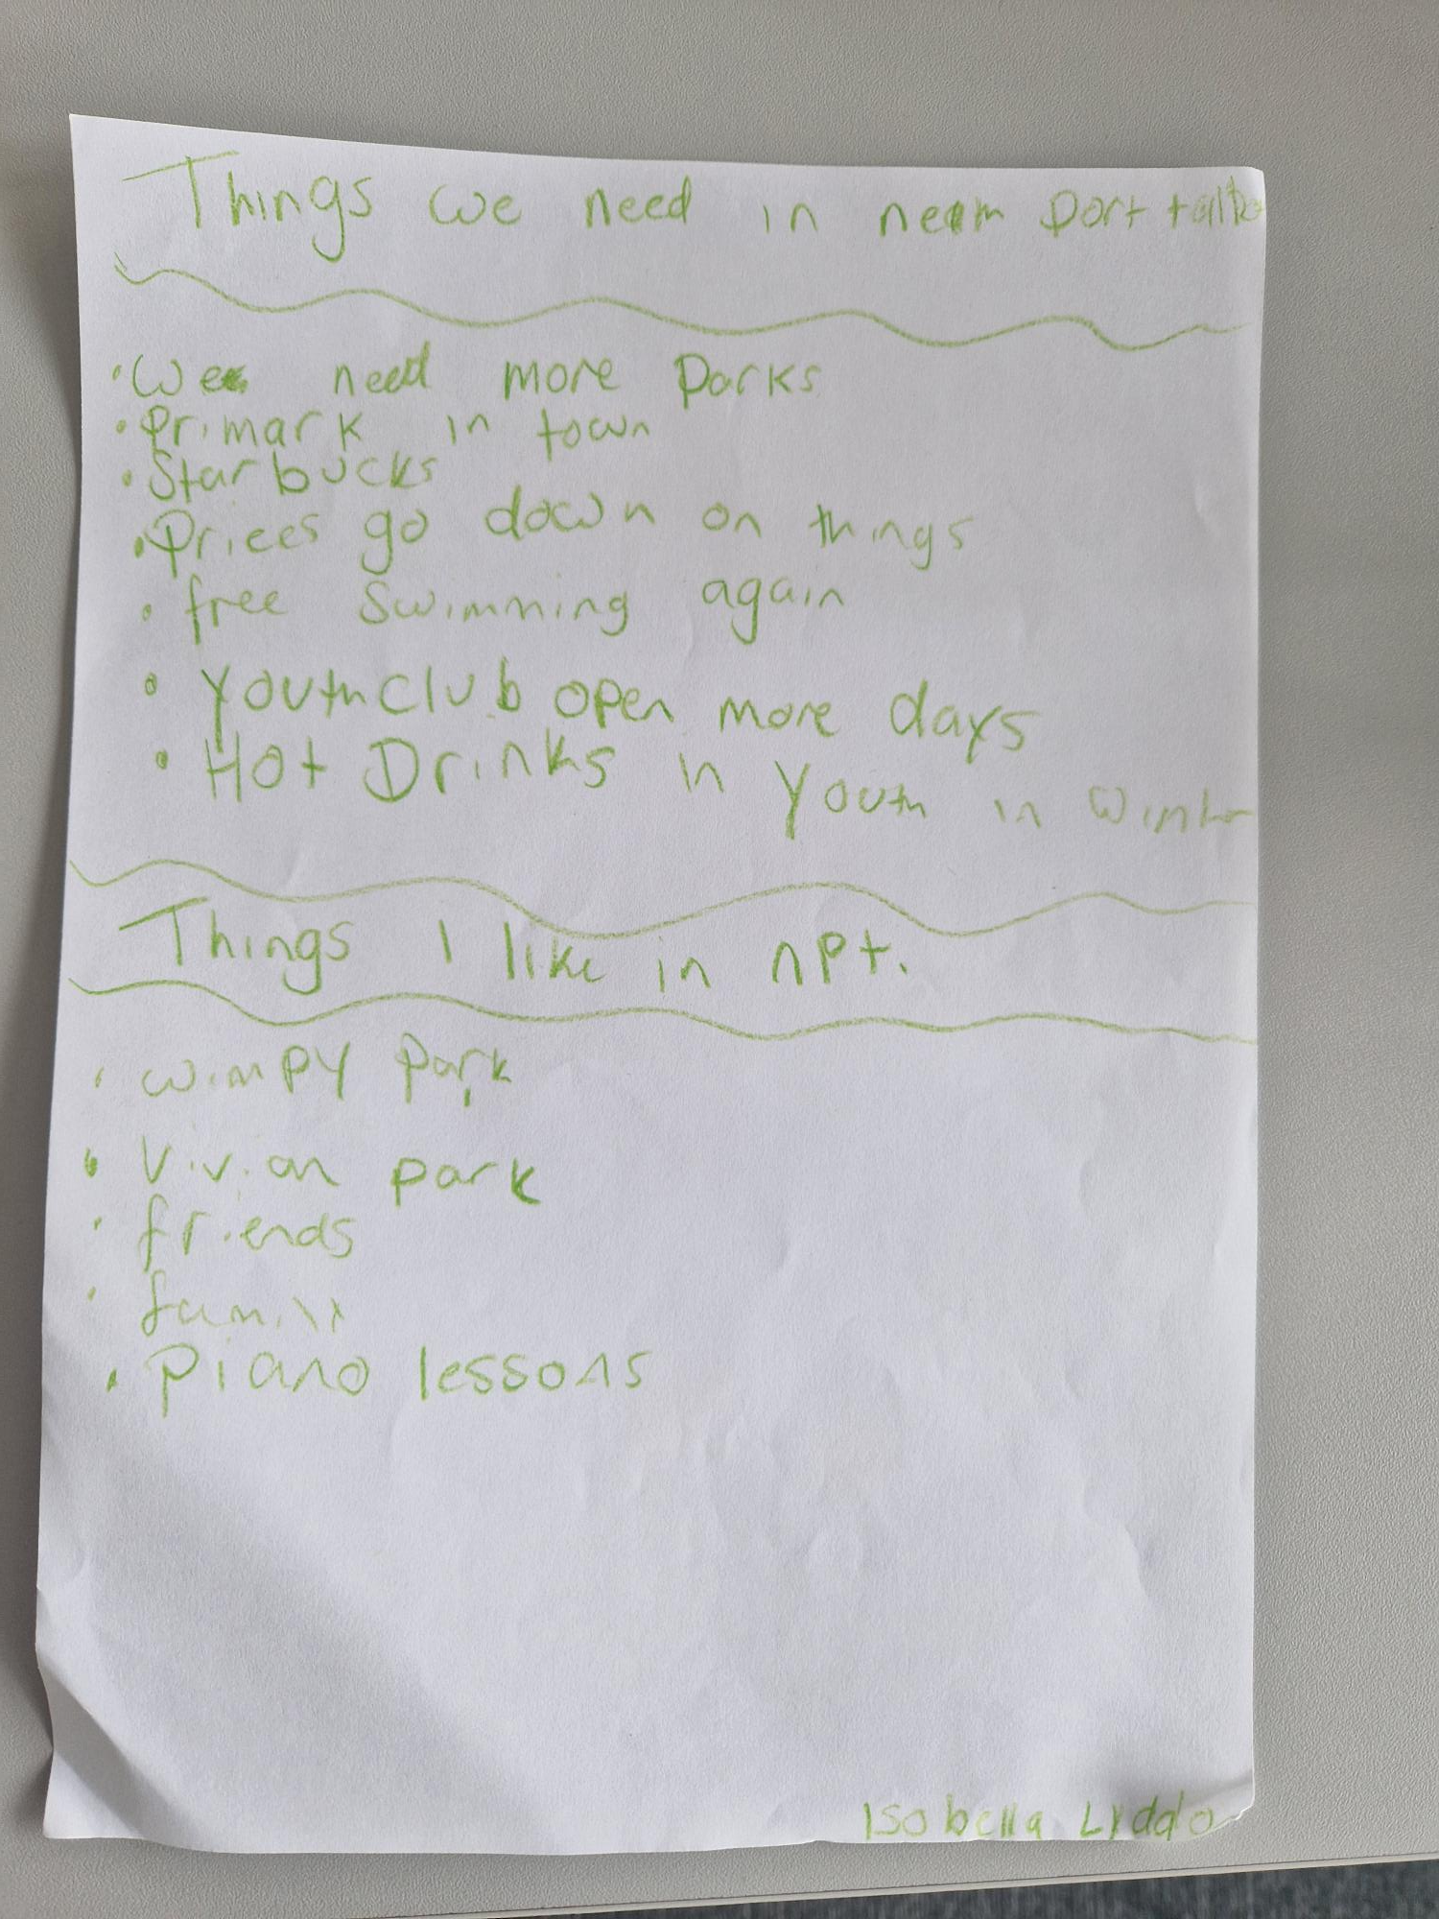

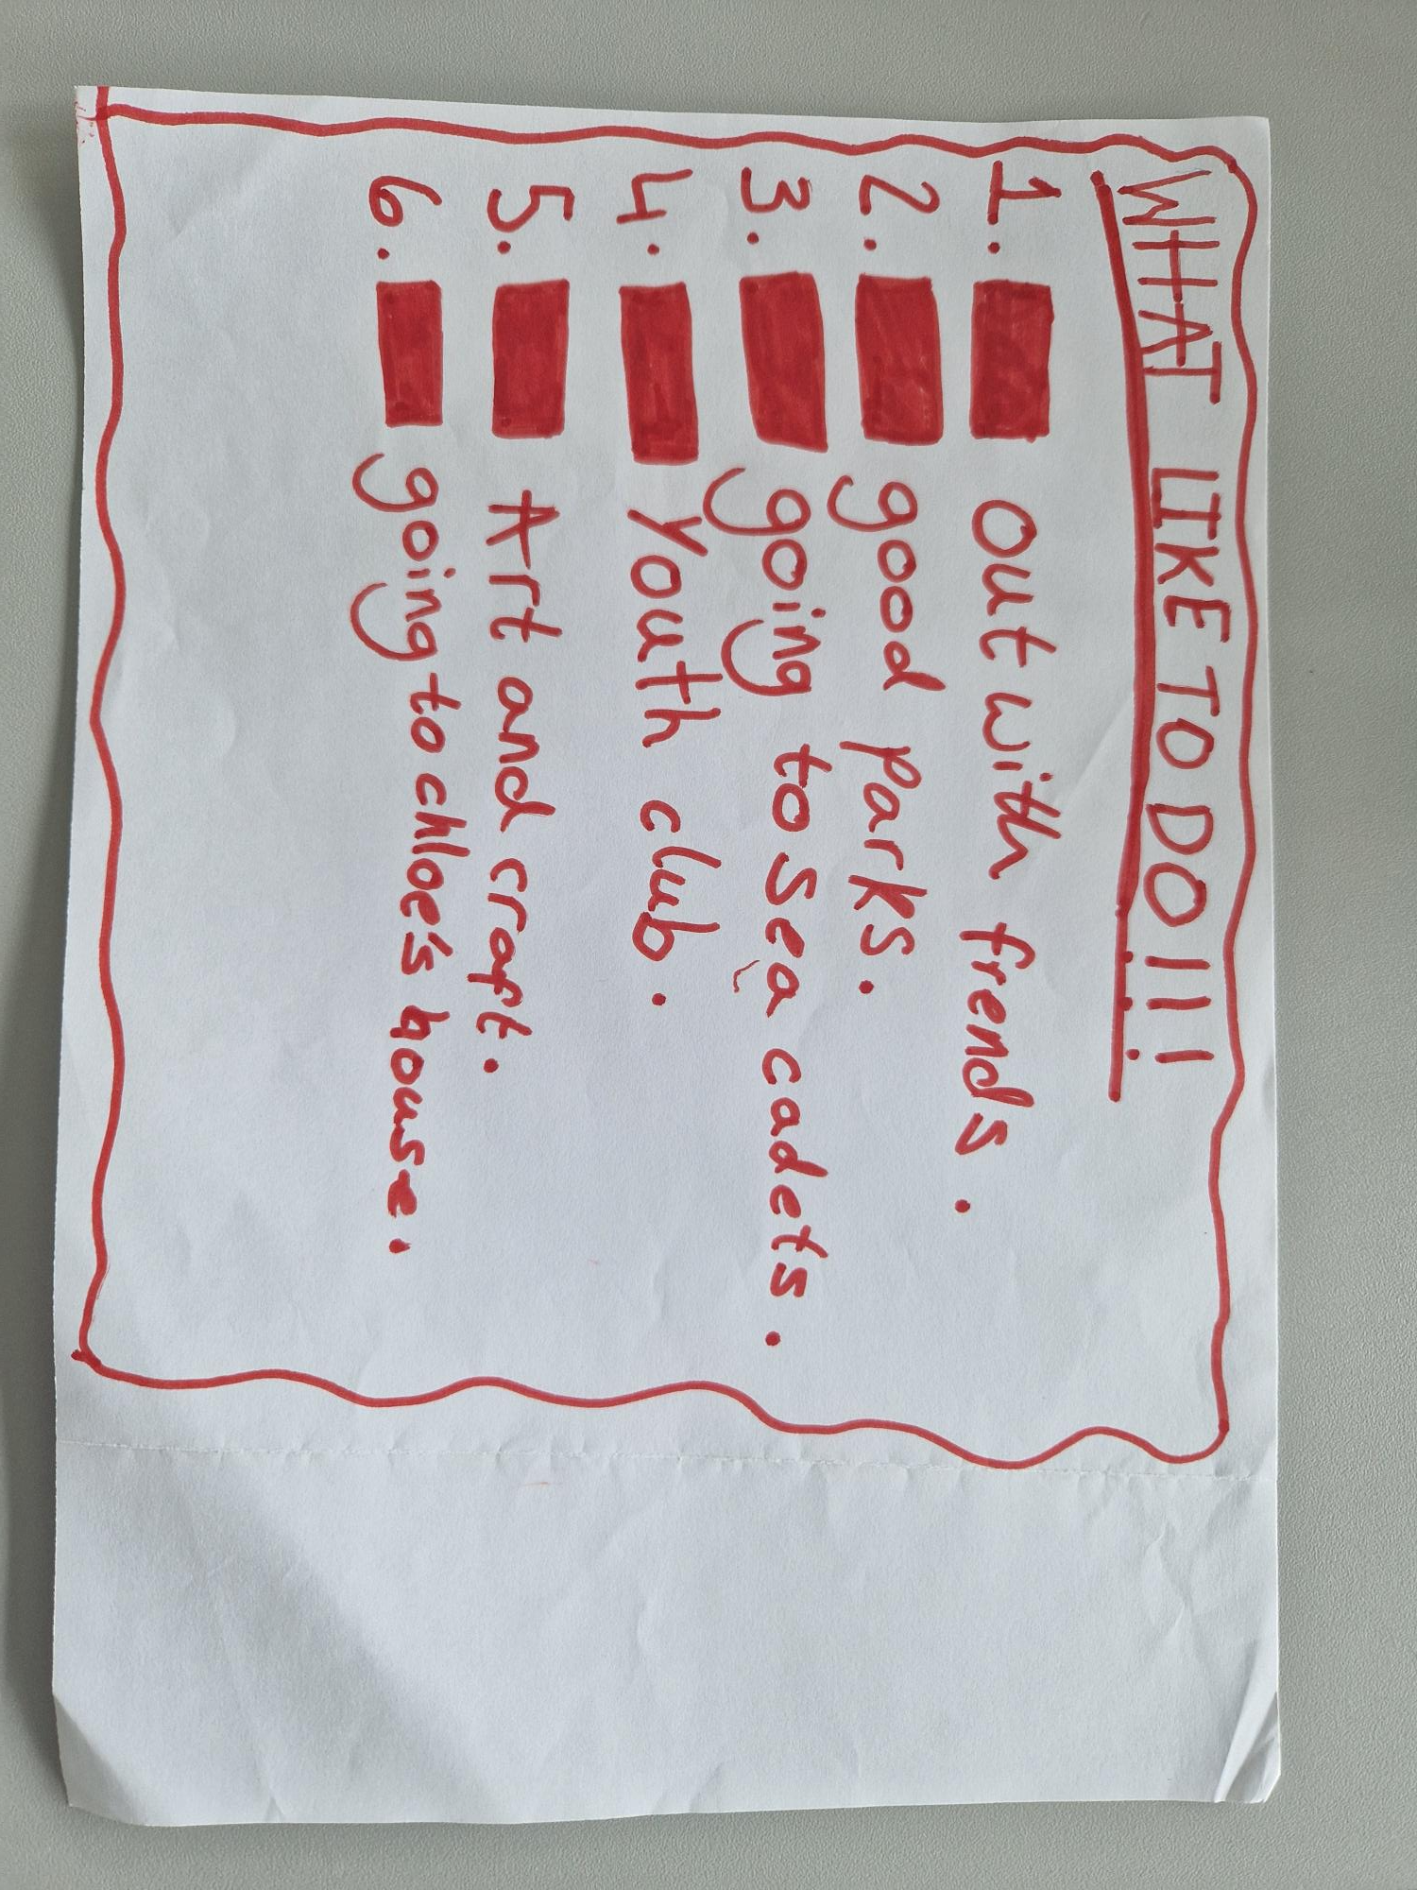

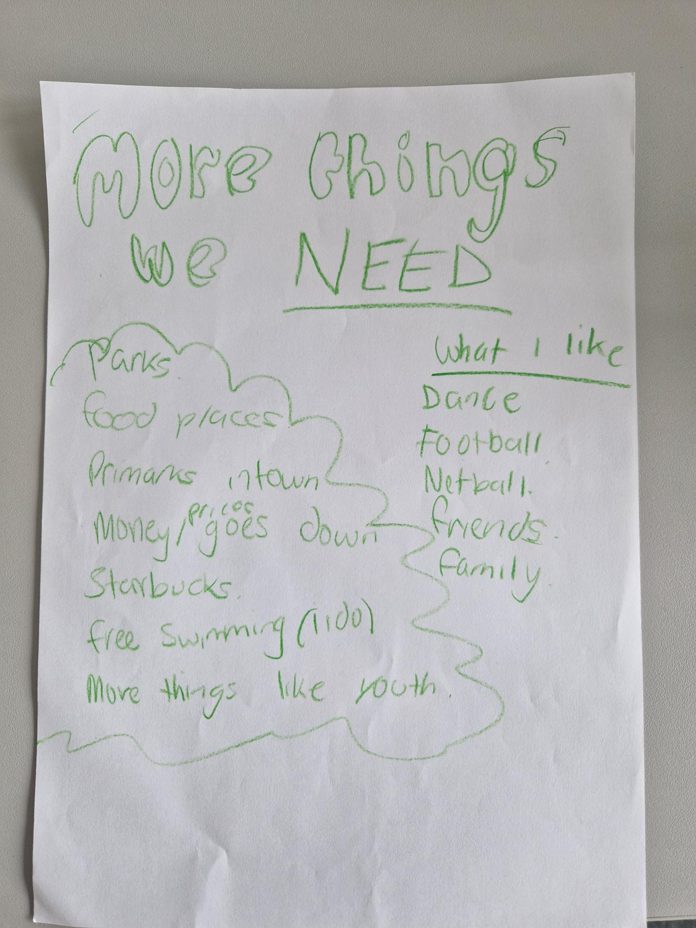

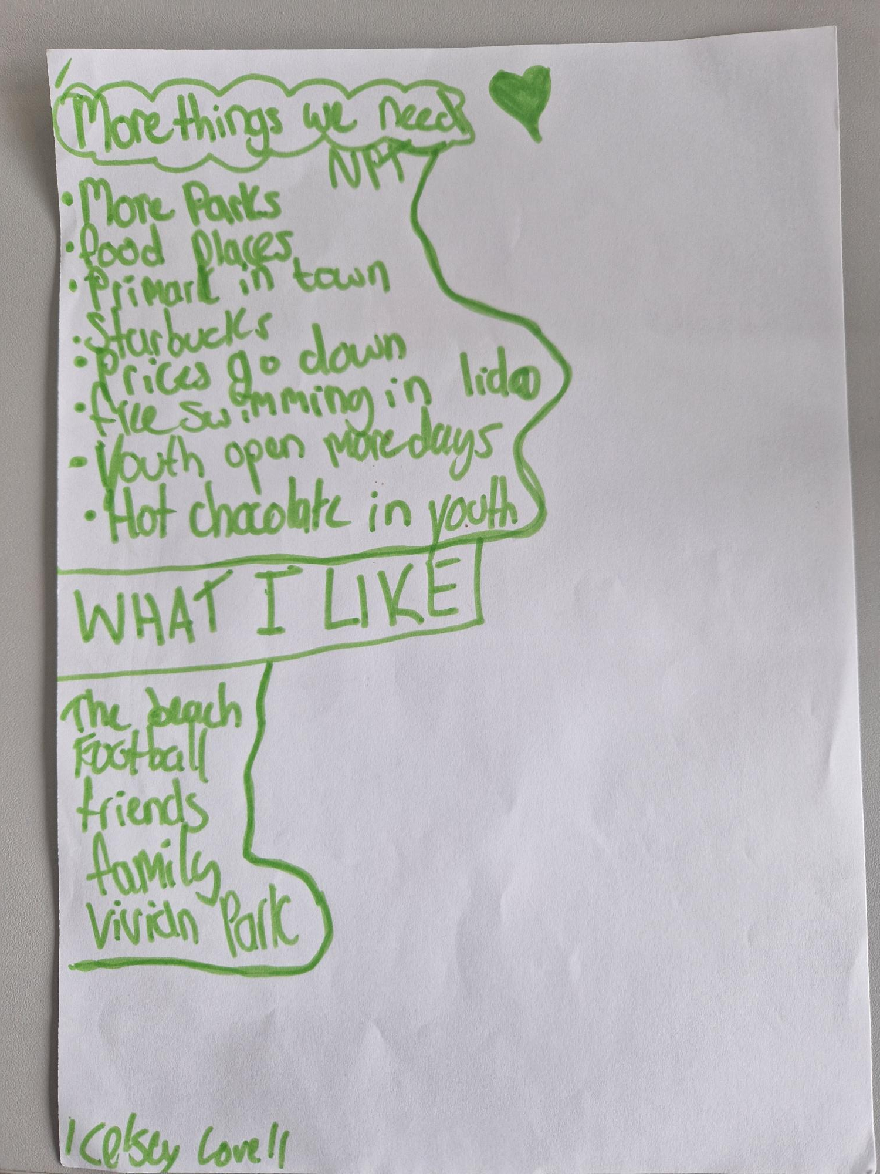
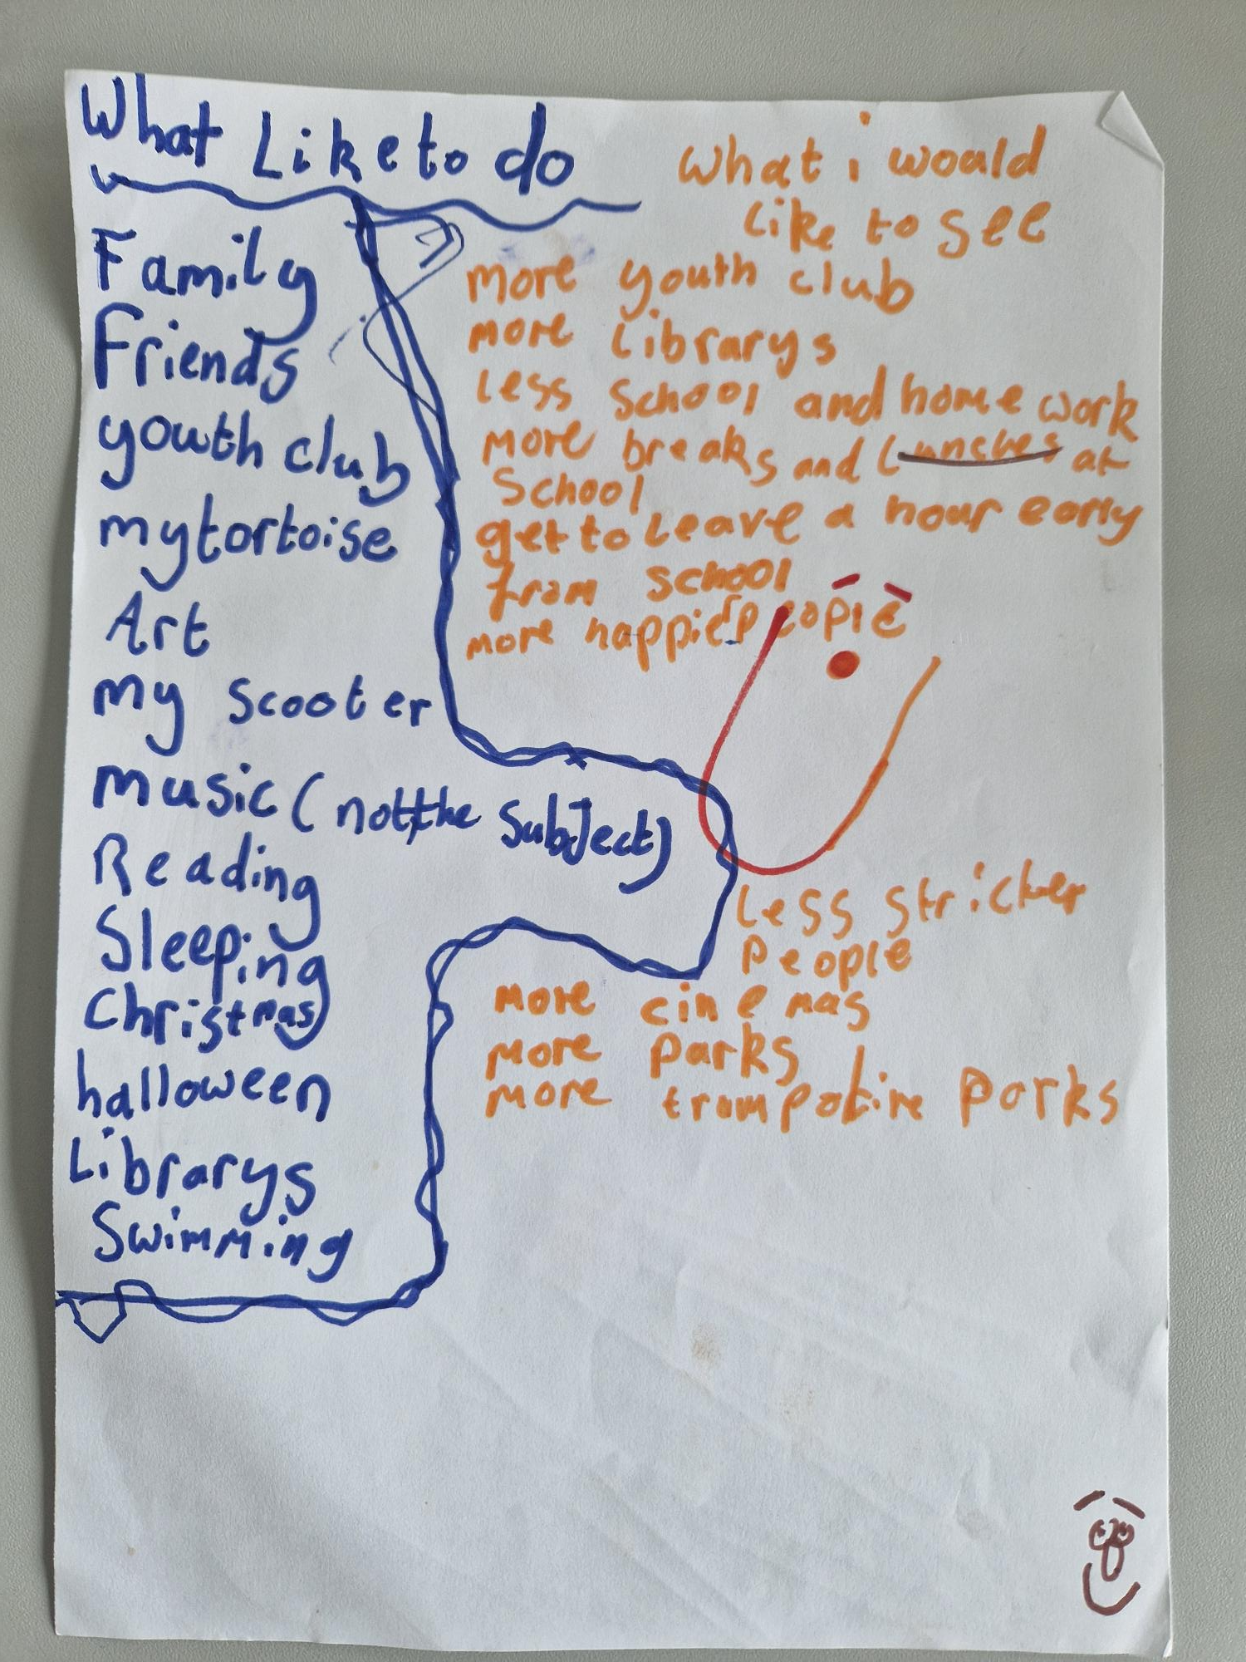
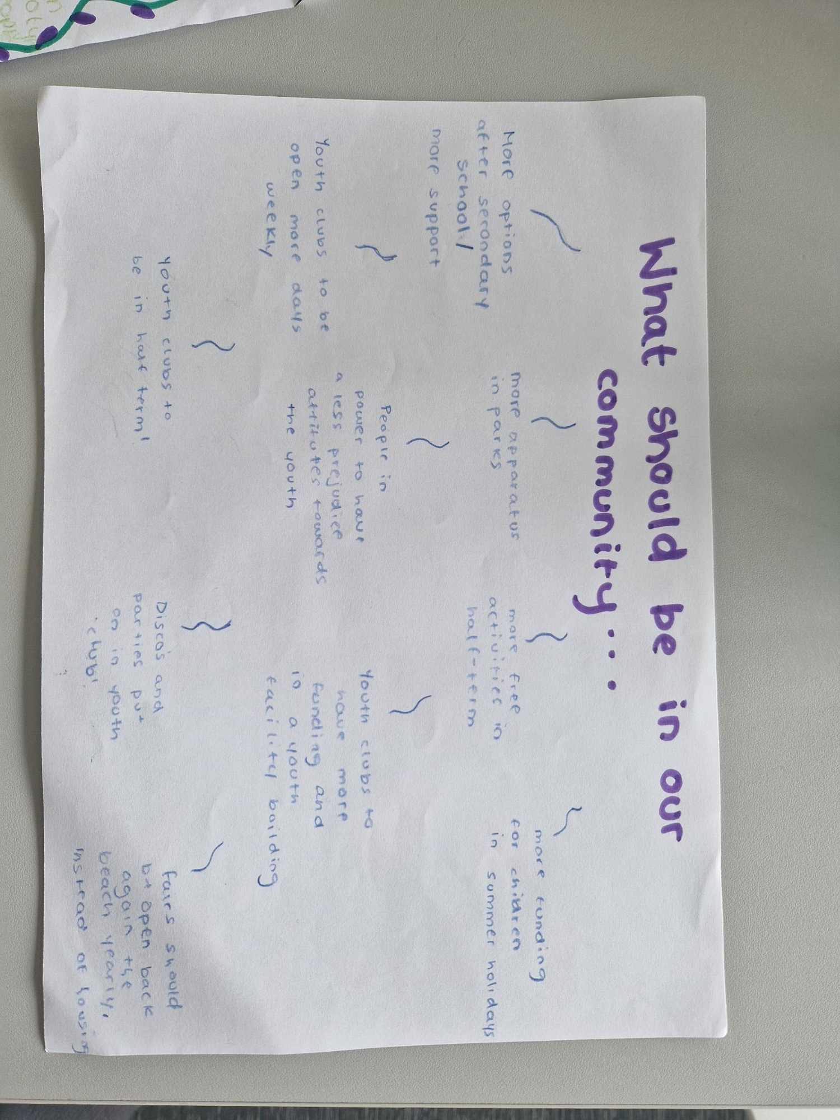
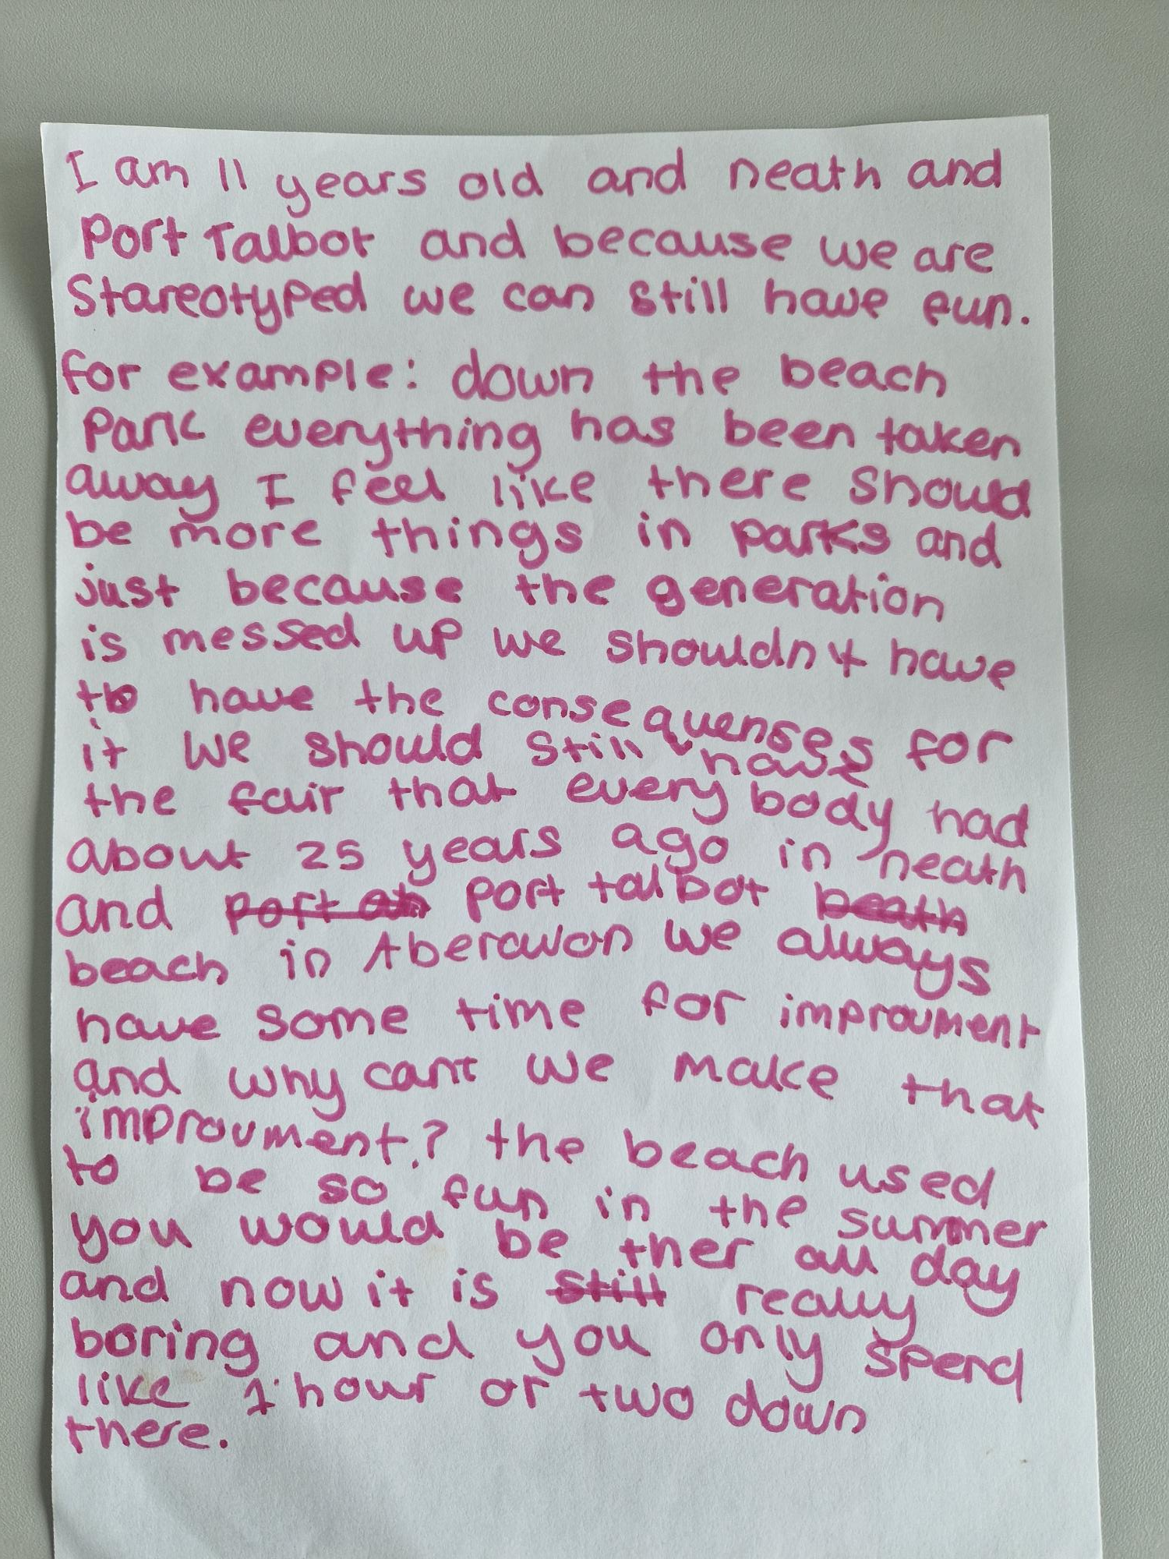

Appendix 2

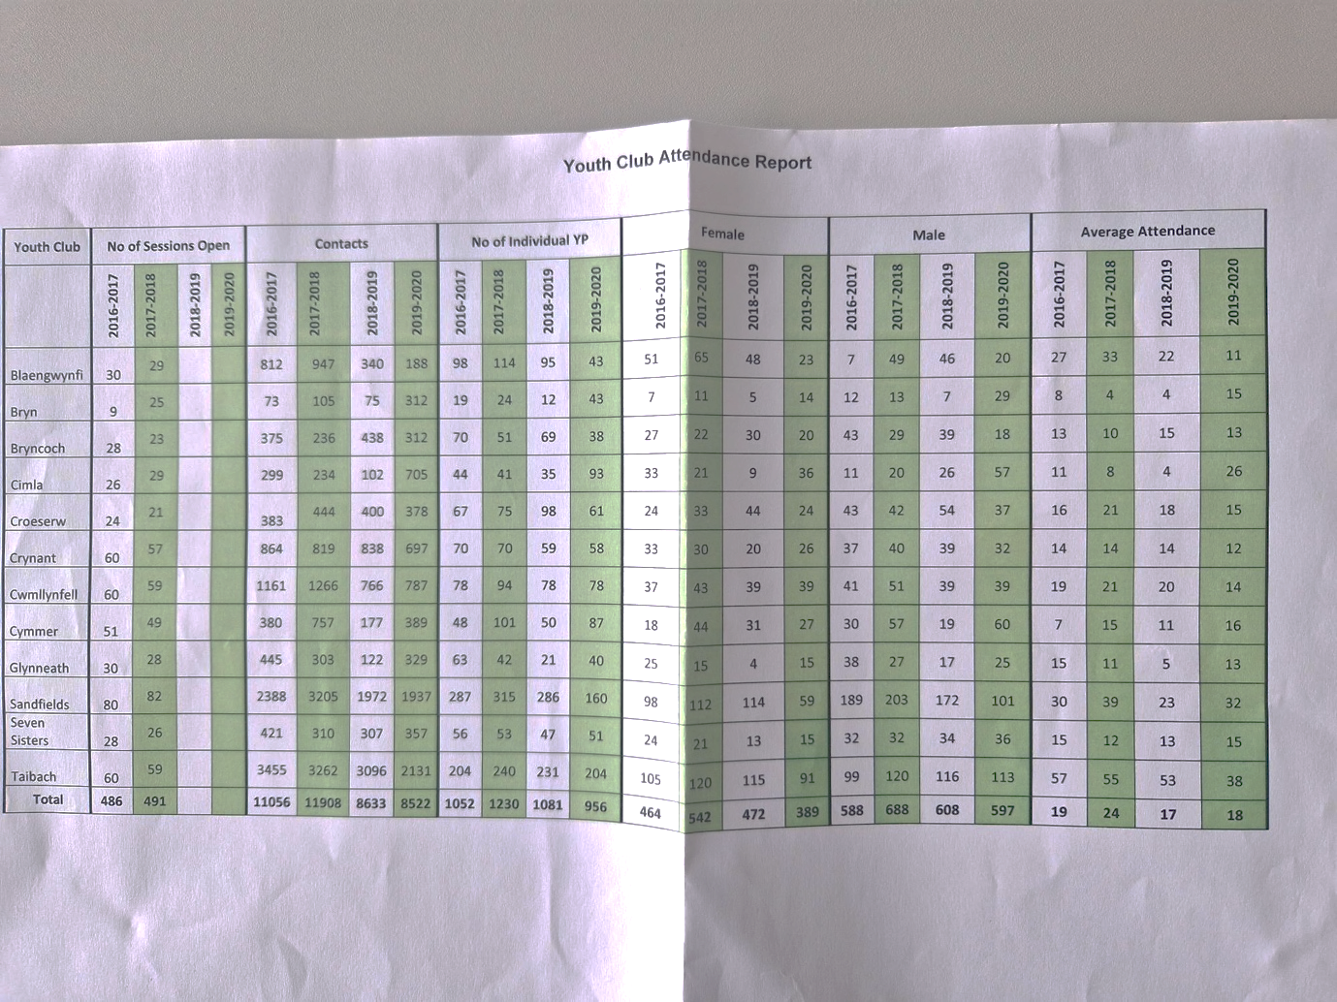

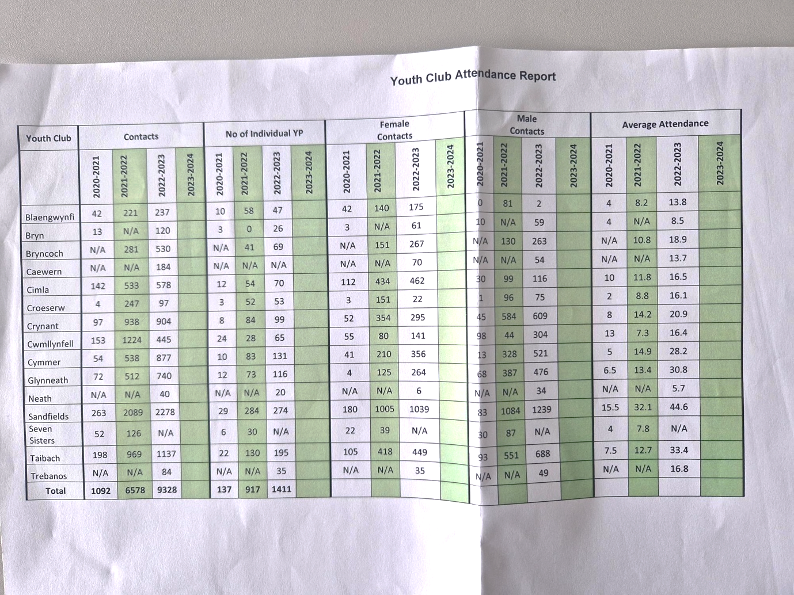

Appendix 3



Appendix 4
appendix 5
Vaping training - course materials.eml

Reference List.
About NPT Youth Service (no date) About NPT Youth Service – Neath Port Talbot Council. Available at: https://www.npt.gov.uk/23665 (Accessed: 23 November 2023).
Geldard, K., Geldard, D. and Foo, R.Y. p,4(2016) Counselling adolescents: The proactive approach for young people. Los Angeles: SAGE.
Europe (no date) (District, United Kingdom) - Population Statistics, Charts, Map and Location. Available at: https://www.citypopulation.de/en/uk/wales/admin/W06000012__neath_port_talbot/ (Accessed: 23 November 2023).

Hawtin, M., Hughes, G. and Percy-Smith, J. (1994) Community profiling auditing social needs. Buckingham u.a.: Open Univ. Press.
Horwood), (Image: Matthew and Thomas, A. (2023) Tata Steelworks in Port Talbot ‘would have closed without deal’, Wales Online. Available at: https://www.walesonline.co.uk/news/wales-news/tata-steelworks-port-talbot-losing-27730332 (Accessed: 23 November 2023).
NPT Youth Service (no date) Connect NPT Youth. Available at: https://www.connectnptyouth.co.uk/ (Accessed: 05 March 2024).
NPT Youth Service (no date a) NPT Youth Service Parenting Group. Available at: https://www.connectnptyouth.co.uk/support-1/c/0/i/74505959/npt-youth-service-parenting-group (Accessed: 06 March 2024).
office of the secretary of state for Wales (2024) Tata Steel / Port Talbot Steelworks Q&A, GOV.UK. Available at: https://www.gov.uk/government/news/tata-steel-port-talbot-steelworks-qa (Accessed: 05 March 2024).
Sapin, K. (2013a) ‘building relationships’, in Essential Skills For Youth Work Practice. 2nd edn. Sage Publications.

STATS (no date) Catalogue. Available at: https://statswales.gov.wales/Catalogue/ (Accessed: 23 November 2023).
TATA STEEL (2021) Steel matters issue 8 (Feb 2021).PDF, Tata steel Europe. Available at: https://www.tatasteeleurope.com/sites/default/files/Steel%20Matters%20Issue%208%20(Feb%202021).pdf (Accessed: 06 March 2024).

Youth Work National Occupational Standards (CLD Standards Council Scotland, 2019).

Youth Work In Wales Principles and Purposes,( Review Group, September 2022).

