Introduction to Fieldwork:
Archaeology

AHAH4005

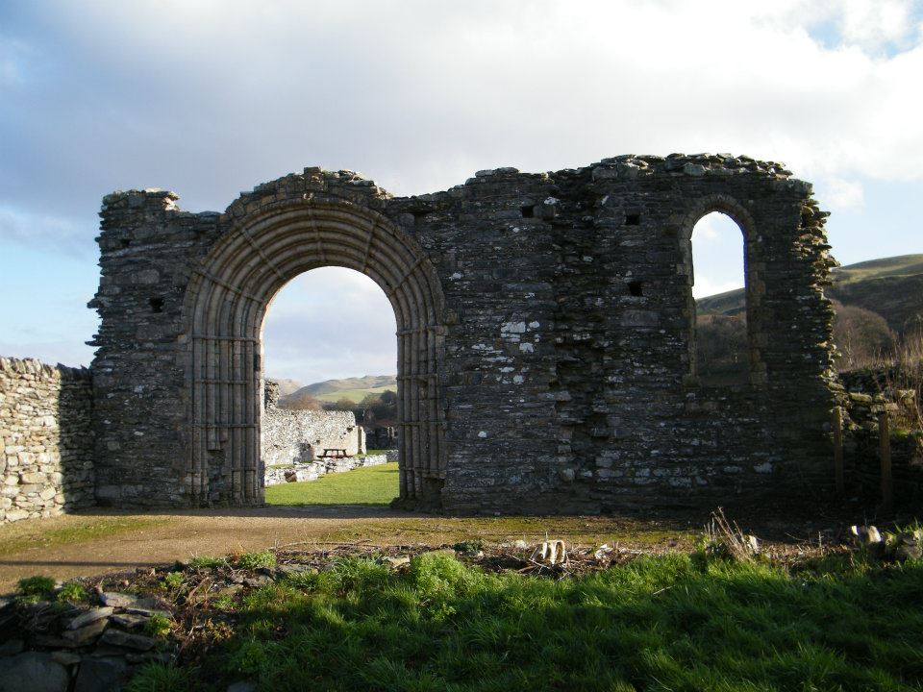

Erika Guttmann-Bond
Quentin Drew

CONTENTS

Course Description
Methods of Assessment
Assessment Criteria
Health and Safety Regulations
Emergency Contact Details
Risk Assessment
The environmental and cultural context of the Upper Teifi Valley
Introductory Bibliography
Figures

FIGURES

- The granges of Strata Florida Abbey (Williams 2001)
- The core grange of Strata Florida re-mapped (Bezant forthcoming)
- Geology
- Historical mapping (Rees 1950)
- Pollen diagram interpretation of Tregaron Bog (Morriss 2001)
- The granges and their farms in 1577 (Bezant forthcoming)
- The study area (OS 1:50 000)

Course Description:

This module is an introduction to the fundamentals of fieldwork and data collection. The aim is to teach you to observe, describe and interpret different types of data. We will begin with a survey of the graveyard at Strata Florida, and later in the term we will be carrying out an informal survey of the earthworks in the woodland adjacent to Strata Florida. We will also be visiting the National Library of Wales in Aberystwyth and the Royal Commission on the Ancient and Historical Monuments of Wales (RCAHMW).

During the course of the field experience students will be given a background to some of the research and methodological issues relating to the study area. The fieldwork will be supported by teaching to enable you to complete your assessed work. The aim of the module is to introduce you to the methods that archaeologists use in the field and in post-excavation. During your Excavation and Fieldwork course, which follows this one, you will be learning a greater range of skills and will have time to practice what you have learned in this brief introduction

Aims:
• To provide an introduction to the processes of field research

• To provide an introductory experience of some primary field methods

• To provide an introduction to the physical, social and historical contexts of mid-Wales, especially in relation to the historic periods at Strata Florida and its locality

Objectives of the module:

• To acquire an initial experience of the practice of field research

• To acquire skills in observation, description and interpretation of research data

• To understand and apply data recording methodologies

The field activities will be in and around Strata Florida.

The module will begin with a lecture on the landscape of the Cambrian mountains area and the Strata Florida Research project, as well as the documentary record and cultural character of the area. You will then be taken into the field for an introduction to the study area. The module will include a day in Aberystwyth, with visits to the National Library and the Royal Commission for the Ancient and Historic Monuments of Wales. This will allow you to have a guided tour of the NLW, with (if possible) relevant documents on display and access to the work and records of the RCAHMW.

The following points should be noted:

• When ‘in the field’ students should bring packed lunches, water and a flask with them each day. There is no food on site.

• Students must be prepared for bad weather. We shall work through all but the most inhospitable conditions. You should have, therefore, rainproof clothing (coat AND trousers) and stout, waterproof footwear.

• There are codes of conduct for the site (see below). Most are common sense, but anyone not conforming to these may be barred from the fieldwork component of this module.

Methods of Assessment

1. Field Report: Graveyard at Strata Florida (2000 words)
(50% of your mark)
This report should begin with an introduction to graveyard survey in general. This background will be based on your reading, and will outline what we can learn from graveyard surveys. You will then describe your methods, i.e. how you collected the data and what information you recorded. The next section will be your results, which might include graphs, maps, tables and photographs. The final section will be a discussion, in which you interpret and discuss your results. The things you learned from your background reading should be integrated here, as this information will help you to interpret your findings.
2. Field Report: Strata Florida earthworks (2000 words)
(50% of your mark)
The report should contain an introduction (including a location map), followed by a short summary of previous research and fieldwork in the study area. The methods section should contain a short description of your field methods. The next section will be your results: what did you observe? Describe your findings, including any photos, graphs or tables you may need to support your observations. A concluding section should discuss and interpret these results, and consider how your observations fit in with past research. Do your findings tie in with earlier historical and archaeological research (including maps)? Don’t forget to reference every piece of evidence and every idea that is not your own.

Some hints to help you get started:
Start reading early in the term, and take notes as you go along. The more you know in advance, the more you will understand when we get out into the field.

Assessment Criteria for Surveys/Reports

The main criteria on which your survey will be judged are the following:
- The engagement and focus on the task set
- The extent to which you use/manipulate data in an appropriate manner
- How correctly and appropriately you use conventions
- How appropriately and meaningfully you use illustrations (whether visual or derived from documentary sources)
- The assurance of your writing and clarity of expression
- The standard to which you present your survey
- The coherence of your argument or analysis
- The extent to which you attribute the references which support your text
- The wideness and thoroughness of your reading

With all assessment, judgments will include an element of subjectivity. However, the School is able to offer you the following indicators to assess your performance and progress. Please note that there may be more relevance placed on some areas above others based on the approach you use in your survey. For example, your survey might include plans and/or drawings and photographs that you have made, while another person’s might draw on archival sources.

HIGH FIRST CLASS (marks of 80 and above)
High First class work is of an outstanding standard. It will display all, of the following attributes:

- Keen and relevant focus on the task set
- Sophisticated use of data
- Exemplary use/manipulation of data
- Exemplary application and use of conventions
- Well-chosen illustrations, which are appropriate and meaningful
- Sophisticated writing and excellent clarity of expression
- Presentation to an excellent scholarly standard
- An argument or analysis which is subtle, coherent and balanced
- Excellent integration of your reading and your observations in the field
- Fully attributed and supported by a wide range of references
- Wide and thorough reading
- Independent thought

FIRST CLASS (marks of between 70 and 80)
High First class work is of an excellent standard. It will display all, of the following attributes:

- Clear and relevant focus on the task set
- Sophisticated use of data
- Correct use/manipulation of data
- Correct application and use of conventions
- Well-chosen illustrations, which are appropriate and meaningful
- Assured writing and excellent clarity of expression
- Presentation to an excellent scholarly standard
- An argument or analysis which is subtle, coherent and balanced
- Excellent integration of your reading and your observations in the field
- Fully attributed and supported by a wide range of references
- Wide and thorough reading
- Independent thought

UPPER SECOND CLASS (marks between 60 and 69)
Upper Second Class work is of a very good standard. It may show some of the qualities of First Class work, but not in a sustained way. Work of the Upper Second Class is characterised by some, but not necessarily all, of the following attributes:

- Clear and relevant focus on the task set
- Appropriateness of the data used
- Correct use/manipulation of data
- Correct application and use of conventions
- Well-chosen illustrations, which are appropriate and meaningful
- Assured writing and very good clarity of expression
- Presentation to a very good scholarly standard
- An argument or analysis which is coherent and balanced
- Good integration of your reading and your observations in the field
- Fully attributed and suitably referenced
- Wide and comprehensive reading
- Independent thought

LOWER SECOND CLASS (marks of between 50 and 59)
Lower Second Class work is of a good standard. It is work that may show some of the qualities of work in a higher class, but not in a sustained way. Lower Second Class work displays some, but not necessarily all, of the following features:

- Clear and relevant focus on the task set
- Appropriateness of the data used
- Correct use/manipulation of data
- Correct application and use of conventions
- Appropriate and meaningful illustrations
- Writing and clarity of expression of a reasonable standard
- Presentation to a reasonable scholarly standard
- An argument or analysis which is coherent and balanced
- Integration of reading with observation in the field
- Sources attributed but with some problems in the referencing
- Some relevant reading but with gaps in the literature consulted

THIRD CLASS (marks of between 40 and 49)
Third Class work is of an adequate/fair standard for an honours degree. It may show some of the qualities of work in a higher class, but not in a sustained way. Work in this class is marked by some, but not necessarily all, of the following qualities:

- Limited focus on the set task
- Data not always appropriate or not made so
- Inconsistent or incorrect use of data
- Conventions not used, or used inconsistently
- Illustrations sometimes superfluous or irrelevant
- Clarity of expression less evident
- Some attempt at scholarly presentation
- Little or no evidence of analysis or coherence of argument
- Poor or no attribution
- Limited evidence of reading

FAIL CLASS (marks of 39 and below)
Fail class work is unsatisfactory. It is work that may display some of the characteristics of the Third Class standard but not in a sustained or significant amount.

- Little or poor focus on the set task
- Data not collected, not appropriate or not made so
- Poor or incorrect use of data
- Conventions not used, or used inconsistently
- Superfluous or irrelevant illustrations used
- Clarity of expression less evident
- Poor presentation
- Little or no evidence of analysis or coherence of argument
- Poor or no attribution
- Limited evidence of reading

Health and Safety Regulations

1. General behaviour
- At all times behave responsibly, sensibly and courteously.
- While on the Project please show exemplary behaviour towards local people. We will be undertaking further field seasons in these communities in future years, so please give no-one cause to regret your visit.
- We will expect you to be alert and fully able to participate in the work during the days, not hung-over or ill. In addition, please be aware that alcohol abuse will not be tolerated, especially as we do not want to upset the local people, with whom we wish to remain on good terms for future years.
- You are advised not to take too much in the way of valuables on the field class. On a day-to-day basis, carry on your person only what you think you will need for that day.
- In general, keep together as a group, and be alert to the safety of other members of the group.

2. Behaviour during field trips
- Avoid dangerous and potentially dangerous situations (e.g. you should avoid entering restricted spaces in the ground deeper than 1.2 m; standing under objects that may fall on your head; or entering old mine workings or caves).
- Students should behave in a responsible manner when visiting sites and should not expose themselves, or third parties, to unnecessary risks.
- Do not expose yourself to danger by climbing on walls or other elevated locations and do not enter any areas or buildings where access is restricted.
- Avoid damage or disturbance to the archaeological fabric of sites.
- Obey the instructions of the group leaders and act on these immediately.
- When in smaller groups take particular care not to expose yourself or your partners to any unnecessary risks.
- Behave in an appropriate way for prevailing conditions. If in doubt, take shelter. Do not climb onto high or exposed locations in strong winds. In thunderstorms, do not seek shelter beneath or near isolated features such as trees or rock outcrops.
- You should not work alone and should not wander off from the area within which you are supposed to be working without informing a member of staff.
- ALWAYS wear a safety helmet (provided by the Department) in areas designated for their use or where instructed by the Course Leaders.
- Avoid damage and disturbance to livestock, wildlife and the environment; follow the Country Code; and observe laws of trespass.

3. Insurance
- On field trips, you are covered by the University insurance for the usual range of matters that you would expect of holiday insurance.
- For insurance purposes, it is vital that the organisers know in advance of any specific medical conditions that may affect cover.
- In the same way that the University is not liable for personal injury, damage to property, or injury to third parties resulting from the student’s own unauthorised actions (i.e. actions which do not occur under the direction and supervision of University staff) whilst resident in Lampeter, so the University extends no legal indemnity to students for such actions whilst in attendance on field classes. You are therefore asked to act responsibly and sensibly at all times for your own good. No legal liability accrues to the field class organisers, their Departments or the University authorities in the event of any insurance claim arising as a result of your own unauthorised actions.

4. Health and First Aid
- Students will be asked, prior to the field class, to inform the organisers of any medical conditions affecting their health on the accompanying medical questionnaire form. It is vital that anyone who suffers from epilepsy, asthma or similar problems that may afflict them at any time without warning, explicitly notify one of the Field class Leaders.
- Students must ensure that their protection against tetanus and polio is up-to-date.
- Students should make sure they have their own first-line medicines, which should be carried at all times, as well as any special personal medications. In addition, first-aid kits equipped to deal with minor accidents will be carried during the trip.
- Anyone giving first-aid should wear rubber gloves as a precaution against blood-borne infections.
- Students should at all times be conscious of the danger of over-exposure to the sun and take appropriate action.
- Students should wear appropriate clothing. Even in the summer it can be quite cold and wet in Wales, especially at higher elevations. Be sure to have warm, waterproof clothing and stout waterproof boots. The weather can sometimes deteriorate quite quickly.
- Where appropriate, you should be careful about sun and heat – sun cream may be necessary even on cloudy days, and it is better not to work in shorts or take off shirts (on many building sites workers are no longer allowed to work bare back due to risk from sunlight).
- Take plenty of water to avoid dehydration.
- In the event of an accident during project work, students should make contact with one of the field class leaders, either directly or indirectly through members of the class.
- Hygiene: please take care in the field when consuming food at lunch. Wash hands before eating if possible.

Emergency Contact Details

Telephone numbers:
College Main Switchboard (01570) 422 351
Doctor’s Surgery (01570) 422 665

Intro to Fieldwork: Risk Assessment

This risk assessment has been undertaken with respect to the CVCP Code of Practice for Safety in Fieldwork, issued in July 1995, and especially the check lists included on pp. 30-33, and modified in accordance with the UCEA Health and Safety Guidance when Working Overseas (January 1998) and its checklists on pp.20-27. It should be read in conjunction with the information provided to students in the Departmental Notes for Undergraduate Students, Appendix 1 Safety in the Field Regulations.

Checklist 2 - Feasibility of Project
Access: This presents no problems. We are operating from the University of Wales Lampeter campus on a daily basis. Access to and from the site (Strata Florida and environs) will be by specially hired buses, staff cars and students’ own insured cars, and where appropriate, by foot. The sites are on private farmland and woodland immediately adjacent to public roads, access to which is covered by special permission. There will be loos, but not shelter. Students will be under instruction from members of staff and designated postgraduate assistants who have mobile phones. The sites also are very close to a Cadw Guardianship monument with a land-line from which assistance can be called should problems arise while it is open. When shut, the landline of the Arch family will be used, or the team leader will drive to the nearest mobile phone reception point. In the event of problems arising during project work, appropriate advice has been included in the advice notes (see Safety I the Field Regulations, section 2). The party is covered by University of Wales, Lampeter insurance arrangements, and there will be first aiders among the staff while in the field.

Fitness: No specific pre-project training is needed. Potential problems are identified through the medical questionnaire issued to staff and students.

Training: The members of staff involved (Erika Guttmann-Bond and Quentin Drew) have had appropriate first-aid training. Issues of health and first aid will be raised with students before setting out.

Health: All staff and students have had to complete a confidential medical questionnaire. This has been used to identify particular problems (mainly asthma) and where appropriate has been the subject of discussion between the student concerned and the Field Class leader. All students have been told to carry their own first-line medications (see Safety in the Field Regulations section 2 in their student handbooks) and staff will be carrying a basic first-aid kit to deal with minor accidents (ibid).

Staffing: There will be at least one member of staff and an appropriate number of postgraduate assistants to supervise the students at all times in the field.

Checklist 3 - Risks inherent in the site(s)
Physical Hazards: The project area includes rough ground and watercourses, so the main hazards will be tripping. One potential area of difficulty is over-exposure to inclement weather conditions. All students have been requested to take suitable water-proof and warm clothing. This is drawn to the attention of the students in the Safety in the Field Regulations (section 2).

Biological and Chemical Hazards: None identified. All farm chemicals are housed safely by the farmer and not held in any areas accessible to students in the course of their working day.

Man-made Hazards: Inevitably there are potential hazards with ancient sites, both in terms of uneven ground and insecure walls and buildings. Students will be warned not to climb on walls or enter any of the buildings and areas where access is restricted (see Safety in the Field Regulations section 2). Advice has also been given on the need to take appropriate footwear (see Safety in the Field Regulations section 2) and to behave sensibly and with their, and others’, safety in mind at all times. Problems can also arise within the group itself as a result of alcohol abuse or other forms of ill-judged behaviour (Safety in the Field Regulations section 1). However, the site is well away from a public house and the students would normally be expected to remain on-site for the normal working day.

Environmental Hazards: There are few potential dangers from natural hazards in the landscape. These might include small river cliff edges, small quarries and the rivers themselves, but they are usually at very low levels at this time of the year. Weather is anticipated as being consistent with a Welsh spring, fluctuating from warm, dry to cold and/or wet days. Students have been advised to take all precautions against heat exposure and getting cold and wet. Appropriate clothing has been advised and any necessary skin protection has been identified as the responsibility of the students. Students have also been warned not to expose themselves or others to risk and have been forbidden to enter any areas where access is restricted (see Safety in the Field Regulations section 1). Advice has also been given on the need to take appropriate footwear (see Safety in the Field Regulations section 2) and to behave sensibly and with their and others’ safety in mind at all times.

Checklist 4 - Risks Inherent in Work
Training: All students have been advised on appropriate Health and Safety issues, with reference to first-line medicines (Safety in the Field Regulations section 2), appropriate footwear and clothing (Safety in the Field Regulations section 2) and personal safety (Safety in the Field Regulations section 1). Advice has also been given on site behaviour, especially with respect to dangerous buildings and restricted areas of access, and on what to do in the event of an emergency (Safety in the Field Regulations section 2). Staff have received appropriate first-aid training and first-aid kits will be available in the minibuses (Safety in the Field Regulations section 2). Students will be trained on site in the safe and appropriate use of tools.

Chemical and Biological Hazards: None identified.

Personal Safety: The attention of the students is drawn to the Safety in the Field Regulations.

Checklist 5 - Organisation of Fieldwork
Pre-planning: The Research Experience Module has been organised under the direction of Erika Guttmann-Bond and Quentin Drew, who are experienced field archaeologists.

Catering: Students bring their own packed lunches, water and a flask.

The Group: A clear chain of command has been identified and will be communicated to the students. The ratio of 1:10 is well within accepted limits. The students may, at times, be spread over an area of several square kilometres, but are all within sight of each other, and the staff and students will be divided among them in various groupings.

The Individual: Lone working for students will be avoided as much as possible and will only occur for very short periods in exceptional circumstances (Safety in the Field Regulations section 1). Advice is given on appropriate footwear and clothing (Safety in the Field Regulations section 2).

Equipment: All necessary equipment has been organised.

Checklist 6 - Conduct of Fieldwork
Local Conditions: No problems or risks require consideration, beyond those already identified.

Transport: Students will be transported to and from the site each day, except for those who live locally who have the option to make their own way there (who are responsible for their own insurance and safety under these circumstances). The bus driver(s) will be provided by the bus hire company.

The Group: The group and sub-group sizes are small enough for the location of everyone to be known through the working day.

Working Practices: The size and management of groups and sub-groups have already been indicated and there is adequate supervision at all times.

Emergencies: In the event of an emergency, procedures have been put in place to ensure rapid communication.

Summary
Everything has been done to minimise the risks inherent in the fieldwork, building both upon good practice and upon the experience of previous field courses of this nature. Appropriate advice has been taken from the First Aid instructor and from the University Insurers; appropriate training in first aid has been undertaken; and appropriate advice and warning will be given to students from the outset. No risk assessment, however, can cover every eventuality, or take into account unforeseen circumstances which lie beyond the control of the Project leaders.

The environmental and cultural context of the Upper Teifi Valley

The Afon Teifi flows on a gentle arc in an extensively glaciated valley from its source at Teifi Pools in the north-east out into Cardigan Bay in the south-west (Fig.). Topographically the massif of the Cambrian Mountains lies to the west, increasing in height from about 300 metres in the south to over 500 metres in the north. To the east is Mynydd Bach a much lower ridge of hills separating the Teifi Valley from the valleys and narrow plain of the coast. The bedrock base consists mainly of old sedimentary Silurian shales, grits and sandstones which predominate in Central Wales. These rocks are overlain by varying depths of glacial and periglacial deposits of sands, gravels and clays generated by glaciers stemming from the Cambrian Mountains to the east and the Plynlimon area to the north. The Teifi valley itself was deepened and widened by a glacier which, as it began to retreat northwards at the beginning of the present (Holocene) interglacial, left behind considerable quantities of moraine. One of these main moraine dumps, where Tregaron is now, created behind it a periglacial lake of rotting ice and water which slowly began to infill with sediment and vegetation over the last 10-12000 years to form Tregaron Bog. The pollen sequences from this bog and elsewhere in upland Cardiganshire (Fig. 2) have provided much vital information for the history of vegetation and human intervention in the environment during the Holocene (Turner 1964, Moore 1994). At the beginning of this period of warming about 10000bp the sequence of woodland colonisation commenced. By 9000 bp climax birch/hazel woodland with pine covered the Teifi valley: evidence suggests this may have been open canopy woodland perhaps caused by Mesolithic burning to create clearings. The beginning of the next phase, at c.7000bp is marked by an expansion of alder at the expense of the pine and a rise also in, first, elm and then oak. The rise in alder may also have been influenced by increasing Mesolithic and Neolithic forest clearance creating impeded drainage and the necessary wetter conditions for this shrub and tree type. Although the period 7000-5000bp saw a dense cover of this mixed woodland in the Teifi Valley, the higher peaks along the ridge of the Cambrian Mountains may have been open or more lightly wooded (McCarroll and Walker (eds 2001), Caseldine 1990). In Ceredigion as elsewhere in Britain a major ecological event was the ‘Elm Decline’, a sudden and dramatic drop in the pollen record of this species. Until recently this was thought to be caused by extensive forest clearance by Neolithic farmers as they established arable fields and the first fixed settlements. Opinion is now more inclined to see this as an early appearance of elm disease, since other species appear not to be affected and remains of the transmitter beetle (Scolytus) have also been found in sediments of approximately the same date. In Ceredigion, there has also been little sign of Neolithic arable activity, although we should be cautious about interpreting this as evidence for its non-existence. By contrast there is some evidence to suggest that it was Neolithic creation of grazing by burning and clearance of the lighter vegetation on the tops of the Cambrians, thus initiating the formation of the blanket peat bogs which are so much a feature of their present-day environment. Throughout this early post-glacial period, from the end of the Palaeolithic to the Neolithic (8000-2000bc), finds and sites which can be attributed to human activity are relatively rare in Ceredigion and the Upper Teifi Valley. There are scatters of stone implements found by chance, but only four monuments which can with any confidence be related to burial or ritual practices; none of them in our area. There are, however, a few standing stones which might be of Neolithic date on the more open top of the Cambrians and it is interesting that some are boundary markers into historic times. On the valley floors the first major traces of clearance and cultivation come in the middle Bronze Age. Parts of the pollen sequences (from 3500bp, 1500bc) seem to consist of episodes of use and abandonment for farming (swidden agriculture). Although this clearance was extensive on the upland, the main impact on the woodland of the valley floor appears to have been in the later stages of the Iron Age and through the Roman period, by the end of which time the region was effectively deforested. The bulk of the known Bronze Age archaeology consists of burial cairns to be found on the ridges of the Cambrians and Mynydd Bach. They are clearly designed to be visible from the valleys, but evidence of contemporary settlement there is singularly elusive, although the number and spacing of cairns strongly suggests a pattern of social control and territory well established in the area. There are also occasional rather rudimentary stone circles and some clearance features. The Iron Age, by contrast, has the impressive remains of hill-forts on the edges of the Cambrians and their locations and size indicate the localised nature of power and activity in the Upper Teifi Valley at this time (Driver 2006). Their purpose was not simply local warfare and expression of authority, but also the economic and social management of the upland pasture grounds for cattle and sheep as well hunting. Aerial photography and some excavation is also beginning to show that the valley floors were now being intensively occupied and farmed often from enclosures surrounded by large banks and ditches. This impression of more intensive land use and clearance is confirmed by more recent work on the Tregaron Bog pollen sequences (Fig 3 from Morriss 2001). There are also traces of field systems and long-distance routeways both along the valley floor and the ridges. This landscape and land use continued largely untouched by the Roman period although one military road (Sarn Helen) was driven south to north through Ceredigion in the late first century AD with the usual auxiliary forts laced along its length. The nearest to the subject area is at Llanio near Llanddewi Brefi, just south of Tregaron. This trend of woodland clearance and intensive farming was reversed in the early post- Roman period of the fifth and sixth centuries AD and the forest began to re-generate. This, however, did not cause the collapse of an agrarian way of life and there are strong indications of a complex network of settlements and centres of authority throughout the area. This period, sometimes known as the ‘Dark Ages’, but better the ‘early medieval’, is the first to be recorded properly in the historical record and in the eighth and ninth centuries we begin to see clearly for the first time the emergence of the kingdom of Ceredigion which maintained a kind of independence, but was often under the direct control of more powerful kingdoms to the south (such as Dyfed and Deheubarth) and north (Gwynedd). During this period we are conscious of a pattern of local lordship controlling a kin-based society of both free and servile people, working a landscape more wooded, but perhaps not dissimilar to the late Iron Age and Roman periods. The centre of authority in such a dispersed landscape, at least by the end of the period in the tenth and eleventh centuries was the lord’s llys or hall, operating through patterns of drefau or townships which owed tribute and allegiance (Bezant 2007). Allied to this secular power was a Christian church, often, but problematically labelled ‘Celtic’, but based on a network of monastic locations scattered through the landscape functioning on a hierarchy dependant on key central monasteries, such as Llanbadarn and possibly Llanddewi Brefi. These locations may or may not have had chapels and churches, but certainly had cemeteries and inscribed and decorated stones. The earliest of these stones are the oghams, of Irish ancestry and dated usually to the fifth to seventh centuries, although there is dispute as to whether these are actually Christian or pagan in nature. The stones whether oghams or the later, more certainly Christian, items are the main artefactual evidence for the fifth to eleventh centuries in the area, and it is one of the great problems of the archaeology in the area that the church sites and the secular settlements, including the llysau, have been so difficult to find and have been rarely seen archaeologically. The long period of woodland regeneration ended in the twelfth century when extensive clearance began again and there is evidence for widespread introduction of managed pasture species on the upland (Fig.3 from Morriss 2001). This all correlates well with the arrival at Strata Florida in 1184 of the Cistercians, whose new, much more intensive agrarian techniques seem to have transformed the vegetation and economy of the Upper Teifi valley and its adjacent uplands. Also from the late eleventh century the region came under pressure form Anglo-Norman aggression from the east and south as they extended their Marcher baronies along the river valleys and over the Cambrians. The first incursion was at the end of the eleventh century when Ceredigion was attacked from the Montgomery Earldom of Shrewsbury. As a result of this a number of knights established several small motte or motte and bailey ‘castles’ in the landscape. Several larger castles were built, including Ystrad Meurig at the head of the Teifi Valley overlooking Tregaron Bog, and these lords may have created the small marketing boroughs such as Lampeter and Tregaron. However, it seems to remain the case that it was the Cistercians, rather than the secular Anglo-Normans who had the most dramatic effect on the way in which people farmed and led their lives in the Upper Teifi Valley. Although the Cistercians at Strata Florida were the local representatives of a European corporation, within a highly structured and international Church, and although they undoubtedly brought more modern and ‘feudal’ systems of management in to the landscape, they are not so much associated with the Anglo-Normans as with independent Welsh princes struggling to keep the English authority at bay, because at the point that the Abbey was founded in 1164, the Welsh won back control of Ceredigion. This they held until 1283-4 when Edward I completed the territorial conquest and annexation of Wales. This heralded a sea change in the way in which the land of Ceredigion was administered and owned. The pollen record seems to show the agrarian setbacks of the fourteenth and fifteenth centuries which generally affected the rest of Europe, but were exacerbated in the region by the leasing out by Strata Florida of its former grange lands (Fig. 3 from Morriss 2001). It was these leasehold lands and their sale at the Dissolution of the monastery in 1539 that led to the creation of large gentry estates which sometimes were directly in the hands of English landlords, but even where they were held by Welsh gentry were being increasingly farmed by methods of management and improvement which were revolutionising agriculture in England and Europe. In this process local Welsh farmers, however, became a depressed tenantry. In strict economic and general terms the use of the land is extensive and relatively prosperous and the pollen record shows a steady rise in arable and pastoral plants to the high point of the Napoleonic period (1793-1815) when great tracts of the upland were ploughed for grain production. There are extensive traces of such cultivation on the hill-tops around the Upper Teifi. Through this long period of the large estates, which also began the extensive exploitation of Ceredigion’s rich reserves of minerals, especially lead and silver, the Welsh found forms of resistant culture and ideology, notably oral traditions of literature and a dissenting and fiercely independent chapel-based practice of religion. There was also a move, through squatting on common and other land usually on the hills (the so-called ‘ty-y-nos’ events, e.g. at Rhosgelligron), for the poorer Welsh families to gain some independent livelihood howbeit marginal and poor. The narratives of such resistance figure strongly in the history which the local communities proudly tell of themselves, and in the traditions which they energetically seek to preserve. Nonetheless the record of the vernacular housing in the area from the sixteenth to nineteenth centuries tells its own story of poverty and long-term repression. From the mid-nineteenth century onwards the farming went into decline and arable production gradually fell off in favour of extensive cattle and sheep grazing. This coincided with the gradual failure, one by one, of the great estates and their sale which continued well into the twentieth century. The land was sold largely to the local Welsh tenants who thus, for the first time in hundreds, maybe thousands of years, gained direct control of their landscape. It came, however, at a cost: the economic decline of traditional mixed agriculture continued under the pressure of world trade and production and many farms failed, especially those on the upland and particularly in the twenties and thirties when the markets were also hit by the Depression. In the last half of the twentieth century this decline was held at bay by the twin strategies of increasing monocultures of sheep and cattle, and agricultural subsidy. The period also saw the making of huge plantations of largely Sitka Spruce. These dark woodlands created by the Forestry Commission on the abandoned farmlands of the upland are now themselves under threat as the value of the wood has plummeted, making it economically unviable. Added to this, the increasing pressure of world markets, the decline in meat consumption in the west and the removal of subsidies have again brought the farming way of life into crisis and the small dispersed communities of this region feel their whole way of life to be under the severest of threats. Today there are important moves to strengthen this economy by diversification into other fields of activity such as cultural tourism and high-tech home-based production. As part of this there are also moves to make the upland and the lowland of the Upper Teifi Valley more biologically diverse and there are many important designations and schemes to allow this to happen: such as the Cambrian Mountains Environmentally Sensitive Area and Tir Gofal. All of this is ahead of European funding and archaeology and this Project have a role to play in all of that, as we at Lampeter, as part of the Teifi Valley community, move into the future.

The History of Cistercian Strata Florida
The former Cistercian Abbey of Strata Florida is a small monument managed by Cadw, in the upper part of the Teifi Valley, near Tregaron in central Ceredigion (Fig. 4). It lies on the edge of the Cambrian Mountains Environmentally Sensitive Area and within the recently designated Ceredigion Upland Landscape of Outstanding Historic Interest. The Abbey has a central place in the cultural and political history of Wales, and retains a strong role in the sense of national identity. The Abbey was first founded in 1164 under the patronage of Robert fitz Stephen, a Norman Baron who held extensive estates in West Wales. However, in that same year Yr Arglwydd (the Lord) Rhys ap Gruffudd of Dinefwr led the Welsh attack on the Anglo-Normans which resulted in them being pushed out of Ceredigion. The abbey was re-founded by the Lord Rhys and it continued to lie at the heart of lands under the control of Welsh Princes until as late as 1284 (Fig. 5) (Pryce 2005). In 1166, the first party of monks seems to have arrived from the mother abbey of Whitland (Fig. 6) and began to establish the new foundation in the little valley of the Afon Fflur (River of Flowers) two miles to the south of the present site. There is still a farm there today called Yr Hen Fynachlog (The Old Monastery). The present abbey seems to have been begun in 1184 on a new site in a more isolated location (a Cistercian trait) along the valley of the Afon Teifi east of Pontrhydfendigaid. This is a small, secluded valley, once marshland drained by the monks, and on recent air photographs (Fig. 7) it is possible to pick out the area of the former abbey precinct and other features of the core land use of the monastery (Fig. 8). By 1203 the new church was being consecrated and the monastery occupied by the monks. In plan the Abbey has most of the standard architectural and plan characteristics of other contemporary Cistercian houses, in that it was essentially in the Romanesque style, a deliberately archaic choice given that most of Europe was changing to the newer Gothic styles at the time (Fig. 9). The buildings survived intact until the Dissolution in 1539 although there was at least one disastrous fire in 1284, the year that the English crown finally absorbed the whole of Wales under its jurisdiction. Prior to that the Abbey had lain at the intellectual heart of a growing Welsh consciousness, partly because it was gathering together histories and annals in the Welsh language for the first time and partly because of the network of international contacts and influence it wielded through the Cistercian movement. In 1239, Llywelyn ap Iorweth of Gwynedd (Llywelyn Fawr ‘the Great’) coerced and persuaded the independent Princes and nobles of Wales to swear fealty at Strata Florida to his son in an attempt to guarantee his succession of the extensive hegemony over central and northern Wales which Llywelyn had created. This failed, but it was the substantial germs of an idea of a coherent Welsh state. The wealth of the Abbey was based on huge upland and valley estates in the central parts of modern Ceredigion, northern Carmarthenshire and eastern Powys (Fig. 10). On these lands, farms or ‘granges’ run by the abbey’s lay brethren (conversi) were established looking to improve the output and generate revenues largely by the introduction of large flocks of sheep. This pattern of farming cut across the traditional modes of agriculture and social organisation in upland Wales and they can be seen as the first of the great exploitative European corporations. Apart from farming the Cistercians were also noted for their prowess in mining and in the production of metals using extensive water management systems to power machinery. The Cadw-managed site consists of the foundations of the Church and part of the claustral complex (Figs. 9 & 13). Excavated a hundred years ago (Williams1889) these remains are only a small part of the original monastic complex. The major remains of other buildings, however, lie beneath earthworks to the east and south of the monument, and there are indicators of the rest of the precinct, including the home farm or grange, in surrounding fields and within the modern farm. In addition to this there is some evidence of the major manipulation of rivers and water systems around and within the site, as well as outlying areas of medieval mines and industrial processes. On the hills around are many remains of the granges and other activities of the abbey. It is possible to reconstruct the landscape and site of Strata Florida with growing accuracy (the greater abbey plan). The Abbey was much larger than the site Cadw currently displays and a programme of geophysics and excavation is beginning to define the precinct area and its buildings. After the Dissolution the Abbey and its estates were taken over by various magnates and ‘carpet-baggers’ from England. The site of Strata Florida itself passed first into the hands of the Earls of Essex and then, by 1567, to John Stedman a man from the Marches who had been a steward of the Earls. He seems to have built a mansion (in essence the current farmhouse) out of the old refectory of the Abbey (Abbey Farm plan), while the rest was left to fall into decay, apart from elements of the home grange. The Stedmans came to acquire eight of the former granges of the Abbey by 1630 and the whole was run as an extensive estate. One of these was Abbey Farm, which contained the ruins of the former abbey buildings and its precinct as shown on an estate map of 1765 At the heart of this was the Plas or great house of the Stedmans built out of the remains of the Abbey refectory and around it were gardens, a gatehouse and great barn (Fig. 12). The Plas, the barn and elements of the garden still survive (Fig. 13). The family was to die out in the eighteenth century and the estate passed by marriage to the Powells of Nanteos. In the nineteenth century the break up the great estates began and the Arches came to acquire part of the land and this now forms their farm. In 1887-8 Stephen Williams, a railway engineer and early digger of monasteries, excavated the site of the church and cloisters. In 1931 the Abbey ruins themselves passed into the hands of the crown and various departments of state have looked after it since. Recently Cadw, the current guardians of the site, passed under the jurisdiction of the National Assembly for Wales. The present churchyard to the north of the Cadw monument is a very significant place in the hearts and minds of Welsh people (Fig. 13). It lies around the modern parish church of St Mary, which was probably rebuilt from the remains of an earlier building, perhaps the chapel of the Abbey’s Guesthouse, which was used by the visiting medieval laity. The churchyard is large and apart from containing some very old burials and many from local farms and settlements, there are also many from further afield, notably the London Welsh, who had the aspiration, the hiraeth, to return. Perhaps, however, the most famous and the most iconic grave is that of the fourteenth-century poet, Dafydd ap Gwilym who lies buried beneath a yew-tree in Strata Florida cemetery. Dafydd was the best and the most lyrical of the medieval poets of Wales and his poems in the Welsh language are part of the foundations of Welsh culture. The Village of Swyddfynnon The small hamlet of Swyddfynnon lies on the northwestern shoulder of Cors Caron in central Ceredigion. It lies astride the small Camddwr Fach which drains into the bog and this stream also forms the boundary of the estate granted to Strata Florida Abbey in the late 12th century by Lord Rhys ap Gruffudd. This vast estate was divided at some point into four separate granges and Swyddfynnon lies inside Mefenydd grange which takes its name from the ancient commote in which it sits. This grange structure is enigmatic. Was it invented arbitrarily to aid the monastic administration of such a large area or did it comprise existing and ancient territorial divisions based upon the pre-Cistercian maenor/tref model? Certainly there are remnants of such an early landscape evident in place names and morphology for example but this complex situation is compounded when we look at Lledrod parish boundary which is not wholly respected by Rhys’s carefully constructed grant. The parish as an indictator of early units is thus compromised in this area and may be the result of complex monastic rearrangement. . The village of Swyddffynnon is evidently early and forms a compact unit including the outlying farms of Pengwndwn, Swydd, Ty Mawr and Cruglas. Fennanoyer is mentioned in the very earliest surviving grant made by Lord Rhys sometime between 1165 and 1184 (for grants see Pryce 2005). Finnaun Oyer appears again shortly afterwards in a grant made by Lord Rhys in 1184. Fennanoir appears again in 1198 and as Finnaun Oyr in 1202 and Fennaun Oyer between 1280 and 1282. The function and character of this location during the medieval period remains opaque but it is assumed that the village or hamlet was a bond settlement and was perhaps an administrative focus for the monastic grange of Mefenydd. A mill, presumably with medieval origins lies centrally to the village and this may be the unidentified Ritheuelin or Rhyd felin mentioned in the 1165 grant. More detail about the surrounding holdings appears with the Dissolution surveys (1540 Crosswood II,3). Fononoyer along with Bryn llelle (Penbryn), Dol Vawre and Fullenoyre also appear at this time. Fononoyer is leased by Philip ap Ieuan Bedo at an annual rent of 8s 4d. He also owes 2.5 teals of meal, 5 trucks of ‘horse oats’, 3 lbs of wool, 4d in lieu of ‘work’ and 12d exenium, every 3 years a commorth of 5s 10d is paid along with 1 sheep every 2 years. Wmffre puts this holding at Swydd Farm though he does not rule out Ty Mawr (2005: 835). Fullenoyre is leased to Richard ap Morgan for 8s4d plus 2.5 teals of meal, 7 truckso f horse oats, 1 topstone of wool, 6d of work, 12d of exenium, 1 sheep every 2nd year, and a commorth of 5s10d. This level of detail apparently shows that Fynnonoer was a complex settlement comprising more than one location and several families producing a range of different agricultural goods. Cruglas is also mentioned as leased to the heirs of David Bene for 5s annually. They pay meal, oats, work, exenium, sheep and commorth. Another rental of the same date (1540 Crosswood IV, 1) gives an even more complex picture. Monacsty (Monks House) Ffynonoer appears alongside Monacsty Hen and both properties are leased to more than one individual. Sononoyer then appears in 1546, still leased to Philip ap Ieuan Bedo for 8s4d which is described as the ‘rent of assize’. By 1577 when an extensive and detailed rental was made for the entire core estate, we see the appearance of Monachty Ffynnonoer and the 4th part of Lletty Hen. This entry is made twice and clearly comprises 2 major holdings though both the families appear to be related. We also see the first appearance of Cruglas and the mill of Ffynnon Oer. This last has a lease dating to 1538 made out to John Stedman who gained the abbey’s demesne after the Dissolution carve-up. The Stedmans are an important part of the Strata Florida story, gaining the abbey and it’s home farm and demsene and builidng Mynachlog Fawr Farm which must be one of the oldest secular buildings in the county. By mapping their other holdings, we might also be able to piece together the vital clues as to how the estate was run by the monks.

Bibliography

The Strata Florida Project at http://www.lamp.ac.uk/STRATA-FLORIDA/index.html

Graveyards and graveyard survey
Davies, D.J. 2005. A brief history of death. Malden, MA: Blackwell.

Deetz, J. 1977. In Small Things Forgotten: the archaeology of early American life. Garden City, N.J.: Anchor Press/Doubleday.

Jones, J.A. 1979. How to read graveyards. London: Council for British Archaeology.

Regional history and archaeology
Bezant, J. 2007 Medieval Welsh Settlement and Territory: Archaeological Evidence from a Teifi Valley Landscape. University of Wales, Lampeter, BAR Archaeologcial Reports 487, British Series.

Davies, W. Early Medieval Wales. Leicester: LUP

Driver, T. 2006 The Hillforts of North Ceredigion: Architecture, Landscape Approaches and Cultural Contexts. University of Wales, Lampeter, unpublished PhD thesis.

Edwards, N. (ed) 1997, Landscape and Settlement in Medieval Wales. Oxford: Oxbow Monograph 81

Jones, G.R.J. 1985, ‘Forms and patterns of medieval settlement in Wales’ in Hooke, D. (ed) Medieval Villages. Oxford, 155-169:29

Jones Pierce, T. (1959). "Medieval Cardiganshire, a Study in Social Origins." Ceredigion III: 1-19.

Lewis, W.J. An Historical Alas of Ceredigion Aberystwyth: Cyngor Ceredigion County Council

Lloyd, T., Orbach, J. and Scourfield, R. 2006. Carmarthenshire and Ceredigion. Pevsner architectural guides. Yale University Press.

Morgan, G. 2005 Ceredigion: A Wealth of History. Llandysul, Gomer.

Muckle, P.T. & G.H. Williams 1992. An archaeological survey of the Groes Fawr Valley.

Pryce, H. 2005 The Acts of the Welsh Rulers, 1120-1283. Cardiff, University of Wales & Board of Celtic Studies.

Rees, W. 1951 An Historical Atlas of Wales. Cardiff: Willaim Lewis.

Wmffre, I. (2004). The Place-Names of Cardiganshire, Vols. 1-3. BAR British Series 379. Oxford.

Aston, M. 1993, Monasteries. London: Batsford

Fleming, A. and L. Barker (2008). "Monks and Local Communities: The Late Medieval Landscape of Troed y Rhiw Caron Uwch Clawdd, Ceredigion." Medieval Archaeology 52: 261.

Greene, J.P. 1992. Medieval Monasteries. Leicester

Pierce, T. Jones 1950-1, ‘Strata Florida Abbey’, Ceredigion, 1, 18-33

Nash-Williams, V E, 1950. The Early Christian Monuments of Wales. Cardiff: National Museum of Wales and the Board of Celtic Studies.

Robinson, D.M. & Platt, C. 1992, Strata Florida Abbey and Talley Abbey (Cadw Guide) Cardiff: Cadw

Robinson, D. M. (2006). The Cistercians in Wales: Architecture and Archaeology 1130- 1540. London, Society of Antiquaries.

Smith, P. 1998, ‘Vernacular architecture of Ceredigion’ in Jenkins and Jones 1998 (for the Steadman farm-house, Abbey Farm)

Williams, D.H. 1984, The Welsh Cistercians, (2nd edn), 2 vols, Caldey Island

Williams, D.H. 1990, Atlas of the Cistercian Lands in Wales. Cardiff

Williams, S.W. 1889, The Cistercian Abbey of Strata Florida London: Whiting and Co. (the full text of this book has been published online at http://www.archive.org/details/cistercianabbeyo00will

Field and building survey

Bezant, J. 2007 Geophysical Survey at Strata Florida Abbey, Henfynachlog Farm and Troedyrhiw Upland Settlement, Ceredigion. Archaeology in Wales 47.
Bowden, M. (ed) 1999, Unravelling the Landscape: an inquisitive approach to archaeology Stroud: Tempus

Brown, A. 1987, Fieldwork for Archaeologists and Historians, London: Batsford.

Gaffney, C. and Gater J. 2003 Revealing the Buried Past: Geophysics for Archaeologists, Tempus Publishing. Stroud

Hindle, B. 1988, Maps and Local History, London: Batsford Field methods and recording

Wood, J. (ed) 1994, Buildings Archaeology: applications in practice. Oxbow Monograph 43, Oxford: Oxbow

Physical Geography and Geology of the Strata Florida region
Bowen, D.Q. 1994, ‘The land of Cardiganshire’ pp.3-20 in Davies & Kirby (eds) 1994

Rudeforth, C.C. 1994, ‘Soils and land use’, pp.21-25 in Davies & Kirby (eds) 1994
Environmental

Caseldine, A. 1990 Environmental Archaeology in Wales. Lampeter, Department of Archaelogy, St. David’s University College.

Condry, W. 1994, ‘The vertebrate animals of Cardiganshire’, pp. 76-90 in Davies & Kirby (eds) 1994

Godwin, H. and V. M. Conway (1939). "The Ecology of a Raised Bog Near Tregaron, Cardiganshire." The Journal of Ecology 27(2): 313-359.

James, D.B. 2001, Ceredigion, its Natural History, Bowstreet, Ceredigion: Author

Moore, P.D. 1994, ‘The history of vegetation in Cardiganshire’, pp. 26-42 in pp.3-20 in Davies & Kirby (eds) 1994

Morriss, S. 2001 ‘Recent Human Impact and Land Use Change in Britain and Ireland : a pollen analytical and geo-chemical study’, Unpublished PhD, Southampton University

Turner, J. 1964, ‘The anthropogenic factor in vegetational history: I. Tregaron and Whixall Mosses’, New Phytologist, 63, 73-90

Walker, M. J. C. & McCarroll, D. 2001 Quaternary Research Association West Wales Field Guide

Figures
1. The granges of Strata Florida Abbey (Williams 2001)
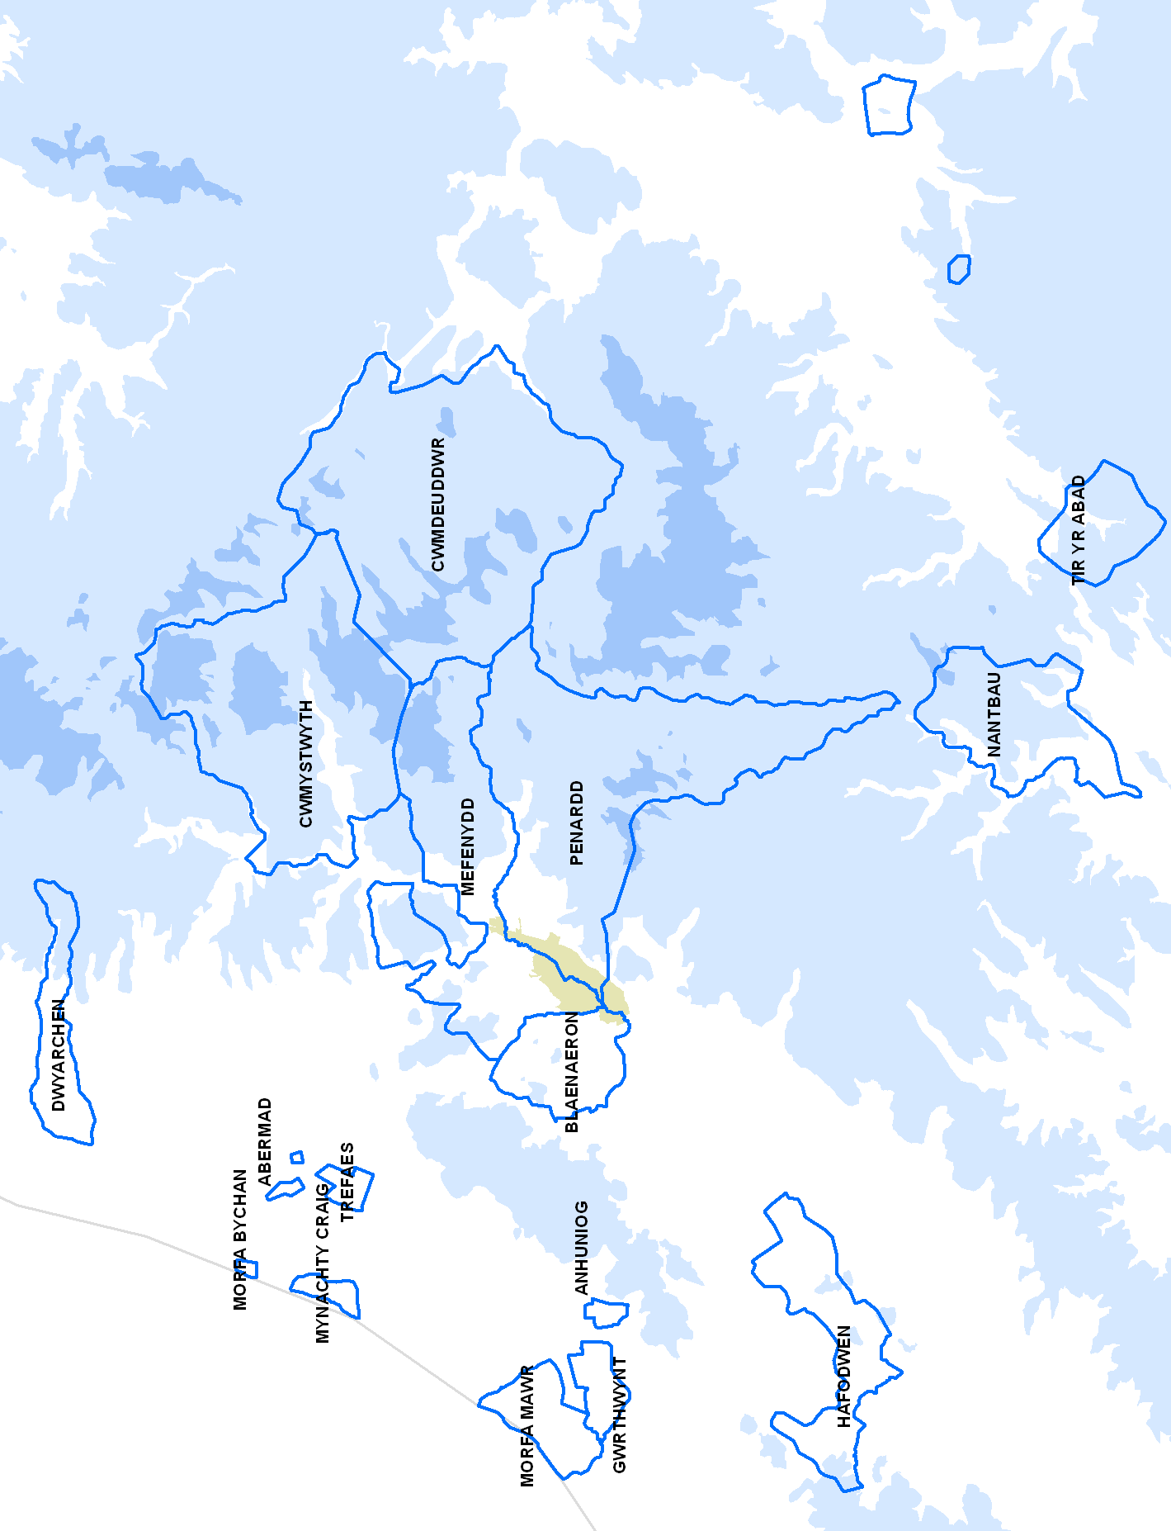
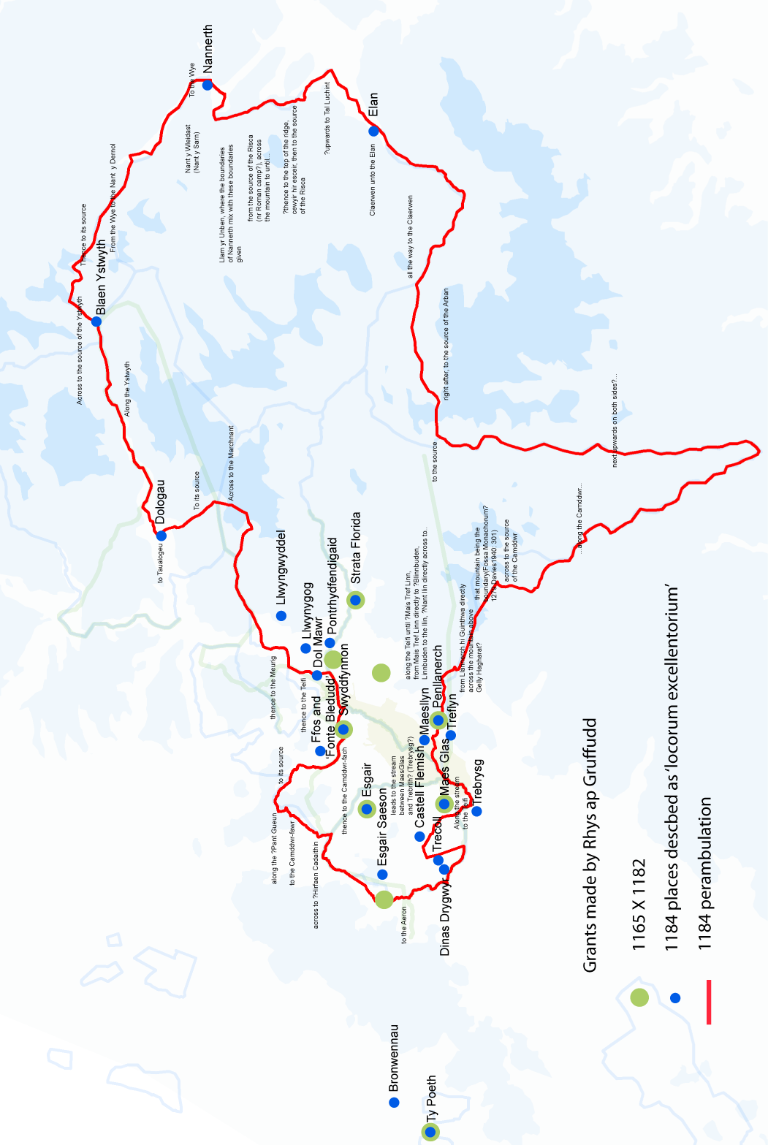
2 The core grange of Strata Florida re-mapped (Bezant forthcoming)

3 Geology
4 Historical mapping (Rees 1950)

5 Pollen diagram interpretation of Tregaron Bog (Morriss 2001)
6 The granges and their farms in 1577 (Bezant forthcoming)

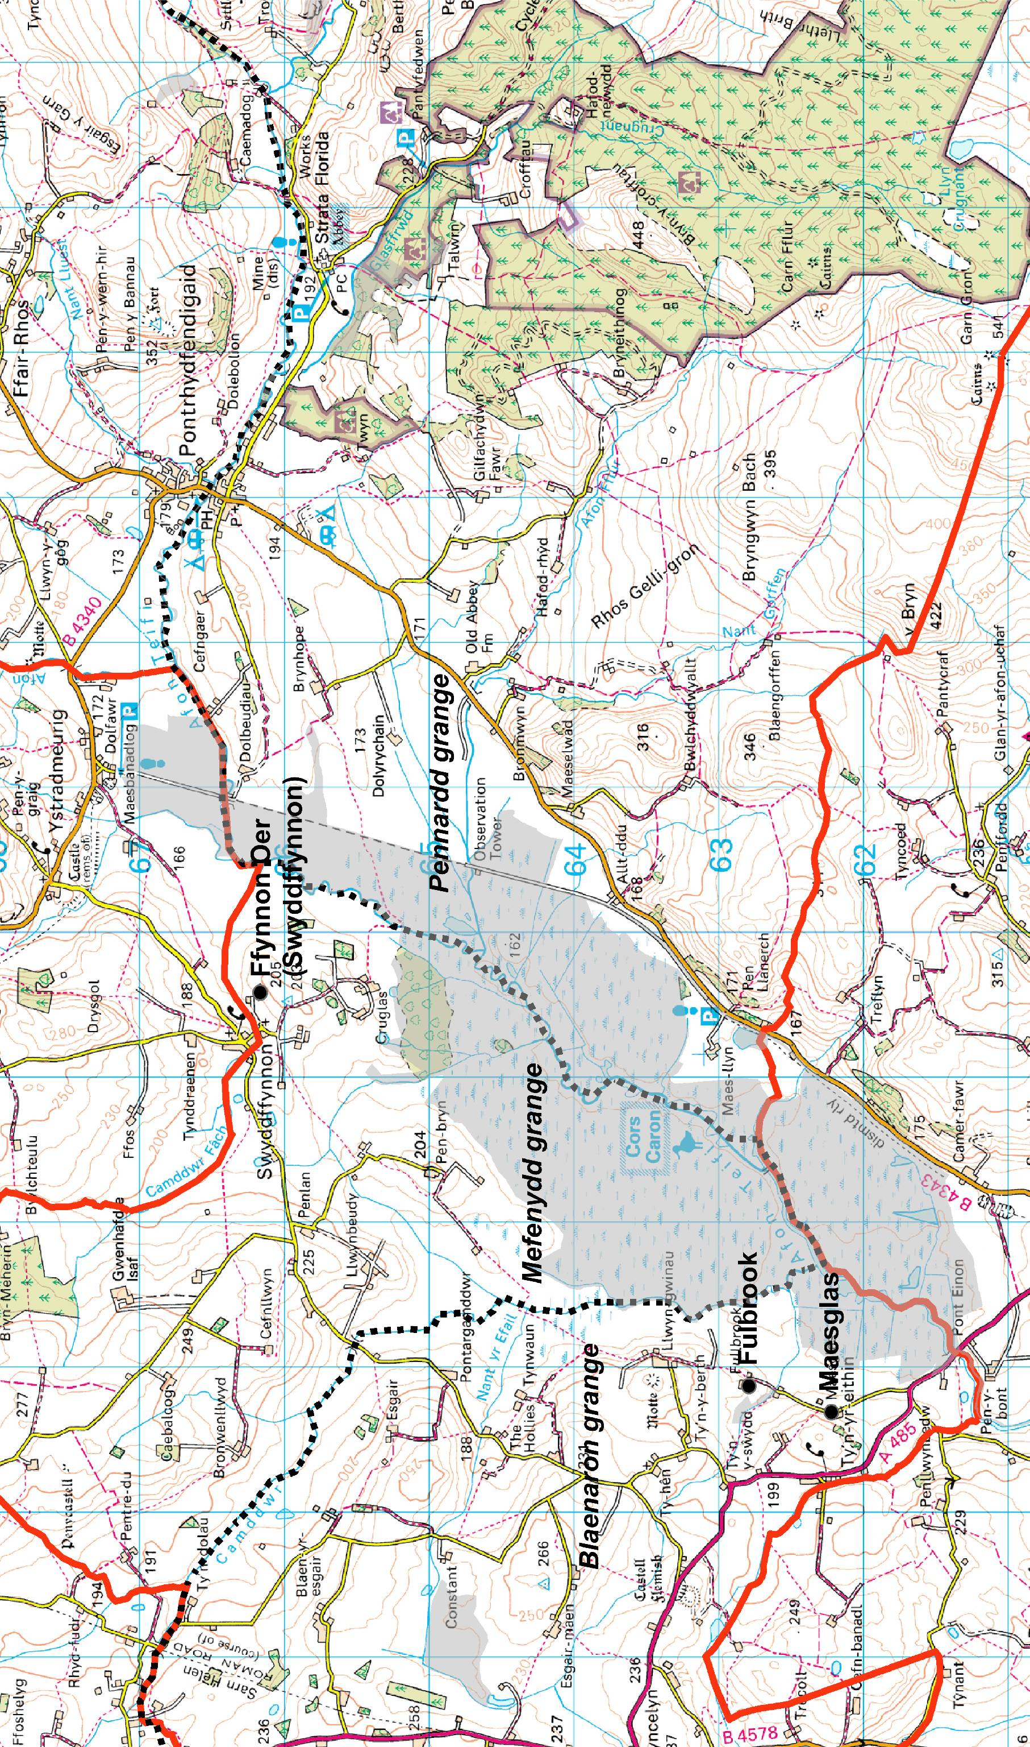
7 The study area (OS 1:50 000)

