Module Name: Operating Systems
Programme: CertHE Computing Skills for Workplace
Assignment Title: Component 2 Coursework
Module Code: ACCA4022
Student Name: Wil Phan
Student ID: 2507504
Lecturer’s Name: Dr Md Shantanu Islam
University: Wales Trinity Saint David

Submission date: 26/03/2026

Introduction
This coursework focuses on the fundamentals of Computer Architecture and Operating Systems, giving a clear overview of how modern systems function. The report explores the key roles of an operating system, including how it manages tasks, applications, files, and hardware devices. It also looks at how security is maintained within a system to protect data and users. In addition, practical elements are included by command line interfaces in both Windows and Linux environments, helping to demonstrate real-world system management skills. Overall, the assignment combines theory and practice to build a solid understanding of operating system operations.

Key functions of general Operating Systems
Microsoft introduced the Windows operating system in 1985, and it has since become one of the most popular choices for personal computers. It helps users interact with their devices by managing hardware, running programs, and organising files. With its user-friendly design, Windows has made everyday tasks, work, and digital activities much simpler and more accessible for people around the world [1].

Task Management
Task management in Microsoft Windows helps users stay in control of what their computers are doing. By using the built in Task Manager, you can easily see which apps and processes are running in the background at any time. If a program freezes or slows your system down, you can quickly close it without hassle. The tool also gives clear insights into your computer’s performance, including CPU, memory, and disk usage. Overall, Task Manager makes it easier to keep your computer running smoothly, organised, and responsive, creating a more user friendly and stress free experience. This makes everyday computing simpler and efficient [2].
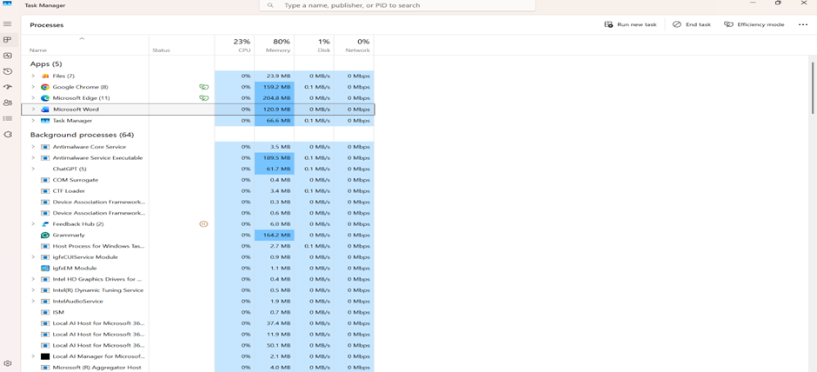

Application, Program and Management
Managing applications in Windows refers to how the operating system handles the programs you install and use every day. It plays a key role in making sure your apps run smoothly and efficiently. Windows provides built-in tools like Control Panel, Settings, and Task Manager to help you install, monitor, and manage these applications with ease. Keeping your programs well organised is essential for maintaining a stable and responsive system. It also helps protect your computer from unwanted or harmful software, while ensuring your important applications stay updated, secure, and perform at their best whenever you need them most [3].
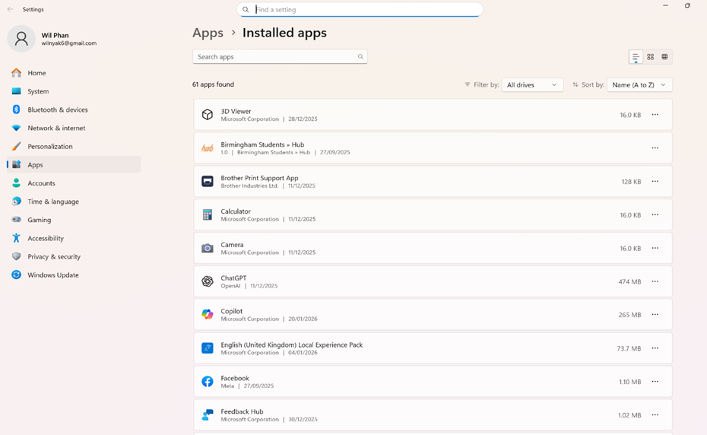

File, Directory & Management
Managing files and folders in Windows makes it easier for people to organise their information. A file can be anything from a document to a photo or a video, while a folder is simply a place where related files are kept together. Using File Explorer, users can create, edit, move, copy, or delete items with just a few clicks. Keeping files in clearly named folders saves time and helps avoid confusion when trying to find important things later. Good organisation also makes your computer feel less cluttered and easier to use every day. Everything stays neat and easy to manage [4].

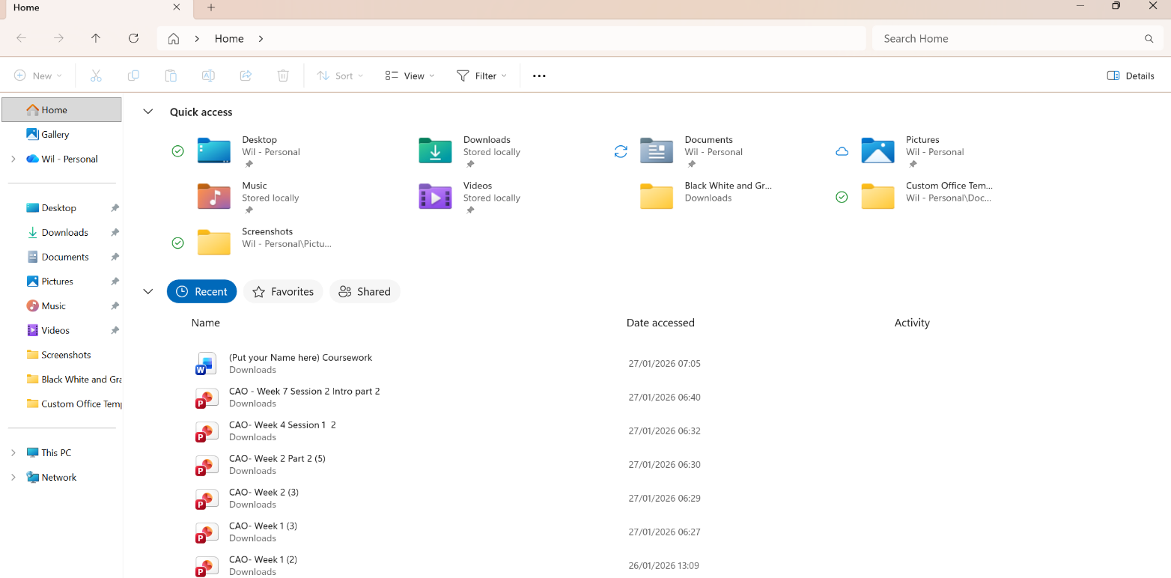

Device Management
Device management in Windows plays a crucial role in making sure the computer works smoothly with all the hardware connected to it, from printers and keyboards to graphics cards and USB devices. Think of it like a control hub that keeps everything running in harmony. For example, if your printer suddenly stops working, you can use Device Manager to check for issues or update its driver to get it working again. By monitoring and managing these devices, Windows helps prevent problems and keeps your system running reliably, so you can go about your daily tasks without unnecessary interruptions or frustration [5].
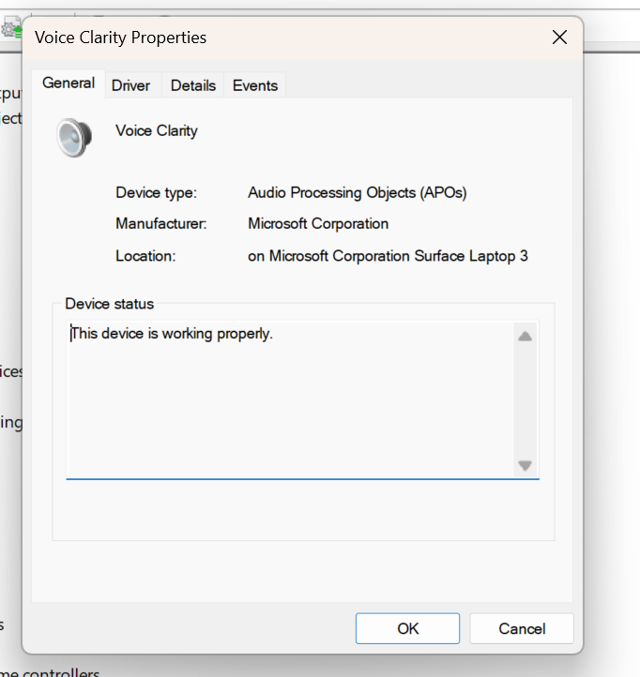

Security Management
Security management in Microsoft Windows focuses on keeping the computer, its data, and the people using it safe on a daily basis. Windows comes with a variety of built-in tools designed to control who can access the computer and what actions they can perform. For example, Microsoft Defender Antivirus helps detect and remove harmful software before it can damage the system. Beyond protection, Windows ensures the computer stays up to date and that data is safeguarded with the right user permissions. This combination of features gives users peace of mind, knowing their information and activities are secure [6].

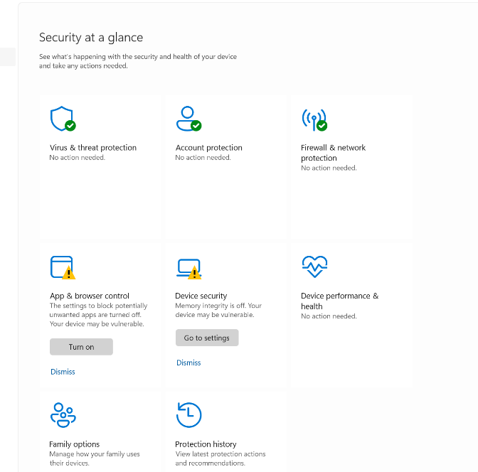

Use of Windows OS CLI commands
The Windows Command Line Interface lets users communicate directly with their operating system by typing commands. It provides a fast and efficient way to carry out tasks, giving users more control and flexibility to perform actions exactly the way they need [7].

The dir command in Command Prompt lists files and folders in a directory. Here, it shows the contents of C:\Users\home, including system folders, dates, and available disk space.

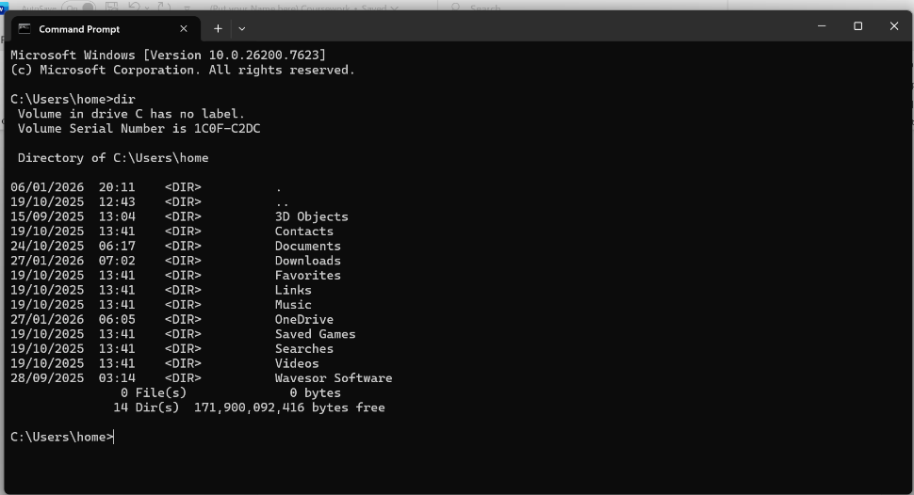

I first move into Documents using cd Documents. Then I try dc, but that's a typo. Command Prompt doesn’t recognise dc, so it shows an error saying it isn’t a valid command.
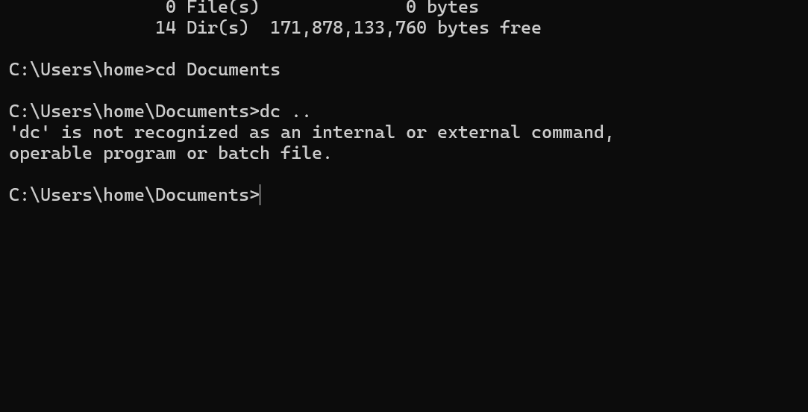

I navigated to Documents using cd, mistyped dc, which caused an error, then created a folder named Wil with mkdir, and confirmed it exists using dir in the listing.
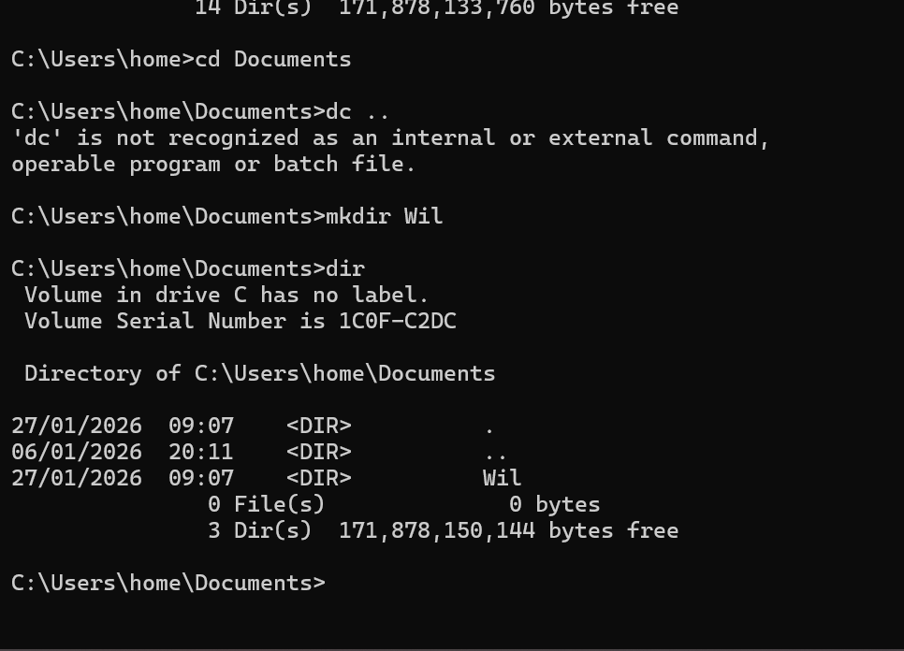

I changed into Documents, mistyped cd as dc, so it failed, created a folder named Wil, listed contents to confirm it exists, then tried deleting non-existent “new” folder, causing an error message.
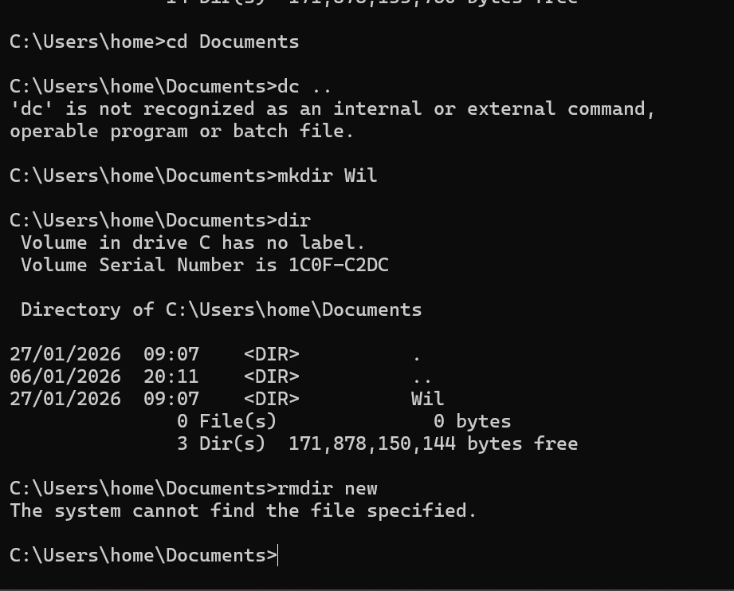

The command creates or opens a simple text file and adds a short line to it. The output shows the written sentence displayed inside the editor, confirming that the text was successfully saved.
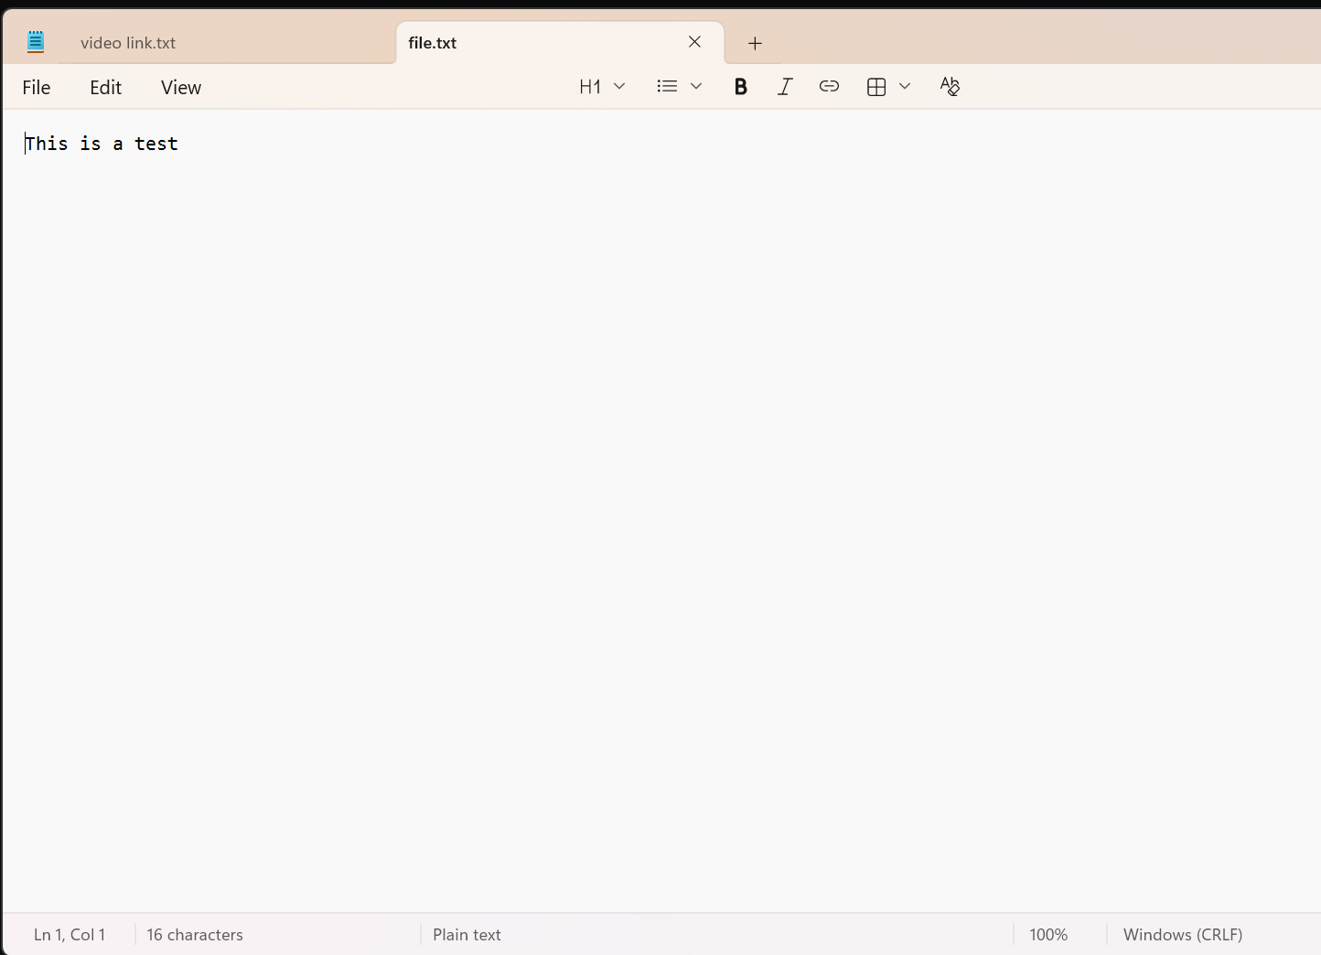

The command creates a text file, lists the folder contents, attempts to open the file, and then displays running processes with their IDs and memory usage in a Windows environment.
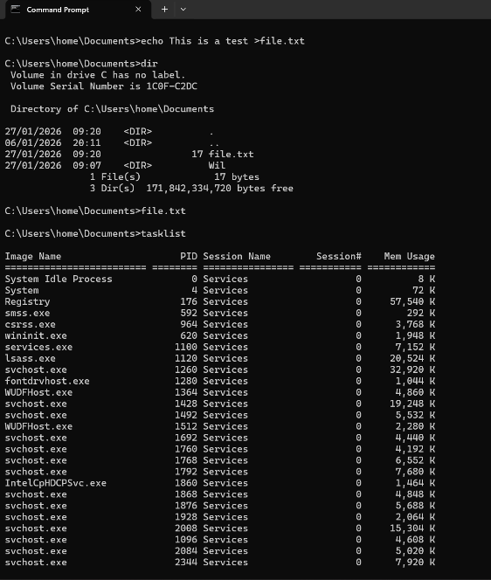

The command creates a text file with a short message, lists the folder contents to confirm it exists, and then shows running processes on the system with details like memory usage.
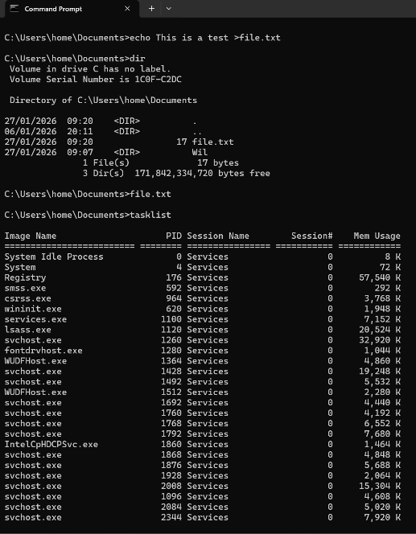

The user tries to run ipconfig /all, but the system says it isn’t recognised. Then I list files with dir, which shows folders, one text file, and available disk space.
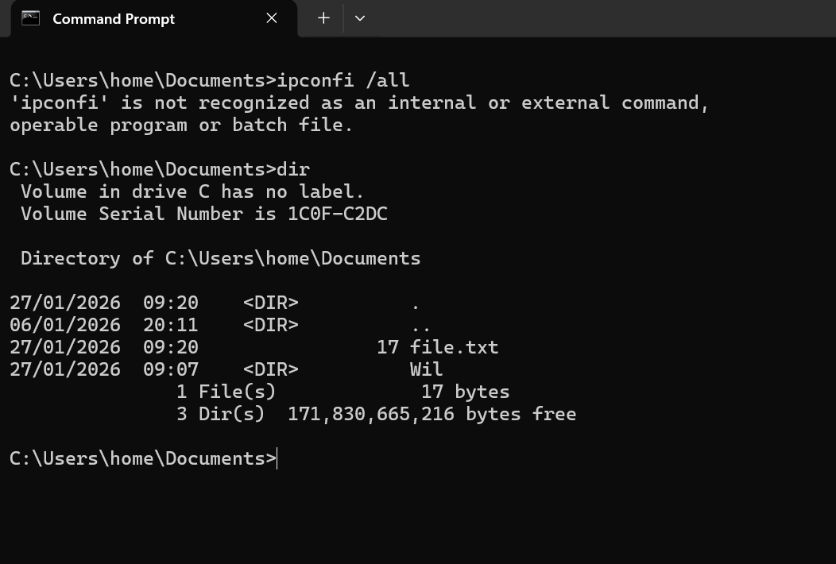

The ping command checks connectivity to Google.com by sending packets and measuring response time. The replies show latency in milliseconds, and the summary confirms all packets were received with no loss.
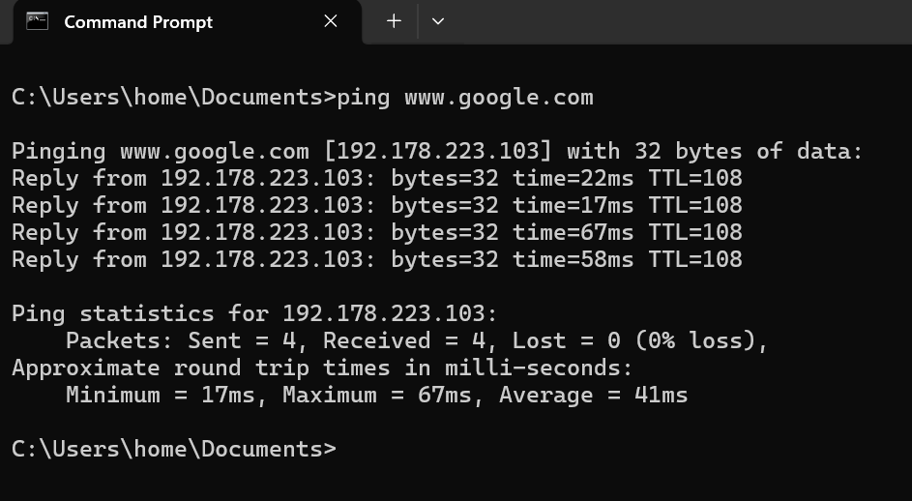

These commands test network connectivity: ping checks if google.com responds and measures delay, while tracert shows the path data takes across routers, including response times and where requests start timing out eventually.
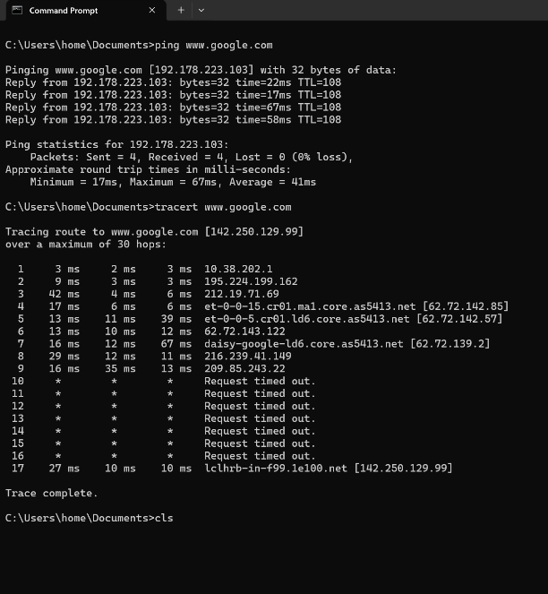

Use of Linux OS CLI commands
Using the Linux command line can feel a bit intimidating at first, but it’s a powerful and flexible way to interact with your system. It lets you manage files, run programs, automate tasks, and troubleshoot issues quickly and efficiently [8].

There was a first mistypes su in uppercase, causing an error. Then I correctly use su, enter the password, switch to root, and finally change back to the sysadmin user.
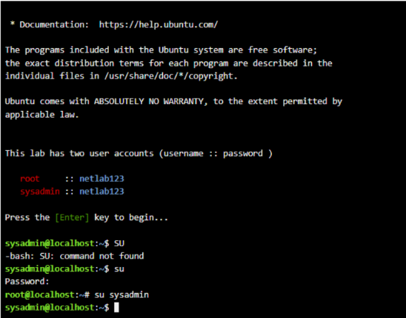

The pwd command shows the current working directory. Here, it displays /home/sysadmin, meaning it is currently located in their home directory on the system.
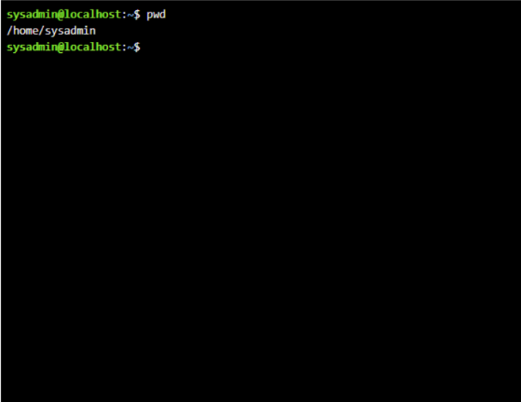

The pwd command shows the current directory path, while ls lists files and folders. and -a displays hidden files, helping to better understand directory contents.
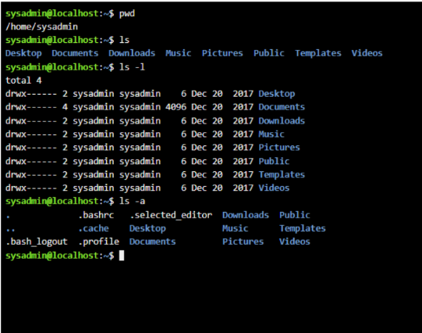

The cd Desktop/ command changes the current directory to Desktop. The prompt then updates to show I’m now inside the Desktop folder, confirming the command worked successfully.
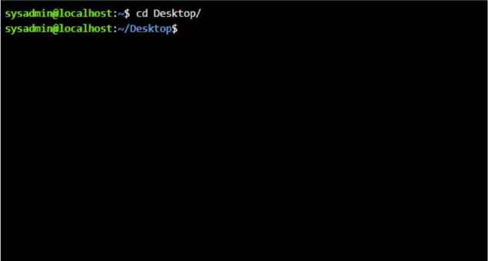

The command creates three folders named new, folder1, and folder2 on the Desktop. The command then lists them, confirming they were successfully created and are now present.
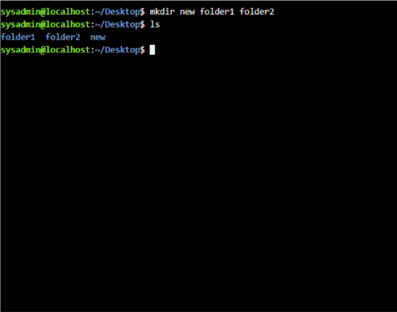

There are three lists of folders, three folders, then remove them using the rmdir command. Running ls again shows nothing, confirming the folders were successfully deleted from the directory.
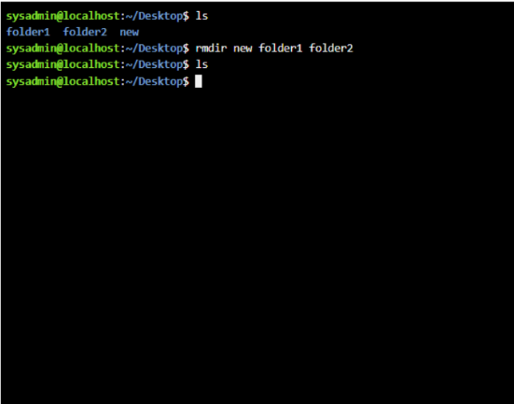

The touch file.txt command creates an empty file named file.txt. Then lists the files in the folder, showing file.txt, confirming it was successfully created and now exists.
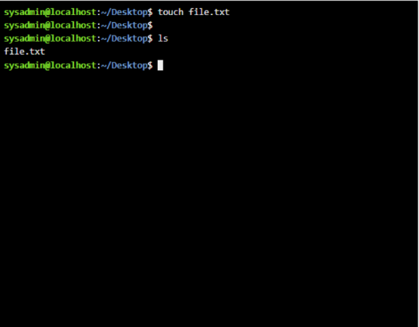

The first command writes the text this is a test into a file named file.txt. The second command displays the file’s content, showing that the text is saved correctly.
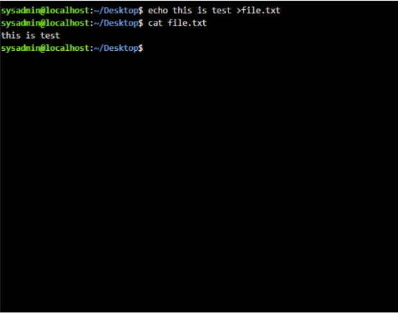

The ifconfig command shows the system’s network details. Here, it lists the Ethernet (eth0) with IP 192.168.1.2 and the loopback (lo), confirming both interfaces are active and running.
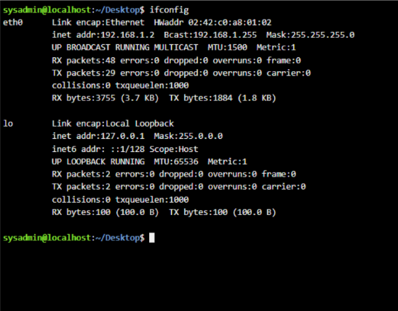

The terminal shows basic Linux commands: checking the current user, displaying the system date, and deleting a file. Batch scripting automates repetitive tasks, improving efficiency in system management and operations.
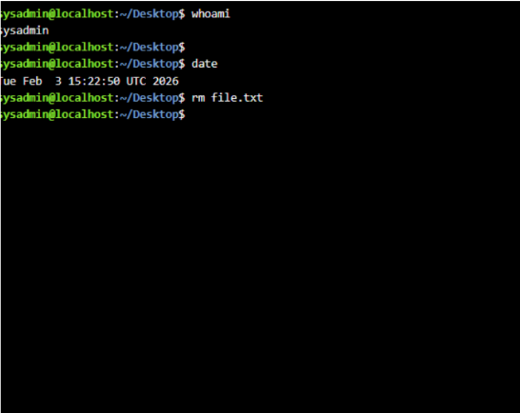

Use of Windows OS scripts
Batch scripting is a simple way to automate tasks in a Windows environment using command-line instructions. It is commonly used for repetitive jobs such as file management, system backups, software installation, and basic calculations. By writing a sequence of commands in a .bat file, users can execute multiple operations at once without manually typing each command.
The script shown is a basic example of user input and arithmetic in a batch file. The line @echo off hides command prompts for a cleaner display. The set /p commands ask the user to enter two numbers, storing them in variables num1 and num2. The line set /a sum=num1+num2 performs the addition. Then, echo displays the result in a readable format. Finally, pause keeps the window open so the user can see the output. The output shows the user entering 76 and 90, and the program correctly calculates and displays their sum as 166 [9].
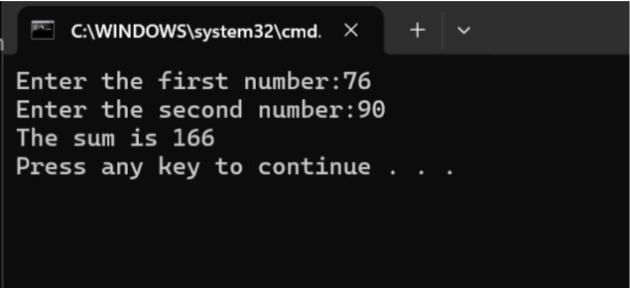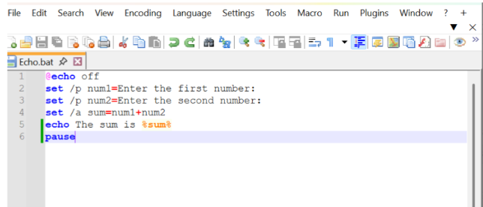

This script is a simple Windows batch program that asks to enter age and then checks whether they are eligible to vote. First, it displays a prompt asking for the user’s age and stores the input in a variable. It then uses a conditional statement to compare the entered age with 18. If the age is 18 or older, the program prints a message saying the user is eligible to vote. Otherwise, it displays that the user is not eligible.

When you run the script, it opens a command prompt window and waits for your input. For example, if you enter 6, it tells you that you are not eligible to vote. If you enter 67, it confirms that you are eligible. Finally, the “pause” command keeps the window open so you can read the result before it closes.
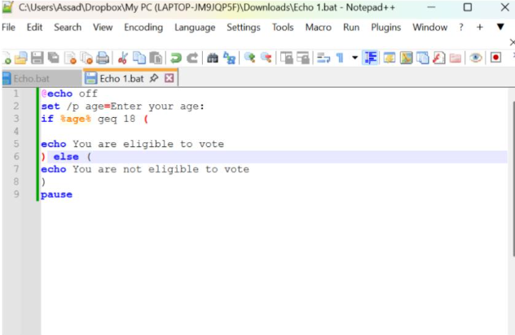

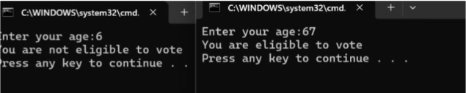
Use of Linux OS Use scripts
This simple shell script asks to enter two numbers and then calculates their sum. First, it displays a message prompting the user to type the first number and stores that value in a variable called num1. It then asks for the second number and saves it in num2. After collecting both inputs, the script performs a basic arithmetic operation to add the two numbers together and stores the result in a variable named total. Finally, it prints a message showing the calculated sum.

When the script is executed, the user sees prompts in the terminal asking for each number. In the example shown, the user enters 22 as the first number and 222222 as the second. The script then adds these values and displays the result as “The sum of 222244.” This demonstrates how user input and arithmetic operations work together in a basic shell script [10].
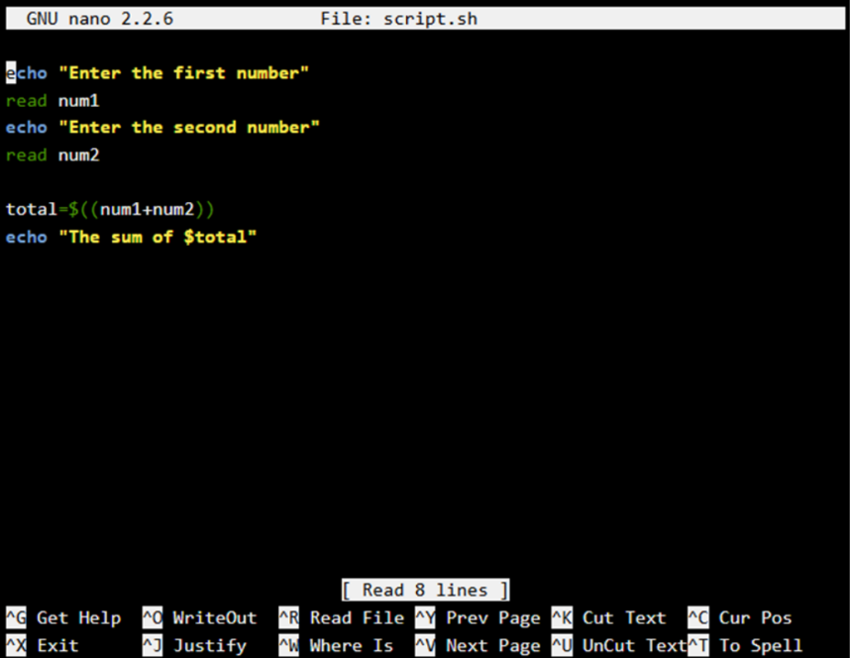
Figure 30: Description
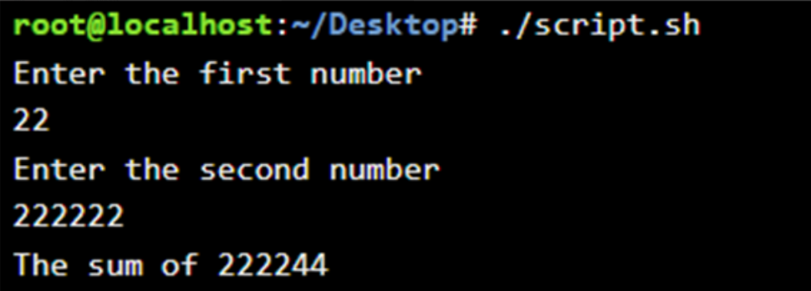

This script is a simple Bash loop written in a file named loop.sh, and it demonstrates how a for loop works in shell scripting. The loop starts with the variable i set to 1, continues running as long as i is less than 10, and increases i by 1 after each iteration. Inside the loop, the echo command prints the current value of i to the terminal.
When the script is executed, it produces a sequence of numbers from 1 to 9, each displayed on a new line. This happens because the loop stops before i reaches 10, due to the condition i < 10.
Overall, this is a straightforward example that helps beginners understand how loops control repetition in Bash. It clearly shows how a variable changes step by step and how output is generated during each cycle of execution.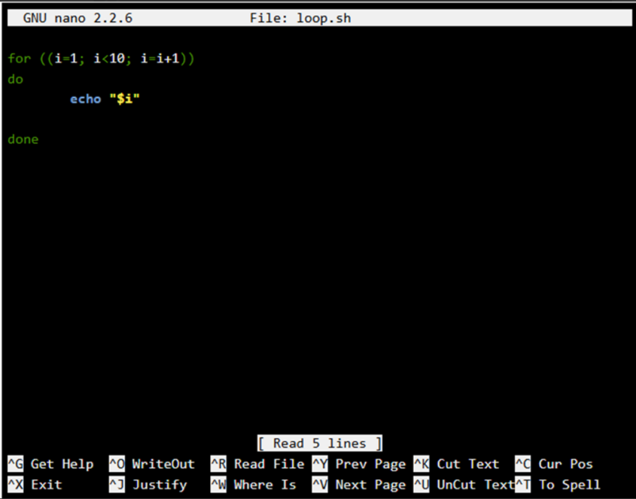
Fig 32: Description


Conclusion
I feel that this coursework has really helped me understand how operating systems work in both theory and practice. Learning about Windows and Linux, especially using the command line and scripts, has made me more confident in managing systems and solving problems. I now have a clearer understanding of how systems connect and stay secure and efficient.

Appendices Online Course name 

Certificate of completion



References
[1] M. Bruneau and A. Reinhorn, “Exploring the Concept of Seismic Resilience for Acute Care Facilities,” Earthquake Spectra, vol. 23, no. 1, pp. 41–62, Feb. 2007, https://doi.org/10.1193/1.2431396.
[2] “Volunteer Task Ideas,” The Volunteer Management Report, vol. 23, no. 12, pp. 7–7, Nov. 2018, https://doi.org/10.1002/vmr.31060.
[3] P. Fang et al., “Research progress on AI-assisted screening and prediction of systemic diseases based on retinal images,” The Visual Computer, vol. 41, no. 12, pp. 9509–9537, May 2025, https://doi.org/10.1007/s00371-025-03977-8.
[4] M. Lim, “An Active File Mode Transition Mechanism Based on Directory Activation Ratio in File Synchronisation Service,” Applied Sciences, vol. 13, no. 10, p. 5970, May 2023, https://doi.org/10.3390/app13105970.
[5] N. Mansor, W. M. Shah, and Najwan Khambari, “DEVICE-TO-DEVICE COMMUNICATIONS DIRECTION FOR DISASTER MANAGEMENT: A REVIEW,” Journal of Information Systems and Technology Management, vol. 9, no. 34, pp. 66–81, Mar. 2024, https://doi.org/10.35631/jistm.934005.
[6] “Security Risk Management,” Network Security, Vol. 2011, no. 10, p. 4, Oct. 2011, https://doi.org/10.1016/s1353-4858(11)70103-9.
[7] S. S and V. Pai T, “Use of Windows Presentation Foundation and Windows Forms in Windows Application Programming,” SSRN Electronic Journal, 2016, https://doi.org/10.2139/ssrn.2967900.
[8] A. Kumar and C. S. Jadon, “Installation of KOHA with Commands in UBUNTU: Linux Operating System,” International Journal of Information Dissemination and Technology, vol. 12, no. 4, pp. 148–150, 2022, https://doi.org/10.5958/2249-5576.2022.00030.9.
[9] N. A. Fedkova and D. A. Fedkov, “Development of PowerShell Scripts for Automating Windows OS Administration Processes. Automating the Process of Creating and Distributing SSL Certificates to Servers, Vestnik NSU. Series: Information Technologies, vol. 20, no. 1, pp. 81–96, May 2022, https://doi.org/10.25205/1818-7900-2022-20-1-81-96.
[10] P. Boyanov, “DISCOVERING WIRELESS NETWORKS VIA MODIFIED SCRIPTS IMPLEMENTING LINEAR ALGORITHMS FOR LINUX BASED OPERATING SYSTEMS,” Journal Scientific and Applied Research, vol. 24, no. 1, pp. 89–101, Nov. 2023, https://doi.org/10.46687/jsar.v24i1.372.
‌

‌

‌

‌

‌

‌

‌

‌

‌

‌

