

Student Name: Vrushabh Rakeshbhai Patel
Student ID: 2528085
Programme: Master of Business Administration
Module Name: International Marketing: Principles and Practices
Module Code: LCMB7026
Lecturer’s Name: Dr. Piyumika Gamage
Word count: 5166
Term: 2
Assignment Title: A Critical Evaluation of Adidas’s International Market Entry Strategy and Marketing Mix: A Comparative Analysis of the United Kingdom and India

Table of Contents
1. Section 1: Report 3
1.1 Introduction 3
1.2 Comparative Macro-Environmental Analysis 4
1.3 Comparative Cultural Analysis 7
1.4 Comparative STP Analysis 9
1.5 Comparative International Marketing Mix 12
1.6 Market Entry Strategy: India 14
1.6.1 Adidas’s Entry into India 14
1.6.2 Theoretical Framework: Uppsala Model 14
1.6.3 Critical Evaluation 15
1.6.4 Current Strategic Implication 15
1.7 Ethical Analysis of adidas's Marketing 15
1.7.1 Ethical Issue: Sustainability Communication 15
1.7.2 Stakeholder Theory 16
1.7.3 Utilitarian and Deontological Perspectives 16
1.7.4 Legal versus Ethical Responsibility 16
1.7.5 Critical Judgement 16
1.8 Strategic Recommendations 17
1.9 Conclusion 18
2. Section 2: Reflective Account 18
3. References 22

Section 1: Report

Introduction

Figure 1: Adidas AG
Source: (Adidas, 2018)
Internationalization has increased the level of competition in the global sportswear industry, necessitating global consistency while adapting to diverse cultures and economic markets (Gashi, 2025). Adidas AG was founded in Germany in 1949 and is one of the major players in the global sportswear industry dealing in shoes, apparels, and other sporting gear (Adidas, 2018). The firm’s product range includes a blend of sports wear with lifestyle lines, which enables it to compete in both performance and fashion-conscious markets. Adidas recorded sales revenues of €24.811 billion in 2025 compared to €23.683 billion in 2024, an increase of about 4.8% (adidas, 2026).
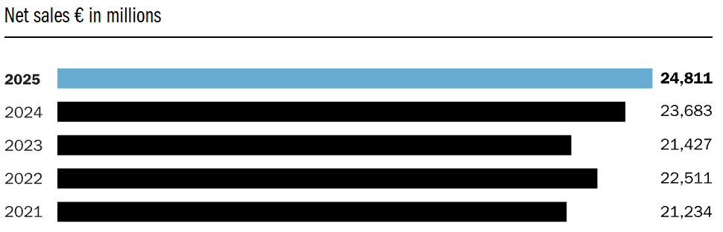
Figure 2: Net Sales
Source: (Adidas, 2025)
The comparison between the UK and India is strategically important on account of the variation in economic development, consumer culture, preferences for sports and retail environment. In August 2025, a consumer survey of sportswear buyers in India included 20,359 respondents aged 16 years and above, suggesting that a considerable number of consumers have been reached in the sportswear purchases in India (Statista, 2025). Also, growth projections in India's footwear market up to 2030 ensure future appeal of the country to international sportswear brands.
The current report will provide a critical evaluation of international marketing strategy of adidas in the UK and India in terms of PESTLE, Hofstede’s cultural dimensions, STP and the 7 Ps of marketing, as well as an assessment of market entry strategy in India and ethical marketing practices. Selective adaptation is considered to be more adequate than standardisation or localisation of the marketing strategy.

Comparative Macro-Environmental Analysis
PESTLE is a strategic framework that examines Political, Economic, Social, Technological, Environmental, and Legal aspects of external environment of an organisation.
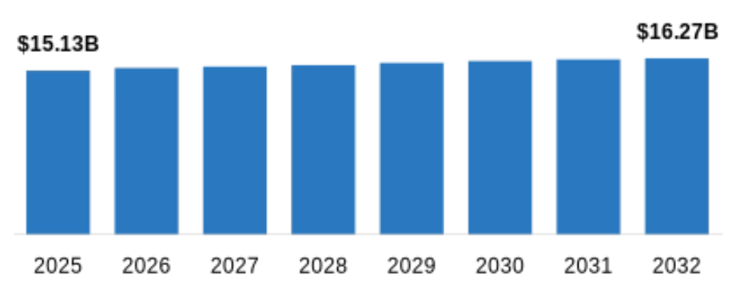
Figure 3: UK Footwear Market
Source: (Vyansa Intelligence, 2026)
Factor | Analysis
Political | UK: The United Kingdom provides Adidas with an institutionally and regulation-wise stable business environment, which decreases political instability and fosters investments in retail and digital infrastructure (DLT Barbosa, 2022). The conditions post-Brexit add more complexity to international goods flow, customs clearance, and logistics. For Adidas, which is engaged in a global value chain, political stability does not mean that there is no operational risk involved.  India: India, for its part, develops economically, industrially, and builds necessary infrastructure under the umbrella of a stable democracy. Despite possible risks of higher prices on energy and potential disruptions of supply chains that will affect growth in fiscal year 2027, according to the World Bank, India will grow at the rate of 6.6% (Sahi Markets, 2026). However, India's federalism and unevenness between the states can complicate regulation and administration. While India seems to have more economic prospects in the long term, the United Kingdom remains more predictable in terms of institutions. Adidas needs to keep a centralized governance structure globally but allow the flexibility for Indian units.
Economic | UK: The UK represents a mature, relatively high-value consumer market for adidas, supporting premium sportswear positioning. The market sales of footwear in the United Kingdom will be US$15.13 billion in 2025 with the forecasted annual growth of 6.0% (Vyansa Intelligence, 2026). Taking into account the economic environment and prudent spending of customers, adidas faces a dilemma between maintaining premium prices for the protection of property rights and losing customers because of high prices. Instead of competing through pricing, the company may focus on the premium positioning and promotion.  India: adidas has higher long-term development potential in India, but lesser buying power makes UK price transfer problematic. However, lower purchasing power in comparison with the UK market makes it harder to transfer prices there. Sales of Indian footwear are expected to grow up until 2030 because of growing consumer demand (Grand View Research, 2025). Market growth does not remove the issue of affordability. Thus, the company can sell both low-priced and premium goods.
Social | UK: Sportswear consumption increasingly overlaps with fashion, identity and lifestyle. Adidas values football, jogging, gym culture, and athleisure. European adidas-brand sales climbed 10% on a currency-neutral basis, with growth in Performance and Lifestyle categories (Adidas Group, 2025). Locally focused product assortments and activations underpinned global growth.  India: Social opportunities are fundamentally different. Cricket is culturally significant, and younger urban customers are more interested in fitness and aspirational consumerism. Thus, applying a UK football-led communication approach to India risks cultural mismatch. adidas's Indian cricket cooperation and marketing show why sports significance must be locally built, not internationally assumed (Gashi, 2025). Regional, linguistic, social, and generational disparities make national-level assumptions necessitate local consumer research in India. This constraint also shows why cultural and STP analysis should follow PESTEL.
Technological | UK: The customer journey map of Adidas is based on digital technologies like e-commerce, apps, social media and personalization. The digital spend dropped by 2.5% in May 2025 compared to the previous year. At the same time, online sales constitute 27.2% of total retail transactions (team, 2025). It shows that digitalization is vital, but it is not enough for growth alone, as price sensitivity remains an issue even in well-developed industries.  India: Digitalization in India has its particularities, and Adidas can use them. It connects with customers via mobile commerce and digital payments outside the physical stores. Digitalization can overcome geographic barriers and become more influential in this country (Sindakis & Showkat, 2024). But digitalization alone does not guarantee purchases. Adidas needs to combine digital commerce with physical retail and marketplaces in order to reach the entire state.
Environmental | UK: Environmental criteria provide both opportunities and risks to reputation. UK advertising regulation requires that general environmental claims need to be substantiated, qualified and evidenced throughout the product lifecycle (Navraj Singh Ghaleigh, 2025). The ASA has found 61,000 general environmental claims out of 7.7 million UK business-to-consumer ads for September–November 2025, highlighting the increasing importance of green advertising regulations (ASA, 2026). Even though sustainability may provide a unique feature to Adidas, it might raise the risk of greenwashing.  India: Environmental concerns are on the rise, but cost and availability remain important factors, changing the balance of strategy. Adidas should not expect that sustainability arguments that will work in the UK will also work in India. Initiatives on sustainability should be clearly tied up with customer value and include durability, recycled products and ethical production processes (Chen, 2024). The notion of sustainability needs to be communicated as a value proposition based on facts and not marketing only.
Legal | UK: Adidas follows strict consumer protection and advertising laws. Advertising Standards Authority (ASA, 2024) states that all objective claims have to be substantiated and environmental claims must be clear. Although these laws increase costs of compliance, at the same time, they improve clarity of competitive interactions.  India: Consumer Protection Act 2019 along with Guidelines for Prevention of Misleading Advertisements and Endorsements for Misleading Advertisements of 2022 protect consumers in India. International standards on deception marketing tend to coincide with trends in regulation. Nevertheless, implementation occurs in a market that is even more complicated and diverse. Adidas' strategy should go beyond simply complying with laws. Adopting an international standard of marketing governance that is above the local minimum can decrease regulatory risks, strengthen the company’s brand reputation, and create a unified market.

Comparative Cultural Analysis
The Hofstede cultural dimensions represent a way to analyze different national cultures along six dimensions such as Power Distance, Individualism, Masculinity, Uncertainty Avoidance, Long Term Orientation, and Indulgence (Wale, 2025). Such a framework may help adidas detect differences in the value systems of consumers; nevertheless, their scores at the national level should be viewed only as a means of analysis but not predictions due to high internal diversity of cultures.
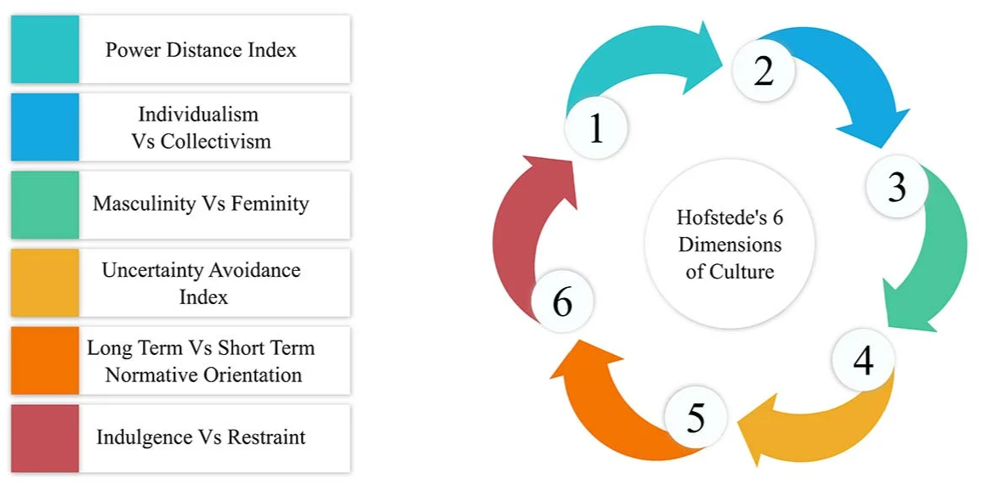
Figure 4: Hofstede’s Cultural Dimensions
Source: (Nickerson, 2025)
Power Distance
India scores 77, compared with 35 for the UK, indicating a substantially greater acceptance of hierarchy and unequal power distribution in India. This difference would imply the use of authority-based legitimacy and high-status sports figures as a powerful component of Indian marketing strategies. Thus, Adidas may benefit from using its famous Indian cricketers as credibility factors. At the same time, the lower UK score suggests that communications in the UK may be less formal and egalitarian (Elfadl et al., 2025). Power distance, however, should not be taken as an indicator that all Indian customers favor hierarchical communication.
Individualism versus Collectivism
The UK has a significantly higher degree of individualism, while India represents a more collectivist culture (Rashedkhan, 2021). Consequently, self-expression and success of individuals may become an important feature of advertising in the United Kingdom. Meanwhile, messages about sports linked to community life, pride in one's country, and team success will probably resonate with Indian customers. Nevertheless, it should be acknowledged that digitally connected Gen Z consumers in India combine their lifestyle with global individualistic one (Phuong and Pan, 2026). Thus, segmentation needs to work in conjunction with Hofstede's dimensions.
Masculinity
In India, masculinity is scored at 56, while in the UK – at 66. It means that achievement, competition, and performance values play an essential role in both countries' cultures. Hence, Adidas may base its campaign on performance and achievement in both countries (Pratama et al., 2022). However, a higher UK score cannot be understood as an encouragement to use more aggressive advertising strategy. Individual market diversity because of different gender, age, and sport subculture segments must be taken into account.
Uncertainty Avoidance
India scores 40 and the United Kingdom 35, reflecting lower levels of uncertainty avoidance in each setting. This means that innovation, innovative products, and unconventional marketing can be tolerated. Therefore, Adidas will be able to launch new footwear, digital products, and partnerships without facing any cultural resistance. Trust, product quality, and information will still remain economically crucial; hence, cultural tolerance of ambiguity should not lead to ignoring the customers' need for credible proof (Ebele et al., 2024).
Long-Term Orientation
This dimension has scores of 51 for both countries. Hence, there will probably be no difference here. Adidas can communicate product value, longevity, and sustainability to both markets. Customers can focus on price or value depending on economic circumstances despite equal scores (Choi et al., 2025).
Indulgence and Critical Evaluation
India has 26 in this dimension, while the United Kingdom has 69, meaning that India is more reserved, while the UK focuses more on leisure and pleasure. This difference can make Adidas' position related to the lifestyle better in the UK market. The methodology validity of Hofstede has been challenged; the recent validation study raises concerns whether national scores correspond to cultural diversity today (Tan, 2025). Instead of considering national scores as the true picture of consumer behavior, Adidas could consider Hofstede framework as a hypothesis and confirm cultural assumptions via customer research locally.

Comparative STP Analysis
STP (segmentation, targeting and positioning) refers to the marketing strategy used by organizations for segmenting heterogeneous markets into customer groups, choosing attractive groups, and positioning differently in customers' perceptions (Hanlon, 2024). Adidas finds STP valuable since purchasing power, sports culture, lifestyle and customer requirements in the United Kingdom and India are different.
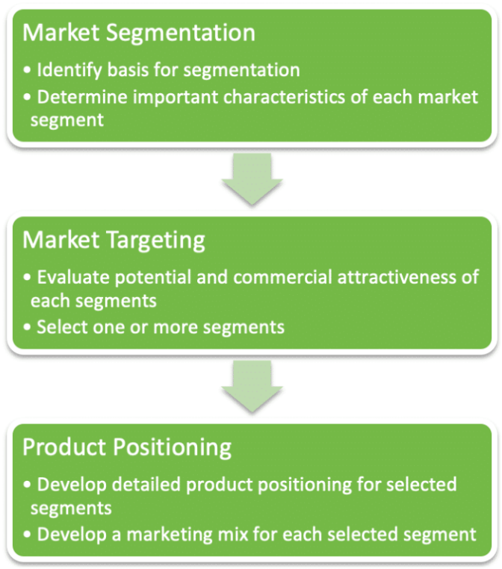
Figure 5: STP (Segmentation, Targeting and Positioning)
Source: (Hanlon, 2024)
Segmentation
The segmentation is defined as splitting the market into clusters with similar needs, characteristics, or behaviors (Lee and Kim, 2023). In the United Kingdom, Adidas could identify various segments such as Gen Z, millennials, football lovers, runners, fitness lovers, sneaker lovers, and fashion-oriented customers based on demographic, psychographic, and behavioral criteria. The combination of sports and fashion makes psychographic segmentation particularly useful. The Originals line, which includes such models as Samba and Gazelle, can be attractive for non-athletes (Rubeiz, 2025).
In India, the segmentation would be affected by income, geographic location, sports activities, and culture. The segments of urban Gen Z population, young professionals, cricket lovers, fitness lovers, and middle class aspirants would become relevant (Dinh, 2024). Cricket is an excellent behavioral and cultural variable in Adidas' market segmentation.

Using only the demographic variables would not be enough. Two people who belong to the same age group can have different levels of disposable income, sports preferences, and perceptions of global brands. Therefore, Adidas should use a combination of demographic, psychographic, and behavioral variables to improve targeting.
- Targeting
Targeting is the choice of the most appealing segments from the company's perspective (Hoenig, 2025). In the United Kingdom, Adidas should focus on style-conscious and sports-oriented younger digital generation that values performance and style. The significant purchasing power in the UK emphasizes the importance of premium targeting strategy.
In India, Adidas should take into consideration heterogeneous purchasing power. The company could target urban Gen Z and millennial generations but use differentiated products for aspirational middle and luxury trainer segments (Sagar & Varghese, 2026). Cricket lovers would become another relevant segment because of their cultural relevance that cannot be achieved using global marketing campaigns. India should not be considered as a uniform "big youth market". Multi-segment targeting strategy supported by the local market research is needed instead.
Positioning
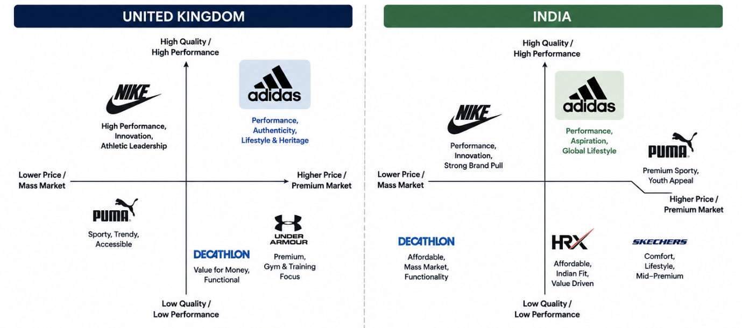
Figure 6: Positioning Map
Source: (Self-created)
Positioning deals with the process of distinguishing a brand through the perception of targeted customers from other competing brands (Duarte, Till and Hafeez, 2024). The positioning map places Adidas among top athletic brands based on quality/performances and prices. In the UK and India, Adidas is a luxury brand which blends performance and sophistication. As far as the competition is concerned, UK positioning highlights football, fashion and heritage whereas Indian positioning focuses on performance, ambition and global brand. Such an approach will help in selective adaptation without losing global brand image.

Comparative International Marketing Mix
The 7Ps marketing mix adds people, process, and physical proof to the product, price, location, and promotion framework, allowing organisations to analyse both tangible offers and consumer experience (Sramkowski, 2021). Sportswear consumption internationally combines performance, fashion, identity and experience; therefore, 7Ps are quite appropriate in the case of Adidas. The comparative international analysis suggests that Adidas needs to maintain its global brand base while modifying its marketing mix in the UK and India.
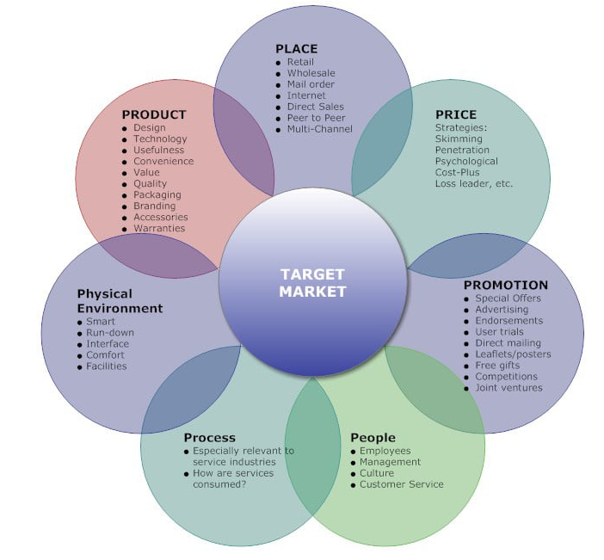
Figure 7: 7Ps Marketing Mix
Source: (Sramkowski, 2021)
Product
Products cover both physical and non-physical features created to meet customer needs. In the UK, Adidas offers performance footwear and apparel along with lifestyle products such as Samba, Gazelle, and Campus (Adidas, 2023). In India, there is a need to increase the level of localization due to differences in preferences for various sports, climate, and purchasing power. There is a need to focus on cricket, running, and fitness products in India. Most importantly, complete standardization may decrease cultural sensitivity, and high customization may lead to increased complexity and decreased efficiency of scale. Thus, Adidas must pursue selective adaptation by maintaining global technologies and brand image while adapting the product mix according to the local consumers' needs (Adidas, 2026).
Price
The price indicates the monetary value paid for the product and is an indicator of its quality and positioning (Todorova, 2026). In the UK, Adidas may maintain high prices because of the high purchasing power and existing brand equity although the cost of living leads to increased price sensitivity. In India, more heterogeneous income levels require the use of a segmented pricing approach with affordable and premium segments. For example, the price of running products in Adidas India starts from approximately ₹3,999, whereas Ultraboost products cost about ₹17,999 (Adidas, 2026b). Importantly, selective pricing may help penetrate the market without extensive discounting.
Place
Place refers to methods and channels of product delivery. In 2025, Adidas made 60% of its sales via wholesaling and 40% via direct selling. Adidas has an advanced infrastructure of UK omnichannel network including e-commerce, specialty merchandising, and brick-and-mortar stores. In India, development of physical retailing, wholesaling, and internet sales is needed for addressing geographies and socio-economic disparities. Importantly, pure focus on direct distribution will limit market potential through exclusion of wholesaling. Complementarity of channels (using direct and indirect channels) allows Adidas greater flexibility, accessibility, and market penetration in both countries.
Promotion
Promotion delivers the value using advertising, digital marketing, sponsorship, and public relations. In the UK, Adidas can advertise football, running, fashion and street wear to reinforce its positioning on performance and lifestyle. In India, cultural relevance can be achieved by focusing on cricket, Indian sports personalities, youth and community sport. The localization should modify the communication context without fragmentation of the global brand. Thus, Adidas strategy of "global brand with a local mindset" ensures balance between consistency and flexibility for relevant advertising of the global brand (Adidas, 2025a).
People
People include employees and service personnel who influence customer experience and brand perception (N S and K R, 2025). For addressing the needs of sophisticated customers, Adidas requires product and digital competence and good customer service. Taking into account linguistic and geographic diversity, India values cultural sensitivity and multilingual communication. Standardization can lead to lack of cultural responsiveness while over-adaptation can negatively affect service consistency. Thus, Adidas should standardize quality of services, ethical standards and training but allow for regional communication and interaction as "global brand with a local mindset" (Adidas, 2026).
Process
Processes refer to the processes through which customers seek out, purchase, receive, and gain assistance from the company (Fan et al., 2023). The Adidas brand provides omnichannel offerings in the United Kingdom, involving personalized recommendations, e-commerce, and the use of click-and-collect facilities. In the Indian market, issues like mobile-first shopping, digital payments, delivery, and return flexibility become very significant. The adiClub initiative combines digital and physical buying and interaction. However, in some cases, over-standardization may not meet the needs of local consumers. Thus, Adidas must have globally linked systems but offer regionally adjusted implementation.
Physical Evidence
Physical evidence refers to tangible clues which affect consumer perception regarding service quality and brand value. Store design, packaging, and visual display come under the category of physical evidence (Chitturi, Londoño, and Henriquez, 2021). Adidas can enhance its premium position in the United Kingdom by means of modern storefronts, football history and digital signage. Keeping a globally consistent visual identity while using culturally appropriate sports can improve local relevancy in India. Physical retail should provide brand experience and community engagement, not just transactions. Concept stores of Adidas help engage customers with product, team, and communities (Wang, 2024).

Market Entry Strategy: India

Adidas’s Entry into India
Market entry strategy refers to the process through which a firm enters and builds its activities within a foreign market in consideration of risk, control, commitment of resources, and market understanding (Hafez, 2023). Adidas offers a relevant case study of phased internationalization in India. It is worth noting that while the previous incarnation of the company had filed for the adidas trademark in India in 1971, market entry took place in 1989 through a licensing arrangement with Bata India. The firm launched Adidas India Marketing Private Limited through a joint venture in 1996, which was later dissolved in 2006.

Theoretical Framework: Uppsala Model
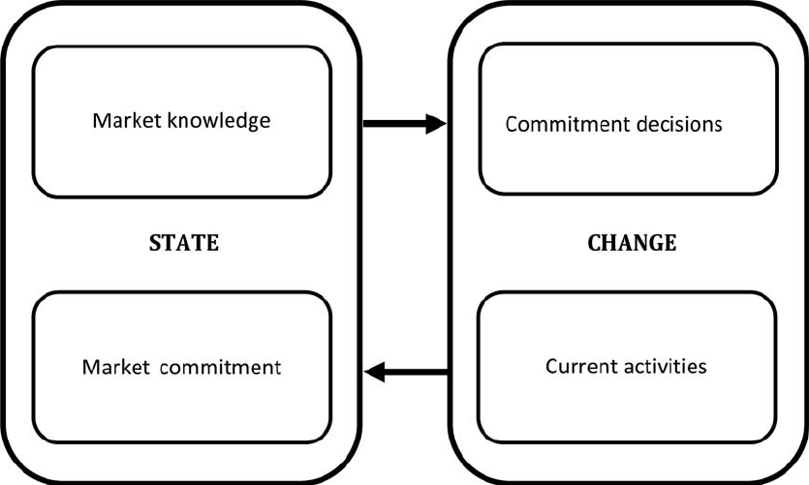
Figure 8: Uppsala Internationalisation Model
Source: (Costa e Silva, 2012)
The Uppsala Internationalisation Model suggests that enterprises gradually enhance foreign-market commitment as they learn and minimise uncertainty (Costa e Silva, 2012). The development of Adidas’ strategy of licensing, then joint venture, followed by subsidiary fits well with the concept being discussed here. In the first step, licensees obtained knowledge of the local market conditions and distribution channels without taking on too much financial risk. In the second stage, Adidas increased market knowledge and engagement as a result of the joint venture (Rahman, 2025). Ownership allowed the company greater control over branding, distribution, and strategic planning. The Uppsala model should not be implemented blindly, as operating outside major business networks creates uncertainties, therefore the updated version stresses the importance of networking.

Critical Evaluation
There were many advantages of licensing in terms of reduced capital investment and market risk and contribution of local knowledge of Bata. However, small ownership comes with disadvantages of lesser brand control, coordination difficulties, and dependence on partners. Joint ventures increase knowledge about the market and resources integration but raise the issues related to goal congruence and decision-making (Rezaei, Pironti and Quaglia, 2024). Subsidiary ownership allows for greater control and helps maintain the premium global position.

Current Strategic Implications
One should recognize that the entry mode could be dynamic, and this is shown in the India case above. The companies are likely to make more investments and obtain more control depending on their market knowledge and confidence. Local partnerships provide companies with necessary networks and knowledge of the local culture, meaning that total control is not always beneficial. Therefore, Adidas needs to strike a balance between strategic control and local partnerships in distribution, cricket, online shopping, and community relations (Jiang, 2023).

Ethical Analysis of adidas's Marketing

Ethical Issue: Sustainability Communication
Ethics in marketing involves the obligation of the companies to promote information accurately and protect the interests of the customers as well as the wider society (None Yendra & Zakaria, 2025). One example is the paid advertisement of Adidas on Google in UK by the name “Adidas Recycled Running Shoes.” In June 2026, the Advertising Standards Authority (ASA) found the complaint against the organization to be valid in that it was misleading because the consumers would take the statement to mean that the shoes are made of entirely recycled materials (Advertising Standards Authority, 2026).

Stakeholder Theory
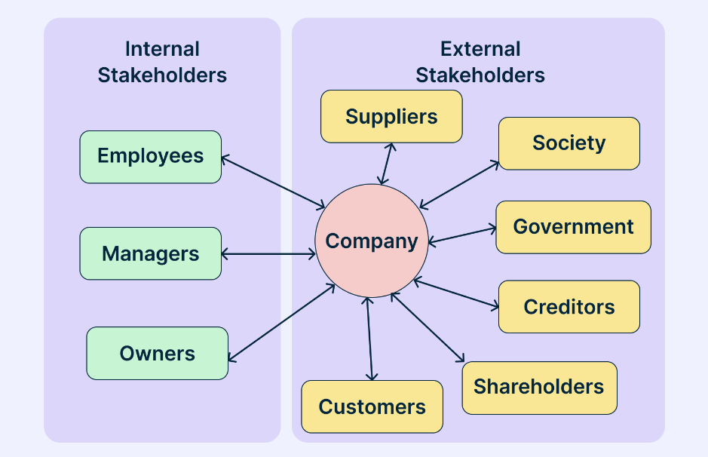
Figure 9: Stakeholder Theory
Source: (George, 2024)
Stakeholder theory states that companies have duties to many groups impacted by their choices, not only shareholders (George, 2024). There is room for ambiguity with regard to the sustainability message, which could reduce the confidence of consumers and their buying behaviour. The regulation activities that negatively affect brand trust could hurt the shareholder not only in financial terms but also in reputation. Regulators aim at truthful and evidence-based advertisement, whereas environmental organizations and society as a whole want to protect themselves from misleading sustainability marketing. Reputation conflicts could reduce employee morale and decrease the trust towards the stakeholders (Helm, 2011). Thus, adidas’ reputation among the shareholders is put at risk not only due to one case of advertisement.

Utilitarian and Deontological Perspectives
Sustainability marketing encourages people to buy environmentally friendly products and brings good results (Mumcu, 2024). However, misleading information could be harmful to consumers and the reputation, and thus it undermines the benefits mentioned. According to deontology, adidas has an ethical obligation to be truthful in their communication regardless of their business (Riquet and Lachenaud, 2024).

Legal versus Ethical Responsibility
Legal compliance represents a starting point; ethical marketing includes transparency, consumer freedom, and stakeholder well-being. According to the Advertising Standards Authority (ASA), marketers have to prove recycled-content and environmental claims (ASA, 2026). However, merely complying with legal standards is not enough for ethics.

Critical Judgement
The lawsuit does not prove adidas's sustainability approach is immoral. Instead, it shows a disconnect between actual environmental actions and their communication. Instead, they reflect the gap between real actions toward the environment and communications on this issue. Therefore, it is important for the company to formulate product-related claims correctly, report on the content of recycled products, and verify all environmental claims independently (Nguyen, 2023). This would provide consumers with sufficient information about the products and prevent greenwashing. Moreover, sustainable communication has to be viewed as strategic competence rather than mere compliance.

Strategic Recommendations
Based on the comparison of approaches, it is necessary for Adidas to avoid both absolute uniformity and over-localization. Brand equity of the company globally has to stay unchanged while marketing strategy changes according to the conditions of the UK and India (Husain, Ahmad and Khan, 2022).
- Adopt a “Global Core, Local Adaptation” Strategy
Adidas must have a globally unified brand identity, quality of products, technology standards, and values but also adapt to local contexts through the selection of specific product portfolios, communication strategies, and collaborations. There is an opportunity for realizing economies of scale through this balance. Evidence shows that international marketing performance positively correlates with a balance between standardization and adaptation, not an either-or approach (Lin, Xiaoyu, and Jianqiang, 2023).
- Develop Tiered Pricing in India
Adidas needs to refine its good–better–best pricing strategy in India by providing a range of affordable products, as well as mid-range and premium performance goods (Dhinessh Kumar A, 2025). This will cater to different income segments but also protect its premium brand equity. Adidas should refrain from extensive discounting because it may negatively impact the perception of exclusivity and quality of its products.
- Expand Cricket-Based Community Marketing
Adidas should move beyond celebrity endorsements and develop a broader cricket ecosystem, including grassroots, women's and youth cricket programmes. Cricket can be more culturally legitimizing than any global marketing in India. This approach will increase the brand engagement and support communities at the same time.
- Create Global Sustainability-Claim Governance
Given the UK ASA decision, Adidas should establish a mandatory evidence-based system for the approval of all sustainability claims. Marketing divisions should state what percentage of their products contain recycled materials, define the scope of products, and mention relevant certificates before publishing any claims (Emanuel, 2022). This system will prevent greenwashing and build customer and stakeholder trust.
- Increase the Responsibility of Digital Personalization in Both Markets
Adidas must leverage AI, customer information, and loyalty programs to provide personalized experience and recommendations through various channels. Personalization must be performed based on clear data policies and taking into account customers' privacy considerations (Abidi, 2026). It allows the company to implement technological innovations in a proper manner in both markets.

Conclusion
It has been revealed that, in order to ensure international competitiveness of the company, the main idea is to find the balance between global consistency and local responsiveness. The UK is an advanced market in terms of technology and high quality, while India is a market where there is room for growth, but at the same time it is quite diverse in terms of economy, culture, and legislation. It is possible to explain why the single approach cannot be used based on analyses made using PESTLE, Hofstede, and STP models. Analysis of 7Ps shows that it is necessary to use selective adaptation when it comes to such areas as pricing, product mix, promotion, and distribution. The step-by-step entering of adidas into the Indian market shows the benefit of gradually developing the commitment and control. Finally, the problem of sustainability advertising shows the need to maintain the proper ethics.

Section 2: Reflective Account
Gibbs' Reflective Cycle can be used to analyze an experience through the use of description, feelings, evaluation, analysis, conclusions, and action plan (Dutta, 2023). It was used to reflect on the experience of researching and writing the international marketing report on adidas in the UK and India. Reflection focuses on my research techniques, use of theory, analysis of evidence, and building academic and professional skills.
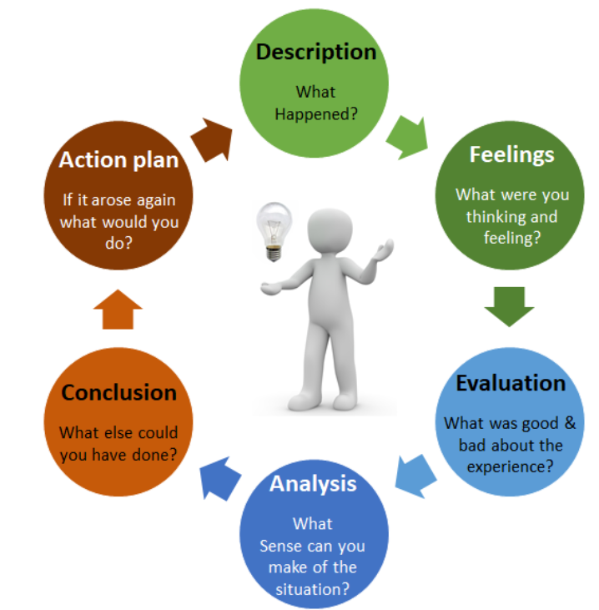
Figure 10: Gibbs’ Reflective Cycle
Source: (Dutta, 2023)
Description
This assignment required me to critically evaluate Adidas's international marketing strategies in the United Kingdom and India. Areas covered were market environments, culture, segmentation, targeting, and positioning (STP), the 7Ps, market entry, and ethics in marketing. The choice of the above two countries relates to the differences in their economic, cultural and sporting environments. Sources of information used include academic literature, Adidas's reports, government statistics, regulatory agencies and credible business sources. PESTLE analysis approach was applied to conduct macro environment analysis, Hofstede's dimensions to compare cultures and STP together with the 7Ps for marketing analysis. Moreover, I analyzed Adidas's market entry in India and Adidas's sustainability campaign in the United Kingdom before making evidence based recommendations.
Feelings
At first, there was some amount of uncertainty regarding synthesis of the above analytical approaches within the limited number of words. This is because there was an assumption that use of PESTLE, Hofstede, STP and the 7Ps may lead to descriptive analysis contrary to critical analysis that should be at the postgraduate level. Credibility of sources was an issue as Adidas's reports may contain the company's point of view on the issues under discussion. Sustainability case was very useful as the evidence from an independent regulatory agency was available.
Evaluation
I was able to come up with several strengths in terms of my research process. It included use of academic journals, company reports, government statistics, and regulation documents which enabled me to use triangulation of evidence in order to increase the credibility of my arguments. Research becomes much better when information is analyzed in the context of its relevancy, credibility, and purpose, rather than blindly accepting information as it is (Titip Elyas, Widya Sagita, and Wahidah Fitriani, 2025). Another strength was successful integration of the theoretical framework where PESTLE analysis, Hofstede’s model, STP, and 7 Ps were used together as a strategy rather than separate tools. However, at the beginning of the research process, I was overly reliant on the sources provided by the company, hence the biased organizational perspective. As a result, I used external information in order to balance out any possible bias.
Analysis
The most significant learning from this assessment was recognising that critical analysis requires more than describing frameworks or repeating evidence. At first, I viewed PESTLE, Hofstede, STP, and 7Ps as different models of analysis that could be used separately, but later I realized that my postgraduate level of studies demands me to integrate the above frameworks in order to make a strategic connection. Critical thinking includes asking questions regarding assumptions, possible interpretation and analysis of evidence before reaching a conclusion (Butler, 2024). This was achieved by linking cultural differences identified using Hofstede framework with the promotion and positioning strategies chosen by Adidas. Furthermore, I understood that standardization is not always better than adaptation, because the best strategy depends on the market situation and the company's objectives. From the research I discovered that each framework has some limitations. In particular, Hofstede model provides very useful comparisons at the national level, but does not explain the behavior of individuals and generations (Nickerson, 2025). Therefore, I have learned to feel more confident while connecting theories with evidence.
Conclusion
In general, this assessment has helped me to develop the skills needed for conducting the systematic international marketing research and constructing evidence-based arguments. I have learned that using of various frameworks does not mean doing critical analysis; the point is to connect findings in one strategic argument. The most important thing that I have improved through this research is how to go beyond questioning what the evidence says and start to question its reliability and the underlying assumptions.
Action Plan
For my future assignments, I am going to formulate a precise main argument before I begin thorough research, thus saving myself from excessive descriptions. In addition, I will try to prefer peer-reviewed studies, governmental statistics, and regulation data; corporate resources will be used only to obtain organizational information and test major claims. Moreover, I will evaluate the assumptions and limitations of the theoretical framework before using it, instead of treating such frameworks like PESTLE and Hofstede as final ones. Finally, I will improve my use of quantitative data and will include ethics in my reasoning.

References
Abidi, S.A. (2026). Personalised and generic messages: Effects on perceived intrusiveness and consumers’ intention to purchase high- and low-value products online. [online] Epublications.vu.lt. Available at: https://epublications.vu.lt/object/elaba:277676257/ [Accessed 10 Aug. 2026].
Adidas (2018). Home. [online] Adidas-group.com. Available at: https://www.adidas-group.com/ [Accessed 10 Aug. 2026].
Adidas (2023). Global brands. [online] adidas Annual Report 2023. Available at: https://report.adidas-group.com/2023/en/group-management-report-our-company/global-brands.html [Accessed 10 Aug. 2026].
Adidas (2025a). Adidas annual report 2025 - adidas annual report 2025. [online] adidas Annual Report 2025. Available at: https://report.adidas-group.com/2025/en/? [Accessed 10 Aug. 2026].
Adidas (2025b). Income statement - Adidas annual report 2025. [online] adidas Annual Report 2025. Available at: https://report.adidas-group.com/2025/en/group-management-report-financial-review/business-performance/income-statement.html [Accessed 10 Aug. 2026].
adidas (2025). Markets and sales channels - Adidas annual report 2025. [online] adidas Annual Report 2025. Available at: https://report.adidas-group.com/2025/en/group-management-report-our-company/description-of-business-model/markets-and-sales-channels.html [Accessed 10 Aug. 2026].
adidas (2026a). Adidas annual report 2025 - adidas annual report 2025. [online] adidas Annual Report 2025. Available at: https://report.adidas-group.com/2025/en/? [Accessed 10 Aug. 2026].
adidas. (2026b). Adidas India official website | sneakers and sportswear | adidas IN. [online] Available at: https://www.adidas.co.in/? [Accessed 10 Aug. 2026].
Adidas Group (2025). Adidas Group. [online] adidas. Available at: https://www.adidas-group.com/en/media/press-releases/adidas-reports-record-revenues-for-2025-and-expects-strong-sales-and-profit-growth-to-continue-over-the-next-years [Accessed 10 Aug. 2026].
Advertising Standards Authority (2026). Calvin Klein Europe BV. [online] Asa.org.uk. Available at: https://www.asa.org.uk/rulings/calvin-klein-europe-bv--a26-1327724-calvin-klein-europe-bv.html [Accessed 10 Aug. 2026].
ASA (2024). Environmental claims: General “green” claims. [online] www.asa.org.uk. Available at: https://www.asa.org.uk/advice-online/environmental-claims-general-green-claims.html [Accessed 10 Aug. 2026].
ASA (2026). Pulse report: Environmental claims in ads. [online] Asa.org.uk. Available at: https://www.asa.org.uk/resource/pulse-report-environmental-claims-in-ads.html [Accessed 10 Aug. 2026].
Butler, H.A. (2024). Predicting everyday critical thinking: A review of critical thinking assessments. Journal of Intelligence, 12(2), pp.16–16. doi:10.3390/jintelligence12020016.
Chen, C.-W. (2024). A framework of hybrid method for developing optimal sustainable product strategies and sustainable product roadmap. Sustainability, [online] 16(4), p.1374. doi:10.3390/su16041374.
Chitturi, R., Londoño, J.C. and Henriquez, M.C. (2021). Visual design elements of product packaging: Implications for consumers” emotions, perceptions of quality, and price. Color Research & Application, 47(3). doi:10.1002/col.22761.
Choi, D., Tewari, D., Seo, Y. and Ko, E. (2025). How awe shapes sustainable “buy less, buy premium” consumer preference. Journal of Business Research, 200, p.115654. doi:10.1016/j.jbusres.2025.115654.
Costa e Silva, S. (2012). FIGURE 1. Uppsala model: Basic mechanism of internationalization—State... [online] ResearchGate. Available at: https://www.researchgate.net/figure/Uppsala-Model-Basic-Mechanism-of-Internationalization-State-and-Change-Aspects-Source_fig1_259332386 [Accessed 10 Aug. 2026].
Dhinessh Kumar A (2025). Factors that influence customer intention to buy Adidas product. Brand Strategy Quarterly, [online] 1(1), pp.15–31. doi:10.64229/4m31qy83.
Dinh, K.P. (2024). The consumption motivation of Vietnamese generation Z consumers: An exploratory study of branded sports footwear - research repository. Glos.ac.uk. [online] doi: https://eprints.glos.ac.uk/14694/1/14694%20Dinh%20%282024%29%20DBA_The%20consumption%20motivation%20of%20Vietnamese%20Generation%20Z%20consumers.pdf .
DLT Barbosa (2022). Adapting to the new sporting goods market era: Adidas differentiation in digital retail - ProQuest. [online] www.proquest.com. Available at: https://search.proquest.com/openview/922cf95a63626eaa9bd41b16f1ff12cb/1?pq-origsite=gscholar&cbl=2026366&diss=y [Accessed 10 Aug. 2026].
Duarte, A., Till, B. and Hafeez, K. (2024). Strategies for Brand Communications and Management Bridging Academia and Practice. [online] Available at: https://www.gbppublications.com/_files/ugd/5e526c_c3bf3b6cf4554b91a722de8e7c512c9a.pdf#page=99 [Accessed 10 Aug. 2026].
Dutta, S. (2023). Gibbs” reflective cycle (adapted from Gibbs, 1988). [online] ResearchGate. Available at: https://www.researchgate.net/figure/Gibbs-reflective-cycle-Adapted-from-Gibbs-1988_fig1_371536633 [Accessed 10 Aug. 2026].
Ebele, E., Iyelolu, V., Idemudia, N.C. and Ignatius, T. (2024). Exploring the relationship between sustainable business practices and increased brand loyalty. International Journal of Management & Entrepreneurship Research, [online] 6(8), pp.2463–2475. doi:10.51594/ijmer.v6i8.1365.
Elfadl, A., Alshakhsi, S., Ali, R. and Yankouskaya, A. (2025). Revisiting preferences for communication styles in computer-mediated communication: A study amongst UK and arab samples. Telematics and Informatics Reports, [online] p.100263. doi:10.1016/j.teler.2025.100263.
Emanuel, A. (2022). Analysis of standards and certification protocols for verifying recycled content in plastic products. [online] Scholaris.ca. Available at: https://ucalgary.scholaris.ca/items/85c2942c-fdb7-47af-a37a-dfd47cbadf54 [Accessed 10 Aug. 2026].
Fan, T.-Y., Pan, B.-Y., Tseng, S.- Der and Chao, L.-P. (2023). How to enhance corporate customers’ loyalty on purchasing service products? Exploring from the perspective of information search. Sustainability, 15(9), p.7101. doi:10.3390/su15097101.
Gashi, A. (2025). Sports marketing strategies, navigating the intersection of globalization and internationalization. Interdisciplinary Journal of Research and Development, [online] 12(1), p.190. doi:10.56345/ijrdv12n123.
George, C. (2024). Implementing stakeholder theory for business succes | creately. [online] creately.com. Available at: https://creately.com/guides/stakeholder-theory/ [Accessed 10 Aug. 2026].
Grand View Research (2025). India Footwear market size & Outlook, 2030. [online] Grandviewresearch.com. Available at: https://www.grandviewresearch.com/horizon/outlook/footwear-market/india [Accessed 10 Aug. 2026].
Hafez, M. (2023). Market entry strategies for construction firms in developing countries. [online] Ssrn.com. Available at: https://papers.ssrn.com/sol3/papers.cfm?abstract_id=4802232 [Accessed 10 Aug. 2026].
Hanlon, A. (2024). The segmentation, targeting, positioning (STP) marketing model. [online] Smart Insights. Smart Insights. Available at: https://www.smartinsights.com/digital-marketing-strategy/customer-segmentation-targeting/segmentation-targeting-and-positioning/ [Accessed 10 Aug. 2026].
Helm, S. (2011). Employees” awareness of their impact on corporate reputation. Journal of Business Research, 64(7), pp.657–663. doi:10.1016/j.jbusres.2010.09.001.
Hoenig, H. (2025). Understanding market segmentation: A comprehensive guide. [online] Investopedia. Available at: https://www.investopedia.com/terms/m/marketsegmentation.asp [Accessed 10 Aug. 2026].
Husain, R., Ahmad, A. and Khan, B.M. (2022). The impact of brand equity, status consumption, and brand trust on purchase intention of luxury brands. Cogent Business & Management, [online] 9(1), pp.1–19. doi:10.1080/23311975.2022.2034234.
Jiang, R.X. (2023). Research on the Digital Marketing Strategy of Adidas. [online] ResearchGate. EWA Publishing. Available at: https://www.researchgate.net/publication/376131290_Research_on_the_Digital_Marketing_Strategy_of_Adidas [Accessed 10 Aug. 2026].
Lee, J. and Kim, J.-J. (2023). A study on market segmentation according to wellness tourism motivation and differences in behavior between the groups—Focusing on satisfaction, behavioral intention, and flow. International Journal of Environmental Research and Public Health, 20(2), p.1063. doi:10.3390/ijerph20021063.
Lin, Q., Xiaoyu, L. and Jianqiang, Z. (2023). Global marketing standards and local adaptation: An analysis of the literature. International Journal of Management and Human Science (IJMHS), [online] 7(2), pp.44–57. doi:10.31674/ijmhs.2023.v07i02.006.
Modinat Moshood (2025). Assessing brand-driven supply chain customization and its role in enhancing operational efficiency and sustained market expansion for global enterprises. [online] Available at: https://www.researchgate.net/publication/394406659_Assessing_Brand-Driven_Supply_Chain_Customization_and_its_Role_in_Enhancing_Operational_Efficiency_and_Sustained_Market_Expansion_for_Global_Enterprises [Accessed 10 Aug. 2026].
Mumcu, A.Y. (2024). Exploring the intersection of utilitarianism and
sustainability in business: A conceptual analysis. Economics, Management and Sustainability, [online] 9(1), pp.119–131. Available at: https://www.ceeol.com/search/article-detail?id=1260732 [Accessed 10 Aug. 2026].
N S, S. and K R, R. (2025). Transforming sports culture in India: Bridging heritage and modernity. International Journal of Sports and Physical Education, [online] 11(1), pp.1–5. doi:10.20431/2454-6380.1101001.
Navraj Singh Ghaleigh (2025). Between scepticism and rigour: Greenwash and UK advertising regulation. doi:10.2139/ssrn.5345163.
Nguyen, N. (2023). Fast fashion & greenwashing: The worst combination for sustainability. [online] Available at: https://www.researchgate.net/profile/Ngoc-Nguyen-456/publication/373632703_Fast_Fashion_Greenwashing_The_Worst_Combination_for_Sustainability/links/64f453f8827074313ff598ad/Fast-Fashion-Greenwashing-The-Worst-Combination-for-Sustainability.pdf [Accessed 10 Aug. 2026].
Nickerson, C. (2025). Hofstede’s cultural dimensions theory & examples. [online] Simply Psychology. Available at: https://www.simplypsychology.org/hofstedes-cultural-dimensions-theory.html [Accessed 10 Aug. 2026].
None Yendra and Zakaria, Z. (2025). Evaluation of ethical dilemmas and business sustainability in maintaining a company’s reputation in global markets. PARADOKS Jurnal Ilmu Ekonomi, [online] 8(3), pp.837–851. doi:10.57178/paradoks.v8i3.1490.
Peterdy, K. (2025). PESTEL analysis. [online] Corporate Finance Institute. Available at: https://corporatefinanceinstitute.com/resources/management/pestel-analysis/ [Accessed 10 Aug. 2026].
Phuong, T.U.H. and Pan, X. (2026). Global Heritage vs. local identity: How Chinese gen Z consumers interpret western luxury brands’ collaborative storytelling - a case study of Louis Vuitton. [online] Lub.lu.se. Available at: https://lup.lub.lu.se/student-papers/search/publication/9232272 [Accessed 10 Aug. 2026].
Pib (2019). Consumer protection act, 2019 to strengthen provisions for consumer protection. [online] Pib.gov.in. Available at: https://www.pib.gov.in/Pressreleaseshare.aspx?PRID=1945167&reg=3&lang=2 [Accessed 10 Aug. 2026].
Pratama, A., Sutopo, W., Hisjam, M. and Istiqomah, S. (2022). Comparative study of global business strategy: Lessons learned from excellent sports-wear companies (Nike and Adidas).
Rahman, M.S. (2025). The use of social media platforms in customer relationship management: An analysis of Adidas. - Research repository. Uwtsd.ac.uk. [online] doi: https://repository.uwtsd.ac.uk/id/eprint/3909/1/Rahman_MS_MBA_Thesis.pdf .
Rashedkhan, M. (2021). Individual’s leadership style changes due to different culture in the UK title individual’s leadership style changes due to different culture in the UK international journal of trend in scientific research and development (IJTSRD) individual’s leadership style changes due to different culture in the UK of the creative commons attribution license (CC By 4.0). International Journal of Trend in Scientific Research and Development (ijtsrd), [online] 5(3), pp.1136–1143. doi:10.5281/zenodo.4730640.
Rezaei, M., Pironti, M. and Quaglia, R. (2024). AI in knowledge sharing, which ethical challenges are raised in decision-making processes for organisations? Management decision. doi:10.1108/md-10-2023-2023.
Riquet, C. and Lachenaud, C. (2024). The impact of Adidas Sustainable Marketing and corporate social responsibility on brand image and responsible sustainable consumer behavior. [online] www.theseus.fi. Available at: https://www.theseus.fi/handle/10024/820744 [Accessed 10 Aug. 2026].
Rubeiz, R. (2025). Global Sports Brands in Lebanon : A comparative analysis of consumer behavior and perceptions among sports and non-sports university students. Hal.science. [online] doi: https://theses.hal.science/tel-05417667 .
Sagar, S.R. and Varghese, T. (2026). Marketing in the new era. [online] ResearchGate. kripa Drishti publication. Available at: https://www.researchgate.net/publication/401641574_MARKETING_IN_THE_NEW_ERA [Accessed 10 Aug. 2026].
Sahi Markets (2026). World Bank holds India’s FY27 GDP growth forecast at 6.6% despite demand headwinds. [online] SAHI. Available at: https://www.sahi.com/news/world-bank-holds-india-s-fy27-gdp-growth-forecast-at-6-6-despite-demand-headwinds-gdp-PE3_MACR [Accessed 10 Aug. 2026].
Sindakis, S. and Showkat, G. (2024). The digital revolution in India: Bridging the gap in rural technology adoption. Journal of Innovation and Entrepreneurship, [online] 13(1), pp.1–28. doi:10.1186/s13731-024-00380-w.
Sramkowski, L. (2021). From 4Ps to 7Ps: Towards an integrated marketing mix. [online] ExportPlanning. Available at: https://www.exportplanning.com/en/magazine/article/2021/03/03/from-4ps-to-7ps-towards-an-integrated-marketing-mix/ [Accessed 10 Aug. 2026].
Statista. (2025). Purchase of sportswear in India 2025, by type. [online] Available at: https://www.statista.com/statistics/1620493/india-sportswear-purchase-by-type/?srsltid=AfmBOopI4Xg21p0JwsdpEfne6roCGmoBRDRZ9RSEsPi9NDCW8QbPpHIZ#google_vignette [Accessed 10 Aug. 2026].
Tan, K.H. (2025). Beyond cultural essentialism: A critical examination of Hofstede’s cultural dimensions theory and the... ResearchGate. [online] doi:10.13140/RG.2.2.21761.16480.
team, R.S. (2025). Retail sales, Great Britain. [online] Ons.gov.uk. Office for National Statistics. Available at: https://www.ons.gov.uk/businessindustryandtrade/retailindustry/bulletins/retailsales/may2025 [Accessed 10 Aug. 2026].
Titip Elyas, Widya Sagita and Wahidah Fitriani (2025). Assessment of the quality and credibility of literature in academic research. Journal of English Language and Education, [online] 10(6), pp.922–927. doi:10.31004/jele.v10i6.1699.
Todorova, M. (2026). Price as а communication signal: Theoretical dependencies between price and perceived quality. Open Journal of Business and Management, [online] 14(01), pp.681–692. doi:10.4236/ojbm.2026.141040.
Vyansa Intelligence (2026). UK footwear market size, growth drivers & forecast 2026-2032. [online] Vyansaintelligence.com. Available at: https://www.vyansaintelligence.com/industry-report/uk-footwear-market-size [Accessed 10 Aug. 2026].
Wale, H. (2025). Hofstede’s cultural dimensions theory. [online] Corporate Finance Institute. Available at: https://corporatefinanceinstitute.com/resources/management/hofstedes-cultural-dimensions-theory/ [Accessed 10 Aug. 2026].
Wang, M. (2024). The role of interactive technologies in the physical retail fashion store - white rose eTheses online. Whiterose.ac.uk. [online] doi: https://etheses.whiterose.ac.uk/id/eprint/35947/1/Wang_M_Design_PhD_2024.pdf .

