Michael Leather 2218482
Assignment 4
Task
To review and explore the concepts of burial evidence and how we interpret and gain meaning from this.
Review
An Archaeological site in Piddington, Northamptonshire revealed the presence of 17 perinates / infants within the boundaries of a Roman Villa, which had underlying Iron Age settlement. The Author, Dr Claire Hodson from Reading University, looks at the skeletal evidence to identify the underlying reasons for their deaths and explore the implications of these findings within the context of Iron Age and Roman Britain.
Hodson does this by focusing around the use of clinical measurements of the length and width of Leg and cranial bones using calculative research by Scheuer et al, (this research was used for the same application on another site.) as well as the control and dental data using research carried out by Moorrees et al which measures the development of the teeth o identify age. The variation between the development of infants in Past times and the research controls of present day is minimal and therefore points the evidence to age the Piddington skeletons between 34 weeks and 56 weeks in the gestation period, with 40 weeks being taken as the norm.
The identification of the span of the deaths does indicate that these were probably not ritual infanticides but the author does not speculate on this, instead hypothesises that with the gestational ages, along with the findings of cranial bleeds, due to the presence of meningeal vessels, Indicates health and growth issues brought about by living conditions and stresses pertaining to the period. This leans towards a conclusion that the deaths are a result of still births or miscarriages in the younger skeletons and high mortality in those after birth. Whether it is infanticide or the discarding of stillborn is subject to some debate as was the case at the site at Hambleden, Buckinghamshire where there was the recovery of 97 infant skeletal remains. Some scholars argued infanticide responsible for the disposal of the bodies. and some have suggested the infants are the unwanted offspring of slaves at the villa
The investigation is very much science based and heavy going for those not tuned into the bioarchaeology, that said, very precise in its findings on how it arrives at the conclusion regarding age of the skeletons. It does succeed in this endeavour; however, it loses me in the explanation of the 2 additional graphs to the one identifying the gestation age by teeth and bone measurement along with their explanations.
The article does not deal with is clarification of the era in time and invites the question. Something that could be done with carbon dating or looking at the reasons for the growth and health stress by looking into the isotopes within the bones or any dietary evidence gained from the surrounding archaeology. This would assist in identifying if the dietary intake has some bearing on the growth and health stresses. The other omission is the matter of the sex of the skeletal matter. This could very well have assisted in the discussion of the cause of the deaths.
It only briefly covers the geographical location of the burials and evidences the location of them within the boundaries of the villa, Fig 1, in a random pattern with some evidence of them being placed in ground between 2 underlying Iron Age Settlements, buried in the foetal position, some in pairs, and with evidence within the bones that indicate levels of health and growth stress. There is no indication in the article of any artifacts being found with the burials. Whilst this was not the objective of the author, it does invite further investigation to give a more accurate overview of the finds. The usage of the settlement / villa might also highlight why there is such a concentration of infant burials, all of a similar age in such concentration. Whilst I accept that because of living conditions and dietary intake during this period, mortality rates would be high, the concentration of the burials suggest other factors. It is speculation on my behalf but what if within the settlements, this was the location of the birthing practices carried out by that one person in the settlement. The absence of more adult remains is also something needing further investigation.
There have been similar random burials of infants excavated in Frocester Court, Gloucestershire, Fig 2. And Hambleden, Buckinghamshire. This leads to the suggestion that it was a common practice and the fact that there were no artifacts in the ground with the infants leads to the possibility that no sentimentalism or attachment was given to these disposals, rather a more utilitarian function. This might also explain why the skeletal remains were buried in the foetal position: perhaps to leave them in their pre-existence, and therefore without identity.
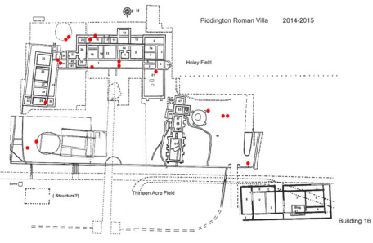
Fig 1. Site plan of Piddington. The red dots indicate the location of a single perinatal burial.
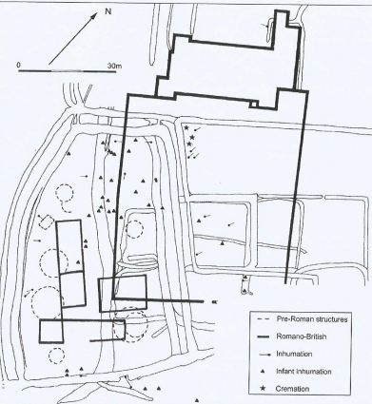
Fig 2. Distribution of burials in relation to principal iron age and roman features at Frocester Court.
Summation
The article, whilst being in depth and well referenced with familiar sources, (some of them dominant to the piece), does nothing unique in establishing a methodology for assessing the age of the infant bones, as this has already been used on other archaeological digs. It establishes the ages the Piddington Perinatal infant deaths and highlights the growth and health stresses, but falls short of coming to a conclusion as to the whys and wherefores. It feels almost like a gateway of evidence to allow those that follow to answer the broader questions about the areas culture, ecology and burial rituals. It achieves what Hodson set out to establish but its usefulness to a wider audience other than those in the similar field of bioarchaeology, has to be questioned.
In regards to the presentation of the article, I found it difficult to concentrate on what was a difficult read anyway, because of the number of references made throughout: 95 in all!! I think the article falls short of being a thesis statement purely it being too short and over referenced.

Illustrations
Fig 1. Site Plan of Piddington. The red dots indicate the location of a single perinatal burial
Fig 2. Distribution of burials in relation to principal iron age and roman features at Frocester Court
Bibliography
- Reading University, Dept of Archaeology, visited on 15th Oct 2022 https://www.reading.ac.uk/archaeology/staff/claire-hodson
- Scheuer, L., Musgrave, J.H., and Evans, S.P. 1980: , Annals of Human Biology, ‘The Estimation Of Late Foetal And Perinatal Age From Limb Bone Length By Linear And Logarithmic Regression’ 7.3, 257–65
- Mays. S, Eyers. J, Journal of Archaeological Science, Perinatal infant death at the Roman villa site at Hambleden, Buckinghamshire, England, Aug 2011, p1931-1938
- Moorrees, C.F.A., Fanning, E.A., and Hunt, E.E. 1963: ‘Formation And Resorption Of Three deciduous teeth in children’, American Journal of Physical Anthropology 21, 205–13
- Hodson, Claire, M., Britannia, Between The Roundhouse And Villa; Assessing The Perinatal And Infant Burials From Piddington, Northamptonshire, 2017, Vol 48, P195-219
- Frere, S.,1967. Britannia, a History of Roman Britain. Edition 7, P266, Routledge & Keegan Paul, London
- Cocks, A.H., 1921. A Romano-British homestead, in the Hambleden valley, Bucks. Archaeological 71, p141-198.
- Mays. S, Eyers. J, Journal of Archaeological Science, Perinatal infant death at the Roman villa site at Hambleden, Buckinghamshire, England, Aug 2011, p1931-1938
- Pearce, John., 2013, Contextual Archaeology Of Burial Practice, Fig 6.16 p95 BAR British Series 588

Dr Claire Hodson Bio Page
Sheuer et al 1980
Mayers 2011
Moorrees et al 1963 a & b
Mayers ibid
Frere 1967
Cocks 1971
Mayers ibid
Pearce 2013

