Student Name: Sarah Doody
Student Number 2407283
Module: Changemakers Building your own personal brand for sustainable employment
Module code: BMHP5015
Lecturer Name: Robert Nartowski
Assignment Title : Component, online portfolio of set exercise
Developing My Personal Brand
My career goal is to become a care assistant because I want to support people who need help with their daily lives. I believe my personal brand is based on being caring, empathetic and a good listener. These qualities are important in health and social care because people should feel respected, valued and understood.
My mood board represents the kind of person I want to be in a professional environment. The themes of kindness, communication and supporting others reflect my interest in helping people. Although I am currently studying and do not yet have work experience, I can begin developing my personal brand by improving my knowledge and learning about the responsibilities of a care assistant.
Dacre Pool and Sewell (2007) explain that employability involves developing personal qualities and skills alongside knowledge and experience. This relates to my career goal because being caring is important, but I also need to develop practical skills, confidence and professional communication.
In the future, I would like to gain experience through volunteering or a placement in a care setting. I could also complete relevant training, learn about safeguarding and confidentiality, and develop my ability to work effectively as part of a team. These steps would help me become more confident and prepared for employment.
Overall, I want my personal brand to show that I am compassionate, reliable and willing to learn. By continuing my studies and developing my skills, I hope to become a care assistant who treats every individual with dignity and respect.

Task 2

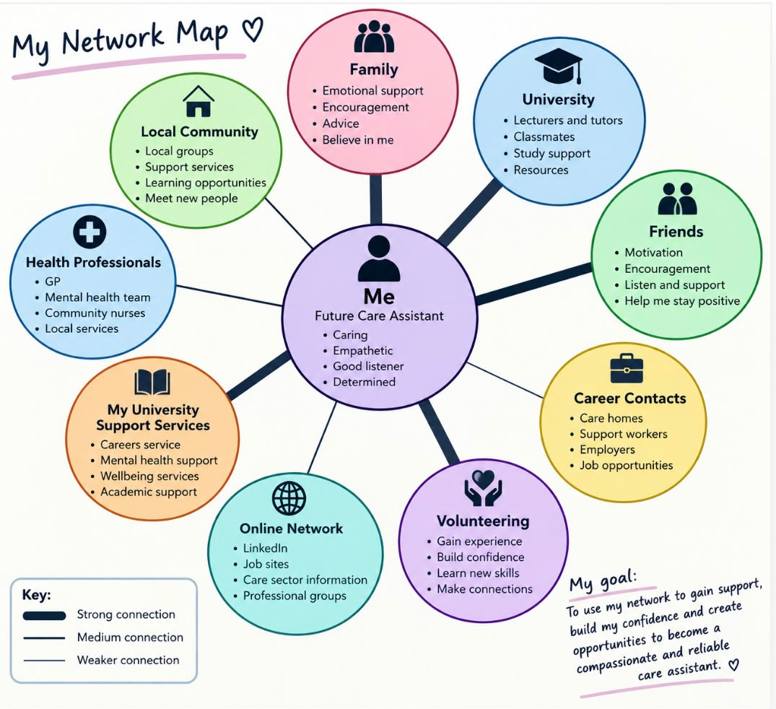

Task 3

Why Empathy Matters in Health and Social Care

Introduction: Why does empathy matter?
Have you ever felt better because someone took the time to listen to you? In health and social care, small acts of kindness can make a difference. Empathy involves trying to understand another person’s feelings, while compassion means responding with care and consideration. These qualities help care workers build positive relationships and support people with dignity and respect (Skills England, 2026).

The importance of listening and understanding
Care assistants support people with different needs, backgrounds and experiences. Some individuals may feel worried, lonely or frustrated when they need help with everyday activities. Listening carefully, communicating clearly and showing patience can help people feel heard and understood.
The Social Care Institute for Excellence (SCIE, 2014) explains the importance of involving people in decisions about their care and keeping their wishes and preferences at the centre of care planning. This is known as person-centred care. It means treating each person as an individual and respecting their choices, independence and dignity.

Developing my skills for a career in care
My career goal is to become a care assistant. As I am currently studying Health and Social Care and have not yet gained work experience, I want to develop the knowledge and practical skills required for this role. I believe being caring, empathetic and a good listener will help me build positive relationships with the people I support.
My personal network can also help me achieve this goal. Family and friends can encourage me, while university lecturers and classmates can support my learning. In the future, I could look for volunteering opportunities or speak to care professionals to gain a better understanding of working in care.

How can we make a difference?
Care workers can create a positive environment by listening without judging, respecting people’s choices and protecting their dignity. They should also continue learning and understand their professional responsibilities. The adult care worker occupational standard highlights the importance of supporting individuals’ wellbeing, independence and dignity (Skills England, 2026).

Task 4 – Quiz answers with Harvard reference

- What is the primary goal of the NHS Equality, Diversity and Inclusion Improvement Plan?
The main goal is to tackle discrimination and create a fairer, more inclusive NHS workplace where staff feel valued and have equal opportunities (NHS England, 2023).

- How does the plan propose to tackle the gender pay gap?
The plan recommends analysing pay-gap data, developing improvement plans and promoting fair career progression and flexible working opportunities (NHS England, 2023).

- What is meant by ‘intersectionality’?
Intersectionality means that different forms of disadvantage can overlap. For example, a person may experience discrimination related to both their race and disability (NHS England, 2023).

- Why is a psychologically safe work environment important?
It allows staff to raise concerns, ask questions and report mistakes without fear of unfair treatment. This supports staff wellbeing, teamwork and patient safety (NHS England, 2023).

- How does the plan aim to improve the experience of internationally recruited staff?
It recommends comprehensive induction, clear information about employment conditions, pastoral support and equal access to training and career development (NHS England, 2023).

- What role does leadership play in advancing EDI objectives?
Leaders should have specific, measurable EDI objectives, challenge discrimination and take responsibility for creating an inclusive workplace (NHS England, 2023).

- Identify one way the plan aims to reduce health inequalities within the workforce.
One way is to reduce bullying and harassment and use workforce information to identify and address inequalities affecting staff (NHS England, 2023).

- Why is collecting and analysing data on protected characteristics important?
It helps the NHS identify patterns of discrimination and unequal treatment, allowing organisations to develop targeted improvements and monitor progress (NHS England, 2023).

- How can flexible working policies contribute to equality and inclusion?
Flexible working can help staff balance their work with caring responsibilities, health needs and other commitments, making employment more accessible (NHS England, 2023).

- What is one strategy to combat bullying and harassment?
The plan recommends reviewing reports and data on bullying and harassment, setting improvement targets and ensuring staff can raise concerns safely (NHS England, 2023).

Task 5

Dear Younger Me,
I want you to know that even when life feels difficult, things can get better. There may be times when you feel overwhelmed, worried or unsure of yourself, but this does not mean you are weak. You are learning and growing, even when you cannot see it.
Looking back, I realise that during difficult times it is important to understand my emotions rather than ignore them. Emotional intelligence means recognising how I feel, understanding why I feel that way and thinking about how my emotions affect my actions and other people. If I had developed this skill earlier, I might have found it easier to communicate my feelings, ask for support and deal with situations more calmly.
I have also learnt about the importance of resilience. Resilience means being able to cope with challenges, learn from difficult experiences and keep moving forward. It does not mean that I must always be strong or deal with everything alone. Sometimes, being resilient means taking a break, speaking to someone I trust or accepting that I need help.
Developing my emotional intelligence and resilience could have helped me manage stress, build my confidence and make better decisions. These skills are also important for my future career in health and social care because I will need to understand other people’s feelings, listen without judging and remain calm in challenging situations.
My advice to you is to be kinder to yourself. Do not compare your journey with anyone else’s, and remember that asking for help is a strength, not a weakness. Every experience can teach you something valuable. Keep believing in yourself, take things one day at a time and remember how far you can come.

With love,
Your older self

Task 6

This Gantt chart outlines the activities required to achieve my career goal of obtaining employment as an Administrative Assistant within six months. The first stage involves researching job requirements to identify the qualifications, skills and experience employers are seeking. Once this information has been gathered, I will update my CV and cover letter to ensure they are tailored to the role.
The next stage is completing relevant training courses to improve my administrative and digital skills. Alongside this, I will create and develop my LinkedIn profile to increase my professional online presence and network with potential employers.
After developing the necessary skills and application documents, I will begin searching and applying for suitable vacancies. This task will continue over several weeks as multiple applications may be required before securing interviews. During this period, I will also prepare for interviews by researching employers, practising common interview questions and improving my communication skills.
The final stage is attending interviews and following up on applications. Each task contributes towards the overall objective and some activities overlap to make the process more efficient. By following this schedule, I will remain organised and increase my chances of successfully achieving my employment goal within the planned timeframe.

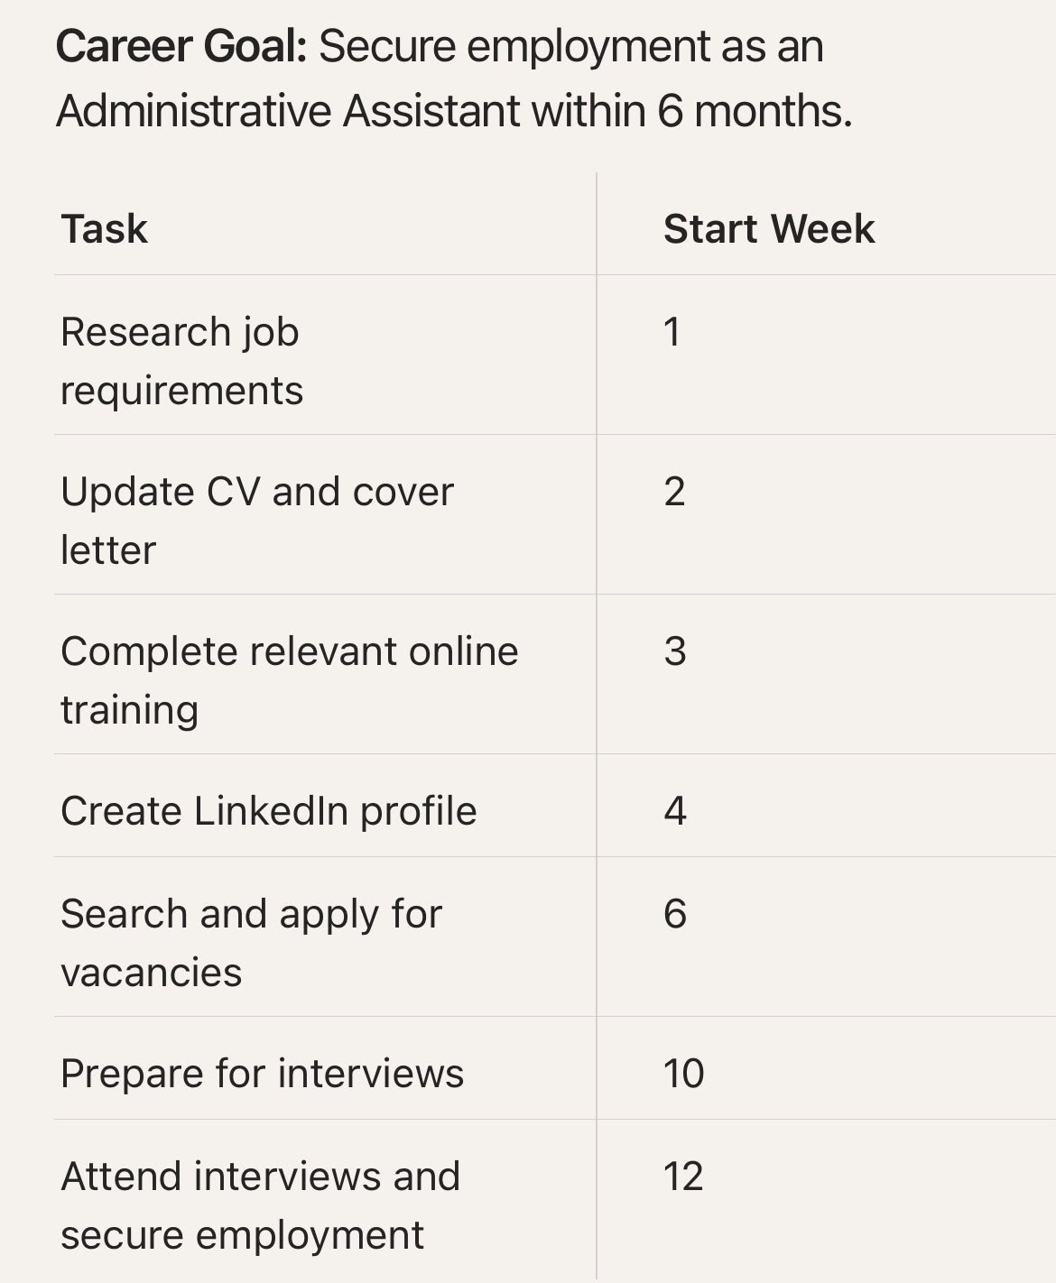

Task 7 – Making Changes Report

Report: Implementing Person-Centred Activity Scheduling

Prepared by: Care Home Team Lead

What change I want to make
I plan to update how daily activities are arranged for residents. Currently, we follow a set routine that applies to everyone regardless of preference. I want to move towards creating individual activity schedules based on each person’s likes, past hobbies, and current capabilities. This approach means residents get to do things that truly matter to them, helping them feel more independent and happier in our home.

How I will do it
I will apply Lewin’s Three-Step Model of Change to guide the process (Burnes, 2020):
- Unfreeze: Hold team meetings to discuss the limitations of our current system. Share positive examples and research showing how personalised activities improve wellbeing, plus feedback from residents and relatives.
- Transition: Create individual profiles for each resident with help from families. Introduce the new approach gradually — starting with one unit or a small group — and adjust as we go.
- Refreeze: Gather feedback every 6 weeks, update our procedures, and celebrate small wins until this approach becomes our standard practice.

Skills needed
Leading this change requires strong communication — being able to explain the benefits clearly and listen to staff ideas. I’ll also need empathy, good organisational skills, and the ability to encourage confidence when people feel unsure (NHS Leadership Academy, 2021). Being a good role model will help the team feel supported throughout.
Possible problems and how to fix them
Some team members might feel this will create more paperwork or extra work. I will address this by demonstrating how good planning can actually make days run more smoothly and sharing tasks evenly. Where information about residents’ personal history is missing, I will create a simple “My Life Story” form for families to complete on admission (Care Quality Commission, 2023). Task 1: Developing My Personal Brand
My career goal is to become a care assistant because I want to support people who need help with their daily lives. I believe my personal brand is based on being caring, empathetic and a good listener. These qualities are important in health and social care because people should feel respected, valued and understood.
My mood board represents the kind of person I want to be in a professional environment. The themes of kindness, communication and supporting others reflect my interest in helping people. Although I am currently studying and do not yet have work experience, I can begin developing my personal brand by improving my knowledge and learning about the responsibilities of a care assistant.
Dacre Pool and Sewell (2007) explain that employability involves developing personal qualities and skills alongside knowledge and experience. This relates to my career goal because being caring is important, but I also need to develop practical skills, confidence and professional communication.
In the future, I would like to gain experience through volunteering or a placement in a care setting. I could also complete relevant training, learn about safeguarding and confidentiality, and develop my ability to work effectively as part of a team. These steps would help me become more confident and prepared for employment.
Overall, I want my personal brand to show that I am compassionate, reliable and willing to learn. By continuing my studies and developing my skills, I hope to become a care assistant who treats every individual with dignity and respect.

