Introduction to Web and Database Concepts
  - Module ACCA4023 Assignment
by
  - John Dunkley-Williams
1903715

Contents

- Introduction
- Requirements
- Implementation
  - Screen shots
  - Validation
- Evaluation
  - Research
  - Usability
  - Search Engine Optimisation
  - Accessibility
- References
- Appendices

Introduction

Requirements

The website is designed as an online portfolio and contact point for the works of “Ixtran Cosplay”.
“Cosplay” from the words “costume” and “play” is the art of making and wearing the costumes of characters from movies, television, videogames and anime. The spectrum is wide, from individuals buying a simple costume off Amazon to wear to a Comic Convention for a day, to spending months or even years hand making costumes, even superior to those used on the sets of movies with greater attention to the detail of the source material, or bringing to life characters for the first time, to compete on a global stage.
This website will showcase completed cosplays of Ixtran Cosplay, often professionally photographed, and list those by character for ease of access and navigation.
The website will link to Ixtran Cosplay’s social media outlets, where content is published daily, including behind the scenes, making of and tutorials to follow should a viewer wish to create their own cosplay.
The target audience will be a combination of the pre-established “followers” of Ixtran Cosplay, should they wish to purchase printed photographs or simply view and navigate the completed cosplays. It will also be a contact point for the industry, should conventions wish to get in touch to enlist Ixtran Cosplay as a “Guest” attendant, or should a photographer or publisher wish to work with Ixtran Cosplay directly.

3. Implementation

Screen Shots

Home Page
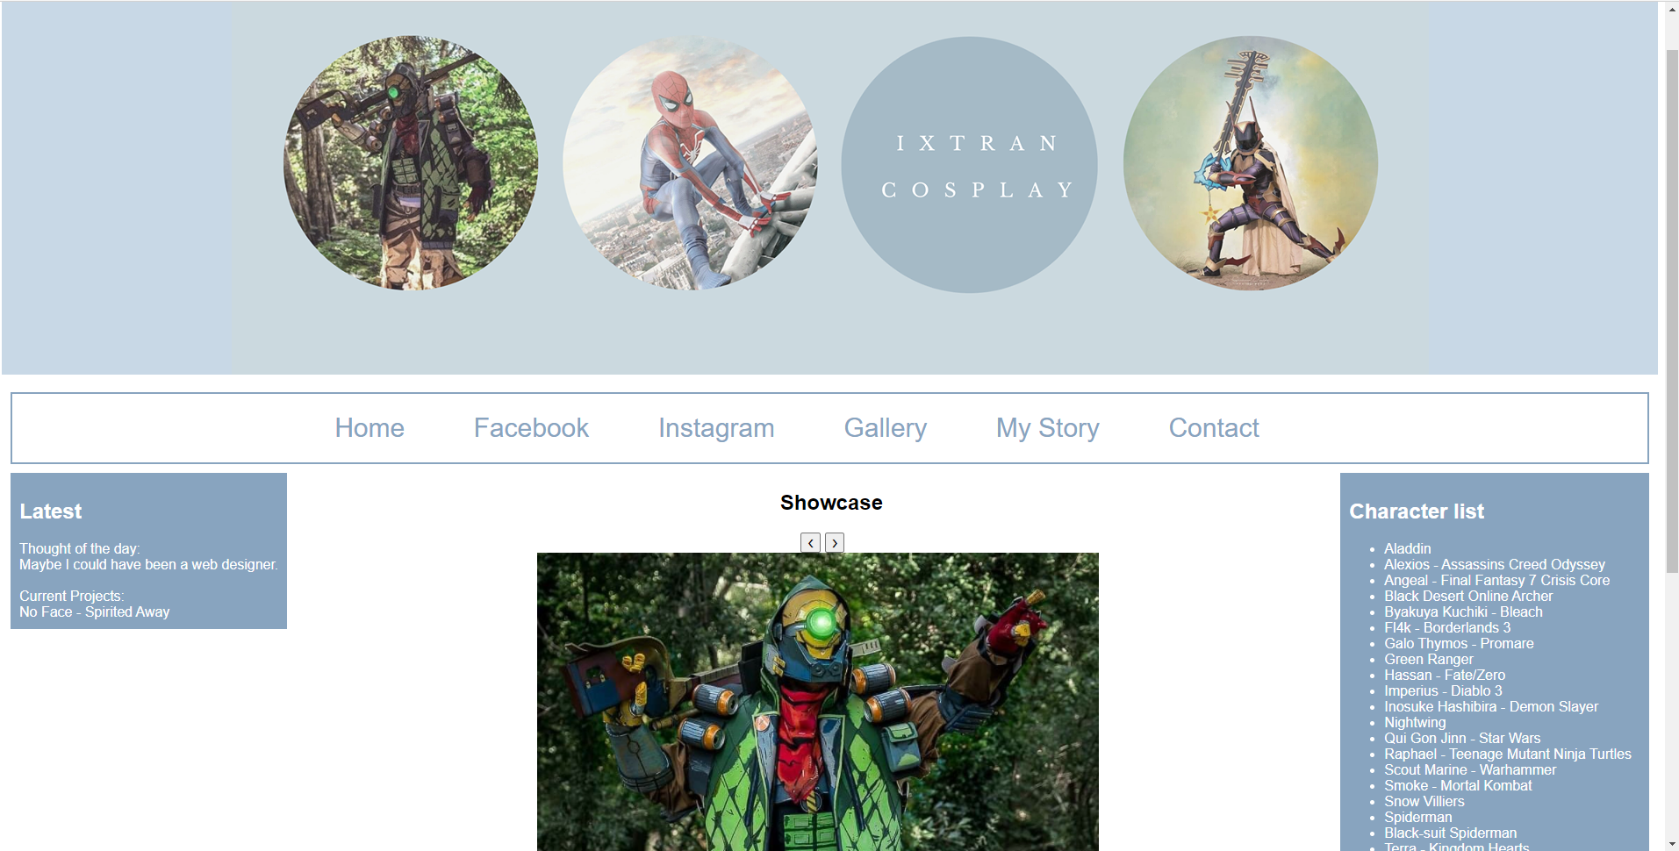

Gallery
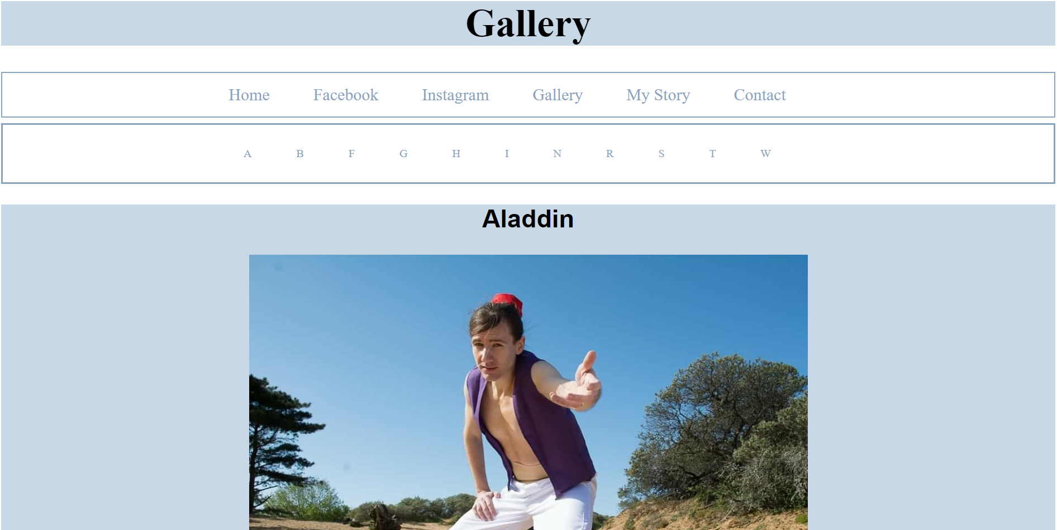

My Story
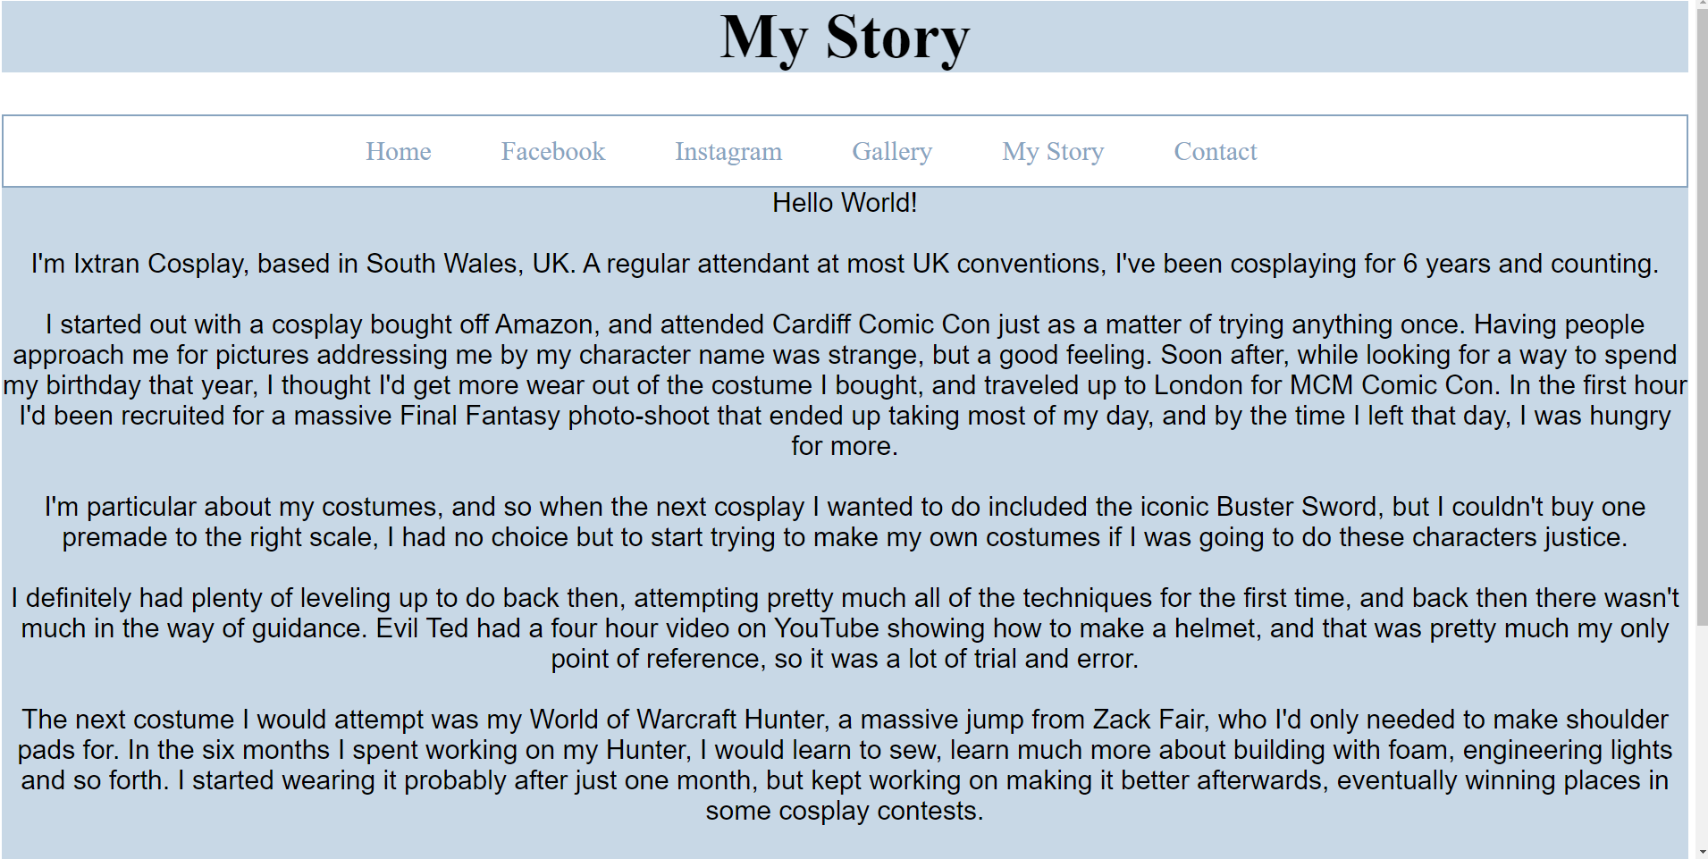

Contact
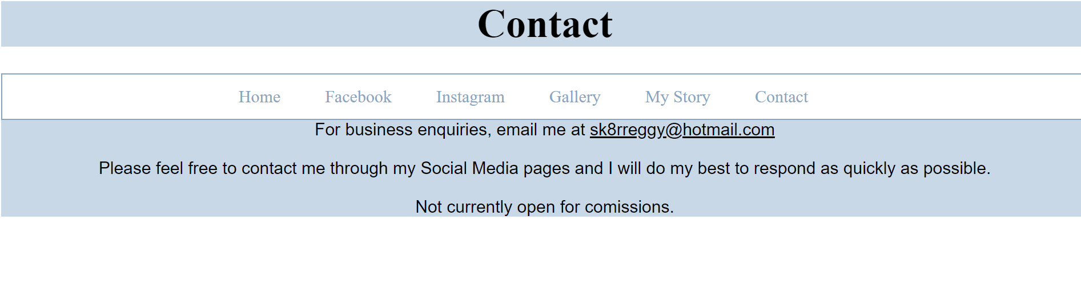

3.2 Validation

Error: Start tag seen without seeing a doctype first. Expected <!DOCTYPE html>.
From line 1, column 1; to line 1, column 6
<html>↩<head

Simple error, easily corrected.
Error: Bad value Styles\CSS2.css for attribute href on element link: Backslash ("\") used as path segment delimiter.
From line 5, column 2; to line 6, column 23
</title>↩ <link rel="stylesheet" type="text/css"↩href="Styles\CSS2.css">↩ ↩<st

Simple error, easily corrected.

Error: End tag div seen, but there were open elements.
From line 68, column 2; to line 68, column 7
/a></li>↩ </div>↩</nav

Missing closing list tag.
Error: Bad value Images\Fl4k.jpg for attribute src on element img: Backslash ("\") used as path segment delimiter.
From line 89, column 3; to line 89, column 59
button>↩ <img class="mySlides" src="Images\Fl4k.jpg" height="800">↩ <im

Incorrect slash used.
Error: An img element must have an alt attribute, except under certain conditions. For details, consult guidance on providing text alternatives for images.
From line 89, column 3; to line 89, column 59
button>↩ <img class="mySlides" src="Images\Fl4k.jpg" height="800">↩ <im

Missing alt text.

Error: End tag div seen, but there were open elements.
From line 96, column 1; to line 96, column 6
↩↩ </div>↩</div>↩<scri

<section> not closed.

Error: End tag div seen, but there were open elements.
From line 146, column 1; to line 146, column 6
↩ </ul>↩</div>↩↩</bo

<Aside> not closed.

Error: Stray start tag footer.
From line 149, column 1; to line 149, column 20
↩↩</body>↩<footer id="footer">↩ <div

Footer included in template but not used.
57 | #navbar2 | Value Error : padding only 0 can be a unit. You must put a unit after your number : 10
147 |  | Parse Error @media)max-width:600px){ /*If we reduce the window below 600 pixels it will remove the float*/ #main{ width:100%; float:none; } #sidebar{ width:100%; float:none; } #navbar li{ display:block; { }

While reducing the padding, eventually there was no need to keep padding defined when reduced to 0.
Picked up on “commented out” code.

Evaluation

Research
When creating a website there are various elements to consider beyond the content itself. There is an established “best practice” that maximises the quality of a website, from usability; making it easy for your users to navigate the site and locate the thing they are searching for, in turn making it more likely that they will stay longer or return, through to search engine optimisation, making your website more discoverable and more likely to appear in search results.

4.1.1 Usability

“In order for website and applications to be successful, designers and developers should start with understanding its intended audience. Sites should be optimized around helping users complete their tasks as easily as possible” Yale University, 2021 [1]
The first thing to consider is why a user has come to your site. What are they hoping to achieve? If it is a shopping site, the objective would be to find the product they are looking for quickly, potentially with some options on the specifics of that product, and then order quickly and easily.
The page layout will be the first thing a user is confronted with. “Eye-scanning studies indicate that users commonly start looking at a page by scanning the left-hand list” [2] If we know the common behaviour of the potential user, then we can place things accordingly so they are quick to find.
Next, designing the navigation itself. Do you list the website destinations simply alphabetically, or will the user expect something else? A list ordered by popularity? Having a diverse team for input is valuable at this point “if the group contains different enough people, any misunderstandings of terms and activities will be…addressed” [2].
Usability testing is invaluable in web development, “If the user cannot find what they are looking for on one site, they will automatically move on to the next.” [3] – more than just a complete inability to use your website, if the user feels like they could find what they were looking for even slightly more efficiently elsewhere, they will go there instead. A high street store must compete with other stores on the street that sell the same products. On the internet, there are hundreds of thousands of stores and the customers don’t even have to work to use another store. An optimal user experience is more important that the product you are offering when it comes to web design. Amazon isn’t so popular because it has the best products, it’s popular because it’s familiar and easy to use, and the customer trusts Amazon with their custom.
That being said, familiarity is another factor to consider. While websites need to stand out (and not infringe on design copyright), users expect thing to work in the way they know. “Place your navigation strategically. It should be at the top or left of each page. Why? Because this is where your users expect to see it.” [4]
With this considered, every element of a website should be designed and tested to best perform its function. Put as much time and manpower in to the design of a website as possible, because it will all convert in to website users.

4.1.2 Accessibility

“Accessibility means more than putting things online. It means making your content and design clear and simple enough so that most people can use it without needing to adapt it, while supporting those who do need to adapt things.” UK Government, 2018 [5]
More than good practice, accessibility regulations came in to force for public sector bodies on 23 September 2018. [5] If a person is working professionally as a web designer, it is more than worthwhile working with Web Content Accessibility Guidelines (WCAG) in mind to avoid limiting oneself work, plus it will only strengthen a portfolio.
“WCAG 2.1 covers a wide range of recommendations for making Web content more accessible. Following these guidelines will make content more accessible to a wider range of people with disabilities, including accommodations for blindness and low vision, deafness and hearing loss, limited movement, speech disabilities, photosensitivity, and combinations of these, and some accommodation for learning disabilities and cognitive limitations” WCAG 2018 [6]
There are many considerations when making a website accessible, from colour contrast, to tagging the headings appropriately in the html so they can be easily navigated by assistive software.
There are an increasing number of tools to help web developers operate within the guidelines. Contrast Checker for example is a “tool built for designers and developers to test the color contrast compliance with the [WCAG] as set forth by the World Wide Web Consortium.” [7]
“Color-blind or visually impaired people can have trouble distinguishing a link from regular text” [8] beyond hyperlinks changing colour, turning bold or underlined, there is also the basic readability of a page. The contrast checking tools can ensure a website conforms to an algorithm as laid out in WCAG to ensure text is as readable as possible.
Other considerations within the guidelines include
- Images should have Alt text [6], this will enable screen readers to tell a blind person when an image appears, and what it is of. It will make link images descriptive, and describe the function of buttons on a page.
- Video and audio content should have alternatives, such as subtitles and descriptive audio, and should play on user activation. [6]
- Content should have clear language use, and the guidance suggest Felsch-Kincaid grade level of no more than 12. [6]
- Page sections should be clearly defined, such as boxes or line breaks to indicate content area. Paragraphs should avoid being too long, and lists should contain no more than 14 items before being divided up further and given sub-headings. [6]
- Tables should be avoided where possible, as should interior frames with a scroll function that might “trap” the keyboard. [6]
- Navigation should be clear and consistent, and usable with keyboard only control. [6]
There are many more aspects to consider, and some will not effect all types of website depending on the content there-on, but every potential user should be considered in web development, regardless of the size of the minority. Aspects of design such as colour contrast benefit all users, not just those with sight impairment, and following format conventions for the likes of screen readers in turn translates to a uniform layout that will extend across the internet as WCAG is increasingly used, improving the usability of the internet as a whole.

4.1.3 Search Engine Optimisation

“SEO – Search engine optimization: the process of making your site better for search engines.” Google, 2021 [9]
Conducting a “Search” has become an integral part of using the internet. Whether searching within a site for content, or a particular item if you are shopping, or searching the wider internet using a search engine for a website to fit your needs. The demand has only increased as it now takes less than a fraction of a second to deliver users hundreds of thousands of answers from a single short search query.
There are a wide range of potential search engines out there, though one has long dominated the market, but the basic task of searching is the same across these. The driving technology behind these search engines are “crawlers”, software driven by algorithms that visit all pages across the web and return a Search Engine Result Page according to that programming.
“To offer the best possible results, search engines must attempt to discover all the public pages on the World Wide Web and then present the ones that best match up with the user’s search query.” [10]
A Search Engine will then return a results page, ranked by relevance, based on the programmed algorithm; the defining difference between one Search Engine and the next, and the reason why one has continued to dominate the market, as the monetary advantage of its success has been fed back in to further develop the advanced AI that power the Search today.
To optimise a website for these search engines, a web developer learns what drives the algorithms behind these search engines, and designs the website in a way that will engage with this software as much as possible.
This includes
- Creating unique, accurate page titles, and tagging them appropriately in the html [9]
- Using descriptive meta data tags
- Using structured data markup to enable search engines to understand what is on a web page [9]
There are also structural factors of a web site that can effect the search engine algorithms. When content is buried deeper in folders, sub folders and pages of a website, some algorithms deem the content less important.
Some aspects of accessibility also impact search engine results, such as alt text on images, and the use of clear and easy to understand language will also go a long way. [9]
On a basic level, search engines can even look at how many times a word was used in a page when delivering the most “relevant” results. There are a wide variety of search engines that have been developed over the years that the internet has existed, some optimised to search the World Wide Web and others customised to search specific content within sites. Some search engines are capable or separating out shopping sites or images and giving those results options to the users for further ease of use. It all cycles back ultimately to usability, and giving users what they want as quickly and effectively as possible.

Usability
The website is a showcase for the cosplay works of “Ixtran Cosplay”. That being the case, the website is designed to be very visual. The header banner showcases cosplays immediately, while the home page content has a showcase as the centrepiece to keep the page very visually orientated.
Next, the horizonal navigation menu presents the user with options to navigate to the specific content they are looking for without the need to scroll to find information. The user can go straight to Ixtran Cosplay on social media for the most recent updates and to follow along costume progress and daily content. Next, an organised gallery, alphabetised by character name gives the user the choice of cosplay or character to view, giving the user the power to view characters they know and like.
This was an important feature for a website, since social media lacks such flexible user controlled navigation, and so there is also a character list on the home page, which links to anchor points in the gallery for an alternative quick access route for user controlled content.
My Story provides a background to the development of Ixtran Cosplay for those who are interested, or perhaps starting out and looking for some direction. This lastly followed by a contact page for businesses wishing to get in touch to book me, or businesses or individuals looking to commission me for work.
This design and layout allow the user to control the content and navigate quickly to the cosplay content they are looking for, much more so than they could on social media. The navigation options are presented immediately at the top of the page, with latest news in the top left, where studies show users will look first, before a large eye-catching image and finally something of a website index.
The character list and gallery are alphabetised to enable any user to be able to quickly navigate if they are looking for a specific character. Organising by order of creation date would mean less to the user, and while popularity was a strong option for organisation, it would largely diminish the likelihood that characters at the bottom of the list would be seen. Alphabetisation is the strongest option for the benefit of user and creator.
The website follows the currently popular grid layout in order to create a sense of familiarity with the user. This presents showcase content in the top and centre, while navigation options and news exist in columns to the right and left.
Further improvements were considered, such as the embedding of live social media feeds in place of the Latest News box. This would reduce some need for frequent update from the creator, as latest events are pulled directly from social media.
While there is a running theme throughout the website, more work could be done to make the more information orientated pages more visually pleasing, as opposed to just text-based pages.
The showcase banner could also be automatic instead of manual. The small navigation buttons might go unseen, but a rolling banner would automatically showcase multiple cosplays and take that manual task away from the user.

Search Engine Optimisation
“Ixtran Cosplay” is a unique name, and therefore direct searches should have little trouble navigating to the website. For users who are not intentionally navigating to this website, each page is titled and correctly formatted to be easily read by crawler software.
The website is very visual, and so alt tags are essential for content detection. This is present on every image, but to go a step further, additional description text could be added to each image to increase the volume of meta data available for crawler detection.
Content is never more than one folder/link deep, so search engines should do little to lower the priority of any website content.

4.4 Accessibility
Considerations have been made in the website design to WCAG 2.1. Again, html content is appropriately structured with headings and tags to allow screen readers to navigate content effectively. Alt text has been used for every image to describe them for the visual impaired, as well as on links that screen readers will need to navigate through.
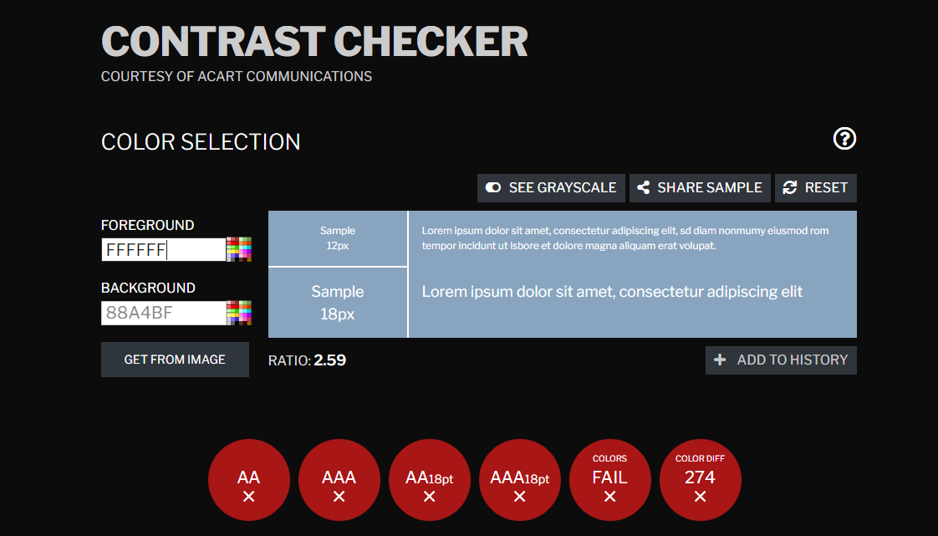
The initial colour scheme failed the contrast checker for accessibility. It could be greatly improved my make the text black instead of white, otherwise we need to darken the pale blue to improve the contrast for the website.
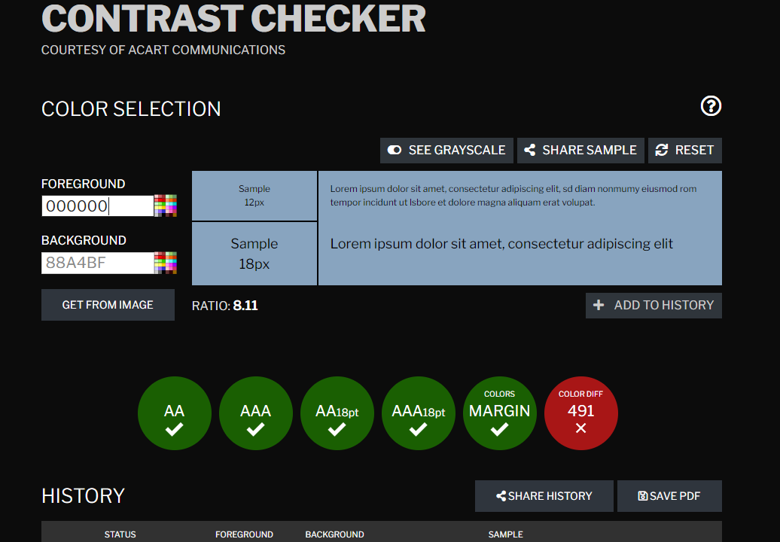
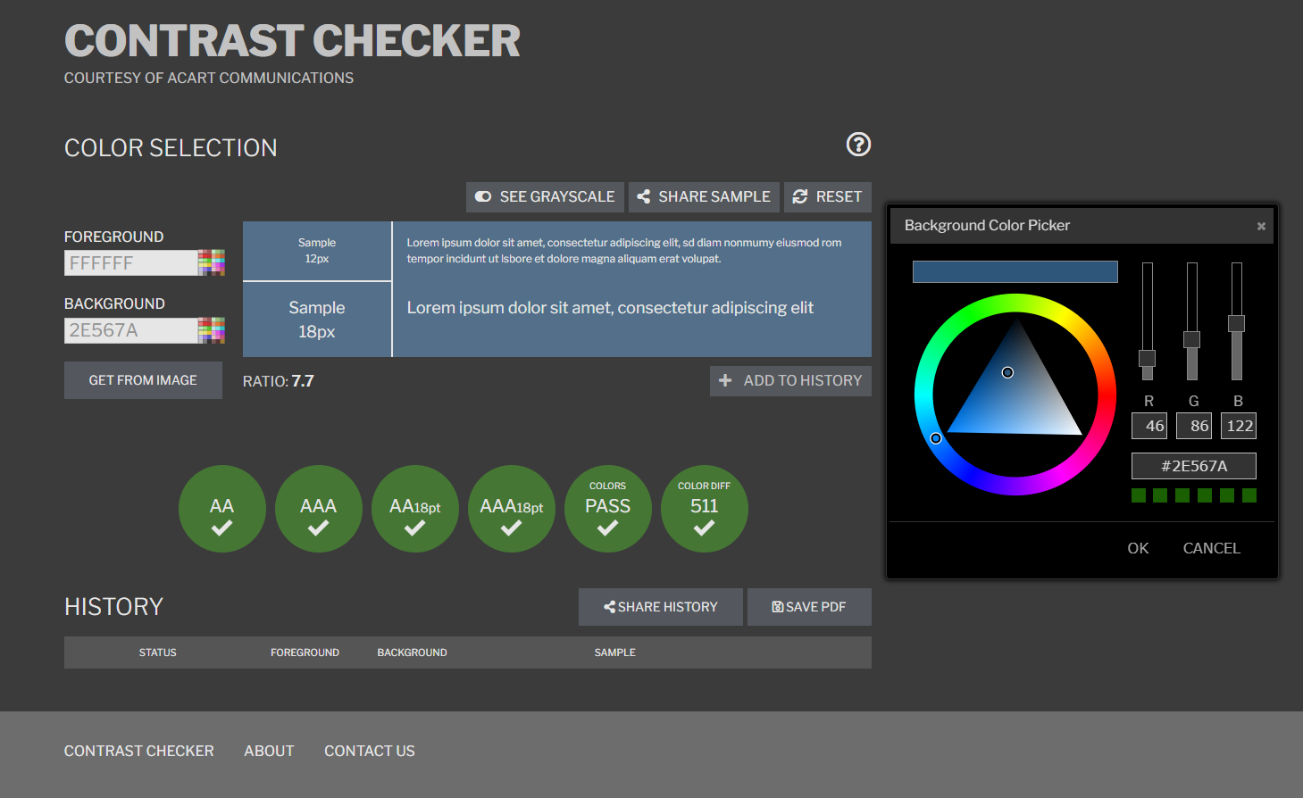

References

[1] | Yale University, “Usability & Web Accessibility,” Yale University, 2021. [Online]. Available: https://usability.yale.edu/understanding-your-user. [Accessed 6 April 2021].
[2] | S. Fowler and V. Stanwick, Web Application Design Handbook : Best Practices for Web-Based Software, Amsterdam: Morgan Kaufmann, 2004.
[3] | Design the Planet, “The Importance of Web Usability Testing,” Design The Planet, 5 August 2013. [Online]. Available: https://www.designtheplanet.com/the-importance-of-web-usability-testing/#:~:text=One%20of%20the%20main%20reasons,move%20on%20to%20the%20next.. [Accessed 6 April 2021].
[4] | Nexus, “Article: The really useful huide to web usability,” Nexus DP, 2020. [Online]. Available: http://www.nexusdp.co.uk/services/web-design/the-importance-of-web-usability/. [Accessed 6 April 2021].
[5] | UK Government, “Understanding accessibility requirements for public sector bodies,” UK Government, 9 May 2018. [Online]. Available: https://www.gov.uk/guidance/accessibility-requirements-for-public-sector-websites-and-apps. [Accessed 6 April 2021].
[6] | A. e. a. Kirkpatrick, “Web Content Accessibility Guidelines,” 5 June 2018. [Online]. Available: https://www.w3.org/TR/WCAG21/. [Accessed 6 April 2021].
[7] | Acart Communications, “Contrast Checker,” Acart Communications, 2017. [Online]. Available: https://contrastchecker.com/about/. [Accessed 6 April 2021].
[8] | D. Karlins, Building Website All-in-one for Dummies, For Dummies, 2012.
[9] | Google, “Search Engine Optimization (SEO) Start Guide,” Google, [Online]. Available: https://developers.google.com/search/docs/beginner/seo-starter-guide. [Accessed 6 April 2021].
[10] | E. Enge, The art of SEO, O'REILLY, 2021.

Appendices

Ixtran Cosplay – Home

<!DOCTYPE html>
<head>
<meta charset="utf-8" />
<title>Ixtran Cosplay</title>
<link rel="stylesheet" type="text/css"
href="Styles/CSS2.css">

<style>
.item1 { grid-area: header; }
.item2 { grid-area: menu; }
.item3 { grid-area: main; }
.item4 { grid-area: right; }
.item5 { grid-area: footer; }

.grid-container {
display: grid;
grid-template-areas:
'header header header header header header'
'menu menu main main right right'
'footer footer footer footer footer footer';
grid-gap: 10px;
padding: 10px;
font-family:Arial, Helvetica, san-serif;
}

.grid-container > div {

padding: 20px 0;
font-size: 16px;
}

a{
color:white;
text-decoration: none;
}
a:hover{
color:yellow;
}

.item2 ul{
padding:0;
list-style:none;
}

</style>
<body>

<header id="main-header">
<div class="container">
<img src="Images/FB Banner.png" alt="Ixtran Cosplay" />
</div>
</header>

<div class="grid-container">

<div class="item1">
<nav id="navbar">
<div class="sub-header">
<ul>
<li><a href="#">Home</a></li>
<li><a href="https://www.facebook.com/ixtrancosplay">Facebook</a></li>
<li><a href="https://www.instagram.com/ixtran">Instagram</a></li>
<li><a href="Gallery.html">Gallery</a></li>
<li><a href="My Story.html">My Story</a></li>
<li><a href="Contact.html">Contact</a></li>
</ul>
</div>
</nav>
</div>

<div class="item2">
<section id="latest">
<h2> Latest </h2>
Thought of the day:<br>
Maybe I could have been a web designer.
<br><br>
Current Projects:<br>
No Face - Spirited Away
</section>
</div>

<div class="item3">
<section id="showcase">
<div class="showcase">
<h2> Showcase </h2>
<button class="w3-button w3-display-left" onclick="plusDivs(-1)">&#10094;</button>
<button class="w3-button w3-display-right" onclick="plusDivs(+1)">&#10095;</button>
<img class="mySlides" src="Images/Fl4k.jpg" alt="Fl4k" height="800">
<img class="mySlides" src="Images/Green Ranger 3.jpg" alt="Green Ranger" height="800">
<img class="mySlides" src="Images/Tokoyami Black Abyss.jpg" alt="Tokoyami" height="800">
<img class="mySlides" src="Images/Spiderman 3.jpg" alt="Spiderman" height="800">
<img class="mySlides" src="Images/Terra 8.jpg" alt="Terra" height="800">

</div>
</section>
</div>
<script>
var slideIndex = 1;
showDivs(slideIndex);

function plusDivs(n) {
showDivs(slideIndex += n);
}

function showDivs(n) {
var i;
var x = document.getElementsByClassName("mySlides");
if (n > x.length) {slideIndex = 1}
if (n < 1) {slideIndex = x.length}
for (i = 0; i < x.length; i++) {
x[i].style.display = "none";
}
x[slideIndex-1].style.display = "block";
}
</script>
</section>

<div class="item4">
<aside id="sidebar">
<h2>Character list</h2>
<ul>
<li><a href="Gallery.html#Aladdin">Aladdin</a></li>
<li><a href="Gallery.html#Alexios">Alexios - Assassins Creed Odyssey</a></li>
<li><a href="Gallery.html#Angeal">Angeal - Final Fantasy 7 Crisis Core</a></li>
<li><a href="Gallery.html#Archer">Black Desert Online Archer</a></li>
<li><a href="Gallery.html#Byakuya">Byakuya Kuchiki - Bleach</a></li>
<li><a href="Gallery.html#Fl4k">Fl4k - Borderlands 3</a></li>
<li><a href="Gallery.html#Galo">Galo Thymos - Promare</a></li>
<li><a href="Gallery.html#Green Ranger">Green Ranger</a></li>
<li><a href="Gallery.html#Fate">Hassan - Fate/Zero</a></li>
<li><a href="Gallery.html#Imperius">Imperius - Diablo 3</a></li>
<li><a href="Gallery.html#Inosuke">Inosuke Hashibira - Demon Slayer</a></li>
<li><a href="Gallery.html#Nightwing">Nightwing</a></li>
<li><a href="Gallery.html#Qui Gon">Qui Gon Jinn - Star Wars</a></li>
<li><a href="Gallery.html#Raphael">Raphael - Teenage Mutant Ninja Turtles</a></li>
<li><a href="Gallery.html#Scout">Scout Marine - Warhammer</a></li>
<li><a href="Gallery.html#Smoke">Smoke - Mortal Kombat</a></li>
<li><a href="Gallery.html#Snow">Snow Villiers</a></li>
<li><a href="Gallery.html#Spiderman">Spiderman</a></li>
<li><a href="Gallery.html#Venom">Black-suit Spiderman</a></li>
<li><a href="Gallery.html#Terra">Terra - Kingdom Hearts</a></li>
<li><a href="Gallery.html#Tokoyami">Tokoyami Fumikage - My Hero Academia</a></li>
<li><a href="Gallery.html#Wolverine">Wolverine - X-Men</a></li>
<li><a href="Gallery.html#Hunter">World of Warcraft Hunter</a></li>
</ul>
</aside>
</div>

</body>

</html>

Gallery

<html>
<head>
<meta charset="utf-8" />
<title>Ixtran Cosplay</title>
<link rel="stylesheet" type="text/css"
href="Styles\CSS2.css">

</head>
<body>
<header id="main-header">
<div class="container">
<h1>Gallery</h1>
</div>
</header>
<nav id="navbar">
<div class="sub-header">
<ul>
<li><a href="Ixtran Cosplay.html">Home</a></li>
<li><a href="https://www.facebook.com/ixtrancosplay">Facebook</a></li>
<li><a href="https://www.instagram.com/ixtran">Instagram</a></li>
<li><a href="Gallery.html">Gallery</a></li>
<li><a href="My Story.html">My Story</a></li>
<li><a href="Contact.html">Contact</a></li>
</div>
</nav>
<nav id="navbar2">
<div class="a to z">
<ul>
<li><a href="#Aladdin">A</a></li>
<li><a href="#Byakuya">B</a></li>
<li><a href="#Fl4k">F</a></li>
<li><a href="#Galo">G</a></li>
<li><a href="#Fate">H</a></li>
<li><a href="#Imperius">I</a></li>
<li><a href="#Nightwing">N</a></li>
<li><a href="#Raphael">R</a></li>
<li><a href="#Smoke">S</a></li>
<li><a href="#Terra">T</a></li>
<li><a href="#Wolverine">W</a></li>
</div>
</nav>

<header id="Aladdin">
<div class="content-block">
<h2>Aladdin </h2>
<img src="Images\Aladdin.jpg" alt="Aladdin" width="1000"/>
<div class="bookmark">
<a href="#main-header">Back to Top</a>
</div>
</div>

<header id="Alexios">
<div class="content-block">
<h2>Alexios - Assassins Creed Odyssey</h2>
<img src="Images\Alexios 2.jpg" alt="Alexios" height="800"/>
<img src="Images\Alexios 3.jpg" alt="Alexios" height="800"/>
<img src="Images\Alexios 4.jpg" alt="Alexios" height="1000"/>
<img src="Images\Alexios 5.jpg" alt="Alexios" />
<img src="Images\Alexios 6.jpg" alt="Alexios" height="800"/>
<img src="Images\Alexios 7.jpg" alt="Alexios" width="800"/>
<img src="Images\Alexios 8.jpg" alt="Alexios" width="800"/>
<img src="Images\Alexios 9.jpg" alt="Alexios" height="1000"/>
<div class="bookmark">
<a href="#main-header">Back to Top</a>
</div>
</div>
<header id="Angeal">
<div class="content-block">
<h2>Angeal - Final Fantasy VII Crisis Core </h2>
<img src="Images\Angeal.jpg" alt="Angeal" height="800"/>
<div class="bookmark">
<a href="#main-header">Back to Top</a>
</div>
</div>

<header id="Archer">
<div class="content-block">
<h2>Black Desert Online Archer </h2>
<img src="Images\Archer.jpg" alt="Archer" height="800"/>
<div class="bookmark">
<a href="#main-header">Back to Top</a>
</div>
</div>
<header id="Byakuya">
<div class="content-block">
<h2>Byakuya Kuchiki - Bleach</h2>
<img src="Images\Byakuya.jpg" alt="Byakuya" height="800"/>
<div class="bookmark">
<a href="#main-header">Back to Top</a>
</div>
</div>
<header id="Fl4k">
<div class="content-block">
<h2>Fl4k - Borderlands 3 </h2>
<img src="Images\Borderlands.jpg" alt="Borderlands" height="900"/>
<img src="Images\Fl4k 2.jpg" alt="Fl4k" />
<img src="Images\Fl4k 3.jpg" alt="Fl4k" />
<img src="Images\Fl4k 4.jpg" alt="Fl4k" height="900"/>
<img src="Images\Fl4k 5.jpg" alt="Fl4k" height="900"/>
<img src="Images\Fl4k 6.jpg" alt="Fl4k" />
<img src="Images\Fl4k 7.jpg" alt="Fl4k" height="900"/>
<img src="Images\Fl4k 8.jpg" alt="Fl4k" height="900"/>
<img src="Images\Fl4k.jpg" alt="Fl4k" />
<div class="bookmark">
<a href="#main-header">Back to Top</a>
</div>
</div>
<header id="Fate">
<div class="content-block">
<h2>Hassan - Fate/Zero </h2>
<img src="Images\Assassin.jpg" alt="Assassin" height="800"/>
<div class="bookmark">
<a href="#main-header">Back to Top</a>
</div>
</div>
<header id="Galo">
<div class="content-block">
<h2>Galo Thymos - Promare </h2>
<img src="Images\Galo 2.jpg" alt="Galo" height="800"/>
<div class="bookmark">
<a href="#main-header">Back to Top</a>
</div>
</div>
<header id="Green Ranger">
<div class="content-block">
<h2>Green Ranger - Mighty Morphin' Power Rangers</h2>
<img src="Images\Green Ranger 2.jpg" alt="Green Ranger" height="800"/>
<img src="Images\Green Ranger 3.jpg" alt="Green Ranger" height="800"/>
<img src="Images\Green Ranger 4.jpg" alt="Green Ranger" />
<img src="Images\Green Ranger 5.jpg" alt="Green Ranger" height="900"/>
<img src="Images\Green Ranger Edit.jpg" alt="Green Ranger" height="900"/>
<img src="Images\Green Ranger.jpg" alt="Green Ranger" height="900"/>
<div class="bookmark">
<a href="#main-header">Back to Top</a>
</div>
</div>

<header id="Imperius">
<div class="content-block">
<h2>Imperius - Diablo 3 </h2>
<img src="Images\Imperius 2.jpg" alt="Imperius" />
<img src="Images\Imperius.jpg" alt="Imperius" />
<div class="bookmark">
<a href="#main-header">Back to Top</a>
</div>
</div>
<header id="Inosuke">
<div class="content-block">
<h2>Inosuke Hashibira - Demon Slayer </h2>
<img src="Images\Inosuke 2.jpg" alt="Inosuke" height="800"/>
<img src="Images\Inosuke 3.jpg" alt="Inosuke" height="800"/>
<img src="Images\Inosuke 4.jpg" alt="Inosuke" height="800"/>
<img src="Images\Inosuke 5.jpg" alt="Inosuke" height="800"/>
<img src="Images\Inosuke 6.jpg" alt="Inosuke" height="800"/>
<img src="Images\Inosuke 7.jpg" alt="Inosuke" height="800"/>
<img src="Images\Inosuke w Tanjiro.jpg" alt="Inosuke" height="900"/>
<div class="bookmark">
<a href="#main-header">Back to Top</a>
</div>
</div>
<header id="Nightwing">
<div class="content-block">
<h2>Nightwing </h2>
<img src="Images\JL Nightwing.jpg" alt="Nightwing" />
<img src="Images\Nightwing 2.jpg" alt="Nightwing" />
<img src="Images\Nightwing 3.jpg" alt="Nightwing" height="900"/>
<img src="Images\Nightwing 4.jpg" alt="Nightwing" height="900"/>
<img src="Images\Nightwing 5.jpg" alt="Nightwing" height="900"/>
<img src="Images\Nightwing 6.jpg" alt="Nightwing" height="900"/>
<img src="Images\Nightwing.jpg" alt="Nightwing" />
<div class="bookmark">
<a href="#main-header">Back to Top</a>
</div>
</div>
<header id="Qui Gon">
<div class="content-block">
<h2>Qui Gon Jinn </h2>
<img src="Images\Qui Gon 2.jpg" alt="Qui Gon Jinn" height="800"/>
<img src="Images\Qui Gon.jpg" alt="Qui Gon Jinn" height="800"/>
<img src="Images\Qui Gon 3.jpg" alt="Qui Gon Jinn" height="800"/>
<div class="bookmark">
<a href="#main-header">Back to Top</a>
</div>
</div>
<header id="Raphael">
<div class="content-block">
<h2>Raphael - Teenage Mutant Ninja Turtles </h2>
<img src="Images\Raphael 2.jpg" alt="Raphael" height="800"/>
<img src="Images\Raphael 3.jpg" alt="Raphael" height="800"/>
<img src="Images\Raphael.jpg" alt="Raphael" height="800"/>
<div class="bookmark">
<a href="#main-header">Back to Top</a>
</div>
</div>
<header id="Scout">
<div class="content-block">
<h2>Scout Marine - Warhammer </h2>
<img src="Images\Warhammer.jpg" alt="Scout Marine" />
<div class="bookmark">
<a href="#main-header">Back to Top</a>
</div>
</div>

<header id="Smoke">
<div class="content-block">
<h2>Smoke - Mortal Kombat </h2>
<img src="Images\Smoke 2.jpg" alt="Smoke" height="900"/>
<img src="Images\Smoke.jpg" alt="Smoke" height="900"/>
<div class="bookmark">
<a href="#main-header">Back to Top</a>
</div>
</div>
<header id="Snow">
<div class="content-block">
<h2>Snow Villiers - Final Fantasy XIII</h2>
<img src="Images\Snow 2.jpg" alt="Snow Villiers" height="800"/>
<img src="Images\Snow.jpg" alt="Snow Villiers" height="800"/>
<div class="bookmark">
<a href="#main-header">Back to Top</a>
</div>
</div>
<header id="Spiderman">
<div class="content-block">
<h2>Spiderman </h2>
<img src="Images\Spiderman 2.jpg" alt="Spiderman" height="800"/>
<img src="Images\Spiderman 3.jpg" alt="Spiderman" />
<img src="Images\Spiderman 4.jpg" alt="Spiderman" height="800"/>
<img src="Images\Spiderman 5.jpg" alt="Spiderman" height="800"/>
<img src="Images\Spiderman edit 3.jpg" alt="Spiderman" />
<img src="Images\Spiderman edit.jpg" alt="Spiderman" height="800"/>
<img src="Images\Spiderman Venom.jpg" alt="Spiderman" />
<div class="bookmark">
<a href="#main-header">Back to Top</a>
</div>
</div>
<header id="Venom">
<div class="content-block">
<h2>Black-suit Spiderman </h2>
<img src="Images\Venm 2.jpg" alt="Black-suit Spiderman" height="800"/>
<img src="Images\Venom 3.jpg" alt="Black-suit Spiderman" height="800"/>
<img src="Images\Venom 4.jpg" alt="Black-suit Spiderman" />
<img src="Images\Venom 5.jpg" alt="Black-suit Spiderman" height="800"/>
<img src="Images\Venom 6.jpg" alt="Black-suit Spiderman" height="800"/>
<img src="Images\Venom Edit 2.jpg" alt="Black-suit Spiderman" />
<img src="Images\Venom Edit 3.jpg" alt="Black-suit Spiderman" height="800"/>
<img src="Images\Venom Edit.jpg" alt="Black-suit Spiderman" height="800"/>
<img src="Images\Venom.jpg" alt="Black-suit Spiderman" />
<div class="bookmark">
<a href="#main-header">Back to Top</a>
</div>
</div>
<header id="Terra">
<div class="content-block">
<h2>Terra - Kingdom Hearts </h2>
<img src="Images\Terra 2.jpg" alt="Terra" height="800"/>
<img src="Images\Terra 3.jpg" alt="Terra" height="800"/>
<img src="Images\Terra 4.jpg" alt="Terra" />
<img src="Images\Terra 5.jpg" alt="Terra" height="800"/>
<img src="Images\Terra 6.jpg" alt="Terra" height="800"/>
<img src="Images\Terra 8.jpg" alt="Terra" />
<img src="Images\Terra 9.jpg" alt="Terra" />
<img src="Images\Terra 10.jpg" alt="Terra" />
<div class="bookmark">
<a href="#main-header">Back to Top</a>
</div>
</div>
<header id="Tokoyami">
<div class="content-block">
<h2>Tokoyami Fumikage - My Hero Academia </h2>
<img src="Images\Tokoyami Black Abyss.jpg" alt="Tokoyami" height="900"/>
<br>
<img src="Images\Tokoyami Class 2.jpg" alt="Tokoyami" height="800"/>
<img src="Images\Tokoyami Class.jpg" alt="Tokoyami" height="800"/>
<img src="Images\Tokoyami Dark Shadow 2.jpg" alt="Tokoyami" />
<img src="Images\Tokoyami Dark Shadow 3.jpg" alt="Tokoyami" />
<img src="Images\Tokoyami Dark Shadow 4.jpg" alt="Tokoyami" height="800"/>
<img src="Images\Tokoyami Dark Shadow 5.jpg" alt="Tokoyami" height="800"/>
<img src="Images\Tokoyami PE.jpg" alt="Tokoyami" height="800"/>
<div class="bookmark">
<a href="#main-header">Back to Top</a>
</div>
</div>
<header id="Wolverine">
<div class="content-block">
<h2>Wolverine - X-Men </h2>
<img src="Images\Wolverine 2.jpg" alt="Wolverine" height="800"/>
<img src="Images\Wolverine 3.jpg" alt="Wolverine" height="800"/>
<img src="Images\Wolverine 4.jpg" alt="Wolverine" height="800"/>
<img src="Images\Wolverine 5.jpg" alt="Wolverine" height="800"/>
<img src="Images\Wolverine Edit.jpg" alt="Wolverine" height="900"/>
<div class="bookmark">
<a href="#main-header">Back to Top</a>
</div>
</div>
<header id="Hunter">
<div class="content-block">
<h2>World of Warcraft Hunter </h2>
<img src="Images\WoW Hunter.jpg" alt="Hunter" height="900"/>
<div class="bookmark">
<a href="#main-header">Back to Top</a>
</div>
</div>

</body>
</html>

My Story

<html>
<head>
<meta charset="utf-8" />
<title>Ixtran Cosplay</title>
<link rel="stylesheet" type="text/css"
href="Styles\CSS2.css">

</head>
<body>
<header id="main-header">
<div class="container">
<h1>My Story</h1>
</div>
</header>
<nav id="navbar">
<div class="sub-header">
<ul>
<li><a href="Ixtran Cosplay.html">Home</a></li>
<li><a href="https://www.facebook.com/ixtrancosplay">Facebook</a></li>
<li><a href="https://www.instagram.com/ixtran">Instagram</a></li>
<li><a href="Gallery.html">Gallery</a></li>
<li><a href="My Story.html">My Story</a></li>
<li><a href="Contact.html">Contact</a></li>
</div>
</nav>

<div class="content-block">
Hello World!
<br><br>
I'm Ixtran Cosplay, based in South Wales, UK. A regular attendant at most UK conventions, I've been cosplaying for 6 years and counting.
<br><br>
I started out with a cosplay bought off Amazon, and attended Cardiff Comic Con just as a matter of trying anything once. Having people approach me for pictures addressing me by my character name was strange, but a good feeling. Soon after, while looking for a way to spend my birthday that year, I thought I'd get more wear out of the costume I bought, and traveled up to London for MCM Comic Con. In the first hour I'd been recruited for a massive Final Fantasy photo-shoot that ended up taking most of my day, and by the time I left that day, I was hungry for more.
<br><br>
I'm particular about my costumes, and so when the next cosplay I wanted to do included the iconic Buster Sword, but I couldn't buy one premade to the right scale, I had no choice but to start trying to make my own costumes if I was going to do these characters justice.
<br><br>
I definitely had plenty of leveling up to do back then, attempting pretty much all of the techniques for the first time, and back then there wasn't much in the way of guidance. Evil Ted had a four hour video on YouTube showing how to make a helmet, and that was pretty much my only point of reference, so it was a lot of trial and error.
<br><br>
The next costume I would attempt was my World of Warcraft Hunter, a massive jump from Zack Fair, who I'd only needed to make shoulder pads for. In the six months I spent working on my Hunter, I would learn to sew, learn much more about building with foam, engineering lights and so forth. I started wearing it probably after just one month, but kept working on making it better afterwards, eventually winning places in some cosplay contests.
<br><br>
I continued to make and buy costumes and attending conventions that I could get to, but my next leap would happen when I start working collaboratively with Pixel Wizard Photography. What started as my reaching out to a local starting up photographer to bring to life an idea I had for a Facebook banner image, would lead to years of projects as we continued to inspire each other to new heights. I made Imperius for a photoshoot idea he had, and we leveled up the photography again when we brought Alexios to life with jumps and action shots the likes of which we hadn't often seen from other hobbying cosplayers, with more cinematic goals in mind. We would go from there to deliver talks at conventions to pass on what we'd learned to other cosplayers, and it was at this point that I really started more intently engaging with the wider cosplay community instead of just those cosplaying the same source material that I was at the time.
<br><br>
I've continued to cosplay and bring characters to life with increasing frequency, even as the pandemic has cancelled conventions for over a year, instead focusing on content for social media. I've made and worn over 30 cosplays at this point, and who knows where it will end.
</div>
</body>
</html>

Contact

<html>
<head>
<meta charset="utf-8" />
<title>Ixtran Cosplay</title>
<link rel="stylesheet" type="text/css"
href="Styles\CSS2.css">

</head>
<body>
<header id="main-header">
<div class="container">
<h1>Contact</h1>
</div>
</header>
<nav id="navbar">
<div class="sub-header">
<ul>
<li><a href="Ixtran Cosplay.html">Home</a></li>
<li><a href="https://www.facebook.com/ixtrancosplay">Facebook</a></li>
<li><a href="https://www.instagram.com/ixtran">Instagram</a></li>
<li><a href="Gallery.html">Gallery</a></li>
<li><a href="My Story.html">My Story</a></li>
<li><a href="Contact.html">Contact</a></li>
</div>
</nav>

<div class="content-block">
For business enquiries, email me at <a href="mailto:sk8rreggy@hotmail.com">sk8rreggy@hotmail.com</a>
<br><br>
Please feel free to contact me through my Social Media pages and I will do my best to respond as quickly as possible.
<br><br>
Not currently open for comissions.
</div>
</body>
</html>

Style

.sub-header{
width:95%;
margin:auto;
}

.container{
width: 80%;
margin: auto;

}

.showcase{
width: 80%;
margin: auto;
text-align: center;
}

.content-block{
margin: auto;
text-align: center;
background-color: #c8d8e6;
font-family: Arial, sans-serif;
font-size: 30px;
}

.bookmark{
text-align: right;
font-size: 20px;
}

a{
color:black;
}
a:hover{
color:blue;
}

#main-header {
background-color:#c8d8e6;
color:black;
font-size:35px;
text-align:center;
}

#navbar {
color:#2E567A;
border:solid 2px;
font-size:12px;
margin-top:10px;
text-align:center;
}

#navbar2 {
color:#2E567A;
padding:10;

border:solid 3px;
font-size:20px;
margin-top:10px;
text-align:center;

}

#navbar ul { /* > li selects the list/child */

padding:10px;
list-style:none;
}
#navbar2 ul { /* > li selects the list/child */

padding:10px;
list-style:none;
}
#navbar li{
display:inline; /* displays the list in a horizontal line instead */
}
#navbar2 li{
display:inline; /* displays the list in a horizontal line instead */
}
#navbar a{
color:#2E567A;
text-decoration:none;
font-size:30px;
padding-right:75px;
}
#navbar2 a{
color:#2E567A;
text-decoration:none;
font-size:20px;
padding-right:75px;
}

#sidebar{
float:right;
background:#2E567A;
color:white;
padding:10px;
box-sizing: border-box;
}

#latest{
float:left;
background:#2E567A;
color:white;
padding:10px;
box-sizing: border-box;
}

#leftbar{
float:left;
width:25%;
background:#2E567A;
color:white;
padding:10px;
box-sizing: border-box;
margin-top:75px;
}

#showcase{
text-indent:20px;
padding-left:20px;
}

#content-block {
background-color:#c8d8e6;
color:black;
font-size:30px;
text-align:center;
}

@media)max-width:600px){ /*If we reduce the window below 600 pixels it will remove the float*/
#main{
width:100%;
float:none;
}
#sidebar{
width:100%;
float:none;
}
#navbar li{
display:block;
{
}

