Social and Ethical Marketing
Alexandra Olivia Safadi
Assignment 1
Jessica Shaw

Contents

Introduction 3
The change in Marketing 3
The marketing concept theory 4
What companies are doing today 5
Technologies effect on marketing 8
Are the 4 Es replacing the 4 Ps to marketing? 9
Ethical Marketing 11
Factors that may lead to unethical practice and the solutions that can be implemented 12
Conclusion 15
References 17

Introduction

This essay aims to address how social and ethical marketing has impacted businesses through defining marketing within business today and how businesses have changed their approach to management through time, whilst using supporting theories throughout.

The change in Marketing

Dr. Philip Kotler defined marketing as “the science and art of exploring, creating, and delivering value to satisfy the needs of a target market at a profit. Marketing identifies unfulfilled needs and desires. It defines, measures and quantifies the size of the identified market and the profit potential. It pinpoints which segments the company is capable of serving best and it designs and promotes the appropriate products and services” (Cohen, 2011).
Professionals indicate that the pace of technological change is quickly changing and technological skills that people grasped in the past have become less effective and people-skills are becoming more effective. Technology is one of the main changes to marketing today; if a business isn’t up-to-date with current media tools, they may potentially become out-of-date in comparison to those businesses maximising sales through the use of tools.
Tools are continuously developing, business industries have been forced to change throughout the movement of word-of-mouth, posters, then development into phones, laptops and using advanced technology to create adverts and videos.
Prior to marketing becoming social, businesses created products and focussed on how to make them appealing to customers although today the customers are in control. Businesses now deliver to consumer demands (Rabinowitz, 2011).

The marketing concept theory

According to Carlton P. McNamara, “The marketing concept is a term which pervades marketing literature and provides a framework in which marketing management is taught” (McNamara, 2019).
The marketing concept (1950) is the implementation structure of the marketing philosophy. This philosophy includes four areas-
- Customer Orientation, this area involves businesses understanding customers behaviour, needs and wants.
- Integrated Effort meaning that the marketing function must be integrated into all areas of the Business. This stage is particularly important as many businesses today lack this. Marketing isn’t always fulfilling businesses needs. For example, bad packaging.
- Profit Direction, businesses put emphasis on creating profit rather than sales volumes
- Competitor orientation which involves analysing competitors’ approach
The marketing concept identifies customers’ needs and satisfies them through producing products which sell instead of the past ethos of creating something then figuring out how to sell it. This concept realises that the consumer is paramount, and is classed as the importance over the product and created freedom to allow consumers to buy products of place, quality, kind and quantity which in turn satisfies the esteem of consumers (relating on Maslow’s hierarchy of needs) (Cherry, 2017). This concept draws upon the marketing approach to gain confidence of buyers and to achieve businesses targets.
The method of understanding the customers may have changed through changes in social media tools although the main concept hasn’t changed such as the importance of providing customers with the importance rather than the product (Rao, 2018).
Apple is a company which is known for their brilliance in understanding how to market their product. The company is known by defining the next ‘big thing’ and creates something new in the existing market before customers know what they want. Although, they create products based on the pattern of success of their other inventions. They rely closely upon the customers wants but expand this to something unexpected which supports this concept (Tobak, 2012).

What companies are doing today

Marketing has existed in different forms since businesses began. Social media is new in comparison to the world of marketing although there is no doubt that social media has been the most influential tool on marketing. Social media gives smaller businesses a plat form to be noticed in an industry full of successful corporations. The cost of marketing is massive, social media has allowed smaller businesses with lower capital to be acknowledged.
Companies are now using media networks to market their company which saves thousands of pounds on expensive ads.
Social media concentrates on the business target audience, businesses are able to learn for free what consumers like and want through browsing the web giving them an insight on consumers need (supporting the marketing concept) (Dzhingarov, 2015).
Social media has had a huge impact on how businesses operate today. A recent study shows that, “social media usage by small business owners increased from 12% to 24% in just the last year, and almost 1 out of 5 actively uses social media as part of his or her marketing strategy” (Porterfield, 2010).
It appears that businesses have progressed from using the Traditional form of marketing and now concentrate on the contemporary method of marketing.
Traditional marketing is a term that describes a variety of marketing methods. For example, traditional TV adverts or flyers and posters.
Some may suggest that this marketing approach is outdated with the rise of social marketing. Research suggests that those businesses that stopped using methods associated with the traditional approach and instead used contemporary methods are more successful with sales.
The Marketing Mix involves the Traditional concept. This theory is created using 7p’s which are Product, promotion, price, packaging and positioning (kenton, 2019). Traditional concepts aim to attract buyers to the item created despite its price, the approach doesn’t regard the buyer which is a reason it is regarded as outdated.
Although, there are businesses that use the traditional methodology subtly to attract target customers (John Lewis man on the moon advert addressed below) (News, 2015). In contrast, the Contemporary methodology involve theories such as ‘The shared value marketing theory’ (Williamson, 2019). The approach provides a marketing strategy which creates support to buyers with items that change according to the needs of customers instead of what the company wants the buyer to have.
An example of a business that used this approach is Tesla, who contributed by providing huge sums of money to create electric vehicle charging stations across the world. These electric stations are able to be utilised by other branded electric cars. showing that tesla have attempted to better the market, at the same time attracting more individuals to their brand as they give customers the impression that they care about them and the crisis involving pollution and not only about their branded vehicles (Williamson, 2019).
A part of the contemporary marketing theory is the development of social marketing which now drives the marketing industry of most corporations.
According to Kotler and Zaltman, “Social marketing is a process that applies marketing principles, tools and techniques to create, communicate and deliver value in order to influence target audience behaviours that benefit society” (Lee & Kotler, 2008).
Social marketing can be defined as behavioural changes which exist in mass communication which encourage movements that aim to better society. The theory considers more than just the product and instead concentrate on behaviour and the attitudes of the customer.
‘Thai insurance’ (Ng, 2014) adapted the social marketing method. The advert was named, ‘Unsung Hero’, the advert become globally recognised as the message touched many. The advert shows a man completing acts of kindness. The message of the video became apparent towards the end, the man "witnesses happiness, feels love and receives what money can't buy - a world made more beautiful". This advert attracted huge attention for the message that it created rather than the product (insurance) (Fox, 2014).
Some companies misrepresent their adverts as social marketing strategies whilst their focus is on the product rather than the message. For example, the 2015 John Lewis ‘Man on the Moon’ advert (News, 2015). The advert involves a little girl trying to contact the lonely man on the moon. The little girl uses a telescope and continuously tries to attract his attention but fails. On Christmas day she tied a gift to balloons to contact the man. She gave him his only present; a telescope. They then began to communicate and he was no longer on his own. The message of this advert was to provide awareness to those who are lonely at Christmas, although the advert appeared to corporate underlying traditional principles as John Lewis then concentrated their stores on their product which was the traditional telescope. The advert appears to attract children who may wish to see the man on the moon. Brands occasionally use children as a target audience to attract sales can be unethical (Sheffield, 2015).

Technologies effect on marketing

The 7 Eras of marketing show how marketing has changed throughout time. The traditional approach to marketing was used throughout the simple trade era and production era. Through the development of technology (1860s-1920s) mass production became available which aided in business growth still using the traditional methodology. During this stage Henry Ford said, ‘Any customer can have a car painted any colour he wants, so long as it’s black’ (Guru in a bottle, 2013).
During the sales era technology allowed corporations to produce mass production which saturated the industry forcing corporations to work harder to create revenue leading to the creation of bargaining, new products, price competition and better marketing tools in the marketing department era. The marketing company era (1960s-90s) consisted big changes to marketing where businesses realised the consumer had power, they would now need to produce products that consumers want. This led to businesses focussing on the quality of data to aid with their business growth during the relationship era.
Marketing today is placed in the collaboration era. Marketing focusses on connections with consumers and social methodologies. The consumer creates the demands instead of the business owners. Businesses must develop trust with customers, produce sustainable aims and a social message to attract customers (Guru in a bottle, 2013). Theorists suggest that the 4 P’s are now being replaced with the 4 E’s- experience, exchange, everyplace and evangelism.
Due to advanced technology it is challenging for businesses to attract buyers to products; Individuals are able to search products that they are contemplating buying prior to purchase, giving them ability to create an opinion on a brands ethos or product within seconds. The internet creates competition within the retail sector. Businesses are continuously trying to produce the best prices in comparison to their competitors which can potentially lead to unethical issues which will be discussed.

Are the 4 Es replacing the 4 Ps to marketing?

The 4Ps of marketing was created by Jerome McCarthy in 1960. Kotler refined the marketing theory based on the 4Ps creating an additional P known as ‘perception’. Kotler believed that; “Marketing is a social and managerial process by which individuals and groups obtain what they need and want through creating and exchanging products and value with others” (Sodhi, 2013).
The 4 E’s are interpreted as strategies used to communicate and create importance to the clients.

Product Experience
IS
Place Everyplace
Price Exchange
Promotion Evangelism

The 4P’s are an effective way of how to market, however how relevant is it today? Contemporary marketing isn’t now what it used to be. Due to technology marketing is at a touch of a button and businesses now cater for buyers needs. Social marketing is further from tradition as they sell a difference or as behaviour rather than a product. For example; selling HIV testing in Africa, the cost is now to prevent HIV.
Experience has become an important aspect to marketing, businesses today provide ‘pop-up’ stores and give customers an experience to enjoy rather than providing a product. Providing an experience can create publicity and loyalty to the brand whilst enabling customers to try products. The store ‘Lush’ have adapted this method.
This leads to the next point, ‘everyplace’; enabling buyers to participate with brands when they wish to, potentially providing pathways for customers to purchase giving buyers control. Businesses are aware that customer can chose to buy products online therefore businesses are now utilising the time with buyers to create a good experience rather than pressuring sales.
Price is still important in terms of businesses remaining competitive and customers seeking bargains. Although, customers are now open to pay for items with value rather than paying less for less valuable goods. Exchange entails more than revenue, it involves providing good experiences and value to buyer’s time. Benefits Cosmetics company provide skilled classes on makeup which gives buyers opportunity to get involved or simply test makeup.
Through the implementation of the 3E’s mentioned; the company can access buyers to evangelise the business. Technology offers ways to create recognition to brands through paying influencers, using social media platforms or advertisement. Although, according to professional’s word-of-mouth is the most effective way to promote.
Corporations that motivate buyers to think before purchasing products such as Apple are successful in transforming buyers into evangelists (Danziger, 2016).

Ethical Marketing

Ethical marketing involves the encouragement of truthfulness in corporations marketing approach to decrease deception, misrepresentation and unfairness in businesses (Marketing-Schools.org, 2019).
Marketing has the potential to affect vulnerable people. Social marketing creates a positive effect on the vulnerable. Businesses must decide whether their aim is to support or negatively affect individuals. Consumers are demanding more ethics within marketing today.
Social marketing is steeped heavily within ethics. Social marketing is contemporary and resolves the issues that marketing can create.

Factors that may lead to unethical practice and the solutions that can be implemented
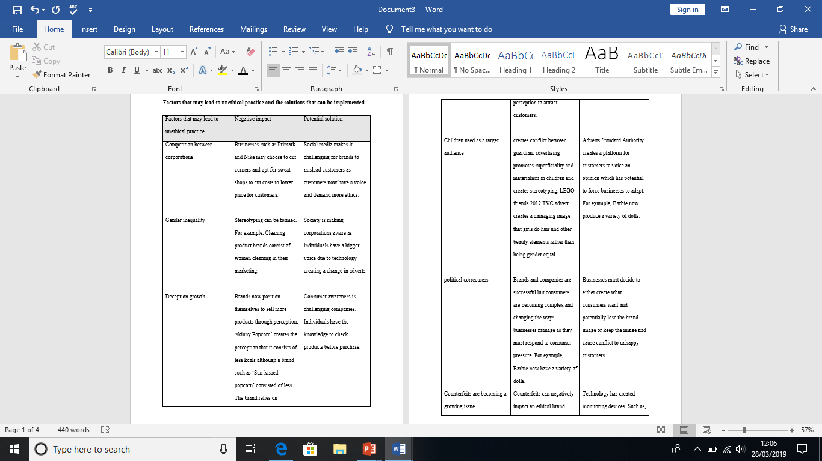

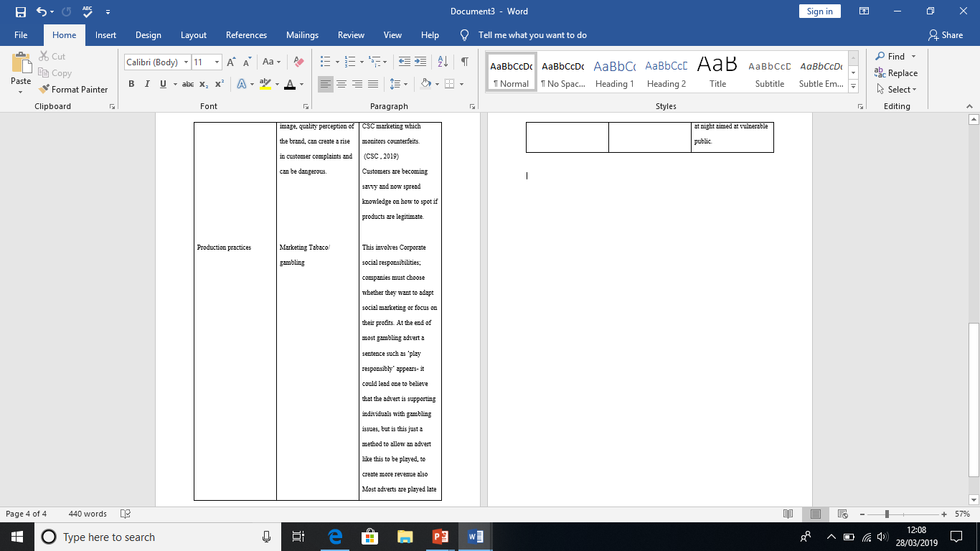

Businesses today face increased pressure to use ethical and sustainable practices due to consumer demands for example companies no longer use printing. Brands are keen to advertise that they are sustainable which will expand their marketing and create a better image for the brand whilst staying current with sustainable regulations.
It can be argued that brand strength is challenging ethical issues. Customers are aware of sweat shops used in brands such as Nike or Primark but customers power is driving the business creating consistent revenue although ethical issues are known.

Conclusion

To conclude, businesses have rapidly changed throughout the 7 Eras of marketing due to the changing pace of technology, social media and consumer demand. Businesses used to focus on traditional methodologies but now focus more on contemporary methods. A part of contemporary marketing is the development of social marketing. Businesses today must consider customers needs through producing products that consumers demand (supporting the marketing concept theory). It appears that traditional concepts for example The Marketing Mix have become outdated and have either been replaced with social methods or kept subtly within corporations whilst giving the illusion of a social marketing advert (the john Lewis advert as discussed). Businesses today emphasise the importance on providing customers with experience which links to the 4E’s rather than emphasising the product (4P’s). Social marketing is affecting ethics as consumers are demanding more ethics within marketing forcing corporations to decide whether they wish to respond to consumers through altering their image and providing consumers with adverts and products that they agree with or whether they will keep contradictory products and adverts and keep the brand image.

References

Cherry, K. (2017, May 24). Maslow’s Hierarchy of Needs. Retrieved from Explore Psychcology : https://www.explorepsychology.com/maslows-hierarchy-of-needs/
Cohen, H. (2011, March 29). 72 Marketing Definitions. Retrieved from Heidi Cohen: https://heidicohen.com/marketing-definition/
CSC . (2019). Anti-Counterfeiting Solutions . Retrieved from CSC: https://www.cscdigitalbrand.services/en/anti-counterfeiting/
Danziger, P. (2016, November 17). Luxury Marketing’s Higher Calling – from the 4Ps to the 4Es. Retrieved from Unity Marketing: https://unitymarketingonline.com/luxury-marketings-higher-calling-from-the-4ps-to-the-4es/
Dzhingarov, B. (2015, April 3). How Does Social Media Influence Marketing Communication? Retrieved from Socialnomics: https://socialnomics.net/2015/04/03/how-does-social-media-influence-marketing-communication/
Fox, E. (2014, April 12). World's most heart-warming video: Thai 'Unsung Hero' advert will make you grab the tissues. Retrieved from Express: https://www.express.co.uk/news/weird/470050/Making-the-world-beautiful-Heartwarming-Unsung-Hero-Thai-advert-goes-viral-worldwide
Guru in a bottle. (2013, December 13). The Seven Eras of Marketing. Retrieved from Guru in a bottle: https://www.guruinabottle.com/the-seven-eras-of-marketing/
kenton, W. A. (2019, March 15). Marketing Mix. Retrieved from Investopedia: https://www.investopedia.com/terms/m/marketing-mix.asp
Lee, N. R., & Kotler, P. (2008). Social Marketing: Influencing behaviours for Good. In K. P, & L. N, Social Marketing: Influencing behaviours for Good. SAGE publications.
Marketing-Schools.org. (2019). Ethical Marketing. Retrieved from Marketing-Schools.org: http://www.marketing-schools.org/types-of-marketing/ethical-marketing.html
McNamara, C. P. (2019, January 21). The Present Status of The Marketing Concept . Retrieved from SAGE: https://www.jstor.org/stable/1250868
News, M. (2015, November 25). The Man on the Moon (John Lewis' Christmas Advert 2015). Retrieved from Youtube: https://www.youtube.com/watch?v=sMqMNV_raB4
Ng, C. (2014, April 5). creative ads touching heartwarming thai life insurance commercial. Retrieved from Youtube: https://www.youtube.com/watch?v=632CHpeHYZE
Porterfield, A. (2010, March 29). 3 New Studies Prove Social Media Marketing Growth. Retrieved from Social media examiner: https://www.socialmediaexaminer.com/3-new-studies-prove-social-media-marketing-growth/
Rabinowitz, I. (2011, December 22). Social media explorer. Retrieved from 7 Ways Marketing HAS Changed (And It’s Not Just The Tools): https://socialmediaexplorer.com/content-sections/news-and-noise/how-marketing-has-changed/
Rao, D. N. (2018, January 23). The Marketing Concept - Kotler. Retrieved from Blogspot: http://nraomtr.blogspot.com/2011/12/marketing-concept-kotler.html
Sheffield, H. (2015, November 6). John Lewis Christmas Advert 2015: watch the Man on the Moon . Retrieved from Independent: https://www.independent.co.uk/news/business/news/john-lewis-christmas-ad-2015-watch-the-man-on-the-moon-a6723606.html
Sodhi, R. (2013, April 4). Dr Philip Kotler Refines the Theory of Marketing. Retrieved from Rajiv Sodhi: http://www.rajivsodhi.com/dr-philip-kotler-refines-theory-marketing/
Tobak, S. (2012, February 17). 10 companies with insanely great marketing. Retrieved from CBS news: https://www.cbsnews.com/news/10-companies-with-insanely-great-marketing/
Williamson, W. (2019, January 25). Traditional Vs Contemporary marketing strategies. Retrieved from jdr group digital prosperity: https://blog.jdrgroup.co.uk/digital-prosperity-blog/traditional-vs-contemporary-marketing-strategies

