Student: Andrei Alexandru Agopian
ID: 1905498
Module: Academic and Employability Skills
Lecturer: Lloyd Beharry

Student: Andrei Alexandru Agopian
ID: 1905498
Module: Academic and Employability Skills
Lecturer: Lloyd Beharry

Now What?

Introduction

The purpose of the following pages is to produce an academic level report on the impact “Academic and Employability Skills” has had over my development.

I started studying at University of Wales Trinity St. David in October 2019. Previously to that my education had halted at high-school level in my birth country, Romania. I have achieved, however, equivalent of GCSE’s and A-levels in a wide range of subjects such as Romanian, English, IT, Mathematics. Unfortunately, as most of my current colleagues, I was unable to attend university due to a precarious financial situation. At that point I was content with the fact that sometimes in life, much like in a poker game, you are dealt some bad cards and there is nothing you can do to change the outcome. Differently from poker, in real life trying to bluff does not work.
Years have passed since then and without a plan whatsoever I ended up in the United Kingdom, where I thoroughly enjoyed a renewed hope for the future. I distinctly remember seeing so many people on the bus reading and that made me recall school and the joy of learning. And despite my deep desire to return to the school environment, in this new found heaven, the prices were significantly above my pay-check. Another obstacle for me was cultural: growing up, I was taught that it is wrong to accept handouts or any form of social welfare from the Government and so I never bothered to look more in-depth at the options available to me. It was only after several months of conversations with a couple of my friends that I decided to pursue this avenue of continuing higher education.
Thinking back to last October I realize how grateful I have to be to both of them for unknowingly fighting against all my arguments: “I’m too old”, “what if I can’t study anymore?”, “what if I won’t be able to pay back what I owe?” and many more.
University started and the module captivated me from the start, mainly because I am a very practical person and straight away, I could see how widely applicable and how useful they would be in a workplace. From being able to understand and uncover data and information to dreaming of setting up your own little corner shop, it awoken a new purpose in me. What if you refuse to give up just yet? What will the new hand of cards be in the game of poker that is life?

Employability

In terms of how employable I was last year, as most human beings, I tend to over-evaluate myself. I would give myself a merit badge in all academic skills – I always had Google and the willingness to learn more – and I have naturally been more reserved when it came to soft skills. So, as I wrote in my previous term assignment on this same module, based on O’Neil’s “Workforce Readiness: Competencies and Assessment”, I ranked higher on mathematical skills than on interpersonal ones. Of course, I can still see I am more technically orientated as the top three skills I would want a prospective employee to have are still unchanged:
-communication
-adaptability
-problem solving
Overall I can see how much UWTSD has changed me for the better, not only thanks to the acquisition of new skills, but by highlighting neglected aspects of my preparation and by constantly putting me in a position where I have to use various software application and people skills.

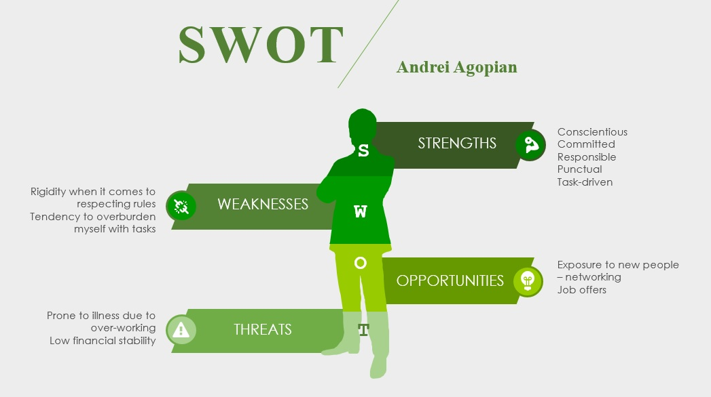

Creating a personal development plan has helped me understand the importance of goal setting and following through, as highlighted below:

Personal Development Plan
 | Short-Term Time Frame  What do I want to accomplish in the next three to six months? | Mid-Term Time Frame  What do I want to accomplish in the next six months to two years? | Long-Term Time Frame  What do I want to accomplish in the next two to three years?
My Goals | -pass my probation at the new workplace  - change job role to a supervisor position | - learn to write with my non dominant hand  - learn Armenian  - move into a managerial role | - own or start paying for my own house  - continue developing my career and move into a high management position  -move to Switzerland
Tools Needed to Complete the Goals | -acquired or provided within the company  - participate to all meetings available within the work environment  -attend university ; the course I’ve chosen covers all aspects that would ensure my success in my endeavour | -practice  -video tutorials  -connect with the community | -start a savings fund  -market research  - continue career development  -gather experience that makes me an “unique product” which makes me extremely valuable for any employer
How Am I Going to Achieve | -online training  -attending university  -networking | -watch tutorials  -practice : use own and paper, create a schedule of a minimal amount of time dedicated to each goal; by minimal I mean an amount of time that would be respected every day | -bank and market research  -internet research

 | Short-Term Time Frame  What do I want to accomplish in the next three to six months? | Mid-Term Time Frame  What do I want to accomplish in the next six months to two years? | Long-Term Time Frame  What do I want to accomplish in the next two to three years?
Resources | -course fees  -maintenance loan  -internet access  -calendar (time management is crucial and I need to write things on paper; electronic devices are too good at distracting me) | -internet access  -calendar | -internet access  -financial discipline
Time Frame | -work rota varies from month to month; three types of shifts: night, day, middle  -university Wednesday and Friday 09:00-14:00 | -10 minutes daily  -any time outside my short-term goals schedule that can be classed as leisure time | -links into short term goals as well; the time spent working on those furthers the achievement of long-term goals  -10 minutes reading daily
When will I start? | -1st of October 2019  -14th of October 2019 | -1st of November 2019 | -1st of November 2019
When do I expect to finish? | -1st of January 2020 | -1st of January 2021 | -1st of January 2022
Completion | □__√________  Date  □___√_______  Date  □__________  Date | □__________  Date  □__________  Date  □__________  Date | □__________  Date  □__________  Date  □__________  Date

Reflective writing

Reflection is the lost art of being human. By reflecting we need to stop the daily routine and create an imaginary situation or go back to an event from the past and go beyond the menial task of just describing it; it is a process in which we want to look at all the implications that event brings. From my own attempt at understanding the subject I can mentally draw a model where an “observer/analyst” interacts with an “event/action” and becomes a new person. The act of reflective thinking and writing has as an effect the death of the previous ego.
Reflective practice has the role of directing a subjective action into an objective outcome and is governed by traits such as clarity, in depth observation, assumption of the self and theoretical and analytical research. As such it exists since humans have called themselves a specie and optimal models have been put forward since William I. Thomas and Dorothy Swaine Thomas’ work was adapted by Robert K. Merton in 1948.

"If men deﬁne situations as real, they are real in their consequences”.
William I. Thomas

The most notable ones are Gibbs, Kolb and Fry, Schön, Driscoll and Johns, with Gibbs being the earliest proposed and Johns’ one of the most recent.
One model that stood out was Borton’s in 1970 – work continued and adapted by Driscoll from the beginning of the ’90 to late 2000 – due to its simplicity and efficiency. The model is formed of three questions/stages:
What?
So What?
Now What?
Initially you identify the event, how the event impacted you and, in the third step, you look at what is there to be learnt from it. Much like the thought process I applied when a major occurrence broke down a regiment daily schedule. By comparing this model with the one presented by Rolfe et al., I was able to develop my one theory and note of criticism. Rolfe expanded Driscoll in 2001 and below each question added an expansion, for instance “what” became “what is the problem”, “so what” evolved to “so what does this teach me” and lastly “now what” was expanded to “now what do I need to do to improve?”. Although I see the necessity of providing examples, my main critique is that it hinders a natural process that occurs within a human, teaching us to function on set patterns. In turn, changing the thinker from human to automaton. Main utility for this model would be the structured work environment, where an implementer might want to get the same style results from performing reflexion. I conclude that what Driscoll proposed is closer to the definition of a model – something that applies to a wide range of things – rather than what Rolfe is doing. I conclude that Driscoll’s model is a direct translation of meditation in Western language, focus on one thing, absorb it and let it shape you.

Analytical and critical thinking

Another subject dear to me this term was looking at analytical and critical thinking. By analytical thinking we take an event apart and look at all its components, trying to make sense of it. A thought process is critical in nature when the same previously analysed event becomes subjected to outside information (Allen and Bekoff, 1999).

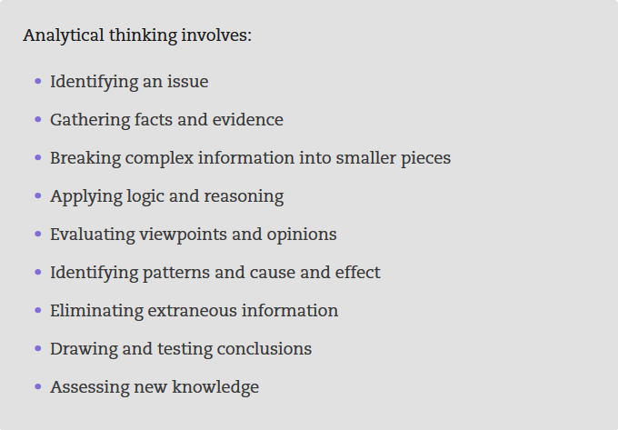

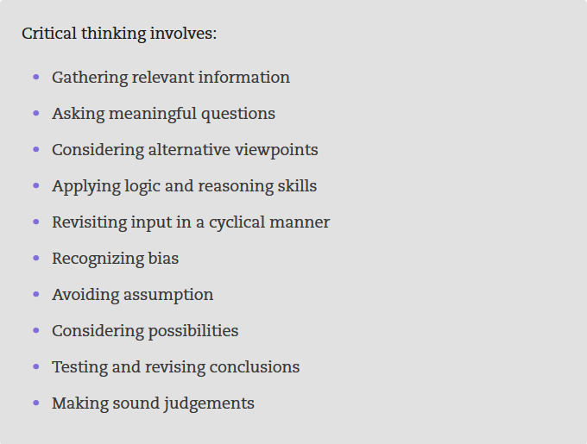

Public speaking and presenting

During my lectures I was exposed to some very productive experiences. One in particular that stands out was a quick exercise in “Academic and Employability Skills” where Benedict Maher asked us to create a PowerPoint presentation about the traits that make you stand out from the crowd in higher education. The exercise was interesting because it was limited to 10 minutes. I then presented my part and was subjected to a medium sized audience. After this exposure, in the same module, another exercise was to deliver a presentation for which you were allowed to prepare for the same amount of time, on a subject that was new to all of us. With newfound confidence, I volunteered for the task, and I could already notice an improvement in my skills. Maybe from 3 I had reached a 5-6 on the previously mentioned scale. After these occurrences, I enrolled in a course in my workplace where the admission task was creating and presenting a collection about myself. I was still overwhelmed by emotions but tried to focus on the details of the task and respect the guidelines I had received during my lessons at University. After the day was over, and all attendees had a chance to discuss with the higher management, I was congratulated on my skills, both by them, as well as by some of my colleagues. The fact that some even asked if I had help from outside stood as proof that my skills had gone significantly up. I was now maybe a 7 or 8.
What I concluded from this experience is that public speaking and presenting are very powerful and useful skills, and for the future, my goals is to emphasize them further.

Paraphrasing

The skill of paraphrasing is much more than “expressing someone else’s idea in your own words”, it is turning “he/she said that” into an academic work. It shows power of analysis and synthesis, strength of vocabulary and a deep understanding of the topic. It is a means of translating a message conveyed in higher academic circles into words that outsiders can comprehend (Chaita, 2016).
Paraphrasing was something that I have always had a good grasp of - this is assessed by looking back at some of the in-class exercises we did last term – and a skill without university work cannot be achieved. The main fountain of information in a student’s assignments comes from rewording pre-existing works and creating something new out of them. And in literary work paraphrasing is “translation with latitude, where the author is kept in view by the translator so as never to be lost, but his words are not so strictly followed as his sense” (Hooley, 1988). I admit the above quote might have required the use of my own words, but I prefer preserving the authenticity of the text and its beautiful perfection in simplicity.
I am aware that I am still navigating unchartered territory when it comes to this skill, and I am looking forward to the next couple of years and future assignments where, hopefully, I will be able to “paraphrase the paraphrase” in a superior way. To pursue this objective, I am focusing actively on my reading, making the most of the time spent commuting.

Conclusion

The purpose of this work was to make sense of what I have experienced this entire scholastic year, to look at the activities I was involved in and how they transformed me.
To the best of my abilities I have tried to respect Driscoll’s model and what I have discovered – thing that both enforces and disputes Rolfe – is that it is quite testing to respect the pattern ad litteram. Thoughts happen spontaneously and I accept here that by practicing, one becomes better at it, but in my head at least, the three questions happen simultaneously. For this reason, I must praise Rolfe’s model, for the extra suggestions present in that model and for its attempt at minimizing the “where was I” moments. The critique, on the other hand, is something that it is easily seen all around us:
Art – Nietzsche said God is dead, but he has not seen modern art. Soulless metal buildings scratch the sky and museums are filled with piece of cloth covered in paint dripping from a swirling bucket hung up by string. Art is dead and rules killed it, because, as Serge Lutens put it, beauty hates rules. The only rule in art is having no rules to be able to give life to beauty. And when people are taught to stick to a certain pattern, there is little room for innovation.
Science – many scientists warn that we are getting close to the point where new discoveries have been exhausted. Some suggesting it is high time we focus on artificial intelligence and let – hope – a machine can do a better job than us, on this plane the humans being limited by the shortness of their lifespan (Dworkin, 2019).

References

Allen, C. and Bekoff, M., 1999. Species of Mind. Cambridge: MIT Press.
Athans, S. and Parente, R. (2015). Tips & tricks for summarizing text. The Rosen Group.
Bolton, G., 2011. Reflective Practice: Writing and Professional Development. London:
Jessica Kingsley Publishers.
Bubb, S. and Earley, P. (2007). Leading and managing continuing professional development. London: Paul Chapman.
Bustin, S., 2016. The Authority Guide to Presenting and Public Speaking. Bristol: SRA Books.
Chaita, M. (2016). Developing graduate employability skills. Boca Raton: Universal Publishers.
Coelen, R. and Gribble, C. (2010). Internationalization and employability in higher education. Rutledge.
Copus, J. (2009). Brilliant Writing Tips for Students. Julia Corpus.
Cottrell, S., 2017. Critical Thinking Skills. London: Macmillan International Higher Education.
Duarte, N., 2013. Resonate: Present Visual Stories That Transform Audiences. California: John Wiley & Sons.
Dworkin, R., 2019. The Limits of Science. [Online] Nationalaffairs.com. Available at: <https://www.nationalaffairs.com/publications/detail/the-limits-of-science> [Accessed 28 April 2020].
Engell, J., 1989. Forming the Critical Mind. Cambridge, Mass: Harvard University Press.
Handler, C., Handler, C. and Gill, D., 2017. English and Reflective Writing Skills in Medicine. CRC Press.
Hooley, D., 1988. The Classics in Paraphrase: Ezra Pound and Modern Translators Of Latin Poetry. 1st ed. Dublin: Susquehanna University Press.
Michelson, E., 2019. Paraphrasing Wisdom: Truths You Can Only Get From Poetry... Or Something. 1st ed. Morrisville, North Carolina: Lulu.com.
Thomas, W. and Thomas, D., 1970. The Child in America. New York: Johnson Reprint Corp.

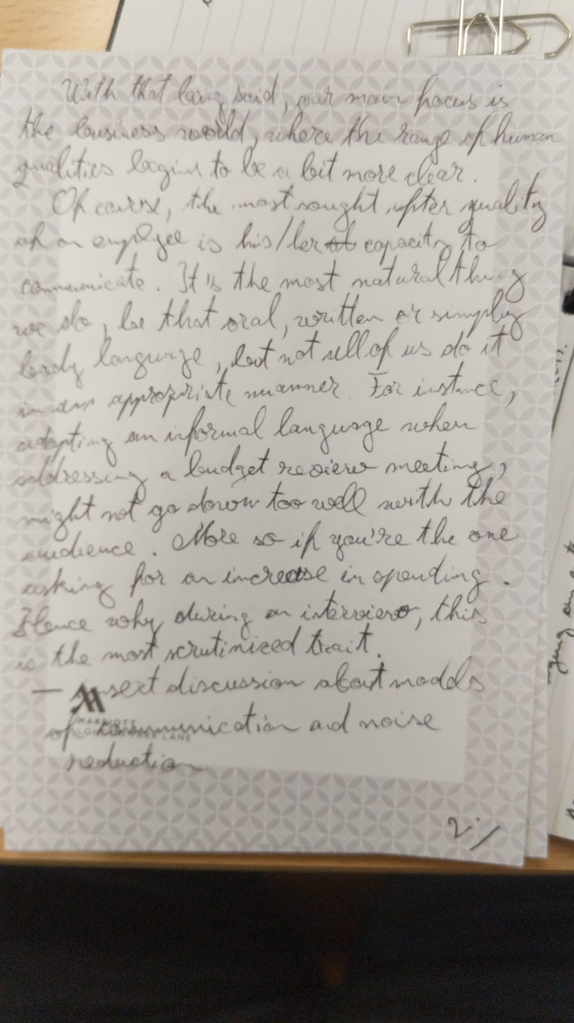
Appendix


