

Assessment 1 – Reading Task Template
PART 1: Upload your photo of your A3 in-class notes here:
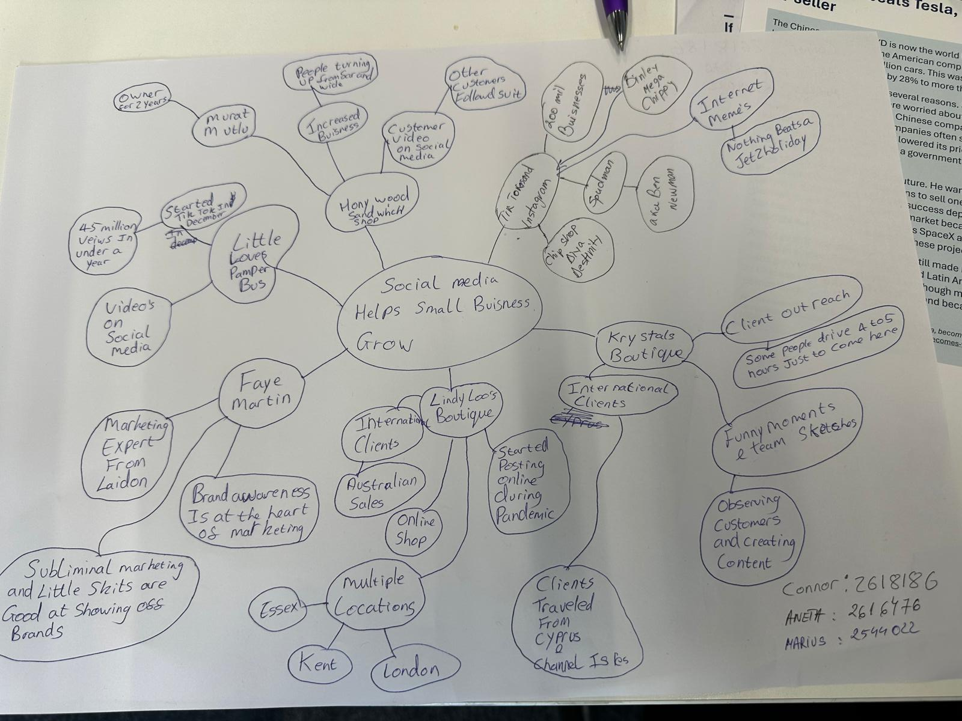

PART 2:
- What is the main idea of the whole text?
The central point of the article is that social media platforms like Instagram and TikTok can be utilised as a tool for small businesses to expand and gain more customers and boost sales. The article provides several examples of businesses that have been successful after creating viral videos and posts by customers, demonstrating how social media can provide new business options.
- What is one key point that supports the main idea, and which specific example from the text shows this?
One key point is that social media can help to bring in new customers to small establishments. The Honywood Sandwich Shop is a case in point – one of the videos was posted online, and word of it got around. Consequently, those who came wanted to order in the chicken burger, which they had to travel up to 3 hours to get to.
- What is a different key point that supports the main idea, and which specific example from the text shows this?
One more major advantage is social media can assist businesses to target clients outside their local markets. For instance, Boutique, owned by Lindy Loo, has re-positioned its clothing company in the online Space and now ships outfits all over the UK as far back as Australia.
- Which part of the text do you think is most important, and why?
The most crucial thing I think is how social media has enabled small business to connect with more people. For instance, Pamper Bus from Little Love garnered nearly 45 million social media views in a span of less than a year. This demonstrates that there are new possibilities and opportunities provided by social media, and that it can assist a business in growing.
Reflection:
- What did you find difficult in this task (including in-class components), and why was it difficult?
Identifying the central idea and/or key points of the article was challenging. There was much information to learn and multiple business examples to comprehend. I also struggled to find the information to organise into A3 mind map as clearly as possible.
- What helped you with this difficulty, and how did it help you?
Focusing on the details of the article helped me grasp the main idea and details of the passage. I created an A3 mind map to help me organise and make links between information and business examples. Class time and articles examples were helpful.

