Improving Employee Engagement at META Inc.: Analysis, Assessment, and Recommendations

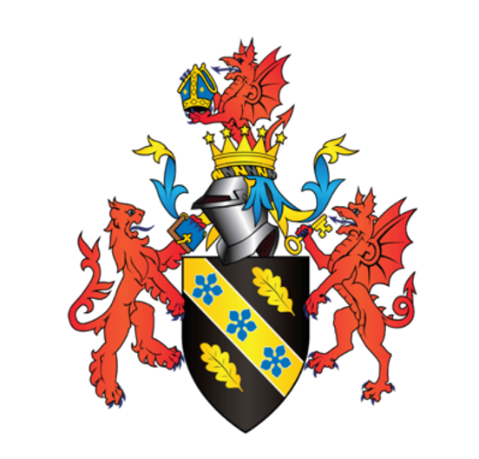

March 2023

STUDENT NAME: Qiyuan Zhu
STUDENT NUMBER:2216868

Executive Summary

This report provides recommendations to improve employee engagement at META. The report highlights the importance of employee engagement in improving motivation, job satisfaction, and overall productivity, which can lead to better organizational performance.

The report recommends several strategies that META can adopt to improve employee engagement, including improving communication, establishing a clear and transparent communication policy, and offering professional development opportunities. Effective communication fosters open and transparent communication channels, enabling employees to feel more involved and valued, leading to better job satisfaction, increased productivity, and lower turnover rates. Offering professional development opportunities can increase employee engagement and job satisfaction, demonstrating META's commitment to their career growth and encouraging them to stay with the company.

Additionally, META can invest in training its managers on effective communication skills, including active listening, empathy, and conflict resolution, to foster a positive work environment. Leadership training, mentoring, and coaching programs can also improve employee engagement levels.

Overall, implementing these recommendations can help META to create a positive work environment, improve employee engagement levels, and achieve better organizational performance.

Contents

1.0 Introduction
2.0 Organizational Overview

3.0 Main Discussion
3.1 Organisational Priority Area
3.2 Current Shortfalls
3.3 Impact on the Organisation
3.4 Benefits of Improving Employee Engagement

4.0 Conclusions

5.0 Recommendations
5.1 Improve Communication
5.2 Offer Professional Development Opportunities
5.3 Foster a Culture of Diversity and Inclusion
5.4 Foster a Positive Organizational Culture
5.5 Monitor and Evaluate Progress

6.0 Reference List

1.0 Introduction

Employee engagement is an important aspect of HRM that has gained significant attention in recent years. It refers to the level of emotional commitment and attachment employees have towards their work, colleagues, and organization. It impacts an organization's performance, productivity, and profitability as engaged employees tend to be more motivated, innovative, and committed to the organization's goals and objectives. However, employee engagement is a complex and multifaceted concept that requires a comprehensive approach. Effective strategies and practices are essential for organizations to foster employee engagement. This report aims to analyze the current state of employee engagement at Meta Inc., identify its weaknesses, and assess its impact on the organization. Furthermore, feasible recommendations will be provided to improve employee engagement in the company.

2.0 Organizational Overview

Meta Inc. is a global technology company that has established a strong presence in the industry due to its innovative and customer-centric approach. The company's diverse workforce comprises employees from different cultural backgrounds, nationalities, and languages, which enables the organization to understand and meet the needs of its customers worldwide.

Meta Inc.'s HR function operates on a decentralized model, where the HR team collaborates with business units to formulate and implement HR policies, procedures, and practices. This approach ensures flexibility and customization to meet the unique needs of each business unit. The HR function is represented at the executive level, with the Chief Human Resource Officer reporting directly to the CEO. This indicates the importance that Meta Inc. places on its employees and the critical role that the HR function plays in the overall success of the organization.

Meta Inc. fosters a performance-driven work culture, where employees are encouraged to push themselves to achieve organizational objectives while maintaining work-life balance. The company places a strong emphasis on employee empowerment, enabling employees to take ownership of their work and contribute to the organization's success. Professional growth is a critical component of Meta Inc.'s HR strategy, with the company investing heavily in employee training and development programs to enhance employee skills and knowledge.

Figure1

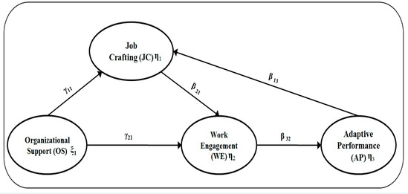
Diversity and inclusion are core values that guide Meta Inc.'s HR function. The company believes in creating an environment where employees feel valued, respected, and included regardless of their race, ethnicity, gender, sexual orientation, or other personal characteristics. Meta Inc.'s diversity and inclusion initiatives include the recruitment of employees from diverse backgrounds, the implementation of inclusive policies and practices, and the provision of training to employees on diversity and inclusion.

Meta Inc.'s HR function operates on a decentralized model, with a focus on innovation, customer-centricity, and employee empowerment. The organization places a strong emphasis on diversity and inclusion and invests heavily in employee training and development programs to enhance employee skills and knowledge. This approach has enabled Meta Inc. to establish a strong presence in the industry while ensuring the continued success of the organization on innovation, customer satisfaction, and employee engagement.

3.0 Main Discussion
3.1 Organizational Priority Area

Employee engagement is a crucial priority area that requires improvement for any enterprise to achieve its objectives and maintain a competitive advantage in today's fast-paced business environment. Employee engagement refers to the level of emotional and psychological connection that an employee has with their work and the organization they work for (Saks, 2006). Engaged employees are more committed, motivated, and productive, leading to higher levels of job satisfaction and organizational performance (Khan, 1990).

Figure2

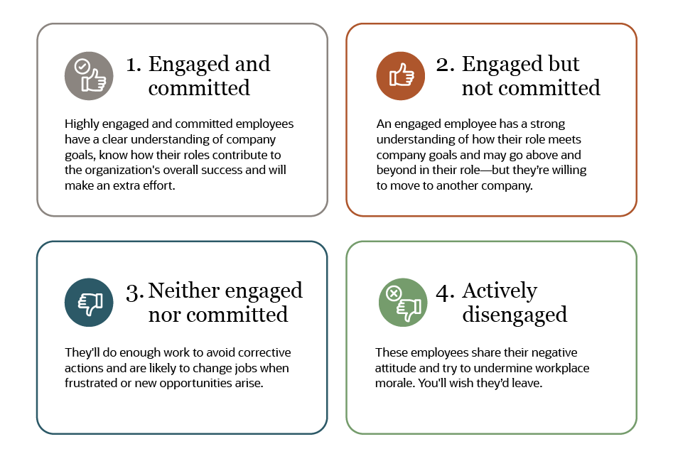
(Khan, 1990).

In recent years, employee engagement has become a critical area of focus for many enterprises, including meta enterprises. Despite their reputation for being some of the most innovative and successful companies globally, many meta enterprises have struggled to maintain high levels of employee engagement. It is imperative that meta enterprises prioritize improving employee engagement levels to enhance productivity, reduce turnover rates, and enhance their reputation as an employer.

3.2 Current Shortfalls

Several factors have contributed to the current state of employee engagement in meta enterprises. Firstly, highly competitive and demanding work environments can lead to burnout and low morale among employees (Lipman, 2017). Meta enterprises are known for their high-performance culture, where employees are expected to work long hours and meet tight deadlines. This work culture can lead to stress and exhaustion among employees, leading to disengagement and low job satisfaction.
Secondly, meta enterprises have been criticized for not doing enough to promote diversity and inclusion in their workforce, leading to feelings of disengagement among underrepresented groups (Walters, 2019). Meta enterprises have been accused of having predominantly male-dominated workforces, which can make it challenging for employees from diverse backgrounds to feel included and engaged. Diversity and inclusion are essential for fostering a sense of belonging and engagement among employees, and meta enterprises need to address this issue to improve their employee engagement levels.
Thirdly, meta enterprises have been criticized for their lack of transparency and communication with employees, leading to feelings of mistrust and disengagement (Greenberg, 2019). Meta enterprises are known for their culture of secrecy, which can make it challenging for employees to feel informed and involved in the company's decision-making process. Lack of transparency and communication can also lead to uncertainty and confusion among employees, leading to disengagement and low morale.

3.3 Impact on the Organisation

The impact of low employee engagement on an organization is well documented in the literature (Khan, 1990; Saks, 2006). As mentioned, one of the main consequences of low employee engagement is increased turnover rates. When employees feel disengaged, they are more likely to look for new job opportunities that they believe will be more fulfilling (Saks, 2006). This results in a loss of talent, knowledge, and experience, which can be detrimental to the organization's performance.

Another negative impact of low employee engagement is lower productivity and efficiency. Engaged employees are more likely to be committed to their work and the organization, and therefore, they are more likely to put in extra effort and go above and beyond their job duties (Khan, 1990). In contrast, disengaged employees may do just enough to get by, and they may not put in any extra effort. This can lead to lower productivity levels and may negatively impact the organization's performance.

Low employee engagement can also have a negative impact on the organization's reputation as an employer. Disengaged employees are more likely to speak negatively about their experiences working for the company, and this can impact the organization's ability to attract and retain top talent (Greenberg, 2019). In the technology industry, where competition for top talent is fierce, a negative reputation can have significant consequences.

In META's case, the impact of low employee engagement on the organization has been significant. The company has faced criticism from former employees who have spoken out about their negative experiences working for the organization (Greenberg, 2019). This negative publicity can have a ripple effect, as potential job candidates may be discouraged from applying to work for the company. Additionally, META has lost several high-profile employees in recent years, which has been attributed, at least in part, to low levels of employee engagement (Lipman, 2017). Losing key employees can be detrimental to the organization's performance, as it may result in a loss of knowledge, experience, and talent.

Overall, it is clear that low employee engagement can have a significant negative impact on an organization. For META, addressing this issue is critical to maintaining its position as a leader in the technology industry. By improving employee engagement, META can increase productivity, reduce turnover rates, and enhance its reputation as an employer.

3.4 Benefits of Improving Employee Engagement

Improving employee engagement in META would have several positive outcomes for the organisation, employees, and other stakeholders. Firstly, it would lead to increased productivity, which refers to the level of output per unit of input. Engaged employees are more likely to be motivated, committed, and willing to put in extra effort, resulting in higher levels of productivity (Saks, 2006). Increased productivity can lead to higher profits, improved customer satisfaction, and a competitive advantage in the market.

Figure3

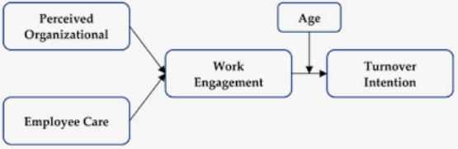
(Saks, 2006)
Secondly, improving employee engagement can lead to decreased turnover rates, which refers to the percentage of employees who leave an organisation in a given period. Disengaged employees are more likely to leave their jobs, resulting in high turnover rates, which can be costly for the organisation (Khan, 1990). The cost of replacing employees includes recruitment, training, lost productivity, and reduced morale, among others. By improving employee engagement, META can reduce turnover rates, save costs, and retain its top talent.

Thirdly, improving employee engagement can improve META's reputation as an employer. Engaged employees are more likely to speak positively about their experiences working for the organisation, which can attract top talent and customers. In contrast, disengaged employees are more likely to speak negatively, which can damage the company's brand image and reputation (Greenberg, 2019). By improving employee engagement, META can enhance its employer branding and attract top talent, which can lead to innovation, creativity, and growth.

In summary, improving employee engagement in META would have several benefits, including increased productivity, decreased turnover rates, and an improved reputation as an employer. These benefits can lead to higher profits, improved customer satisfaction, and a competitive advantage in the market.

4.0 Conclusions

In conclusion, META needs to prioritise employee engagement to improve its organisational performance and ensure that it remains competitive in the technology industry. The current shortfalls in employee engagement are caused by a highly competitive and demanding work environment, lack of diversity and inclusion, and poor communication and transparency. The negative outcomes of low employee engagement include increased turnover rates, lower productivity and efficiency, and a negative impact on META's reputation as an employer. Improving employee engagement would have several benefits for the organisation, employees, and other stakeholders, including increased productivity and efficiency, decreased turnover rates, and an improved reputation as an employer.

5.0 Recommendations

Based on the previous discussion and analysis, several recommendations can be made to improve employee engagement in META. These recommendations are aimed at improving employee motivation, job satisfaction, and overall productivity, which can lead to better organizational performance.

5.1 Improve Communication
META can improve communication within the organization by establishing a clear and transparent communication policy. This policy should include regular meetings between employees and management, open-door policies, and feedback mechanisms to encourage two-way communication. META should also invest in training its managers on effective communication skills, including active listening, empathy, and conflict resolution.

Effective communication is critical in building trust and enhancing employee engagement (Saks, 2006). By fostering open and transparent communication channels, employees are more likely to feel valued and engaged, leading to better job satisfaction, increased productivity, and lower turnover rates. Regular meetings between employees and management provide an opportunity to discuss issues, share ideas, and address concerns, improving employee morale and motivation. Additionally, feedback mechanisms enable employees to provide feedback on organizational policies, practices, and procedures, making them feel more involved and valued. Offering training to managers on effective communication skills is also essential in fostering a positive work environment, where employees feel comfortable communicating their needs, concerns, and ideas.

Figure4
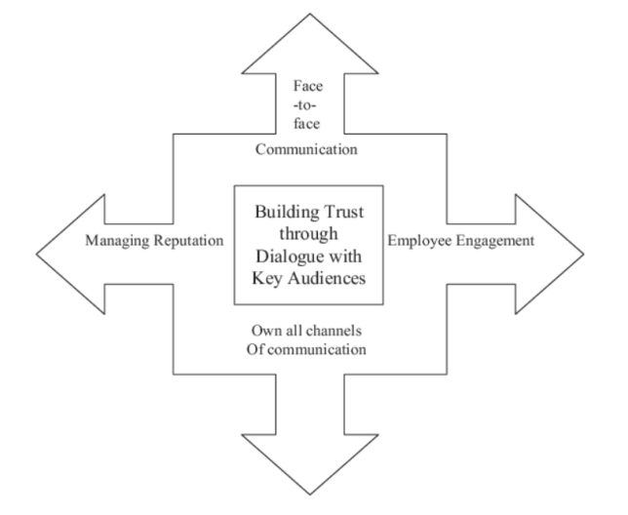
(Saks, 2006)

5.2 Offer Professional Development Opportunities

Professional development opportunities can increase employee engagement and job satisfaction. META can offer training and development programs to its employees, including leadership training, mentoring, and coaching programs. By investing in its employees' professional development, META can demonstrate its commitment to their career growth and encourage them to stay with the company.

Offering professional development opportunities is an essential aspect of employee engagement and retention (Khan, 1990). Employees who feel that their company is invested in their career growth are more likely to be engaged, motivated, and committed to their work. META can offer leadership training to employees who show potential for leadership positions, providing them with the skills and knowledge necessary for advancement within the organization. Mentoring programs can also be implemented, where experienced employees can mentor and guide new hires, enhancing their skills and knowledge. Coaching programs can be offered to employees who need help in specific areas, such as time management or communication skills. By offering these programs, META can create a culture of learning and growth, where employees feel valued and supported in their professional development.

5.3 Foster a Culture of Diversity and Inclusion

Fostering a culture of diversity and inclusion is crucial in improving employee engagement, job satisfaction, and organizational performance. META can promote diversity and inclusion by implementing policies and practices that support equal opportunities for all employees, regardless of their background, gender, race, or ethnicity. META can also establish employee resource groups (ERGs) that provide a platform for underrepresented groups to connect, network, and collaborate, enhancing their sense of belonging and engagement.
Research has shown that diverse and inclusive workplaces lead to better organizational performance, increased innovation, and higher employee engagement (Walters, 2019). By promoting diversity and inclusion, META can attract and retain top talent, enhance creativity and innovation, and improve overall organizational performance. ERGs provide a platform for underrepresented groups to share their experiences, challenges, and successes, improving their sense of belonging and engagement within the organization. ERGs can also provide a forum for discussion on policies, practices, and procedures that affect underrepresented groups, enabling META to make informed decisions on how to improve diversity and inclusion within the organization.

5.4 Foster a Positive Organizational Culture

META can foster a positive organizational culture by promoting values such as respect, teamwork, and diversity. The company can encourage collaboration among employees, promote work-life balance, and offer flexibility in working arrangements. META can also create a supportive and inclusive workplace environment that values diversity and encourages creativity and innovation.

5.5 Monitor and Evaluate Progress

Monitoring and evaluating the progress of employee engagement initiatives is critical to ensuring their effectiveness and making data-driven decisions. META can use various methods, such as surveys and focus groups, to collect feedback from employees on the effectiveness of its engagement strategies. For instance, the company can use engagement surveys to measure employees' satisfaction levels, their perceptions of the company's culture, leadership effectiveness, and overall engagement levels. Focus groups can be used to gain more detailed insights into employees' experiences and their suggestions for improving engagement.

Once the feedback has been collected, META should analyze it to identify trends and areas for improvement. The data should be used to make data-driven decisions to develop and refine engagement strategies that address employees' concerns and preferences. Additionally, regular progress reports should be shared with senior management to ensure their support and to provide transparency into the engagement initiatives' impact.

Monitoring and evaluating employee engagement initiatives are essential to ensure their success and effectiveness in addressing organizational needs. META should regularly assess its engagement programs' impact and make necessary adjustments to improve employee engagement levels and foster a positive work environment.

6.0 Reference List

Bakker, A. B., & Demerouti, E. (2008). Towards a model of work engagement. Career development international, 13(3), 209-223.

Greenberg, J. (2019). Managing behavior in organizations. Routledge.

Kahn, W. A. (1990). Psychological conditions of personal engagement and disengagement at work. Academy of Management Journal, 33(4), 692-724.

Saks, A. M. (2006). Antecedents and consequences of employee engagement. Journal of managerial psychology, 21(7), 600-619.

Shuck, B., & Reio Jr, T. G. (2014). Employee engagement and well-being: A moderation model and implications for practice. Journal of leadership & organizational studies, 21(1), 43-58.

Sonnentag, S., & Fritz, C. (2015). Recovery from job stress: The stressor‐detachment model as an integrative framework. Journal of Organizational Behavior, 36(S1), S72-S103.

