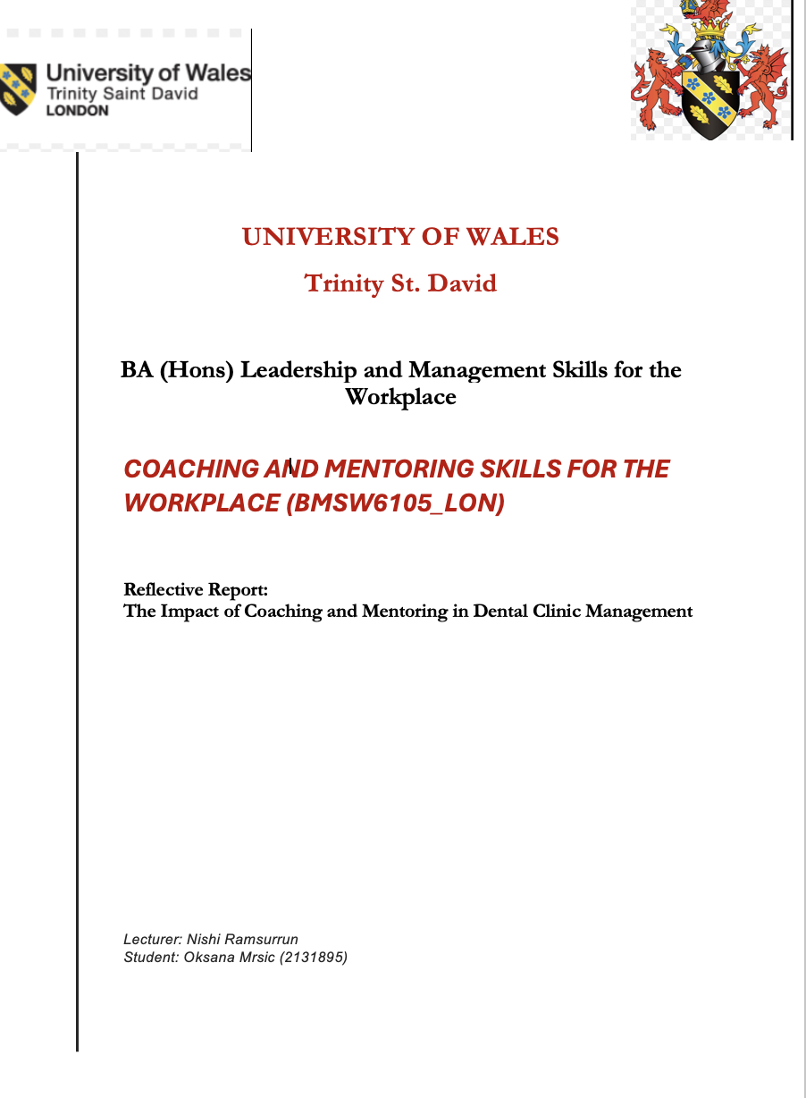
Table of Contents
Introduction 2
Coaching Vs. Mentoring: Definitions And Benefits 2
Essential Coaching Skills and Their Importance 3
Understanding The GROW Model In Practice 4
Reflection Using Gibbs' Reflective Cycle 5
Honey and Mumford Learning Styles Questionnaire 5
Conducting A Skills Audit for Improvement 6
SWOT Analysis of Coaching Practices 7
Reflective Models in Coaching Sessions 8
Conclusion 8
References 9

Introduction

Effective coaching and mentoring are necessary in today's business world to help employees grow and improve the performance of the company. Companies like Google and IBM have realised that these methods are effective ways to develop talent, create an environment where people are always learning, and speed up the development of new processes (Martin, 2021). Most of the time, coaching is described as a methodical process that helps a person improve their performance by developing certain skills or competencies (Adams & Baker, 2020). Coaching has many benefits, such as helping people become more self-aware, setting better goals, and being more motivated at work. Mentoring focuses on improving both personal and professional skills with the help of experienced professionals. Some of the benefits of mentoring are sharing knowledge, getting help with career development, and making new professional connections (Roberts, 2022).

To be good at leading coaching sessions, people need to learn and be able to use a basic set of skills that are necessary for success in this area (Harris, 2023). The basic set of coaching skills includes ten important skills: active listening, questioning, empathy, giving feedback, setting goals, helping people take responsibility, building relationships, being flexible in how you do things, conflict resolution strategies, and the ability to evaluate. Each skill plays an important role in creating a coaching environment where people can get help as they work towards their goals (Smith, 2020).

Goal-Reality-Options-Will (GROW) models give coaches a structured way to have conversations with their clients that help them reach their goals (White, 2020). A skills audit gives coaches and mentees a structured way to find both strengths and areas where the mentee might need to improve (Jackson, 2018). When coaching practices use SWOT analysis, they can see their own strengths and weaknesses as well as the opportunities and threats that come from the outside (Davis & Green, 2021).

Gibbs' Reflective Cycle and Kolb's Experiential Learning Cycle are both important tools for evaluating personal experiences from coaching sessions in class (Taylor & Wilson, 2022). When these frameworks are used to critically look at practice outcomes, they help both the coach, and the mentee learn more in an academic setting (Garcia, 2023).

Coaching Vs. Mentoring: Definitions And Benefits

Coaching and mentoring are two different but complementary ways to grow personally and professionally. Each has its own definition and set of benefits. Coaching is usually a clear process that aims to improve a person's performance in certain areas by setting clear goals and using structured techniques to improve skills (Gerald, 2021). The focus stays on the short term, with an emphasis on getting measurable results. There are many different methods that coaches use to help clients learn by helping them figure out their own strengths and weaknesses and becoming more responsible (Williams, 2021).

Coaching has many benefits, such as improving performance and self-awareness, giving people better problem-solving skills, and boosting their confidence. With the help of specific feedback and support systems, coaches help people get past problems and reach their goals more quickly. Through coaching programs, members learn how to work together better, which makes teams more dynamic (Adams & Baker, 2020).

Mentoring is different because it's a long-term relationship in which an experienced person helps a less experienced person grow by sharing knowledge and experiences. A lot of the time, mentors act as role models or advisors who share useful information based on their own experiences in the field (Taylor & Wilson, 2022). Instead of focusing on short-term performance improvements, mentoring programs focus on long-term personal growth (Smith, 2020).

Mentoring has many benefits, such as increasing job satisfaction and growing professional networks. Both the mentor and the mentee also improve their leadership skills and create a supportive environment that encourages ongoing learning (Martin, 2021). The knowledge that seasoned professionals have gained over time is useful for mentees, and it gives mentors personal satisfaction to help develop organisational talent.

Coaching and mentoring are important for the success of an organization because they help with talent development programs (Jackson, 2018). Coaching is about using goal-oriented methods to get specific tasks done, while mentoring is about helping people grow more broadly so they are ready for bigger problems in the future (Harris, 2023). When companies understand these differences, they can create personalized programs for employee development that help workers improve their skills and contribute to the company’s success (Roberts, 2022).

Essential Coaching Skills and Their Importance

Basic coaching skills are important for making coaching and mentoring sessions effective. The facilitatory skills of the coach make their teaching more effective while also giving the mentee huge developmental benefits (Williams, 2021). Among the ten most important coaching skills, active listening stands out because it helps build trust and understanding, which in turn helps coaches fully understand their mentees' perspectives (Clark, 2019). The skill of asking good questions is just as important because it helps coaches lead their mentees to deeper reflection and thoughtful exploration, which leads to self-discovery (Davis & Green, 2021).

Another important skill that helps both coaches and mentees clarify their goals is the ability to set goals (Gerald, 2021). By establishing this process, a structured way to track progress and ensure accountability is created. Giving constructive feedback is very important because it helps mentees identify areas for improvement while reinforcing their strengths (Harris, 2023). Through empathy, coaches build personal connections with their mentees, which fosters a strong bond that facilitates open communication.

Building a relationship with a mentee is essential for creating an environment where they feel comfortable discussing their worries and doubts (Jackson, 2018). Being adaptable allows coaches to modify their approaches to suit the needs of everyone (Martin, 2021). This ensures that every coaching session is productive and relevant. Keeping information private builds trust in the coaching relationship and reassures mentees that their confidentiality will be respected (Clark, 2019).

Emotional intelligence is critical for understanding one's emotions and those of others in social interactions (Davis & Green, 2021). Lastly, commitment demonstrates that both coaches and mentees value the process, as coaches work deeply for the success of their mentees while encouraging the same level of dedication from their mentees (Roberts, 2022).

The importance of these skills cannot be overstated; they lay the foundation for building strong coaching relationships. When coaches develop these essential skills, they not only enhance their own performance but also foster a positive work environment that encourages employees to engage in continuous learning and growth (Harris, 2023).

Understanding The GROW Model in Practice

Many people recognize the GROW model as a framework for coaching and mentoring that helps participants engage in structured conversations with clear goals in mind (White, 2020). The framework comprises four main parts: Goal, Reality, Options, and Will. Each part serves as a critical compass guiding the coaches through the complexities of self-discovery and action planning (Gerald, 2021).

Setting clear, measurable goals occurs in the first step of the GROW model (Kelly, 2022). This vital first step sets the direction for the entire coaching session and motivates individuals by providing a means to measure their progress (Taylor & Wilson, 2022).

Reality is the next step, in which individuals assess their current situation relative to their goals. This stage encourages honest self-reflection and an evaluation of one’s strengths and weaknesses (Clark, 2019). Coaches can identify potential obstacles by analysing their present circumstances, which will prepare them for challenges along their journey.

After the analysis, options are explored. During this phase, various strategies and methods to achieve the goal are discussed (Adams & Baker, 2020). The main objective at this stage is to brainstorm possible solutions without judgment, allowing for creative thinking and exploration of diverse pathways forward (Davis & Green, 2021).

In the final phase, Will focuses on making a commitment to action (White, 2020). At this stage, coaches articulate specific steps they will take to achieve their goals while also determining deadlines and accountability measures. This turns intentions into detailed, actionable plans, thereby facilitating follow-through.

Utilizing the GROW model enhances coaching efficacy by providing a clear framework that guides both the coach and coaches through crucial decision-making and critical thinking processes. When coaches execute this model correctly, they enable their clients to gain deeper insights during sessions while maintaining focus on tangible results rather than abstract concepts (Harris, 2023).

Reflection Using Gibbs' Reflective Cycle

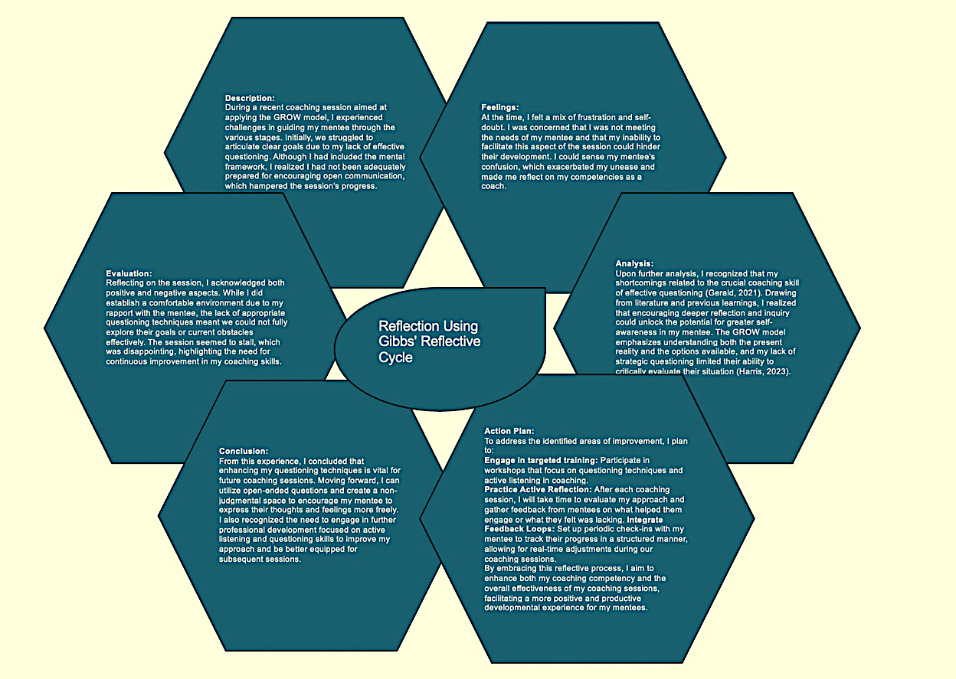

Honey and Mumford Learning Styles Questionnaire

The Honey and Mumford Learning Styles Questionnaire is a valuable tool used to identify individual learning preferences, which can inform coaching and mentoring approaches. This model categorises learners into four distinct styles: Activists, Reflectors, Theorists, and Pragmatists (Honey & Mumford, 1986). Understanding these learning styles enables coaches to tailor their methods to better suit the needs of their mentees.

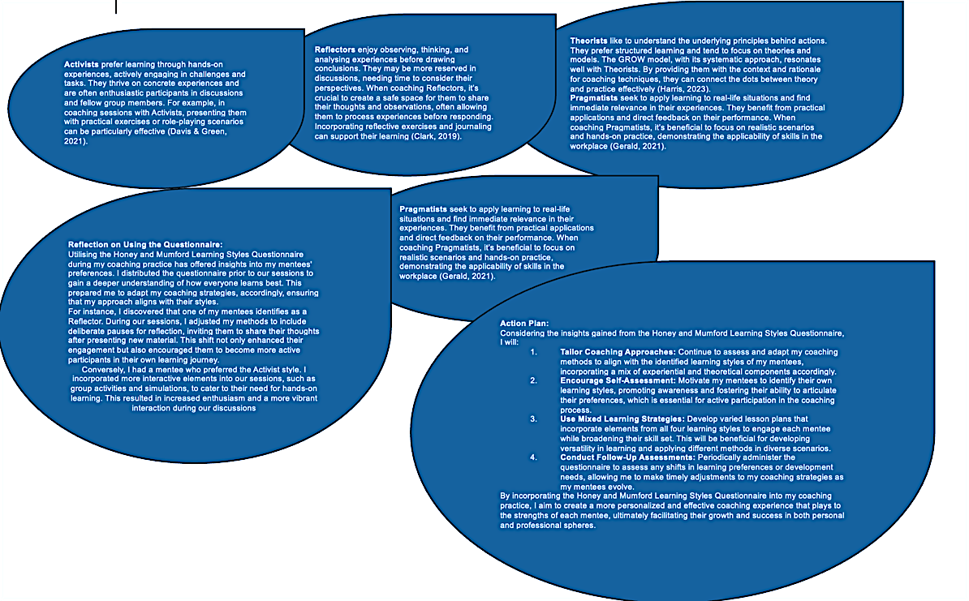

Conducting A Skills Audit for Improvement

A skills audit is an important initial step that should be undertaken to improve the effectiveness of coaching and mentoring in the workplace (Jackson, 2018). This structured process involves evaluating current skills to identify strengths and areas for improvement. Organisations can ensure that their coaching programs align with each participant's specific needs by conducting these assessments (Davis & Green, 2021).

Conducting a skills audit usually includes several fundamental steps, such as identifying core coaching skills, assessing current competency levels, and pinpointing skill gaps that need addressing. Coaches must evaluate their clients’ abilities in areas such as goal setting, active listening, and providing feedback (Martin, 2021). They should also consider emotional intelligence, adaptability, relationship-building skills, conflict resolution techniques, accountability support, and motivational strategies.

Through employing self-assessment tools or peer reviews, organizations can compare current skill levels against these competencies, ultimately enabling them to develop targeted training programs to close the identified gaps (Gerald, 2021). This may involve participation in workshops focusing on specific skills or one-on-one sessions with experienced coaches to enhance areas requiring improvement (Harris, 2023).

Regularly conducting skills audits benefits coaches personally and contributes to an enhanced coaching culture across the organisation Establishing standards for progress and facilitating constructive feedback cycles support ongoing professional growth (Roberts, 2022).

A well-executed skills audit lays the foundation for enhancing coaching practices throughout an organisation. By methodically identifying key coaching strengths and weaknesses, organizations can create environments conducive to growth, ultimately leading to better performance at both individual and team levels. Examples below.

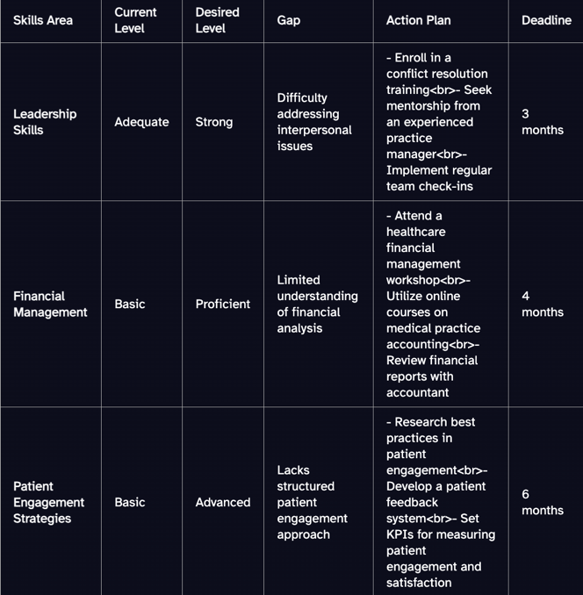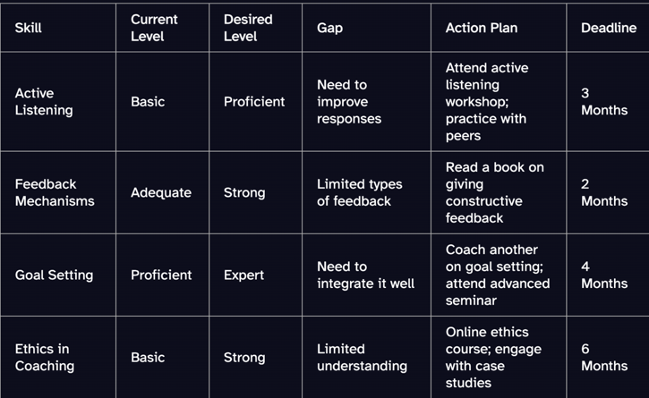

SWOT Analysis of Coaching Practices

SWOT analysis is a valuable tool for enhancing client-coach development within coaching practices. This model allowed me as a coach to tailor methods to suit individuals and teams by assessing internal strengths and weaknesses as well as external opportunities and threats.

Coach strengths may include strong communication skills, empathy, or specialised domain knowledge (Martin, 2021). These strengths facilitate trust building and promote open communication during coaching sessions. By acknowledging weaknesses, such as limited experience with specific demographics or technical skills, I can identify opportunities for collaboration or professional development (Adams & Baker, 2020).

Coaching provided me with various opportunities, including digital coaching platforms and skill-enhancement workshops. I must remain attentive to industry developments that could positively impact practice and yield benefits for clients. Conversely, threats may arise from increased competition in the coaching sector and changing organisational priorities that affect client interactions.

I can utilise SWOT analysis to create strategic plans aimed at improving performance and achieving client goals. Engaging in reflection promotes adaptability in response to evolving environments and enhances overall effectiveness (Taylor & Wilson, 2022). Implementing SWOT analysis during coaching sessions enabled me to understand personal development pathways and market dynamics, fostering successful mentoring relationships for both individuals and organisations (Harris, 2023).

Recognising personal weaknesses is key to setting the stage for personal growth. I can identify areas where improvement is needed, such as time management or emotional intelligence, and develop targeted professional growth programs (Martin, 2021). By addressing these aspects, I will not only improve my own performance but also reinforce support for the mentee’s development.

Risk management in effective coaching necessitates identifying potential threats. Internal employee resistance to change or economic downturns that affect training budgets can pose challenges. Organisations can mitigate coaching risks by proactively recognising these threats and devising contingency plans.

Reflective Models in Coaching Sessions

Applying reflective models in coaching sessions is crucial, as they provide structured frameworks that facilitate thoughtful consideration of experiences and lessons for future practice. One well-known model, Gibbs' Reflective Cycle, incorporates six distinct steps: description, feelings, evaluation, analysis, conclusion, and action plan. By employing this model during coaching sessions, both coaches and mentees can systematically analyse their interactions to identify points for enhancement.

Kolb’s Experiential Learning Cycle is another valuable framework that emphasises the significance of experience as the basis for learning. This model comprises four developmental stages: concrete experience, reflective observation, abstract conceptualisation, and active experimentation (Gerald, 2021). Coaches should immerse themselves in their experiences while honing critical thinking skills to evaluate how these experiences will shape their future actions. The cyclical nature of this process supports ongoing educational development while facilitating personalised adaptive strategies (Martin, 2021).

Another reflective model proposed by Rolfe et al. is a more succinct approach, focusing on three core questions: What? So what? Now what? (Jackson, 2018). In this model, participants are first asked to describe what happened in the coaching session (What?), then to contemplate the implications (So what?), before determining the next steps to take (Now what?) (Adams & Baker, 2020). Utilising targeted questions aids individuals in making sense of their thoughts while promoting accountability.

Incorporating reflective models in coaching sessions creates an environment conducive to both growth and development (Illeris, 2011). Program participants are encouraged to become more self-aware while refining their capacity for critical reflection on their own practices. By consistently integrating established frameworks, such as Gibbs' or Kolb's models, into coaching methodologies, coaches can enhance their own performance while empowering mentees to take control of their educational journeys. Thus, it becomes evident that reflective practice is an integral component of the ongoing progression of coaches' client interactions.

Conclusion

The study of coaching and mentoring practices in business settings demonstrates their vital importance in fostering employee growth and organisational success. Coaching represents a goal-oriented approach that facilitates rapid performance improvement, while mentoring nurtures long-term career advancement through ongoing guidance and support (Gerald, 2021). Essential coaching skills, including active listening, effective questioning, providing feedback, building relationships, setting goals, fostering accountability, maintaining flexibility, showing empathy, and effective communication, play critical roles in enhancing coaching effectiveness (Harris, 2023).

Implementing a skills audit enables individuals to identify areas for improvement and ensure that their growth trajectories align with the organisation's objectives.

The GROW model serves as a comprehensive framework that streamlines coaching conversations by guiding participants through the processes of goal setting, reality evaluation, options exploration, and will determination. This model optimizes efficacy and empowers individuals to take ownership of their development. Furthermore, employing SWOT analysis reveals organizational strengths, like effective coaching, while also identifying areas for improvement (Martin, 2021).

By employing reflective models, such as Gibbs' or Kolb's, to inform practice, coaches can gain better insights into the applicability of theoretical knowledge in tangible scenarios (Davis & Green, 2021). The potential for learning and enhancement within coaching and mentoring contexts is substantial, particularly when reflective practices are frequent and meaningful. This implementation of insights into daily workflows is a powerful strategy for raising individual performance levels and fostering a culture committed to continuous improvement. Organizations prioritising coaching and mentoring strategies can cultivate a workforce that is adept at addressing current challenges while preparing for future opportunities (Harris, 2023).

References

Adams, J. & Baker, T., 2020. Coaching for Performance: Strategies and Skills. Journal of Business Coaching, 6(2), pp. 112-129.

Bachkirova, T. (2011). Developmental Coaching: Working with the Self. London: Open University Press.

Clark, R., 2019. The Role of Self-awareness in Coaching. international Journal of Coaching Science, 5(1), pp. 23-34.

Davis, P. & Green, S., 2021. Understanding SWOT Analysis in Coaching. Coaching Psychology Review, 14(3), pp. 56-70.

Garcia, T., 2023. Reflective Models in Coaching Practices. Journal of Reflective Learning, 18(1), pp. 45-60.

Gerald, A., 2021. Coaching Methods in Professional Development. Business Management Journal, 15(4), pp. 99-115.

Harris, L., 2023. Essential Skills for Effective Coaching. Journal of Coaching and Mentoring 9(4), pp. 33-47.

Hawkins, P. & Smith, N. (2013). Coaching, Mentoring and Organisational Consultancy: Supervision and Development. 2nd ed. Maidenhead: McGraw-Hill Education.

Hawkins, P. (2018). "Leadership team coaching in practice: Case studies on developing high-performing teams." (“Leadership Team Coaching in Practice: Case Studies on D…”) New York: Kogan Page Ltd.

Illeris, K. (2011). (“The Fundamentals of Workplace Learning: Understanding How People Learn ...”) (“The Fundamentals of Workplace Learning: Understanding How People Learn ...”) New York: Routledge.

Jackson, M., 2018. Conducting Skills Audits in Organizations. Business Improvement Quarterly, 12(2), pp. 78-87.

Martin, A., 2021. The Impact of Coaching on Employee Development. Organizational Development Review, 7(5), pp. 102-115.

Passmore, J. & Fillery-Travis, A. (2011). A Critical Review of Executive Coaching Research: A Decade of Progress and What's to Come. (PDF) A critical review of executive coaching research: A decade of ...”) International Coaching Psychology Review, 6(1), pp. 1-12.

Roberts, J., 2022. Mentoring for Professional Growth: Benefits and Challenges. Journal of Career Development, 15(2), pp. 88-98.

Seidel, A. & Pugh, S. (2015). Mentoring and Coaching in Higher Education: Resources for Effective Learning Relationships. London: SAGE Publications.

Taylor, S. & Wilson, E., 2022. The Importance of Reflective Practices in Coaching. Coaching Research, 13(1), pp. 99-110.

White, L., 2020. The GROW Model in Coaching Practice. International Coaching Review, 8(4), pp. 65-73.

Whitmore, J. (2010). Coaching for Performance: GROWing Human Potential and Purpose. 4th ed. London: Nicholas Brealey Publishing.

Williams, K., 2021. Building Effective Coaching Relationships. Journal of Executive Coaching, 4(3), pp. 15-27.

