Extreme Temperature Conditioning and Chamber Pressure of Small Arms Ammunition (SAA)
final project Research proposal
Luke Malcolm (S/N 2030773)
BEng. Ordnance, munitions, and explosives engineering
University of wales, trinity saint david
proposed supervisor: tbc
2025
Contents
Table of Figures 2
Table of Tables 2
1. Introduction 3
2. Background 4
3. Aims & Objectives 6
4. Experimental Design 7
4.1 Experimental Procedure 7
4.2 Data Collection 7
4.3 Data Evaluation 7
4.4 Risks & Limitations 7
4.5 Ethics 8
5. Resources 9
5.1 Physical Resources 9
5.2 Human Resources 9
5.3 Other Resources 9
6. Planning 10
6.1Gantt Chart 10
References 11
Annexe A – Ethics Form 12

Table of Figures
Figure 1 – Pressure-time curve for propellant at 21°C 4
Figure 2 – Pressure-time curve for propellant at 71°C, showing an a 25% increase in chamber pressure (unaged) compared to figure 1 5
Figure 3 – Pressure-temperature curve, showing a 22% increase between +21°C & +71°C 5
Figure 4 - Project Gantt Chart 10

Table of Tables
Table 1 - Example Firing Plan 7

1. Introduction
All firearms in the UK must be proved before they can be sold or transferred, in a process dating back to 1637. This process involves firing two over-charged cartridges, designed to produce a minimum of 25% overpressure (“proof loads”). If the firearm is not damaged, a special proof mark is applied denoting that the test was passed. Presently, loads are developed, tested, and produced in a time-consuming and expensive process. This is done by changing the type of propellant, increasing the amount of propellant, increasing the bullet weight, or a combination thereof. Proof is governed by statutory instruments – principally, the 1868 Proof Act. The Permanent International Commission for the Proof of Small Arms (CIP) set out the Rules of Proof. These rules form schedules of the statutory acts.
It is known that heating ammunition results in higher pressure. Burning is a chemical process, therefore is affected by temperature (rate laws) [1]. Powder manufacturers attempt to “engineer out” this phenomenon, but the laws of thermochemistry cannot be defied.
The Proof House expends considerable money and effort each year producing cartridges required to prove tens of thousands of guns. The aim of this project is to see if these outlays can be reduced, and if a “rule of thumb” can be produced allowing the proof of cartridges for which no standard exists.

2. Background
There is very little research concerning chamber pressure at extreme temperature – both a literature review and discussion with a local SME revealed that no work on chamber pressure has been conducted in temperature regimes above 71°C, with virtually all high-temperature work concentrating on either cook-off or stabiliser depletion [2] [3] [4]. A common open-source internal ballistics modelling tool is unable to calculate pressures with propellants above 60°C. ^{author’s copy}. This is unsurprising, as few organisations have access to pressure barrels.
Boulkadid, et al. fired 5.56mm cartridges containing spherical double-base powder across a temperature range of -54°C to +71°C (also looking at aged vs. unaged propellant). Their findings concerning pressure are shown in Figure 1, Figure 2, and Figure 3 [5]. They also establish a basic temperature-pressure relationship of 1.234MPa/°C. There is a 104MPa difference between the P_{max} and Proof Pressure of a 308 Winchester round [6], this figure gives a helpful starting point (and suggests that a temperature increase of approx. 84°C would result in this overpressure), but it is important to note that the relationship between temperature and pressure is not a linear one (Figure 3) so cannot be taken entirely at face value - nonetheless it does indicate that the desired 25% overpressure level should be achievable by conditioning alone, within acceptable temperature ranges.
It should be noted that the above paper does not mention bullet weight, whereas CIP does specify a minimum proof energy – care must be taken when selecting ammunition to ensure that even at 25% overpressure, muzzle energy is sufficient.
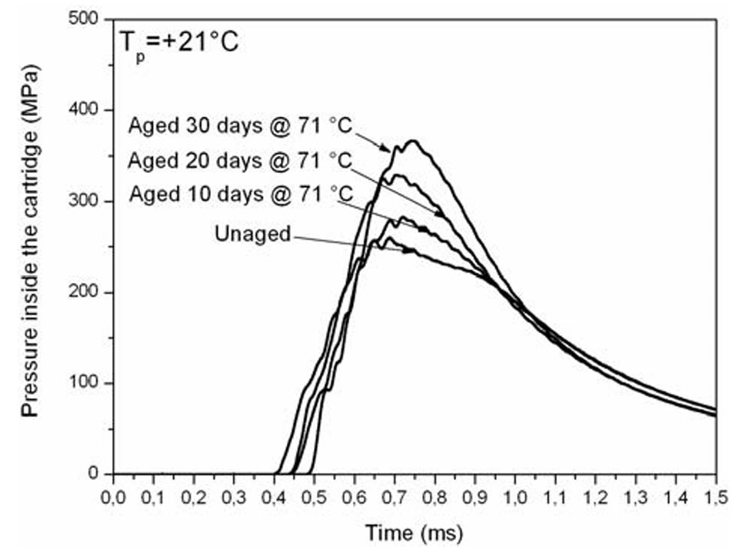
Figure 1 – Pressure-time curve for propellant at 21°C

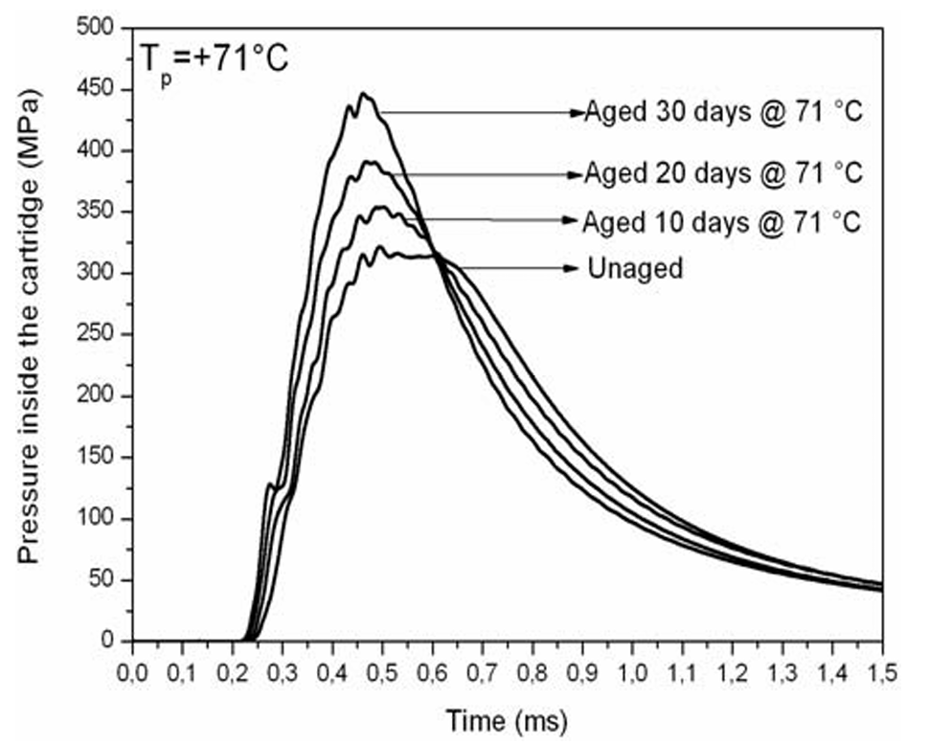
Figure 2 – Pressure-time curve for propellant at 71°C, showing an a 25% increase in chamber pressure (unaged) compared to figure 1
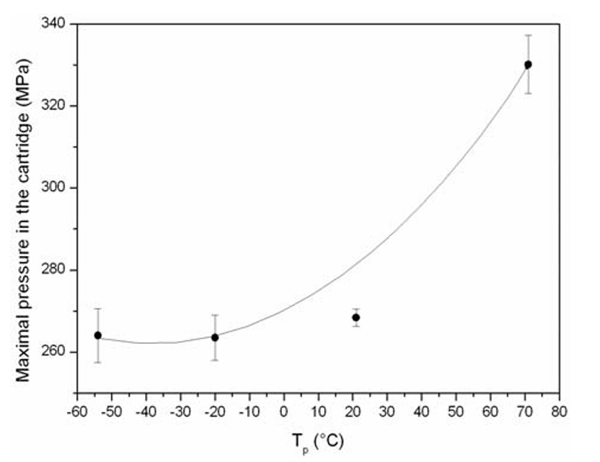
Figure 3 – Pressure-temperature curve, showing a 22% increase between +21°C & +71°C

3. Aims & Objectives
The aim of this project is twofold:
- Investigating if factory ammunition can be used as a proof load, if conditioned at high temperature
  - Resulting in time and cost savings for the Proof House
  - Even if a rule of thumb cannot be established, knowing what the relationship is for certain cartridges required in volume will provide savings

- Investigating if a general temperature versus pressure “rule of thumb” can be established for SAA, aiding with proofing exotic or one-off chamberings which have not been standardised by CIP
  - Proving these cartridges is currently difficult, and not science-based
  - Having pressure barrels, or even cartridge cases created for some of these cartridges is difficult, so a straightforward means of proof is valuable.
Following the completion of the experimental phase, a single report will be produced, and recommendation made as to if a general “rule of thumb” is viable. If it is not, recommendations will be made as to each individual cartridge tested as to the temperature increase required to generate 25% overpressure.

4. Experimental Design

4.1 Experimental Procedure
Ammunition will be conditioned in accordance with AEP-97 (12.6.1) [7], then removed from the oven, loaded, and fired.

4.2 Data Collection
Peak pressure measurements will be captured using the conformal Kistler 6215 pressure transducer – this transducer is required by CIP. Equipment held by the Proof House will give an instant peak pressure reading. Data will be analysed using MS Excel.
Table 1 - Example Firing Plan
Cal.  Temp. | 223 Rem | 308 Win | 300 Win Mag | 9mm Para
+21°C | 20 | 20 | 20 | 20
+52°C | 20 | 20 | 20 | 20
+60°C | 20 | 20 | 20 | 20
+71°C | 20 | 20 | 20 | 20
+80°C | 20 | 20 | 20 | 20
+90°C | 20 | 20 | 20 | 20
+100°C | 20 | 20 | 20 | 20
+110°C | 20 | 20 | 20 | 20
+120°C | 20 | 20 | 20 | 20
TOTAL RDS | 180 | 180 | 180 | 180

4.3 Data Evaluation
Data will be collected for several chamberings (ideally small-calibre, intermediate, and magnum rifle, along with a pistol calibre) and overlaid on a pressure-temperature graph to see if a straightforward relationship can be observed and general rule of thumb produced. Preferably, both rounds with both single-based and double-based propellants will be used - the latter being significantly more temperature sensitive. Distinction will be made in the results.

4.4 Risks & Limitations
There are three principal risks to consider:
- Manual handling & loading of hot ammunition
  - This is straightforward to mitigate with the appropriate heat-proof PPE
- Ignition of hot ammunition outside of the breech
  - Temperature of Ignition of the propellant and the primer compound must be known, so as not to condition rounds either close to or over these temperatures (nitrocellulose based propellants typically ignite at 160-170°C) [2] [4] [3]
- Propellant stabiliser depletion
  - Extremely high temperature will cause rapid depletion of propellant stabiliser. Rounds subject to conditioning must be disposed of immediately and not placed back into stores.
  - A conditioning “time limit” will be devised using AOP-48
All above points will be considered in-depth and documented as part of the risk assessment process.

4.5 Ethics
A completed ethics form is given in Annexe A – Ethics Form

5. Resources

5.1 Physical Resources
Principal physical resources required are:
- Pressure barrel(s) & ancillaries
- Firing facilities
- Kistler 6125 transducers & ancillaries
- Conditioning oven
- Ammunition

5.2 Human Resources
Human resources required are:
- Researcher (author)
- Proof Master
- Proof House Staff

5.3 Other Resources
No other resource requirements have been identified.

6. Planning

6.1Gantt Chart
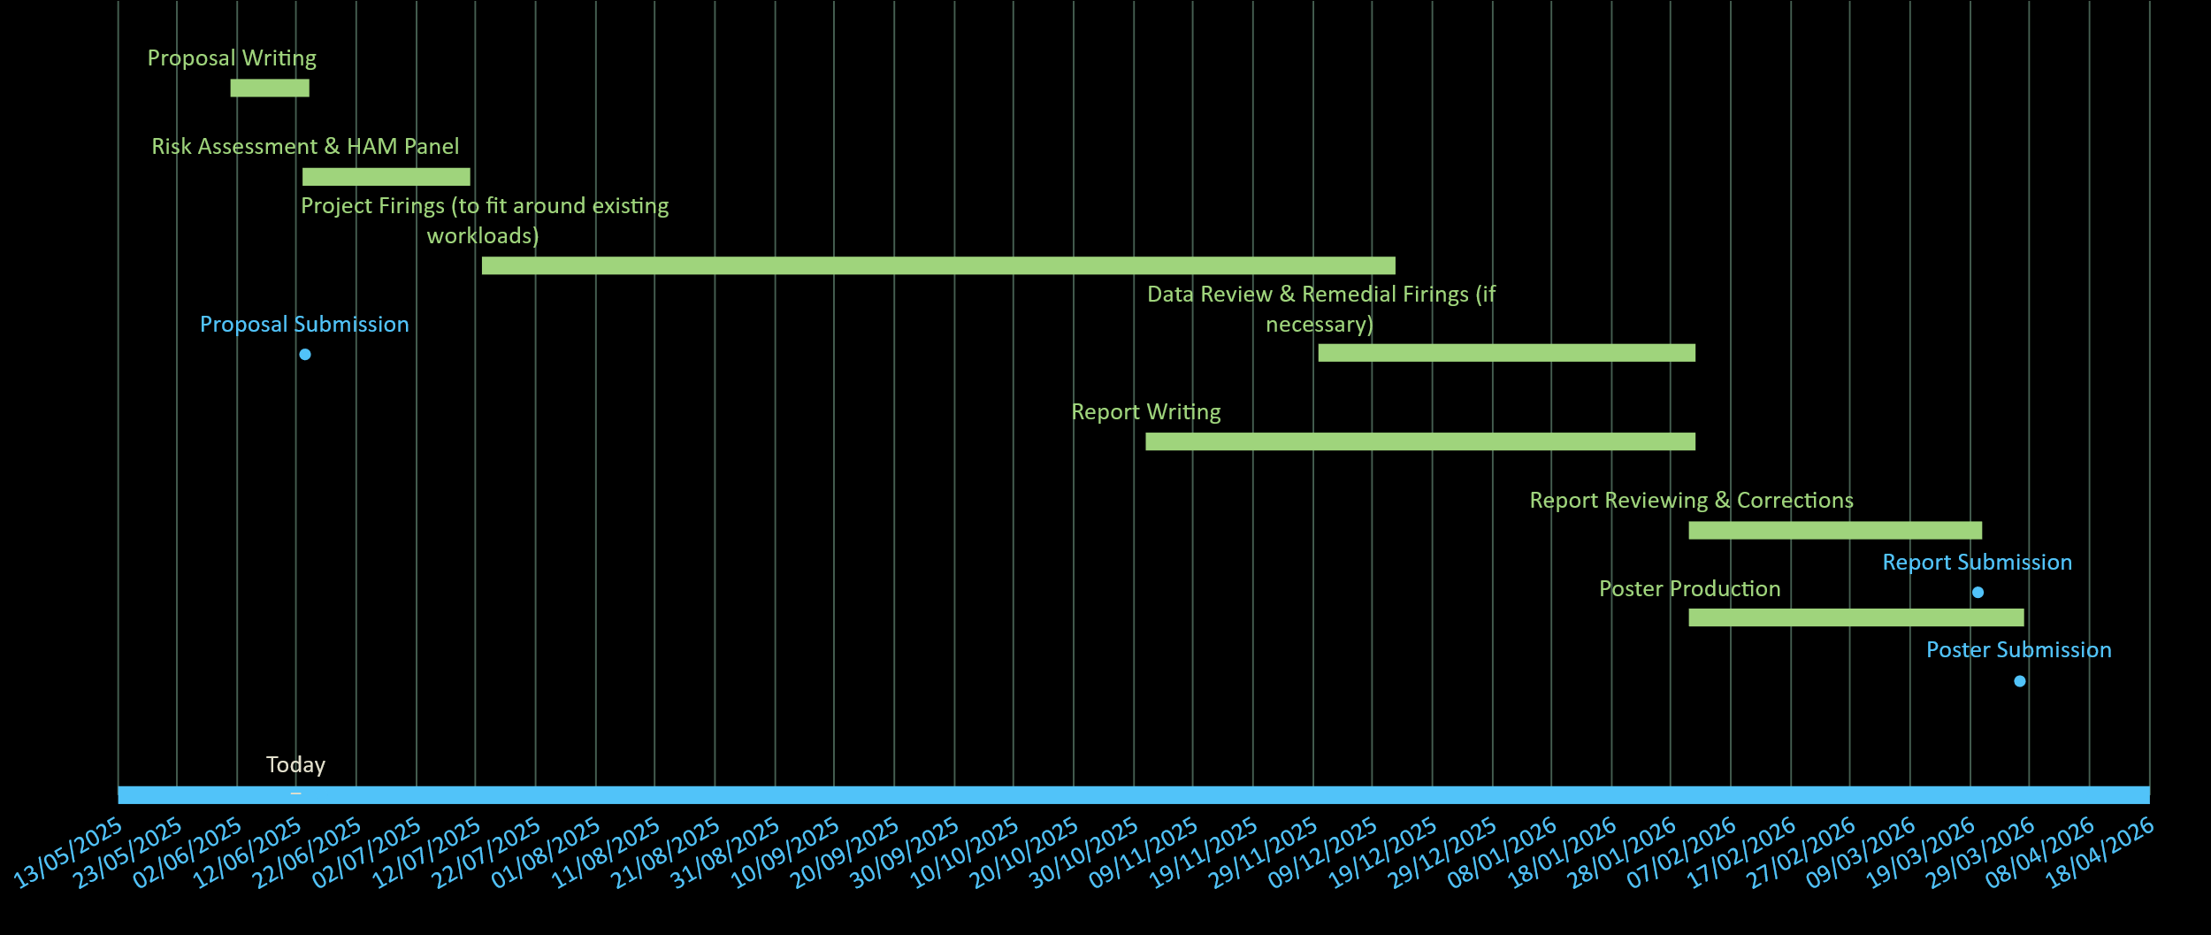
Figure 4 - Project Gantt Chart

References

[1] | J. Akhavan, The Chemistry of Explosives - 2nd Edition, Royal Society of Chemistry, 2004.
[2] | A. Hameed, M. Azavedo and P. Pitcher, “Experimental investigation of a cook-off temperature in a hot barrel,” Defence Technology, vol. 10, no. 2, pp. 86-91, 2014.
[3] | P. Loudová, J. Schejbal, J. Štěpán and O. Večerek, “STUDY OF NITROCELLULOSE SELF-IGNITION TEMPERATURE,” Synthesia AS, 2018.
[4] | P. Pitcher, “Assessment of Self Ignition Temperature (Cook-Off) in Gun Barrels,” Cranfield University, 2012.
[5] | K. M. Boulkadid, M. Lefebvre, L. Jeuniea and A. Dejeaifve, “Influence of Firing Temperature on Properties of Gun Propellants,” Journal of Chemistry and Chemical Engineering , no. 9, pp. 415-247, 2015.
[6] | COMMISSION INTERNATIONALE PERMANENTE POUR L'EPREUVE DES ARMES A FEU PORTATIVES, “308 Win,” 1984.
[7] | NORTH ATLANTIC TREATY ORGANIZATION, “ALLIED ENGINEERING PUBLICATION 97: MULTI-CALIBRE MANUAL OF PROOF AND INSPECTION (M-CMOPI) FOR NATO SMALL ARMS AMMUNITION,” NATO STANDARDIZATION OFFICE , 2020.

Annexe A – Ethics Form
APPLICATION FOR ETHICAL APPROVAL

In order for research to result in benefit and minimise risk of harm, it must be conducted ethically.

The University follows the OECD Frascati manual definition of research activity: “creative work undertaken on a systematic basis in order to increase the stock of knowledge, including knowledge of man, culture and society, and the use of this stock of knowledge to devise new applications”. As such this covers activities undertaken by members of staff, postgraduate research students, and both taught postgraduate and undergraduate students working on dissertations/projects.

The individual undertaking the research activity is known as the “principal researcher”.

This form must be completed and approved prior to undertaking any research activity.

SECTION A: About You (Principal Researcher)
1 | Full Name: | Luke Malcolm
2 | Student Number: | 2030773
3 | Email address: | 2030773@student.uwtsd.ac.uk
4 | Programme of Study: | L6 Ordnance, Munitions, and Explosives
5 | Director of Studies/Supervisor:

SECTION B: Internal and External Ethical Guidance Materials
 | Please list the core ethical guidance documents that have been referred to during the completion of this form (including any discipline-specific codes of research ethics, location-specific codes of research ethics, and also any specific ethical guidance relating to the proposed methodology). Please tick to confirm that your research proposal adheres to these codes and guidelines. You may add rows to this table if needed.
1 | UWTSD Research Ethics & Integrity Code of Practice | ☒
2 | UWTSD Research Data Management Policy | ☒
3 |  | ☐

SECTION C: Details of Research Activity
1 | Indicative title: | Extreme Temperature Conditioning and Chamber Pressure of Small Arms Ammunition (SAA)
2 | Proposed start date: | July 2025 | Proposed end date: | April 2026
Introduction to the Research (maximum 300 words in each section)
Ensure that you write for a Non-Specialist Audience when outlining your response to the three points below:
- Purpose of Research Activity
- Proposed Research Question
- Aims of Research Activity
- Objectives of Research Activity
Demonstrate, briefly, how Existing Research has informed the proposed activity and explain
- What the research activity will add to the body of knowledge
- How it addresses an area of importance.
3 | Purpose of Research Activity  All firearms in the UK must be “proved” before they can be sold or transferred, in a process dating back to 1855. This process involves firing two dangerously over-charged cartridges, designed to produce a minimum of 25% overpressure (“proof loads”). If the firearm is not damaged, a special proof mark is applied denoting that the test has been passed. Presently, loads are specially developed, tested, and produced in a time-consuming and expensive process. This is typically done by changing the type of powder filling the cartridge, increasing the amount of propellant, increasing the bullet weight, or a combination of the three. The Proof process is governed both by statutory instruments – principally the Proof Act of 1868. The Permanent International Commission for the Proof of Small Arms (CIP) set out the Rules of Proof. The CIP rules form schedules of the statutory acts.  (this box should expand as you type)
4 | Research Question  Can temperature conditioning alone be used as a means of turning a standard factory-produced round of ammunition into a proof load?  (this box should expand as you type)
5 | Aims of Research Activity  To reduce the cost and time associated with the production of proof ammunition, and to give the Proof House a method of proofing exotic or “one-off” cartridges, for which pressure barrels do not exist and for which even getting hold of cartridge cases is difficult  (this box should expand as you type)
6 | Objectives of Research Activity  Following the completion of the experimental phase, a single report will be produced, and recommendation made as to if a general “rule of thumb” is viable. If it is not, recommendations will be made as to each individual cartridge tested as to the temperature increase required to generate 25% overpressure.  (this box should expand as you type)
Proposed data collection methods (maximum 600 words)
Provide a brief summary of all the methods that may be used in the research activity to collect data, making it clear what specific techniques may be used. If methods other than those listed in this section are deemed appropriate later, additional ethical approval for those methods will be needed. You do not need to justify the methods here, but should instead describe how you intend to collect the data necessary for you to complete your project.
7 | Cartridges will be heated in a conditioning chamber, loaded into a special barrel (drilled and tapped to accept a pressure transducer) and the cartridge then fired remotely.  The pressure reading will be recorded.  This will be repeated a number of times across a number of different temperatures. It is this straightforward – nothing more, nothing less.  (this box should expand as you type)

SECTION D: Scope of Research Activity
 | Will the research activity include: | YES | NO
1 | Use of a questionnaire or similar research instrument? | ☐ | ☒
2 | Use of interviews? | ☐ | ☒
3 | Use of focus groups? | ☐ | ☒
4 | Use of participant diaries? | ☐ | ☒
5 | Use of video or audio recording? | ☐ | ☒
6 | Use of computer-generated log files? | ☐ | ☒
7 | Participant observation with their knowledge? | ☒ | ☐
8 | Participant observation without their knowledge? | ☐ | ☒
9 | Access to personal or confidential information without the participants’ specific consent? | ☐ | ☒
10 | Administration of any questions, test stimuli, presentation that may be experienced as physically, mentally or emotionally harmful / offensive? | ☐ | ☒
11 | Performance of any acts which may cause embarrassment or affect self-esteem? | ☐ | ☒
12 | Investigation of participants involved in illegal activities? | ☐ | ☒
13 | Use of procedures that involve deception? | ☐ | ☒
14 | Administration of any substance, agent or placebo? | ☐ | ☒
15 | Working with live vertebrate animals? | ☐ | ☒
16 | Procedures that may have a negative impact on the environment? | ☒ | ☐
17 | Other primary data collection methods. Please indicate the type of data collection method(s) below. | ☒ | ☐
 | Details of any other primary data collection method:  Data will be collected using Kistler 6215 pressure gauges and analysed using MS Excel  (this box should expand as you type) | ☒ | ☐

If you have ticked NO to every question then the research activity is (ethically) low risk and you may skip section E and continue to section F.

If YES to any question, then no research activity should be undertaken until full ethical approval has been obtained.

SECTION E: Intended Participants
 | Who are the intended participants: | YES | NO
1 | Students or staff at the University? | ☐ | ☒
2 | Adults (over the age of 18 and competent to give consent)? | ☐ | ☒
3 | Vulnerable adults? | ☐ | ☒
4 | Children and Young People under the age of 18? (Consent from Parent, Carer or Guardian will be required) | ☐ | ☒
5 | Prisoners? | ☐ | ☒
6 | Young offenders? | ☐ | ☒
7 | Those who could be considered to have a particularly dependent relationship with the investigator or a gatekeeper? | ☐ | ☒
8 | People engaged in illegal activities? | ☐ | ☒
9 | Others. Please indicate the participants below, and specifically any group who may be unable to give consent. | ☐ | ☒
 | Details of any other participant groups:  N/A  (this box should expand as you type) | ☐ | ☒

Participant numbers and source
Provide an estimate of the expected number of participants. How will you identify participants and how will they be recruited?
10 | How many participants are expected? | 3-4 (note – these are people who will be present for the research activity, they are not subject to any questionnaires, surveys, etc etc)
11 | Who will the participants be? | Researcher, Proof Master, Proof House Staff Member(s)  (this box should expand as you type)
12 | How will you identify the participants? | Participants have already had input to the research proposal.  (this box should expand as you type)

 | Information for participants: | YES | NO | N/A
13 | Will you describe the main research procedures to participants in advance, so that they are informed about what to expect? | ☒ | ☐ | ☐
14 | Will you tell participants that their participation is voluntary? | ☒ | ☐ | ☐
15 | Will you obtain written consent for participation? | ☐ | ☐ | ☒
16 | Will you explain to participants that refusal to participate in the research will not affect their treatment or education (if relevant)? | ☐ | ☐ | ☒
17 | If the research is observational, will you ask participants for their consent to being observed? | ☐ | ☐ | ☒
18 | Will you tell participants that they may withdraw from the research at any time and for any reason? | ☒ | ☐ | ☐
19 | With questionnaires, will you give participants the option of omitting questions they do not want to answer? | ☐ | ☐ | ☒
20 | Will you tell participants that their data will be treated with full confidentiality and that, if published, it will not be identifiable as theirs? | ☐ | ☐ | ☒
21 | Will you debrief participants at the end of their participation, in a way appropriate to the type of research undertaken? | ☒ | ☐ | ☐
22 | If NO to any of above questions, please give an explanation
 | No personal data will be collected and no questionnaires issued. Research is not observational. I do not believe written consent is required, as all “participants” are part of the research team or already involved in the proposal of the research.

 | Information for participants: | YES | NO | N/A
24 | Will participants be paid? | ☐ | ☒ | ☐
25 | Is specialist electrical or other equipment to be used with participants? | ☐ | ☒ | ☐
26 | Are there any financial or other interests to the investigator or University arising from this study? | ☐ | ☒ | ☐
27 | Will the research activity involve deliberately misleading participants in any way, or the partial or full concealment of the specific study aims? | ☐ | ☒ | ☐
28 | If YES to any question, please provide full details

SECTION F: Anticipated Risks

 | Outline any anticipated risks that may adversely affect any of the participants, the researchers and/or the University, and the steps that will be taken to address them.
1 | Risks to participants  For example: sector-specific health & safety, emotional distress, financial disclosure, physical harm, transfer of personal data, sensitive organisational information. If you have identified in section D that there are no participants then enter N/A and go skip to question 3.
 | Risk to participants:  - Burns due to manual handling of hot ammunition  - Physical harm by ignition of hot ammunition outside of the gun breech¹ by cook-off (temperature of ignition)  - Physical harm by ignition of hot ammunition outside of the gun breech¹ by autocatalytic reaction (stabiliser depletion)²  ¹Note to those unfamiliar with small arms ammunition – an ignition outside of a breech/barrel results in the cartridge case rupturing and the bullet flying off with only a tiny fraction of the energy it would normally have when leaving a gun system. This is due to the complete lack of confinement. Tests conducted by the Sporting Arms & Ammunition Manufacturer’s Institute (SAAMI) show that the standard protective clothing worn by firefighters is enough to prevent injury by fragments entirely, thus it can be drawn that while fragments may have sufficient energy to cause a wound against bare skin, they will not cause severe injury.  The researcher has eight years of experience working with energetic materials and ammunition at QinetiQ, and 12 years of experience routinely handling small arms & ammunition.  ²all propellant contains a chemical stabiliser with the role of absorbing nitrogen oxides that are produced over time, thus suppressing any autocatalytic decomposition. The stabilisers are slowly depleted over time – usually 10+ years in good storage, but they deplete faster at higher temperatures. By ensuring that conditioned ammunition is used immediately (but is also a comfortable temperature away from its automatic ignition temperature) the risk of this is reduced. | How you will mitigate the risk to participants:  - Wearing of the appropriate heat-proof PPE  - Ensuring that the temperature of ignition of constituent energetic parts is known, and by staying a comfortable distance away from it from a temperature standpoint (nitrocellulose-based gun propellant T temperature of ignition 160-170C, proposing to “stop” at 120C), wearing of an appropriate face shield while handling ammunition  - Ensuring that conditioned rounds are disposed of immediately (by firing) and not placed back into storage, wearing of an appropriate face shield while handling ammunition
2 | If research activity may include sensitive, embarrassing or upsetting topics (e.g. sexual activity, drug use) or issues likely to disclose information requiring further action (e.g. criminal activity), give details of the procedures to deal with these issues, including any support/advice (e.g. helpline numbers) to be offered to participants. Note that where applicable, consent procedures should make it clear that if something potentially or actually illegal is discovered in the course of a project, it may need to be disclosed to the proper authorities
 | N/A – none of the above involved.
3 | Risks to the investigator  For example: personal health & safety, physical harm, emotional distress, risk of accusation of harm/impropriety, conflict of interest
 | Risk to the investigator:  Per section F1 | How you will mitigate the risk to the investigator:  Per section F1
4 | University/institutional risks  For example: adverse publicity, financial loss, data protection
 | Risk to the University:  - Adverse publicity due to student injury  - Financial loss due to student injury | How you will mitigate the risk to the University:  1 & 2: Student (researcher) will follow precautions in section F1
5 | Environmental risks  For example: accidental spillage of pollutants, damage to local ecosystems
 | Risk to the environment:  - Lead contamination from the firing of small arms ammunition | How you will mitigate the risk to environment:  - The Proof House uses special water-filled snail traps to capture the fired bullets and particulate matter. These are then separated and recycled. No handling of exposed lead (or any other hazardous material) will be required by this project.

SECTION G: Feedback, Consent and Confidentiality

If you have identified in section D that there are no participants then enter skip this section and continue to section H.

1 | Feedback  What de-briefing and feedback will be provided to participants, how will this be done and when?
The final report will be distributed once it has been completed – to my employer and to the London Proof House.

(this box should expand as you type)
2 | Informed consent  Describe the arrangements to inform potential participants, before providing consent, of what is involved in participating. Describe the arrangements for participants to provide full consent before data collection begins. If gaining consent in this way is inappropriate, explain how consent will be obtained and recorded in accordance with prevailing data protection legislation.
N/A – no questionnaire being produced, people involved in the research are already involved in the proposal.

(this box should expand as you type)
3 | Confidentiality / Anonymity  Set out how anonymity of participants and confidentiality will be ensured in any outputs. If anonymity is not being offered, explain why this is the case.
The naming of any organisations will only be done with their explicit permission. Names will not be mentioned without explicit permission.

(this box should expand as you type)

SECTION H: Data Protection and Storage

 | Does the research activity involve personal data (as defined by the General Data Protection Regulation 2016 “GDPR” and the Data Protection Act 2018 “DPA”)? | YES | NO
1 | “Personal data” means any information relating to an identified or identifiable natural person (‘data subject’). An identifiable natural person is one who can be identified, directly or indirectly, in particular by reference to an identifier such as a name, an identification number, location data, an online identifier or to one or more factors specific to the physical, physiological, genetic, mental, economic, cultural or social identity of that natural person. Any video or audio recordings of participants is considered to be personal data. | ☐ | ☒
 | If YES, provide a description of the data and explain why this data needs to be collected:
2 | N/A
 | Does it involve special category data (as defined by the GDPR)? | YES | NO
3 | “Special category data” means sensitive personal data consisting of information as to the data subjects’ –  (a) racial or ethnic origin,  (b) political opinions,  (c ) religious beliefs or other beliefs of a similar nature,  (d) membership of a trade union (within the meaning of the Trade Union and Labour Relations (Consolidation) Act 1992),  (e) physical or mental health or condition,  (f) sexual life,  (g) genetics,  (h) biometric data (as used for ID purposes), | ☐ | ☒
 | If YES, provide a description of the special category data and explain why this data needs to be collected:
4 | N/A

 | Will data from the research activity (collected data, drafts of the thesis, or materials for publication) be stored in any of the following ways? | YES | NO
5 | Manual files (i.e. in paper form)? | ☒ | ☐
6 | University computers? | ☐ | ☒
7 | Private company computers? | ☒ | ☐
8 | Home or other personal computers? | ☒ | ☐
9 | Laptop computers/ CDs/ Portable disk-drives/ memory sticks? | ☐ | ☒
10 | “Cloud” storage or websites? | ☒ | ☐
11 | Other – specify: | ☐ | ☐
12 | For all stored data, explain the measures in place to ensure the security of the data collected, data confidentiality, including details of backup procedures, password protection, encryption, anonymisation and pseudonymisation:
All data will be kept in password protected cloud storage on the University Office 365 system which
will not be shared. Audio/visual data will be transcribed and would be shown to participants to
check accuracy of reporting. Any USB sticks used to store or transfer data will be password protected. All participants will be given a unique identifier to ensure confidentiality and this list will be kept securely in the password protected folder.

(this box should expand as you type)

 | Data Protection
 | Will the research activity involve any of the following activities: | YES | NO
13 | Electronic transfer of data in any form? | ☒ | ☐
14 | Sharing of data with others at the University outside of the immediate research team? | ☐ | ☒
15 | Sharing of data with other organisations? | ☒ | ☐
16 | Export of data outside the UK or importing of data from outside the UK? | ☐ | ☒
17 | Use of personal addresses, postcodes, faxes, emails or telephone numbers? | ☐ | ☒
18 | Publication of data that might allow identification of individuals? | ☐ | ☒
19 | If YES to any question, please provide full details, explaining how this will be conducted in accordance with the GDPR and Data Protection Act (2018) (and/or any international equivalent):
No personal information is being collected or stored. Data will be shared with my employer (QinetiQ Ltd) and the London Proof House – with whom the testing will be conducted.

(this box should expand as you type)
20 | List all who will have access to the data generated by the research activity:
Researcher, supervisor, workplace team & group leads, external examiner, second marker, endpoint assessment team

(this box should expand as you type)
21 | List who will have control of, and act as custodian(s) for, data generated by the research activity:
 | Principal researcher
22 | Give details of data storage arrangements, including security measures in place to protect the data, where data will be stored, how long for, and in what form.
All data will be encrypted and kept in password protected cloud storage on the University Office 365 system which will not be shared. Any USB sticks used to store or transfer data will be password protected, and will be reformatted at the end of the project in order to destroy the data. The data will be stored until the completion of the project and then deleted.

(this box should expand as you type)
22 | Confirm that you have read the UWTSD guidance on data management (see https://www.uwtsd.ac.uk/library/research-data-management/) | ☒
23 | Confirm that you are aware that you need to keep all data until after your research has completed or the end of your funding | ☒

SECTION I: Declaration
The information which I have provided is correct and complete to the best of my knowledge. I have attempted to identify any risks and issues related to the research activity and acknowledge my obligations and the rights of the participants.

In submitting this application I hereby confirm that I undertake to ensure that the above named research activity will meet the University’s Research Ethics and Integrity Code of Practice which is published on the website: https://www.uwtsd.ac.uk/research/research-ethics/
 | 1 | Signature of applicant: | L Malcolm | Date:
2 |  | Director of Studies/Supervisor: |  |  | Date:
3 |  | Signature: |  |  | Date:

FOR INTERNAL USE ONLY:
 | Ethical approval given
1 | Signature of assessor: |  | Date:
2 | Name:
3 | Role:

