Question:
Write a case study which critically analyses the inclusive intervention and support provided for a pupil in your setting. Refer to theory, policy and practice citing reputable and appropriate sources.
Focus: Does the use of internal inclusion rooms effectively support the behaviour management of pupils with behavioural issues within a mainstream secondary school setting?
Introduction
The mainstream secondary school is set within a rural area with a wide catchment of pupils from all backgrounds. ‘School A’ is a community comprehensive school, catering for 1432 pupils, 232 are on free school meals (FSM) and 552 pupils are on varying stages of the additional learning needs (ALN) register either placed within the school’s inclusion unit or mainstream ALN provision. 115 pupils are statemented or on an individual education plans (IDP) with the remaining 107 on the action plus stage, 327 on action stage of ALN. (‘School A’ Provision Map, 2018). School ‘A’ is a statutory education setting for pupils of all abilities between the ages of 11 to 18 rather than age 16 as the school has retained a sixth form of around 240 pupils.
Pupil ‘A’ is a 15-year-old boy that is experiencing behavioural issues; he is a chatty, keen skateboarder that is extremely popular with his peers. He has a very empathetic nature towards younger and less able pupils (pupils one-page profile as seen in appendix A). Pupil ‘A’ joined the school in September 2017 from a placement in a pupil referral unit (PRU) where he had spent all his secondary education due to previous behavioural issues in a primary setting. Pupil ‘A’ is also a looked after child (LAC), he was placed into care at the age of 9 due to parental drug and alcohol misuse. Contact with parents is limited to supervised fortnightly visits. Pupil a has a statement of educational need for his low academic ability, with an overall Global grade E (academic record as seen in appendix B) and behavioural difficulties (example risk assessment for challenging behaviour as seen in appendix C).
Within this case study the writer will explore the effectiveness of inclusion rooms as a method of behaviour management in a mainstream secondary school through research findings, Department of Education behaviour case study (2017), the Estyn Report (2006) and behavioural theorists Skinner (1938) and Bandura (1977).
School ‘A’ introduced an internal inclusion room in September 2018 as an intervention to support behaviour management within the school, with a view to reducing low level behavioural disruptions to teaching and learning and reducing the number of external exclusions being given.
An internal inclusion room is the practice of removing disruptive pupils to a designated room to exclude them from the lesson they are disrupting. It is a short-term provision that should allow the pupil to complete the work set in their lesson and reflect on the behaviour they have displayed. It should be supervised by a trained member of staff that is able to discuss the incident that led to the exclusion from the lesson. A register of the pupils placed in inclusion should be taken every lesson and those deemed to be regular users should then be placed on an appropriate behaviour intervention programme (DCSF, 2009).
Methodology
This is a qualitive, ethnographic case study of the use of inclusion rooms in a mainstream secondary school. For the purposes of this case study the child and setting has been anonymised and due to ethical considerations, all documentation in this case study has been anonymised and where too much information is held within these documents example documentation is used rather than originals. It will analyse the reasoning behind the use of these rooms through research and question their effectiveness in the management of the pupils experiencing behavioural difficulties. The researcher will gather information from the setting in which they work and gather the views of colleagues through informal conversations with in the setting regarding the use and effectiveness of the room to the pupil. Date will be gathered through the pupil’s attendance record and the record of attendance to the inclusion room with in a short period. It will analyse the effectiveness through the data collection and to show whether the frequency the pupil has been placed in the room changed and therefore adjustments were made to their behaviour.

Findings
During the research for this case study pupil ‘A’ was observed for a period of 4 weeks. During this time, he attended the inclusion room on 6 different occasions. Each occasion totalled 5 lessons a day. Each of these sessions’ pupil ‘A’ refused to take part in any of the work set and on 3 separate occasion walked out after having verbally abusing the teaching member of staff. On these occasions’ pupil ‘A’ was given a further punishment of an external exclusion, making the loss of education nine complete days. Some of the examples of behaviours displayed by pupil ‘A’ can be seen in (appendix D) along with his attendance record (appendix E) as you can see not all sessions within the inclusion room were recorded. When calculating the actual ratio of educational time missed it is 9:20 far higher than documentation shows.
Within conversation with staff members who had supervised pupil ‘A’ within the inclusion room they had suggested that responsibility for records fell with either the class teacher at point of incident or with the member of the senior leadership team that had placed pupil ‘A’ within the room. Whilst staff felt that some pupils spent a large amount of time out of class in the room and were sympathetic of this they also felt that pupils remaining in class were given the opportunity to learn once the distractions of behaviour were removed and that this was being shown with increased attainment within their lessons and could be measured during the end of term testing. These staff findings are supported by a 2014 pole of teachers suggested that 57% of Welsh teachers saw a decline in pupil behaviour which they felt was having a direct impact on the standard of teaching in Wales. It also welcomed the introduction of isolation or inclusion rooms to deal with this low level of continued disruption to their lessons (Evans, 2014).
There have been many reports carried out in regards behaviour in school. Three reports that support the development and use of internal inclusion rooms are the Estyn Report (2006), the Steer Behaviour Report (2009) and the Department of Education Case Study in to behaviour practices in schools (2017).
The Estyn Report (2006) regarding behaviour in Wales it states that the number of permanent exclusions for pupils in a mainstream secondary school setting in Wales had significantly reduced. However, short-term exclusions had increased. This was attributed to robust, effective strategies being in place and the development of behaviour management intervention programmes and the introduction of inclusion rooms (Estyn, 2006).
The Steer Behaviour Report (2009) recognized that schools needed to adopt a whole school policy when dealing with behavioural issues. It stated that clear specialist and effective pastoral support was needed for those pupils in crisis with adjustments being needed to the curriculum to make it more accessible for all learners and that schools needed to ensure pupils felt a pride and belonging to the community of the school (Steer Behaviour Report, 2009).
Within a case study carried out for the Department of Education in to behaviour management in schools rated outstanding (2017) three secondary schools were highlighted as having inclusion rooms. From evidence gathered from these schools it was clear that no one of the strategies or approaches should be used as considerations to local context was needed within the school to implement and refine techniques and policy. However, each school suggested that key elements needed were; detailed records of attendance and behaviour incidents to be used to identify behaviour patterns in order to focus a behaviour programme that was restorative and reflective in nature (Skipp, Hopwood, 2017).
School ‘A’ has a Behaviour Policy (Appendix F) that was developed by staff and school governors in 2008 and last reviewed in 2016. The policy contains clear classroom management responsibilities for pupils, teachers and members of the senior leadership team. It outlines three clear behaviour levels and the punishments that will go along with the behaviour displayed at that level. For example; at level three behaviour such as, verbal/physical abuse towards staff or other pupils there will be a punishment of an internal withdrawal from lessons or an internal exclusion. Further to these levels the policy also states that the ‘In school exclusion’ will take place in the Pastoral Room for a fixed period, supervised by the pastoral staff and the incident will be recorded by a member of the leadership team. Whilst this policy is in place in the school the practice has gone through a number of changes.
The ‘In school exclusion’ no longer takes place within the Pastoral Room but in a repurposed administration room and it is now called ‘an inclusion room’ which is the preferred name given by Estyn, 2006. Pupils are now supervised in this room by teaching staff who are timetabled through their allocation of planning, preparation and assessment time (PPA) which does not allow for consistence for the pupils and very little support to complete the work they are allocated from class as the staff are doing their own planning. And as previously stated within this case study pupil ‘A’s time spent in the inclusion room is not always recorded and no behaviour management programmes are being used at the point of incident or the time taken to talk to the pupil to allow reflection of the behaviour. In addition to this there is no recognition for those pupils that have modified their behaviour.
The behaviourist theorist Skinner (1938) suggested that for behaviour modification to occur pupils needed to understand the behaviour and consequence relationship. Good behaviour gains a positive consequence and a bad behaviour results in a negative consequence. However, he suggested that positive reinforcement gained more influence to changing behaviours than the negative as punishment alone cannot teach anything new (Skinner, 1938). Bandura (1977) agreed with Skinner (1938) however, he also suggested that pupils model behaviours from their surroundings from observations through imitations of others (Bandura, 1977). Therefore, pupils who regularly attend the inclusion room at the same time as a negative punishment without positive reinforcement or behaviour intervention may continue to reoffend.
School ‘A’ has many interventions that are used to support the pupils as seen in the school’s provision map (Appendix G). Two programmes that school ‘A’ use to support the general low-level behavioural issues are ‘Getting it Right’ and ‘Exploring Feelings Cognitive Behavioural Therapy to Manage Anger’. ‘Getting it Right ’was introduced in 2016 with the purpose and aims of supporting pupils to change their behaviour through positive thinking, motivation and to allow them to develop strategies to cope with ‘triggers’ and control anger, be assertiveness and manage conflicts in a calm manner and expressing their feelings. The approach is one of self-management approach (Casey, 2002). The behavioural management programme ‘Exploring Feelings Cognitive Behavioural Therapy to Manage Anger’ the programme designed by Dr Tony Attwood supports anxiety disorders and anger management in pupils with additional needs such as Asperger’s Syndrome and high functioning Autism. The intervention concentrates on emotions, feeling and anger that can arise from anxiety (Attwood, 2004).
However, the programmes are not a quick fix. Pupils are placed on these programmes through head of learning referrals and are taken out of lessons by a keyworker for intense sessions, these sessions are ongoing with many pupils needing the support for several months. Due to budget constraints school ‘A’ only has one such keyworker and the waiting list to attend these programmes is extensive.
Pupil ‘A’ has not yet attended any of these behaviour programmes and due to his complex needs he would need intensive continued support throughout his schooling.
Geddes (2006) suggested that a pupil that had experienced early childhood disruptions such as those pupil ‘A’ may have experienced may have attachment difficulties which would make education in a mainstream setting difficult due to their primary need being one of defence and survival to protect themselves from anxiety and fear (Geddes, 2006). This theory is supported by Maslow’s (1968) hierarchy of needs theory where he states that pupils need to feel both physically and emotionally secure in order to fulfil their potential. External influences such as pupil ‘A’s would make this difficult but not impossible to overcome if the basic needs were addressed and the environment became a stabilising factor (Maslow, 1968).
With these theories in mind is placing pupil ‘A’ in an inclusion room without the addition of a behaviour management programme the correct course of action? With pupil ‘A’ a capabilities approach is needed when addressing his behaviour plan. Which through observations and the involvement of the pupil alternative questions and the gathering of all information can be achieved. Rather than the use of a social or medical approach which would have previously been used (Robeyns, 2017)

Conclusion
While these reports and the case study reflect and describe the effectiveness of behaviour management in schools and suggest how school policy and introductions of interventions such as, inclusion rooms are effective, does practice reflect this?
It is clear form research that pupil ‘A’s frequency within the inclusion room was not documented correctly and no additional support had been put in place at point of incident, making this ineffective in changing or adjusting his behaviour. However, it has supported staff in effectively teach those pupils that had previously been affected by disruptions to their education.
The Education Act (1981) promotes participation and inclusion as part of Human Rights. Which can also be seen through the Salamanca Statement (1994). Where it states all social institutes need to make a concerted effort to achieve inclusive schools for all and policy and practice should seek to give opportunities equally (Salamanca Statement, 1994).
The use of inclusion rooms is not therefore an inclusive practice as it isolates or excludes pupils from the school community in the same way that an external exclusion would. There is clearly a case for removing disruptive pupils from lessons to allow others to learn however, schools must ensure that behavioural programmes are in place and readily accessible to the pupils. Reducing timetables or making adjustments to the curriculum may also have a benefit to these pupils as many may thrive with a more practical and person-centred approach to their learning.

Reference:
Attwood, T (2004) Exploring Feelings: Cognitive Behaviour Therapy To Manage Anger. Texas: Future Horizons.
Bandura, A. (1977) Social learning theory. Englewood Cliffs, NJ: Prentice Hall
Casey, J. (2002) Getting it Right: A Behaviour Curriculum. UK: Sage Publications.
Department for Children, Schools and Families (2009) Internal Exclusion Guidance
Crown copyright [Online] Available from: https://dera.ioe.ac.uk/712/1/DCSF-00055-2010.pdf (Accessed 3rd February 2019)
Evans, G. (2014) Decline in pupil behaviour is an increasing problem for teachers. Wales online, [online] Available from: https://www.walesonline.co.uk/news/wales-news/decline-pupil-behaviour-issue-teachers-6708231 [Accessed 13th February 2019]
Geddes, H. (2006) Attachment in the classroom: The link between children’s early experiences, emotional well-being and performance in schools. London: Worth Publishing Ltd.
Robeyns, I. (2017) Wellbeing, Freedom and Social Justice, The Capabilities Approach Re Examined. Cambridge, UK: Open book Publishers.
School ‘A’ Behaviour Policy (2016) [Accessed 13th February 2019]
Skinner, B.F. (1938) The Behaviour of Organisms. New York: Appleton-Century-Crofts.
Skipp. A and Dr. Hopwood. V. (2017) Case Study of behaviour management practices in schools rated outstanding, Department of Education [Online] Available from: https://assets.publishing.service.gov.uk/government/uploads/system/uploads/attachment_data/file/602506/Behaviour_Management_Case_Studies_Report.pdf (Accessed 18th February 2019)
United Nations Ministry of Educational, Scientific and Education and Science Cultural Organization (1994) The Salamanca Statement and Framework for action [Online] Available from: http://www.unesco.org/education/information/nfsunesco/pdf/SALAMA_E.PDF (Accessed 18th February 2019)
Wales: Department for Education, Lifelong Learning and Skills (2006) Inclusion and Pupil Support, Cardiff: Welsh Assembly Government

Appendix: A – Example One Page Profile

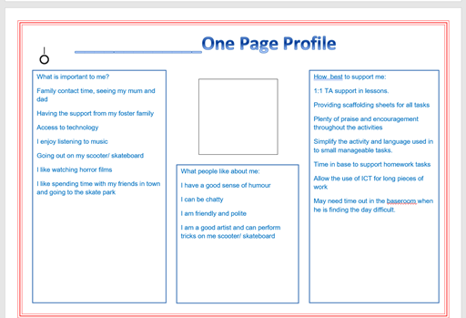

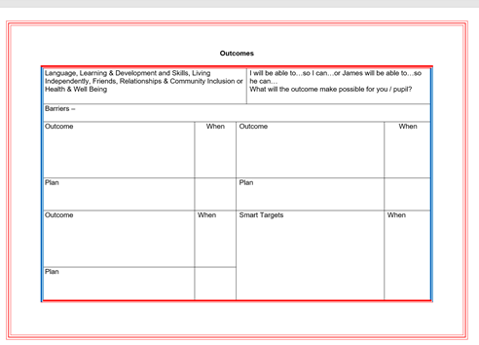

Appendix: B – Pupil’s Academic Record
Aspect Name | Result Date | Resultset | Type | Result
Maths Test 3 | 28/01/2019 | Year 10 Maths Scores | Marks-Integer | 76
% Attendance Tracking 5 | 02/12/2018 | Year 10 Attendance Tracking | Marks-Decimal | 96.70
Maths Test 2 | 29/11/2018 | Year 10 Maths Scores | Marks-Integer | 84
Capped 9 2019 | 26/11/2018 | Year 10 Autumn Term | Marks-Decimal | 260.00
English Conduct W | 23/11/2018 | Year 10 Autumn Term | Grade | Excellent
English Effort W | 23/11/2018 | Year 10 Autumn Term | Grade | Excellent
English KS4 Est. Grade | 23/11/2018 | Year 10 Autumn Term | Grade | E2
Art Conduct W | 20/11/2018 | Year 10 Autumn Term | Grade | Excellent
Art Effort W | 20/11/2018 | Year 10 Autumn Term | Grade | Excellent
Art KS4 Est. Grade | 20/11/2018 | Year 10 Autumn Term | Grade | C1
Biology Test | 16/11/2018 | Year 10 Autumn Term | Marks-Integer | 61
Physics Test | 16/11/2018 | Year 10 Autumn Term | Marks-Integer | 61
Science Conduct W | 16/11/2018 | Year 10 Autumn Term | Grade | Excellent
Science DA KS4 Est. Grade | 16/11/2018 | Year 10 Autumn Term | Grade | E3
Science Effort W | 16/11/2018 | Year 10 Autumn Term | Grade | Good
Science Global Grade | 16/11/2018 | Year 10 Autumn Term | Grade | E
Maths Conduct W | 14/11/2018 | Year 10 Autumn Term | Grade | Good
Maths Effort W | 14/11/2018 | Year 10 Autumn Term | Grade | Excellent
Maths Global Grade | 14/11/2018 | Year 10 Autumn Term | Grade | E
Maths KS4 Est. Grade | 14/11/2018 | Year 10 Autumn Term | Grade | E3
Numeracy KS4 Est. Grade | 14/11/2018 | Year 10 Autumn Term | Grade | E3
Welsh Bacc Conduct W | 14/11/2018 | Year 10 Autumn Term | Grade | Excellent
Welsh Bacc Effort W | 14/11/2018 | Year 10 Autumn Term | Grade | Good
Hos and Cat Conduct W | 13/11/2018 | Year 10 Autumn Term | Grade | Excellent
Hos and Cat Effort W | 13/11/2018 | Year 10 Autumn Term | Grade | Good
Hos and Cat KS4 Est. Grade | 13/11/2018 | Year 10 Autumn Term | Grade | D2
RS Conduct W | 13/11/2018 | Year 10 Autumn Term | Grade | Good
RS Effort W | 13/11/2018 | Year 10 Autumn Term | Grade | Good
RS KS4 Est. Grade | 13/11/2018 | Year 10 Autumn Term | Grade | C2
% Attendance Tracking 4 | 12/11/2018 | Year 10 Attendance Tracking | Marks-Decimal | 95.30
Chemistry Test | 07/11/2018 | Year 10 Autumn Term | Marks-Integer | 28
Maths Test 1 | 26/10/2018 | Year 10 Maths Scores | Marks-Integer | 28
% Attendance Tracking 2 | 16/10/2018 | Year 10 Attendance Tracking | Marks-Decimal | 100.00
EN TA: English Subject Level KS3 Wa | 04/10/2018 | Key Stage 3 Validated Result | Grade | 5
WCS KS3: Core Subject Indicator TA | 04/10/2018 | Key Stage 3 Validated Result | Grade | Y
WE TA: Welsh 2nd Lang Sub Level KS3 Wa | 04/10/2018 | Key Stage 3 Validated Result | Grade | D
Art Global Grade | 28/09/2018 | Year 10 Autumn Term | Grade | E
Eng Lang Global Grade | 28/09/2018 | Year 10 Autumn Term | Grade | E
Hos & Cat Global Grade | 28/09/2018 | Year 10 Autumn Term | Grade | E
RS Global Grade | 28/09/2018 | Year 10 Autumn Term | Grade | E
% Attendance Tracking 1 | 24/09/2018 | Year 10 Attendance Tracking | Marks-Decimal | 100.00
% Attendance Tracking 14 | 13/09/2018 | Year 9 Attendance Tracking | Marks-Decimal | 98.30
Overall Global Grade | 11/09/2018 | Year 10 Autumn Term | Grade | E

Appendix: C – Examples of Challenging Behaviour Risk Assessment

Risk Assessment of
Challenging Behaviour

Pupil’s Name:

Year Group:

Completed by:

Completed on:

Proposed Review Date:

Behaviours causing concern:

Use the table overleaf to record the first two aspects of the risk assessment.

Target:

The target column should be used to indicate the person to whom the challenging behaviour is usually directed, using the following key:-

Self The pupil him or herself
Staff Members of staff
Visitor Visitors to the school; members of the public when outside of school.
Pupils Other pupils
Property The physical environment

Probability:

Record an informed estimate of the likelihood that the behaviour will occur again, ranging from:

HL (3) Highly likely. Existing evidence leads staff to conclude that the behaviour is more likely than not to occur again.

L (2) Likely. There is a possibility that the behaviour will occur again.

U (1) Unlikely. Although the behaviour has occurred before, the context has changed or can be changed to make it unlikely to happen again.

Seriousness:

Make a judgement about the seriousness of each predicted behaviour:

A (3) This would include physical injury requiring medical attention beyond basic First Aid; extensive damage to property; significant distress caused to self or others; or lengthy disruption to the normal school routines.

B (2) This includes physical injury requiring basic First Aid within the school; minor damage to property; some distress caused to self or others; or brief disruption to normal school routines.

C (1) No physical injury or damage to property; minor distress or disruption.

Influencing factors:

These are described in more detail in Table Two. The numbers referring to each factor
may be transcribed as appropriate.

Table One

Behaviour (Risk) | Target | Probability | Seriousness | Influencing Factors
Verbal aggression (threatening, swearing)

Physical aggression

Intimidation communicated by physical action

Property destruction – sabotage

Walking away from immediate environment

Walking off site

Refusal to cooperate

Other (please specify):

Influencing Factors

Risk assessment also involves an analysis of the “hazards” – the environmental factors
which influence the probability of the behaviour causing concern. In a school situation,
these “hazards” are likely to include features of the daily timetable, and interaction with other pupils, and even the skills that adults demonstrate when working with the pupil.

Use the table below to show the factors that are associated with the behaviours causing concern.

Table Two

Possible influencing factors
1. Periods of unstructured activity
2. Transition times
3. Availability of dangerous equipment
4. Periods of increased pressure, e.g.,

- Home factors (change of home circumstances)
- School factors (assessment periods, routine changes)
- Other (please specify):

5. Spaces which involve close physical proximity
6. Particular pupils/adults (please specify):

7. Other (please specify):

Some influencing factors will be particularly closely related to particular behaviours. You may choose to show this by recording the number relating to each influencing factor in the final column of Table One. This will enable you to plan your preventive measures more specificall

Preventive Measures

A range of common preventive measures can be taken to reduce the risk associated with challenging behaviour. Use the table below to show whether these are:

- Currently planned (P)
- Currently being actioned (A)
- Felt to be inappropriate to the particular risks presented (I)

Table Three

Preventative Measure |  | P |  | A |  | I
Proactive Measures
Eliciting pupil view in planning and review.
Providing regular feedback and pastoral support to pupil.
Involving parent/carer in decision-making and planning.
Involving outside agencies (e.g., EP, EWO, Social Services).
Establishing an individual plan.
Providing regular supervision to staff working with the pupil.
Adapting curriculum arrangements to reflect challenge, choice and structure levels which are appropriate to the pupil’s assessed needs.
Adapting group arrangements to promote positive peer models and minimise inappropriate contact.
Arranging furniture and other equipment to minimise movement and frustration.
Providing frequent rest or change of activity opportunities.
Establishing a positive teaching programme to increase the pupil’s range of appropriate skills.
Providing a range of rewards which the pupil can earn by demonstrating the skills defined in the teaching programme, and through other appropriate behaviour.
Identifying the message communicated by the pupil’s behaviour.
Agreeing key reactive strategies for handling incidents of challenging behaviour with all staff likely to be in contact with the pupil, and ensuring that these plans are shared with parents.

Providing staff support at difficult times, such as start of day, changeover between lessons, break-times, specific lessons.
Systematically reviewing difficult incidents in order to improve upon practice and learn from experience.
Other proactive measures :

Reactive strategies to respond to early warning signs or an escalating situation
Active listening
Environmental adaptation (removing triggers/changing peer/staffing arrangements.
Diversion/distraction to a preferred activity (please specify):

Assistance in the use of an agreed strategy such as a particular communication symbol, or an exit card (please specify):

Physical intervention (specify the planned technique):

Other (please specify):

Key Actions

It is expected that any pupil whose behaviour is challenging will have an individual statement. This will already record many of the preventive and reactive strategies designed to reduce the level of risk presented by the pupil’s behaviour. There is no need to repeat these below. Instead, note the date when this statement was initially drawn up, and its proposed review date, and use the space available below to record any additional measures to be employed to reduce risk and the person responsible for implementing changes.

Date of current individual statement: ……………………………………………..

Proposed date for review of current statement: ……………………………………………..

Further measures to be taken | Responsible person

Table Four

Challenging behaviour risk assessment summary for ……………………………………………… Completed on: ……………………..

Behaviour(s) causing concern | Environment(s) where it is likely to be shown | Seriousness  (A, B or C) | Key preventive strategies | Key reactive strategies

Appendix: D- Examples of Behaviour
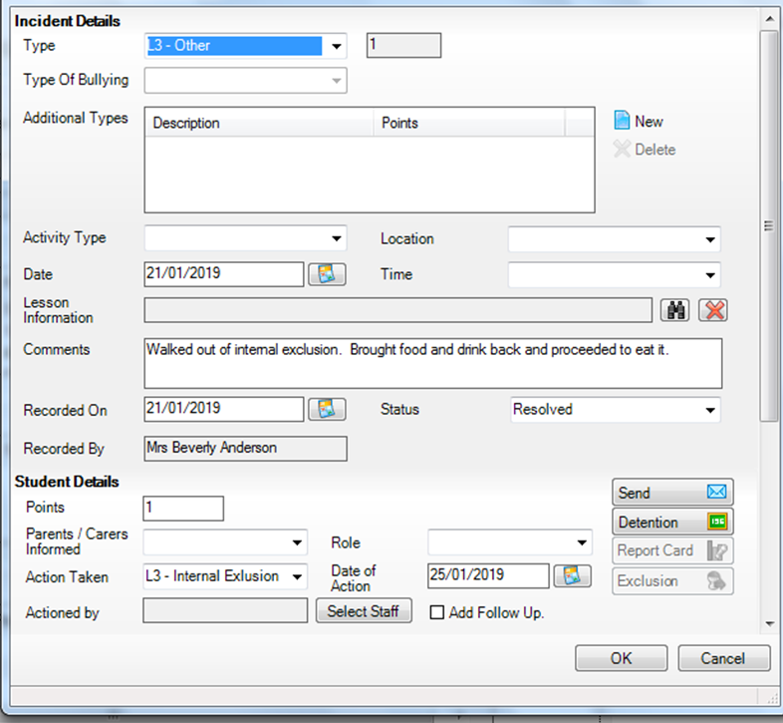

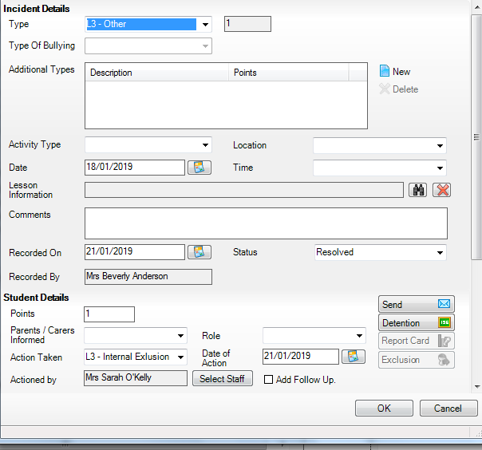

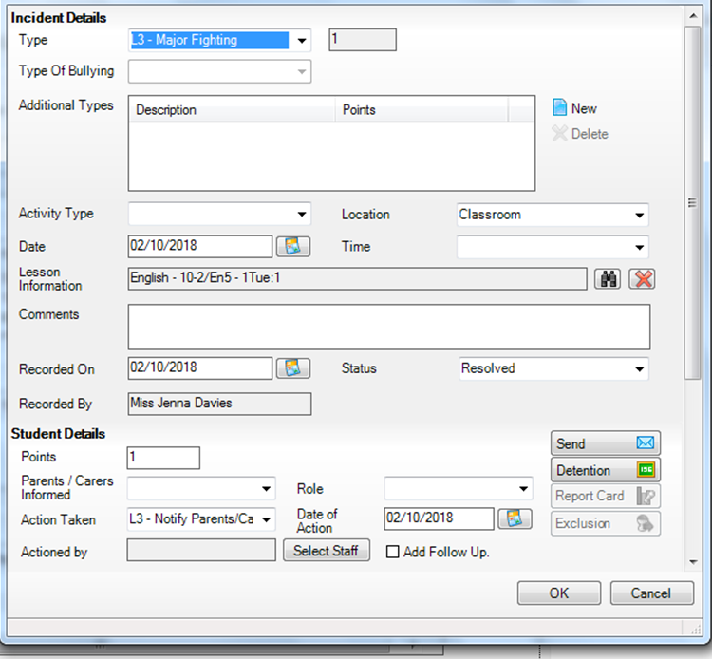

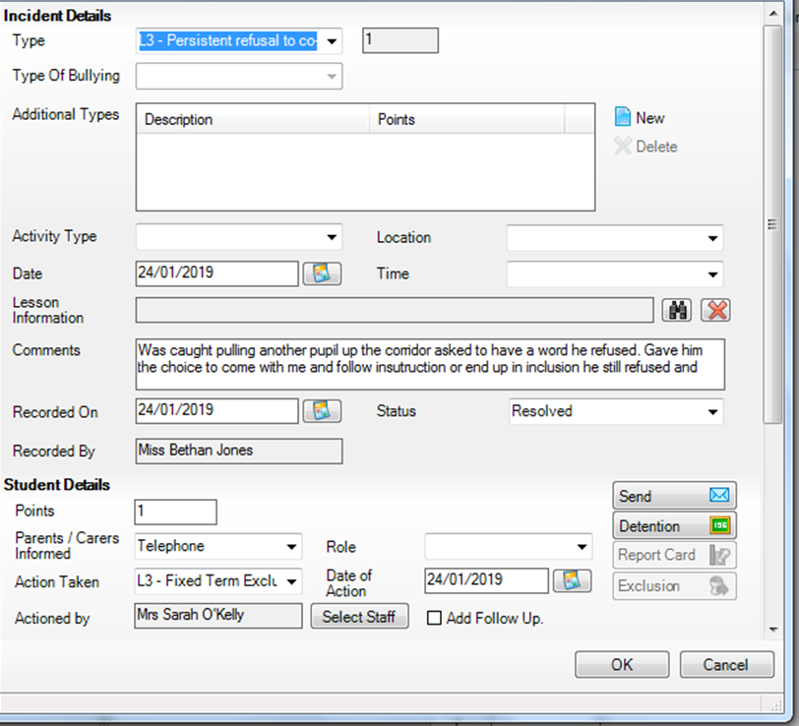
Appendix: E – Pupil’s Attendance Record
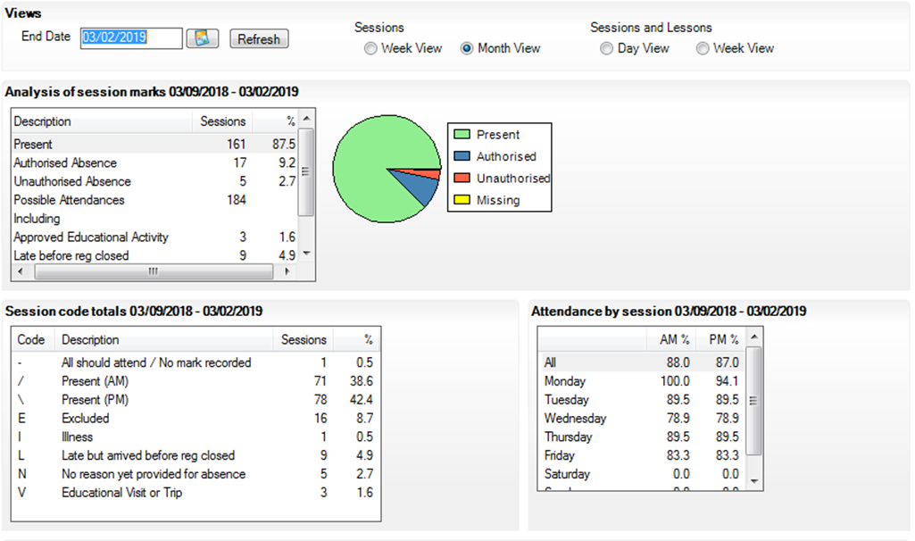

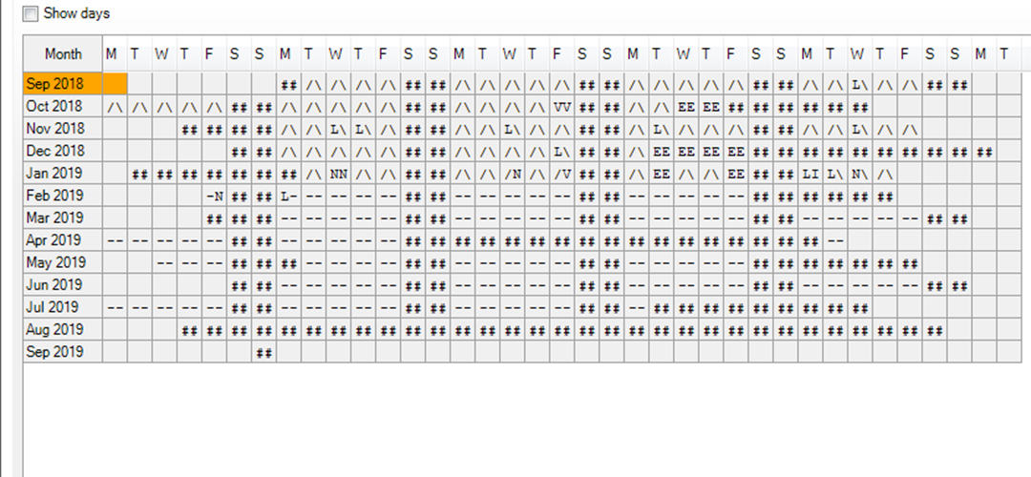

Appendix: F- School ‘A’s Behaviour Policy
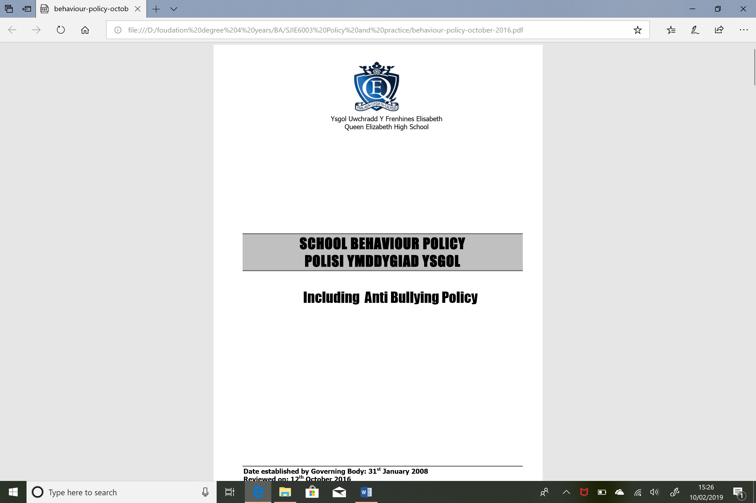

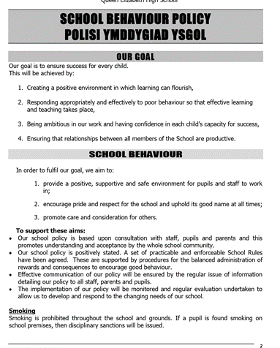

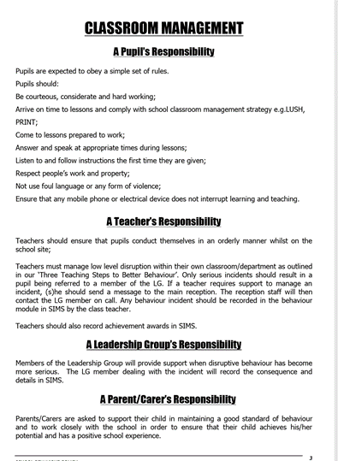

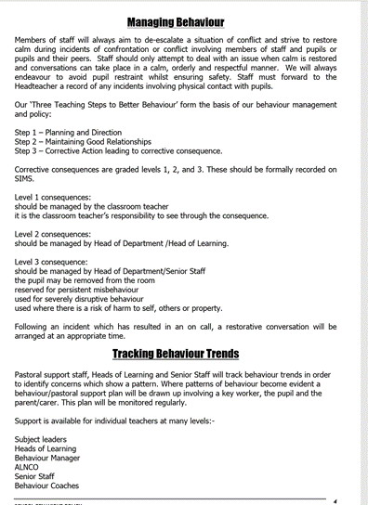

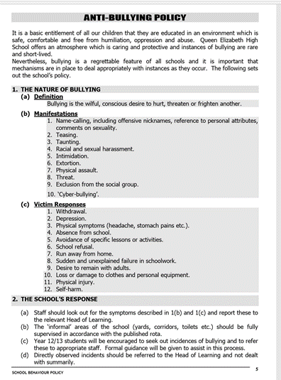

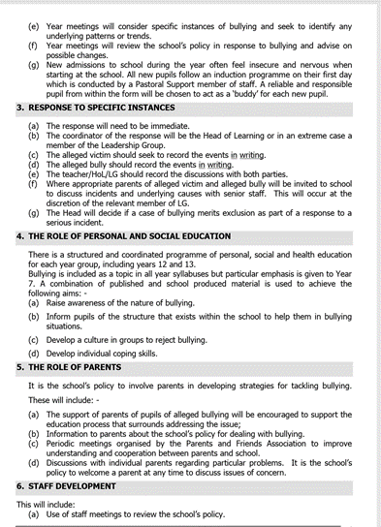

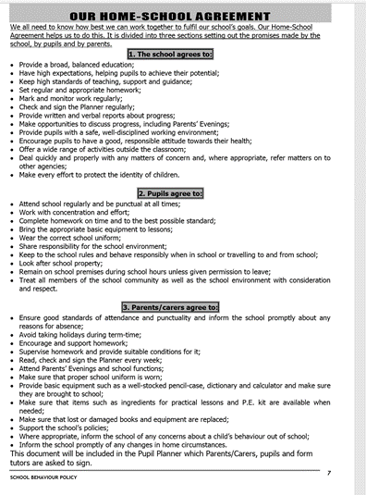

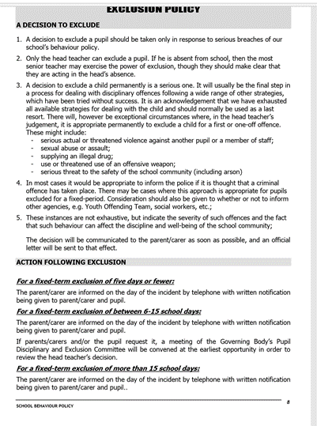

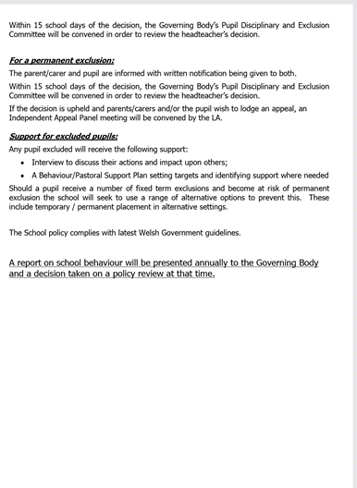

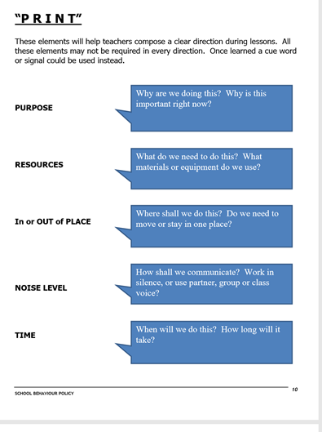

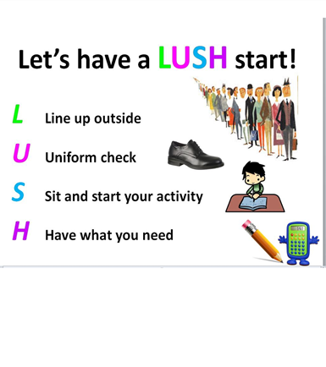

Appendix: G – School ‘A’s Provision Map


