
UWTSD Swansea
Application of maths for software development

David Williams & Beverly Holland

Daniel Algie 1706977

Contents
Introduction 3
Database Design 4
Comparing ERD 5
Creating the database 6
SQL 6
Input Masks 6
Macros 7
Forms 7
Reports 7
User Manual 9
Main menu 9
Reports 9
Adding Customer 10
Searching for existing customers. 11
Conclusion 12
References 13
Appendix 14

Figure 1-ERD 4
Figure 2-Access relations 4
Figure 3-customer new letter list 6
Figure 4-post code input mask 6
Figure 5- book form 7
Figure 6-Report 8
Figure 7-main menu design 9
Figure 8-report section main page 9
Figure 9-books report 10
Figure 10-customer input button 10
Figure 11-add new button 10
Figure 12-finished customer details 11
Figure 13-delete and save button 11
Figure 14-find button and search 11
Figure 15-found customer details 12

Introduction
Dylan’s Book Store is a Successful book store in Swansea but doesn’t have a database system and in this report it will be shown how Dylan’s Book Store new database was created and how to use the database this will consists of screen shots of the database and a user manual to help staff understand the use and benefit from the new database.

Database Design
The first steps of creating the database system was to design an Entity Relationship Diagram using Microsoft Visio. The Entity Relationship Diagram created what tables and relationships were needed to make Dylan’s Book Store database an easy and user friendly system for the user to make the storing of data and efficient.
Due to the sizing of the Entity Relationship Diagram please find a larger Version of The Entity Relationship Diagram in the appendix.

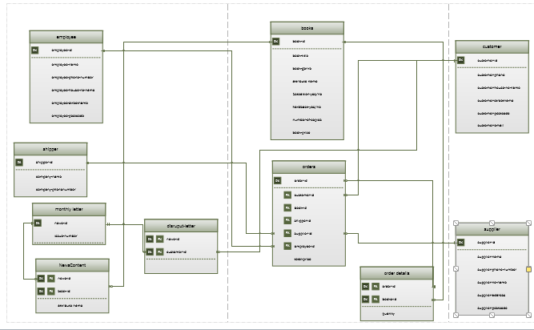
Figure 1-ERD
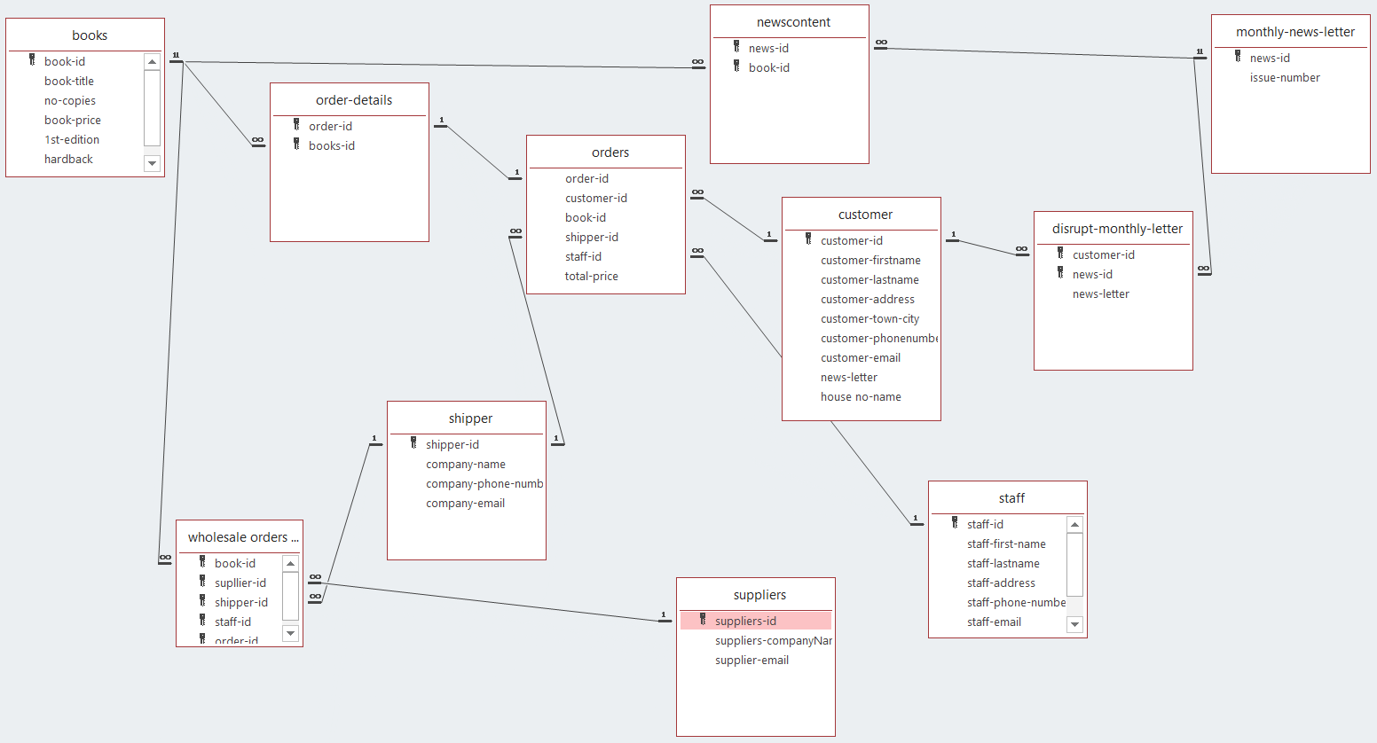
Figure 2-Access relations

Comparing ERD
When comparing between the Visio Entity Relationship Diagram used to complete the draft of what the database should look like and the final database Relations using Microsoft Access. The results are pleasing there were only few minor changes. When construction of the visual Entity Relationship Diagram was created it was a rough design and there need to be some changes to make sure that all entities were utilized, and all fields had the correct purpose and connected to each other to make sure there was no unwanted or wasted data. A couple of problems occurred along the progress of the database these were:
- When creating the orders table, it was noticed that orders had a supplier id in the table this was invalid and irrelevant do to the fact that the customer didn’t need to know where Dylan’s book store were buying there stock from and could result in loss of business due to customers looking for where Dylan’s book store has bought the books from looking for a better price buying from the specialised dealers themselves. Now the field was delete from the database there was no relation between suppliers this was a problem because now there was a table with no relationships with another table having no purpose or no entity links to other fields to collect the need data from other tables. To rectify the problem a new table was created for dealing with creating a separated table for Dylan’s book store to complete in bound orders from suppliers and special book details and keep customer and store orders separate.
- Though the same kind of problems there were still more fields in the tables which were not needed and didn’t really have relevance to the table it was stored in. This was a simple fix of just deleting the not needed fields such as book id stored in orders it was already stated in the order-details tables so it was not relevant to have to repeat the process and the customer doesn’t need the book id just the order id if they have a problem and need to discuss the order.

Creating the database
Now with a template of the hopeful database fields and relationships the next step was to create the tables and fields created in the Entity Relationship Diagram using Microsoft Visio

SQL
Structured Query Language (SQL) WAS as used to create the queries and tables for the Dylan’s Book Store. With the use of SQL it was made possible to create all the tables used in the Microsoft Visio ERD and was the foundations of creating this database. It was also made available that if a user needed to see a specific field of the database such as finding a customers who wanted the monthly newsletter making it easier and more user friendly to help with functionality and help save time for the user to complete tasks [1].
SELECT [customer-id], [customer-email], [customer-lastname]
FROM customer
WHERE ([news-letter] = Yes);
The above SQL code was used for the creation of the queries monthly newsletter to show a table of all customers who wished to receive the monthly newsletter.
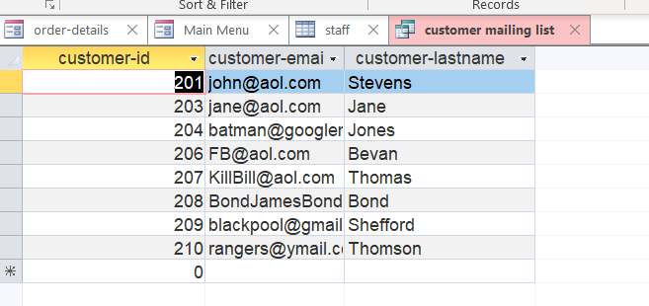
Figure 3-customer new letter list

Input Masks
Input masks were a vital part of completing the fields with the tables. The input masks were the final part of making the database functional and correct. Input masks are used to set what you want your fields to be able to do. This could include setting the user id, address, phone numbers, emails and many more. When creating the input masks it was important that data couldn’t be entered in the wrong format an example of this is when setting the post code it was set in the input mask so it must be a set amount of characters and all the characters must be filled out in the correct way for it to be accepted into the database.
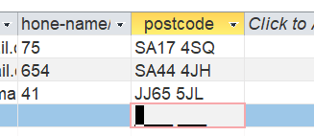
Figure 4-post code input mask

Macros
Macros were used to help increase the functionality and make it easier for the user to complete tasks.
The first macro created was the Autoexec macro which will help and make easier to use the database. When the user opens up the database the autoexec macro will automatically open to the main page making it easier for the user to use.
The second macro created was the print preview button on all reports making it easier to print forms and also print of only the report which is needed.
Finally a main menu button was created and added to all reports and forms making it easier to navigate and easier to get to the form or report you wish to read if clicking the wrong button [2].

Forms
Forms were created as an interface for the database to make it easier for the user to find the data needed. Forms were created for the tables in the database, the forms can have labels and buttons on them. The buttons can do a variety of things such as adding a new record to the books table, customers table, staff table, suppliers and shippers tables or could be used for searching for an order which has not been received by the customer. There is also a delete feature making it simpler to remove unwanted data from the database [3].
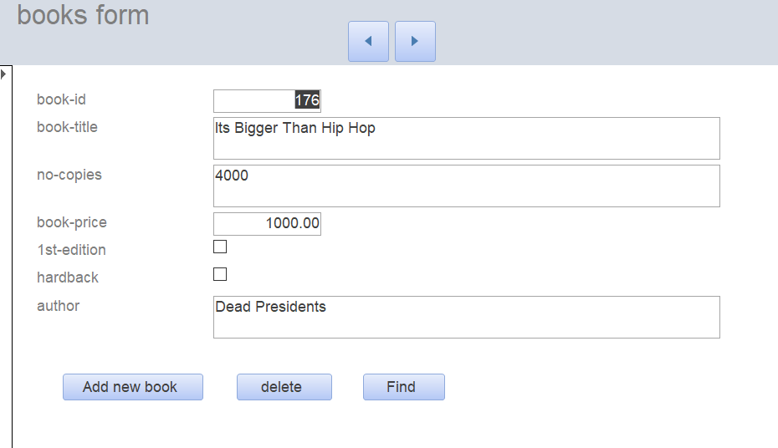
Figure 5- book form

Reports
Reports were created for the database so that management would be able to see the figures and could see every order or how much stock is kept or how many new customers there were each month. These reports are important to predict future figures and to keep the book store with the correct stock [3].
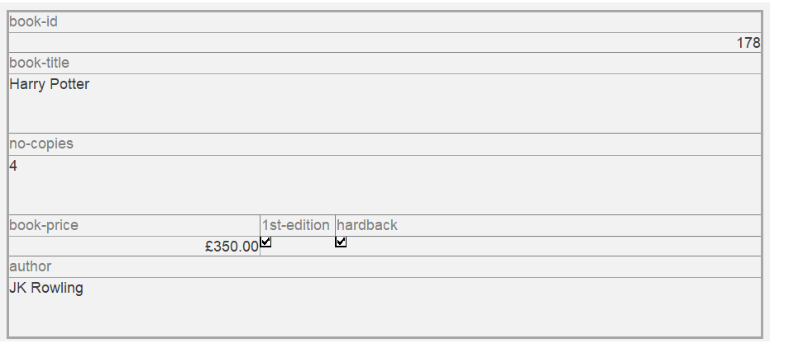
Figure 6-Report

User Manual

Main menu
The main menu is the hub of the database this is where you can access all your queries, forms and reports. Each section is in columns to make it easier to find as well as titles and different colour backgrounds to make each section stand out and to help with users with spelling or reading difficulties to know which section is which. Each form, query and report have their own buttons to direct you to the section you wish to view. For example if you wish to check if the customer wishes to receive a monthly newsletter go to the queries section and click the button for newsletter queries and it will show you the table of every customer who wishes to receive a monthly newsletter.
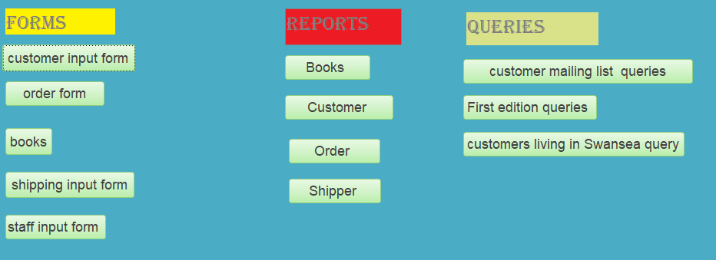
Figure 7-main menu design

Reports
To access your reports just simply click one of the buttons titled for the report which you wish to read.
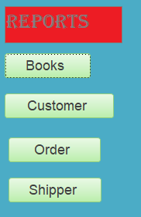
Figure 8-report section main page
If you want to see the customer reports just click the button stating customer and it will take you to the customer report. Once the books report button has been clicked it will open and display the books report.

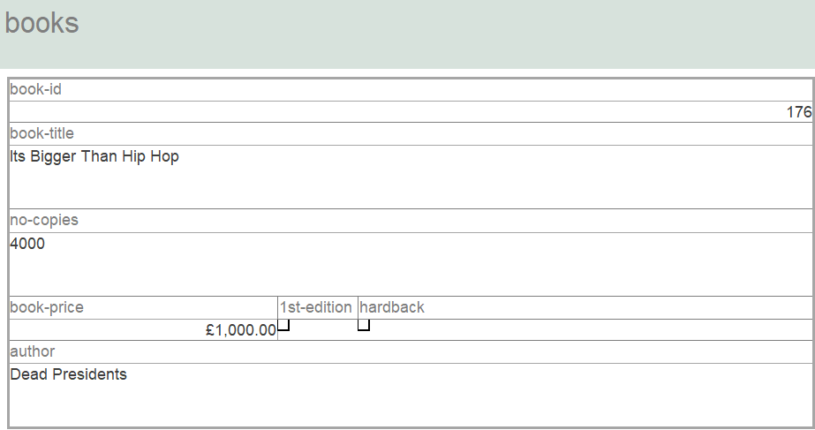
Figure 9-books report

Adding Customer
- To add a customer, you must first go to the main menu and under the forms section click the customer input form button.

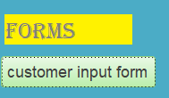
Figure 10-customer input button

- Then when one the customer forms click the button which says add new.

Figure 11-add new button

- Then add the customer details into the correct empty fields
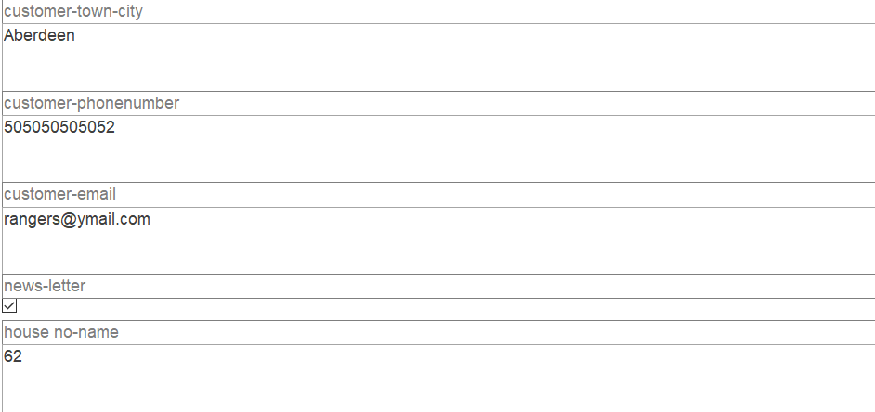
Figure 12-finished customer details

- Once finished entering all the customer details if all correct then click the save button.
- if there has been a mistake with spelling or the data is no longer needed simply click the delete button to get rid of the unwanted data.
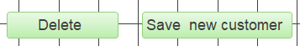
Figure 13-delete and save button

Searching for existing customers.
To search for a customer there are two different ways. There are two buttons at the top of the form to navigate forward and back to see the next customer or the previous this can be very long winded to find the customer you are looking to for. If you click the find button.
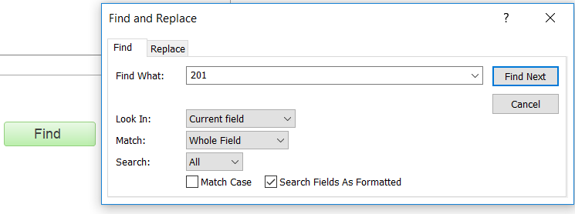
Figure 14-find button and search

Once you have clicked on the find button it will display a find and replace box (shown in the image above) once this is displayed enter in the find what field the customer id for the customer you wish to view and click the find next button to the right of the customer id you just entered and it will automatically display the customer details you wish to see.

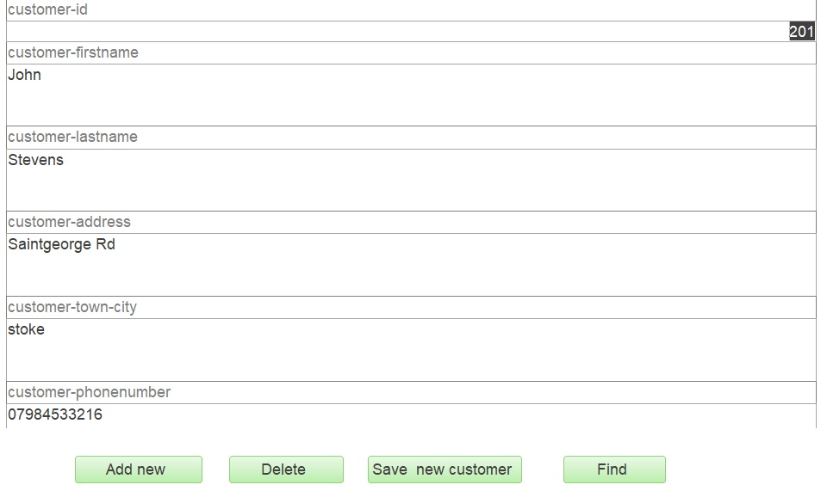
Figure 15-found customer details
To find more customer details just repeat the steps above.

Conclusion
In conclusion the completion of Dylan’s book store database went well. If there was more time to complete the database there would be a few fields to upgrade and make run more smoothly this is something that will be worked on in the future and helping Dylan’s book store grow. This is a vast in improvement to their old system and will help Dylan’s book store move forward and help grow the business and speed up production of sales and keep track of the customers’ orders to keep their customers satisfied.

References

[1] | U. O. York, “Essential Access Book 1,” York.
[2] | S. Lauesen, “Microsft-Access Tutorial,” 2011.
[3] | “Creating And Using Database With Microsoft Access”.

Appendix
Here is a full view of the ERD diagram used in Microsoft Visio Studios



