STUDENT’S NAME: JANAT KICONCO
STUDENT NUMBER: 2426595

Poster and Written Pitch – CarerConnect: An AI-Powered Digital Support Platform for Unpaid Carers in the UK

Table of Contents
PART A: POSTER 3
PART B: WRITTEN PITCH 4
1. Introduction 4
2. Need for the Innovation 4
3. Innovation in Practice 4
4. Innovation, Creativity and Value Creation 5
5. Policy, Legislation and Professional Services 6
6. Public Engagement, Benefits and Challenges 6
7. Conclusion 6
Reference List 7

PART A: POSTER
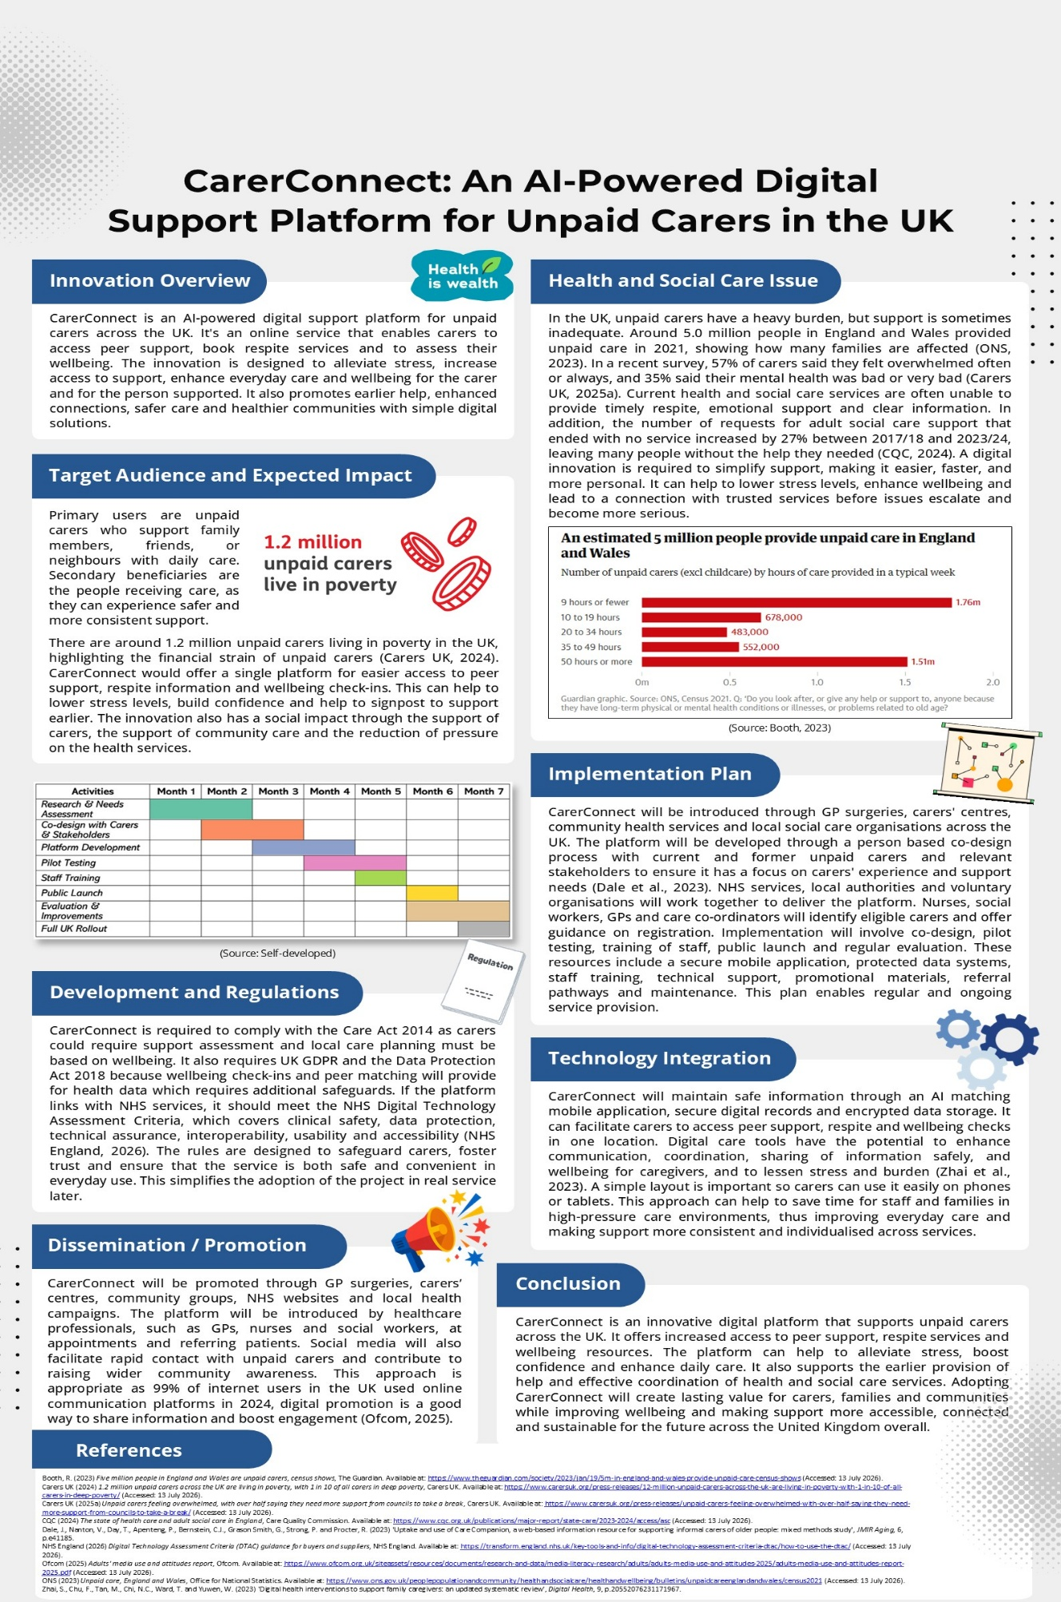

PART B: WRITTEN PITCH

1. Introduction
CarerConnect is a new online support system for unpaid carers throughout the UK. It brings together information on respite care, peer support and wellbeing check-ins in one place. The platform is designed to enhance access to support and ease the care process. Many unpaid carers experience stress, isolation and difficulties finding the right services. A similar web-based resource, Care Companion, was developed to provide carers with personalised information and links to relevant local and national support (Dale et al., 2023). Building on this concept, CarerConnect provides a streamlined and integrated digital support solution.

2. Need for the Innovation
Unpaid carers make an important contribution to health and social care, but many do not receive the support they need. Caring responsibilities can have an impact on physical health, emotional wellbeing and everyday life, and locating the right services can be challenging. Recent evidence shows that 51% of unpaid carers said they needed more support from the NHS, compared with 42% two years earlier (Carers UK, 2025b). In addition, 44% reported that the person they cared for had an emergency hospital admission or unplanned hospital visit during the previous year, and only 14% said they were asked about their ability to continue caring during hospital discharge (Carers UK, 2025b). The findings reveal that there is not always recognition of carers, or participation in care planning. Current systems often provide assistance when the problems become serious rather than resolving the problems before they get serious. CarerConnect seeks to overcome these challenges by integrating information, peer support and wellbeing resources into a single digital platform to provide carers with timely guidance and more coordinated support across their caring journey.

3. Innovation in Practice
CarerConnect is a safe online place to connect with other unpaid carers, access respite information, connect with wellbeing check-ins and access trusted guidance. Users can set up their own profile so that the platform can suggest the most appropriate local services and link them to carers with similar experiences. AI assists in providing tailored recommendations and increased access to relevant assistance. Most co-created technological solutions for caregivers are delivered through mobile or web applications, with caregivers actively involved during the design and development process to improve usability and relevance (Merchán-Baeza et al., 2023). The platform will be introduced through GP surgeries, carers’ centres, NHS community services and voluntary organisations. Carers will be encouraged to register and receive continuous support from nurses, GPs, social workers and care coordinators. A co-designed online peer support network has also highlighted the importance of trusted information, emotional support and private digital communication for caregivers (O’Donnell et al., 2024). CarerConnect is expected to lead to an improvement in wellbeing, better care coordination and greater confidence in everyday caring.

4. Innovation, Creativity and Value Creation
CarerConnect is a creative service that delivers a range of peer support, respite information, wellbeing check-in and AI guidance in a single digital platform. It contributes value by making it easier for unpaid carers to access support, and more personalised. The innovation is based on Value Co-creation, which is an approach that brings carers, health professionals and community organisations together to enhance care. This collaborative process enhances engagement and fosters a positive experience for all participants (Peng et al., 2022). One drawback is that effective co-creation requires active participation from all parties involved, which might not always occur.
The platform also uses Rogers' Diffusion of Innovation, rolling it out first through GP surgeries, carers' centres and community services before the service is rolled out more widely. Early adopters can share their positive experiences to inspire others to use the platform. This incremental approach helps to ease into acceptance and broader adoption. However, some carers may have limited digital skills or internet access, slowing adoption and reducing equal access to the innovation.
CarerConnect also achieves Social Value by increasing the wellbeing of carers; and decreasing the strain on health and social care services. Co-production and co-design are evidenced to be effective for bolstering services through user engagement throughout development (Masterson et al., 2022). One constraint is that social value has to be sustained by ongoing funding, working together and regular service enhancements.

5. Policy, Legislation and Professional Services
CarerConnect follows the Care Act 2014, which gives unpaid carers the right to a needs assessment and requires local authorities to provide support when eligibility criteria are met (Foster, 2025). The platform also meets the requirements of the UK GDPR and Data Protection Act 2018, safeguarding personal and health data with secure digital systems. If connected to NHS services it will conform to NHS Digital Technology Assessment Criteria (DTAC) to ensure it complies with clinical safety, data protection and accessibility. Professional support will involve NHS services, local authorities, carers' charities, GPs, nurses, social workers and care coordinators working together to identify and support unpaid carers. The Care Quality Commission (CQC) also inspects local authorities' performance in relation to their duties for unpaid carers under the Care Act, promoting safe and good practice (CQC, 2026). Following these legal and professional requirements will help CarerConnect provide trusted, safe and person-centred support across health and social care services.

6. Public Engagement, Benefits and Challenges
The public should support CarerConnect because unpaid carers play an essential role in helping people live safely at home. Family members, volunteers and community groups can get involved by offering the platform, being involved in awareness campaigns and encouraging carers to register. There are also opportunities to raise and support unpaid carer recognition and support through NHS events like Carers Week across communities (NHS England, 2025). CarerConnect can improve wellbeing, reduce isolation and strengthen links with local services. However, some carers may have limited digital skills. Providing simple training and alternative offline support can help overcome this challenge.

7. Conclusion
CarerConnect offers an innovative way to improve support for unpaid carers across the UK. It helps to fill existing service gaps, delivering information, peer support and wellbeing resources on one digital platform. Implementing this innovation can improve carers' wellbeing, strengthen health and social care services, and promote more connected, person-centred care for everyone.

Reference List
Booth, R. (2023) Five million people in England and Wales are unpaid carers, census shows, The Guardian. Available at: https://www.theguardian.com/society/2023/jan/19/5m-in-england-and-wales-provide-unpaid-care-census-shows (Accessed: 13 July 2026).
Carers UK (2024) 1.2 million unpaid carers across the UK are living in poverty, with 1 in 10 of all carers in Deep poverty, Carers UK. Available at: https://www.carersuk.org/press-releases/12-million-unpaid-carers-across-the-uk-are-living-in-poverty-with-1-in-10-of-all-carers-in-deep-poverty/ (Accessed: 13 July 2026).
Carers UK (2025a) Unpaid carers feeling overwhelmed, with over half saying they need more support from councils to take a break, Carers UK. Available at: https://www.carersuk.org/press-releases/unpaid-carers-feeling-overwhelmed-with-over-half-saying-they-need-more-support-from-councils-to-take-a-break/ (Accessed: 13 July 2026).
Carers UK (2025b) Rising numbers of unpaid carers say they need more support from the NHS, Carers UK. Available at: https://www.carersuk.org/press-releases/rising-numbers-of-unpaid-carers-say-they-need-more-support-from-the-nhs/ (Accessed: 13 July 2026).
CQC (2024) The state of health care and adult social care in England ..., Care Quality Commission. Available at: https://www.cqc.org.uk/publications/major-report/state-care/2023-2024/access/asc (Accessed: 13 July 2026).
CQC (2026) Assessment framework for local authority assurance, Care Quality Commission. Available at: https://www.cqc.org.uk/guidance-regulation/local-authorities/assessment-framework/theme1/assessing-needs (Accessed: 13 July 2026).
Dale, J., Nanton, V., Day, T., Apenteng, P., Bernstein, C.J., Grason Smith, G., Strong, P. and Procter, R., (2023). Uptake and use of care companion, a web-based information resource for supporting informal carers of older people: mixed methods study. JMIR aging, 6, p.e41185.
Foster, D. (2025) Local Authority support for unpaid carers in England, House of Commons Library. Available at: https://commonslibrary.parliament.uk/research-briefings/cbp-7756/ (Accessed: 13 July 2026).
Masterson, D., Areskoug Josefsson, K., Robert, G., Nylander, E. and Kjellström, S., (2022). Mapping definitions of co‐production and co‐design in health and social care: a systematic scoping review providing lessons for the future. Health Expectations, 25(3), pp.902-913.
Merchán-Baeza, J.A., Borralleras Andreu, C., Minobes-Molina, E., Grau Carrión, S., Romero-Mas, M. and Ramon-Aribau, A., (2023). Co-created technological solutions for caregivers in health care: systematic review. Journal of Medical Internet Research, 25, p.e41260.
NHS England (2025) NHS England Carers Week 2025, NHS England. Available at: https://www.events.england.nhs.uk/nhs-england-carers-week-2025 (Accessed: 13 July 2026).
NHS England (2026) Digital Technology Assessment Criteria (DTAC) guidance for buyers and suppliers, NHS England. Available at: https://transform.england.nhs.uk/key-tools-and-info/digital-technology-assessment-criteria-dtac/how-to-use-the-dtac/ (Accessed: 13 July 2026).
O’Donnell, E.A., Van Citters, A.D., Khayal, I.S., Wilson, M.M., Gustafson, D., Barnato, A.E., Buccellato, A.C., Young, C., Holthoff, M.M., Korsunskiy, E. and Tomlin, S.C., (2024). A web-based peer support network to help care partners of people with serious illness: co-design study. JMIR Human Factors, 11, p.e53194.
Ofcom (2025) Adults’ media use and attitudes report, Ofcom. Available at: https://www.ofcom.org.uk/siteassets/resources/documents/research-and-data/media-literacy-research/adults/adults-media-use-and-attitudes-2025/adults-media-use-and-attitudes-report-2025.pdf?v=396240 (Accessed: 13 July 2026).
ONS (2023) Unpaid Care, England and Wales, Office for national statistics. Available at: https://www.ons.gov.uk/peoplepopulationandcommunity/healthandsocialcare/healthandwellbeing/bulletins/unpaidcareenglandandwales/census2021 (Accessed: 13 July 2026).
Peng, Y., Wu, T., Chen, Z. and Deng, Z., (2022). Value cocreation in health care: systematic review. Journal of Medical Internet Research, 24(3), p.e33061.
Zhai, S., Chu, F., Tan, M., Chi, N.C., Ward, T. and Yuwen, W., (2023). Digital health interventions to support family caregivers: An updated systematic review. Digital health, 9, p.20552076231171967.

