LCHS4009
Professional Development within Health and Social Care
Mary Vicentina Novasis
ID: 2436907
Presentation on
Working in Teams Essential Skills for Health and Social Care


Contents
Introduction and Definition of Working in Teams 3
Importance of Teamwork in Healthcare 4
Practical Example in Health and Social Care 5
Tuckman’s Team Development 6
Evidence-Based Benefits 7
Conclusion 8
References 9

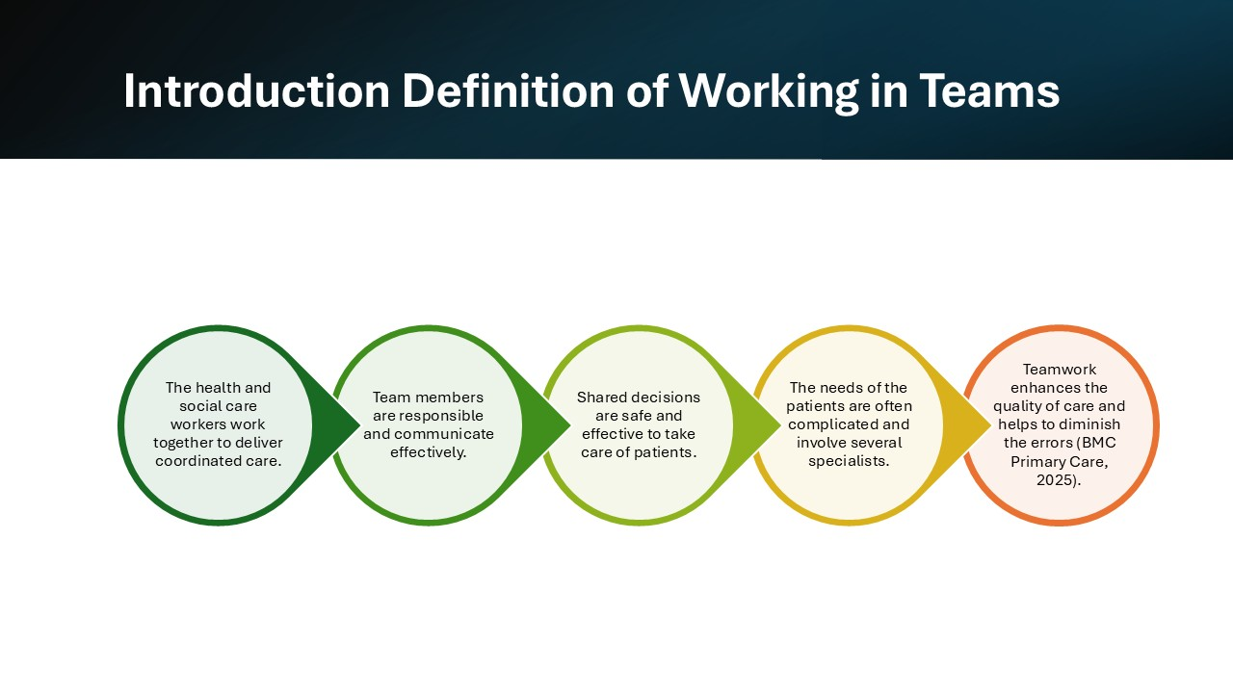
Introduction and Definition of Working in Teams
Working in teams implies that health and social care practitioners such as nurses, doctors, and allied personnel cooperate to offer coordinated care to patients. All members communicate clearly and share responsibilities and make joint decisions to achieve patient care as safe and effective safety (BMC Primary Care, 2025). The collaboration is necessary as patients tend to have multiple needs that demand the contributions of many specialists at once. Individual skills and knowledge are effectively used by teams to increase patient outcomes and minimize the error. The literature indicates that teamwork activities that lead to the coordination of efforts have a direct positive effect on the quality of care provided and the patient.

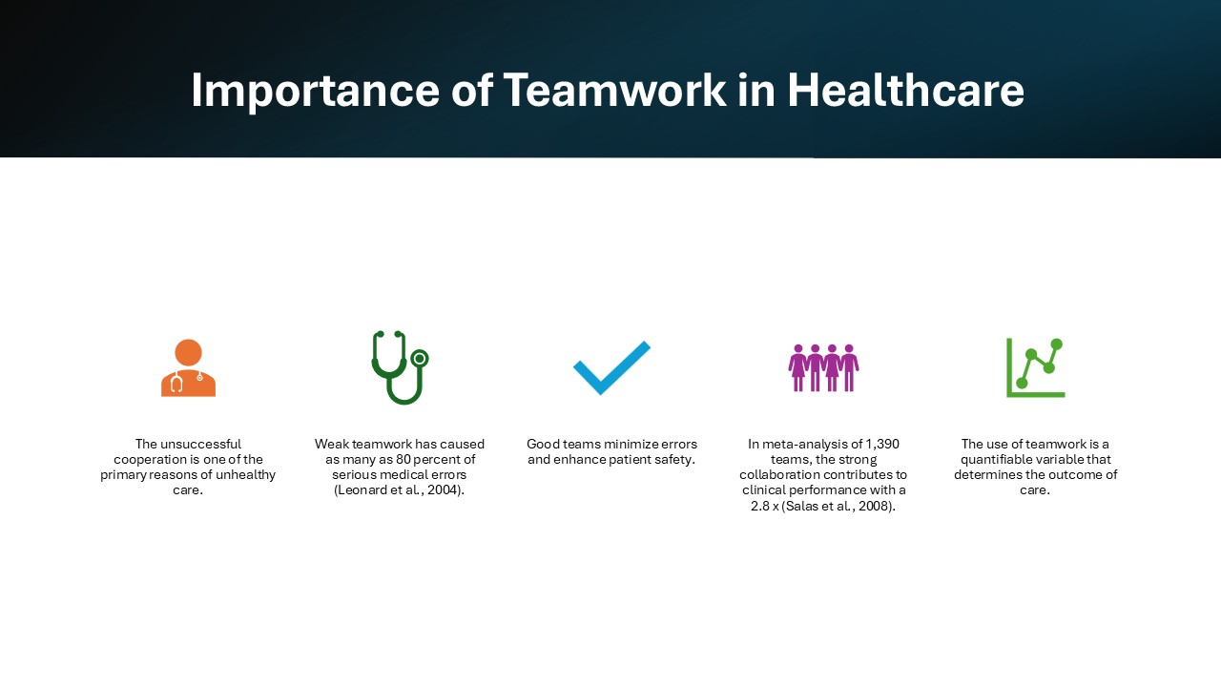
Importance of Teamwork in Healthcare
Collaboration is imperative since ineffective teamwork is one of the causes of unsafe care. Research indicates that a large percentage of severe medical errors are caused by the lack of communication or effective teamwork (Leonard et al., 2004). Successful teams minimize errors, enhance security and minimize employee anxiety. In 31 healthcare investigations with 1,390 teams, the robust collaboration enhanced clinical achievement 2.8 times, as compared to less robust teams (Salas et al., 2008). This demonstrates that teamwork is a quantifiable variable that can have a high impact on patient care and result.

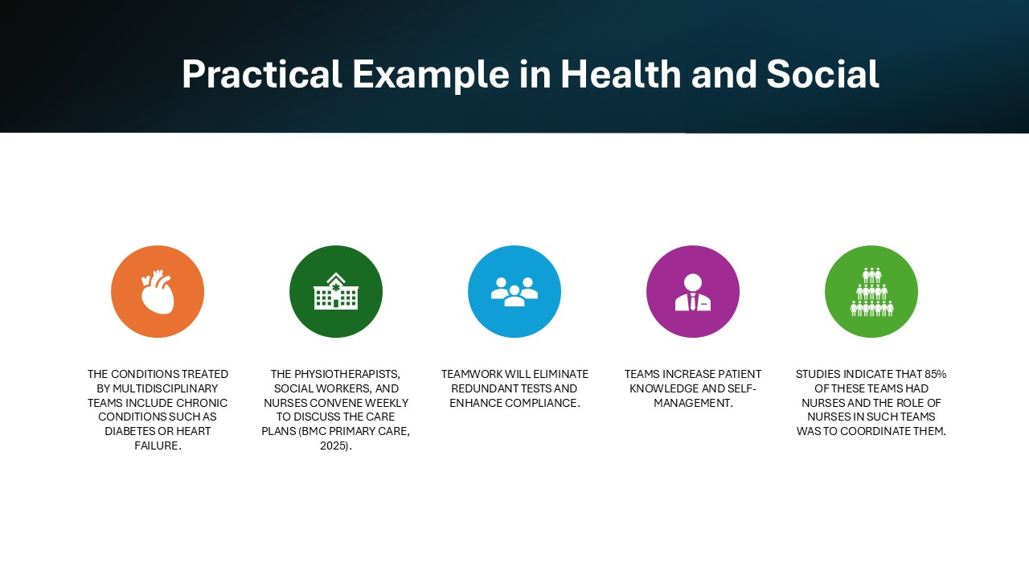
Practical Example in Health and Social Care
One of them is the use of multidisciplinary teams in chronic conditions such as diabetes or heart failure. The nurses, physiotherapists, and social workers gather on a weekly basis to review care plans, modify medications, and organize follow-ups (BMC Primary Care, 2025). Efficient teamwork prevents the re-testing, enhances compliance and makes patients aware of their care. Investigations conducted on 39 studies demonstrated that these teams enhance patient-reported outcomes, such as satisfaction and self-management. Nurses were the focus in these teams with 85% of them included and this indicates that they play a key role in coordinating care.

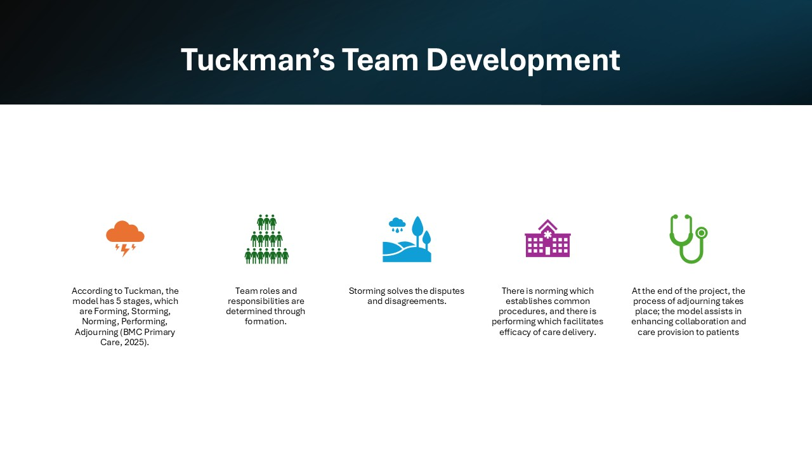
Tuckman’s Team Development
The Team Development Model developed by Tuckman describes the way teams develop and perform. The phases include Forming, Storming, Norming, Performing and Adjourning (BMC Primary Care, 2025). Forming, Storming, Norming, Performing, and Adjourning are roles in healthcare, which define roles, conflict resolution, shared processes, and deliver high-quality care, respectively, and end the project, respectively. Using this model will assist the teams in determining the obstacles, enhancing teamwork, and offering uniform patient care.

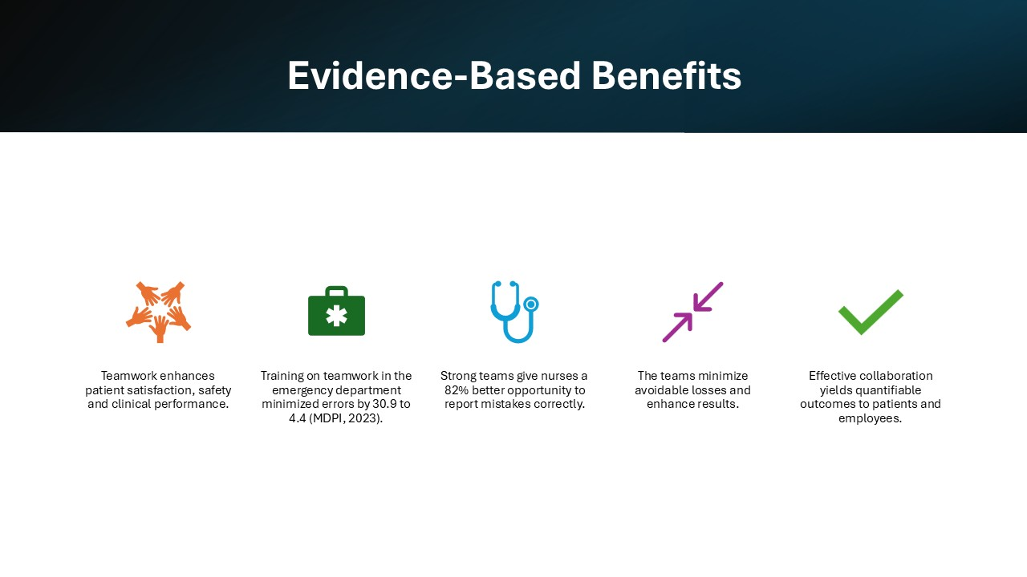
Evidence-Based Benefits
Teamwork enhances patient satisfaction, clinical performance, and safety. As an example, the training of structured teamwork in emergency departments decreased the incidence of clinical errors to 4.4% as compared to 30.9% (MDPI, 2023). Strong teams also record higher levels of error reporting with an 82% probability of accurately reporting mistakes. Teams minimize avoidable damage and enhance results, which have quantifiable advantages to patients and medical personnel.

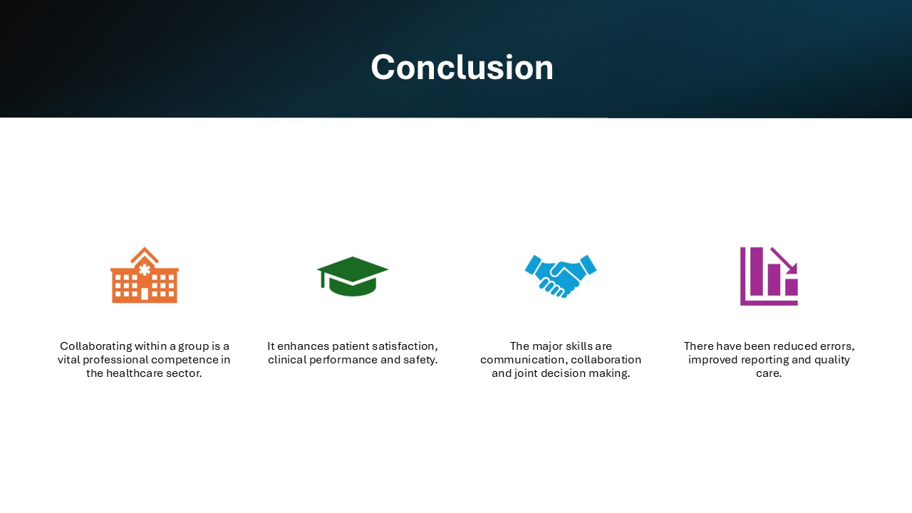
Conclusion
To sum up, team effort is an essential professional value in health and social care. It enhances patient satisfaction, clinical performance and safety. Such skills like communication, collaboration, shared decision-making, etc. are required. It has been demonstrated that strong teams bring about quantifiable change such as reduction in errors, improvement in reporting and quality of care and as such, teamwork is essential in contemporary healthcare.

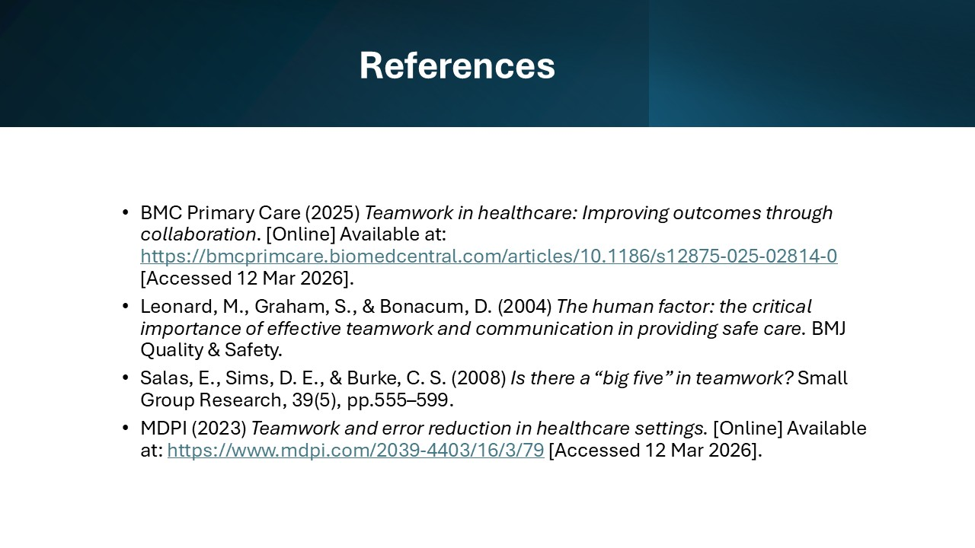
References
BMC Primary Care (2025) Teamwork in healthcare: Improving outcomes through collaboration. [Online] Available at: https://bmcprimcare.biomedcentral.com/articles/10.1186/s12875-025-02814-0 [Accessed 12 Mar 2026].
Leonard, M., Graham, S., & Bonacum, D. (2004) The human factor: the critical importance of effective teamwork and communication in providing safe care. BMJ Quality & Safety.
MDPI (2023) Teamwork and error reduction in healthcare settings. [Online] Available at: https://www.mdpi.com/2039-4403/16/3/79 [Accessed 12 Mar 2026].
Salas, E., Sims, D. E., & Burke, C. S. (2008) Is there a “big five” in teamwork? Small Group Research, 39(5), pp.555–599.

