

Assignment Title: Energy Efficiency and Sustainable Materials
Name: James Cullen
Student Number: p151951
Course Title: Contract Practice and Procedures
Submission Date: 13/02/20

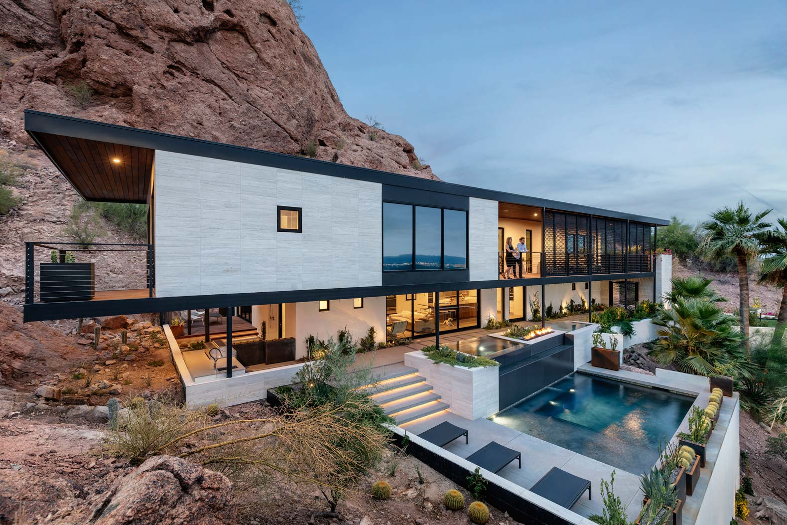
Table of Contents

Page 1: Introduction

Page 2: Harnessing Natural Ventilation

Page 4: Heating Methods

Page 5: Thermal Bridges

Page 6: Lighting or Shading Methods

Page 8: Conclusion

Page 9: List of plates

Page 10: Bibliography

Page 11: Appendices

Introduction

The realisation of the affects that climate change will inflict upon the Planet has led to the introduction of not only legislation, but the development of technology designed to limit its consequences. This is particularly present within the construction industry where regulation and innovation are commonplace, especially for new building projects. At the forefront has been research and advancements in these fields of where it is now recognised that “improving the energy efficiency of our homes presents an excellent opportunity to reduce greenhouse gas emissions and increase thermal comfort” (Pelenur, 2018).
This assignment will investigate the techniques and theories in use for domestic dwellings by demonstrating the alterations that could be made to the design of a property.

Harnessing Natural Ventilation
One method of reducing the carbon footprint of a property that can be incorporated into building designs are using natural ventilation systems. These provide fresh air from the surrounding environment and also extract from the properties, releasing it into the atmosphere, without using mechanical aids. As well as producing no carbon emissions, there a number of other advantages to implementing these types of approaches. The most prominent of which is that they have very little or no operating and maintenance costs once installed. Furthermore, the systems are generally reliable and provide a high level of control for the householder.
Conversely, there are some drawbacks to their use. These include the fact that they are unsuitable for use in certain types of buildings where “it seems to be impractical, especially those of deep plans, or those requiring high control level of indoor environment such as hospital buildings” (Asfour, 2015). In addition, concerns over security and the unreliability of nature have also been cited.
There are several types of natural ventilation that are utilised in building design and could be suitable for installation in the building design in question such as Cross Ventilation and Solar Chimneys. Cross Ventilation uses wind to enter buildings via an inlet which then subsequently pushes warm stale air out of the building via a corresponding outlet:
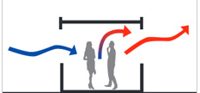
(Image 3: Vent Smoke and Natural Ventilation (2020), view of Cross Ventilation System in use)
When planning to use such a system research must be undertaken during the design stage regarding the local conditions, namely the wind direction at certain times of year. This will inform the location of the vents and outlets in the property. For example, in general in Britain, the most common winds derive from the South West, so inlets could be position within surfaces facing this direction.
A similar arrangement involves the use of Solar Chimneys. They are a “natural-draft device that uses solar radiation to move air upward, thus converting solar energy (heat) into kinetic energy (motion) of air” (Charvat, Date unknown). A stack or chimney is constructed and into a building’s envelope as per below:
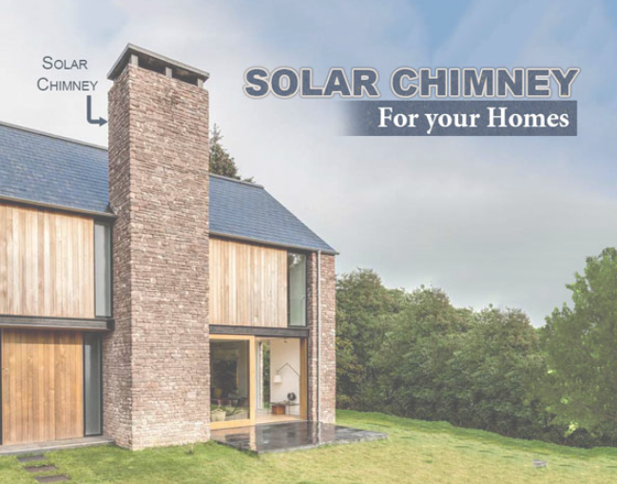
(Image 4: Gharpedia (2020), view of a solar chimney in a residential setting)
Once again, the orientation of the installation is of paramount importance in order to experience its full potential. In the Northern Hemisphere, it is best to face them to the South where they will absorb the most sunlight which can be used to heat the property. If the property is already sufficiently warm, the stack can be opened, releasing excess heat. Other concepts for sufficiently ventilating properties include cold and warm zoning, air cooling and trickle ventilation.

Heating Methods
While solar chimneys could be considered useful in both heating and ventilating homes, other design specifications purely revolve around harnessing and conserving the solar energy within properties. On such method the implementation of a Trombe Wall within a property. This employs a layer of glass installed outside of a masonry wall with an air void between the two layers as per below:
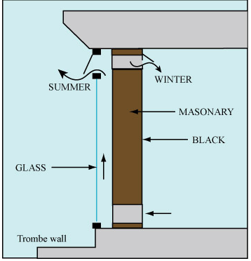
(Image 5: Mr Bim (2018), cross section of a typical Trombe Wall)
Solar energy penetrates through the glass where it is absorbed by the thick masonry wall which acts as a reservoir, gradually releasing the heat into the home and generally at night when it is most required. In winter, integrated vents can be used to direct heat from the air void directly into the home or back out into the atmosphere during warmer periods. As with solar chimneys, its results are optimised by placement on south facing walls in the Northern Hemisphere.
Other less passive methods of heating homes in a sustainable style relate to harnessing the sun’s energy to power heating appliances. Technology in this field is advancing at an extremely fast pace and some methods could be suitable for the design of this property. These include solar panels mounted on the roof (orientated correctly) as well as heat pumps which in a well-insulated property “provide all your heating needs by themselves” (Energy Saving Trust 2020). Alternatively, a heat pump configuration could be utilised to heat the swimming pool included in the design.

Thermal Bridges
In modern day construction, in order to comply with current energy efficiency standards and building regulations, unnecessary heat loss from buildings must be kept to a minimum. While a fully insulated and well-designed property should help to ensure this, thermal bridges can also help to negate their affects and lead to heat loss. They are sections within a building’s fabric which have a higher rate of heat transfer than its surroundings such as a crack or hole in a wall or where timbers interrupt the coverage of insulation.
A potential thermal bridge in the design is connected to the balcony on the building’s front façade. It is possible that “the interaction between the geometric thermal bridge (cooling fin effect of the cantilever) and the material thermal bridge (penetrating the thermal insulation layer with reinforced concrete or steel) leads to significant heat loss” (Schock, 2020). In order to minimise its effect, the balcony’s connection to the building envelope must be suitably insulated.

Lighting or Shading Methods
Maximising natural light to make residential properties as comfortable for habitation as possible is a major consideration for architects during the design stage. If carried out efficiently, specifications can help reduce carbon emissions as well as reducing household energy bills.
Similarly, to taking advantage of solar energy to heat your home, naturally lighting it also heavily depends on the notion of solar orientation. In Britain for properties, it would be beneficial to have more glazed areas facing South to capture the sunlight which radiates from that direction. This will also have implications upon the layout of houses as it would be more advantageous to having living spaces and rooms facing south with other rooms such as bedrooms where sunlight is less welcome situated on the north side of buildings.
These aspects can be manipulated further to additional optimise conditions with the use of fittings attached to house such as eaves, pergolas or even more dynamic mechanisms such as slats, blinds and awnings. A more natural solution which garden design implications is profiled below:

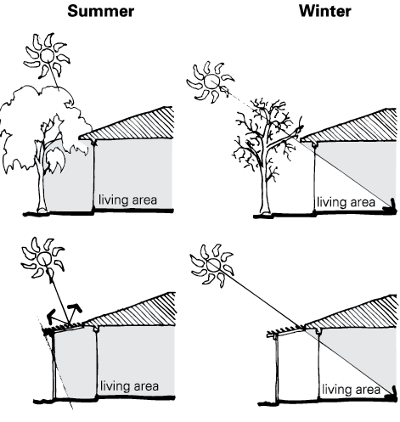
(Image 6: McGhee (2013), diagram depicting the effect of shading by trees on a property)
Trees can be planted at opportune conditions near properties to help shade or allow sunlight based on their location and time of year. A very sustainable method, its is also relatively cheap and compatible with retrofitting.

Conclusion
The report has demonstrated that there are many methods now being employed to take advantages of natural assets and replacing means of lighting, heating and cooling homes. In order for the construction industry to contribute to combatting climate change it is apparent that such measures must be continued to be implemented more widely.
Unfortunately, currently it is apparent that such techniques are only accessible to a small fraction of the population indicating that the full support of governments and policy makers are required to fully make a difference.

Evaluation
The report focused on 1 property based in Britain. Further investigation in future could undertaken into:
- Structures of differing usages.
- A whole resource system (rain water harvesting to limit water usage etc).
- Residential properties in other parts of the world.

List of Images
Image 1: Cover Page Top: Sustainability Matters (2019), Depiction of a Sustainable World, https://www.sustainabilitymatters.net.au/content/sustainability/news/global-commission-targets-energy-efficiency-813405191, accessed 16/01/20
Image 2: Cover Page Bottom: Damewood (2018), View of dwelling located on side of Camelback Mountain in Phoenix Arizona, https://inhabitat.com/substance-harmonizes-with-style-in-this-former-spanish-colonial-revival-home/, accessed 16/01/20
Image 3: Vent Smoke and Natural Ventilation (2020), view of Cross Ventilation System in use, http://www.vent.co.uk/natural-ventilation/natural-systems.php#, accessed 30/01/20
Image 4: Image 4: Gharpedia (2020), view of a solar chimney in a residential setting, https://gharpedia.com/blog/solar-chimney-sustainable-solution-for-homes/, accessed 30/01/20
Image 5: Mr Bim (2018), cross section of a typical Trombe Wall, http://mrbimarchitects.com/blog-en/trombe-wall-passive-temperature-conditioning/, accessed 30/01/20
Image 6: McGhee (2013), diagram depicting the effect of shading by trees on a property, https://www.yourhome.gov.au/passive-design/shading, accessed 30/01/20

Bibliography
Asfour (2015), Natural Ventilation in Buildings: An Overview, Natural Ventilation: Strategies, Health Implications and Impacts on the Environment, Edition 1, pp 1-25, NOVA Publication, USA
Bennett (2019), Pros and Cons of Natural Ventilation Systems - Why Choose Natural Ventilation, Bedson Reps Natural Ventilation, https://www.bedsonreps.com/blog/posts/pros-and-cons-of-natural-ventilation-systems, UK
Charvat, Jicha, Stetina (Date Unknown), Solar Chimneys for Residential Ventilation, Department of Thermodynamics and Environmental Engineering Faculty of Mechanical Engineering Brno University of Technology, Czech Republic
Energy Saving Trust (2020), Air Source Heat Pumps, https://energysavingtrust.org.uk/renewable-energy/heat/air-source-heat-pumps, UK
Pelenur (2018), Household energy use: a study investigating viewpoints towards energy efficiency technologies and behaviour, Energy Efficiency, Volume 11, Issue 7, pp 1825–1846, UK
Schock (2020), Examples of structural thermal bridges, https://www.schoeck.co.uk/en-gb/structural-thermal-bridges, UK

