March 5, 2018
Emma-Sian Davies (1502478)
Digital Marketing Social media tool plan for
the Primporium

Table of Contents

Terms of reference 2

Analysis of the Case Study Organisation and Customers 3

Justification /Evidence for Social Media plan 4

Description of the implementation of the plan 5

References 7

Appendices 8
APPENDIX 1 ……………………………………………………………………………………………….…..……8
APPENDIX 2 ……………………………………………………………………………………………..….………9
APPENDIX 3 ………………………………………………………………………………………………….……10
APPENDIX 4 ………………………………………………………………………………………………….……11
APPENDIX 5 ………………………………………………………………………………………………….……12

Terms of reference

This marketing plan is based on a small Beauty and Therapy organisation within the rural market town of Newcastle Emlyn. The Primporium offer an array of beauty and complimentary therapies to their clients; however, have fallen short of reaching their desired demographic. Current clients are predominantly between 45 and 75 years of age, and though they have a presence on social media, they would like to see it improved with an alternative and updated marketing technique. The overall aim is to create a more prominent presence on the social media site Facebook, by appealing to a lager demographic. By implementing a strategy using their current followers, the anticipation is to increase not only the number of Facebook followers but to broaden the demographic and in turn the number of clients visiting and returning to The Primporium.

Analysis of the Case Study Organisation and Customers

The beauty and complimentary therapy industry has been continuously increasing in popularity worldwide for decades. Trends change and there is a rise in mobile Therapists (Akbareian, 2015). In order for The Primporium to compete with this and other organisations it needs to do all that it can to promote itself and stand out from others.
The Primporium has been a popular salon to visit for beauty and complimentary therapies for nearly twenty years and though returning clients help the organisation stay on a steady keel, there are occasions when cancelled appointments or seasonal spaces need filling. The list of packages and treatments offered is vast but information about these and ‘offers’ are only available in brochures and on a notice board which is on the wall inside the salon.
During a meeting with the proprietor, Trudie Peters and Manager Zoe Hancox it was clear changes were inevitable to enable them to keep up with changing trends. Mrs’ Peters and Hancox were happy to discuss the daily running of The Primporium but could not divulge particular details of information due to the nature of their business and client confidentiality. Upon review of the details we could discuss however, there was a consensus that most of their client base (some 64%), were retired women and wedding make-up clients (approximately 12%). The rest were made up of walk-ins and clients who frequented maybe once or twice a year (Peters & Hancox, 2018). We discussed their current marketing strategy and how they had always relied upon referral by word of mouth. It is only in recent years they decided to try social media as a marketing tool but openly admitted that neither had enough of an understanding of Facebook Business to be proficient in its use and so, only use the site when business is low.
The Primporium was the first salon of its kind to open in Newcastle Emlyn. Although a relatively small parish, statistics by the Office of National Statistics shows a population of 1,184 in 2011 (Office of National Statistics, 2018). The ratio of women to men was greater as can be seen on Appendix 2 and would have been their targeted demographic. However; as we can see in Appendix 3, only 33.5% were within their desired age and this is a combination of both men and women. They were able to manage and maintain their client base within the first ten years but business has slowed and they rely on their regular clients. Population of the parish and surrounding areas is increasing and there is far more competition in the area that in previous years.
With no other avenues of marketing ventured in to, both proprietor and manager of The Primporium feel that with help from and independent source they will become better skilled at marketing their brand making it more sustainable in future years.
By improving their understanding of how social media has had a positive impact on small businesses in the area, they will be able to utilise the information. They can keep their Facebook page up to date, providing new and existing clients with the latest offers, treatments, comments and products.

Justification /Evidence for Social Media plan

With a wealth of beauty and complimentary therapies on offer, a small organisation would find it difficult to offer all of these to clients. The training and product cost can become overwhelming and many establishments prefer to offer a handful. Having a varied brochure can increase the number of clients walking through the door but knowing your target audience can help distinguish what treatments can be beneficial to your organisation.
The town’s Hotel and another hair salon now offer beauty and complimentary therapies as well as a growing number of mobile therapists. Many of whom use websites and/or social media to promote their treatments. Current statistics by The Hair and Beauty Industry Authority (HABIA, 2017), show the most popular subject specific areas and the percentage to which they are utilised. With a 43.3% combined total for Spa and complimentary therapies and 51.3% for beauty treatments, they show as the favoured treatment, seen in appendix 4.
Through online research using similar, local organisations in this field I have discovered some of the different ways organisations promote themselves. Few companies advertise in local newspapers or use a website; most appear to use Facebook as their social media platform.
The user friendly social sharing site allows a user to search for a company using partial details and produces a list of suggested outcomes. If the organisation is known and easily found there are two different ways to become a part of that group. In one instance a page is created and a follower may ‘like’ the page. This provides instant access to details, offers, testimonials, regular treatment prices and any other posted information. Alternatively, a user will be required to add the organisation as a friend. This is a lengthier process as the page admin may not always be available instantly. The initial route is a public group where the second is a private group where the creator has control of who becomes acquainted with their organisation.
By becoming part of social media an organisation is made available to 98% of digital consumers Worldwide.
“98% of digital consumers are social media users and figures are high even among 55-64s (94%). An average of 2 hours and 15 minutes per day is spent on social networks and messaging – a figure that continues to increase across the markets we track.” (Globa Web Index, 2017)
An organisation may decide to concentrate on a localised area however; there is nothing to stop them attracting global popularity. Passing trade during the peak seasons can help boost a slump where regular clients may be holidaying themselves.
Research shows that the beauty industry is within the top five industries on Facebook (Rose McGrory Social Media Ltd, 2018). With 35,369,629 followers, of which our local organisations need only to reach a small percentage. Through this evidence we can see there is possibly no better way to boost awareness of your organisation than by taking full advantage of Facebook.
As a smaller organisation, there is nothing to stop you looking to see how larger and sometimes different organisations make use of Facebook and what it has to offer. Scale it down to the brand specifics; location, demographics, interests and behaviours.

Description of the implementation of the plan

Before discussing the implementation of the plan for The Primporium we need to understand some of the different page strategies used by organisations. Three examples of Facebook organisations have been chosen to illustrate the different ways of benefiting from its usage.
The first, Renaissance Beauty Therapy (Renaissance Newcastle Emlyn, 2017), the PROFILE page. An organisation within Newcastle Emlyn, formally situated above Mark Hayward Hair Salon; now trading as part of the Emlyn Arms Hotel and at an independent venue in town. There is little more than a mention of the ‘Spa’ services offered on the Hotel website (Emlyn Hotel Riverside Retreat, 2017). Guests booking via the hotel may prefer to see what is available so they may book in advance of their trip to avoid disappointment but they do provide contact details for Renaissance should it be required however; there is a wealth of information on the Renaissance Facebook page. To gain access to this information one must first add the proprietor as a friend. As previously mentioned, this can be a lengthy process and could lead to consumers booking an alternative hotel with full website access to treatments thus causing a knock-on effect to other organisations.
Once connected to the proprietors Facebook page, all details for treatments and prices are available. As it is set up in a different format to the business format, there is no way of seeing reviews of the organisation, unless the user viewing it scrolls through each post to see if there are any comments of ratings. A long drawn out process which can be less desirable. One can see the number of friends added to the page and this may give an indication of the popularity is lieu of ratings.
The second example used is for an organisation named Beauty & Reflexologist (Beauty & Reflexologist, 2017), a GROUP page. This is similar to a profile page in that users are able to join the group by clicking the ‘Join Group’ button. In some cases, such as this one, a user has wait until the group admin accepts or denies their request to join. The difference here is that depending on the settings used by the group, a user can be added by a friend who is already a member. Again, the drawback here is there is no section for reviews.
The third and final example is Pampaura Holistic Therapies (Pampaura Holistic Therapies, 2017), a PAGE. Like a profile page, page creators can post stories, images and create events. All of which will show on the newsfeed of any users following. This page is open to everyone to ‘like’ and once liked all treatment prices, offers and other information is visible on their own newsfeed. Reviews are easily accessible as are contact details; appointments can also be made via this method of page setup. All amenities in one, easy to access page.
The Primporium (The Primporium, 2018) already have a Facebook presence our aim is to increase its use to draw in more people as clients. Changes are already underway and the first step was to update the cover picture with an image that represents The Primporium and includes contact details as shown in appendix 5. The image also shows some of the products used for their organisation which allows existing and future clients to see the high quality on offer. Their current page has 477 likes and 6, 5 star reviews.
The initial aim is to create an upturn in page likes. Throughout the digital marketing industry, we hear the phrase ‘users add value’. With the added likes and reviews to this page users are adding value to Facebook as well as The Primporium. This is the overall aim, for clients to make an impact and help The Primporium gain a more robust number of clientele of a variety of genres.

To attract new clients, increase likes to their page and increase the number of ratings a competition has been developed which starts with the existing page followers. The devised competition runs for the whole of March and drawn at 9pm on March 31st. It requires that the participant ‘like’ the organisation page, tag three Facebook friends in the comment box and then share the competition.
The incentive to keep it going is a prize for the person who initially liked the post and the three-people tagged. Anyone worldwide can be tagged and can take advantage of this competition as long they can get to the salon. Once the draw is done they will each receive a £50 voucher to put towards a treatment of their choice during April and May. A total prize of £200 for four friends to share or take individually.
If each person currently following their page likes, comments and shares the competition post they will increase the number of people seeing the competition and The Primporium page by a staggering 1,431, reaching a larger audience in a larger radius and demographic; in turn multiplying by another 4293 if those initially tagged follow on.
As initially outlined, the current aim is to increase the presence of The Primporium on Facebook. This is certainly a way to begin their journey forward. An underlying strategy to this competition is to get people through their doors in the form of appointments. Through being tagged in the post and them subsequently looking to see what relaxing treat they could get for their £50; they may indeed decide to book a treatment despite the competition.

References

Akbareian, E., 2015. The Independent. Makeup on the move: The rise of mobile beauty services, 26 November.
Beauty & Reflexologist, 2017. Beauty & Reflexologist. [Online]
Available at: https://www.facebook.com/groups/140124036022586/
[Accessed 25 February 2018].
Emlyn Hotel Riverside Retreat, 2017. Spa - Relax & Unwind at the Emlyn Hotel. [Online]
Available at: http://www.emlynhotel.co.uk/spa.html
[Accessed 28 February 2018].
Globa Web Index, 2017. GWI Social, London: Trendstream Limited.
HABIA, 2017. Beauty industry statistics. [Online]
Available at: https://www.habia.org/beauty-industry-statistics/
[Accessed 26th 02 2018].
Office of National Statistics, 2018. nomis official labour market statistics. [Online]
Available at: https://www.nomisweb.co.uk/reports/localarea?compare=1170221804
[Accessed 26th February 2018].
Pampaura Holistic Therapies, 2017. Facebook. [Online]
Available at: https://www.facebook.com/pampaura/
[Accessed 25 February 2918].
Peters, T. & Hancox, Z., 2018. The Primporium [Interview] (26th February 2018).
Renaissance Newcastle Emlyn, 2017. Renaissance Newcastle Emlyn. [Online]
Available at: https://www.facebook.com/renaissance.newcastleemlyn
[Accessed 25 February 2018].
Rose McGrory Social Media Ltd, 2018. UK Social Media Statistics for 2018. [Online]
Available at: http://www.rosemcgrory.co.uk/2018/01/01/uk-social-media-statistics-for-2018/
[Accessed 26th February 2018].
The Primporium, 2018. The Primporium. [Online]
Available at: https://www.facebook.com/The-Primporium-343934585726172/
[Accessed 2 March 2018].

Appendices

APPENDIX 1

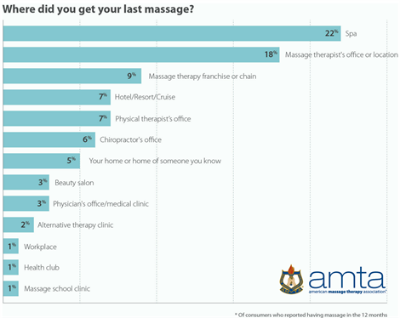

APPENDIX 2
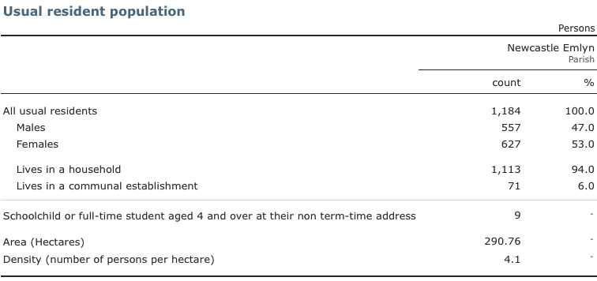

APPENDIX 3

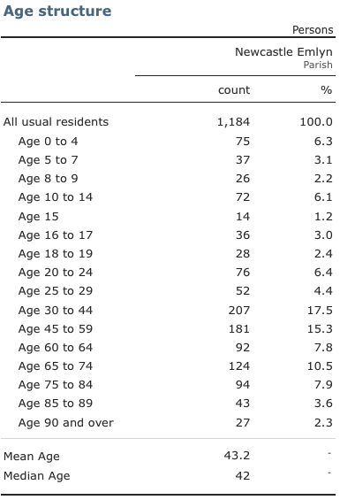

APPENDIX 4

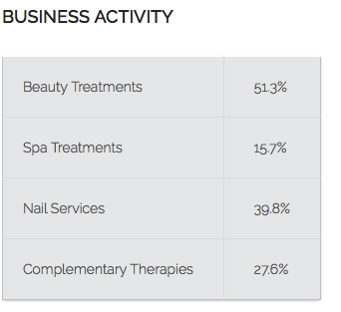

APPENDIX 5



