Bethan Watkins (P140639)
Bwatkins.140639@student.uwtsd.ac.uk
A critical evaluation of Oldwalls Collection and the usage of an e-marketing communication channel
Digital marketing and social media in tourism (M7x02122)
Lecturer: Chris Thomas

Contents Page
Executive Summary…………………………………………………………………………2
1.0. Introduction…………………………………………………………………………..3
1.1. Digital Marketing………………………………………………………..……3
1.2. Oldwalls Collection…………………………………………………………..3
1.3. Fairyhill Business Objective………………………………………………...4
2.0. Social Media………………………………………………………………………….5
2.1. Facebook vs other Social Media……………………………………………5
3.0. RACE analysis……………………………………………………………………….6
3.1. Reach…………………………………………………………………………6
3.2. Interact………………………………………………………………………..7
3.3. Convert & Engage……………………………………………………………7
3.3.1. Stage Models of Digital Media………………………………………7
3.3.2. Online tactical marketing segmentation……………………………8
4.0. Digital Marketing Environment……………………………………………………...8
4.1. Macro-environment………………………………………………………….8
4.2. Customer Journey………………………………………………………….10
5.0. Benefits of Digital Media/Facebook………………………………………………11
5.1. Oldwalls Collection/Fairyhill……………………………………………….11
5.2. Challenges of Digital Media……………………………………………….12
6.0. Conclusion……………………………………………………………………...…..13
7.0. Recommendations…………………………………………………………………13
8.0. Appendix…………………………………………………………………………….14
8.1. Facebook vs other Social Media………………………………………….14
8.1.1. Other Social Media Platforms……………………………………..15
8.2. RACE: Reach-Act (Interact)-Convert-Engage…………………………..16
8.3. Fairyhill contact information-RACE-Interact……………………………..17
8.4. The waves of change………………………………………………………17
8.5. Fairyhills’ advertises showcase on Facebook…………………………...18
8.6. Fairyhills’ Sizzle…………………………………………………………….18
8.7. Purchase decision flow for digital customers……………………………19
8.8. Tangible and intangible benefits from internet marketing………………19
9.0. References………………………………………………………………………….20

Executive Summary
Social Media plays a major part in almost every single person on the planet. Social Media gives people the opportunity to communicate with people from all over the Globe, from Australia to the United Kingdom. Providing a platform for any company to use Social Media as typically creating an account is free while also its free advertisement and sales for the company. The Oldwalls Collection is one of these companies that use Facebook as a way to communicate with potential happy couples reaching the whole of the United Kingdom.
Oldwalls Collection has been hosting wedding venues since 2009, winning ‘Best Wedding Venue’ in 2017 and ‘Welsh-National Wedding Awards’, recently the Oldwalls Collection purchased Fairyhill, a Georgian Hotel in the heart of Gower. In 2017, Fairyhill announced on Facebook that they will be closing as a hotel and reopening as a wedding venue, just as their sister venue had done in past years, causing a mixed reaction from the public.
By using the RACE analysis created by Chaffey (2012), the 5’s of digital marketing, Fairyhill will be able to follow these strategies to ensure that they use their Facebook page as a way to draw people to visit Fairyhill or make a wedding sale. Throughout this process the customer lifecycle will change continuously, providing benefits for any company using Facebook, however, Fairyhill must ensure that this is being handled correctly or this can result to the challenges of an organisation using Facebook.
It is recommended that Fairyhill as Fairyhill will be opening their doors soon to the public as a wedding venue, the digital marketing strategy must fall into place to ensure the company using Facebook as a source to communicate sales and enquiries.

1.0. Introduction
This chapter introduces definitions of digital marketing and social media and what chosen company the researcher has selected for this report.

1.1. Digital Marketing
Throughout the years digital marketing has been known as many different titles such as digital marketing, internet marketing, e-marketing and web marketing. Resulting in digital marketing being defined as “achieving marketing objectives through applying digital technologies and media.” (Chaffey & Ellis-Chadwick, 2016) Chaffey and Ellis-Chadwick (2016) give this brief definition but also reminds that it should be the result that is delivered by the technology. Chaffey, Mayer, Johnston, & Ellis-Chadwick (2003) defines marketing as two distinct meanings; 1) the range of specialist marketing functions and also 2) an approach or concept that can be used as the guiding philosophy.

1.2. Oldwalls Collection
Oldwalls Collection has been hosting wedding venues since 2009, winning ‘Best Wedding Venue’ in 2017 and ‘Welsh-National Wedding Awards’, is a five-star wedding venue in South Wales, Gower. Oldwalls Collection consists of two wedding venues, Oldwalls and the new sister venue, Fairyhill. (Facebook, 2018) (Oldwalls Collection, 2018)
Fairyhill, originally privately owned, was bought by Oldwalls Collection in 2017. On the 17th of November, Fairyhill announced that the hotel will be “transformed into a dedicated wedding and special events venue.” (WalesOnline, 2017) This news received a “mixed reaction” from formal guests of Fairyhill, comments such as “Shame. It was a lovely hotel,” “such a shame, my husband and I loved coming here to eat,” and lastly, “Very sad news – guess it was always on the cards when current owners took over”, however, Fairyhill commented that “We’ve made the decision to transition into a dedicated wedding venue as we believe the reasons for Oldwalls.” (Facebook, 2018) The announcement was made on Facebook while all comments that were mentioned were commented on the story. In March 2018, Fairyhill will be opening exclusively for couples that will be getting married. As Fairyhill is transitioning through this, pictures have been uploaded on Facebook of the extension work that has been occurring but no pictures have been uploading on Instagram, the picture sharing website. Please see Appendix 8.1. Facebook vs Instagram/Fairyhil to view recent pictures of both websites.

1.3. Fairyhill Business Objective
After reviewing Fairyhills’ website, the business objective became very clear of what brides and grooms are to expect of Fairyhill.
“Luxury, First class service. Fantastic food. These are the things we guarantee at our luxurious wedding location. We promise to inject our award-winning formula into your special day. We believe that special moments should happen in the most enchanting of locations” (Fairyhill, 2018)
This report shall analyse whether Fairyhills’ Facebook is using all the elements of Facebook to encourage newly engaged couples to book their wedding at Fairyhill.

2.0. Social Media
“Social Media is the term commonly given to Internet and mobile-based channels and tools that allow users to interact with each other and share opinions and content. As the name implies, social media involves the building of communications or networks and encouraging participation and engagement” (CIPR, 2011)
Social Media can be identified as different things to different people. As many know that Facebook, Twitter, Snapchat are a few of top known social media around the globe, however, Shah & Halligan (2009) expresses that the strategy of how social media platforms are used in an inbound marketing platform.
Putting social media and digital marketing hand-in-hand, social media can be found on digital technologies such as desktop, mobile, tablet and other sorts of digital technologies. (Chaffey & Ellis-Chadwick, 2016)

2.1. Facebook vs other Social Media
Facebook, unlike other social media platforms, is by far the most popular social media platform. According to Price (2015), Facebook has successfully accomplished five categories which are leadership, business acumen, willingness to change, willingness to steal and comprehensive, all factors to create Facebook more successful.
Like all other organisations, Fairyhill joined Facebook under the name of @FairyhillGower. The options that they have to offer for visitors are to view photos of Fairyhill, these could be by professional pictures and videos or pictures that visitors have uploaded which follows reviews that visitors can leave their views.
Nevertheless, Fairyhill makes it very apparent to keep all social media platforms updated, please view appendix 8.1.1 to view Fairyhills’ Twitter and Instagram recent posts.

3.0. RACE Analysis
Smart Insights (2010) created the RACE analysis to help marketers “manage and improve the commercial value that their organisations gain from digital marketing” (Chaffey & Ellis-Chadwick, 2016) In shorter terms RACE helps organisations to review their digital marketing strategy. RACE involved four steps that Fairyhill can use as a digital marketing strategy. Please view Appendix 8.2. the figure of RACE: Reach-Act (Interact)-Convert-Engage.
Chaffey & Ellis-Chadwick (2016) identifies the four steps as reach where Fairyhill should build awareness of the brand, products and services that Fairyhill offers this will result into a traffic of visitors to the website, interact encouraging online presence on the website (Facebook), convert after creating an online presence this can create an online sale, and lastly, engage with the customers from the website to create relationships.

3.1. Reach
As mentioned previously, reach, is the stage where Fairyhill must raise awareness of the organisation and what the organisation has to offer, As Fairyhill is owned by the award-winning wedding venue of Oldwalls, Oldwalls can offer free publicity for Fairyhill. On Facebook, Oldwalls shared a post commenting “Our sister Fairyhill will be following in our footsteps to become an exclusive wedding venue” and another post that was shared five days later commenting “cheers to the next chapter! We can’t thank you all enough for your continued support…” (Facebook, 2017) Overall, these post reached 1,000 ‘reactions’ (likes, loves, etc.) with over 123 comments.
Overall, Fairyhill is successfully reaching to audiences with over 5,850 liking the Facebook page.

3.2. Interact
Fairyhills’ official website offers the visitor to contact the organisation via email or phone, nonetheless, offer visitors to view the Facebook page via the contact page – www.fairyhill.co.uk/contact-us or appendix 8.3 to view the Facebook logo that is available for hyperlink which will take visitors directly to the Facebook website. Wales Online (2016) published an article where they describe the details of the new work that Fairyhill is undertaking with the Facebook link on the article.

3.3. Convert & Engage
Due to the circumstances of the change that is occurring at Fairyhill, which is within the next year, it is unknown whether or not Fairyhill are creating a sales via Facebook and continuing the relationship after sale on Facebook. However, Andrew Hole (2016), owner and director of Oldwalls Collection comments saying that “within the last year Oldwalls venue has increased sales by fifty weddings in the last four years, expecting 230/210 just as popular as the wedding venue in Surrey” (Hole, 2016).

3.3.1. Stage Models of Digital Media
As the Oldwalls Collection is a growing company throughout South Wales and England it is important to understand what their current level of stage models is and what is their next level they should be achieving to complete. Chaffey & Ellis-Chadwick (2016) created the stage models levels helps organisations to develop their digital media experiences and marketing activities. It is believed that Oldwalls Collection/Fairyhill would lay with Level 3 due to the fact that there is a simple static website where visitors are able to search the website to retrieve information and ask queries. This is done via Oldwalls’ personal website and Facebook.

3.3.2. Online tactical marketing segmentation
Due to the current circumstances of Fairyhill being converted to a wedding venue, Facebook was the first social media platform that Fairyhill posted this news on. However, as their sister wedding venue, Oldwalls, has a base of a customer groups, Oldwalls are able to target correct audience for their product and services via Facebook sharing. Fairyhill will need to grow their base of a target audience, creating a market segmentation between the two wedding venues, this can be done by Fairyhill choosing the correct tactical marketing segmentation decisions that Chaffey & Ellis-Chadwick (2016) have created.
In order for Fairyhills’ Facebook page to be used to build engagement with the target audience, Decision 5: Customer engagement and social media strategy of Chaffey & Ellis-Chadwick (2016) have been selected as a platform that Fairyhill can redevelop their Facebook website to base their intentions on customer engagement strategies.

4.0. Digital Marketing Environment
Digital marketing environment refers to “the contexts in which firms operate, including how they relate to customers and other businesses participating in their markets”. (Chaffey & Ellis-Chadwick, 2016) The digital marketing environment can be broken down into two parts which are micro and macro-environment. According to Chaffey & Ellis-Chadwick (2016), micro-environments is when the stakeholder’s interactions influence the organisation’s marketplace and the macro-environments are the broad forces affecting the organisation in the marketplace.

4.1. Macro-environment
The macro-environment forces can influence digital marketing. The macro-environment can deal challenges due to the characteristics of the environment of the company. For example, due to the change of Fairyhills’ hotel getting converted into a wedding venue, the Facebook page will have changed from promoting hotel services to wedding services, this change is rapid. These changes can be presented in Appendix 8.4 the waves of change. By using the PESTLE analysis, Fairyhill is able to use this mnemonics as a way to determine the challenges of macro-environment of how customers may use the Facebook website.
Technological forces can play a major part in the way that the macro-environment can affect Fairyhill. Currently, there is no mobile app that’s available for the wedding venue, however, by using your mobile phone, Facebook is easy and accessible via the Facebook app. However, as Instagram is becoming more increasingly popular, this may be a threat to the Facebook as Fairyhill is in-fact uploading pictures frequently onto their page and also the hashtag of Fairyhill on Instagram has over 1,500 posts.
Economic factors could include the influence of customer spending on the company by doing this Facebook is able to access customers profile, this can reveal their age, gender, lifestyle and working patterns and occupations. This can be put into demographics to help the company understand what customers are viewing and commenting Fairyhills’ Facebook. As Facebook is globally known, the target audience can reach globally, this can cause cultural differences and Facebook again can access all areas of what the company will need to know about the customer.
In 2017, The Guardian (2017) published an article stating that the Government is considering changing the legal status of Facebook due to the copyright infringement and the spread of extremist material online, therefore, Facebook pages have a limited responsibility of what appears on the page. Thus, can cause political issues for companies as adverts that customers may not like may appear and cause friction.
Social Medias have the obligation to maintain all laws for customers, such as data protection and privacy law where all information that is stored on Facebook such as the Facebook Messenger must be deleted, disability and discrimination law ensuring that if there has been a picture uploaded on Facebook that can cause discrimination, while using the trademark name on Facebook the brand must be protected, and intellectual property, contract law and online advertising law.

4.2. Customer Journey
When viewing Fairyhills’ Facebook page, customers will be going through the customer journey of the 5S of e-marketing. Chaffey & Smith (2013) explains that the 5S’s of e-marketing are sell, serve, speak, save and sizzle. Selling is key for any company and with Facebook selling couldn’t be made any easier with global access for anyone worldwide. Through Facebook there may be a deal on the page has been posted directly by Fairyhill this can offer customers a discounted rate for a wedding. Also, due to the nature of the wedding business, showcases can be advertised which invited customers to visit the wedding venue, please view Appendix 8.5 to view an advertisement for their showcase via Facebook.
If customers wish to continue their experience and visit the wedding venue they are able to message Fairyhill directly with any queries via the Facebook Messenger app but also via comments and reviews. Also, in the ‘about’ section on Facebook Fairyhill contact information, where Facebook has automatically inserts ‘typically replies within a day’, which can help customers understand the expectancy of messages being answered. The fourth S is Save, where speaking can be continued and the customer may achieve discounts through the messenger themselves. Finally, the last S is Sizzle, according to Chaffey and Smith (2013) Sizzle is achieved through providing a new proposition and new experience online while at the same time appearing familiar. As customers can ‘Like’ the Facebook page, updates of Fairyhill will continue after all other S’s have been completed. Fairyhill has done this by uploading frequently, please see Appendix 8.6 to view the video created by Fairyhill to entice customers to visit the venue.
These steps should be completed in order to complete the customers’ journey. Smart Insights (2014) also created a cycle that shows the customers journey and how the organisations must view the customers’ journey. Please view Appendix 8.7 to view the purchase decision flow.

5.0. Benefits of Digital Media/Facebook
Digital Media has tangible (physical things) and intangible (non-physical) benefits, please view Appendix 8.8 to view Chaffey and Ellis-Chadwick’s (2016) table that was created where these benefits are discussed, please view appendix 8.8. This section will analyse this figure for Oldwalls Collection and how digital media is a benefit for the company.

5.1. Oldwalls Collection/Fairyhill
Tangible Benefits
As Oldwalls Collection/Fairyhill is a wedding venue, the main aim for any company is to increase sales from new sales giving the organisation new customer numbers and new markets, this can be done as mentioned previously with advertising Showcases’ online through social media. By creating cross-sales with existing customers, again, this will lead to an increase in sales. This can be done by upselling products and services that Oldwalls Collection has to offer via pictures from past couples that have had their weddings at Fairyhill, this could be centrepieces, chair covers, drinks on arrival or even canapes. As the increase in sales will continue, Oldwalls may find cost reductions by using digital marketing resulting to less staff required to meet with the high demand in couples, the increase of online-sales through Facebook and their personal website and also being able to send an online copy of the brochure that will cut printing and distribution costs.
Intangible Benefits
Facebook being one of the most popular social media sites the corporate image communications will rise due to the increased revenue from the brand image that the communications challenges are more responsive via Facebook Messenger which leads to excellent customer service standards and the 5* ratings that Fairyhill have while also receiving feedback from customers which employees are able to monitor and improve their services.

5.2. Challenges of Digital Media Communications
As proven, Facebook can be a reliable source to use for any business where the benefits exceed expectation, however, with every social media site, Facebook has challenges that every company can expect.
According to Businessinfo (2018) has identified four main downsides that Fairyhill should consider. As Facebook is a 24-hour website and anyone can access the page the time and resources may be an issue. After setting up the Facebook page Fairyhill would find it wise to find one member of staff to take on the social media duties. However, the staff member that manages the Facebook page must be trained to ensure they have the right skills for social media. As Facebook is a free platform, a paid advertisement may be an option, however, if Fairyhill has a budget due to their changing work environment this could cause money issues. Finally, although Fairyhill is receiving 5* on their Facebook page, please may leave negative feedback where other public people can reply to the comment.

6.0. Conclusion
To conclude, Fairyhill Facebook website currently is rated 4.8 out of 5* on Facebook. Their page is regular updated where pictures, blogs and comments can be found and their response time to customers is typically within a day. Overall, there is still some minor information that the company will need to update as it is still being promoted as a hotel in the ‘about’ page, but with help from the sister wedding venue Oldwalls, it is believed the trained staff is able to make the Facebook page highly successful.

7.0. Recommendations
As Fairyhill is a sister wedding venue of Oldwalls, the success of weddings should be high in demand. Thus, the customer enquiries will increase and the demand for responsiveness on Facebook will be key to ensure sales will be completed. Fairyhill should now structure a strategic plan following either RACE or the 5’s to ensure that they are on the right to track to improve their Facebook page. As Fairyhill is trying to sell a dream wedding venue, all social media platforms need to continue being updated daily to increase the number of followers on each platform. Although Fairyhill has created aims and objectives for the wedding venue, it is believed that the Facebook page could have a unique selling point that will differentiate the venue from their sister venue. As for their Facebook page in general, the ‘About’ page must be updated to match the aims, objectives and the unique selling point as currently, the Facebook page is still selling as a hotel, not a wedding venue.

8.0. Appendix

8.1. Facebook vs other Social Medias
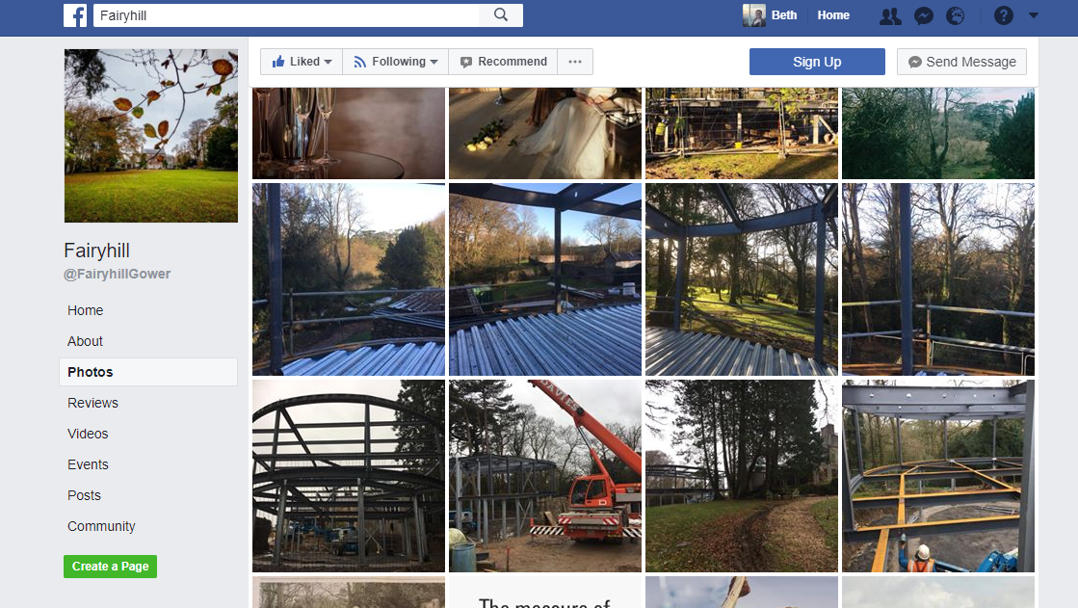
Fairyhill Facebook pictures of new extension. (Facebook, 2018)

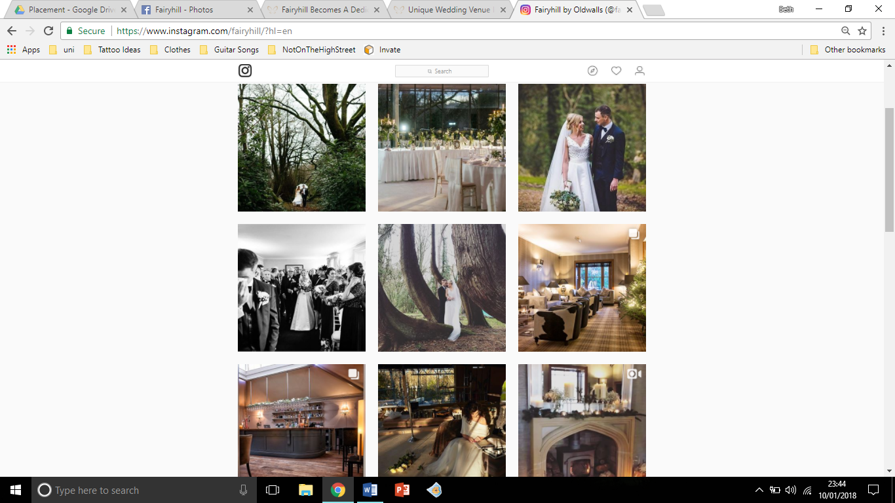
No recent uploads of extension at Fairyhill on Instagram. (Instagram, 2018)

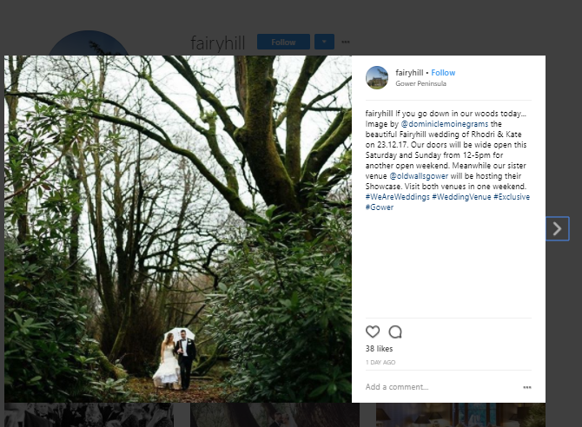
8.1.1. Other Social Media Platforms

Most recent post by Fairyhill on Instagram 10/01/2018 (Instagram, 2018)

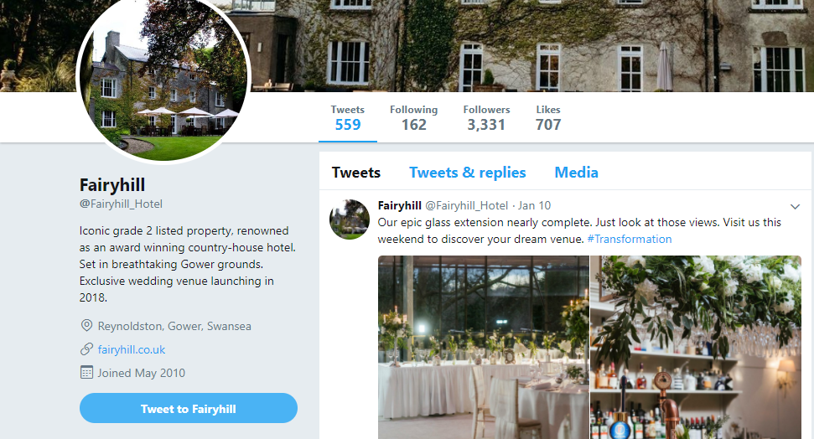
Fairyhills’ Twitter account, recent activity was 10th January 2018 (Twitter, 2018)

8.2. RACE: Reach-Act (Interact)-Convert-Engage

(Chaffey & Ellis-Chadwick, 2016)

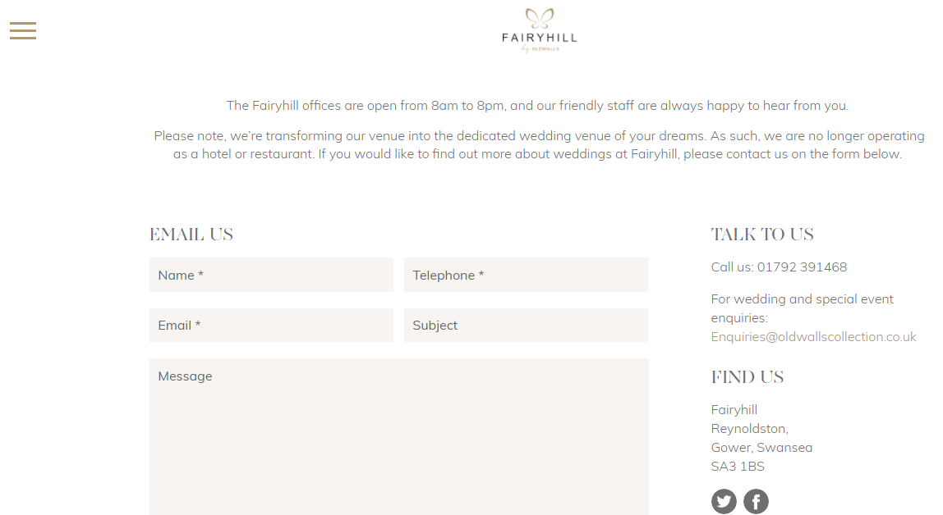
8.3. Fairyhill contact information – RACE- Interact
(Fairyhill, Contact Us page, 2018)

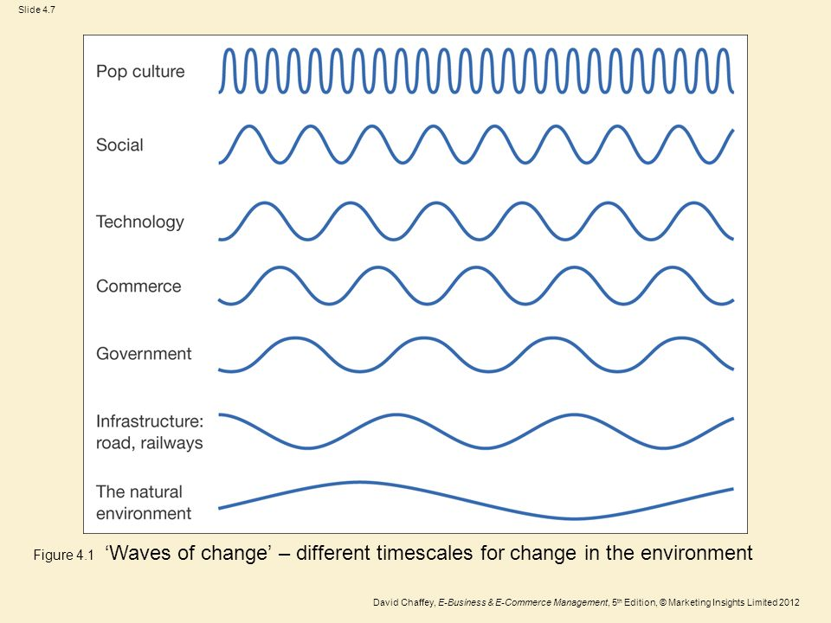
8.4. The waves of change

(Chaffey & Ellis-Chadwick, 2016)

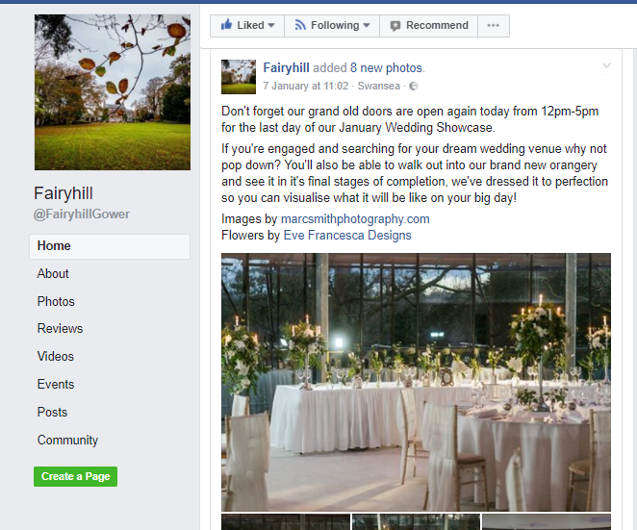
8.5. Fairyhills’ advertises showcase on Facebook

(Facebook, 2018)

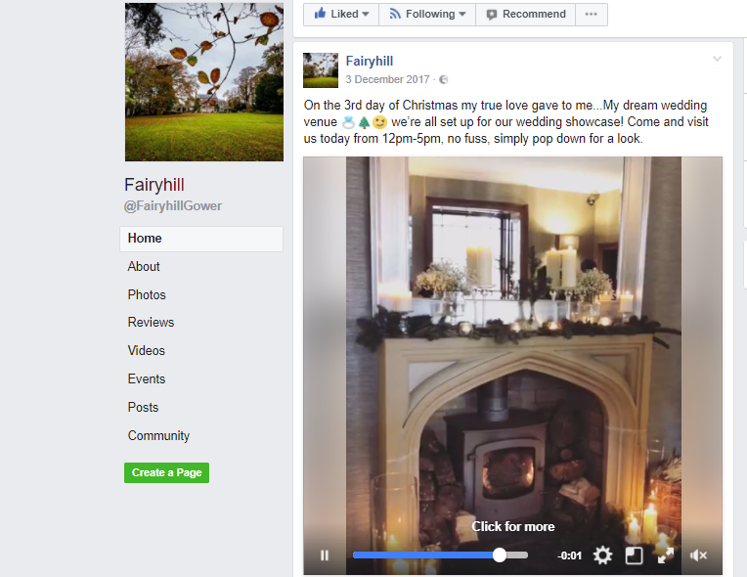
8.6. Fairyhills’ Sizzle

(Facebook, 2018)
Video created by Fairyhill to show customers that doors are open and the winter season has fallen on the Facebook website.

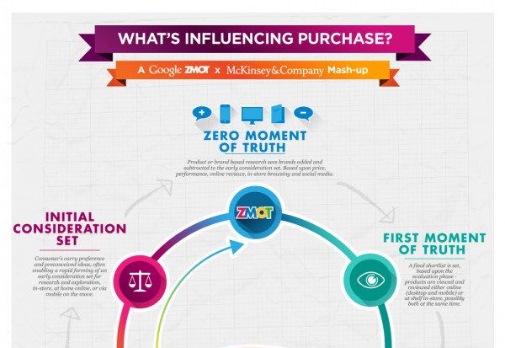
8.7. Purchase decision flow for digital consumers
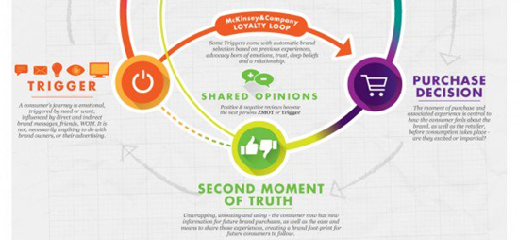
(Smart Insights, 2014)

8.8. Tangible and intangible benefits from internet marketing

(Chaffey & Ellis-Chadwick, 2016)

9.0. References

Businessinfo, 2018. Sales and marketing>Social Media. [Online]
Available at: https://www.nibusinessinfo.co.uk/content/advantages-and-disadvantages-facebook-business
Chaffey, D. & Ellis-Chadwick, F., 2016. Digital Marketing: Strategy, Implementation and Practice. Sixth Edition. Harlow: Pearson Education Limited.
Chaffey, D., Mayer, R., Johnston, K. & Ellis-Chadwick, F., 2003. Internet Marketing: Strategy, Implementation and Practice: Second Edition. Harlow: Pearson Education Limited.
Chaffey, D. & Smith, P., 2013. Emarketing Excellence: planning and optimizing your digital marketing. Oxon: Routledge.
CIPR, 2011. Social Media marketing best practise guide, May 2011 edition. CIPR Social Media Panel.
Facebook, 2017. Oldwalls Gower. [Online]
Available at: https://www.facebook.com/oldwalls.leisure/
Facebook, 2018. Fairyhill. [Online]
Available at: https://www.facebook.com/FairyhillGower/
Facebook, 2018. Fairyhill Photos. [Online]
Available at: https://www.facebook.com/pg/FairyhillGower/photos/?tab=album&album_id=950073225033459
Facebook, 2018. Oldwalls Collection. [Online]
Available at: https://www.facebook.com/oldwalls.leisure/
Fairyhill, 2018. Contact Us. [Online]
Available at: www.fairyhill/contact-us
Fairyhill, 2018. Luxury Weddings In South Wales. [Online]
Available at: http://fairyhill.co.uk/weddings
Hole, A., 2016. Oldwalls Collection [Interview] 2016.
Instagram, 2018. Fairyhill. [Online]
Available at: https://www.instagram.com/fairyhill/?hl=en
Oldwalls Collection, 2018. Weddings at Oldwalls Gower. [Online]
Available at: http://www.oldwallsgower.com/weddings/
Price, M., 2015. How Facebook Succeeded When Other Social Media Sites Failed. Innovation Insights.
Shah, D. & Halligan, B., 2009. Inbound Marketing: Get Found Using Google, Social Media and Blogs.. New York: John Wiley & Sons.
Smart Insights, 2010. Introducing RACE: a practical framework to improve your digital marketing. [Online]
Available at: www.smartinsights.com/digital-marketing-strategy
Smart Insights, 2014. What influences purchase of your product or service?. [Online]
Available at: https://www.smartinsights.com/marketplace-analysis/consumer-buying-behaviour/what-influences-purchase/
The Guardian, 2017. UK government considers classifying Google and Facebook as publishers. [Online]
Available at: https://www.theguardian.com/technology/2017/oct/11/government-considers-classifying-google-facebook-publishers
Twitter, 2018. Fairyhill. [Online]
Available at: https://twitter.com/Fairyhill_Hotel
WalesOnline, 2016. Five star Fairyhill Hotel snapped up by luxury wedding company Oldwalls in seven-figure deal. [Online]
Available at: Five star Fairyhill Hotel snapped up by luxury wedding company Oldwalls in seven-figure deal
WalesOnline, 2017. One of Wales' top hotels is closing and will reopen as a wedding venue. [Online]
Available at: http://www.walesonline.co.uk/business/business-news/one-waless-poshest-hotels-not-13912378?service=responsive#ICID=FB-Wales-main

