Digital Skills and Research Methods
BMSW4003_DSR_JUNE 20_TERM 2_A2 - HSC GROUP 1

Research report: Virtual Learning Environment

Student: Ginka Borisova
Student I.D.: 1915313
Lecturer: Terry Walcott

Table of Contents
Chapter 1: Introduction 3
1.1 Introduction 3
1.2 Research Title 3
1.3 Research Background and Rationale 3
1.4 Research Aims and Objectives 3
Chapter 2: Literature Review 4
Chapter 3: Methodology 5
Chapter 4: Data Analysis 5
4.1 Primary Data Analysis 5
4.2 Secondary Analysis 12
Chapter 5: Conclusions and Recommendations 12
5.1 Conclusions 12
5.2 Recommendations 12
References 13
Appendix 15

Chapter 1: Introduction

1.1 Introduction
The following research report illustrates the various impacts of virtual learning environment (VLE) on students’ learning experience. The results are derived from both primary and secondary data collected to fulfill the set of objectives designed for this research endeavor. The primary data was collected from a survey conducted on 20 students from the University of Wales Trinity Saint David London Campus. For secondary analysis, five articles of published literature have been analysed.

1.2 Research Title
Impact of Virtual Learning Environment on Students’ Learning Experience

1.3 Research Background and Rationale
Various forms of technology are now being used to ease e-learning with several applications demonstrating the use of a combination of blogs, collaborative software and virtual classrooms. Education systems are encouraging the use of VLEs to enhance handling of courses through the use of a consistent and standard interface which is uniform through an institution (Phungsuk et al., 2017). Student engagement has been observed to be a significantly major influencing factor on the learning outcomes in online learning. VLE also promotes student engagement and helps teachers keep track of the same through usage logs and digital traces (Boulton et al., 2018). To this end, VLEs have been evidently observed to create an engaging environment which has substantial influence on the learning experiences of students. Hence, this study is aimed at studying these impacts through primary and secondary data analysis.

1.4 Research Aims and Objectives
Aim: To study the impact of VLE on students’ learning experiences
Objectives:
- To analyse existing literature on VLE and how it has impacted learning experiences
- To investigate the various benefits and limitations experienced by students at University of Wales Trinity Saint David London Campus using VLEs like MOODLE
- To understand if VLE improves learning experiences for students
- To evaluate the convenience of VLEs in terms of learning experiences
- To assimilate and analyse the results from primary and secondary data to provide evidence based conclusions and recommendations

Chapter 2: Literature Review
Several British Higher Education Institutions or HEIs have adapted certain forms of VLEs. These vary from commercial packages like Blackboard or Desire2Learn to open-source VLEs such as MOODLE. The teachers mostly use these environments as simple depository for study materials allowing students to access a wide range of reading lists and power point presentations. As a consequence of such practices, the use of VLEs has significantly increased over the past few years. Bart et al., (2016) found that the increase of usage of VLEs is credited to the perceived ease of use by both teachers and students. The factor has encouraged teachers to invest in teaching through VLEs. One of the various and obvious advantages of Moodle is the access to a wide range of study materials through the web. The platform caters to students and teachers by dividing the functionalities into two different classes: resources and modules. While resources constitute the instructional materials which are created and uploaded to the cloud digitally, modules are implemented to provide an interactive platform for students and teachers (Derkacz-Padiasek, 2017). Moodle also provides communication modules such as Forum. This forum nurtures asynchronous discussions where students are allowed to introduce and then brainstorm their ideas. This way there is a two-way conversation through digital messages between the tutor and their students. Vuopola et al., (2016) studied the interactions between students in different learning environments. They discovered that group-related interaction contributed more to increased concentration on tasks and coordination among the group while also enhancing the planning and organization skills of the students. The use of VLEs such as Moodle and SecondLife further fostered the positive results. These VLEs were shown to increase the number of answers and correspondences in synchronous discussions and enhance the metacognitive discussion skills such as organization of group work. Thereby collaborative study practices through VLEs improve various skills of the students such as creativity, critical thinking and self-motivation. Yang et al., (2018) came up with an emotion recognition model which allows teachers to recognize the emotions of students in a VLE. The model has been assured of efficiency and effectiveness through the use of HAAR Cascades that detect eyes and mouth to identify emotions through neural network approach. The implementation of this model can open future doors of research to further enhance the learning experience of students through virtual learning environments. The use of such models can facilitate teachers to perceive their students better and accordingly change and modulate their teaching strategies to suit the needs of their students. Jackson (2017) stated that MOODLE architecture supports the collaborative use of virtual pedagogy with both the learner and the teacher at the focus of the learning engagement. The research stressed on the importance of MOODLE as a cost effective and efficient learning environment for students in locations where the economic and social conditions are substantially weak, for example Sierra Leone which recently experienced a pandemic. Considering this study and the current situation of the Covid Pandemic, it is therefore important to study and understand the various impact VLEs might have on students’ learning experience. This will further help future researches to enhance learning experiences and provide an efficient alternate method of education is times of crises.

Chapter 3: Methodology
The following research entails two significant approached of data collection: primary and secondary data collection. To obtain primary data, the researcher has conducted an online survey on 20 students from the University of Wales Trinity Saint David London Campus associated with the health and social care group. The survey was constituted of 15 questions with multiple choice options. The participants of the survey will remain anonymous and their consent to use their responses for this research has been taken. The survey form did not require participants to reveal their identity. This data collection technique has been chosen adhering to the on-going pandemic quarantine guidelines, mainly to avoid physical contact. For secondary data collection purposes the researcher has referred to five published journal articles to evaluate researchers’ understanding about the influence of VLE on students’ learning experiences.

Chapter 4: Data Analysis

4.1 Primary Data Analysis
4.1.1 Demographics and prior experience of VLE

Twenty students from the health care studies department of University of Wales Trinity Saint David London Campus participated in the survey. Most of the participants have been in the University for a year or more. Maximum of the correspondents, 65% of them, have had prior experience of using VLE for other courses. This shows that the students are mostly experienced in the technology.
4.1.2 Skills to operate in VLE

A significant population of the correspondents, 65% of them, have agreed that they possess the necessary basic skills require to operate in a VLE. The result reflects that the use of VLE requires a few skills that are mostly possessed by students due to the advancement in technologies. Students are already equipped with the fundamental knowledge required to operate VLEs and thrive within them.
4.1.3 Moodle Usage

Here too, a significantly bigger majority of the correspondents have confirmed that they have been using Moodle for learning purposes. This shows that Moodle has indeed gained popularity among students as predicted in the article by Bart et al., (2016). Therefore, these statistics prove that Moodle has become a common mode of learning among students.
4.1.4 Accessibility of Moodle

The statistics of the responses in this question show that 60% of the respondents find Moodle easy to access. Meanwhile, a moderately significant 40% of the respondents do not find Moodle very accessible. This shows that even though Moodle has gained popularity as a VLE, there are some who have difficulties to access this platform for online courses.
4.1.5 Improvement of learning experience

The results from this answer reflect the opinions of the student on the impact that Moodle has had on their learning experience. About 20% strongly agree that Moodle has improved their learning experience while 35% agree to this, which sums up to 55% of the respondents experiencing an improvement in their learning that forms the majority. Therefore, it can be said that maximum students have improved learning experiences.
4.1.6 Impact on learning skills and performance

The chart shows a clear majority of 60% of the respondents to be in agreement of the fact that Moodle has contributed in improving their learning skills and performance. This aligns to the results of the research conducted by Vuopola et al., (2016) which states the use of VLEs like Moodle enhances the critical thinking skills of students. However, a small portion of the respondents has not observed an improvement in their learning skills and performance.
4.1.7 Classroom learning versus VLE

The survey raised a question on preference of the respondents between VLE and the traditional classroom learning. The results clearly indicate that a majority of the students prefer virtual learning environments to traditional classroom learning environments. This further lays foundation to the claim that VLE enhances learning experience for students.
4.1.8 Interactions with tutors

The clear majority of 55% in the chart indicates that the students feel Moodle has enhanced their interactions with their teachers. This also aligns with the findings of Vuopola et al., (2016) which stated that the interactions were increased on platforms like Moodle. Therefore, Moodle also has a positive impact on the teacher-student interactions.
4.1.9 Engagement in Learning Experiences

The results show that 65% of the participants of the survey feel their engagement has enhanced due to the use of VLE. This confers to the study by Boulton et al., (2018) which states that VLE allows the monitoring of student engagement and thereby increases it. The results further confirm that students are more eager to indulge in VLEs due to the various advantages experienced by them.
4.1.10 Accessibility of Instructions

35% of the respondents have strongly agreed while 15% have agreed to the query that instructions given through VLEs are easier to access. Meanwhile, about 40% have disagreed to this. Even though there is a mixed reaction to this question, the majority of 50% still indicates that instructions given via Moodle are more easily accessible than physical notices and notes.
4.1.11 Standardising VLEs

The statistics to this answer reveals that students would prefer for VLEs to become the standard method of teaching with a majority of 60% who agreed and strongly agreed to this statement. Meanwhile, 30% of the responders disagree with the standardising of VLEs over the classroom-learning environment.
4.1.12 Recommending VLE

For the last question of the survey, 65% of the responders will recommend VLEs such as Moodle to other students and only 10% will not recommend VLEs to other students. This further confirms the increase of popularity of VLEs and the potential development and preference of this platform in the future.

4.2 Secondary Analysis
According to the study conducted by Gulbinskienė et al., (2017) students prefer Moodle for learning activities as crucial as learning languages. The results also showed an improvement of the metacognitive awareness of the student subjects. Al Bataineh et al., (2019) also found that the use of VLE in a blended learning environment setting enhanced the learning experience of the students. Borsova et al., (2016) stated that implementation of VLE allows teacher to have one central location which is accessible to students in various locations. Another study by Bogusevschi et al.,(2020) use of virtual Learning environment to create 3D laboratories enhanced the learning experiences of students in subjects like Physics. The subjects also expressed interest in such approaches. Moodle learning platform is therefore an effective platform that fosters interactive teaching and learning process. It promotes versatility in teaching and enhances learning outcomes foe students (Jackson, 2017).

Chapter 5: Conclusions and Recommendations

5.1 Conclusions
The above report highlights the impact of Virtual Learning Environments on students. While the impact is mostly positive, there are some flaws of the approach that cannot be ignored. The platform has a drawback in terms of students being able to access instructions in which many students still prefer physical notes and notices to Moodle messages.

5.2 Recommendations
The platforms can further enhance learning experiences by improving their communication system. Even though students experience more interaction with their teachers, some find it difficult to access written instructions. The platforms can also entail collaborative environments to allow better management of students.

References
Al Bataineh, K.B., Banikalef, A. and H Albashtawi, A., (2019). The effect of blended learning on EFL students’ grammar performance and attitudes: An investigation of Moodle. Arab World English Journal (AWEJ) Volume, 10.
Bogusevschi, D., Muntean, C. & Muntean, G.M. (2020). Teaching and Learning Physics using 3D Virtual Learning Environment: A Case Study of Combined Virtual Reality and Virtual Laboratory in Secondary School. Journal of Computers in Mathematics and Science Teaching, 39(1), 5-18. Waynesville, NC USA: Association for the Advancement of Computing in Education (AACE). Retrieved August 17, 2020 from https://www.learntechlib.org/primary/p/210965/.
Borysova, A., Belikova, O., Kolesnyk, A. and Manuyenkova, O., (2016). Advantages of using moodle platform in teaching «english for professional communication».
Boulton, C. A., Kent, C., & Williams, H. T. P. (2018). Virtual learning environment engagement and learning outcomes at a “bricks-and-mortar” university. Computers & Education, 126, 129–142. doi:10.1016/j.compedu.2018.06.031
Derkacz-Padiasek, T., (2017). The moodle platform in higher education. Наукові записки Національного університету Острозька академія. Серія: Філологічна, (64 (1)), pp.9-13.
Gulbinskienė, D., Masoodi, M., & Šliogerienė, J. (2017). Moodle as Virtual Learning Environment in Developing Language Skills, Fostering Metacognitive Awareness and Promoting Learner Autonomy. Pedagogika, 127(3), 176-185. https://doi.org/10.15823/p.2017.47
Jackson, E. A. (2017). Impact of MOODLE platform on the pedagogy of students and staff: Cross-curricular comparison. Education and Information Technologies, 22(1), 177–193. doi:10.1007/s10639-015-9438-9
Jackson, E.A., (2016). Proposal for virtual ICT use in Sierra Leone education system: A case of Moodle. Journal of Applied Thought, 5(1).
Phungsuk, R., Viriyavejakul, C., & Ratanaolarn, T. (2017). Development of a problem-based learning model via a virtual learning environment. Kasetsart Journal of Social Sciences, 38(3), 297–306. doi:10.1016/j.kjss.2017.01.001
Rienties, Bart; Giesbers, Bas; Lygo-Baker, Simon; Ma, Hoi Wah Serena and Rees, Roger (2016). Why some teachers easily learn to use a new virtual learning environment: a technology acceptance perspective. Interactive Learning Environments, 24(3) pp. 539–552.
Vuopala, E., Hyvönen, P., & Järvelä, S. (2016). Interaction forms in successful collaborative learning in virtual learning environments. Active Learning in Higher Education, 17(1), 25–38. doi:10.1177/1469787415616730
Yang, D., Alsadoon, A., Prasad, P. W. C., Singh, A. K., & Elchouemi, A. (2018). An Emotion Recognition Model Based on Facial Recognition in Virtual Learning Environment. Procedia Computer Science, 125, 2–10. doi:10.1016/j.procs.2017.12.003

Appendix
Virtual Learning Survey
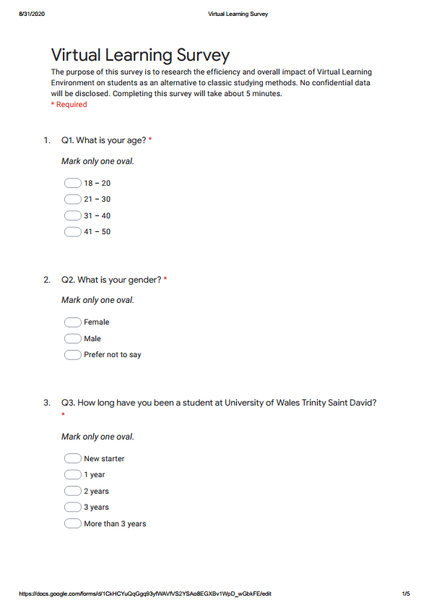
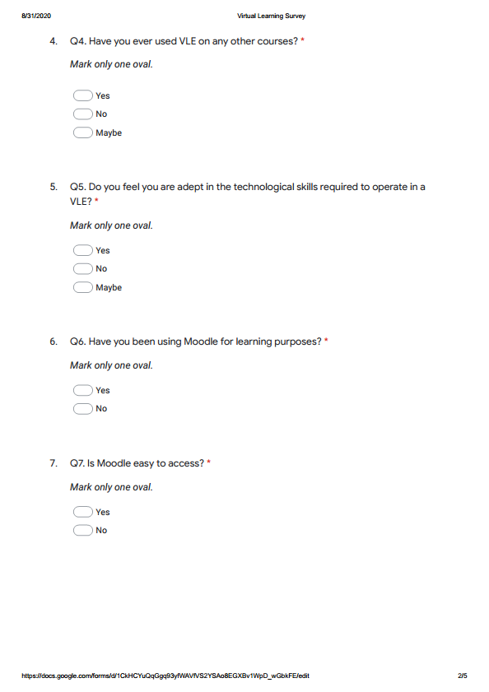

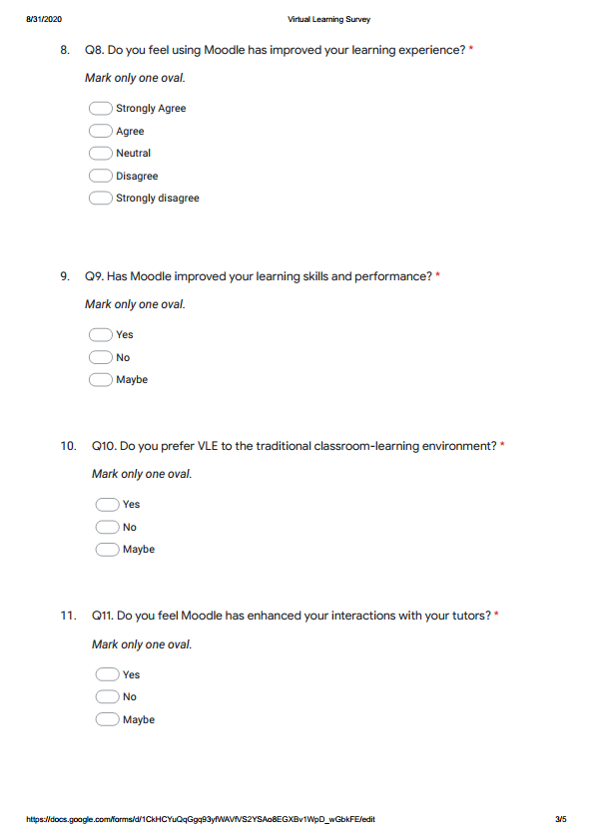

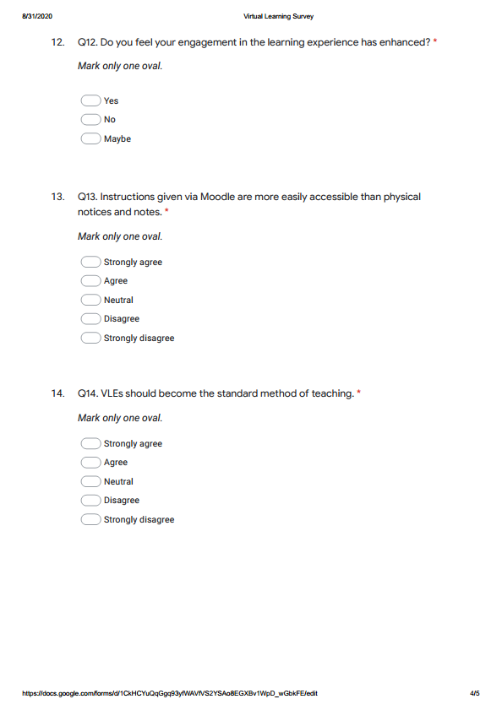

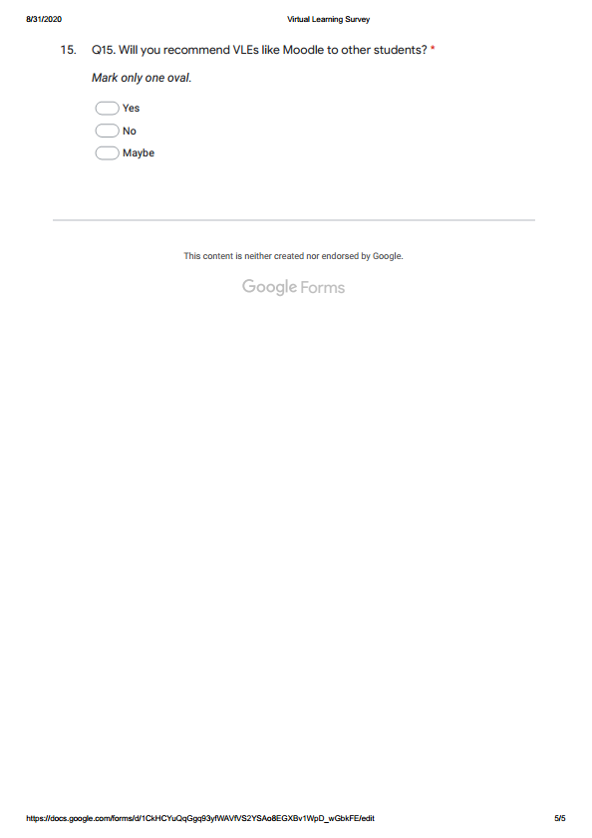

Microsoft Excel Graphs

