Fundamentals of Electrical and Electronic Systems

555 Timer Circuit Assessment

Jamie Hodges 2318712

HNC Level 4

2023 – 2026

December 2024

Contents

- Introduction
- Schematic of Circuit
  - Design
  - Calculations and Results
- Bread Board Circuit
  - Design
  - Results and Collection
- Conclusion
- References

Introduction

The subject of this report is the comparison of a simulation and bread board build of a 555 timer circuit. Voltage readings were taken at 2 points to compare the physical build with the simulation, using Proteus software.
A 555 timer is an IC (integrated circuit) used in a variety of timer, delay, pulse generation and oscillator applications. The primary use is oscillator applications as it can create monostable, bistable and astable oscillators [1]. For this specific example, astable oscillators are the function of the 555 timer as it provides a continuous, square wave output [1].
The 555 timer is named from the three 5kΩ resistors in the threshold driver chain from pin 8 to pin 1 [1]. The pin diagram is shown in Figure 1.
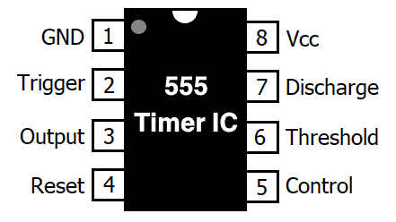

Figure 1: Pin diagram of a 555 timer [2]

Schematic of Circuit

Design
The circuit drawing from the task descriptor is shown in Figure 2. When functioning correctly, the circuit will have interchanging on and off times for the 2 LEDs with an off time overlap giving a small delay between the LEDs turning off and on. This is because of the astable oscillations provided by the 555 timer [1] which charges the capacitors through resistors R1 and R2 but discharges only through R2 as it is connected to pin 7, the discharge pin. The on and off time of the circuit are determined by the value of resistance from R1 and R2 as they control the rate the capacitor charges and discharges. Figure 2 also shows a connection between pins 2 and 6 which allows the circuit re-trigger itself after every full cycle, making it a complete oscillator once connected to a power supply [6]
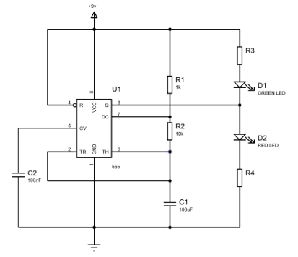

Figure 2: 555 timer circuit drawing

The circuit as shown in Figure 2 contains the following:
- 555 Timer (U1)
- 4 Resistors (R1-4)
- 2 Light-Emitting Didoes (D1, Green, and D2, Red)
- 2 Capacitors (C1 and C2)
All of the components listed above, are shown in Figure 2 using the internationally recognised symbols, and their individual units listed below their labelling. The layout of the 555 timer in Figures 1 and 2 differ from where the pins are connected. The 555 timer in Figure 1 has the same layout as that of the one used later on in section 3 and the one shown in Figure 2 has the same layout as the Proteus software. This caused unnecessary confusion for the student when modelling in the two different ways however it made the simulated design easier to understand as shown in Figure 3.
This circuit drawing was then recreated within Proteus software to simulate the function of the 555 timer. The simulation required the resistance vales for R3 and R4 prior to running as otherwise the software would fail due to lack of values. These calculations are discussed further in section 2.2 of the report. Figure 3 shows the circuit diagram within Proteus as a replica of the drawing from the task descriptor. The correct components were laid out in the same way as the original circuit diagram with junctions and nodes also being placed correctly which are represented by dots between the wires. Junctions and nodes demonstrate where there are connections between different components that would otherwise not be visible. Where two or more wires overlap and a junction or node is not present, this demonstrates that there is no connection between the wires, such as between the oscilloscope and the wire between R3 and D2 in Figure 3.
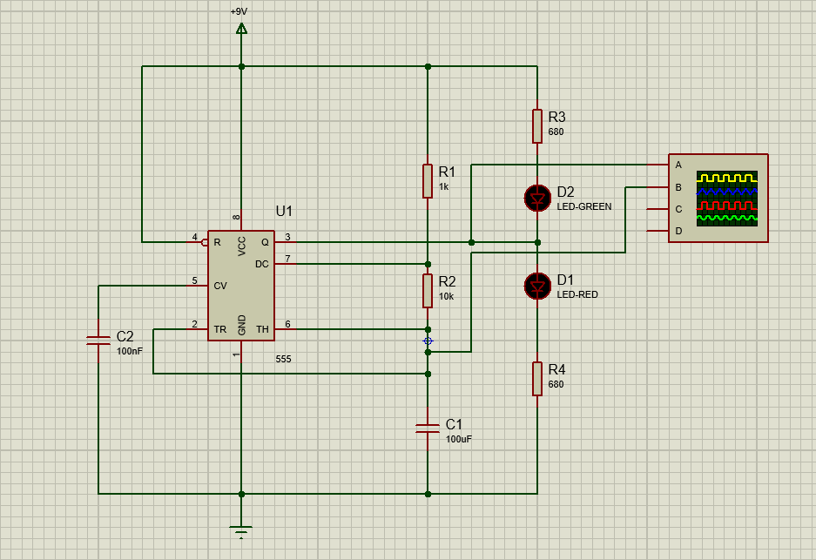

Figure 3: 555 timer circuit diagram in Proteus

Calculations and Results
Prior to running the simulation, the values of resistors R3 and R4 needed to be calculated for the circuit to run correctly. Information was extracted from Proteus to find the forward voltage (2.2 V) and the full drive current (10 mA) of the LEDs. As both D1 and D2 were the same, the resistance required from R3 and R4 is equal. The formula for calculating the resistance is:
R = V / I
Resistance = (Voltage of the Circuit – Forward Voltage of LED) / Full Drive Current of the LED
Therefore, the calculation is (9 – 2.2) / 10 x10⁻³ which is equal to 680Ω.
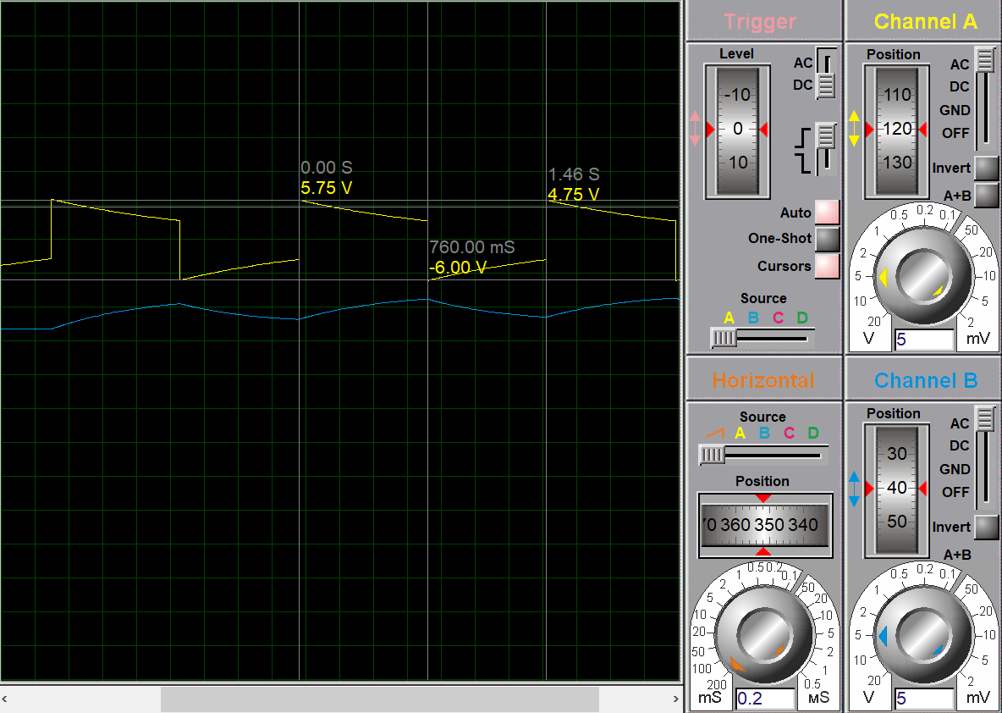
From the oscilloscope connected to the circuit, 2 waveforms are generated across the 2 components of D1 and C1 as shown in Figure 4. The 2 waveforms are in phase and the wavelengths are both equal across the 2 components. Therefore, the calculations of time period, on time and off time for both waveforms are equal. The results were taken from the software using the inbuild oscilloscope cursors to mark points along the waveform.

Figure 4: Waveforms from D1 (Channel A) and C1 (Channel B) from Proteus
The results extracted from Figure 4 gave the following values.
Figure 5: Table of results from the Proteus simulation
Time Period (s) | 1.46
On Time (ms) | 760
Off Time (ms) | 700

The on and off time demonstrate the positive and negative voltages across the LED and capacitor, which is shown by the LED flashing on and off. The time period is one full wave cycle from when the LED turns on and the capacitor begins charging to when the LED will turn on again and the capacitor has finished discharging.
The frequency of the waveform can also be calculated from these results using the formula:
F = 1 / T
Frequency = 1 / Time Period
Therefore, the calculation is (1 / 1.46) = 0.685 Hz

Bread Board Circuit

Design
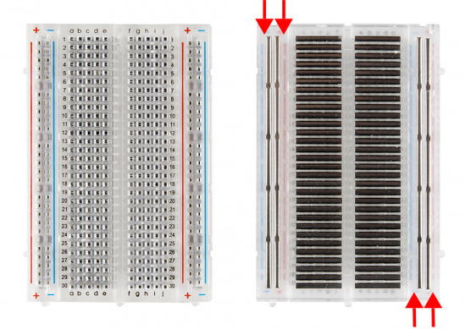
A bread board is a rectangular plastic board with holes divided into 4 sections [3], 2 bus strips and 2 terminal strips [4]. They are solderless boards used to create semi-permanent circuits to trial design and components [3]. They have metal strips running underneath the holes to form connections as shown in Figure 6 [5]. Terminal strips form horizonal connections across 5 pinholes and bus strips form vertical connections spanning the length of the board. Bus strips are primarily used for grounding and connecting a power supply to the circuit and its components whereas terminal strips house the components of the circuit.
Figure 6: Anatomy of a bread board [5]

3.2. Results and Collection
The bread board circuit was created using the drawing from Figure 2 but due to the layout, could not be identically replicated. Some of the components had to be move around based on the pin locations of the 555 timer as the layout on Proteus is not the same as the 555 timer used when physically modelling as shown in Figures 1 and 3. This led to a few issues when modelling as the wires were required to overlap in order to establish connections in the right places.
Figure 7 shows the physical bread board circuit before the power supply and oscilloscope were connected. The variable power supply was connected via fly leads into the ground and power sections within the bus strips, ground being the blue, negative section of the top bus strip in Figure 7 and power being the red, positive section of the bottom bus strip. These leads were then connected to the variable power supply using plier clips connected to the terminals. The oscilloscope was connected around the 100uF capacitor and the green LED to give the graph depicted in Figure 8. The oscilloscope was also connected using plier clips and was grounded onto the terminal of the power supply.
Initially, the bread board circuit did not function as desired with only the green LED flashing and the red LED remaining off. This was due to incorrect wiring between pin 4 of the 555 timer and the power supply. Once this issue was rectified, the circuit functioned correctly, in the same way as on the simulation, and the oscilloscope displayed the correct waveforms.
The two waveforms were then vertically offset to provide a more defined image on the oscilloscope to accurately collect results. The inbuilt cursor on the oscilloscope was used to map points on the waveforms and take recordings to calculate the data required. Unlike the simulation, the cursor locations could not be mapped onto the screen and so Figure 8 shows the picture with no obstruction.
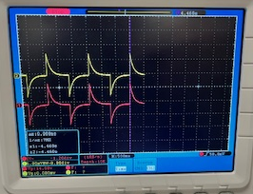
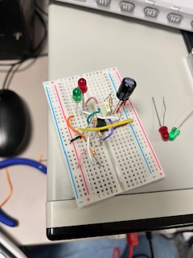
Figure 8: Picture of the graph from the oscilloscope when connected to the bread board circuit
Figure 7: The circuit created on bread board

From the graph on the oscilloscope (Figure 8) it is clear that the two waveforms across both the green LED and the 100uF capacitor have the same time period, on time and off time. The results for these figures are:
Figure 9: Table of results from the bread board model
Time Period (s) | 1.45
On Time (ms) | 750
Off Time (ms) | 700

The frequency can be calculated as done previously:
(1 / 1.45) = 0.690 Hz
The comparison in Figure 10 shows how similar the results collected from both models are which was not as the student expected as they anticipated a larger variation in results due to the human error factor in the bread board modelling in addition to the potential of setup error of equipment used.
 | Proteus Simulation | Bread Board Model
Time Period (s) | 1.46 | 1.45
On Time (ms) | 760 | 750
Off Time (ms) | 700 | 700
Frequency (Hz) | 0.685 | 0.690
Figure 10: Table of results from both the Proteus simulation and bread board model

4. Conclusion

In this study, a detailed comparison of simulated and bread board circuit modelling has been conducted, focussing on a 555 timer circuit with intermittent, flashing LEDs.
The results were collected in waveforms plotted on digital oscilloscopes with the on/off time, time period and frequencies being compared from the two data sets.
Overall, the bread board and simulated model results were almost identical which indicates that both forms of circuit modelling provide accurate results and that the two forms can be interchangeable. In addition, the study also demonstrates the student’s circuit modelling capability due to the likeness of results from both data sets.
From analysing the two frequencies calculated, the error between the bread board modelling and the Proteus simulation is 0.005 Hz which is equivalent to 0.073% error. As the error percentage is very low this indicates that the circuit was correctly modelled in the bread board in the same way as the Proteus simulation. It also highlights the accuracy of the equipment used such as the oscilloscope and the components for the circuit.
In conclusion, for the 555 timer circuit, both the simulation and bread board modelling are interchangeable as they provide the same results. However, the student found the Proteus simulation to be more effective due to it taking less time and having a clearer layout as the circuit diagram that needed to be recreated was laid out in the same format as the software.

5. References
[1] G. L. | D. Electronics | 0, “Introduction to the 555 Timer,” Circuit Basics, Mar. 22, 2021. Available: https://www.circuitbasics.com/what-is-a-555-timer/ accessed 10/12/24
[2] Electrical Technology, “555 Timer IC- Types, Construction, Working & Application – Circuit & Pinout,” ELECTRICAL TECHNOLOGY, Dec. 06, 2014. Available: https://www.electricaltechnology.org/2014/12/555-timer.html accessed 10/12/24
[3] “How to Use a Breadboard,” Science Buddies. Available: https://www.sciencebuddies.org/science-fair-projects/references/how-to-use-a-breadboard#what-breadboard accessed 10/12/24
[4] FXSEO, “How to Use a Breadboard and How It Works,” FX PCB, Sep. 26, 2023. Available: https://sfxpcb.com/how-to-use-a-breadboard-and-how-it-works/ accessed 12/12/24
[5] “How to Use a Breadboard - SparkFun Learn,” learn.sparkfun.com. Available: https://learn.sparkfun.com/tutorials/how-to-use-a-breadboard/anatomy-of-a-breadboard accessed 12/12/24
[6] Electronics Tutorial, “555 Oscillator Tutorial - The Astable Multivibrator,” Basic Electronics Tutorials, Mar. 04, 2018. Available: https://www.electronics-tutorials.ws/waveforms/555_oscillator.html accessed 20/12/24

