(Medlicott,2022.).
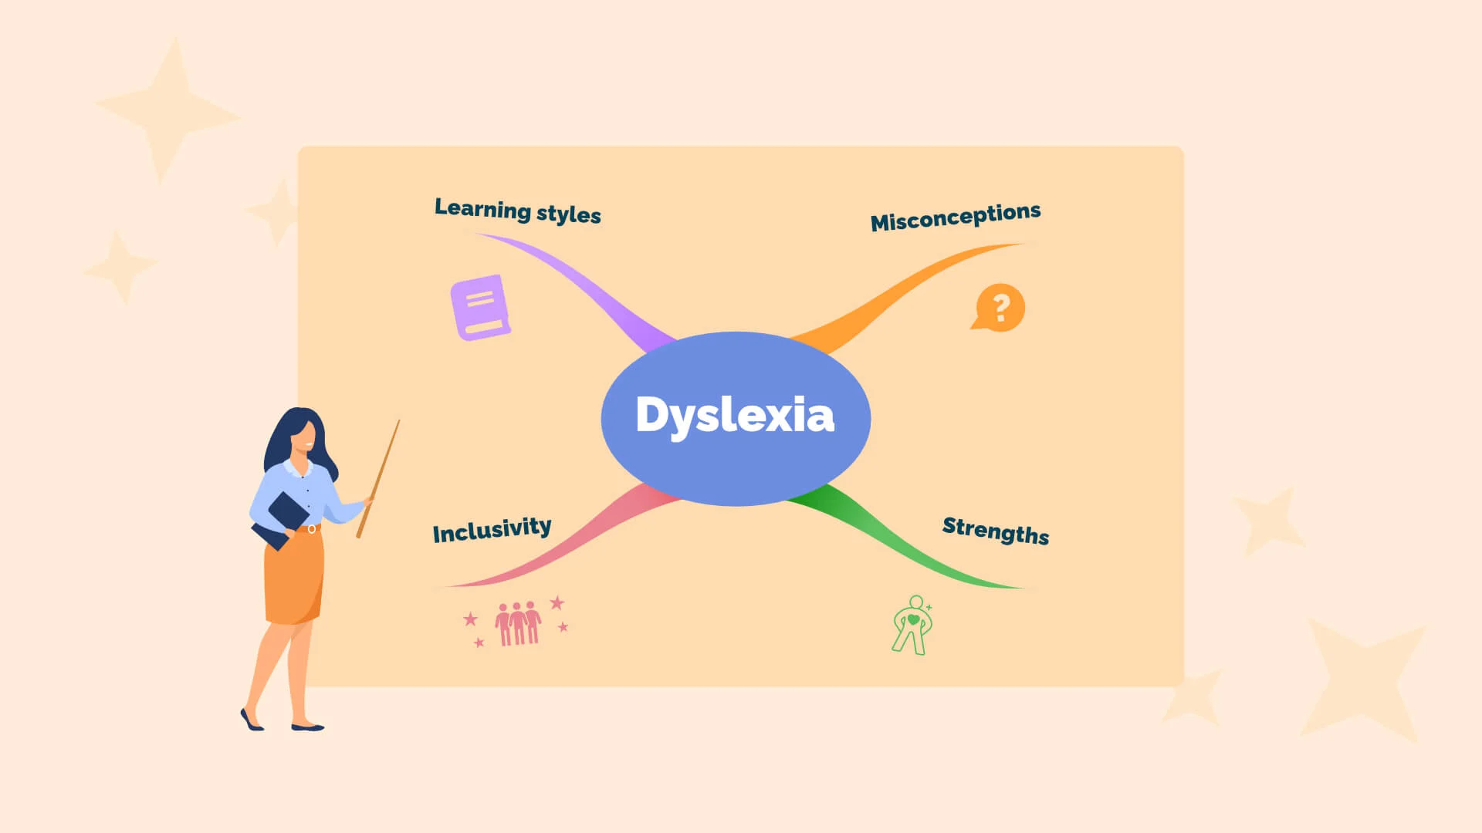

Supporting inclusive practices for comprehensive children with dyslexia.

What this leaflet will cover-
This leaflet will cover a wide range of inclusive practise ideas for teachers to incorporate in classrooms, daily class work and exam support that can better meet the needs of the learners with dyslexia during comprehensive education. Its purpose is to ensure equal opportunities for everyone to achieve their educational goals.
What is dyslexia?
Dyslexia is a specific learning different which predominantly causes impact upon areas such as reading and writing skills. Moreover, its impact extends beyond these skills. For example, dyslexia can be associated with information processing. People with dyslexia may experience challenges when processing and retaining information that they hear and see. It is important to acknowledge that there are various strengths within areas including reasoning and in visual and creative fields. (British Dyslexia Association, n.d.).
Importance of inclusive practise-
Education possessing inclusive practise is the most efficient way of providing all children with equal opportunity to attend school, acquire and enhance the skills that are essential for them to thrive.
Education being inclusive refers to all children learning in the same classroom, in the same educational setting. It represents authentic learning opportunities. (UNICEF, n.d.).
Identifying dyslexia and the barriers-
dyslexia is a wide range of abilities alongside difficulties. Distinctiveness among them that is generally uncovers it. A student with dyslexia, regardless of specific challenges skills may be found orally, in creative aspects, sporting and being very able and knowledgeable. Accompanying these skills can be a range of challenges that can be unique to each learner. Although dyslexia can only be professionally identified through a diagnostic assessment, there can be identifiable markers which can help within written work, reading, numeracy and other areas such as confusion with direction, misunderstanding complected questions and difficulty holding a list of instructions in memory. (British Dyslexia Association, n.d.). (British Dyslexia Association, n.d.), suggests that dyslexia and other specific learning difficulties affect approximately 15% of the population.
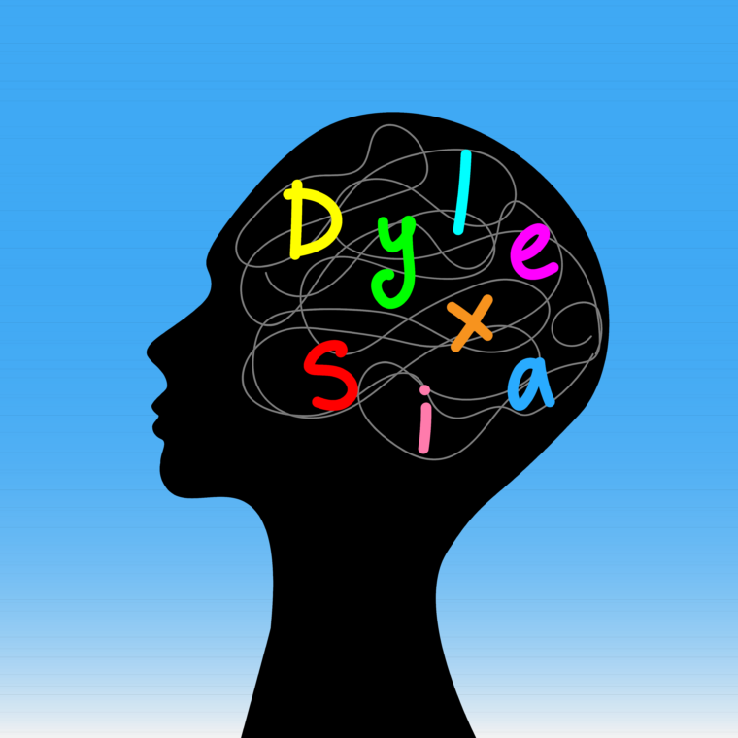

Recent findings from the department of education suggests that, in 2024 26% of students age 11 left primary education not reaching the standard expected for reading. Within the 2023/2024 academic year students with dyslexia (1 in 5) attained a grade 5 or above in GCSE English and maths, in contrast more than half of students with no noted special educational needs. This signifies an attainment gap of more than 30 percentage points. Although barriers relating to spelling, reading and writing were the most frequently described by children and young people we gathered insights from, many also referred to challenges linking with speaking in front of others, memory and organisation skills. These barriers can result in a consistent feeling of lack of independence. (British Dyslexia Association, 2025.). challenging experiences can escalate over time, young people expressed difficulties seeking support due to reception among educators and classmates. By comparison an educator providing support in class that is perceived as open and within the best interest of the pupil, reaching out for support can appear more comfortable. Putting measures in place to ensure modifications are put in place while avoiding the experience of feeling of being set apart from their peers can play a role in reducing the barriers. (British Dyslexia Association, 2025.).

(Callender, n.d.).

(pinpoint,2026.).

Barriers to inclusion-
Pupils with dyslexia can face multiple barriers within the classroom and day to day life, this suggests that it is vital for teachers to create an inclusive learning environment. These barriers can be presented in many ways for example students that are diagnosed with dyslexia may experience difficulties when preforming reading and writing tasks, alongside day-to-day sentence structure and vocal expression in some cases. This results in inconsistent, messy or unclear handwriting due to lack of thought processing without clear structure.
Dyslexia can slow down brain cognitive functions in short term memory situation by delaying the speed information is taken in and processed by the pupil.
When faced with work-based situations, individuals with dyslexia often find themselves shying away from presentation tasks where reading and writing aspects are a main factor. This is associated with a lack of self-belief and self-ability due to the awareness of their barriers. This often increases the chance that a mistake may arise when reading or writing in front of peers due to the anxiety that often can be linked. (Murphy, 2025.).
This can lead to difficulties expressing thoughts and feelings in the moment and can often result in negative impacts on both mental and physical processing action scenarios. This can directly lead to a decrease in mental health as research conducted by the ‘British Dyslexia association’ has found that dyslexia has a hand in hand connection to stress, poor self-esteem and social comparisons which all to a decline in well-being. (British Dyslexia Association, 2023.).
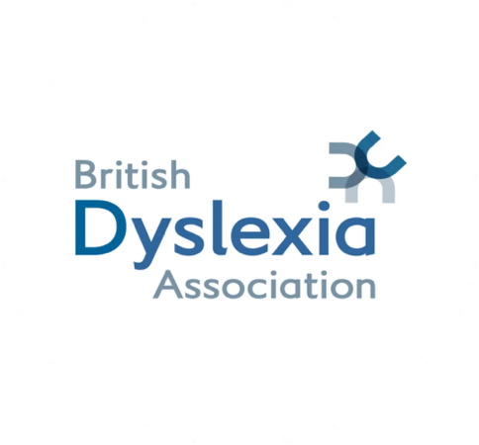
(Reach, n.d.).

Evidence inclusive practise-
Within comprehensive classrooms there are multiple ways to make class work, exams and the overall education experience inclusive for students with dyslexia so they can achieve their goals without barriers. within education it is vitally important that there are inclusive access and achievable work for students with dyslexia, that they are able to obtain resources through different channels. It is an essential element that the presentation of classwork sheets alongside the text style, size and page space is inclusive for students with dyslexia so that information can be understood and work can be achievable. The formatting and design of class work sheets are equally important as the learning content and set tasks. In contrast these barriers can be managed through differentiation and the use of specialised resources. While there are specific programmes for dyslexia, the most effective way may not be within a specific resource but in the teaching and learning process itself. Differentiation is a key element of this process, alongside interactive question and answer lessons, and the development of self-esteem and confidence. (Reid, 2007.p. 6). additional strategies teachers can implement to promote inclusion can include multisensory approaches implementing visual, auditory, hands on and active learning modalities. These methods incorporate multiple senses at the same time. Multisensory techniques can be described as ‘hear it, see it, and write it’. This teaching method has been incorporated for many years and are an essential component in the Orton-Gillingham (OG) programme and other phonics-based interventions. (Reid, 2007. P. 41).
Furthermore, more examples can be seen with including dyslexia-friendly fonts in particular Arial or Comic sans, using large print, for printed resources, posters and classroom boards. To better help pupils to understand key information providing visual aids such as charts and diagrams. Having a well labelled and organised area with resources that can be easy for pupils to access to support them further in education using materials including coloured overlays, rulers and spell check dictionaries. (Murphy, 2025.). dyslexia inclusive resources create beneficial opportunities that other pupils can use. Small adjustments including cream paper, dual coded sheets, can enhance education for the whole class enabling the students with dyslexia to engage in the same classwork as their peers, without the lack of self-esteem or feeling ‘different’. (Cavendish Education, n.d.).
Effective use of technology can assist pupils with dyslexia in their education journey creating a more inclusive environment. For a more effective way of accessing content and complementing classwork/homework, assistive technology can help pupils with dyslexia with things such as text to speech, audiobooks and word prediction software. For both visual and auditory reinforcement, interactive whiteboards and digital learning can provide in strengthening understanding. To provide support in organisation and planning encouraging the use of apps and software, digital planners and note-taking tools can support their ability to manage deadlines and plan, as students with dyslexia can often feel overwhelmed. This can promote opportunities to minimise distractions and enhance accessibility for students to focus on classwork. (Murphy, 2025.).


(Health Shield, n.d.).

Evaluation of inclusive practise-
It is vital to remember that all students with dyslexia are individuals and should have access to support that best suits their abilities. In contrast providing individual support for each pupil can be difficult for the teachers as lack of funding for equipment and technology that may be needed for support during class and exams. Without funding it develops to lack of resources within the school. Additionally, without training and understanding on dyslexia leads to a lack of acknowledgment creating less opportunities for pupils to have screening, having an effect on pupils needs not being recognised in addition this influences inclusive practise not being in place in the school.

Whole school approaches-
An example of a whole school approach is found by the ALN team at Yr Hfan, is committed to ensuring students with additional learning needs achieve the appropriate goals. the staff deliver a range of targeted interventions in areas such as numeracy, literacy, physical development alongside well-being interventions. The educations settings nurturing ethos and the dedication to additional needs training promoting responsibility and engagement across all teachers to identify the students and their personal needs. This represents a whole-school approach which reinforces provision to promote support all students, specifically students with ALN, to thrive within the education. Furthermore, within the education setting a source of reliable and easily accessed source of appropriate information that is relevant to the individual student, in addition improving planning and pedagogy in the setting. An example includes one-page profiles which enables students to gain a voice to ensure staff cater to their individual needs. (Estyn, 2025.). (Cavendish Education, 2026.) states that students with special educational needs have a team of people around them who must work together efficiently to support their learning, emotional and wellbeing progress.
- Teachers
- Support staff
- Specialists
- Parents
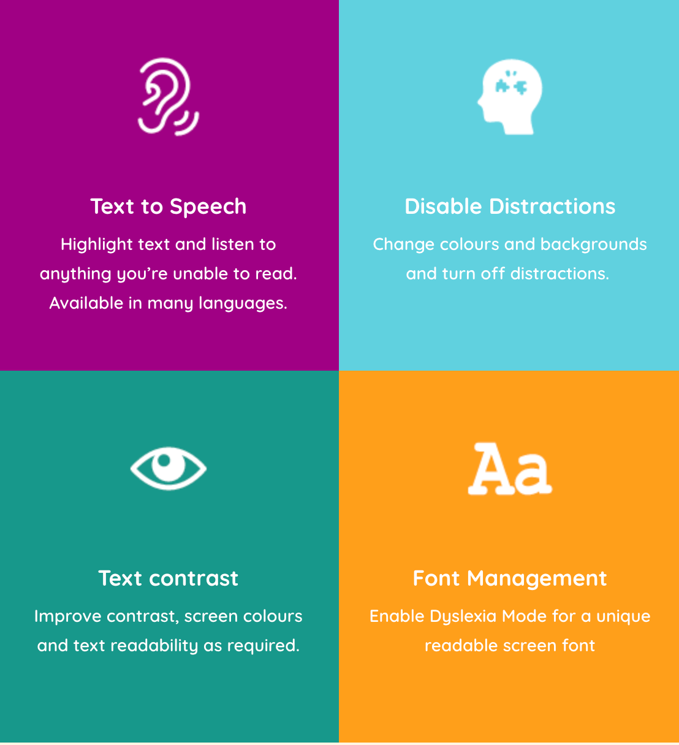

(Selby, 2026.).

Legislation, policy and research-
Law Wales (2024), states that the additional learning needs and education tribunal act (Wales) act 2018 (the Act) makes provision for a new statutory framework for supporting children and young people with additional learning needs. In addition to this act, a statutory code of practise on additional learning needs sets out further obligations for relevant bodies and guidance on how they manage their responsibilities, including guidance on assessments and how appropriate decisions about provision are to be delivered. (Welsh Government, 2024.).
SEND code of practise (2015) principles are stated by (British dyslexia association, n.d.) implies that all children have a right to an education that enables them to make progress so that they:
- achieve their best
- become confident individuals and live fulfilling lives
- makes a successful transition into becoming an adult whether that’s into further and/or higher education, training or work.
The code of practise enables teachers to better understand and remain responsible for the pupils learning, whilst also giving a Clear and structured guide path for those under specialised learning practises. (British dyslexia Association, n.d.). within the SEND code of practise, it is apparent that supporting students with dyslexia does not determine a formal diagnosis. Therefore, it is required that educators track pupils progress of students and ensure there is appropriate support in place. (Department for Education, 2022.). possessing these legislations and policies within classrooms and the whole schools provides teachers with better understanding when supporting pupils, ensuring that pupils with dyslexia receive an inclusive education and can thrive.
The British dyslexia association serves as representatives to individuals with dyslexia. The purpose of the association is to influence government and other institutions to develop a society where day to day life is inclusive for people with dyslexia to reach their full abilities. The mission of the association is to break down barriers within society, to enhance individuals with dyslexia to realise their full potential in education and further in life. They work to provide awareness about dyslexia, providing knowledge and guidance. As a powerful association they work to empower individuals, expressing information on behalf of the dyslexia community creating an inclusive dyslexia society. (British Dyslexia Association, n.d.). Furthermore, the association emphasises the importance of empowerment within the community the (British Dyslexia Association, n.d.) states,
- we listen to and represent the voice of our community to policymakers locally and nationally and advocate on their behalf.
- We provide free information and guidance via our helpline to inform and support the public.
- We support individuals seeking assessments and adjustments.
This association can provide information and resources for teachers on how to support pupils with dyslexia within education, by setting examples and ideas. Teachers can receive support for their educational practises.

Teaching methods
Differentiated instruction refers to modifying teaching approaches and learning resources to accommodate to the diverse needs of all pupils, including those who have dyslexia. This method refers to how pupils are individuals and have different learning styles and techniques. Teachers can acknowledge and modify their teaching approach by including a wide range of teaching strategies and resources. Different methods of incorporating this within the classroom can range from, using visual learning tools such as, colour coding methods and mind maps can enhance support for pupils’ knowledge of different topics. Using images, diagrams and videos to present information assisting in processing and retaining knowledge. The use of oral presentations, discussions and audio versions of reading resources supports pupils who have barriers within reading. Allowing pupils to have an option on various reading material levels of difficulty on the same topic, opens opportunity for pupils to chose based what they feel comfortable reading. (Murphy, 2025.). it is vital to be consistent with inclusive practise to ensure all pupils are achieving.

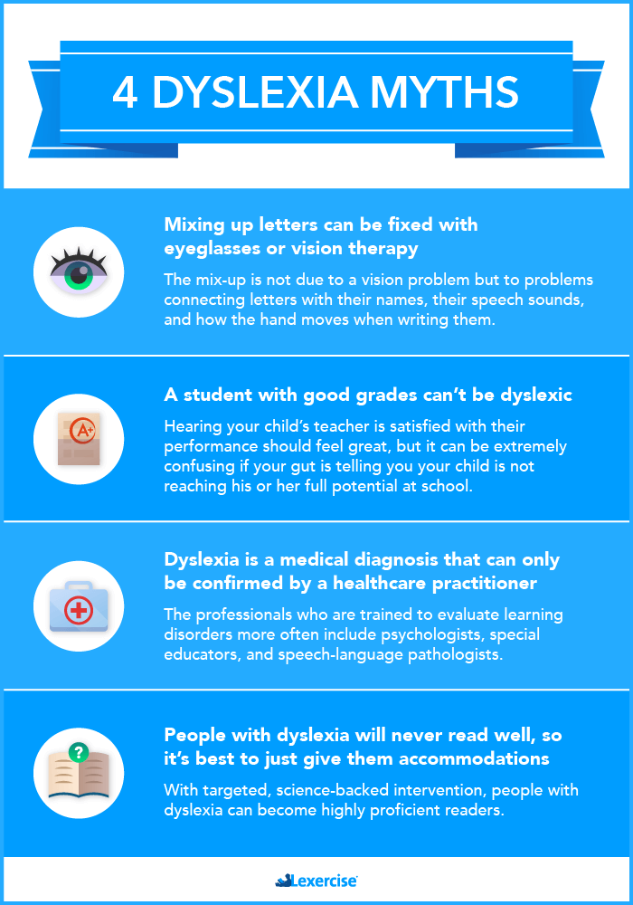

(Blackley, 2025.).

Indicators of dyslexia in compressive school pupils-
Individuals with indicators of dyslexia often struggle to maintain a lengthy level of reading or writing tasks, as in their mind its often quite tiring and an immense challenge to remain focused and piece together even the most basic sentences. This can be shown by the individual struggling to find the correct words or process what they are reading, whilst making sense of the information they are taking in. often, individual that show indicators of dyslexia find they need to re-read sentences in order to find the meaning and take in fully what is being read.
It can be seen as a sign, when planning writing tasks challenges arise as finding the right words to express their meaning can often feel confusing and unclear, leading to mistakes and errors within their sentences. Some individuals may struggle to portray their verbal information down to writing as the words often seem mixed and not directly linked to what is wanted to be portrayed. Furthermore, when trying to portray thoughts and feelings, they often mix up words, leaving sentences incomplete or with words in the incorrect order as to what they would be said or written. This could also result in word being completely left out, as the individual may forget or struggle to find the right words and implement it properly. When writing barriers can be seen in structure of phrases and sentences leaving it confusing where it may be hard for peers to understand. In addition, this links to barriers with re reading their own word and understanding it themselves, as erratic and basic spelling mistakes often hinder their own understanding of items, they themselves have written. (Williams, 2026.).

Reference list-
British Dyslexia Association (n.d.) Signs of dyslexia. Available at: https://www.bdadyslexia.org.uk/dyslexia/about-dyslexia/signs-of-dyslexia (Accessed 14th May 2026).

British Dyslexia Association (2023) Policy Dive- Reforming ITT. Available at: https://www.bdadyslexia.org.uk/news/policy-dive-reforming-itt (Accessed 15th May 2026).

British Dyslexia Association (n.d.) What is Dyslexia? Available at: https://www.bdadyslexia.org.uk/dyslexia/about-dyslexia/what-is-dyslexia (Accessed 15th May 2026).

British Dyslexia Association (2025) “Set up for somebody else”: Young people with dyslexia in the education system. Available at: https://cdn.bdadyslexia.org.uk/uploads/documents/Reports/BDA-Report_Set-up-for-somebody-else-report_Oct-2025.pdf Accessed 16th May 2026).

British Dyslexia Association (n.d.) SEND Code of Practice. Available at: https://www.bdadyslexia.org.uk/advice/educators/what-do-i-need-to-know/send-code-of-practice (Accessed 16th May 2026).

British Dyslexia Association (2023) World Mental Health Day. Available at: https://www.bdadyslexia.org.uk/news/world-mental-health-day (Accessed 15th May 2026).

British Dyslexia Association (n.d.) About us. Available at: https://www.bdadyslexia.org.uk/about/about-the-british-dyslexia-association (Accessed 21st May 2026).

Blackley, S.B. (2025) 4 Dyslexia Myths That Can Confuse Parents. Available at: https://www.lexercise.com/blog/dyslexia-myths (Accessed 20th May 2026).

Cavendish Education (2026) Dyslexia- friendly classrooms. Available at: https://www.cavendisheducation.com/insight-hub/dyslexia/dyslexia-friendly-classrooms/ (Accessed 19th May 2026).

Callender, F. (n.d.) Why Different Brains Experience Dyslexia Differently. Available at: https://www.florencecallender.com/why-different-brains-experience-dyslexia-differently/ (Accessed 14th May 2026).

Department for Education (2022) How we help schools and colleges support pupils with dyslexia. Available at: https://educationhub.blog.gov.uk/2022/03/how-we-help-schools-and-colleges-support-pupils-with-dyslexia/ (Accessed 21st May 2026).

Estyn (2025) Whole-school approach to supporting pupils with additional learning needs (ALN). Available at: https://estyn.gov.wales/improvement-resources/whole-school-approach-to-supporting-pupils-with-additional-learning-needs-aln/ (Accessed 18th May 2026).
Health shield (n.d.) Raising Awareness for Neurodiversity: Dyspraxia and Dyslexia Awareness week. Available at: https://www.healthshield.co.uk/blog/raising-awareness-for-neurodiversity-dyspraxia-and-dyslexia-awareness-week/ (Accessed 20th May 2026).
Murphy, N. (2025) The Role of Schools and Education in Supporting Dyslexic Students. Available at: https://cpdonline.co.uk/knowledge-base/safeguarding/schools-educators-supporting-dyslexic-students/ (Accessed 21st May 2026).
Medlicott, C. (2022) How to begin the conversation about dyslexia in school: a teacher’s guide and resources. Available at: https://www.ayoa.com/ourblog/how-to-begin-the-conversation-about-dyslexia-in-school-a-teachers-guide-and-resources/ (Accessed 17th May 2026).
Pinpoint (2026) Dyslexia guidance & checklists. Available at: https://www.pinpoint-cambs.org.uk/information-hub/your-childs-needs/dyslexia/ (Accessed 16th day 2026).
Reach (n.d.) ALL ABOUT ASL: DYSLEXIA. Available at: https://reach.scot/what-is-asl/all-about-asl/dyslexia/ (Accessed 21st May 2026).
Ried, G. (2007) Dyslexia. 2nd ed. London; Continuum.
Selby, L. (2026) Dyslexia Friendly Schools. Available at: https://louiseselbydyslexia.com/dyslexia-friendly-schools/ (Accessed 17th May 2026).
UNICEF (n.d.) Inclusive Education. Available at: https://www.unicef.org/education/inclusive-education (Accessed 14th May 2026).
Williams, K. (2023) Supporting teenagers with suspected dyslexia. Available at: https://www.dyslexiauk.co.uk/supporting-teenagers-with-suspected-dyslexia/ (Accessed 21st May 2026).
Welsh Government (2024) Additional Learning Needs and Education Tribunal (Wales) Act 2018. Available at: https://law.gov.wales/additional-learning-needs-and-education-tribunal-wales-act-2018 (Accessed 18th May 2026).

