

School of Engineering

Group Project

Robert Morse

1/4/22

Contents
Introduction 3
Greenpower 3
Direct Current Motors. 4
Car Component Specification 5
Methodology 6
Design of Test 6
Measurements 7
Planned Tests 8
Test two 8
Test three 9
Expected Outcome 10
Initial tests 12
Time 12
Current Scale 12
Results 13
Test 1 13
Test 2 13
Test 3 14
Comparison 15
Conclusion 17
Further considerations 17
Bibliography 18

Introduction
An investigation will be carried out to test, evaluate and improve the efficiency of the electrical propulsion system fitted to a Greenpower F24 car. The main focus of the investigation will be assessing temperature control and its impact on motor efficiency.
Various cooling solutions will be introduced and the impact on motor efficiency will be measured, these results will be displayed in graph format to enable easy comparison.

Greenpower
The Greenpower project is designed to engage students of all ages in science, technology, engineering and mathematics (STEM). The students are required to design, build and compete in a single seater race car. There are three different categories dependant on age with ranges from 9 – 25 years.
The challenge for students is to travel the furthest distance within 60 minutes, various designs can be applied to the car for things such as body work and modifications as long as it complies with the regulations. Things such as motors and batteries are supplied by Greenpower and cannot be changed or tampered with.
T1.1. All vehicles must only be driven by Greenpower supplied 24 volt DC electric motors. Hybrid systems are not permitted.
T1.2. Motors are sealed and must not be opened or modified.
(Greenpower, 2022)
Due to these restrictions the motor itself must remain complete and any motor cooling systems must be external,

Direct Current Motors.

A direct current motor is an electrical machine that that converts electrical energy into mechanical energy. When a DC motor is powered a magnetic field is created in its stator. The field attracts and repels magnets attached to the rotor, this then causes rotation of the rotor.
When designing a DC motor many considerations need to be made to ensure torque requirements are met as well as high efficiency. To ensure this, considerations must be made to heat dissipation.
The construction of a D.C motor is the same as a D.C generator. The only difference is that in a generator the generated electro motive force is greater than the terminal voltage, whereas in a motor the generated E.M.F is less than the terminal voltage. (Bird, 2010)
Basic thermodynamic laws tell us that, no matter what its design, in every electric motor some of the input electrical power is undoubtedly lost (via heat) as it is converted to output moving power. The more power lost, the higher the operational and environmental costs, which is why a motor's thermal efficiency is key. (Welch, 2009)
A linear variation of resistance with the temperature of copper prevails over a temperature range of – 50`c to 200`c. the change in resistance is usually proportional to the change in temperature. (T.K Nagsarkar, 2005)

Car Component Specification

Batteries

Nominal Voltage – 12 Current Capacity – 36 Amp Hours

Dimensions:

Length (mm) 196 Width (mm) 130 Height (mm) 158 Mass (kg) 11.2

Two lead acid batteries are wired in series create a 24 volt system.

Motor Specification

Voltage – 24v Rated Speed – 2100RPM Power – 240W

Rated Current – 15A

Methodology

Design of Test
To achieve consistent testing throughout any variables would need to be isolated. Therefore the test will be carried out in controlled conditions in a stationary test.

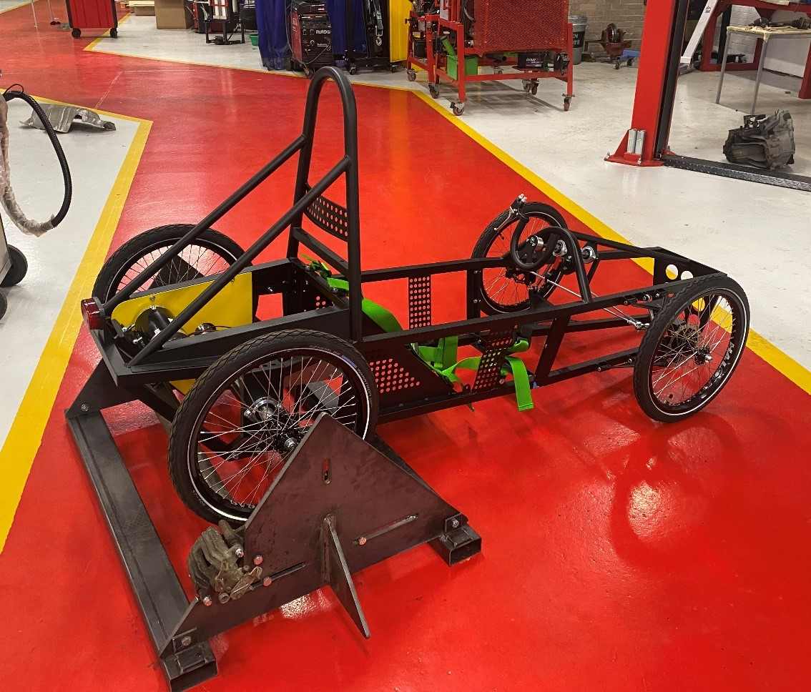

To carry out stationary testing, a set of rollers were designed to apply resistance to the driven wheels of the car. A brake disc was attached to one of the rollers; a rear brake calliper was used to brake the disc. The handbrake lever on the calliper allowed for varying resistance to be applied.

Air Resistance – the test will be carried out stationary, this will ensure zero air resistance acting upon the car.
Temperature - the workshop is thermostatically controlled to achieve a consistent start temperature for every test. This atmospheric temperature will stay consistent throughout.
Rolling Resistance – the car will be fixed on rollers with a consistent force resisting the movement, after the first adjustment to achieve correct resistance this will then remain fixed for all of the testing.
When the car was fitted on the rollers the resistance was varied to achieve the same current draw as an initial test on a flat surface.

Measurements

Temperature – the temperature of the motor and the battery will be monitored throughout all tests using thermocouples that have been attached to the components. These measurements will be validated throughout the test by using a pyrometer to confirm the temperatures are accurate.

Voltage – the battery voltage will be measured throughout, this will be used for two main reasons. Firstly to monitor the state of charge of the battery, this is vital to ensure the same starting point at the beginning of each test it also ensures that the batteries do not reach a point of discharge that will permanently damage them. Secondly monitoring the voltage throughout combined with the current measurement gives the ability to calculate the system resistance.

Current – the motor current will be measured using an inductive amp clamp with a 200 amp maximum scale, this will be connected to an oscilloscope to record the current draw over the full test. The results will be displayed in a graph format that can be saved for future reference.
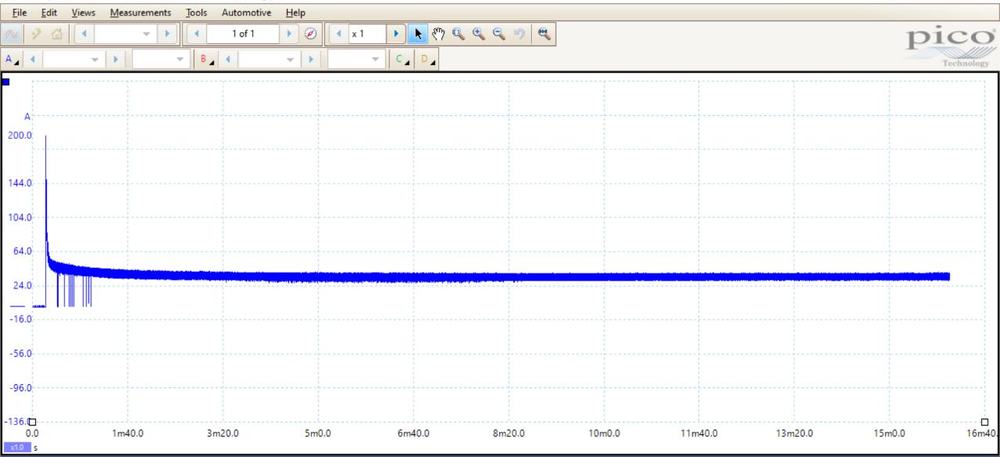
All measurements will be video recorded throughout each test for future reference and to allow the data to be collated into a spreadsheet for future analysis.
After the initial motor start up the current remains consistent throughout the test.
Initial current draw is high, then reduces as the back EMF is generated when the motor starts rotating.

Back EMF – As the armature of a motor rotates, an EMF is induced in the armature windings due to its motion through the magnetic field. The value of this back EMF will be the same as would be generated if the machine was driven as a generator at the same speed.
The resistance of the armature of a DC motor is very small usually considerably less than one ohm. On the other hand, the supply voltage is often in the hundreds of volts. If there was no back EMF to limit the armature current the latter would be excessive. (Robertson, 2001)

Planned Tests

After initial testing there will be three tests carried out, the first test will be a run with a predetermined load and time. There will be no cooling applied to the motor, all components will be standard. All previously mentioned measurements will be recorded.

Test two

A heat sink and electric cooling fan will be applied to the end of the motor, this is powered by a separate 9 volt battery. However this will need to be powered by the main battery while competing. In addition to this, a piece of ducting will be designed and plastic printed to ensure maximum air is extracted from the motor.

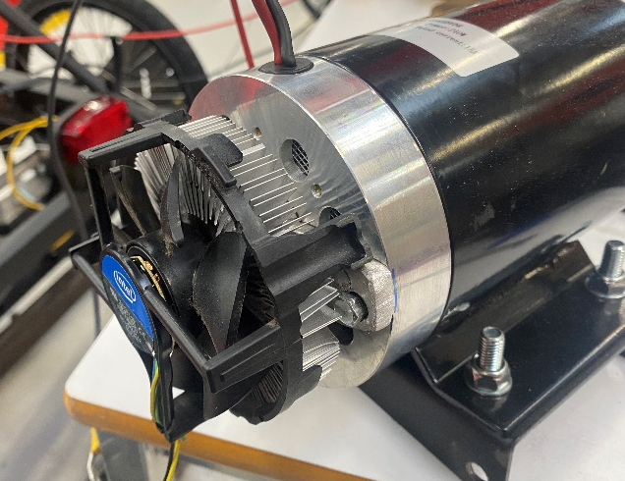

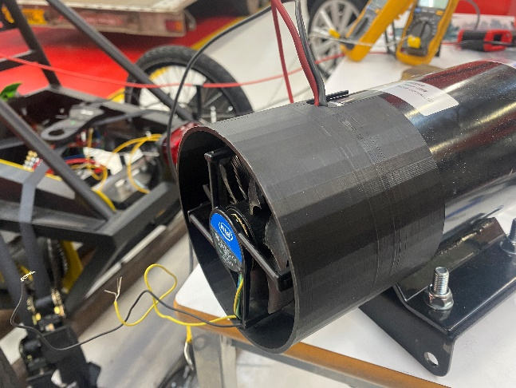

Test three

In addition to the small heat sink and cooling fan there will be a larger heatsink fitted to the body of the motor to aid cooling. A desk fan will also be used to simulate the airflow during normal use of the car on the track. The heatsink will be created using 3 mm aluminium with corrugated fins to increase surface area.

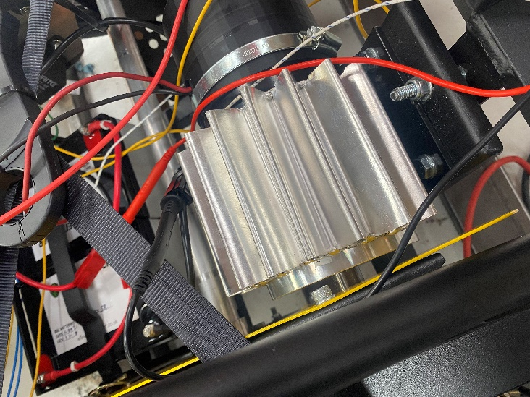
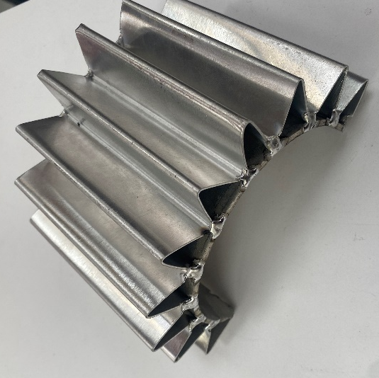

Expected Outcome

Resistance –
The Temperature Coefficient of Copper (near room temperature) is +0.393 percent per degree C. This means if the temperature increases 1°C, the resistance will increase 0.393%. (CIRRIS, 2021)

Heat Transfer –
Convection (Heat sink to air) –
Surface Area – 600 mm X 200mm
Direction of flow – 0.2m
Motor Temperature - 42°C
Heat Sink Temperature – 30 °C = T1
Air Temperature - 19°C = T2
Fan air speed – 6MPH –$(*\frac{1000}{3600}$) = 2.68m/s

Properties of air –
Density =1.204kg/m3 – (P)
Dynamic Viscosity = 1.825 * ${10}^{-5}$ kg/ms (µ)
Thermal conductivity = 0.02514 W/m K (K)
Specific Heat Capacity = 1007 J/kg K (CP)

Reynolds Number = $Re= \frac{u*l*ᴩ}{µ}$

Reynolds Number = $\frac{2.68*0.2*1.204}{1.825* {10}^{-5}}$

Reynolds Number = 8,972.27

Reynolds number is < 50,000 therefore Laminar flow.

Prandtl Number = $\operatorname{Pr}{= \frac{µ* C_{P}}{K}}$

$$=\frac{1.825*{10}^{-5}*1007}{0.02514}$$
Prandtl Number = 0.73

Nusselt Number
$$Nu=0.38*163.54*0.909=56.55$$

$$Nu=\frac{h*l}{K}$$

$$h= \frac{Nu*K}{l}$$
$$h= \frac{56.55*0.02514}{0.2}$$
$$h=0.71 w/m^{2}K$$

Surface Area = 0.6 * 0.2 = 0.12 $m^{2}$

$$Q=hA(T1-T2)$$

$$Q=0.71*0.12 \left(\left(273+30\right)-\left(273+19\right)\right)=0.94 W$$

Initial tests

Initial tests were carried out to approximate parameters for testing, the car was driven on a flat surface with a driver in it. The average current draw measured over three runs was calculated at 40 amps, this will be the target current to achieve during simulation.

Time

Based on a battery capacity of 36-amp hours total capacity, to ensure the battery is not permanently damaged it must not be discharged by any more than 50%.

362=18362=18

18∗60=1080 amps18∗60=1080 amps
Can be delivered in one hour

At 40 amps a maximum of 27 minutes of run time can be achieved.
For testing purposes all three tests will be conducted for 15 minutes, this will ensure the safe working range of the battery is maintained.

Current Scale

The first test demonstrated an initial motor starting current of an average of 190 amps, therefore a 200 amp current clamp will be used and the oscilloscope time scale set to 100 sec/div. this timescale will give 1000 seconds of recording.

Results

Test 1
As demonstrated in the below graph, the motor temperature steadily increased throughout the test. The maximum temperature reached was 52 degrees Celsius. The battery temperature remained relatively constant throughout, only increasing 2 degrees Celsius.

Test 2
Shown in the below graph is the motor and battery temperature from test 2. The battery temperature again follows the same trend as test 1, however the maximum motor temperature reached is 3 degrees Celsius lower.

Test 3

Displayed below are the results from test 3, it is clear that the maximum temperature reached were much lower than previous tests.

Comparison

As demonstrated in the below graph, the starting point of all three tests are within 2 degrees Celsius of each other however the finishing temperature after 15 minutes of running showed a significant decrease between test on and test three. Another point to add is that with test three the temperature increase was a much slower rate compared to the other tests.
In all three tests, the temperatures did not plateau, suggesting that with further run time the temperatures would continue to increase. This may be an area for further investigation if the battery capacity was increased.

The resistance of the motor was calculated using the current consumption and the supply voltage.

$$Resistance=\frac{Voltage}{Current}$$

This was calculated for all three tests for the 15 minutes, the results are displayed in the graph below.

The changes in the resistance were minimal throughout the test, excluding the initial motor start up a maximum variation of 0.05 ohms. Displayed in the graph are all three test results however the resistance remained unchanged throughout the tests.

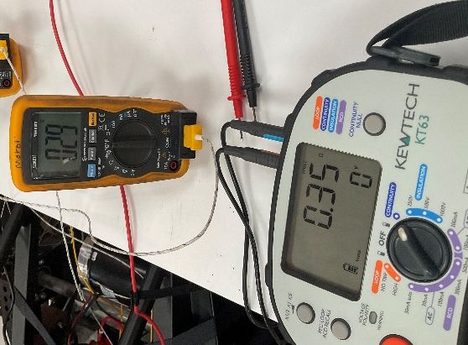
In addition to the calculated results, an ohmmeter was used to measure the motor resistance when disconnected. Multiple measurements were taken as the motor cooled from 55 degrees Celsius, these are shown below.
Motor Temperature  (Degrees Celsisus) | Motor Resistance  (ohms)
55 | 0.39
46 | 0.38
40 | 0.34
37 | 0.35
33 | 0.35
29 | 0.35

As demonstrated the temperature difference had little impact on the resistance of the motor.

Conclusion

The results demonstrate that even with a significant increase in the motor temperature the resistance did not change. One reason for this maybe that the motor temperature was not measured at the copper windings, it was measured at the motor body. With the motor working within the operating parameters it is designed for, the heat should be dissipated through the motor body away from the windings. Therefore the resistance change could not be seen due to the temperature increase not being in the windings.

Another consideration is that the motor temperature did not plateau, this suggests that the temperature would continue to rise if the necessary precautions were not in place to maintain the battery health. If the batteries could be fully discharged, it may push the motor operating temperature outside of the expected operating range. This may then increase the resistance if the motor is at the point it cannot sufficiently dissipate the heat through the body.

Further considerations

Due to the lack of efficiency improvements displayed by cooling the motor, additional testing will need to be carried out to improve the motor efficiency by other means.

The current system design does not allow for any control over the motor, the switch system is simply on or off. Running the motor at full power will only achieve approximately 30 min of run time. By using a motor controller, a pulse width modulated signal can be used to control the motor output. The motor controller has the ability to set the motor output between 0 – 100%.

The recommended operating current for the motor is 15 amps, the testing that has been carried out displayed more than double the recommended amount. Running the motor at a 50% duty cycle may result in better efficiency and could potentially reach the 60 minute run time needed.

When reducing the motor current there will also be a reduction in motor speed, because of this it will be necessary to measure the wheel speed. With this measurement taken into account it will be possible to calculate the distance traveled. Calculations will need to be made to account for distance travelled in comparison to the current used. This will allow the peak efficiency point to be calculated.

Bibliography

Bird, J. (2010). Electrical and Electronic Principles and Technology. Routledge: New York.

CIRRIS. (2021, January 1). Temperature Coefficient of Copper . Retrieved from CIRRIS: https://www.cirris.com/learning-center/general-testing/special-topics/177-temperature-coefficient-of-copper#:~:text=The%20Temperature%20Coefficient%20of%20Copper,the%20resistance%20will%20increase%200.393%25.

Greenpower. (2022). Technical and Sporting Regulations. Sussex: Greenpower.

Robertson, C. (2001). Further Electrical and Electronic Principles . Oxford: Reed Elsevier.

T.K Nagsarkar, M. S. (2005). Basic Electrical Engineering . Oxford: Oxford University Press.

Welch, R. (2009, August 1). Think Thermal To Increase Motor Efficiency . Retrieved from Machine Design: https://www.machinedesign.com/motors-drives/article/21829282/think-thermal-to-increase-motor-efficiency

